End-to-End Data Management Pipeline for a Recommendation System
Group Name: 112
Contribution Table:
Sl. No. | Name (as appears in Taxila) | ID NO | Contribution
1 | SHIVANI | 2024dc04285 | 100%
2 | ARPITA DAS | 2024dc04087 | 100%
3 | SHARATH SABU | 2024dc04091 | 100%
4 | ANAGHA DEEPAK INAMDAR | 2024dc04002 | 100%

1. Problem Formulation
RecoMart is an e-commerce platform aiming to enhance customer engagement and increase conversion rates through personalized product recommendations.
The objective of this assignment is to design and implement a complete end-to-end data management pipeline that supports ingestion, validation, preparation, transformation, feature management, model training, and orchestration.
The pipeline ensures that recommendation models are always trained on fresh, validated, and well-structured data.
- Data Sources:
User interaction logs (views, clicks, purchases, ratings)
Product metadata from catalog APIs
Session, device, and contextual attributes
- Evaluation Metrics:
RMSE, Precision@K, Recall@K, NDCG

2. Data Collection and Ingestion
Two heterogeneous data sources were ingested into the system.
Synthetic user interaction data was generated in CSV format to simulate realistic e-commerce behavior, including intentional data quality issues for validation testing.
Product metadata was exposed through a REST API implemented using FastAPI, simulating an external catalog service.
Automated ingestion scripts (ingest_products_api.py and ingest_interactions.py) fetch data periodically, apply logging, and store data into a raw data lake with time-based partitioning.

3. Raw Data Storage
A local filesystem-based data lake was implemented to store raw ingested data.
Data is organized by source, ingestion mode, and timestamp to support scalability, reproducibility, and auditing.
Eg: data_lake\raw\interactions\csv\2026\01\27.

4. Data Profiling and Validation
Automated profiling and validation checks were applied to both interaction and product datasets.
Checks include null value analysis, duplicate detection, schema validation, and range validation (e.g., rating values between 1 and 5).
Validation outputs were persisted as structured JSON files and consolidated into versioned Data Quality Report PDFs.

5. Data Preparation and Exploratory Analysis
Prepared datasets were created by removing duplicate records, filtering invalid ratings, enforcing constraints, and normalizing timestamps. Exploratory Data Analysis (EDA) was performed using Jupyter notebooks to understand user behavior, item popularity, and interaction sparsity.
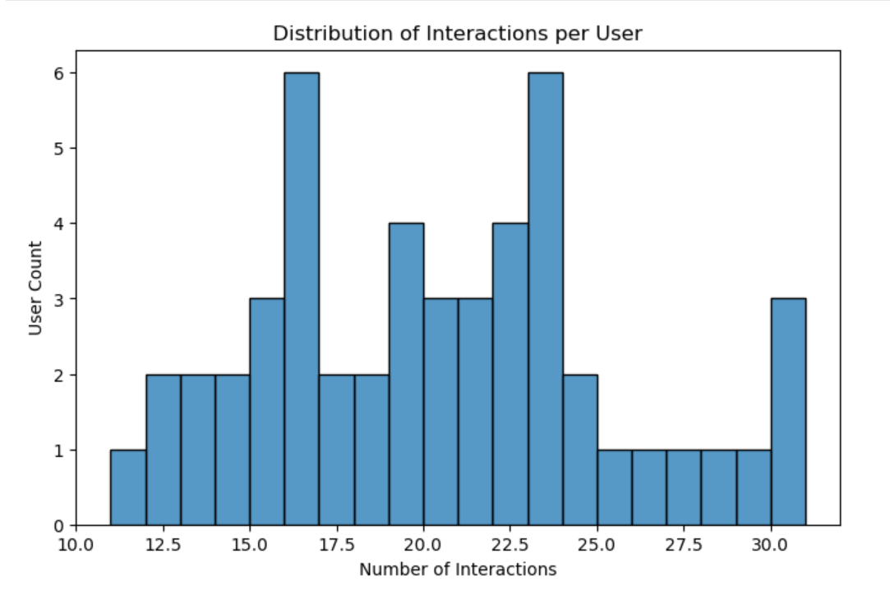
Figure 1: Distribution of Interactions per User
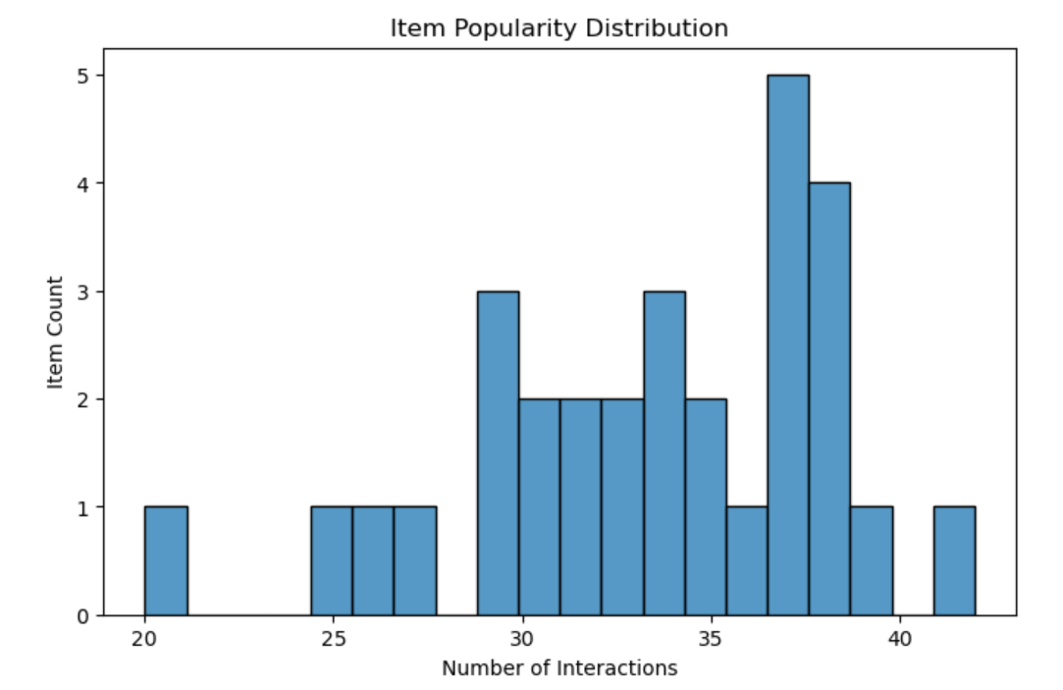
Figure 2: Item Popularity Distribution
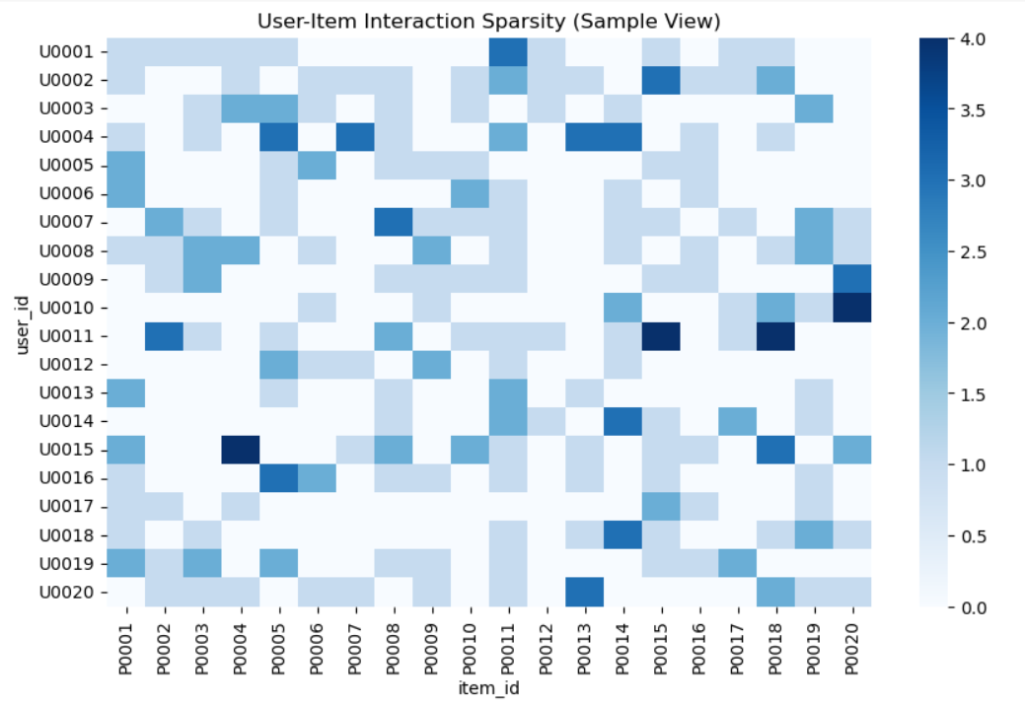
Figure 3: User–Item Interaction Sparsity (Sample View)

6. Feature Engineering and Transformation
Feature engineering was performed by joining prepared interaction and product datasets on item_id.
User-level, item-level, session-level, and contextual features were derived.
Categorical features were one-hot encoded, and numerical features were normalized using Min-Max scaling.

7. Feature Store
A centralized feature store was implemented with two layers: an offline CSV-based store and an online-ready PostgreSQL store.
Features are versioned using timestamps and can be retrieved consistently for training and inference.

8. Data Versioning and Lineage
End-to-end lineage tracking was implemented using a custom logging mechanism.
Each pipeline stage records execution time, input datasets, and output artifacts, ensuring full traceability.

9. Model Training and Evaluation
A collaborative filtering model based on Singular Value Decomposition (SVD) was trained using the Surprise library. Multiple training runs were executed and tracked using MLflow.
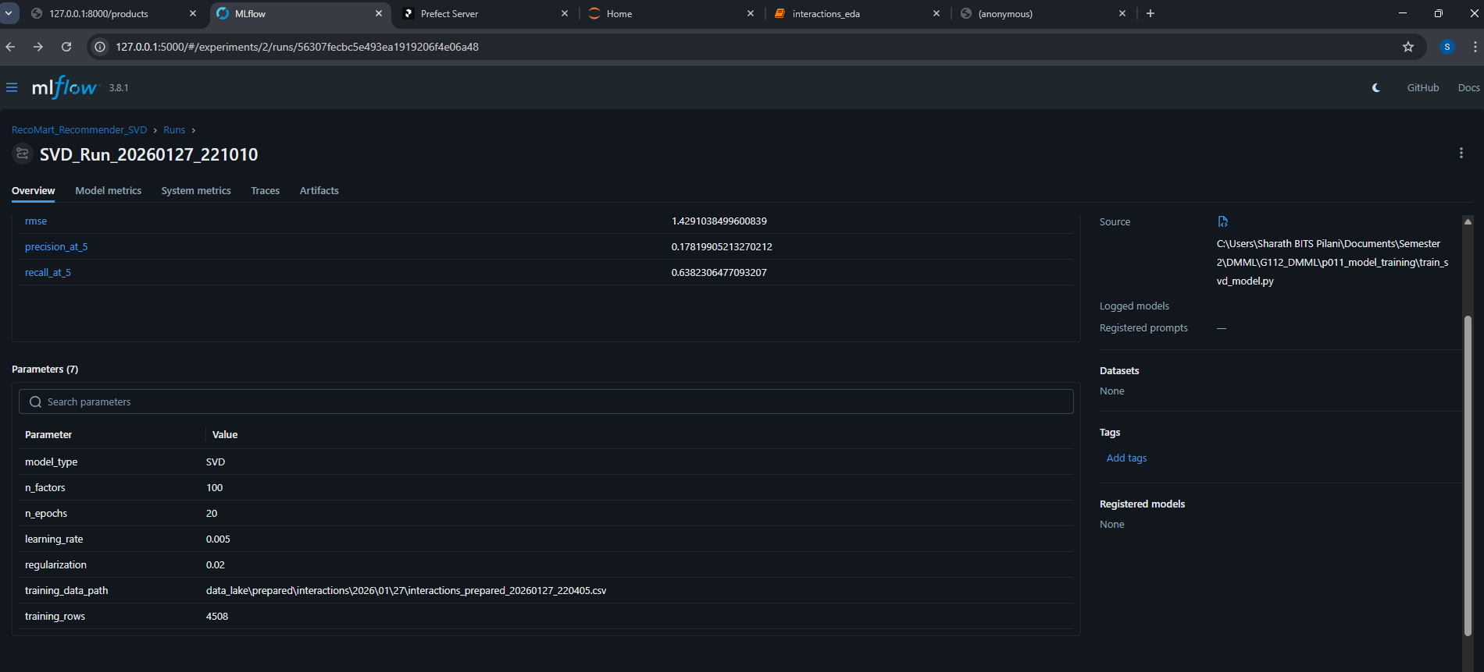
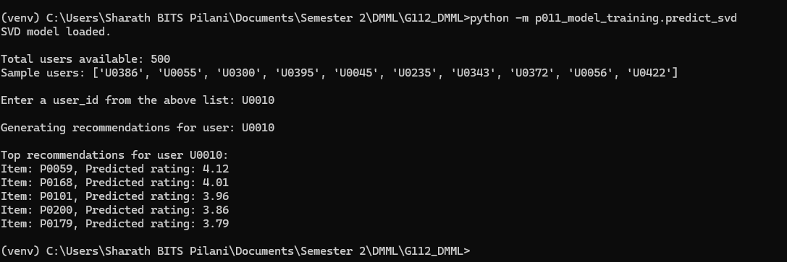

10. Pipeline Orchestration (Prefect-based Implementation)
The complete pipeline was orchestrated using Prefect to manage task dependencies, retries, and logging.
Each major pipeline stage was implemented as an independent Prefect task, including synthetic data generation, ingestion, validation, data quality reporting, preparation, feature engineering, feature store loading, and model training.
Task dependencies ensure strict execution order, for example: ingestion follows data generation, validation follows ingestion, and model training follows feature store updates.
Retry policies were configured for ingestion tasks to handle transient failures, and centralized logging captures stdout, stderr, and execution status for every task.
The Prefect flow provides a production-ready orchestration design that can be deployed on a scheduler with minimal changes.
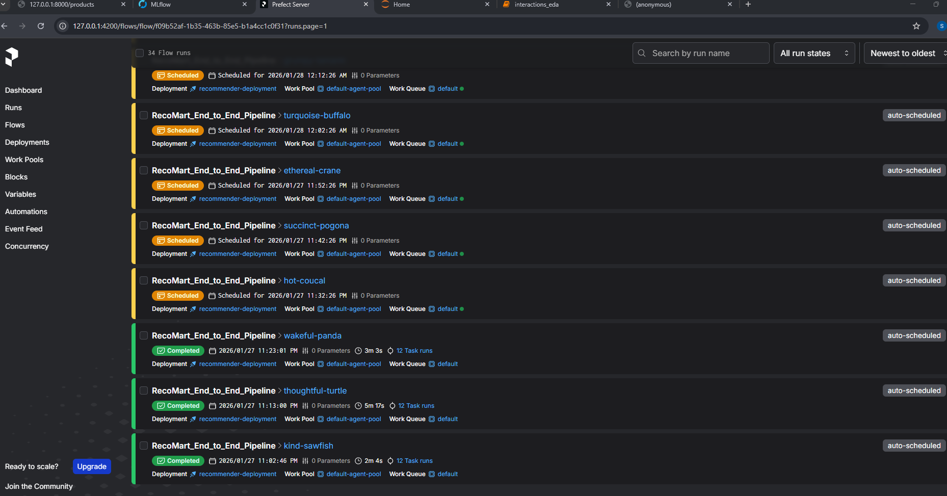

11. Conclusion
This project demonstrates a complete, modular, and reproducible data management pipeline for a recommendation system.
The implementation follows modern DMML best practices and is scalable for production deployment.

