Functionality 1: Query that uses fetch to fetch the first 5 customers who have given a rating

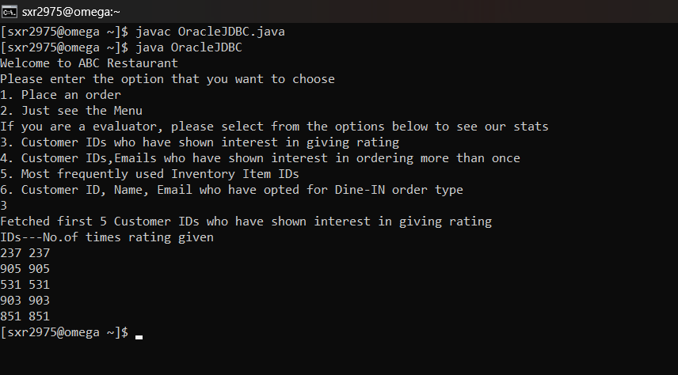

Functionality 2: Query that uses group by and having clause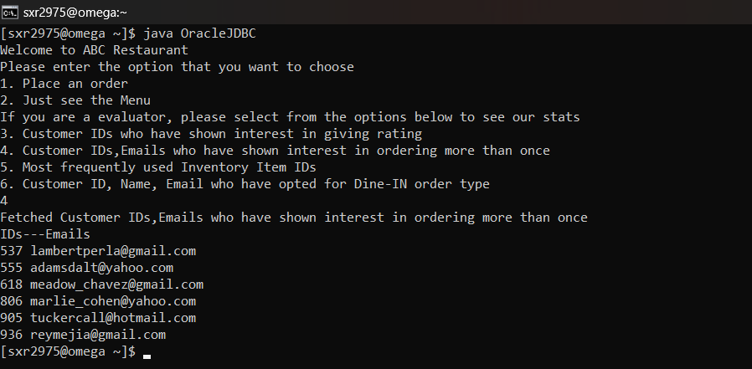

Functionality 3: Query that uses CUBE to give results on aggregations



Functionality 4: Query that uses join and in clauses

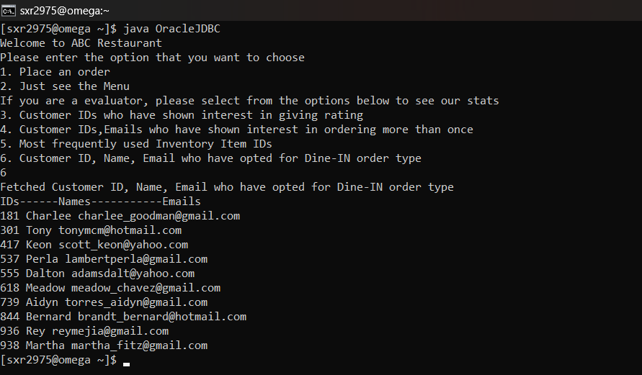

Functionality 5: Query that uses select statement to retrieve the data from a relation(Fall22_S003_2_Order)