**RECOMMENDATION SYSTEM**

**SHIVANI JAISWAL**

**Dr. PRITI KUMARI**

**Dr. VANDANA DUBEY**

**Computer Science and Engineering**

**Ashoka Institute of Technology and Management**

**jaiswalshivani421@gmail.com**

**Abstract**

**This paper focuses on how recommendation systems Work in the real world and use in daily life. Recommendation systems, which is used by user to get exact preference based on their preference and make recommendations. The recommendation system is one of the major technologies for implementing personalization services. Recommendation systems is based on user previous content and choices on basis of these make recommendation.**

**INTRODUCTION**

In this research paper we discuss how the recommendation systems have diluted the tedious tasks done by any individual for apt information. Recommendation systems recommend an item to which a user prefers by using automatic information filtering method. It deals with the detection and delivery of information that the user is likely to find interesting or useful. It assists users by filtering the data source and deliver relevant information to the users. There are two main approaches to build a recommendation system - collaborative filtering and content based with the development of the internet, especially the mobile Internet, information has undergone

an increase. More than 80% of the data in the world was created in

recent years. With the increase of information, the access of people to useful information is more difficult. Hence, the role of recommendation systems have become inevitable.

**Working of Recommendation System**

**Collection :** Data collected can be explicit (ratings and comments on products) or implicit (page views, order history, etc.).

**Storing :** The type of data used to create recommendations can help you decide the kind of storage you should use- No SQL database, object storage, or standard SQL database.

**Analyzing :** The recommender system find

items with similar user engagement data after analysis.

**Filtering :** This is the last step where data gets This is the last step where data gets filtered to access the relevant information required to provide suitable algorithm.

**Types of Recommendation System**

**Collaborative Filtering**: based on similar users Collaborative recommendation systems aggregate ratings or recommendations of objects, recognize commonalities between the users on the basis of their ratings, and generate new recommendations based on inter-user comparisons. The greatest strength of collaborative techniques is they are not dependent of any machine-readable representation of the objects being recommended. Collaborative filtering is based on the assumption that people who agreed in the past will agree in the future and that they will like similar kind of objects as they liked in the past It make recommendations only based on how users rated products in the past, not based on anything about the products themselves.

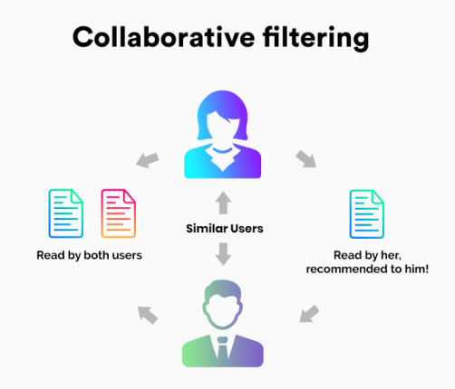

**Content-based Recommendation:** Based on description about the product and user’s choices mainly continuation of information filtering research. In this system, the objects are mainly defined by their associated features and attributes. A content-based recommendation learns a profile of the new user’s interests based on the features present , in objects the user has rated. It’s basically a keyword specific recommender system here keywords are used to describe the items. Thus, in a content-based recommender system the algorithms used are such that it recommends users similar items that the user has liked in the past or is examining currently. In other words, these algorithms try to recommend items that are similar to those that a user liked in the past (or is examining in the present). Basically, these methods use an item profile (i.e., a set of discrete attributes and features) characterizing the item within the system. The system creates a content-based profile of users based on a weighted vector of item features. Citation Indexing: Automatic citation indexing works by using a series of heuristics to process documents. We are exploring techniques through which collaborative filtering may be able to improve the utility of citation indexing systems. 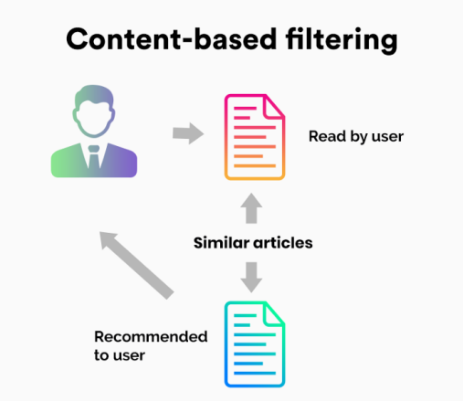

**Hybrid Recommendation Systems**

In hybrid recommendation systems, products are recommended using both content-based and collaborative filtering simultaneously to suggest a broader range of products to customers. This recommendation system is up-and-coming and is said to provide more accurate recommendations than other recommender systems.

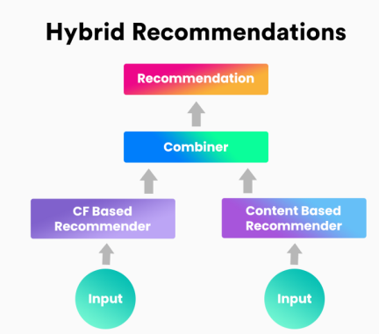

**SURVEY: EXISTING RECOMMENDATION SYSTEMS**

There are several types of recommender systems available which are helpful in various scenarios. This section reviews some of the existing recommendation systems in detail.

**1 Amazon.com Recommendation System** The amazon.com recommendation system uses product to product collaborative technique that can be used for Ecommerce websites. They use recommendation algorithms to personalize the online store for each customer.

**2. Remembrance Agent System** The Remembrance Agent is a software which augments human memory by displaying a list of documents which might be relevant to the user’s current context. It runs without user intervention. It continuously monitors the user activities and identifies the information needs.

**IMPACTS OF MAKING RECOMMENDATION SYSTEM**

### 1. Increased sales/conversion

There are very few ways to achieve increased sales without increased marketing effort. Once you set up an automated recommendation system, you get recurring additional sales without any effort.

### 2. Increased user satisfaction

The shortest path to a sale is great since it reduces the effort for both you and your customer. Recommendation systems allow you to reduce your customers’ path to a sale by recommending them an appropriate option sometimes even before they search for it.

### 3. Increased loyalty and share of mind

By getting customers to spend more on your website, you can increase their familiarity with your brand and user interface, increasing their probability to make future purchases from you.

### 4. Reduced churn

Recommendation system-powered emails are one of the best ways to re-engage customers. Discounts or coupons are other effective yet costly ways of re-engaging customers and they can be coupled with recommendations to increase customers’ probability of conversion.

**CHALLENGES AND ISSUES**

We close by considering several current challenges for recommender systems:

**1.** The first set of challenges concerns issues of bringing people together into communities of interest. A major concern here is respecting people’s privacy.

**2**. The second challenge is to create recommendation algorithms that combine multiple types of information, probably acquired from different sources at different times.

**3** .The personal information of newly registered users can be obtained through registration. Contextual information such as location, time etc. can be obtained through their IP address and those items are recommended that have been mostly viewed, downloaded and purchased by other users having similar contextual information. This can easily avoid cold-start problem.

**4**. The profile having a great history. Several current issues for recommender systems:- One of the major problem faced by the recommendation system is that cold start which is a problem related to recommendations for novel users or new items. In case of novel users, the system does not have information about their preferences

**REFERENCES**

1. Katore L.S., and Umale J.S. Comparative Study of Recommendation Algorithms and Systems using WEKA, International Journal of Computer Applications, Volume 110 – No. 3, pp14-17, 2015.

2. Tewari A.S., Kumar A., and Barman A.G.,. Book Recommendation System Based on Combine Features of Content Based Filtering, Collaborative Filtering and Association Rule Mining, IEEE, 978-1-4799-2572-8, pp 500-503, 2014.

3. Wanaskar U.H., Vij S.R., and Mukhopadhyay D. A Hybrid Web Recommendation System Based on the Improved Association Rule Mining Algorithm, Journal of Software Engineering and Applications, 6, pp 396-404 2013.

4. Shinde U., and Shedge R. Comparative Analysis of Collaborative Filtering Technique, IOSR Journal of Computer Engineering, Volume 10, pp 77-82 2013.

5. CHENG X., WANG J., Danqian LU. Research of Question Analysis Based on HNC and K Nearest Neighbor, Journal of Computational Information Systems, 6:10, pp 3449-3455, 2010.

6. Campos P.G., Bellogín A., Díez F., and Chavarriaga J.E. Simple Time-Biased KNN-based recommendations, ACM, 978-1-4503-0258-6, 2010.

7. Puntheeranurak S., and Pitakpaisarnsin P. Time-aware Recommender System Using Naïve Bayes Classifier Weighting Technique, International Symposium on Computer, Communication, Control and Automation, 3CA, pp 266-269 ,2013.

8. Bellogín A. Castells P. and Cantador I. Precision-Oriented Evaluation of Recommender Systems: An Algorithmic Comparison, ACM, 978-1-4503-0683-6, 2011.

9. Puntheeranurak S. and Sanprasert S. Hybrid Naive Bayes Classifier Weighting and Singular Value Decomposition Technique for Recommender System, IEEE, 978-1-4244- 9698-3, pp 473-476, 2011.

10. Laishram A., Sahu S.P., Padmanabhan V., and Udgata S. K. Collaborative Filtering, Matrix Factorization and Population Based Search: The Nexus Unveiled. ICONIP , Part III, LNCS 9949, pp. 352–361, 2016.

11. Prasad M. and Singh A. A Novel Hybrid Ant Colony Optimization Approach to Terminal Assignment Problem. ACM, AICTC ’16, Article 29, August 12-13, 2016.