Wireless Mobile Charger PROJECT REPORT

**Faculty: Prof. Abhishek G.**

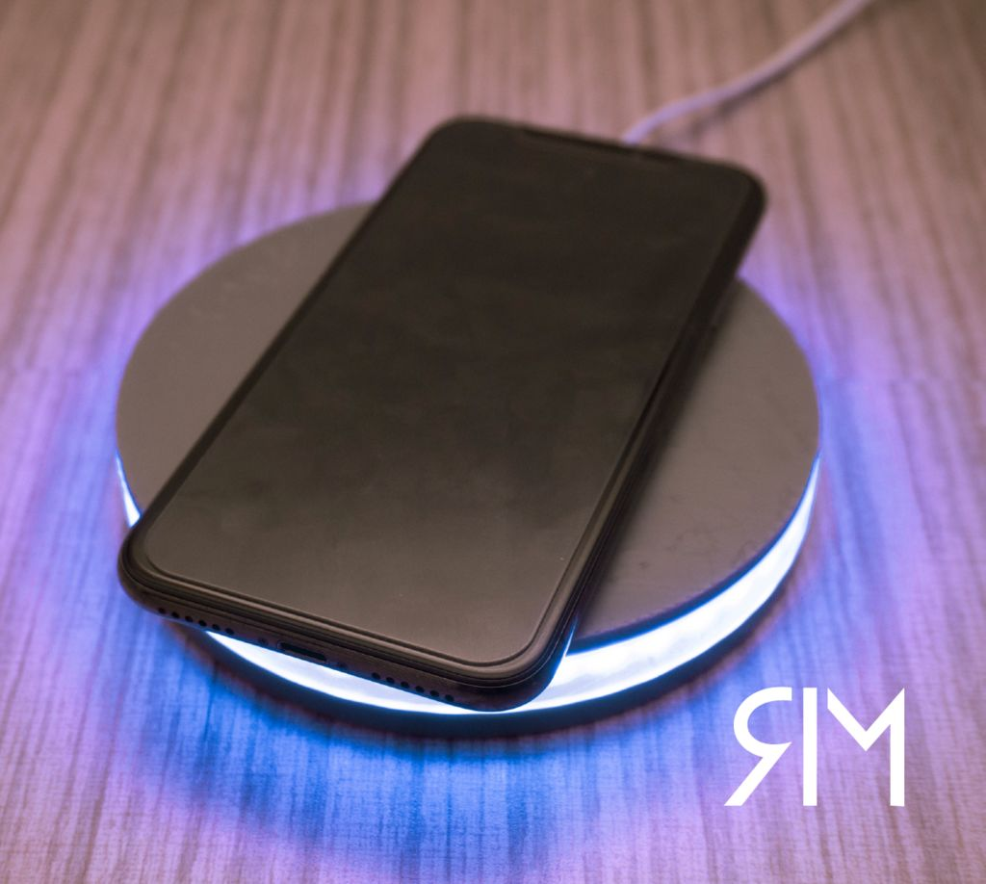**Slot- A1**

SUBMITTED BY:

Shivani Kumari 17BEE0099

Pranjal Kumar Rai 17BEE0240

Melvin Mathew 17BEE0283

Athul Thomas 17BEE0317

**OBJECTIVE**

The goal of this project ‘Wireless power transmission mobile charger circuit using inductive coupling ‘is to charge a low power device using wireless power transmission. The project is meant to charge a low power device quickly and efficiently by *inductive coupling* without the help of wires.

**DISCUSSION**

Wireless Charging is a way to charge a phone, tablet or other devices without using any wires. Wireless charging is as simple as placing a device on a charging pad and letting the charging happen. The charger itself is of course connected to a power source, but the device doesn't have to be physically plugged in. Wireless Power Transmission using inductive coupling, is one of the effective ways to transfer power between points without the use of conventional wire system. It is effective in areas where wire system is unreachable or impossible. The power is transferred using inductive coupling, resonant induction or electromagnetic wave transmission depending on whether its short range, mid-range or high range.

**COMPONENTS REQUIRED:**

1.TIP35C transistor.

2. LM7805 voltage regulator

3.100 uF capacitor

4.1N4007 silicon diode

5.Enameled Copper wire (for coil)

5.Resistor (330 ohms)

6.USB cable

7. Connecting wires

8.Heatsink

**PRINCIPLE:**

This circuit is based on the principle of electromagnetic induction. The principle of Electromagnetic induction is the process in which an electromotive force (emf) is induced in a closed circuit due to changes in the magnetic flux around the circuit. Wireless charging works on the principle of electromagnetic induction. Coils of wire in the base station (the charging plate) create a magnetic field as the alternating current passes through. This field can induce an electrical current in an adjacent coil of wire without actually touching it (Faraday’s law). The current that passes through the primary coil must oscillate at a very high frequency (~15 kHz) due to the high leakage of magnetic flux in air cored transformers at low frequencies.

**DESIGN**

The circuit consists of a DC source, a primary coil connected to a blocking oscillator in the stationary side, and a secondary coil connected with appropriate rectifying and filtering components, which in turn is connected to the phone. The secondary coil along with the aforementioned components are placed in a phone case, hence the charging takes place as soon as the phone is placed on top of the stationary coil. If this wire is part of a battery charging circuit, then you have wireless charging. The transmitter circuit for this wireless cell phone charger is the crucial stage and must be built accurately, and it must be structured as per the popular Tesla's pancake coil arrangement as shown below:

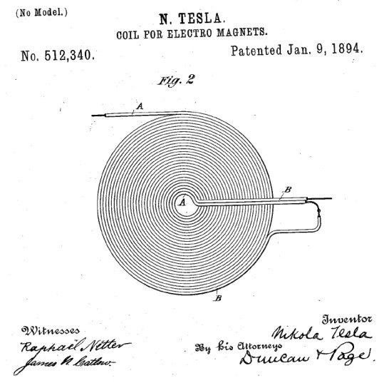

The ends of the above coil are connected to a TIP35C or equivalent transistor, resistor, and a DC power source as shown.

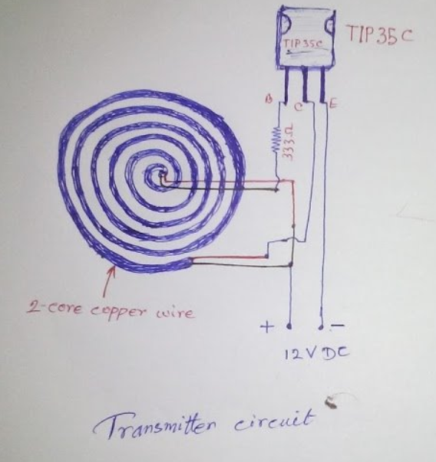

The receiver circuit is designed, keeping the output voltage required in mind. A coil ratio of 2:1 is maintained in order to reduce the heat generated by the LM7805 voltage regulator. The receiver circuit is shown below

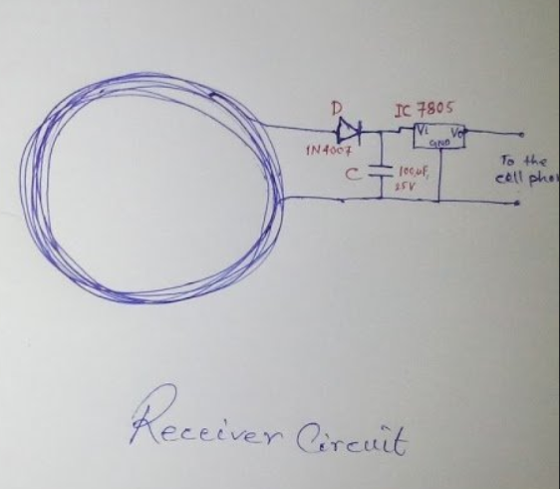

Instead of the single diode rectifier (half wave rectifier), a bridge rectifier can be used in order to increase the efficiency of the system.

The capacitor is used to smoothen the ripples produced due to the rectification of the coil output.

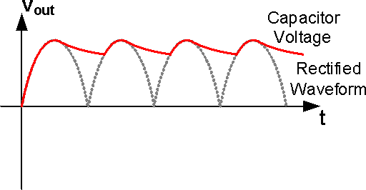

The voltage regulator restricts the voltage across the output terminals to 5V, which is the standard charging voltage used in commercial phone battery charging circuits.

**CIRCUIT PHOTOS:**

Receiver circuit:

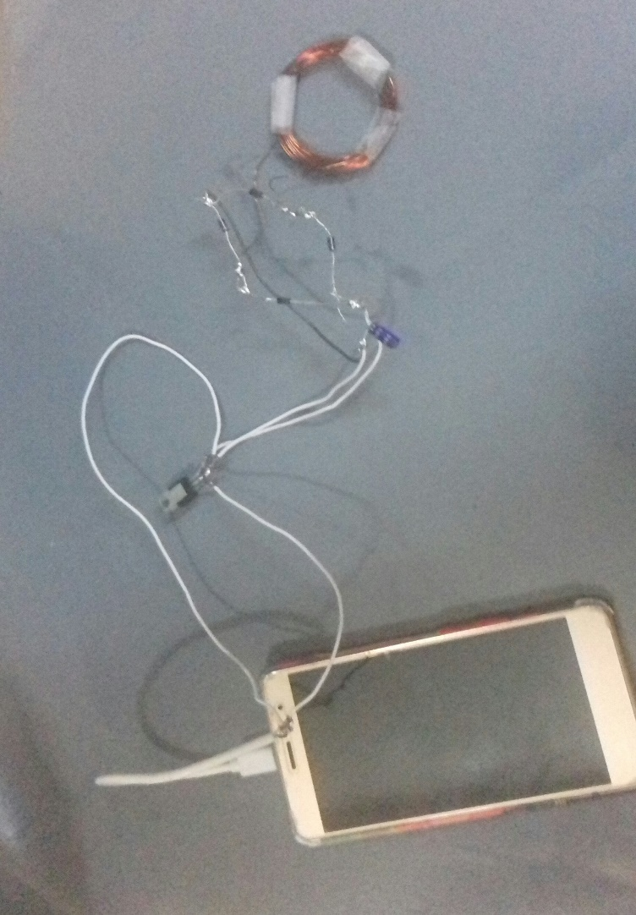

Transmitter circuit:

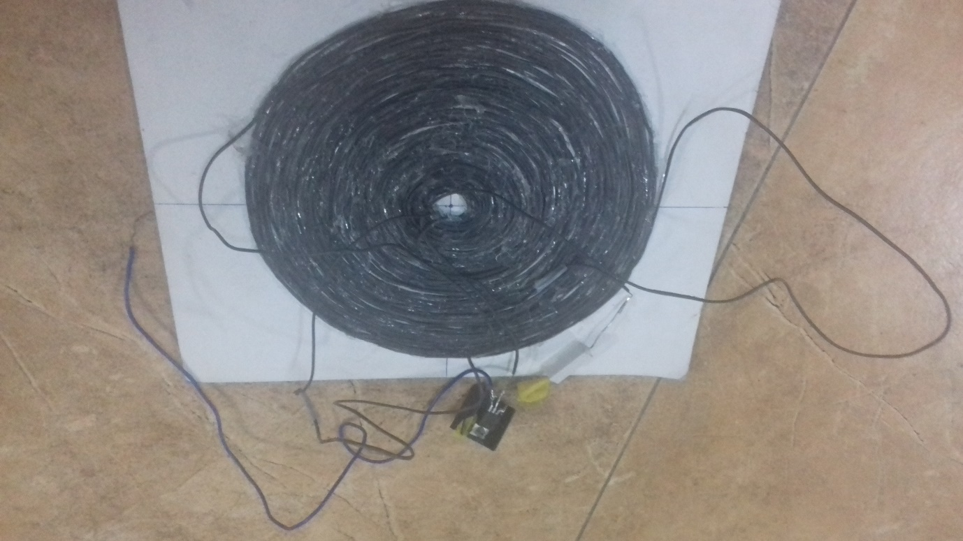

**WORKING:**

The device functions on the principle of electromagnetic induction.

A 12V dc supply is given to the transmitter circuit, which consists of a primary coil, a 330-ohm resistor, and a TIP35C power transistor. This circuit is similar to that of a blocking oscillator. The transistor is cut off for most of the duty cycle and produces periodic pulses. The resistor at the base of the transformer controls the pulse duration and is also important to make emitter-base terminals of the transistor, forward biased.

As time-varying current flows in the primary coil, it induces a current in the secondary coil by Faraday's law. This current induced is changing with time and is converted into a DC signal using a full wave bridge rectifier circuit. After that, the signal is passed via a filter circuit to reduce ripples. Then the signal is let through a voltage regulator to give a constant output DC supply of 5V. This 5V is fed into the mobile which starts to charge after that. In brief,

1.DC current supplied to the transmitter gets converted to high-frequency AC signal, due to the action of TIP35C power transistor. This current flows through the primary coil and creates a magnetic field in and around it.

2.Secondary coil, when placed in proximity to the primary coil, feels the change in magnetic flux through it. (as the current through the primary coil is changing with time) This induces a current in the secondary coil.

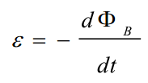

3. Current induced in the second coil is passed via a full wave bridge rectifier that converts alternating current to direct current with ripples.

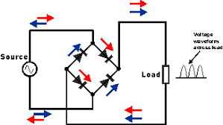

4.The current is then passed via a filter circuit consisting of a capacitor to remove the ripples of the signal.

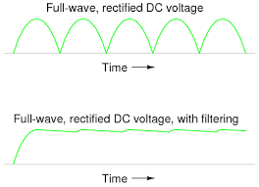

5.Finally, the current is passed via an LM7805 voltage regulator to provide a constant 5V output to the load (mobile).

**APPLICATIONS**

Wireless charging removes the hassle of recharging the devices. By using electromagnetic fields to transfer power from a transmitter to a receiver application, it charges device’s battery without a physical connection.

Now compatible devices from a wide range of receiver applications can charge up cable-free. These include:

* Smartphones and wearables
* Notebooks and tablets
* Power tools and service robots, such as vacuum cleaners
* Multicopters and electric toys
* Medical devices, such as pacemakers, where invasive surgery is required to replace batteries.
* In Car Charging, for the upcoming generation of electric cars. Electromagnetic charging systems can charge an electric car while in motion.

It eliminates tangled charging cables while allowing us to charge multiple devices in parallel.

**The** **Inductive wireless charging** support single-coil and multi-coil inductive topologies and use frequencies of 100-300 kHz. Their widespread use can be attributed to their cost-efficiency. Inductive topologies always rely on in-band communication.

**CONCLUSION**

We have completed designing the circuit component of the wireless charger. We have tested the charger using a Smartphone and the smartphone was seen charging. Thus, we were successful in producing an output.