PROJECT REPORT
VOICE CONTROLLED LIGHTS
Shivani Kumari
17BEE0099
Vellore Institute of Technology

Abstract:

This project aims at creating a lightning system that can be controlled easily by the owner’s voice with the aid of his android phone using iot. With the progressing technology, we feel a need to make advancement in traditional switching methods that use physically hand operated switches to control devices. This project strives to attempt the same.

Apparatus and Platforms:
NodeMcu development board
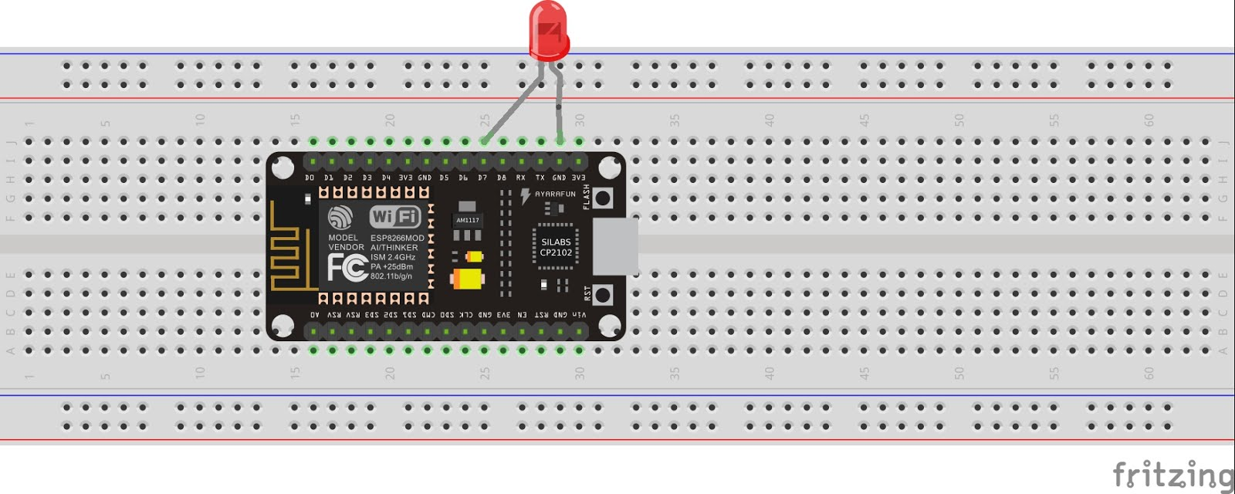
, LED, resistors, USB cable,Android phone, Laptop, Jumper wires

Arduino IDE,
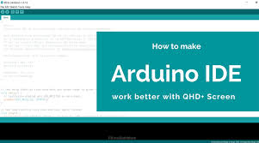
Google digital assistant
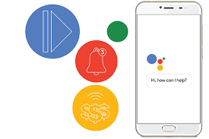
Adafruit


Working:
Whenever the owner speaks-‘OK GOOGLE, BULB ON’ to the phone, it automatically gives the signal to LED in the room to switch on. When the owner speaks, ‘OK GOOGLE, BULB OFF’, then the LED automatically switches off.
The hardware – Nodemcu, is connected via USB to laptop and programmed using Arduino IDE . It’s digital pin is connected to light( an LED), which we want to control using voice. The android phone which was used had IFTTT(If This Then That ) app and Google digital assistant downloaded and installed in it. This project also required the person to create an Adafruit IO account.
Google Digital Assistant in the phone accepts the voice command given by owner and sends a trigger to the owner’s Adafruit account’s dashboard. This information is received using Wifi to the Arduino IDE which sends it to NodeMcu that makes the light turn on or off.

CODE USED:
#include <ESP8266WiFi.h>
#include "Adafruit_MQTT.h"
#include "Adafruit_MQTT_Client.h"
#define light D0
#define WLAN_SSID "AndroidAP"
#define WLAN_PASS "ctkt0890"
#define AIO_SERVER "io.adafruit.com"
#define AIO_SERVERPORT 1883 // use 8883 for SSL
#define AIO_USERNAME "shivani130203"
#define AIO_KEY "4f71809237c946c586bac05815ff9e79"
// Create an ESP8266 WiFiClient class to connect to the MQTT server.
WiFiClient client;
// or... use WiFiFlientSecure for SSL
//WiFiClientSecure client;

// Setup the MQTT client class by passing in the WiFi client and MQTT server and login details.
Adafruit_MQTT_Client mqtt(&client, AIO_SERVER, AIO_SERVERPORT, AIO_USERNAME, AIO_KEY);
// Setup a feed called 'photocell' for publishing.
// Notice MQTT paths for AIO follow the form: <username>/feeds/<feedname>
//Adafruit_MQTT_Publish photocell = Adafruit_MQTT_Publish(&mqtt, AIO_USERNAME "/feeds/photocell");

// Setup a feed called 'onoff' for subscribing to changes.
Adafruit_MQTT_Subscribe onoffbutton = Adafruit_MQTT_Subscribe(&mqtt, AIO_USERNAME "/feeds/bulb");
// Bug workaround for Arduino 1.6.6, it seems to need a function declaration
// for some reason (only affects ESP8266, likely an arduino-builder bug).
void MQTT_connect();

void setup() {
Serial.begin(115200);
delay(10);
pinMode(light,OUTPUT);
Serial.println(F("Adafruit MQTT demo"));

// Connect to WiFi access point.
Serial.println(); Serial.println();
Serial.print("Connecting to ");
Serial.println(WLAN_SSID);

WiFi.begin(WLAN_SSID, WLAN_PASS);
while (WiFi.status() != WL_CONNECTED) {
delay(500);
Serial.print(".");
}
Serial.println();

Serial.println("WiFi connected");
Serial.println("IP address: "); Serial.println(WiFi.localIP());

// Setup MQTT subscription for onoff feed.
mqtt.subscribe(&onoffbutton);
}

uint32_t x=0;

void loop() {
// Ensure the connection to the MQTT server is alive (this will make the first
// connection and automatically reconnect when disconnected). See the MQTT_connect
// function definition further below.
MQTT_connect();

// this is our 'wait for incoming subscription packets' busy subloop

Adafruit_MQTT_Subscribe *subscription;
while ((subscription = mqtt.readSubscription(5000))) {
if (subscription == &onoffbutton) {
Serial.print(F("Got: "));
Serial.println((char *)onoffbutton.lastread);
uint16_t state= atoi((char *)onoffbutton.lastread);
if (state==1)
digitalWrite(light,1);
else
digitalWrite(light,0);
}
}

}

// Function to connect and reconnect as necessary to the MQTT server.
// called in the loop function and it will take care if connecting.
void MQTT_connect() {
int8_t ret;
if (mqtt.connected()) {
return;
}

Serial.print("Connecting to MQTT... ");

uint8_t retries = 3;
while ((ret = mqtt.connect()) != 0) { // connect will return 0 for connected
Serial.println(mqtt.connectErrorString(ret));
Serial.println("Retrying MQTT connection in 5 seconds...");
mqtt.disconnect();
delay(5000); // wait 5 seconds
retries--;
if (retries == 0) {
// basically die and wait for WDT to reset me
while (1);
}
}
Serial.println("MQTT Connected!");
}

HARDWARE IMPLEMENTATION
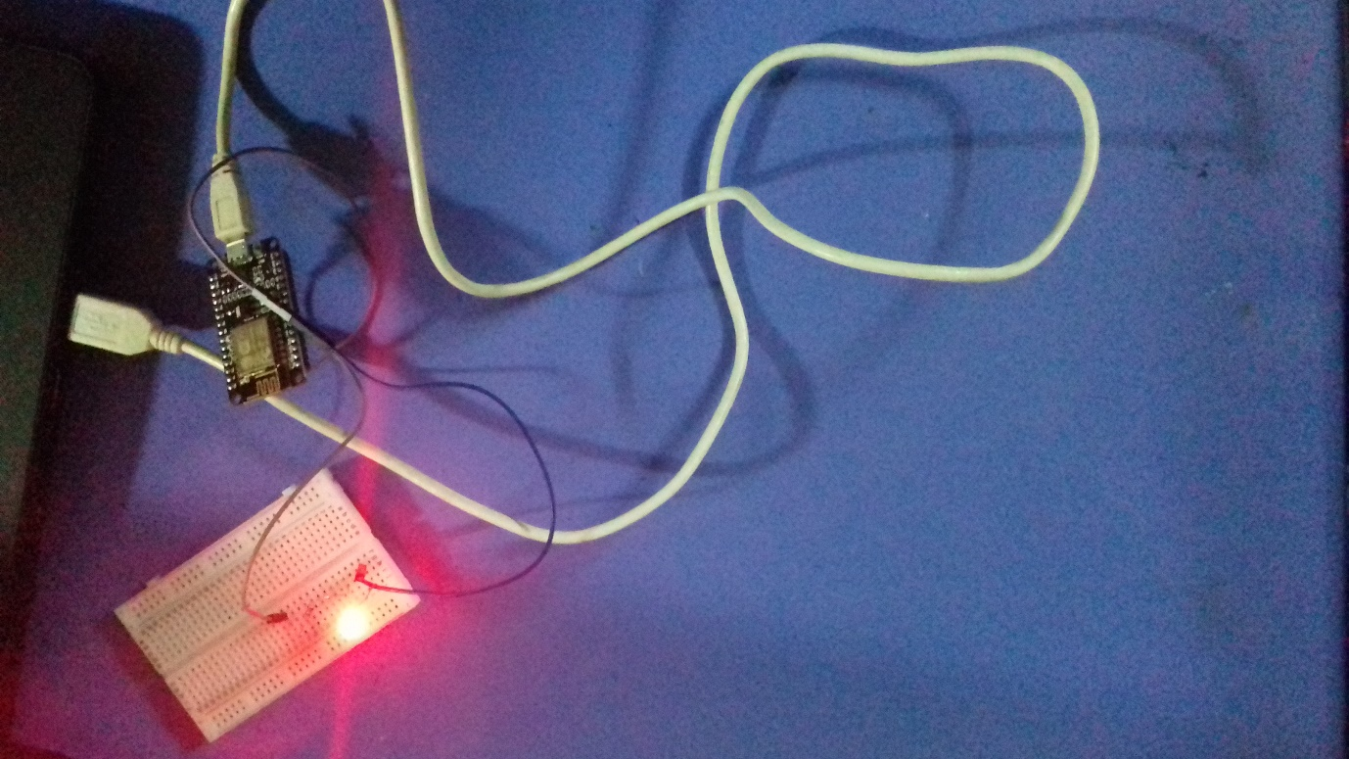
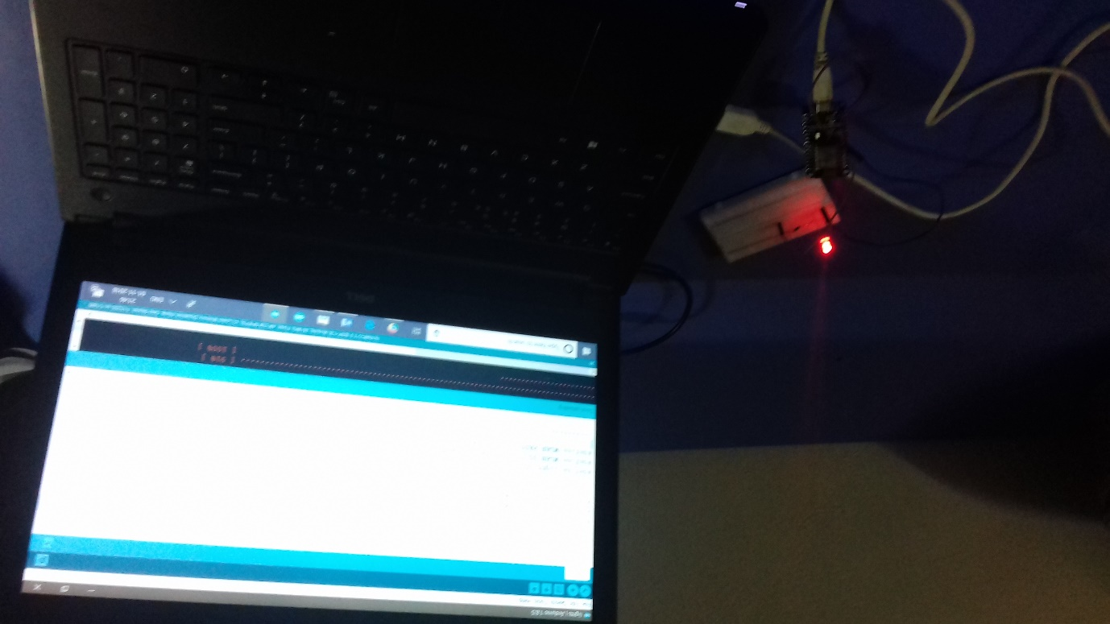
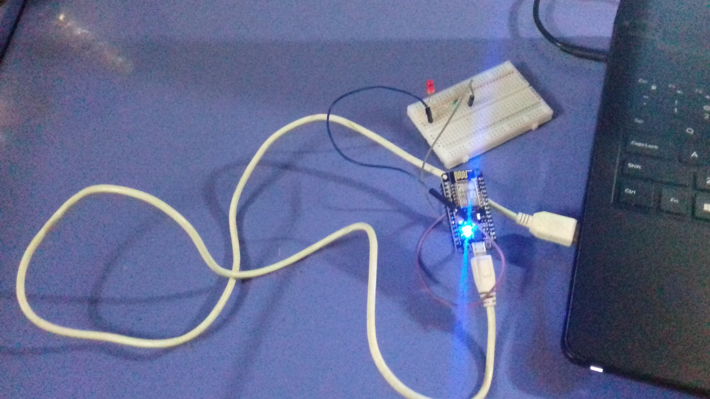

ACKNOWLEDGEMENT
This project was done by Shivani Kumari, 2nd year , B.tech. student at Vellore Institute of Technology under the continuous guidance of Prof. Akshaya Kumar Swain in the subject ‘Introduction to Innovative Project’.

CONCLUSION
This project will help in bidding a goodbye to traditional hand operated switches to control electrical appliances . It will also prevent unnecessary electric shock accidents as people will not have to touch switches anymore to control their home/office lights. Also these lights can be switched from any part of the world using phone. This will lead to a revolution in how we perceive the world today and help to prevent further human accidents due to electricity.

