High Availability Automated Nginx Reverse Proxy Application using Terraform, Ansible & CloudWatch for monitoring.
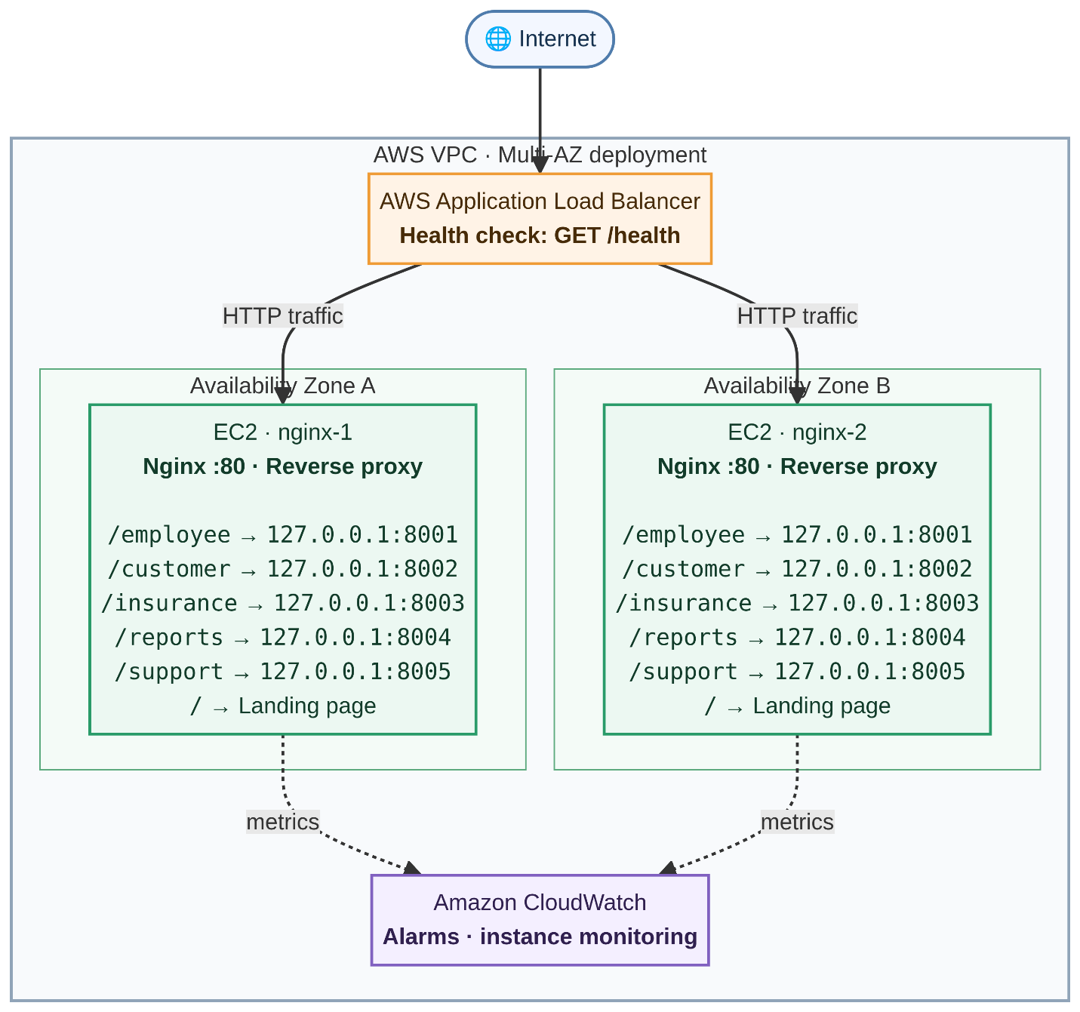
1. Install tools on your computer
bash
sudo apt update && sudo apt install -y ansible unzip curl

# Terraform
wget -O - https://apt.releases.hashicorp.com/gpg | sudo gpg --dearmor -o /usr/share/keyrings/hashicorp-archive-keyring.gpg
echo "deb [signed-by=/usr/share/keyrings/hashicorp-archive-keyring.gpg] https://apt.releases.hashicorp.com $(lsb_release -cs) main" | sudo tee /etc/apt/sources.list.d/hashicorp.list
sudo apt update && sudo apt install -y terraform

# AWS CLI v2
curl "https://awscli.amazonaws.com/awscli-exe-linux-x86_64.zip" -o awscliv2.zip
unzip awscliv2.zip && sudo ./aws/install

2. Connect your AWS account
bash
aws configure
Enter an IAM access key with EC2, ELB, VPC, CloudWatch and SNS permissions. Confirm with:
bash
aws sts get-caller-identity

3. Create an SSH key pair
bash
ssh-keygen -t ed25519 -f ~/.ssh/ha-nginx-key -N ""
Terraform uploads the .pub half to AWS; Ansible uses the private half to log in.

4. Configure Terraform variables
bash
cd ha-nginx-platform/terraform
cp terraform.tfvars.example terraform.tfvars
curl -s https://checkip.amazonaws.com
Open terraform.tfvars and set ssh_allowed_cidr to <your-ip>/32. Adjust aws_region or instance_type if needed.

5. Build the AWS infrastructure
bash
terraform init
terraform validate
terraform plan
terraform apply # type "yes"
This creates the VPC, subnets, security groups, 2 EC2 servers, the ALB, and CloudWatch alarms — and writes ansible/inventory.ini with the servers' IPs automatically. Takes about 3 minutes.

6. Confirm Ansible can reach the servers
bash
cd ../ansible
ansible nginx_servers -m ping
Both nginx-1 and nginx-2 should return pong. If not, wait a minute for the servers to finish booting and retry.

7. Configure Nginx and deploy the 5 websites
bash
ansible-playbook site.yml
This installs Nginx, writes the reverse-proxy and backend configs, and renders all five websites plus the landing page — one server at a time, so the other keeps serving traffic.

8. Open the platform
bash
cd ../terraform
terraform output website_urls
Give the ALB about a minute to mark both targets healthy, then open the alb_dns_name output in a browser.

9. Verify load balancing (optional)
bash
ALB=$(terraform output -raw alb_dns_name)
for i in $(seq 1 10); do curl -sI http://$ALB/ | grep -i x-served-by; done
You should see responses from both servers.

10. Tear down when done
bash
terraform destroy # type "yes"
The ALB bills hourly, so destroy it once you're finished demoing.
The README inside the zip has this same sequence plus troubleshooting and failure-testing steps if you want to demonstrate the self-healing behavior.
sudo apt update && sudo apt install -y ansible unzip curl

# Terraform
wget -O - https://apt.releases.hashicorp.com/gpg | sudo gpg --dearmor -o /usr/share/keyrings/hashicorp-archive-keyring.gpg
echo "deb [signed-by=/usr/share/keyrings/hashicorp-archive-keyring.gpg] https://apt.releases.hashicorp.com $(lsb_release -cs) main" | sudo tee /etc/apt/sources.list.d/hashicorp.list
sudo apt update && sudo apt install -y terraform

# AWS CLI v2
curl "https://awscli.amazonaws.com/awscli-exe-linux-x86_64.zip" -o awscliv2.zip
unzip awscliv2.zip && sudo ./aws/install

aws configure

# 1. SSH key
ssh-keygen -t ed25519 -f ~/.ssh/ha-nginx-key -N ""

# 2. Terraform settings
cd ha-nginx-platform/terraform
cp terraform.tfvars.example terraform.tfvars
curl -s https://checkip.amazonaws.com

#KEY PAIR
aws ec2 create-key-pair --key-name ha-nginx-key \
--query 'KeyMaterial' --output text --region ap-south-1 > ~/.ssh/ha-nginx-key.pem

chmod 400 ~/.ssh/ha-nginx-key.pem
---------------------------------------------------------------------------------------------------------------------
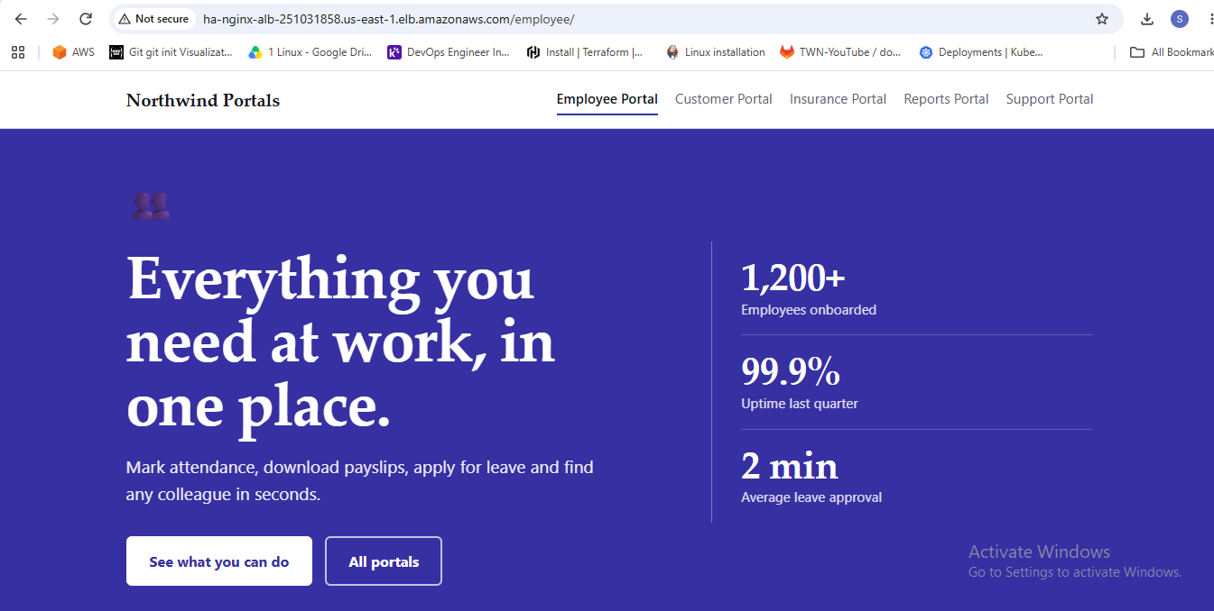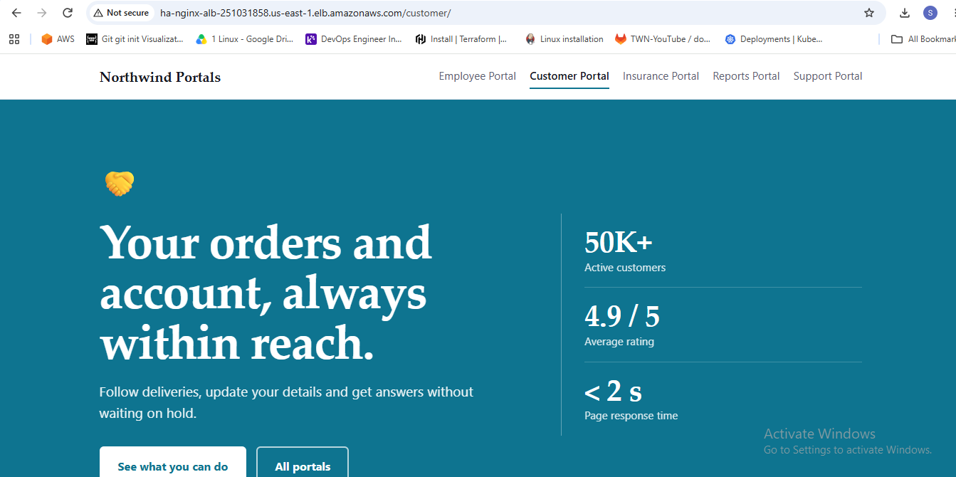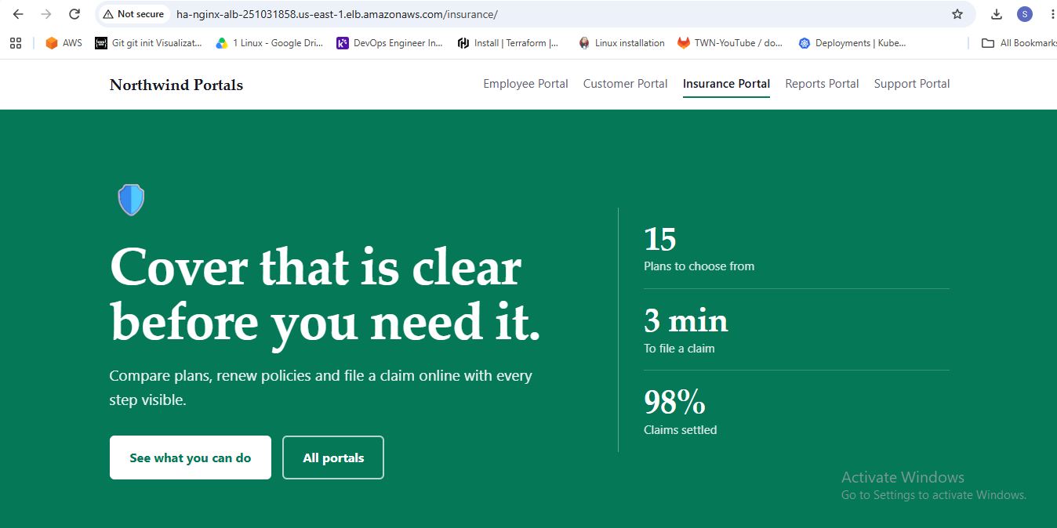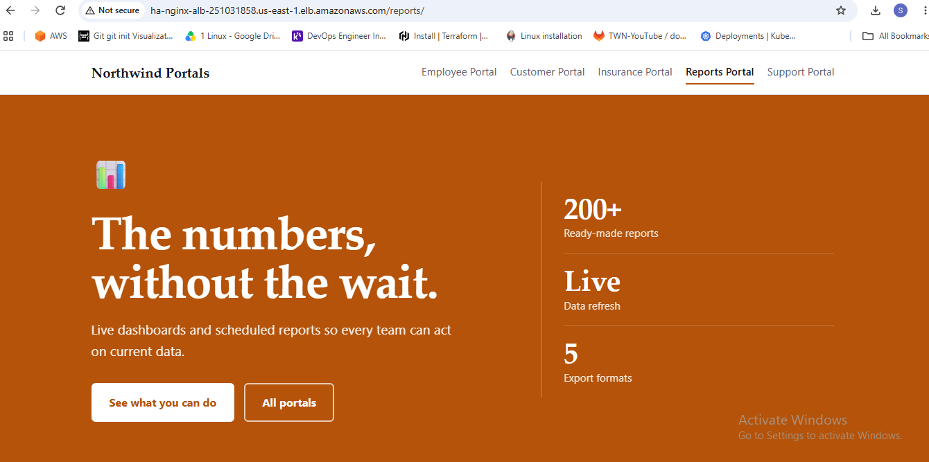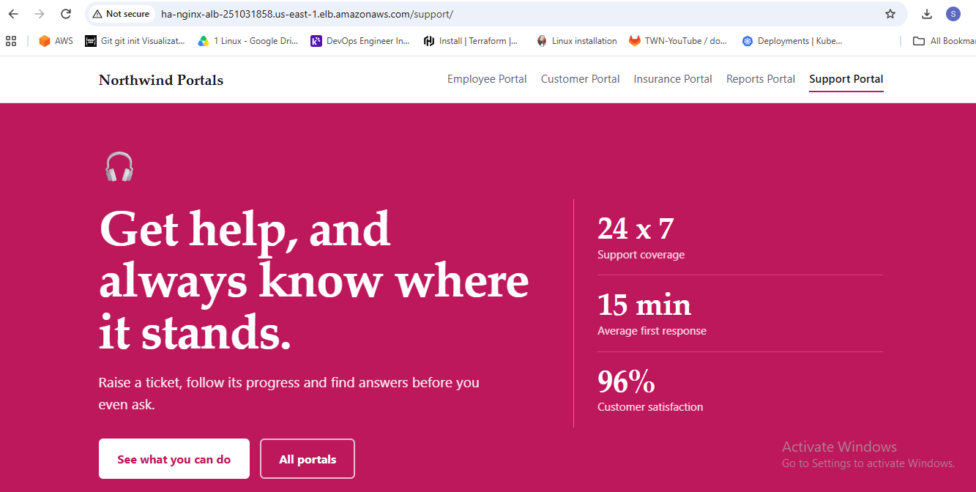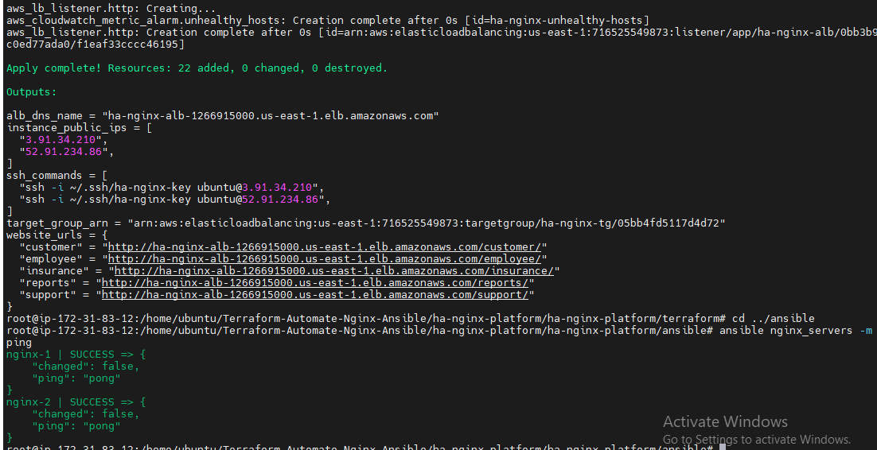

}
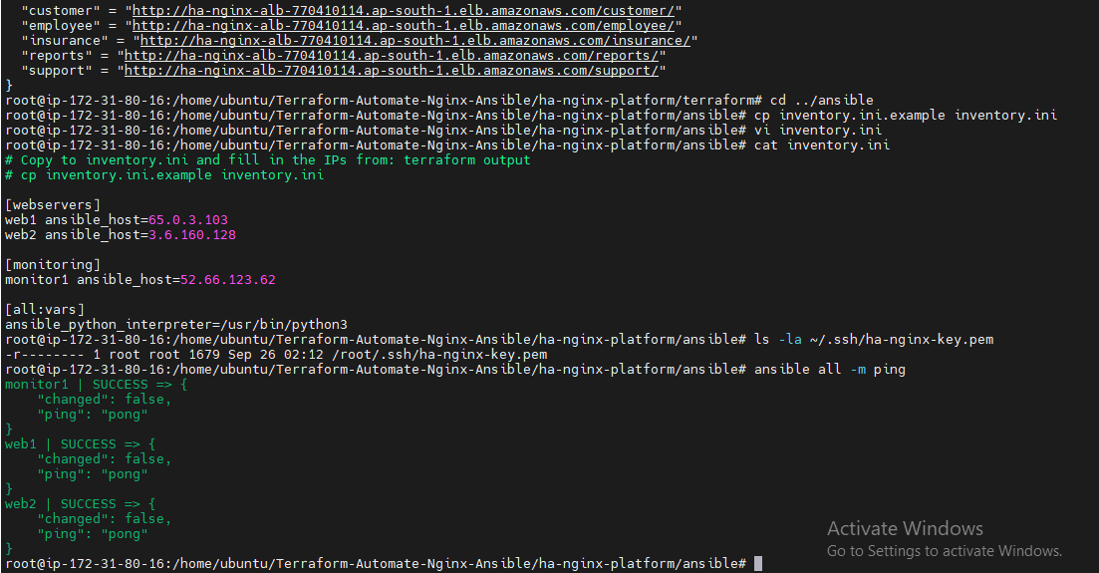
alb_dns_name = "ha-nginx-alb-1266915000.us-east-1.elb.amazonaws.com"
instance_public_ips = [
"3.91.34.210",
"52.91.234.86",
]
ssh_commands = [
"ssh -i ~/.ssh/ha-nginx-key ubuntu@3.91.34.210",
"ssh -i ~/.ssh/ha-nginx-key ubuntu@52.91.234.86",
]
target_group_arn = "arn:aws:elasticloadbalancing:us-east-1:716525549873:targetgroup/ha-nginx-tg/05bb4fd5117d4d72"
website_urls = {
"customer" = "http://ha-nginx-alb-1266915000.us-east-1.elb.amazonaws.com/customer/"
"employee" = "http://ha-nginx-alb-1266915000.us-east-1.elb.amazonaws.com/employee/"
"insurance" = "http://ha-nginx-alb-1266915000.us-east-1.elb.amazonaws.com/insurance/"
"reports" = "http://ha-nginx-alb-1266915000.us-east-1.elb.amazonaws.com/reports/"
"support" = http://ha-nginx-alb-1266915000.us-east-1.elb.amazonaws.com/support/
