Song Recommendation based on Voice Tone Analysis

In this project we have designed deep learning based emotion detection model from voice pitch and based on user pitch emotion Chatbot will suggest songs. Chatbot ask user to record his voice and then analyse user pitch to detect emotion and based on emotion songs will be recommended.

Propose model can identify 8 different emotions such as Happy, Calm, neutral which we are considering as Happy and suggesting JOSH songs. This model will predict other emotions like Sad, Angry, feared, disgust and surprise which are considering user as in SAD mood and suggesting HAPPY songs.

On demand also songs will be suggested where user has to type his feeling as Happy or Josh and based on that songs will be recommended.

SCREEN SHOTS

To run project double click on ‘run.bat’ file to get below screen

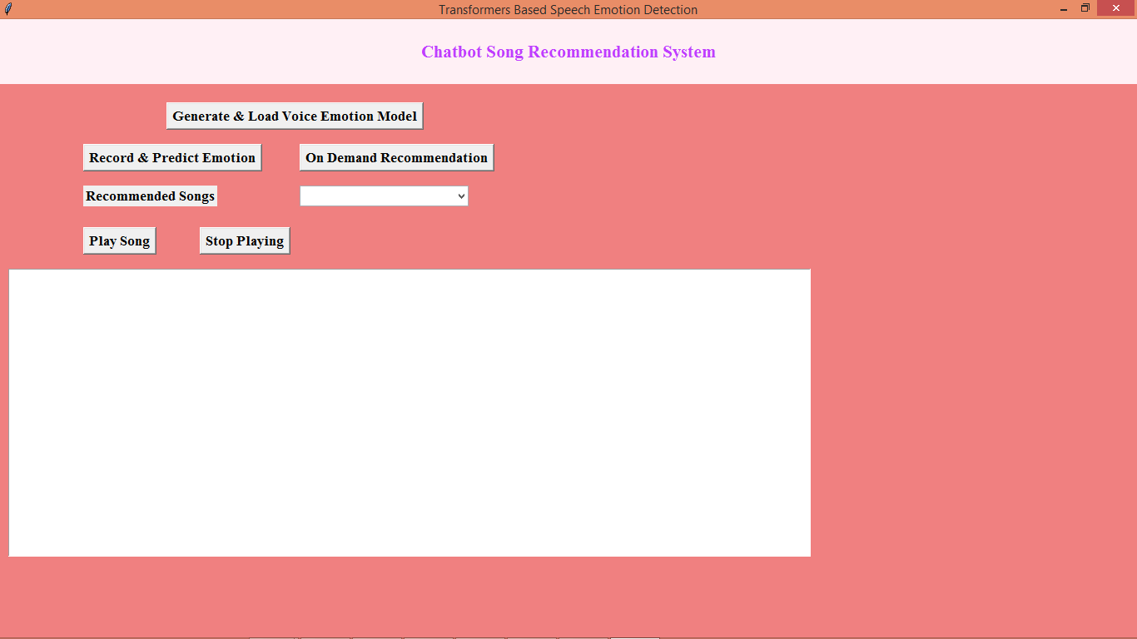

In above screen click on ‘Generate & Load Voice Emotion’ model button to load model and get below output

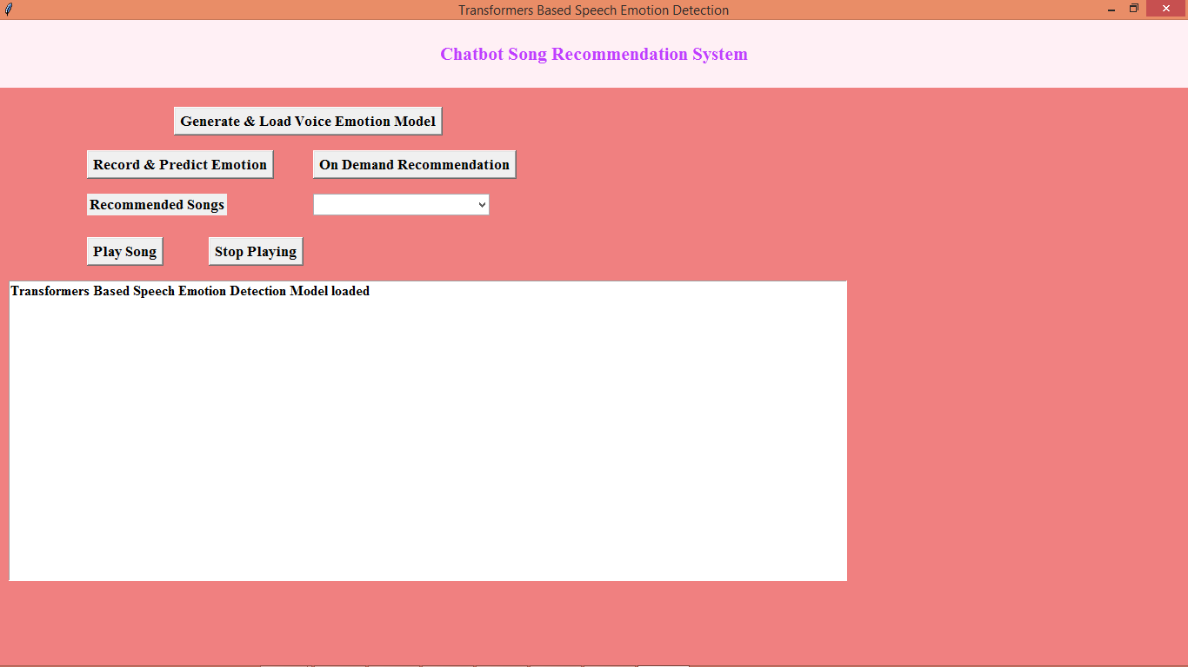

In above screen model is loaded and now click on ‘Record & Predict Emotion’ button to start recorder and then you need to speak something and once model get sufficient voice data then it will predict emotion based on pitch and give below output

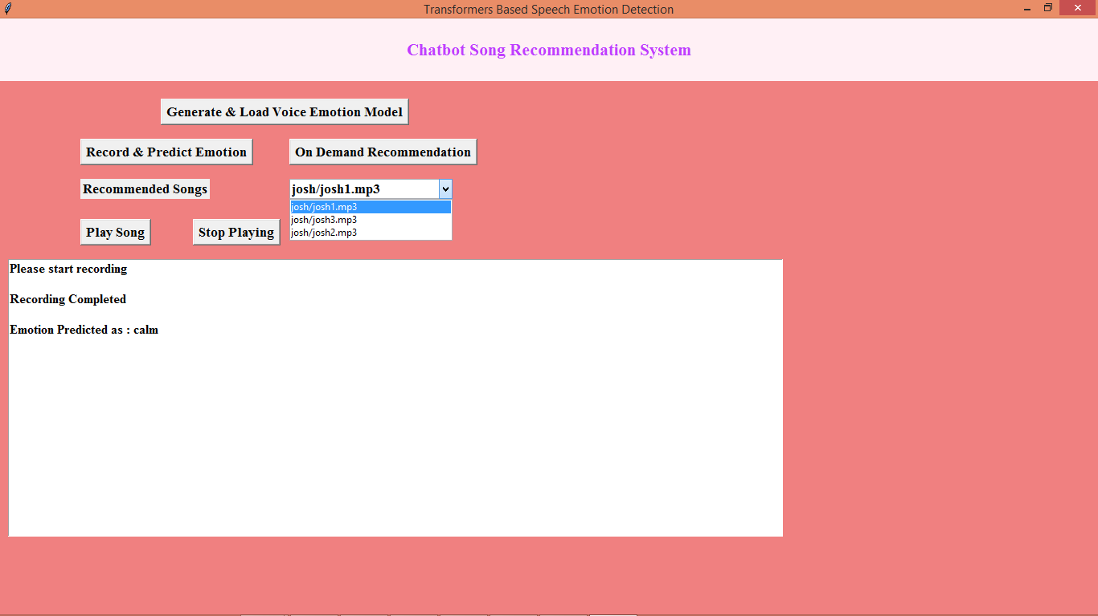

In above screen in text area we can see predicted emotion from pitch is calm and based on predicted emotion we can see list of recommended JOSH songs in drop down list and user can select desired song and click on ‘Play Song’ button to play the song or “Stop Playing” button to stop player. Now in below screen will try another voice from different pitch

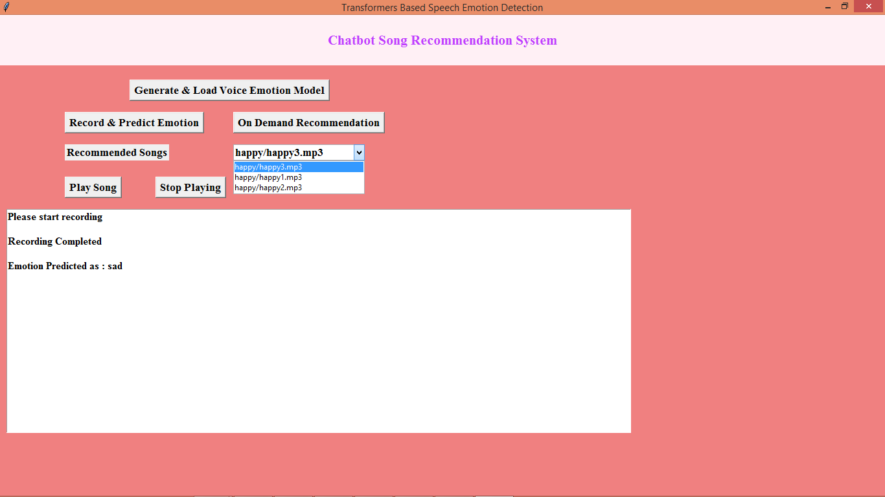

In above screen from voice pitch emotion detected as ‘sad’ and then displaying ‘HAPPY’ songs in dropdown list. Similarly record your voice and get recommended songs from Chatbot. Now click on ‘On Demand Recommendation’ button and user can type words based on his condition and get recommendation

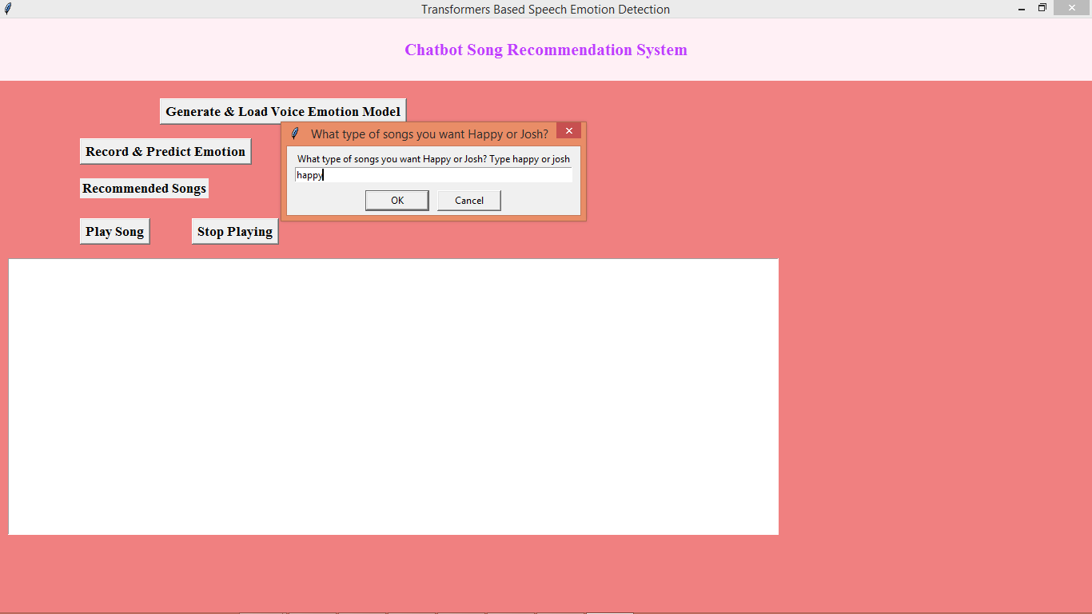

In above screen user is asking for happy songs and below is the recommendation

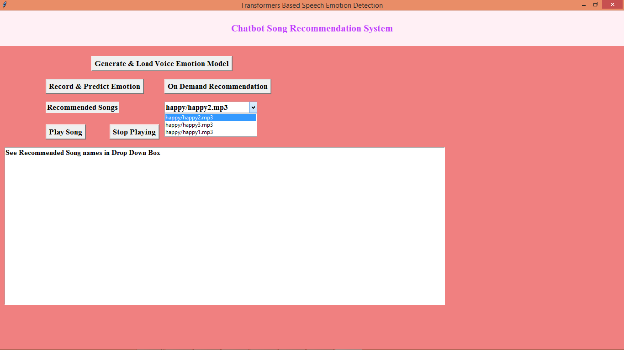

In above screen in drop down box user is got list of happy songs and below is another example

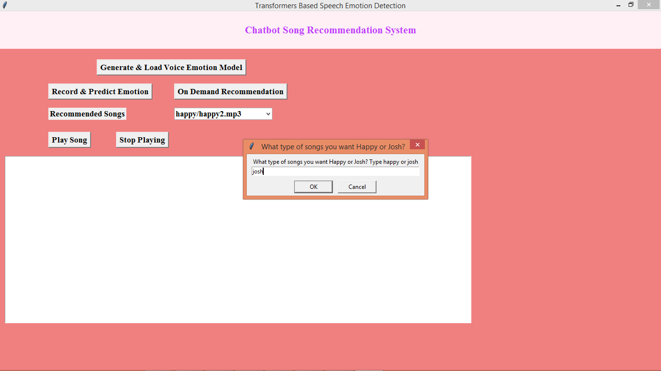

In above screen user is asking for JOSH songs and below are the recommendation

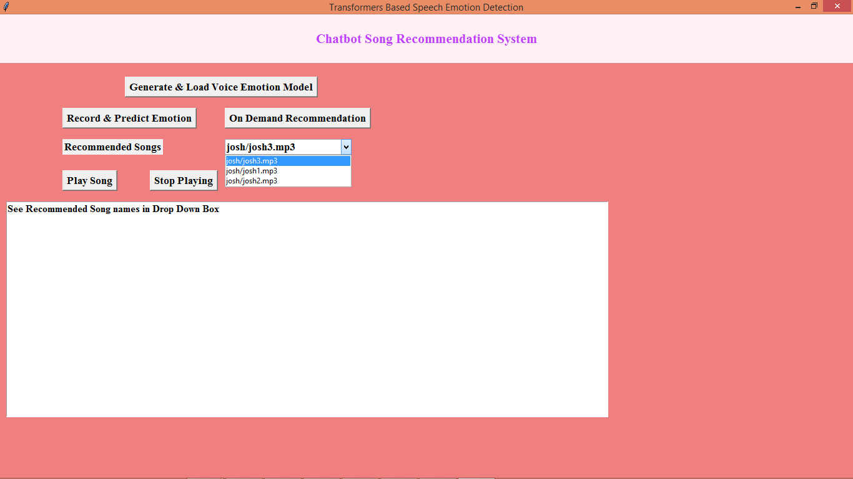

In above screen we got all JOSH songs as recommendation.

Note: if you want you can put new songs inside ‘josh or happy’ folders to get more recommendation. In same application Chatbot allow you to play and stop song playing.