SCALABLE E-COMMERCE
MICROSERVICES ARCHITECTURE
Architecture Design & Technical Documentation

Prepared for: Weekly Software Architecture Task
Platform: Hypothetical high-traffic online marketplace
Architecture style: Domain-oriented microservices

Table of Contents
- 1. Overview of the Architecture
- 2. Detailed Description of Each Microservice
- 3. Data Flow Diagrams
- 4. Justification of Technologies and Tools
- 5. Security Measures
- 6. Scalability, Reliability and Deployment Strategy
- 7. Assumptions and Conclusion

1. Overview of the Architecture
The proposed platform is a cloud-native e-commerce system designed to support high traffic, rapid feature development and independent scaling. It uses microservices: the application is split into small services aligned to business capabilities. Each service owns its business logic and data, communicates through well-defined APIs and asynchronous events, and can be deployed independently.

1.1 Business capabilities
- User registration, login, profile management and role-based access.
- Product catalogue, categories, pricing, product details and product images.
- Product search, filtering and sorting.
- Shopping cart with quantity changes and persistence across sessions.
- Checkout, order creation, inventory reservation and payment processing.
- Order status, customer notifications, administration and operational monitoring.

1.2 High-level architecture
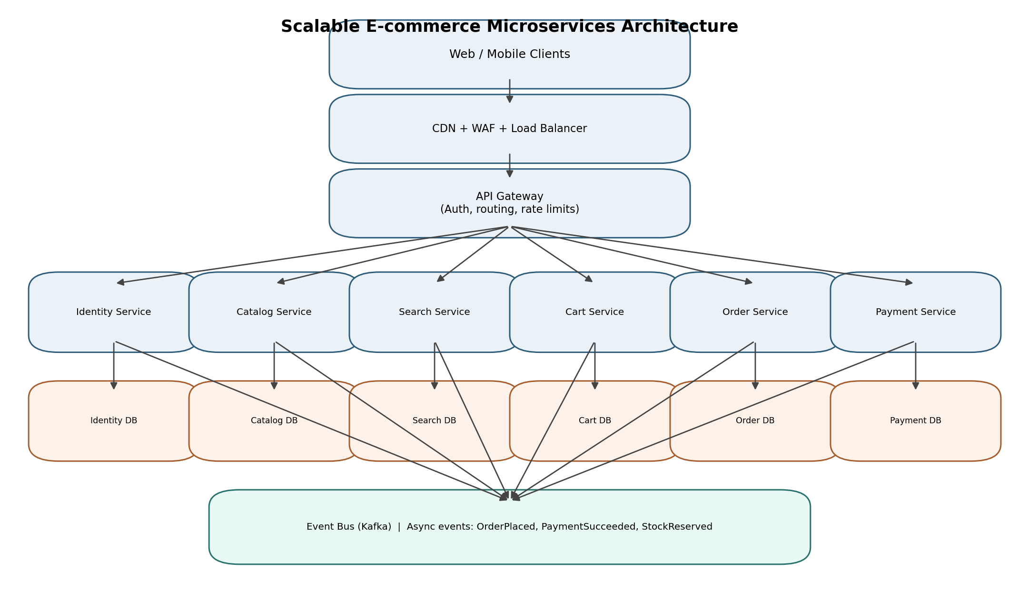
Figure 1. High-level logical architecture. Each service owns its database; Kafka carries asynchronous domain events.

1.3 Architecture principles
- Loose coupling: services interact through versioned APIs and documented events.
- Database per service: no service directly reads or writes another service's database.
- Stateless application instances: session state is held in tokens or shared data stores so instances can scale horizontally.
- Asynchronous processing: non-immediate work such as notifications, analytics and search indexing is event-driven.
- Failure isolation: timeouts, retries, circuit breakers and bulkheads prevent one failing dependency from taking down the platform.
- Consistency by workflow: local ACID transactions are used within a service; cross-service workflows use a saga and compensating actions.

2. Detailed Description of Each Microservice
The following services form the initial logical decomposition. A service may be split further only when independent scaling, ownership or deployment needs justify the added operational complexity.

API Gateway / Backend-for-Frontend
Single public entry point for web and mobile clients. Routes requests, validates access tokens, applies rate limits, request-size limits, API versioning and correlation IDs. It does not contain core business rules.
Data / implementation: Kong, NGINX or managed cloud API Gateway; stateless replicas.

Identity & User Service
Registration, login, password reset, email/phone verification, profile data, account status and roles. Issues or integrates with OAuth 2.0 / OpenID Connect tokens. Passwords are stored as salted adaptive hashes.
Data / implementation: PostgreSQL for user records; Redis for short-lived verification/session data; managed identity provider or Keycloak.

Product Catalogue Service
Creates and manages products, descriptions, categories, attributes, images, product status and product metadata. Admin-only write operations; read-heavy public endpoints.
Data / implementation: PostgreSQL for authoritative catalogue data; object storage + CDN for images; Redis cache for popular product details.

Search Service
Provides full-text search, autocomplete, facets, filters and sorting. Consumes catalogue events and builds a denormalized search index. Search index is a derived copy, not the source of truth.
Data / implementation: OpenSearch / Elasticsearch; Kafka consumer for ProductCreated and ProductUpdated events.

Inventory Service
Tracks stock by SKU and fulfilment location. Reserves stock during checkout, confirms deductions after successful payment, and releases reservations when payment fails or expires. Uses atomic conditional updates to prevent overselling.
Data / implementation: PostgreSQL with row-level/optimistic locking; Redis only for non-authoritative availability hints.

Cart Service
Stores active carts, line items, quantities, selected variants and cart expiry. Validates item availability/prices at checkout rather than treating cached cart values as final.
Data / implementation: Redis for fast, short-lived cart operations; optional durable snapshot in PostgreSQL for recovery.

Pricing & Promotion Service
Calculates current prices, discounts, coupons, taxes and promotion eligibility. Returns a quote with an expiry/version so checkout can detect changes.
Data / implementation: PostgreSQL for rules and campaigns; Redis cache for frequently used price/rule data.

Order Service
Creates orders, stores immutable order-line snapshots, tracks lifecycle states and coordinates checkout using a saga. Publishes OrderPlaced, OrderCancelled and OrderCompleted events.
Data / implementation: PostgreSQL; transactional outbox table to publish events reliably.

Payment Service
Creates payment intents, calls an external payment gateway, handles signed webhooks, records transaction references and supports refunds. Never stores raw card numbers or CVV.
Data / implementation: PostgreSQL for payment state and audit references; PCI-compliant provider-hosted/tokenized payment collection.

Notification Service
Sends order confirmations, payment updates, dispatch notices, password reset codes and promotional messages. Processes events asynchronously and retries transient delivery failures.
Data / implementation: Kafka consumers; provider APIs for email/SMS/push; delivery status store.

Admin / Reporting Service
Provides restricted operational dashboards, catalogue/order administration views and read-optimized business reports. Analytics workloads are isolated from transactional services.
Data / implementation: Read replicas or warehouse/lakehouse; role-restricted APIs; scheduled/event-driven pipelines.

2.1 Service ownership and key data
Service | Primary data owned | Important events / interfaces
Identity | Users, credentials metadata, roles, verification state | REST: register/login/profile; UserRegistered
Catalogue | Products, categories, variants, media references | REST: product CRUD/read; ProductCreated/Updated
Inventory | Stock, reservations, warehouse balances | REST: reserve/release; StockReserved/StockReleased
Cart | Cart, cart items, expiry | REST: get/add/update/remove cart
Order | Order, order lines, order state, saga state | REST: checkout/order lookup; OrderPlaced/Cancelled
Payment | Payment intent, provider reference, refund state | REST: initiate/refund; PaymentSucceeded/Failed
Search | Search index (derived) | Query API; consumes catalogue events
Notification | Message templates and delivery attempts | Consumes business events

3. Data Flow Diagrams
The diagrams show logical data movement. They are intentionally technology-neutral at the process level; actual network calls are protected by service authentication and encryption.

3.1 DFD Level 0 — System Context
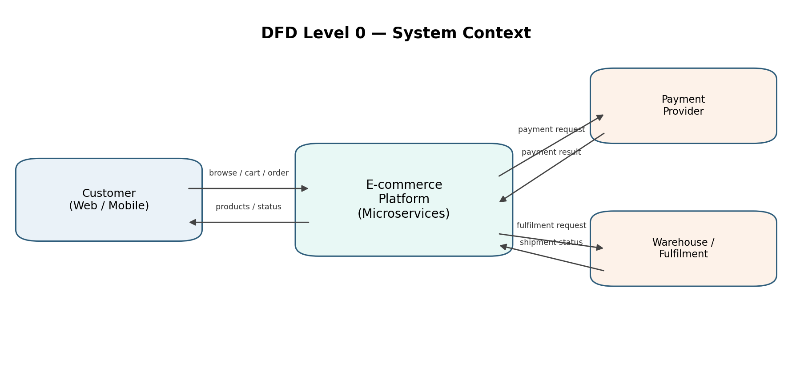
Figure 2. The customer interacts with the platform; the platform exchanges payment and fulfilment information with external systems.

3.2 DFD Level 1 — Checkout and Payment
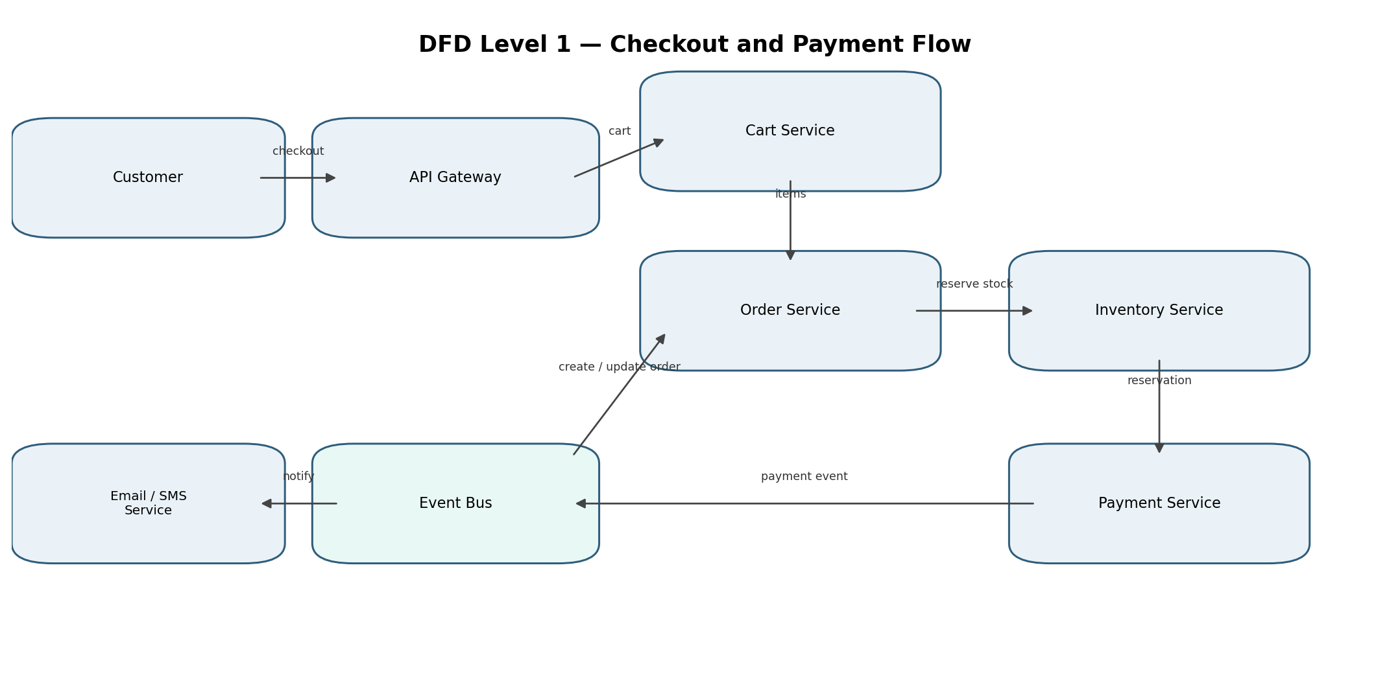
Figure 3. Checkout sequence at service level. The order workflow coordinates inventory reservation and payment, while events trigger notifications.

3.3 Checkout flow — step-by-step
- The customer submits checkout through the API Gateway with an access token and an idempotency key.
- The Order Service requests the Cart Service to retrieve the current cart and asks Pricing to calculate a fresh quote.
- The Order Service creates a PENDING order and starts a checkout saga.
- The Inventory Service atomically reserves the requested quantities. If stock is insufficient, the order is cancelled and the customer is informed.
- The Payment Service creates a payment intent with the external provider using a unique idempotency key. Card data is collected directly by the provider's secure UI/tokenization flow.
- On verified payment success, the Payment Service records the result and publishes PaymentSucceeded. The Order Service marks the order CONFIRMED; inventory reservation is committed.
- On payment failure or timeout, the saga releases reserved inventory and marks the order PAYMENT_FAILED or CANCELLED. The customer can retry safely.
- The Notification Service consumes order/payment events and sends confirmation messages. The Search/analytics pipelines consume relevant events independently.

3.4 Event contracts
Event | Producer | Consumers / purpose
UserRegistered | Identity | Notification; welcome message and analytics
ProductCreated / ProductUpdated | Catalogue | Search indexer; cache invalidation; analytics
StockReserved / StockReleased | Inventory | Order workflow; availability projections
OrderPlaced | Order | Payment workflow; notification; analytics
PaymentSucceeded / PaymentFailed | Payment | Order workflow; notification; reconciliation
OrderCancelled / OrderCompleted | Order | Inventory; notification; reporting

Events should include event_id, event_type, schema_version, occurred_at, aggregate_id, correlation_id and a minimal payload. Consumers must be idempotent because message delivery is normally at-least-once.

4. Justification of Chosen Technologies and Tools
Layer / concern | Recommended technology | Reason for selection
Client delivery | React / Next.js web; native or cross-platform mobile | Mature ecosystems; responsive user experience; independently deployable clients.
API Gateway | Kong / NGINX / managed gateway | Central routing, authentication enforcement, throttling, TLS termination and API versioning.
Backend services | Java + Spring Boot (or Kotlin) | Strong typing, mature ecosystem, validation, security, observability and robust concurrency support.
Synchronous communication | REST/JSON; gRPC for selected internal high-volume calls | REST is easy to integrate and debug; gRPC offers efficient typed internal communication where justified.
Asynchronous messaging | Apache Kafka | Durable event log, partition-based scale, replay, consumer groups and loose coupling.
Transactional databases | PostgreSQL | ACID transactions, indexing, constraints and dependable relational modelling for orders, users and payments.
Cache / cart | Redis | Low-latency reads, TTLs, atomic operations and distributed caching.
Search | OpenSearch / Elasticsearch | Full-text search, relevance ranking, autocomplete and faceted filtering.
Image storage | S3-compatible object storage + CDN | Durable, inexpensive media storage and global edge delivery.
Containerization / orchestration | Docker + Kubernetes | Repeatable deployments, horizontal pod autoscaling, health checks, rolling updates and self-healing.
CI/CD and infrastructure | GitHub Actions / GitLab CI; Terraform | Automated tests/builds/deployments and reproducible infrastructure as code.
Observability | OpenTelemetry + Prometheus + Grafana + centralized logs | Metrics, distributed traces, dashboards, alerting and faster incident diagnosis.

4.1 Why microservices?
- Independent scaling: search and catalogue reads can scale separately from checkout and payment.
- Independent releases: a notification template change does not require redeploying order processing.
- Technology flexibility: a search engine or cache can be selected for its workload without changing the whole system.
- Fault isolation: a search outage should not prevent a customer from viewing an existing order or completing a payment.
- Team ownership: domain-aligned teams can own services, APIs, data and operational health end-to-end.

4.2 Trade-offs and controls
Trade-off | Mitigation
More network calls and latency | Use API composition carefully, cache read-heavy data, set deadlines and avoid chatty service boundaries.
Distributed data consistency | Use saga workflows, transactional outbox, idempotent consumers and reconciliation jobs.
Operational complexity | Adopt platform automation, standard service templates, centralized observability and clear ownership.
Eventual consistency in search/stock views | Display freshness where relevant; revalidate price and inventory during checkout.
Higher infrastructure cost | Start with a small number of well-defined services; scale only hot paths and use managed services where appropriate.

5. Security Measures

Identity and access control
Use OAuth 2.0 / OpenID Connect. Short-lived access tokens and rotating refresh tokens; enforce RBAC for customer, support and administrator roles. Require MFA for privileged users and sensitive account changes.

Transport and network security
TLS 1.2+ for all external and internal traffic; use mTLS between sensitive services where practical. Place databases and brokers in private subnets; expose only the gateway and approved endpoints.

Password and account protection
Hash passwords using Argon2id or bcrypt with unique salts. Apply login throttling, credential-stuffing detection, secure password reset tokens and email/phone verification.

Payment security
Use a PCI DSS-compliant payment provider and hosted/tokenized payment fields. Do not store PAN or CVV. Verify webhook signatures, validate timestamps, and make payment operations idempotent.

Input and application protection
Validate and normalize all inputs; use parameterized SQL; encode output; defend against injection, XSS, CSRF and SSRF. Apply secure headers, content security policy and file-upload scanning.

API abuse prevention
Apply per-user/IP rate limits, quotas, bot detection, request size limits and schema validation at the gateway. Use anti-automation controls on login, coupon and checkout endpoints.

Secrets and encryption at rest
Store secrets in a managed secrets vault; rotate credentials and signing keys. Encrypt databases, backups, object storage and message topics with managed KMS keys.

Audit and monitoring
Record security-relevant actions with actor, timestamp, target and correlation ID. Avoid logging passwords, tokens, card data or unnecessary personal data. Alert on unusual access and payment patterns.

Supply chain and deployment
Scan dependencies and container images, sign build artifacts, protect CI/CD credentials, use least-privilege service accounts and separate production from development.

Privacy and resilience
Collect only necessary personal data, define retention/deletion policies, restrict staff access and test encrypted backups and disaster recovery.

5.1 Security baseline checklist
- Threat model key journeys: registration, login, catalogue administration, checkout, refunds and webhooks.
- Use OWASP ASVS / API Security Top 10 as verification references.
- Perform SAST, dependency scanning, DAST and periodic penetration testing.
- Review access permissions and secrets regularly; revoke compromised credentials immediately.
- Maintain an incident response plan and test security alerts and recovery procedures.

6. Scalability, Reliability and Deployment Strategy

6.1 High-traffic design
- CDN-cache static assets, product images and safe-to-cache catalogue responses close to users.
- Use horizontal autoscaling for stateless service replicas based on CPU, memory, request rate and queue lag.
- Partition Kafka topics by aggregate key (for example order_id or product_id) to preserve ordering where needed and distribute load.
- Use read replicas and carefully designed indexes for read-heavy relational workloads; partition large tables when measured growth requires it.
- Cache popular product pages and category results with short, explicit TTLs and event-driven invalidation.
- Protect checkout with bounded concurrency, queueing for non-interactive work and graceful degradation of non-critical features.

6.2 Reliability patterns
- Timeouts and bounded retries with exponential backoff and jitter; do not retry non-idempotent actions without an idempotency key.
- Circuit breakers and bulkheads around external payment, email and other dependencies.
- Transactional outbox to ensure database updates and event publication are not silently separated.
- Dead-letter topics and replay procedures for poison messages; monitor consumer lag and failed deliveries.
- Health/readiness probes, rolling deployments, canary releases and automated rollback.
- Regular payment/order reconciliation to resolve delayed or duplicate provider callbacks.

6.3 Deployment topology
Deploy containerized services to a managed Kubernetes cluster across multiple availability zones. Run at least two replicas for critical stateless services, distribute replicas across zones, and use managed PostgreSQL, Redis, Kafka and object storage where possible. Use separate environments (development, test, staging and production), infrastructure-as-code and automated CI/CD pipelines.

6.4 Suggested service-level objectives
Journey / component | Illustrative target | Measurement
Product browse API | 99.9% monthly availability; p95 < 300 ms | Gateway and service metrics
Cart API | 99.9% monthly availability; p95 < 250 ms | Request latency and error rate
Checkout API | 99.9% monthly availability; p95 < 800 ms excluding provider wait | End-to-end trace and saga status
Event processing | 99% of routine events processed within 60 seconds | Kafka consumer lag and event age
Recovery | RPO ≤ 5 minutes; RTO ≤ 60 minutes (initial target) | Restore and failover exercises

These are proposed starting objectives, not guarantees. Final targets should be agreed with product owners and validated through load testing.

7. Assumptions and Conclusion

7.1 Assumptions
- The platform sells physical or digital products and integrates with an external payment provider.
- Traffic is variable, with promotional peaks and a much higher browse-to-checkout ratio.
- The system is initially deployed in one primary region across multiple availability zones, with a documented disaster-recovery plan.
- Product, order and payment data are business-critical; search indexes and caches are rebuildable derived data.
- The design is a logical reference architecture; final sizing, service count and cloud provider depend on measured demand and budget.

7.2 Conclusion
This design separates the e-commerce platform into independently deployable, domain-oriented microservices. A gateway provides a controlled client entry point; each service owns its data; synchronous APIs support interactive journeys; and Kafka events decouple background processing. PostgreSQL, Redis, OpenSearch, object storage and Kubernetes are selected to address distinct workload needs. Security is built into identity, network boundaries, payment integration, secrets, monitoring and delivery practices. The result is an architecture that can scale individual hot paths, limit the impact of failures and evolve as traffic and business requirements grow.

References / Further Reading
- Martin Fowler — Microservices: https://martinfowler.com/articles/microservices.html
- OWASP — Application Security Verification Standard (ASVS): https://owasp.org/www-project-application-security-verification-standard/
- OWASP — API Security Top 10: https://owasp.org/www-project-api-security/
- Apache Kafka Documentation: https://kafka.apache.org/documentation/
- Kubernetes Documentation: https://kubernetes.io/docs/
- OpenTelemetry Documentation: https://opentelemetry.io/docs/

