1. Write a program to read in two integers and perform the following operations on them: addition, subtraction, multiplication, division, and modulo.

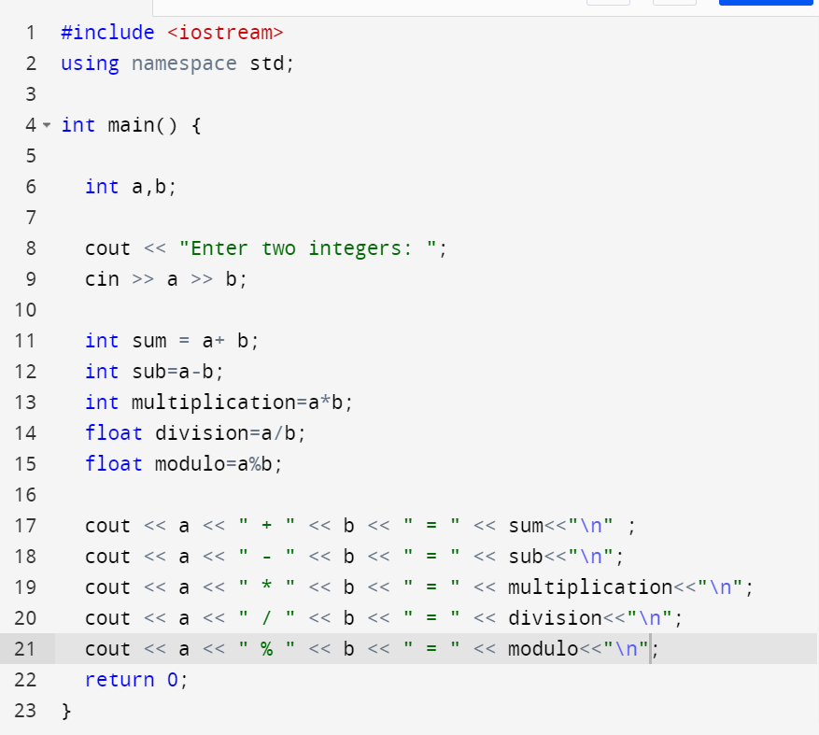

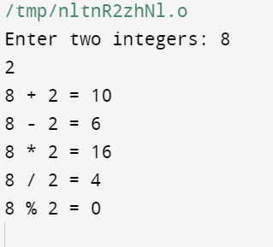

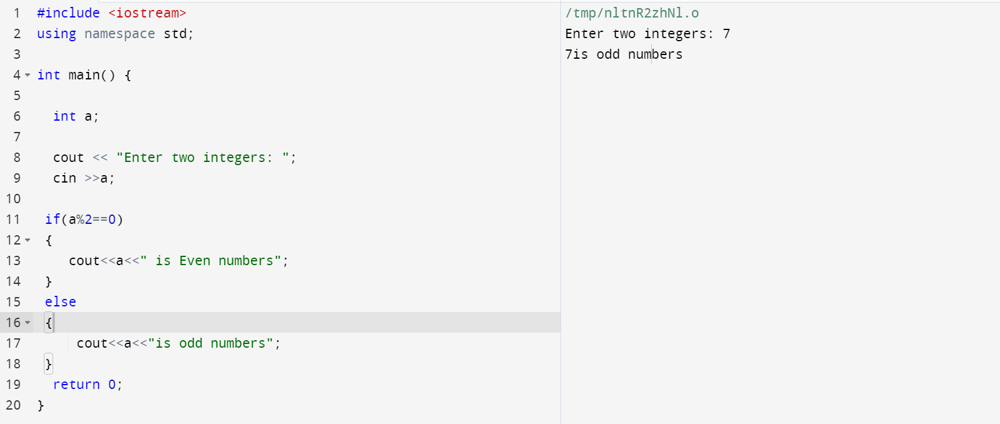

2.Program to determine the integer is odd or even

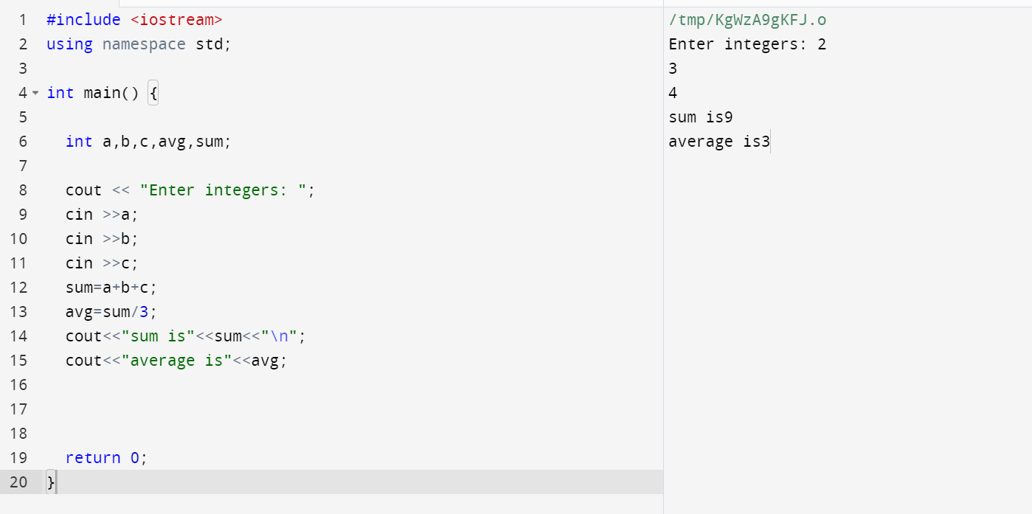3.Program to compute the average of three integers

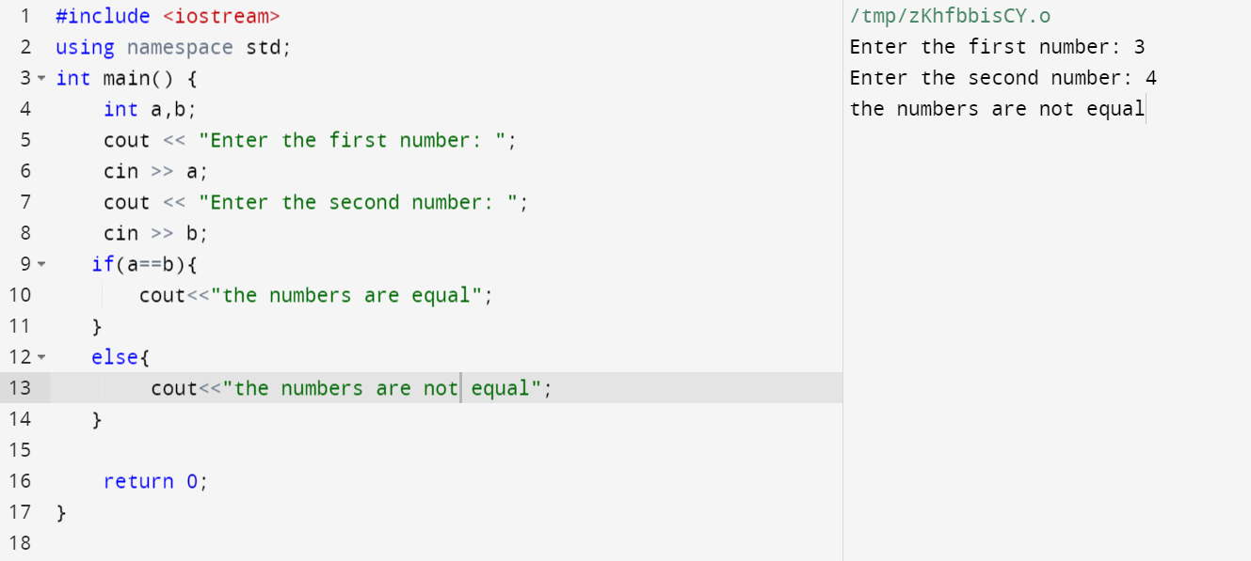4.Program to check two numbers are equal or not

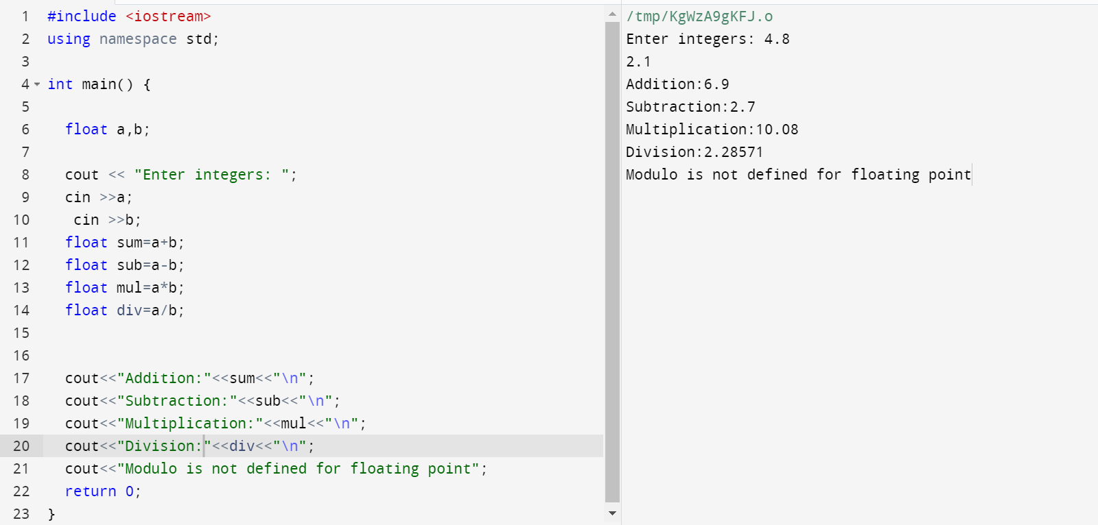5.Write a program to read in two Floating numbers and perform the following operations on them: addition, subtraction, multiplication, division, and modulo.

6.Program to check the character is a vowel or consonant

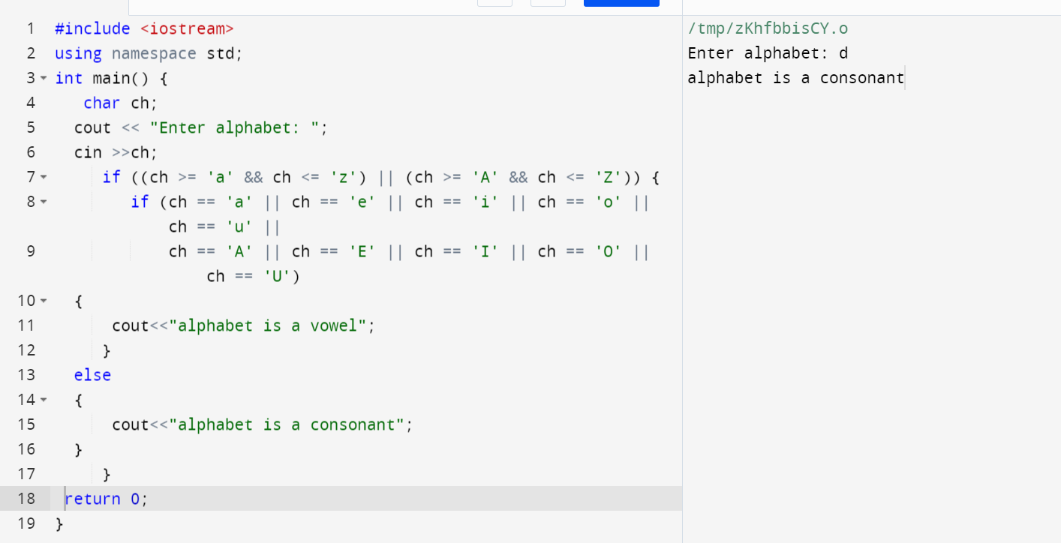

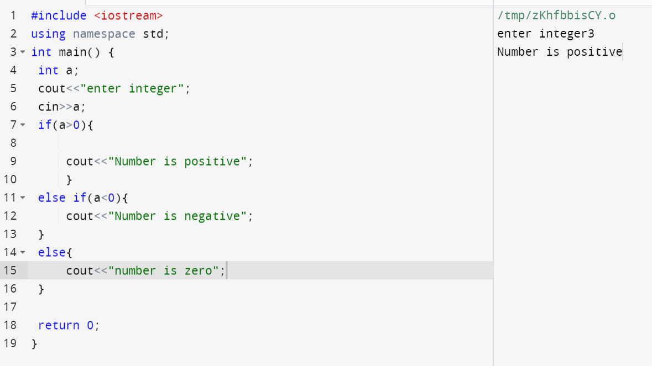7.Program to check the number is positive, negative or zero

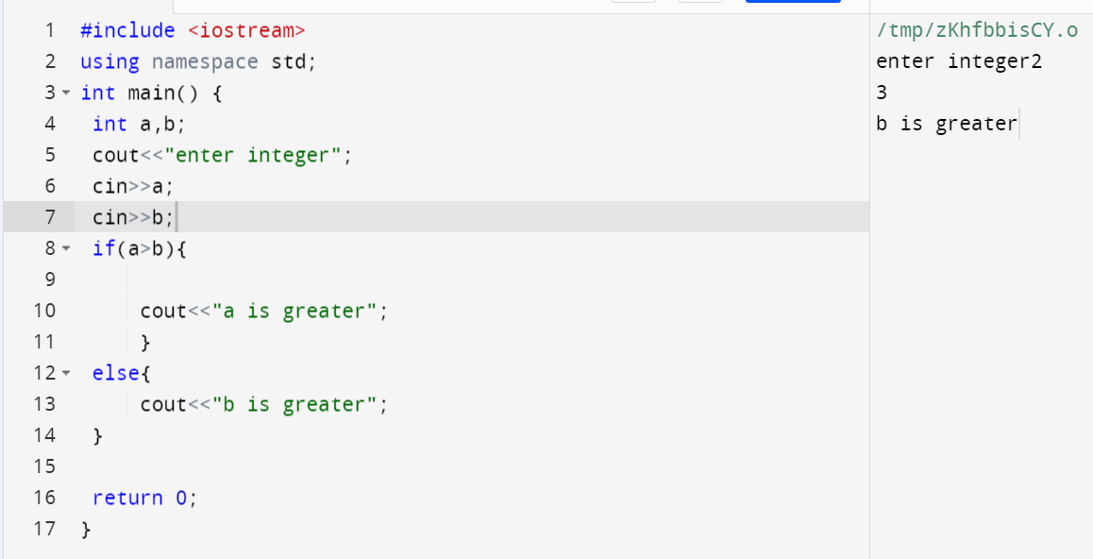8.Program to determine which number is greater among two integers

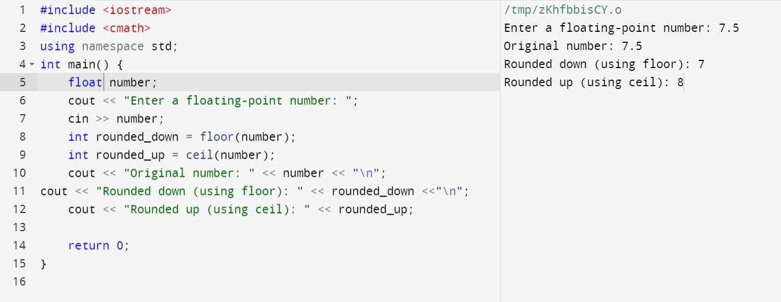9.Program to read a floating-number and round it to the nearest integer using the floor an ceil functions.

10.Program to swap two numbers using bitwise XOR operator

