I used AWS EC2 instance and created an Ubuntu 20.04 VM. Below is the screenshot of the instance details-

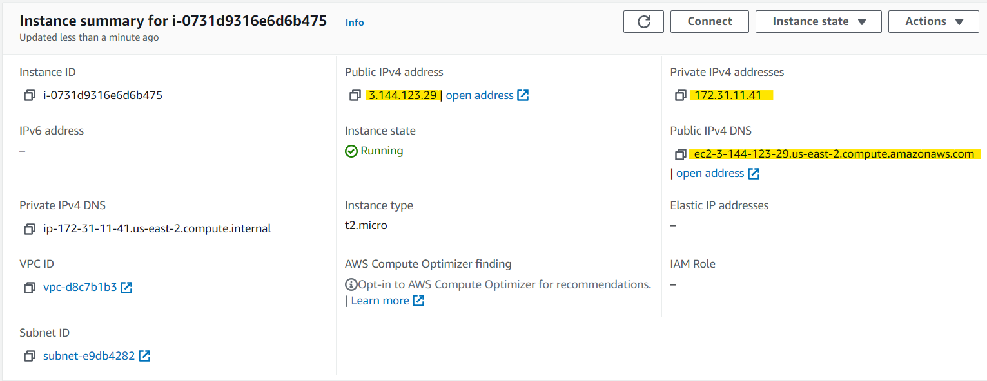

1. To install Apache Web Server, below commands were used-

1. Firstly, made sure ubuntu was accessed with root user using command **sudo su**
2. Updated all repositories using command **apt-get update**.
3. Open SSL was installed - **apt-get -y install make wget libssl-dev libncurses5-dev gcc**
4. Apache Web Server was installed - **apt instsall apache 2**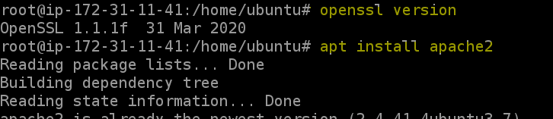
5. Apache2 service is started using command- **systemctl start apache2**
6. Verified using browser if Apache webserver has been successfully installed in the machine.

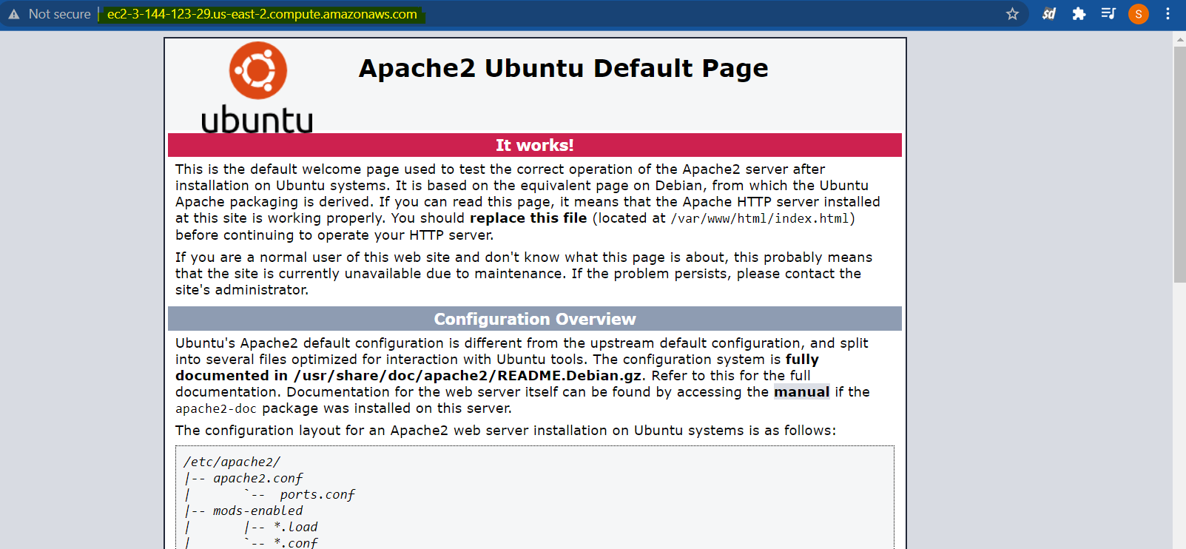

2. To generate Apache Self Signed certificate below command was used-

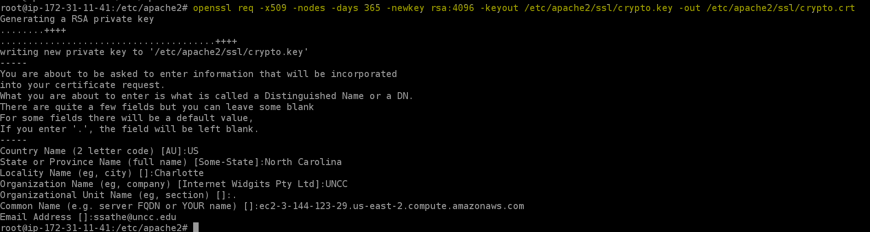**openssl req -x509 -nodes -days 365 -newkey rsa:4096 -keyout /etc/apache2/ssl/crypto.key -out /etc/apache2/ssl/crypto.crt**

Private Key named **crypto.key** is generated as below-

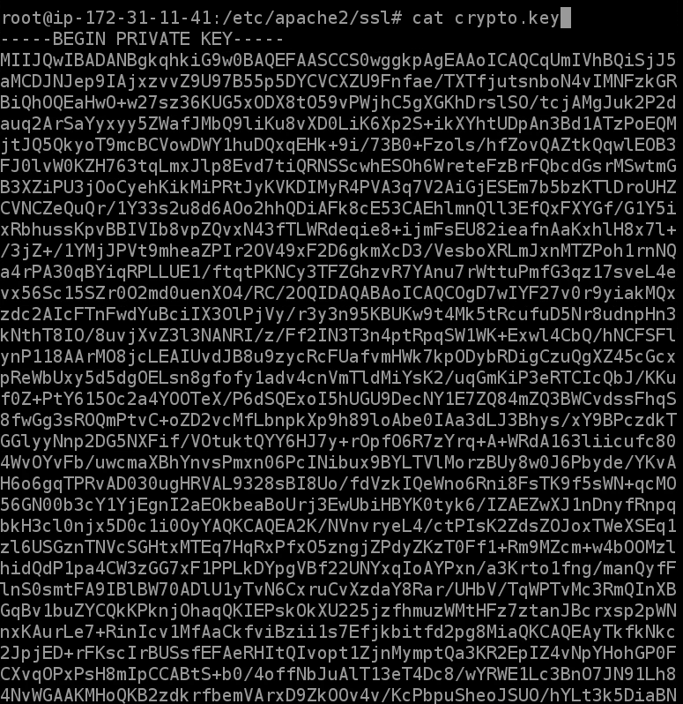

Self-Signed certificate named **crypto.crt** generated as below :

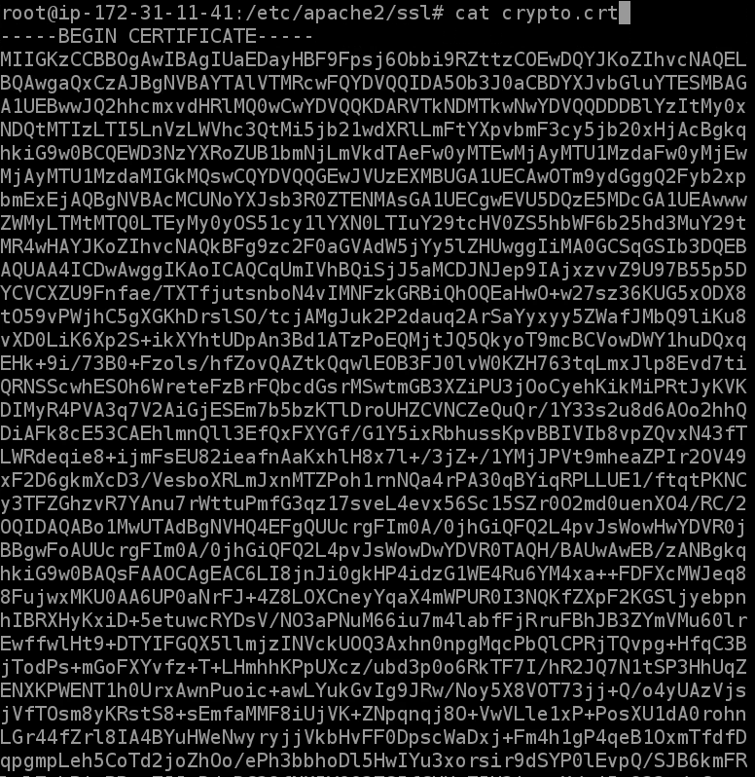

Below changes was made in the configuration file of the Virtual Hosts to install the self-signed certificates.

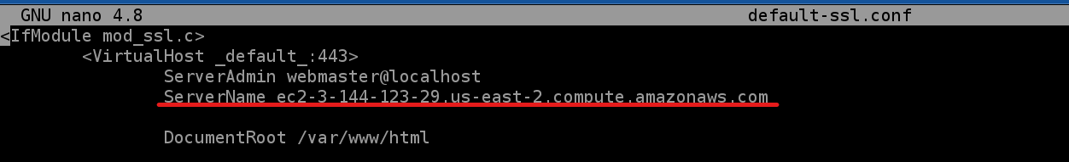

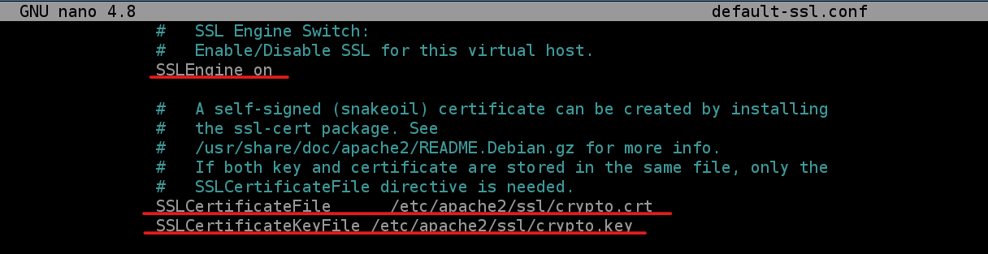

3. Screenshot to show what kind of cryptographic algorithm are supported in your Apache server

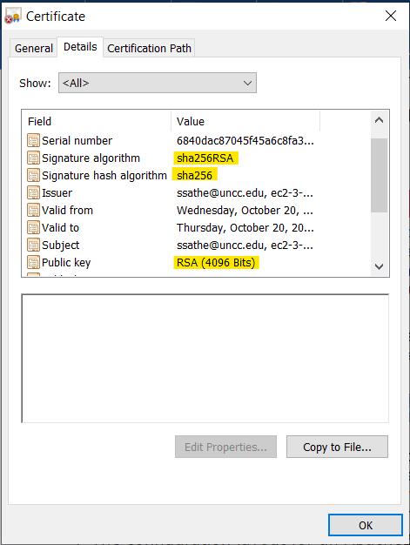

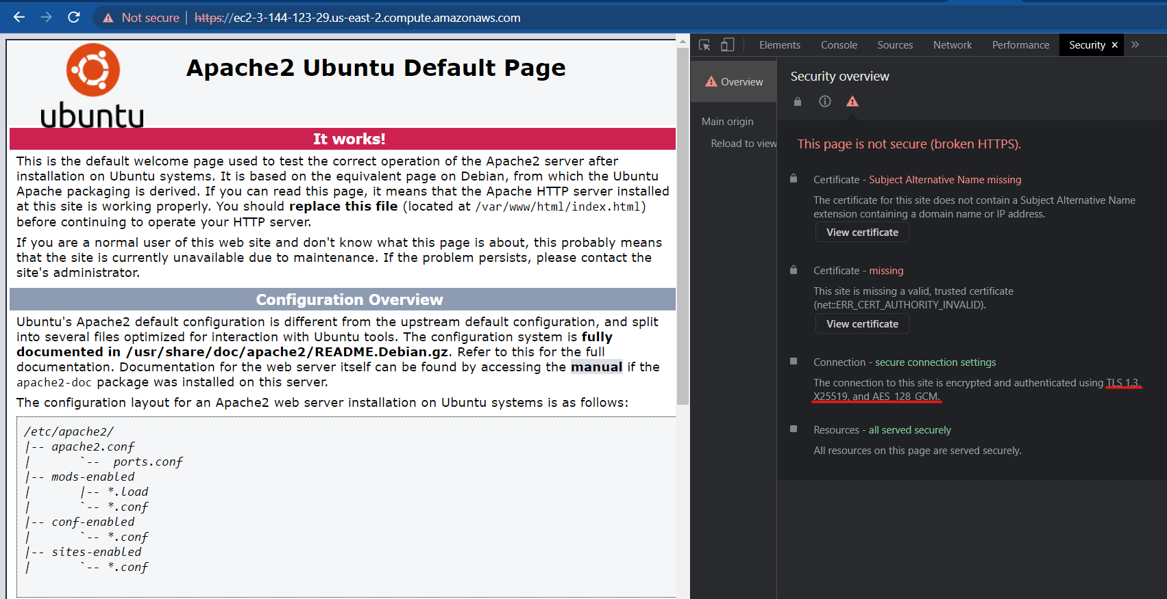

4. Screenshot to show that you can connect to your Apache HTTPD server with https

1. To start the SSL service after generation of root keys and making changes in the configuration file following command was used- **a2ensite default-ssl.conf**
2. Apache2 service was restarted using command- **systemctl reload apache2**

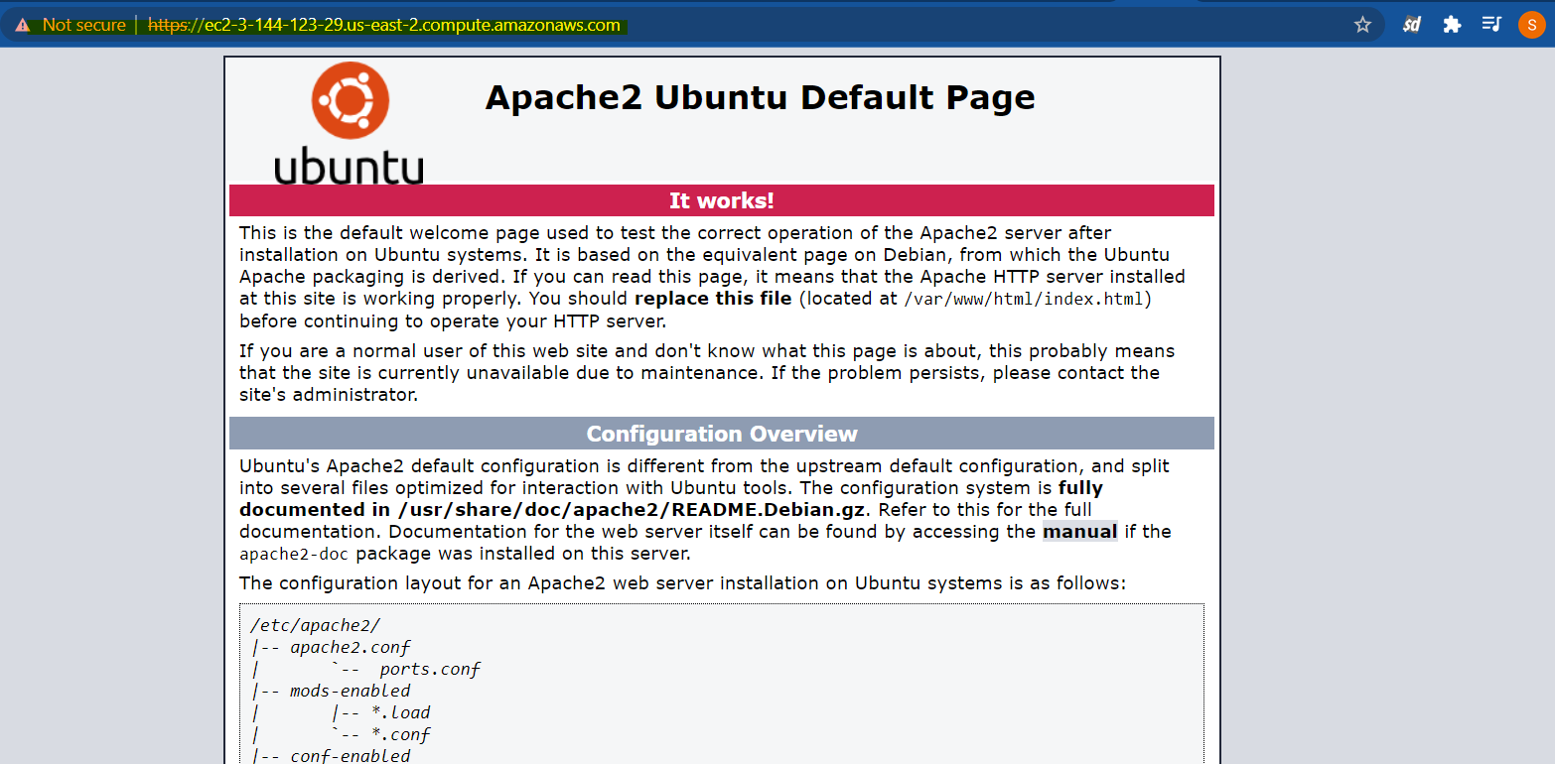

5. The report of testing your Apache server using the test from: <https://www.ssllabs.com/ssltest/>

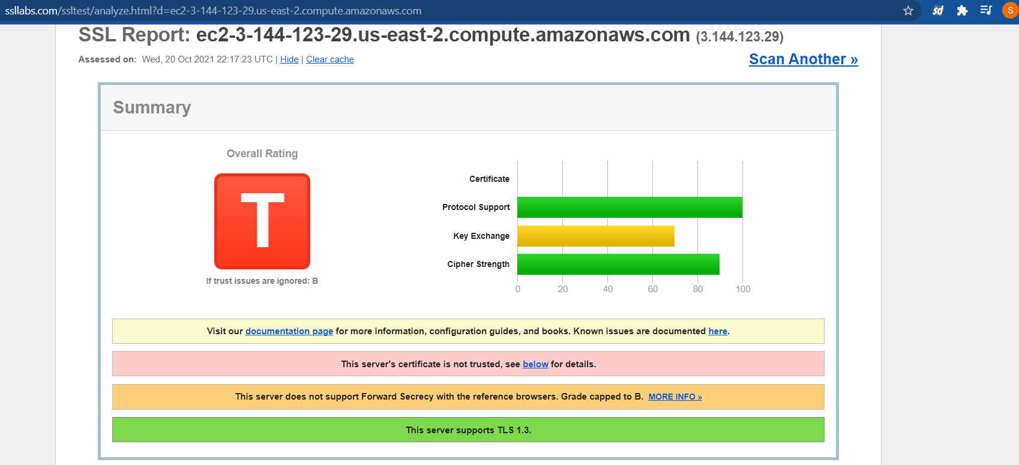

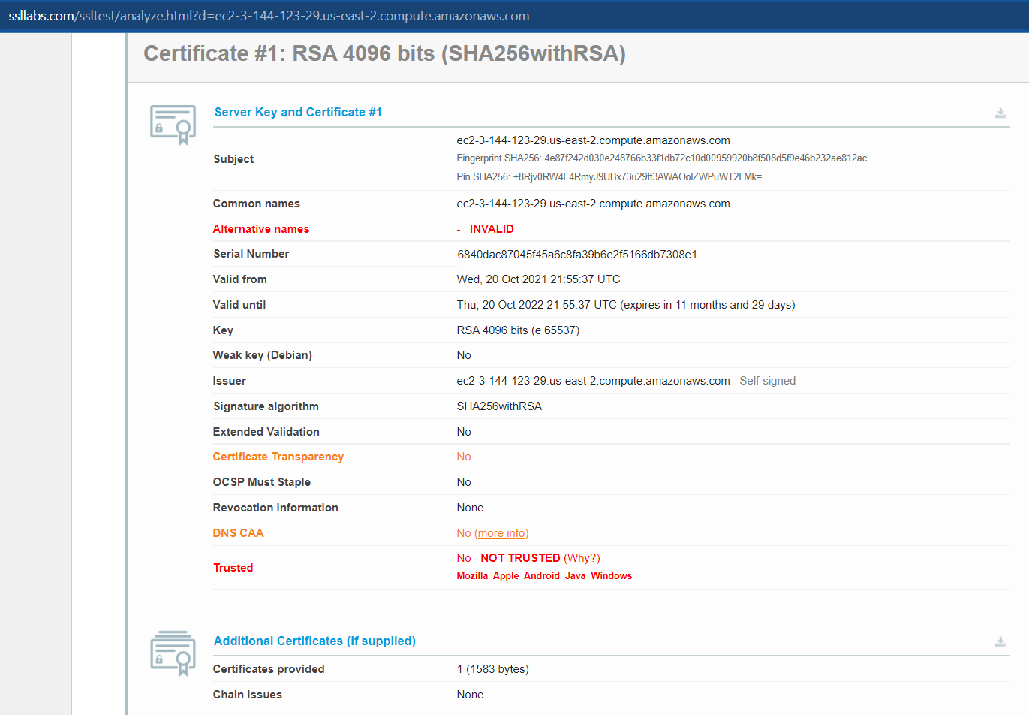

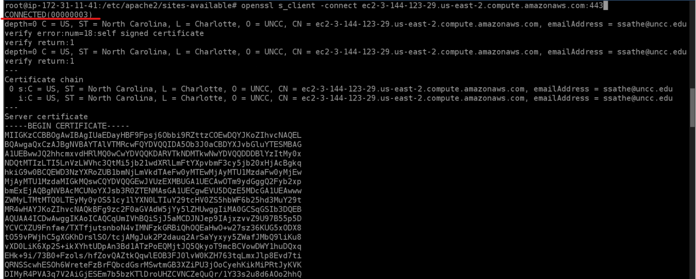6. Using the openSSL command line to connect to your SSL server. A screenshot on the successful connection.

