Certificate:

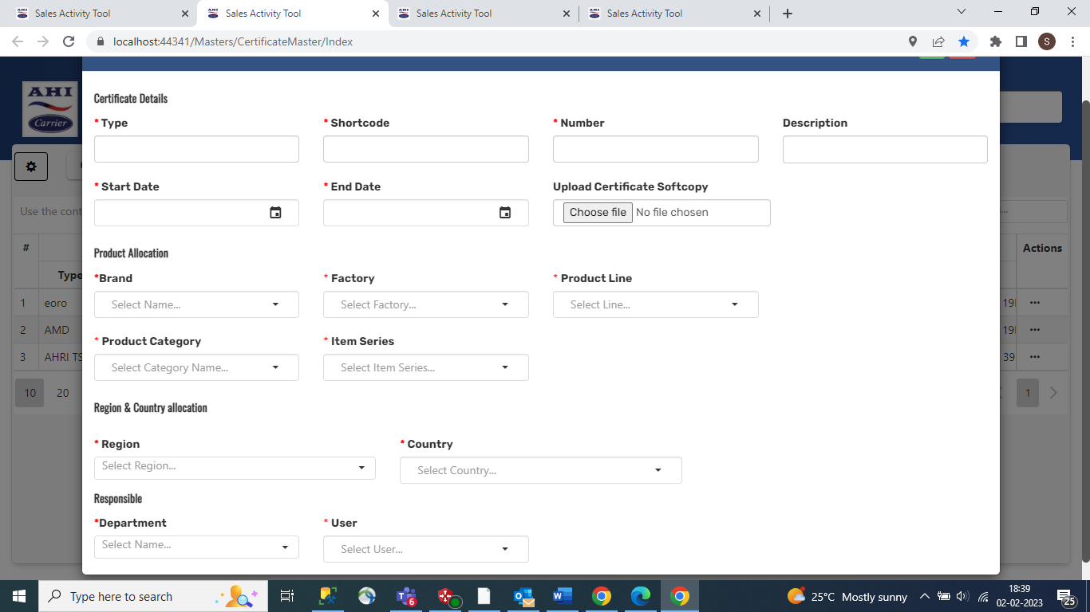

Entity:

Department

