PROJECT REPORT
Hand Motion Dirven Audio Sculptor
A Hand-Gesture Controlled Music and Visual Art System using MediaPipe and OpenCV
Course: | Image and Video Processing
Student Name(s): | Shivani Parate , Mihika Upadhyay
Roll Number(s): | F035 , F040
Programme / Semester / Division: | B.Tech CE ‘A’
Faculty Name: | Dr. Raj Gaurav Mishra
Institute / Department: | SVKM’S NMIMS Indore
Academic Year: | 2026-27

Abstract
Playing music normally needs an instrument and years of practice. Through this project a person can make pleasant music only by moving their hands in front of a laptop camera. We built the Hand Motion Dirven Audio Sculptor, a real-time Python application. Each webcam frame is mirrored and passed to the MediaPipe Hand Landmarker, which finds 21 points on each of up to two hands. The index fingertip is smoothed and tracked from frame to frame. Its height selects a note from a pentatonic scale, so every note sounds pleasant. Its speed sets the loudness, so the music is silent when the hand is still. Its left-right position sets stereo pan and tone brightness. Five hand poses, recognised from landmark distances, switch background beats, instrument sounds, scales, chords and reverb. At the same time, a glowing ribbon is drawn along the finger path using linear interpolation, Gaussian blur and exponential fading. In offline tests the sound engine stayed well inside its 11.6 ms deadline, the visual engine needed about 3.4 ms per frame, and all seven test poses were classified correctly. The result is a playable gesture instrument.
Keywords: Hand tracking, MediaPipe, OpenCV, gesture recognition, real-time video processing, music synthesis.

1. Introduction

1.1 Background of the problem
Traditional musical instruments need physical contact, a lot of practice and some money. Computer vision gives us another way to interact: the computer watches the person through a camera and reacts to what it sees. Cameras are now in every laptop, and deep-learning models such as MediaPipe can find a hand in a video on an ordinary CPU, in real time. This makes touch-free, instrument-free interaction possible for everyone.

1.2 Why the problem is relevant
- Accessibility: People who cannot use a physical instrument can still create music with simple arm and finger movement.
- Education and play: Beginners and children can explore rhythm, scales and harmony without learning notation.
- Interactive art: The same movement that makes sound also draws light trails, so the user sees and hears their gesture.
- Touch-free control: Gesture control is useful where touching a device is inconvenient or unhygienic.

1.3 Role of image and video processing
Image and video processing converts raw camera pixels into numbers that a program can understand. In this project it is used to (a) read and pre-process video frames, (b) extract hand landmarks as features, (c) track the fingertip over time and measure its speed, (d) recognise hand poses from landmark geometry, and (e) produce the visual effect using filtering, blending and exponential decay.

1.4 Motivation
We wanted a project where video processing is not only analysed on screen but can be heard and felt. A second motivation was a technical challenge: random hand movement easily produces noise, not music. Making the output sound musical (using scales, note envelopes, effects and rhythm) required careful design, and this made the project a good way to learn real-time processing, thread-safe programming and gesture recognition together.

2. Problem Statement and Objectives

2.1 Real–world problem

To let a person play music with no instrument, using only hand movement captured by a normal laptop webcam, so that the sound is musical (not noise), reacts without noticeable delay, and is accompanied by attractive visual feedback.

Main difficulties: hand landmarks are slightly shaky from frame to frame , a moving hand can easily make random, unpleasant pitches , the system must also stay silent when the hand is idle , and everything must run in real time on a normal laptop.

2.2 Objectives
- Detect and track the index fingertips of up to two hands in real time from a standard webcam using MediaPipe Hand Landmarker and OpenCV.
- Convert fingertip height, speed and sideways position into quantized pentatonic notes, loudness and stereo pan, so the sound is always harmonious and is silent when the hand is still.
- Recognise five fixed hand gestures from landmarks and use them to change the background beat, instrument sound, scale, chords and reverb.
- Generate music-like audio in real time: instrument envelopes, three background beats, a backing chord pad, echo and reverb.
- Draw a glowing, gap-free particle ribbon that fades smoothly, while keeping the frame processing within about 33 ms (30 frames per second).

3. Scope of the Project

3.1 What the project covers
- Live webcam capture, mirroring and hand landmark detection for one or two hands.
- Index-fingertip tracking, smoothing, speed measurement and note quantization.
- Five hand-pose gestures withhold-to-confirm logic.
- A software synthesizer with three instruments, three drum beats, a chord pad, echo and reverb.
- Real-time particle trail visualisation and an on-screen display (HUD) with keyboard shortcuts.

3.2 What it does not cover
- We did not train our own deep-learning model , the pre-trained MediaPipe hand model is used.
- No recording, looping or MIDI/WAV export of a performance.
- No face, body or full-skeleton tracking , only hands.
- No formal accuracy benchmark on a public dataset , gesture logic was tested on synthetic landmark sets and by trial use.
- Only Western pentatonic-style scales (three presets) and a single webcam , no mobile or web version.

3.3 Type of video and application domain
The input is a live RGB video stream from a laptop webcam (640 x 480, about 30 frames per second), recorded indoors with one person in front of the camera. The application domain is interactive art, music education and entertainment, accessibility, and human-computer interaction demonstrations.

4. Dataset / Input Description
This project works on a live video stream, so there is no stored image or video dataset. The only learned component is the pre-trained MediaPipe hand model, which was trained by Google , we only use it.

Item | Description
Source of video | Built-in laptop webcam
Dataset name | None (live stream).
Number of videos / images | No stored files. A continuous stream of frames is processed while the program runs.
Resolution | 640 x 480 pixels (frames are resized to this if the camera gives a different size).
Format | 8-bit, 3-channel BGR arrays (OpenCV). Converted to RGB before MediaPipe.
Frame rate / duration | About 30 fps requested , duration is as long as the user keeps the program open (test sessions of a few minutes).
Test inputs used in this report | Simulated fingertip paths (sine curves) for the trail figures, and synthetic landmark sets for gesture tests (see Chapter 8).

Sample input frames:
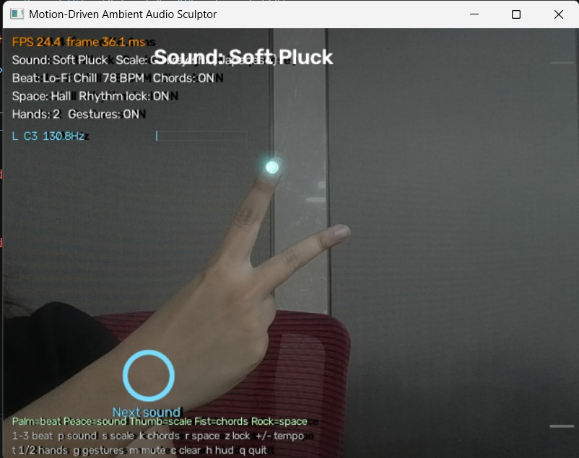
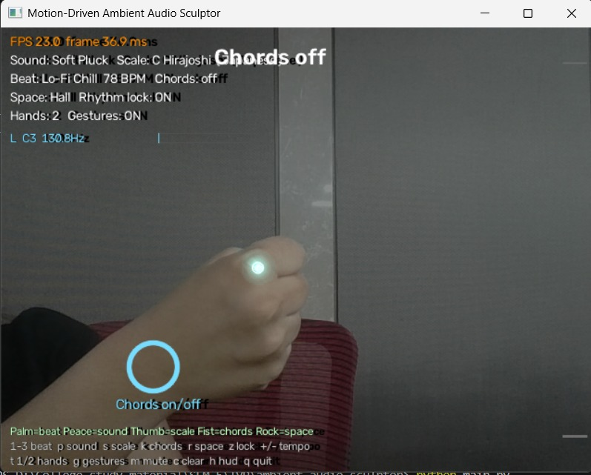
Figure 1: Fist gesture toggles chords Figure 2: Peace sign changes finger-produced sounds.

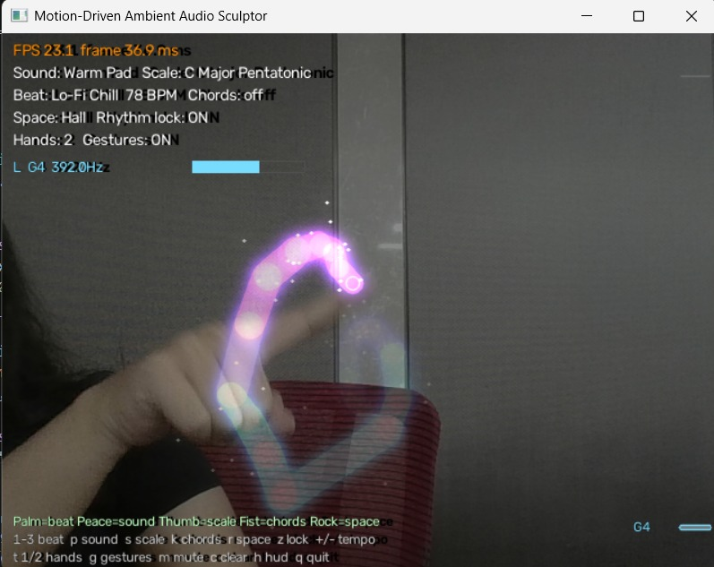
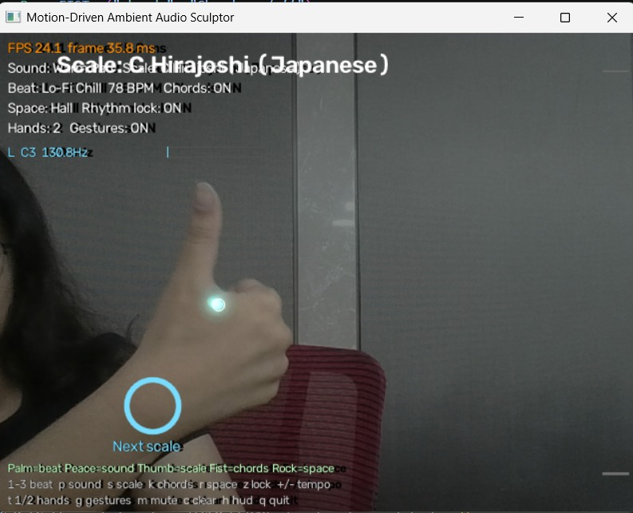

Figure 3: Thumbs up change the scale Figure 4 : Finger trails play sound

5. Methodology
The program runs two loops at the same time. The main loop handles video (about 30 times per second). The audio thread is started by the sound library and creates sound in small blocks of 512 samples (every 11.6 ms). The main loop sends the latest hand data to the audio thread through a lock, so the two never disturb each other.

5.1 Processing pipeline
- Capture: Read one frame from the webcam (640 x 480).
- Mirror: Flip the frame left-right so on-screen movement matches the user.
- Detect: Convert BGR to RGB and run the MediaPipe Hand Landmarker in video mode. It returns 21 landmarks per hand, which are scaled to pixel coordinates.
- Assign hands: The hand on the left of the screen becomes slot 0 and the right one slot 1. With one hand visible, the program remembers its last slot.
- Smooth: The index fingertip (landmark 8) is smoothed with an exponential moving average to remove jitter.
- Gesture check: Distances between landmarks decide the pose. A majority vote over five frames and a 0.7 s hold decide when an action fires.
- Map to music: Height gives the note, speed gives loudness, sideways position gives pan and brightness. A trigger flag tells the synthesizer when a new note should start.
- Make sound: The audio thread plays instruments, the chord pad and the drum beat, adds echo and reverb, and sends the result to the speakers.
- Draw: The trail canvas is faded, new points are interpolated and drawn, blurred for glow, added to the dimmed camera image, and shown with the HUD.
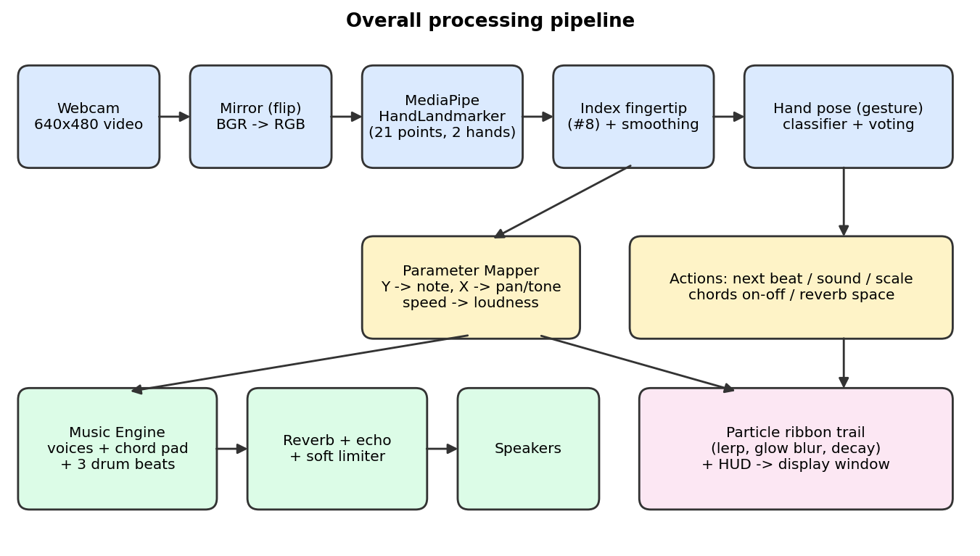
Figure 5: Block diagram of the complete pipeline.

5.2 Algorithm (pseudocode)
initialise camera, HandTracker, ParameterMapper, GestureTracker,
ParticleEngine, AudioEngine (starts audio thread)
while window is open:
frame = flip(camera.read())
hands = tracker.detect(frame) # 2 hands max, 21 points each
for hand in hands:
pose = majority_vote(classify_pose(hand.landmarks))
if pose held 0.7 s: run_action(pose) # beat/sound/scale/chords
playable = pose in {POINT, OTHER}
p = mapper.update(hand.fingertip, playable) # note,gain,pan
audio.update_hand(hand.slot, p)
trails[hand.slot] = (hand.fingertip, p.note, p.gain)
particles.update(trails) # fade, interpolate, glow
show( dim(frame) + particles.render() + HUD )
handle keyboard shortcuts

# audio thread, every 512 samples (11.6 ms)
advance 16-step sequencer -> drum hits, chord changes, quantised notes
sum all voices -> reverb + echo -> soft limiter (tanh) -> speakers

6. Techniques / Algorithms Used

6.1 Image processing
Technique | How it is used
Colour conversion | BGR to RGB for MediaPipe , HSV to BGR to give the ribbon a colour that depends on the note.
Flipping and resizing | Mirror image , resize to 640 x 480 if needed.
Feature extraction | Deep-learning hand model gives 21 landmarks. Euclidean distances and ratios between landmarks are extra geometric features.
Filtering | Gaussian blur (sigma 7, at half size for speed) makes the glow around the ribbon.
Thresholding | Canvas values below 0.5 are set to zero (THRESH_TOZERO) so faded trails vanish cleanly.
Image arithmetic | Weighted addition of glow and core , saturating addition of trail and dimmed video , brightness scaling.
Exponential decay | Canvas multiplied by 0.85 every frame (half-life about 4.3 frames).
Linear interpolation | Extra points are placed between two fingertip positions so the ribbon has no gaps.

6.2 Video processing
Technique | How it is used
Frame acquisition | Frames are read continuously from the webcam with a one-frame buffer to keep delay low.
Object tracking | MediaPipe video mode detects a hand, then tracks it across frames. Hands keep a stable left/right slot. A moving average smooths the fingertip.
Motion detection | Speed = distance moved by the tracked fingertip between two frames (pixels per frame), smoothed, with a start threshold and a lower stop threshold (hysteresis).
Temporal filtering | Pose is decided by majority vote over the last 5 frames, and an action fires only after a 0.7 s hold.

6.3 Supporting audio techniques
To make the sound musical, the audio engine uses additive synthesis (several sine partials per note), attack and release envelopes, low-pass filtering, a 4-line feedback delay network for reverb, a ping-pong echo, and a tanh soft limiter. Drums are synthesised from sine sweeps and filtered noise. These are standard digital signal processing tools and are used only to turn the video data into sound.

7. Implementation
Programming language: Python
Tools: VS Code.
Hardware: Laptop with a built-in webcam and speakers or headphones.
Python 3.12, OpenCV, NumPy, SciPy, MediaPipe and sounddevice were used for implementation.

7.1 Libraries
Library | Purpose
opencv-python 4.10.0.84 | Camera capture, flipping, colour conversion, drawing, blur, display window, keyboard
mediapipe 0.10.14 | Hand Landmarker (video mode), 21 landmarks per hand
numpy 1.26.4 | Array maths for images and audio
scipy 1.13.1 | Fast filters (lfilter) for tone control and reverb
sounddevice 0.5.0 | Real-time audio output with a callback thread

7.2 Modules
File | Role
config.py | All constants (resolution, thresholds, levels, decay, spaces).
motion_detector.py | MediaPipe wrapper, two-hand slots, fingertip smoothing, model download.
gesture_recognizer.py | Pose classification, voting and hold-to-fire actions.
parameter_mapper.py | Fingertip to note / loudness / pan , trigger logic.
music_theory.py | Scales, note names, chord progressions.
synth.py | Instrument patches (pad, pluck, bell) and the Voice class.
beat_engine.py | Drum sounds and three 16-step beats.
effects.py | Ping-pong echo and feedback-delay-network reverb.
audio_engine.py | Audio thread, sequencer, mixing, lock-protected controls.
particle_engine.py | Interpolated ribbon, glow and exponential decay.
main.py | Main loop, gestures to actions, HUD, keyboard.

7.3 Important implementation steps
- Created a virtual environment, installed the libraries from requirements.txt and downloaded hand_landmarker.task.
- Wrapped the MediaPipe Hand Landmarker in video mode. Timestamps are forced to increase every frame, as video mode requires.
- Built the parameter mapper (height to note, speed to loudness) with hysteresis so notes and sound do not flicker.
- Designed instruments with envelopes and filters, and added drums, chord pad, echo and reverb to make the output sound like music and not buzz.
- Ran the audio in a separate callback thread , control values are shared through threading.Lock, so the video loop never waits for audio.
- Added gesture recognition with voting and hold time, so gestures do not trigger by accident.
- Built the particle engine and optimised it to fit the 33 ms frame budget.
- Added the HUD, keyboard shortcuts and safe cleanup of camera, audio and windows.

8. Results and Discussion
How the results were obtained. The trail, pitch, gesture, beat-timing and speed results below were produced by running the project code on simulated inputs (computer-generated fingertip paths and landmark sets) on a development computer.

8.1 Pitch mapping (input position to output note)
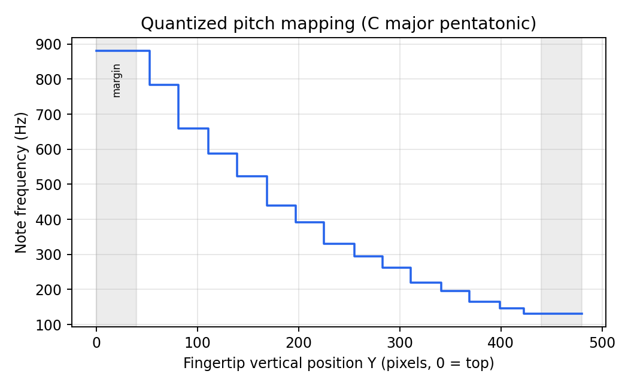
Figure 6: Vertical fingertip position is snapped to steps of the C major pentatonic scale.
The pitch cannot slide between notes, so it never sounds out of tune. The top of the picture gives the highest note (880 Hz, A5) and the bottom the lowest (130.81 Hz, C3). A small margin at the top and bottom makes the extreme notes easy to reach.

8.2 Visual output: ribbon trail and fading
Figure 7: Moving finger leaves a trail that fades when the hand stops.
The ribbon is continuous even for fast movement, because intermediate points are created by linear interpolation. The colour changes with the note, and the thickness and brightness grow with loudness.

8.3 Gesture recognition
Test | Expected
Index only | POINT (plays notes)
Closed hand | FIST (chords on/off)
All fingers open | PALM (next beat)
Index + middle | PEACE (next sound)
Index + little finger | ROCK (next space)
Thumb up, others closed | THUMBS UP (next scale)
Three fingers | OTHER (plays notes)

All 7 test poses were classified correctly (7 / 7). A held palm fired its action exactly once, at frame 21 (0.7 s at 30 fps). When one frame of a 10-frame peace-sign sequence was wrong, the voting still fired the action once and did not reset. A gesture that is not "playable" gives zero loudness, so gestures do not create stray notes.

Mapper test | Observed behaviour
Hand still | No sound (loudness 0) and no note trigger.
Hand starts moving | Loudness above 0 and a single trigger fires.
Hand moves to a new note | A new trigger fires for each new note (E4, G4, C5, D5).
Hand keeps moving inside one note | No extra trigger from the mapper (rhythm lock repeats it on the beat).
Gesture pose or hand lost | Loudness 0 immediately.

9. Challenges / Limitations
- Buzzing sound: The first version played a continuous stack of sine waves with heavy distortion, which sounded like noise. It was solved with note envelopes, instrument patches, filtering, reverb and quantization to a scale.
- Shaky landmarks: Raw fingertip positions jitter, which makes pitch flicker. Smoothing and note hysteresis fixed this, at the cost of a very small lag.
- Idle noise: A still hand must be silent. A speed threshold with hysteresis (start 2.5, stop 1.5 pixels per frame) solved it.
- Slow glow effect: The trail renderer was too slow at first. Profiling found the real cause.
- Gesture mistakes: A relaxed hand can look like a fist, and a turned hand can change finger distances. Voting and a 0.7 s hold reduce false triggers, but strange angles can still fail. Gestures can be switched off with the g key.
- Two hands: If the hands cross over, the left/right slots can swap for a moment.
- Rhythm lock delay: Snapping notes to the beat adds up to one 16th note (about 0.19 s at 78 BPM) of delay. It can be turned off with the z key.
- Hardware limits: Laptop speakers cannot play very low notes such as the kick drum fundamental , a weak CPU may cause audio crackles, which can be reduced by lowering MAX_VOICES.
- Input limits: poor light, a cluttered background or the hand leaving the frame stops tracking. Only one camera is supported.
- Evaluation limits: there is no public dataset , gesture tests used synthetic landmarks and short trials, so no formal accuracy percentage on real users is claimed.

10. Conclusion
What was implemented: A real-time application that reads a webcam, finds up to two hands, and turns the index fingertips into music and glowing light trails. It also recognises five hand gestures to change beats, sounds, scales, chords and reverb.
Techniques used: Frame capture, mirroring and colour conversion , deep-learning landmark detection , tracking with exponential smoothing , speed-based motion detection , geometric gesture classification with voting , Gaussian blur, weighted addition, thresholding, linear interpolation and exponential decay for visuals , and additive synthesis, filters, delay-based reverb and a step sequencer for sound.
What was achieved: In offline tests the pitch mapping, gesture logic, beat timing and rendering behaved as designed, and both the sound and visual parts ran far inside their real-time limits. The system works as a playable, touch-free instrument that is easy to try with only a laptop.
What we learned: How real-time video and audio can be combined , why smoothing, hysteresis and voting are needed when working with noisy camera data , how to use threads and locks safely , how to find a slow step by profiling instead of guessing , and that good sound design matters as much as good tracking. Future work could add a loop recorder, MIDI export, more scales and a trained custom gesture classifier.

