LAB_TEST

Name: Madadi Shivani Reddy
Class: M.tech
Department: CSE
SET 4
Q1. (Algorithms – 5 Marks)
Use AI to generate Python code for Bubble Sort and Insertion Sort.
Compare their execution time using Python's time module.
Prompt: Write a python code for bubble sort and insertion sort by using user function.
EXPECTED CODE:

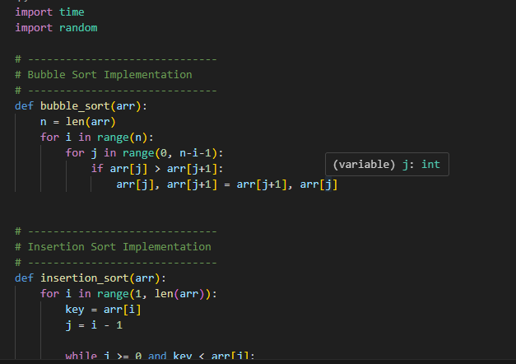
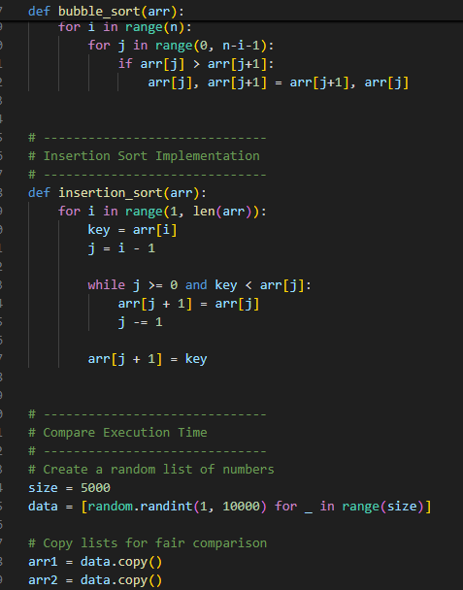
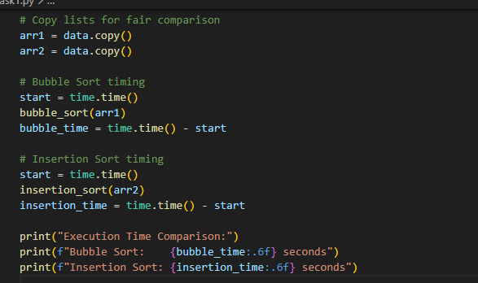
EXPECTED CODE:
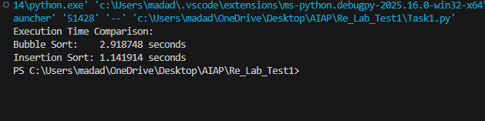
Q2. (Web Frontend – 5 Marks)
With AI help, create a webpage showing a dynamic product list using JavaScript arrays.
Each product must display:
• Name
• Price
• "Add to Cart" button
EXPECTED CODE:
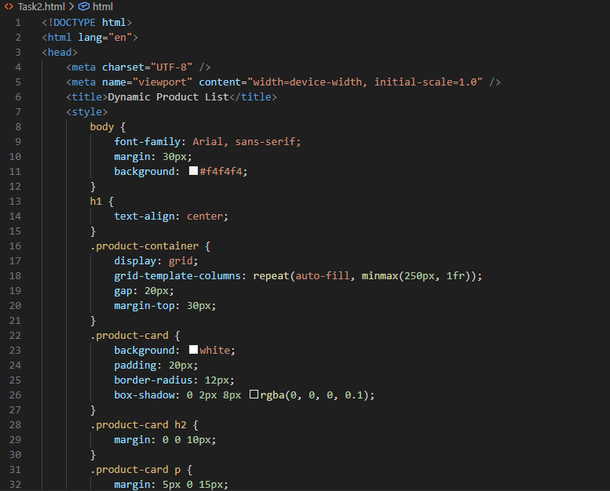
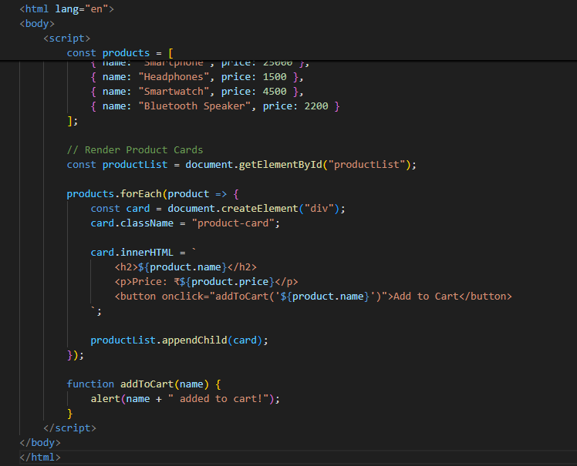
EXPECTED OUTPUT:
