**Module 3) HTML**

**Q1-Are the HTML tags and elements the same thing?**

**Ans-**Yes, in the context of HTML, the terms "tags" and "elements" are often used interchangeably. Both terms refer to the markup used to define and structure content on a web page.

HTML tags/elements are the building blocks of HTML documents. They are enclosed in angle brackets (<>) and consist of an opening tag, optional attributes, and a closing tag (in most cases). Tags/elements define the structure, semantics, and behaviour of different parts of a web page, such as headings, paragraphs, links, images, and more.

For example, <h1>is an HTML tag/element used to define a heading, <p> is used for paragraphs, <a>is used for links, and so on. So, when discussing HTML, the terms "tags" and "elements" can be used interchangeably to refer to these markup components.

**Q2- What are tags and attributes in HTML?**

**Ans-** Tags: Tags are the building blocks of HTML and are used to markup different elements on a web page. They are enclosed in angle brackets (<>).

Attributes: Attributes provide additional information or properties to HTML elements. They are specified within the opening tag of an element and consist of a name-value pair.

**Q3- What are void elements in HTML? With Example.**

**Ans-** Void elements, also known as self-closing or empty elements, are HTML elements that do not require a closing tag. They represent elements without any content. Examples of void elements include <br>, <img> and <input>.

**Q4- What are HTML Entities? With Example.**

**Ans-** HTML entities are special codes that represent reserved characters or symbols in HTML. They are used to display characters that have special meaning in HTML or that are not directly typable on a keyboard. For example, &It; represents the less-than symbol (<), and &copy; represents the copyright symbol ©.

**Q5- What are different types of lists in HTML? With Example.**

**Ans-** Different types of lists in HTML:

Unordered list (<ul>): Represents a bulleted list.

Ordered list (<ol>): Represents a numbered list.

Definition list (<dl>): Represents a list of terms and their definitions.

**Q6- What is the ‘class’ attribute in HTML? With Example.**

**Ans-** The 'class' attribute is used to define a class for an HTML element. It allows you to apply CSS styles or JavaScript functionality to multiple elements with the same class. Example<p class="highlight">This is a highlighted paragraph. </p>

**Q7- What is the difference between the ‘id’ attribute and the ‘class’ attribute of HTML elements? With Example.**

**Ans-** 'id' attribute: It is used to uniquely identify an HTML element on a page. It should be unique within the entire HTML document. Example: <div id="myElement">This is a div element. </div>

'class' attribute: It is used to group elements together and apply common styles or behaviour. Multiple elements can share the same class. Example: <p class="highlight">This is a highlighted paragraph. </p>

**Q8- What are the various formatting tags in HTML?**

**Ans-** Various formatting tags in HTML:

<b>: Bold text

<i>: Italic text

<u>: Underlined text

<strike>: Strikethrough text

<sup>: Superscript text

<sub>: Subscript text

<strong>: Strong emphasis (typically renders as bold)

<em>: Emphasized text (typically renders as italic)

**Q9- How is Cell Padding different from Cell Spacing? With Example.**

**Ans-** Cell Padding: Cell padding is used to define the space between the content of a cell and its border. It is set using the cellpadding attribute in the <table> tag. Example: <table cellpadding="5">

Cell Spacing: Cell spacing is used to define the space between cells in a table. It is set using the cellspacing attribute in the <table> tag. Example: <table cellspacing="10">

**Q10- How can we club two or more rows or columns into a single row or column in an HTML table? With Example.**

**Ans-** To merge cells horizontally (column-wise), you can use the colspan attribute on a <td> or <th> element. Example: <td colspan="2"> merges two adjacent cells into a single column.

To merge cells vertically (row-wise), you can use the rowspan attribute on a <td> or <th> element. Example: <td rowspan="2"> merges two cells vertically into a single row.

**Q11- What is the difference between a block-level element and an inline element?**

**Ans-** Block-level elements: They take up the full width available and create a new line before and after the element. Examples include <div>, <p>, <h1> to <h6>.

Inline elements: They occupy only the space needed for their content and do not create line breaks. Examples include <span>, <a>, <strong>, <em>.

**Q12- How to create a Hyperlink in HTML? With Example.**

**Ans-** To create a hyperlink, use the <a> tag with the href attribute specifying the URL to link to. Example: <a href="https://www.example.com">Visit Example.com</a>.

**Q13- What is the use of an iframe tag? With Example.**

**Ans-** The <iframe> tag is used to embed another HTML document within the current document. It is often used for displaying content from external sources, such as embedding videos or including external web pages.

**Q14- What is the use of a span tag? Explain with example?**

**Ans-** The <span> tag is an inline element used for grouping and applying styles to a specific section of text or elements within a larger block of content. It does not have any semantic meaning of its own but can be styled or targeted with CSS and JavaScript.

**Q15- How to insert a picture into a background image of a web page? With Example.**

**Ans-** To set an image as the background of a web page, we can use CSS. Here's an example: body {background-image: url("your-image.jpg");}.

**Q16- How are active links different from normal links?**

**Ans-** Active links refer to links that are currently being interacted with by the user, such as when hovering over them or clicking on them. They can be styled differently using CSS to provide visual feedback.

Normal links are links that have not been interacted with and are in their default state.

**Q17- What are the different tags to separate sections of text?**

**Ans-** Tags to separate sections of text:

<div>: Divides content into logical sections.

<section>: Defines a section in a document.

<article>: Defines an independent, self-contained content.

<header>: Represents the introductory content at the beginning of a section or page.

<footer>: Represents the closing content at the end of a section or page.

**Q18- What is SVG?**

**Ans-** SVG is a markup language for describing two-dimensional vector graphics in XML format. It allows for the creation of scalable and resolution-independent graphics, such as icons, logos, and illustrations, that can be rendered in web browsers.

**Q19- What is difference between HTML and XHTML?**

**Ans-** HTML (HyperText Markup Language) is an older standard for creating web pages. It has more relaxed syntax rules and allows for certain errors.

XHTML (eXtensible HyperText Markup Language) is a stricter version of HTML that follows the rules of XML. It requires well-formed markup and strict adherence to syntax rules.

**Q20- What are logical and physical tags in HTML?**

**Ans-** Logical tags: Logical tags are used to describe the structure and meaning of the content. Examples include <h1> for heading, <p> for paragraph, <ul> for unordered list, etc.

Physical tags: Physical tags define the appearance or presentation of the content. Examples include <b> for bold, <i> for italic, <font> for changing font properties, etc. Physical tags are less preferred now, and CSS is recommended for styling.

<!DOCTYPE html>

<html lang="en">

  <head>

    <meta charset="UTF-8" />

    <meta http-equiv="X-UA-Compatible" content="IE=edge" />

    <meta name="viewport" content="width=device-width, initial-scale=1.0" />

    <title>HTML</title>

  </head>

  <body>

    <table border="1px" Cellspacing="0px" cellpadding="0px" align="center" width="60%px">

      <tr align="center">

        <td rowspan="2"><a href="">Home</a></td>

        <td rowspan="2"><a href="">about</a></td>

        <td rowspan="2"><a href="">contact</a></td>

        <td rowspan="2"><a href="">help</a></td>

        <td rowspan="2"><a href="">store</a></td>

        <td bgcolor="red"><a href="">download</a></td>

      </tr>

      <tr align="center">

        <!-- <td></td>

            <td></td>

            <td></td>

            <td></td>

            <td></td> -->

        <td bgcolor="red">app</td>

      </tr>

      <tr align="center">

        <td colspan="6">

          <img height="300px" width="100%" src="1.jpg" alt="" />

        </td>

        <!-- <td></td>

            <td></td>

            <td></td>

            <td></td>

            <td></td> -->

      </tr>

      <tr align="center">

        <td colspan="6" bgcolor="pink" align="center">contact-us-page</td>

        <!-- <td></td>

            <td></td>

            <td></td>

            <td></td>

            <td></td> -->

      </tr>

      <tr align="center" >

        <td colspan="6">

          <img height="200px" width="100%" src="2.png" alt="" />

        </td>

        <!-- <td></td>

            <td></td>

            <td></td>

            <td></td>

            <td></td> -->

      </tr>

      <tr align="center" bgcolor="lightblue">

        <td colspan="3">

          <label for="">first-name</label>

          <input type="text" placeholder="Enter Your Name" />

        </td>

        <!-- <td></td>

            <td></td> -->

        <td colspan="3">

          <label for="">last-name</label>

          <input type="text" placeholder="Enter Your Name" />

        </td>

        <!-- <td></td>

            <td></td> -->

      </tr>

      <tr align="center"  bgcolor="lightblue">

        <td colspan="3">

          <label for="">Email-id</label>

          <input type="text" placeholder="Enter Your Email-id" />

        </td>

        <!-- <td></td>

            <td></td> -->

        <td colspan="3">

          <label for="">Phone-no</label>

          <input type="number" placeholder="enter your phone-no" />

        </td>

        <!-- <td></td>

            <td></td> -->

      </tr>

      <tr align="center"  bgcolor="lightblue">

        <td colspan="3">

          <label for="">City</label>

          <select name="" id="">

            <option value="">Ahmedabad</option>

            <option value="">Surat</option>

            <option value="">Vadodara</option>

          </select>

        </td>

        <!-- <td></td>

            <td></td> -->

        <td colspan="3">

          <label for="">Gender</label>

          <label for="abc">MALE</label>

          <input type="radio" name="xyz" id="abc" />

          <label for="pqr">FEMALE</label>

          <input type="radio" name="xyz" id="pqr" />

          <label for="pqs">OTHER</label>

          <input type="radio" name="xyz" id="pqs" />

        </td>

        <!-- <td></td>

            <td></td> -->

      </tr>

      <tr>

        <td colspan="3">

          <iframe

            src="https://www.google.com/maps/embed?pb=!1m18!1m12!1m3!1d3672.7237387824916!2d72.60635807312612!3d22.997184179191546!2m3!1f0!2f0!3f0!3m2!1i1024!2i768!4f13.1!3m3!1m2!1s0x395e85c2fc005927%3A0x918e69150ca1c935!2sTOPS%20Technologies!5e0!3m2!1sen!2sin!4v1685713970267!5m2!1sen!2sin"

            width="550"

            height="200"

            style="border: 0"

            allowfullscreen=""

            loading="lazy"

            referrerpolicy="no-referrer-when-downgrade"

          ></iframe>

        </td>

        <!-- <td></td>

        <td></td> -->

        <td colspan="3">

          <iframe

            width="550"

            height="200"

            src="https://www.youtube.com/embed/Y9pgsPW-KIE"

            title="YouTube video player"

            frameborder="0"

            allow="accelerometer; autoplay; clipboard-write; encrypted-media; gyroscope; picture-in-picture; web-share"

            allowfullscreen

          ></iframe>

        </td>

        <!-- <td></td>

        <td></td> -->

      </tr>

    </table>

  </body>

</html>

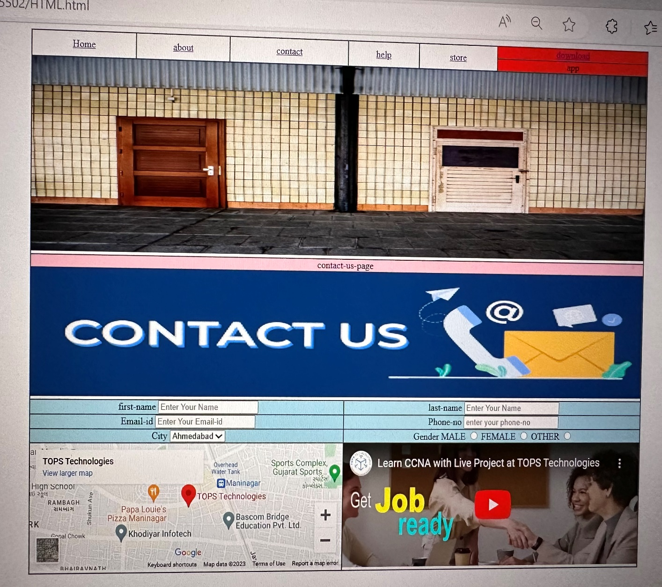

Top of Form