**Module 4) CSS and CSS 3**

**Q-1 What are the benefits of using CSS?**

**Ans-** Benefits of using CSS:

**Separation of content and presentation:** CSS allows you to separate the structure and content of a webpage from its visual appearance. This separation enhances maintainability, flexibility, and reusability of the code.

**Consistency:** CSS enables you to define styles once and apply them to multiple elements throughout your website, ensuring consistent design and layout.

**Efficient updates:** By making changes to a single CSS file, you can update the styles across an entire website, saving time and effort.

**Faster page loading:** CSS files can be cached by the browser, resulting in faster loading times for subsequent pages, especially when using external style sheets.

**Device compatibility:** CSS provides responsive design capabilities, allowing you to create websites that adapt to different screen sizes and devices.

**Accessibility:** CSS can improve the accessibility of your website by separating content from presentation, making it easier to implement accessibility features like screen readers.

**Q-2 What are the disadvantages of CSS?**

**Ans-** Disadvantages of CSS:

**Browser compatibility:** Different browsers may interpret CSS rules differently, leading to inconsistent rendering across browsers. This requires additional testing and sometimes workarounds to ensure consistent display.

**Learning curve:** CSS has a relatively steep learning curve, especially when dealing with more advanced concepts and techniques.

**Lack of layout control:** CSS has limitations when it comes to complex page layouts, especially compared to more robust layout systems like CSS frameworks or grid systems.

**Limited print control:** CSS's print capabilities are more limited compared to its screen styling abilities, which can make it challenging to create optimal print layouts.

**Q-3 What is the difference between CSS2 and CSS3?**

**Ans-** Difference between CSS2 and CSS3: CSS2 and CSS3 are different versions of the CSS specification, with CSS3 being the newer version. Some key differences include:

**Selectors:** CSS3 introduced several new selectors like attribute selectors, structural pseudo-classes (:nth-child, :nth-of-type), and the adjacent sibling selector (+), which provide more powerful and granular selection of elements.

**Box Model:** CSS3 introduced the box-sizing property, which allows for better control over how the width and height of elements are calculated, particularly when dealing with padding and borders.

**Media Queries:** CSS3 introduced media queries, which enable responsive design by allowing styles to be applied based on the characteristics of the device or viewport, such as screen size or device orientation.

**Transitions and Animations:** CSS3 introduced properties for creating smooth transitions and animations, such as transition, transform, and keyframe animations, providing more dynamic and interactive web experiences.

**Q-4 Name a few CSS style components**

**Ans-** Some common CSS style components include:

**Color:** Sets the color of text or background.

**Font:** Defines the font family, size, weight, and style of text.

**Padding:** Specifies the space between the content of an element and its border.

**Margin:** Determines the space between an element and its neighboring elements.

**Border:** Sets the style, width, and color of an element's border.

**Background:** Defines the background color or image of an element.

**Width and Height:** Determines the dimensions of an element.

**Display:** Specifies how an element is rendered (e.g., block, inline, flex).

**Q-5 What do you understand by CSS opacity?**

**Ans-** CSS opacity is a property that controls the transparency of an element. It ranges from 0 to 1, where 0 represents complete transparency (invisible) and 1 represents full opacity (fully visible). By adjusting the opacity value, you can make an element partially transparent, allowing the content beneath it to show through.

**Q-6 How can the background color of an element be changed?**

**Ans-** Changing the background color of an element: To change the background color of an element using CSS, you can use the **background-color** property and specify a color value. For example:

.element {

background-color: #ff0000; /* Set background color to red */

}

**Q-7 How can image repetition of the backup be controlled?**

**Ans-** Controlling image repetition of the background: To control the repetition of a background image, you can use the **background-repeat** property. It allows you to specify whether the background image should repeat horizontally, vertically, both, or not at all. The possible values are:

**repeat**: The background image will repeat both horizontally and vertically (default).

**repeat-x**: The background image will repeat only horizontally.

**repeat-y**: The background image will repeat only vertically.

**no-repeat**: The background image will not repeat.

For example, to prevent a background image from repeating, you can use:

.element {

background-repeat: no-repeat;

}

**Q-8 What is the use of the background-position property?**

**Ans-** Use of the background-position property: The **background-position** property is used to specify the starting position of a background image within an element. It allows you to control where the image is positioned horizontally and vertically.

The property value can be expressed using keywords (e.g., **top**, **right**, **center**, **bottom**) or using specific length or percentage values. For example:

.element {

background-position: center top; /* Position the background image at the center horizontally and at the top vertically */

}

**Q-9 Which property controls the image scroll in the background?**

**Ans-** Property that controls image scroll in the background: The **background-attachment** property controls whether a background image scrolls with the content or remains fixed as the user scrolls. The possible values are:

**scroll**: The background image scrolls with the content (default behavior).

**fixed**: The background image remains fixed relative to the viewport as the user scrolls.

**local**: The background image scrolls with the element itself, rather than the entire page.

**Q-10 Why should background and color be used as separate properties?**

**Ans-** Using separate properties for background and color: Background and color are used as separate properties because they serve different purposes. The **background** property is used to control the background color or image of an element, while the **color** property is used to set the color of the text content within an element. Separating these properties allows for more granular control over the visual presentation of a webpage.

**Q-11 How to center block elements using CSS1?**

**Ans-** Centering block elements using CSS: To center a block-level element horizontally using CSS, you can set the left and right margins to **auto** and specify a width for the element. For example:

.element {

width: 200px;

margin-left: auto;

margin-right: auto;

}

To center a block-level element both horizontally and vertically, you can use CSS flexbox or CSS grid, which provide more flexible and powerful centering capabilities.

**Q-12 How to maintain the CSS specifications?**

**Ans-** Maintaining CSS specifications: To maintain CSS specifications, it is important to keep up with the latest updates and recommendations from the CSS Working Group, which develops and maintains the CSS standard. Following best practices, staying informed about browser compatibility issues, and actively participating in the web development community can help ensure adherence to CSS specifications.

**Q-13 What are the ways to integrate CSS as a web page?**

**Ans-** Ways to integrate CSS as a web page: There are three main ways to integrate CSS into a web page:

1. **Inline CSS:** You can use the **style** attribute directly within an HTML element to apply CSS styles. For example:

<p style="color: blue;">This is a paragraph with blue text.</p>

1. **Embedded CSS:** CSS can be embedded within the **<style>** tags within the **<head>** section of an HTML document. For example:

<head>

<style>

p {

color: blue;

}

</style>

</head>

<body>

<p>This is a paragraph with blue text.</p>

</body>

1. **External CSS:** CSS can be placed in an external file with a .css extension and linked to the HTML document using the **<link>** element. For example:

<head>

<link rel="stylesheet" href="styles.css">

</head>

<body>

<p>This is a paragraph with blue text.</p>

</body>

**Q-14 What is embedded style sheets?**

**Ans-** Embedded style sheets: Embedded style sheets refer to CSS code that is placed within the **<style>** tags in the **<head>** section of an HTML document. The CSS rules defined in the embedded style sheet apply to the elements within that HTML document.

**Q-15 What are the external style sheets?**

**Ans-** External style sheets: External style sheets are separate CSS files with a .css extension that contain CSS rules. They can be linked to multiple HTML documents using the **<link>** element. By using external style sheets, you can apply consistent styles across multiple web pages, promoting code reusability and easier maintenance.

**Q-16 What are the advantages and disadvantages of using external style sheets?**

**Ans-** Advantages of using external style sheets:

**Separation of concerns:** External style sheets allow you to separate the presentation (CSS) from the structure and content (HTML) of a webpage. This separation enhances maintainability and makes it easier to update styles across multiple pages.

**Code reusability:** By linking multiple HTML documents to the same external style sheet, you can ensure consistent design and layout throughout your website without duplicating code.

**Faster loading times:** External style sheets can be cached by the browser, resulting in faster loading times for subsequent pages. This can improve the overall performance of your website.

**Collaboration:** External style sheets facilitate collaboration among designers and developers working on the same project by providing a centralized location for managing styles.

**Q-17 What is the meaning of the CSS selector?**

**Ans-** Disadvantages of using external style sheets:

**Dependency on external files:** When using external style sheets, the rendering of a webpage depends on the availability and proper linking of the external CSS file. If the file is missing or not linked correctly, it can lead to unexpected or incorrect rendering.

**Increased HTTP requests:** External style sheets require an additional HTTP request to fetch the CSS file, which can slightly impact page loading times, especially for the first visit to a website.

**Style conflicts:** If multiple external style sheets are used and conflicting styles are defined, it can lead to unexpected results or require additional effort to resolve conflicts.

**Meaning of CSS selector:** A CSS selector is a pattern that is used to select and target specific HTML elements on a webpage to apply styles. Selectors define the criteria or conditions for matching elements, such as element names, classes, IDs, attributes, or relationships between elements.

For example, in the selector **p**, the "p" refers to the HTML element name (paragraph), and it selects all **<p>** elements on the page to apply styles.

**Q-18 What are the media types allowed by CSS?**

**Ans-** Media types allowed by CSS: CSS allows you to define different styles for different media types, such as screen, print, or speech. Some common media types allowed by CSS are:

**screen**: Styles for screens and devices with a screen.

**print**: Styles for printed documents.

**speech**: Styles for screen readers and text-to-speech devices.

**all**: Styles that apply to all media types.

**Q-19 What is the rule set?**

**Ans-** Rule set in CSS: A CSS rule set consists of one or more CSS declarations inside curly braces **{}**. Each declaration consists of a CSS property and its corresponding value. For example:

selector {

property1: value1;

property2: value2;

/* more properties */

}

The selector specifies the HTML element(s) to which the styles should be applied. Inside the rule set, you can define multiple declarations to set various properties and values for the selected elements.

<!DOCTYPE html>

<html lang="en">

<head>

    <meta charset="UTF-8">

    <meta http-equiv="X-UA-Compatible" content="IE=edge">

    <meta name="viewport" content="width=device-width, initial-scale=1.0">

    <title>Document</title>

    <style>

        *{

            margin: 0;

            padding: 0;

            box-sizing: border-box;

        }

        div{

            display:grid;

            grid-template-columns: repeat(10);

            background-color: black;

        }

        .one{

            padding: 15px;

            margin: 5px;

        }

        #two1{

            grid-column: 1/7;

            grid-row: 1/2;

            background-image: url(unnamed.jpg);

            background-repeat: no-repeat;

            background-size: cover;

        }

        #two2{

            grid-column: 7/10;

            grid-row: 1/2;

            background-image: url(images\ \(1\).jpg);

            background-repeat: no-repeat;

            background-size: cover;

        }

        #two3{

            grid-column: 10/11;

            grid-row: 1/5;

            color: white;

            background-color: black;

            text-align: right;

        }

        #two4{

            grid-column: 1/3;

            grid-row: 2/3;

            background-image: url(images.jpg);

            background-repeat: no-repeat;

            background-size: cover;

        }

        #two5{

            grid-column: 3/8;

            grid-row: 2/3;

            background-image: url(images\ \(2\).jpg);

            background-repeat: no-repeat;

            background-size: cover;

        }

        #two6{

            grid-column: 8/10;

            grid-row: 2/3;

            background-image: url(images\ \(3\).jpg);

            background-repeat: no-repeat;

            background-size: cover;

        }

        #two7{

            grid-column: 1/5;

            grid-row: 3/4;

            background-image: url(images\ \(4\).jpg);

            background-repeat: no-repeat;

            background-size: cover;

        }

        #two8{

            grid-column: 5/10;

            grid-row: 3/4;

            background-image: url(images\ \(5\).jpg);

            background-repeat: no-repeat;

            background-size: cover;

        }

        #two9{

            grid-column: 1/4;

            grid-row: 4/5;

            background-image: url(images\ \(6\).jpg);

            background-repeat: no-repeat;

            background-size: cover;

        }

        #two10{

            grid-column: 4/7;

            grid-row: 4/5;

            background-image: url(images\ \(7\).jpg);

            background-repeat: no-repeat;

            background-size: cover;

        }

        #two11{

            grid-column: 7/10;

            grid-row: 4/5;

            background-image: url(images\ \(8\).jpg);

            background-repeat: no-repeat;

            background-size: cover;

        }

        #nav{

            font-size: small;

            margin-bottom: 500px;

            float: right;

            padding-bottom: 10px;

        }

        #heading{

            margin-bottom: 40px;

        }

        .navbar{

            padding-bottom: 10px;

        }

        #change{

            color: red;

        }

        img{

            height: 15px;

            width: 70px;

            margin-top: 20px;

        }

    </style>

</head>

<body>

    <div>

        <div class="one" id="two1"></div>

        <div class="one" id="two2"></div>

        <div class="one" id="two3">

            <h3 id="heading">SHUTTER</h3>

            <div id="nav">

                <p class="navbar" id="change">HOME</p>

                <p class="navbar">PHOTOS</p>

                <p class="navbar">BIO</p>

                <p class="navbar">BLOG</p>

                <p class="navbar">CONTACT</p>

                <p><img src="images.png" alt=""></p>

            </div>

        </div>

        <div class="one" id="two4"></div>

        <div class="one" id="two5"></div>

        <div class="one" id="two6"></div>

        <div class="one" id="two7"></div>

        <div class="one" id="two8"></div>

        <div class="one" id="two9"></div>

        <div class="one" id="two10"></div>

        <div class="one" id="two11"></div>

    </div>

</body>

</html>

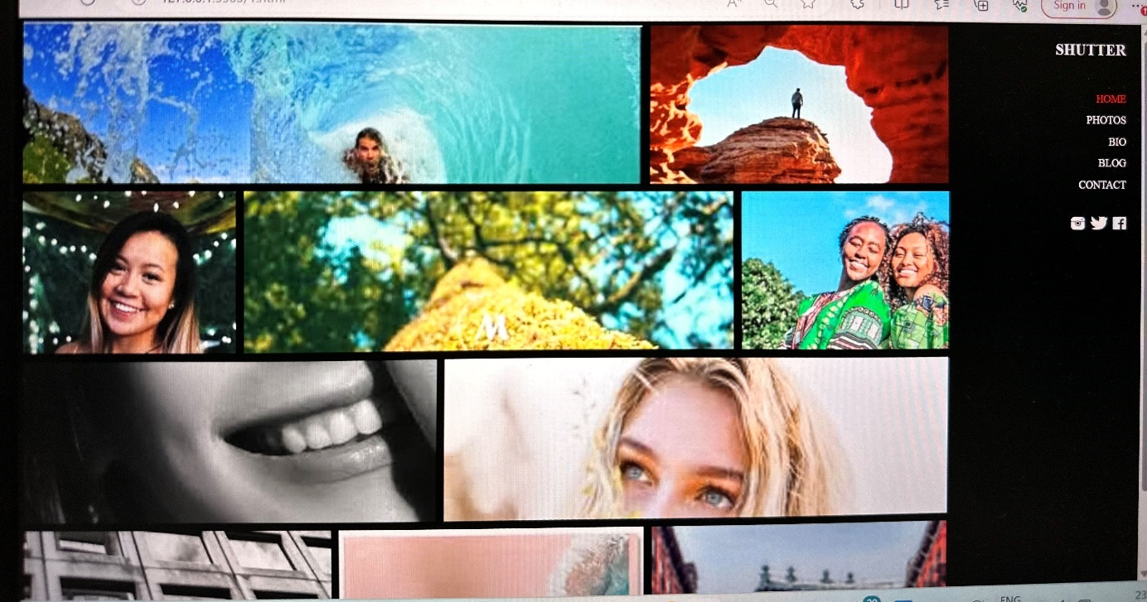

<!DOCTYPE html>

<html lang="en">

<head>

    <meta charset="UTF-8">

    <meta name="viewport" content="width=device-width, initial-scale=1.0">

    <title>Document</title>

    <style>

        * {

            margin: 0;

            padding: 0;

            box-sizing: border-box;

        }

        .main {

            width: 100%;

            height: 450px;

        }

        .container1 {

            position: relative;

            top: 0;

        }

        .logo {

            position: absolute;

            top: 20px;

            left: 200px;

            display: flex;

        }

        #logo1 {

            width: 20px;

            height: 25px;

            background-color: white;

            color: black;

            font-size: 20px;

        }

        #logo2 {

            text-align: center;

            height: 25px;

            width: 50px;

            border: 2px solid white;

            color: white;

            font-size: 20px;

            position: absolute;

            top: 0px;

            left: 20px;

        }

        .navbar {

            position: absolute;

            top: 20px;

            left: 500px;

        }

        .layout2 {

            position: absolute;

            top: 0;

            height: 500px;

            width: 100%;

        }

        .list-nav li {

            display: inline;

            padding: 20px;

            font-size: 14px;

            font-family: "Open Sans";

        }

        .list-nav li a {

            text-decoration: none;

            color: white;

        }

        #color {

            color: #db0808;

            border-bottom: 1px solid red;

        }

        .line0 {

            width: 70px;

            height: 1px;

            background-color: #f4f5f9;

            border: 2px solid #db0808;

            position: absolute;

            top: 25px;

            left: 10px;

        }

        .slider1 {

            height: 20px;

            width: 20px;

            background-color: #6a6a6a;

            position: absolute;

            top: 180px;

            left: 20px;

            background-image: url(fa-angle-left\ \(1\).png);

            background-repeat: no-repeat;

            background-position: center;

            background-size: contain;

        }

        .slider2 {

            height: 20px;

            width: 20px;

            background-color: #c41616;

            position: absolute;

            top: 180px;

            right: 20px;

            background-image: url(arrow.png);

            background-repeat: no-repeat;

            background-position: center;

            background-size: contain;

        }

        .head {

            position: absolute;

            top: 120px;

            left: 500px;

        }

        .head1 {

            font-size: 15px;

            letter-spacing: 1px;

            color: #f4f5f9;

            font-weight: 400;

            font-family: "Source Sans Pro";

            text-align: center;

        }

        .head2 {

            font-size: 60px;

            letter-spacing: 7px;

            color: #f4f5f9;

            font-weight: 700;

            font-family: "Open Sans";

            text-align: center;

        }

        .d-line {

            display: flex;

            position: absolute;

            top: 200px;

            left: 120px;

        }

        .d-line0,

        .d-line2 {

            width: 100px;

            height: 1px;

            border: 1px solid #6a6a6a;

            margin-left: 15px;

            margin-right: 15px;

            justify-content: space-around;

        }

        .d-line1 {

            width: 8px;

            height: 8px;

            border-radius: 10px;

            background-color: #c41616;

        }

        .lorem-text {

            position: absolute;

            top: 250px;

            left: 470px;

        }

        .lorem1 {

            width: 600px;

            height: 122px;

            font-size: 14px;

            line-height: 24px;

            color: #cbc6c0;

            font-weight: 400;

            font-family: "Open Sans";

            text-align: center;

        }

        .button {

            position: absolute;

            top: 390px;

            left: 600px;

        }

        .define {

            height: 100ox;

            width: 100px;

            background-color: tomato;

            padding: 10px;

            text-decoration: none;

            font-size: 15px;

            text-transform: uppercase;

            color: white;

            padding-left: 20px;

        }

        .define1 {

            height: 100ox;

            width: 100px;

            border: 2px solid white;

            padding: 8px;

            text-decoration: none;

            font-size: 15px;

            text-transform: uppercase;

            color: white;

            padding-left: 20px;

            margin-left: 25px;

        }

        .anything {

            position: absolute;

            top: 470px;

            left: 740px;

            width: 54px;

            height: 54px;

            border-radius: 32px;

            background-color: #f4f5f9;

            background-image: url(Forma\ 1\ \(3\).png);

            background-repeat: no-repeat;

            background-position: center;

        }

        .container2 {

            position: absolute;

            top: 500px;

            display: flex;

        }

        .footer1 {

            position: absolute;

            top: 15px;

            left: 70px;

        }

        #imgfooter {

            padding-left: 250px;

        }

        .seek {

            padding: 10px 0px 0px 75px;

            font-size: 15px;

            letter-spacing: 1px;

            text-transform: uppercase;

            color: #e74c3c;

            font-weight: 600;

            font-family: "Open Sans";

            margin-left: 160px;

        }

        .line {

            width: 50px;

            height: 1px;

            border: 3px solid #6a6a6a;

            position: absolute;

            top: 130px;

            left: 270px;

        }

        .lorem {

            text-align: center;

            font-size: 10px;

            position: absolute;

            top: 145px;

            left: 230px;

        }

        #find {

            background-image: url(footer2.png);

            position: absolute;

            top: 35px;

            left: 600px;

        }

        .clean {

            padding-top: 110px;

            padding-left: 580px;

            font-size: 15px;

            letter-spacing: 1px;

            text-transform: uppercase;

        }

        .line1 {

            width: 50px;

            height: 1px;

            background-color: #f4f5f9;

            border: 3px solid #6a6a6a;

            position: absolute;

            top: 140px;

            left: 600px;

        }

        .lorem2 {

            text-align: center;

            font-size: 10px;

            padding: 30px 0px 0px 550px;

        }

        #find2 {

            position: absolute;

            top: 35px;

            left: 850px;

            background-image: url(footer3.png);

        }

        .ideals {

            padding-top: 110px;

            margin-left: 100px;

            font-size: 15px;

            letter-spacing: 1px;

            text-transform: uppercase;

        }

        .line2 {

            width: 50px;

            height: 1px;

            border: 3px solid #6a6a6a;

            position: absolute;

            top: 140px;

            left: 855px;

        }

        .lorem3 {

            text-align: center;

            font-size: 10px;

            padding: 30px 0px 0px 100px;

        }

        #find3 {

            position: absolute;

            top: 35px;

            left: 1100px;

        }

        .picco {

            background-image: url(footer4.png);

            background-repeat: no-repeat;

            background-position: center;

            width: 63px;

            height: 63px;

            border-radius: 2px;

            border: 1px solid #999999;

        }

        .support {

            padding-top: 110px;

            padding-left: 100px;

            font-size: 15px;

            letter-spacing: 1px;

            text-transform: uppercase;

        }

        .line3 {

            width: 50px;

            height: 1px;

            border: 3px solid #6a6a6a;

            position: absolute;

            top: 140px;

            left: 1110px;

        }

        .lorem4 {

            text-align: center;

            font-size: 10px;

            padding: 30px 0px 0px 90px;

        }

        .img01 {

            position: absolute;

            top: 0;

            height: 500px;

        }

        #layer {

            height: 400px;

            position: absolute;

            top: 0;

        }

        .img02 {

            position: absolute;

            top: 0;

            height: 500px;

        }

    </style>

</head>

<body>

    <div class="main">

        <div class="container">

            <div class="layout">

                <img class="img01" src="Foreground copy.png" alt="" srcset="" height="465px" width="100%" />

                <img id="layer" src="main.png" srcset="" height="410px" width="100%" />

                <img class="img02" src="Foreground (1).png" alt="" srcset="" height="465px" width="100%" />

            </div>

            <div class="layout2">

                <div class="logo">

                    <p id="logo1">L</p>

                    <p id="logo2">ogo</p>

                </div>

            </div>

            <div class="navbar">

                <ul class="list-nav">

                    <li><a id="color" href="#">HOME</a></li>

                    <li><a href="#">ABOUT US</a></li>

                    <li><a href="#">PORTFOLIO</a></li>

                    <li><a href="#">PRICING</a></li>

                    <li><a href="#">TEAM</a></li>

                    <li><a href="#">BLOG</a></li>

                    <li><a href="#">CONTACT</a></li>

                </ul>

                <div class="d-line">

                    <p class="d-line0"></p>

                    <p class="d-line1"></p>

                    <p class="d-line2"></p>

                </div>

            </div>

            <div class="slider">

                <p class="slider1"></p>

                <p class="slider2"></p>

            </div>

            <div class="head">

                <p class="head1">Our Clients Are Our First Priority</p>

                <h1 class="head2">Welcome to sky</h1>

            </div>

        </div>

        <div class="lorem-text">

            <p class="lorem1">

                Lorem ipsum dolor sit, amet consectetur adipisicing elit. Quod nemo,

                amet autem expedita ullam temporibus dignissimos doloribus atque

                ea aliquid cupiditate ad in rerum repellendus at blanditiis

                architecto, ex impedit eius libero harum fugit. Minus vero, cumque

                doloremque esse voluptate, illum perferendis laboriosam numquam fugiat repellat

                minima quia quos voluptatem.

            </p>

        </div>

        <div class="button">

            <a class="define" href="#">Get Started Now</a>

            <a class="define1" href="#">Learn More</a>

        </div>

        <div class="anything"></div>

    </div>

    <div class="container2">

        <div class="footer1">

            <img id="imgfooter" src="footer1.png" srcset="" />

            <p class="seek">Seek Design</p>

            <p class="line"></p>

            <p class="lorem">

                Lorem ipsum dolor, sit amet consectetur

                adipisicing elit. Excepturi perferendis

                eius distinctio aut quia et?

            </p>

        </div>

        <div class="footer2">

            <p id="find" class="picco"></p>

            <p class="clean">Clean Code</p>

            <p class="line1"></p>

            <p class="lorem2">

                Lorem ipsum dolor, sit amet consectetur <br />

                adipisicing elit. Excepturi perferendis <br />

                eius distinctio aut quia et?

            </p>

        </div>

        <div class="footer3">

            <p id="find2" class="picco"></p>

            <p class="ideals">Creative Ideals</p>

            <p class="line2"></p>

            <p class="lorem3">

                Lorem ipsum dolor, sit amet consectetur <br />

                adipisicing elit. Excepturi perferendis <br />

                eius distinctio aut quia et?

            </p>

        </div>

        <div class="footer4">

            <p id="find3" class="picco"></p>

            <p class="support">Free Support</p>

            <p class="line3"></p>

            <p class="lorem4">

                Lorem ipsum dolor, sit amet consectetur <br />

                adipisicing elit. Excepturi perferendis <br />

                eius distinctio aut quia et?

            </p>

        </div>

    </div>

    </div>

</body>

</html>

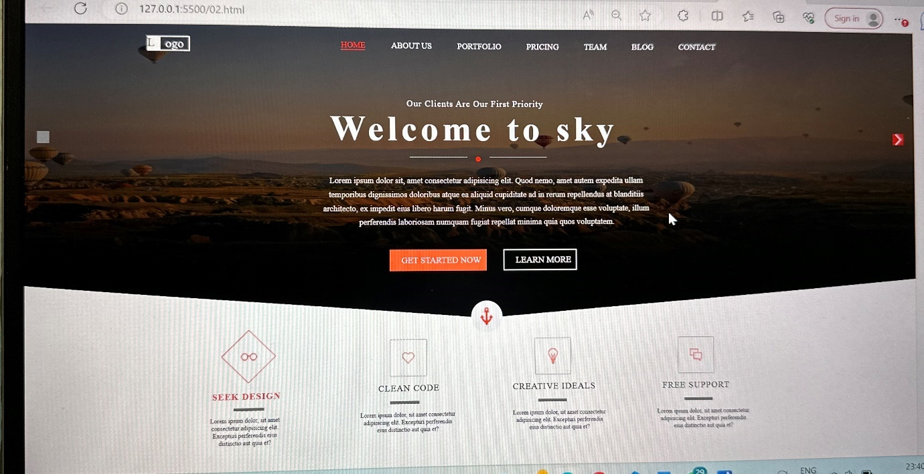

<!DOCTYPE html>

<html lang="en">

  <head>

    <meta charset="UTF-8" />

    <meta name="viewport" content="width=device-width, initial-scale=1.0" />

    <title>Document</title>

    <style>

      body {

        margin: 0;

        padding: 0;

      }

      #main {

        height: 665px;

        display: flex;

      }

      .first {

        width: 750px;

        background-image: url(left.png);

        display: flex;

        flex-wrap: wrap;

        position: relative;

      }

      .right {

        width: 650px;

        background-image: url(right.png);

        background-repeat: no-repeat;

        background-size: cover;

        position: relative;

      }

      .heading {

        font-size: 36px;

        letter-spacing: 4px;

        color: #f4f5f9;

        font-weight: 700;

        font-family: "Source Sans Pro";

        margin-left: 240px;

        margin-top: 80px;

        height: 40px;

      }

      .h2 {

        width: 6px;

        height: 36px;

        background-color: #e74c3c;

        position: fixed;

        top: 48px;

        left: 580px;

      }

      .h3 {

        width: 587px;

        height: 14px;

        font-size: 18px;

        line-height: 29px;

        color: #e74c3c;

        font-weight: 600;

        font-family: "Open Sans";

        text-align: right;

      }

      .h4 {

        width: 587px;

        height: 44px;

        font-size: 14px;

        line-height: 29px;

        color: #999999;

        font-weight: 400;

        font-family: "Source Sans Pro";

        text-align: right;

      }

      #first {

        height: 120px;

        margin-top: 30px;

      }

      .second {

        height: 120px;

        margin-bottom: 10px;

      }

      .circle {

        width: 60px;

        height: 60px;

        border-radius: 50%;

        background-color: rgb(255, 255, 255);

        position: absolute;

        top: 40%;

        transform: translate(-50%, -50%);

      }

      .pic1{

       margin-top: 19px;

       margin-left: 15px;

      }

      #c2{

        position: absolute;

        top: 60%;

      }

      #c3{

        position: absolute;

        top: 80%;

      }

    </style>

  </head>

  <body>

    <div id="main">

      <div class="first">

        <div class="heading">

          OUR SERVICES

          <p class="h2"></p>

        </div>

        <div id="first">

          <p class="h3">WEB DESIGN</p>

          <p class="h4">

            Lorem ipsum dolor sit amet consectetur, adipisicing elit.

            Praesentium a at laboriosam, sit nemo est, similique eum explicabo

            doloremque architecto reiciendis culpa odio. Consequuntur,

            voluptatum!

          </p>

        </div>

        <div class="second">

          <p class="h3">PRINT DESIGN</p>

          <p class="h4">

            Lorem ipsum dolor sit amet consectetur, adipisicing elit.

            Praesentium a at laboriosam, sit nemo est, similique eum explicabo

            doloremque architecto reiciendis culpa odio. Consequuntur,

            voluptatum!

          </p>

        </div>

        <div class="third">

          <p class="h3">PHOTOGRAPHY</p>

          <p class="h4">

            Lorem ipsum dolor sit amet consectetur, adipisicing elit.

            Praesentium a at laboriosam, sit nemo est, similique eum explicabo

            doloremque architecto reiciendis culpa odio. Consequuntur,

            voluptatum!

          </p>

        </div>

      </div>

      <div class="right" id="container">

        <div class="circle" id="c1"><img class="pic1" src="c1.png" alt=""></div>

        <div class="circle" id="c2"><img class="pic1" src="c2.png" alt=""></div>

        <div class="circle" id="c3"><img class="pic1" src="c3.png" alt=""></div>

      </div>

    </div>

  </body>

</html>

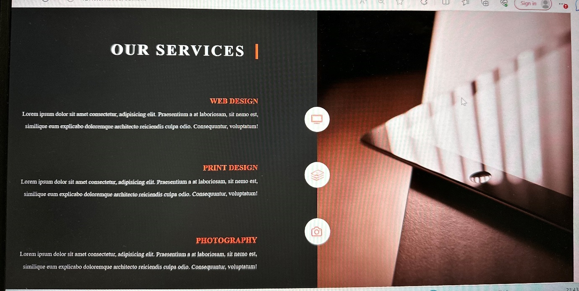

<!DOCTYPE html>

<html lang="en">

  <head>

    <meta charset="UTF-8" />

    <meta name="viewport" content="width=device-width, initial-scale=1.0" />

    <title>Document</title>

    <style>

      body {

        margin: 0;

        padding: 0;

        box-sizing: border-box;

      }

      .main {

        height: 665px;

        position: relative;

        background-color: black;

      }

      .head {

        height: 650px;

        position: relative;

      }

      .mainimg {

        opacity: 0.749;

        width: 1360px;

        height: 660px;

        background-color: #202020;

        position: absolute;

      }

      .wave {

        opacity: 0.6;

        height: 450px;

        position: absolute;

        width: 100%;

        top: 200px;

      }

      .h1 {

        font-size: 36px;

        letter-spacing: 4px;

        color: #ffffff;

        font-weight: 700;

        font-family: "Source Sans Pro";

        position: absolute;

        top: 120px;

        left: 600px;

      }

      .h2 {

        width: 1173px;

        height: 39px;

        font-size: 14px;

        line-height: 29px;

        color: #f4f5f9;

        font-weight: 400;

        font-family: "Open Sans";

        position: absolute;

        top: 200px;

        left: 557px;

      }

      .border{

       position: absolute;

       top: 198px;

       background-color: none;

       width: 100%;

      }

      .pic1{

        width: 65px;

        height: 66px;

        border-radius: 50px;

        background-color: #e74c3c;

        position: relative;

      }

      #c1{

        position: absolute;

        top: 425px;

        left: 300px;

      }

      #c2{

        position: absolute;

        top: 394px;

        left: 500px;

        z-index: 4;

      }

      #c3{

        position: absolute;

        top: 399px;

        left: 700px;

      }

      #c4{

        position: absolute;

        top: 420px;

        left: 900px;

      }

      #c5{

        position: absolute;

        top: 360px;

        left: 1100px;

      }

      .pics{

        width: 90%;

       height: 90%;

       object-fit: cover;

       border-radius: 50%;

       position: absolute;

       right: 4px;

       top: 2px;

      }

      #p2{

       position: absolute;

       z-index: 3;

      }

      .line{

       opacity: 0.5;

       width: 1px;

       height: 107px;

       background-color: #ffffff;

       border: 1px solid #ffffff;

       position: absolute;

       top: 400px;

       left: 530px;

       z-index: 1;

      }

      #hide{

        position: absolute;

        z-index: 3;

      }

      .lasth{

        font-size: 18px;

        letter-spacing: 2px;

        text-transform: uppercase;

        color: #e74c3c;

        font-weight: 500;

        font-family: "Open Sans";

      }

      .lastp{

        font-size: 14px;

        letter-spacing: 1px;

        line-height: 24px;

        color: #ffffff;

        font-weight: 400;

        font-family: "Source Sans Pro";

        position: absolute;

        left: 26px;

        top: 30px;

      }

      .last{

        position: absolute;

        left: 450px;

        bottom: 110px;

        justify-content: center;

      }

    </style>

  </head>

  <body>

    <div class="main">

      <div class="head">

        <img class="mainimg" src="main4.png" alt="" />

        <p class="h1">OUR TEAM</p>

        <p class="h2">Meet the craziest team. Share your thoughts with them.</p>

        </div>

        <img class="wave" src="Shape 174 copy.png" alt="">

        <img class="border" src="Shape 174 (1).png" alt=" no img">

        <div class="last">

            <p class="lasth">WEB DESIGNER</p>

            <p class="lastp">UI/UX Designer</p>

        </div>

        <div class="circle" id="c1"><img class="pic1" src="Ellipse 1 copy.png" alt="">

            <img id="p1" class="pics" src="Ellipse 1 (3).png" alt="">

        </div>

        <div class="circle" id="c2"><img class="pic1" src="Ellipse 1 copy.png" alt="">

            <img id="p2" class="pics" src="Ellipse 1 (7).png" alt="">

            <img   id="hide" class="pics" src="Ellipse 1 copy 2.png" alt="">

        </div>

        <div class="circle" id="c3"><img class="pic1" src="Ellipse 1 copy.png" alt="">

            <img id="p3" class="pics" src="Ellipse 1 (4).png" alt="">

        </div>

        <div class="circle" id="c4"><img class="pic1" src="Ellipse 1 copy.png" alt="">

            <img id="p4" class="pics" src="Ellipse 1 (5).png" alt="">

        </div>

        <div class="circle" id="c5"><img class="pic1" src="Ellipse 1 copy.png" alt="">

            <img id="p5" class="pics" src="Ellipse 1 (6).png" alt=""></div>

        </div>

        <div class="hide">

            <img class="line" src="Line.png" alt=""></div>

      </div>

    </div>

  </body>

</html>

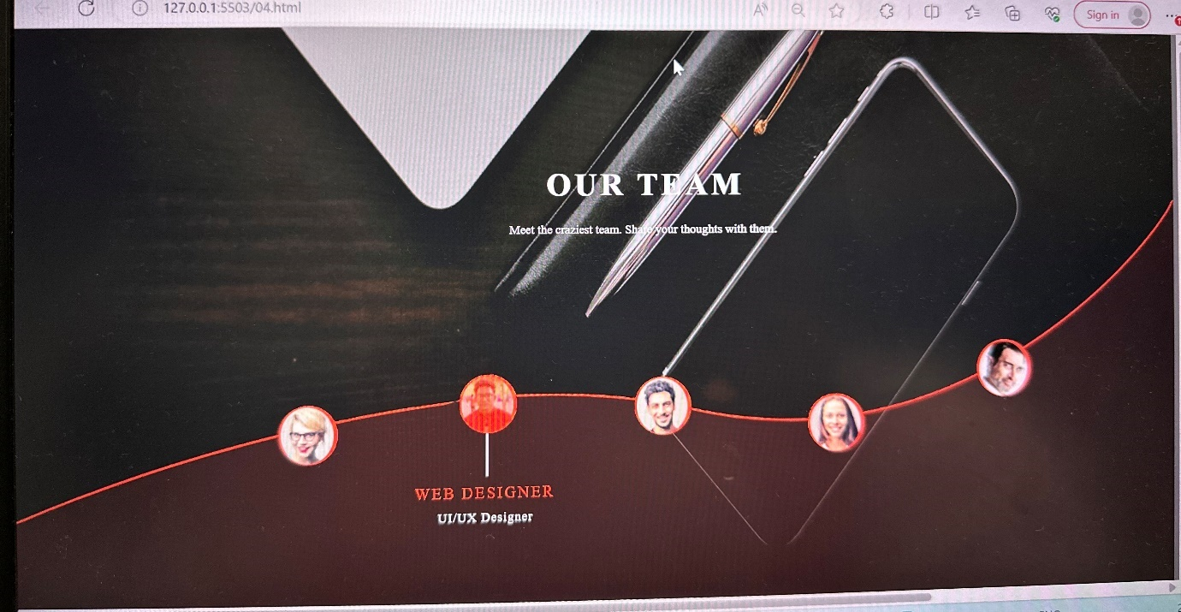

<!DOCTYPE html>

<html lang="en">

  <head>

    <meta charset="UTF-8" />

    <meta name="viewport" content="width=device-width, initial-scale=1.0" />

    <title>Document</title>

    <style>

      .main {

        background-color: rgb(229, 233, 236);

        height: 650px;

        display: flex;

        flex-direction: column;

        align-items: center;

        justify-content: center;

        justify-content: space-evenly;

        flex-wrap: wrap;

      }

      .box {

        height: 300px;

        width: 400px;

        background-color: rgb(255, 255, 255);

        border: 1px solid black;

      }

      .head{

        height: 170px;

        background-color: rgb(114, 114, 122);

        color: white;

        font-size: large;

        display: flex;

        align-items: center;

        justify-content: center;

      }

      .footer{

        height: 130px;

        margin: 0px 20px 0px 20px;

      }

    </style>

  </head>

  <body>

    <div class="main">

      <div class="box">

        <div class="head">Thumbnail</div>

        <div class="footer">

          <p>Lorem ipsum dolor sit amet consectetur, adipisicing elit. Sunt,

          molestias sint? Dicta, similique ipsam magni perspiciatis laboriosam

          ipsa beatae? Quis!</p>

          <button>View</button>

          <button>Edit</button>

        </div>

      </div>

      <div class="box">

        <div class="head">Thumbnail</div>

        <div class="footer">

          <p>Lorem ipsum dolor sit amet consectetur, adipisicing elit. Sunt,

          molestias sint? Dicta, similique ipsam magni perspiciatis laboriosam

          ipsa beatae? Quis!</p>

          <button>View</button>

          <button>Edit</button>

        </div>

      </div>

      <div class="box">

        <div class="head">Thumbnail</div>

        <div class="footer">

          <p>Lorem ipsum dolor sit amet consectetur, adipisicing elit. Sunt,

          molestias sint? Dicta, similique ipsam magni perspiciatis laboriosam

          ipsa beatae? Quis!</p>

          <button>View</button>

          <button>Edit</button>

        </div>

      </div>

      <div class="box">

        <div class="head">Thumbnail</div>

        <div class="footer">

          <p>Lorem ipsum dolor sit amet consectetur, adipisicing elit. Sunt,

          molestias sint? Dicta, similique ipsam magni perspiciatis laboriosam

          ipsa beatae? Quis!</p>

          <button>View</button>

          <button>Edit</button>

        </div>

      </div>

      <div class="box">

        <div class="head">Thumbnail</div>

        <div class="footer">

          <p>Lorem ipsum dolor sit amet consectetur, adipisicing elit. Sunt,

          molestias sint? Dicta, similique ipsam magni perspiciatis laboriosam

          ipsa beatae? Quis!</p>

          <button>View</button>

          <button>Edit</button>

        </div>

      </div>

      <div class="box">

        <div class="head">Thumbnail</div>

        <div class="footer">

          <p>Lorem ipsum dolor sit amet consectetur, adipisicing elit. Sunt,

          molestias sint? Dicta, similique ipsam magni perspiciatis laboriosam

          ipsa beatae? Quis!</p>

          <button>View</button>

          <button>Edit</button>

        </div>

      </div>

    </div>

  </body>

</html>

