**MODULE: 10 List and Hooks**

**Q1- Explain Life cycle in Class Component and functional component with Hooks**

**Ans-** A React component undergoes three phases in its lifecycle:

1. Mounting

* The mounting phase is when a new component is created and inserted into the DOM or, in other words, when the life of a component begins. This can only happen once, and is often called “initial render.”

1. Updating

* The updating phase is when the component updates or re-renders. This reaction is triggered when the props are updated or when the state is updated. This phase can occur multiple times, which is kind of the point of React.

1. Unmounting.

* The last phase within a component's lifecycle is the unmounting phase, when the component is removed from the DOM.

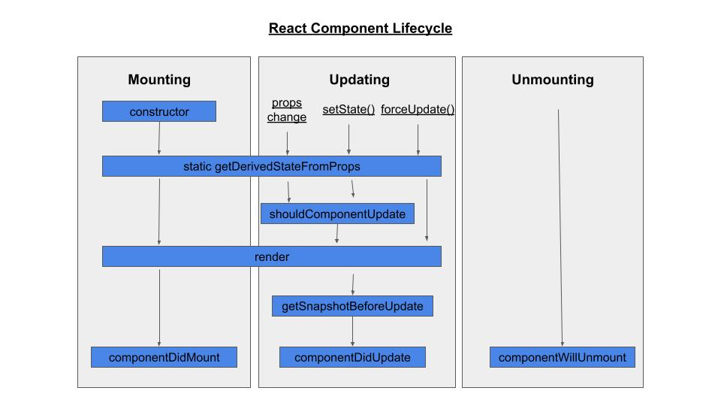

In a class-based component, we can call different methods for each phase of the lifecycle (more on this below). These lifecycle methods are of course not applicable to functional components because they can only be written/contained within a class. However, React hooks give functional components the ability to use states.

import React from 'react';

import  ReactDOM  from 'react-dom/client';

class Test extends React.Component {

    constructor(props){

        super(props);

        this.state = { hello: "World!" };

    }

    componentDidMount(){

        console.log("componentsDidMount()");

    }

    changeState(){

        this.setState({ hello: "React" });

    }

    render(){

        return (

            <div>

              <h1>

                Hello{this.state.hello}

              </h1>

              <h2>

                <a onClick={this.changeState.bind(this)} href='/'>Press Here!</a>

              </h2>

            </div>

          )

    }

    shouldComponentUpdate(nextProps,nextState){

        console.log("shouldComponentUpdate()");

        return true;

    }

    componentDidUpdate(){

        console.log("componentDidUpdate()");

    }

}

export default Test

const root = ReactDOM.createRoot(

    document.getElementById("root")

);

root.render(<Test/>)

**Example of class components and functional components with hooks**

Function Components:

Function components are some of the more common components that will come across while working in the React. These are simply JavaScript functions. We can create a function component to React by writing a JavaScript function.

Example of functional component

import React, { useState } from 'react';

const Functionalcomponent = () => {

  const [count, setCount] = useState(0);

  const increase =()=>{

    setCount(count +1);

  }

  return (

    <div style={{margin: '50px'}}>

      <h3>Counter App using Functional Component : </h3>

      <h2>{count}</h2>

      <button onClick={increase}>Add</button>

    </div>

  )

}

export default Functionalcomponent;

Class Component

This is the bread and butter of most modern web apps built in ReactJS. These components are simple classes (made up of multiple functions that add functionality to the application).

Example of Class component

import React from 'react';

class ClassComponent extends React.Component {

    constructor() {

        super();

        this.state = {

            count: 0

        };

        this.increase = this.increase.bind(this);

    }

    increase() {

        this.setState({ count: this.state.count + 1 });

    }

    render() {

        return (

            <div style={{ margin: '50px' }}>

                <h3>Counter App using Class Component:</h3>

                <h2>{this.state.count}</h2>

                <button onClick={this.increase}>Add</button>

            </div>

        )

    }

}

export default ClassComponent;