
Maven Market Sales & Returns Report
A Power BI Desktop Project
Course: Microsoft Power BI Desktop for Business Intelligence | Maven Analytics

Table of Contents
1. Executive Summary 1
2. Data Sources & Power Query 1
3. Data Model 1
4. DAX Measures & Calculations 1
5. Report Page — Topline Performance 1
6. Business Insights & Recommendations 1

1. Executive Summary
Maven Market leadership needed a fast, reliable way to see which product brands were driving volume without quietly eating into profit margin or driving returns — and how sales were trending by month and by region — without waiting on a manual spreadsheet pull. This project answers that need: a governed Power BI data model and an interactive "Topline Performance" dashboard built directly on top of Maven Market's raw customer, product, store, regional, calendar, transaction, and returns data.
The finished project (MavenMarket_Report.pbix) contains 7 connected data tables — including a Transaction_Data table that combines the 1997 and 1998 transaction files — plus a dedicated Measure Table holding 21 DAX measures. The data model follows a star schema for transactions and returns, with a snowflake extension from Stores to Regions. The report page, "Topline Performance," pulls it together with edited visual interactions, a Top-N filtered brand matrix, KPI trend cards, a map and treemap of regional sales, a weekly revenue trend, and a revenue-vs-target gauge.
$1,199,308  Total Revenue |  | 59.68%  Profit Margin |  | 566,716  Units Sold |  | 1.00%  Return Rate
These figures are pulled directly from the Topline Performance dashboard's KPI totals — the same numbers the matrix, KPI cards, and gauge all resolve to.

2. Data Sources & Power Query
The source data arrived as seven raw CSV exports (plus a folder of two yearly transaction files). Every table was connected and cleaned in Power Query before being loaded into the model. Autodetect relationships was turned off and the import locale was set to English (United States) before any files were connected, so every relationship below was built manually and every date/number field parsed consistently.
Table | Power Query transformations applied
Customers | Imported from CSV, headers promoted, and data types corrected (customer_id as whole number; customer_acct_num and customer_postal_code as text). Added full_name (first + last name), birth_year (year extracted from birthdate, formatted as text), and a conditional has_children column ("Y"/"N" based on total_children).
Products | Imported from CSV and typed (product_id whole number; product_sku text; retail price and cost as decimal). Added discount_price (90% of retail price, rounded to 2 decimals) and replaced null values in the recyclable and low_fat columns with 0. Statistics tools were used to confirm distinct brand and product-name counts.
Stores | Imported from CSV and typed (store_id and region_id as whole numbers). Added full_address (city, state, country merged with a custom separator) and area_code (characters before the dash in store_phone).
Regions | Imported from CSV, headers promoted, region_id typed as a whole number.
Calendar | Imported from CSV and extended with Start of Week (Sunday), Name of Day, Start of Month, Name of Month, Quarter of Year, and Year using the built-in date tools.
Return_Data | Imported from CSV, headers promoted, all ID and quantity columns typed as whole numbers.
Transaction_Data | Connected to a folder containing the 1997 and 1998 transaction CSVs; files combined via the Content column, Source.Name column removed. All ID and quantity columns typed as whole numbers, spanning 1/1/1997 through 12/30/1998.
"Include in Report Refresh" was disabled for all five lookup tables (Customers, Products, Stores, Regions, Calendar), leaving only Transaction_Data and Return_Data refreshing on load — the two tables that actually change over time.

3. Data Model
The 7 tables were arranged in the Model view with lookup tables above the two data tables, connected as a star schema for Transaction_Data and Return_Data, with a snowflake extension from Stores to Regions:
From | To | Cardinality
Transaction_Data[customer_id] | Customers[customer_id] | Many-to-one
Transaction_Data[product_id] | Products[product_id] | Many-to-one
Transaction_Data[store_id] | Stores[store_id] | Many-to-one
Transaction_Data[transaction_date] | Calendar[date] | Many-to-one (active)
Transaction_Data[stock_date] | Calendar[date] | Many-to-one (inactive)
Return_Data[product_id] | Products[product_id] | Many-to-one
Return_Data[store_id] | Stores[store_id] | Many-to-one
Return_Data[return_date] | Calendar[date] | Many-to-one
Stores[region_id] | Regions[region_id] | Many-to-one (snowflake)
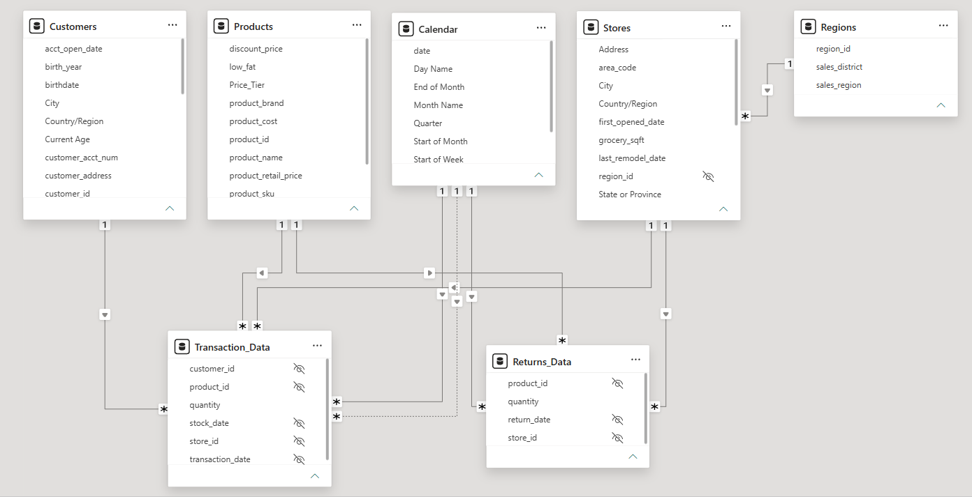
Data model (Model view)
All relationships use one-to-many cardinality with the primary key on the lookup side and filters set to flow one-way, downstream from lookup tables into Transaction_Data and Return_Data — neither data table filters the other directly, and only one date relationship per data table is active at a time. Foreign keys were hidden from Report View in both data tables, along with region_id in Stores. Date fields across all tables were formatted as M/d/yyyy; product_retail_price, product_cost, and discount_price were set to Currency ($ English); and geography categories (City, Postal Code, Country/Region, State or Province, Address) were applied to the relevant Customers and Stores columns.

4. DAX Measures & Calculations
21 measures were written into a dedicated Measure Table, alongside 8 new calculated columns added directly to the lookup tables (Weekend and End of Month in Calendar; Current Age, Priority, Short_Country, and House Number in Customers; Price_Tier in Products; and Years_Since_Remodel in Stores). The measures fall into three functional groups:
Core aggregations
Quantity Sold = SUM ( Transaction_Data[quantity] )
Total Transactions = COUNTROWS ( Transaction_Data )
Total Revenue = SUMX ( Transaction_Data, Transaction_Data[quantity] * RELATED ( Products[product_retail_price] ) )
Total Cost = SUMX ( Transaction_Data, Transaction_Data[quantity] * RELATED ( Products[product_cost] ) )
Total Profit = [Total Revenue] - [Total Cost]
Profit Margin = DIVIDE ( [Total Profit], [Total Revenue] )
Return Rate = DIVIDE ( [Quantity Returned], [Quantity Sold] )
Quantity Returned, Total Returns, and Unique Products (a DISTINCTCOUNT over Products[product_name]) follow the same pattern, and All Transactions / All Returns wrap the row-count measures in CALCULATE ( ..., ALL ( Transaction_Data ) ) to hold a grand total regardless of filter context — used to spot-check the brand matrix in Section 5.
Weekend & percent-of-total analysis
Weekend Transactions = CALCULATE ( [Total Transactions], Calendar[Weekend] = "Y" )
% Weekend Transactions = DIVIDE ( [Weekend Transactions], [Total Transactions] )
Time intelligence
YTD Revenue = TOTALYTD ( [Total Revenue], Calendar[date] )
60-Day Revenue = CALCULATE ( [Total Revenue], DATESINPERIOD ( Calendar[date], MAX ( Calendar[date] ), -60, DAY ) )
Last Month Revenue = CALCULATE ( [Total Revenue], DATEADD ( Calendar[date], -1, MONTH ) )
Revenue Target = [Last Month Revenue] * 1.05
Last Month Transactions, Last Month Profit, and Last Month Returns reuse the same DATEADD pattern against their respective base measures, and drive the KPI trend cards and gauge described in Section 5.

5. Report Page — Topline Performance
The "Topline Performance" page is the centerpiece of the report. The Maven Market logo anchors the top of the page, and every visual below is confirmed in the underlying report definition:
- Matrix — product_brand on rows with Total Transactions, Total Profit, Profit Margin, and Return Rate as values. Total Transactions carries data bars, Profit Margin a white-to-teal color scale, and Return Rate a white-to-red color scale. A visual-level Top N filter limits the matrix to the top 30 brands, sorted descending by Total Transactions.
Note: because the matrix is scoped to the top 30 brands, its Total row (113,668 transactions, $449,627 profit, 59.94% margin) is smaller than the full-dataset KPI totals in Section 1 ($1,199,308 revenue, 566,716 units) — the two numbers describe different slices of the same model, not a discrepancy.
- Three KPI cards — "Current Month Transactions" (vs. Last Month Transactions), "Current Month Profit" (vs. Last Month Profit), and "Current Month Returns" (vs. Last Month Returns, colored Low-is-Good), each trending by Start of Month.
- Map — store city sized by Total Transactions, paired with a store-country slicer (horizontal orientation, "Show Select All" enabled) for regional drill-down.
- Treemap — Total Transactions broken down by store country, with state and city grouped beneath it for drill-up/drill-down. Edit Interactions was used to set the Matrix to "No filter" against the Treemap, so brand-matrix selections don't cross-filter the regional breakdown.
- Column chart, "Weekly Revenue Trending" — Total Revenue by week, filtered at the report level to 1998 only.
- Gauge, "Revenue vs. Target" — Total Revenue against Revenue Target, filtered to the latest Start of Month via a visual-level Top N filter, with data labels removed.
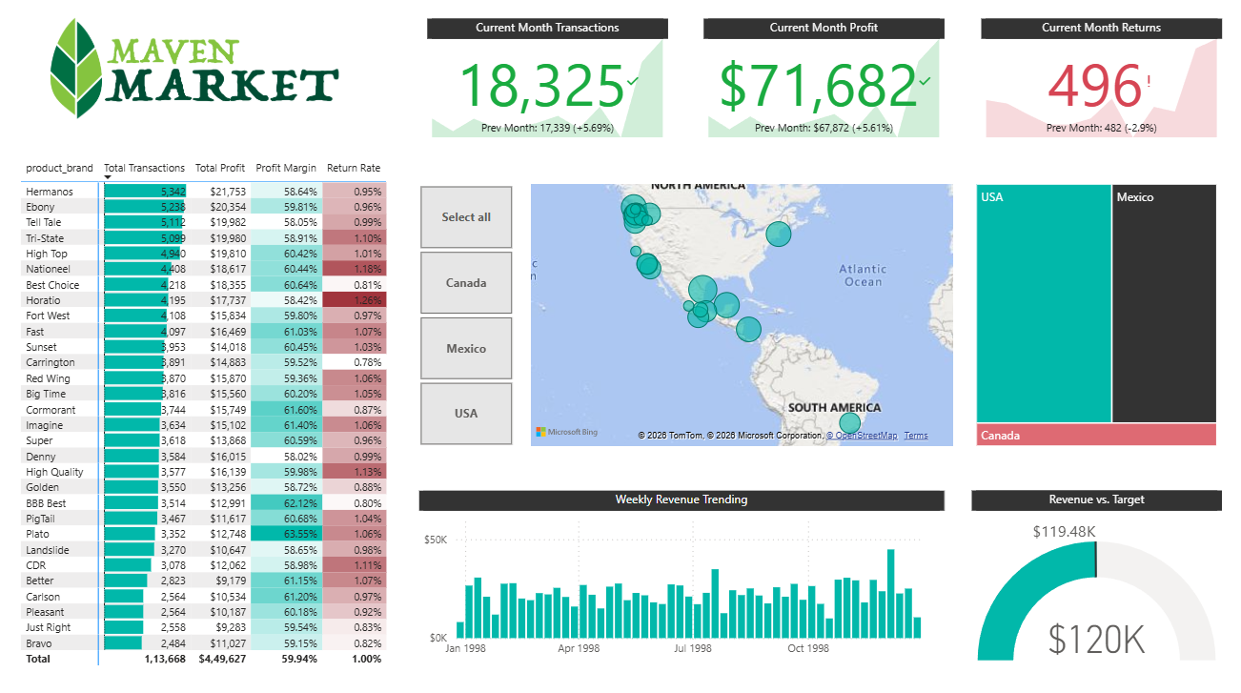
Topline Performance page

6. Business Insights & Recommendations
Beyond the technical build, the model and report are structured to answer specific, recurring business questions rather than just display numbers. Each insight below ties directly back to a measure or visual in the dashboard:
Brand-level profitability & quality
- The brand matrix pairs a Profit Margin color scale with a Return Rate color scale across the top 30 brands (by transaction volume), so a brand that is simultaneously dark red (high returns) and pale (thin margin) is visible at a glance. In the live data, Horatio is the clearest example — a 58.42% margin paired with a 1.26% return rate, the highest return rate in the top 30 — versus a brand like Cormorant, which combines a stronger 61.60% margin with only 0.87% returns. That side-by-side read is what flags a quality, pricing, or listing issue before it erodes margin further.
- Data bars on Total Transactions let volume and profitability be read together, so a high-volume, low-margin brand (a margin risk) is distinguishable at a glance from a high-volume, high-margin brand (a scale opportunity).
Month-over-month performance monitoring
- The three KPI cards compare the current month against Last Month on every visit to the page. As of the latest refresh: Current Month Transactions stood at 18,325 (+5.69% vs. 17,339 last month), Current Month Profit at $71,682 (+5.61% vs. $67,872), and Current Month Returns at 496 (−2.9% vs. 482) — transactions and profit both trending up together while returns trended down, a healthy combination the cards make immediately visible.
- The Revenue vs. Target gauge measures current revenue ($119.48K) against a rolling 5%-lift target (Revenue Target = Last Month Revenue × 1.05, $120K in the latest period) — 99.6% of target, close enough to read as on-pace rather than a shortfall requiring escalation.
- The Weekly Revenue Trending column chart sits beneath the gauge for a reason: when the gauge shows a shortfall, the chart immediately shows whether it's a one-week dip or a sustained decline, which changes the response.
Regional performance & resource allocation
- The Map and Treemap are both driven by Total Transactions but built for different jobs — the Map answers "where," the Treemap answers "how much, at what level." By country, the split is USA 93,986 transactions, Mexico 72,806, and Canada 16,091 (182,883 combined) — the USA leads, but Mexico is close behind at 40% of the total, not a distant third.
- Drilling into the USA on the Treemap shows Washington alone accounts for 46,071 transactions — essentially half (49%) of all USA volume sitting in a single state — a concrete case for weighting store-level marketing and logistics spend toward WA ahead of the rest of the country.
- The country slicer (with Select All) makes it fast to isolate a single region and see how its brand mix, profitability, and return behavior differ from the network average, rather than only ever looking at global totals.
Time intelligence & product breadth
- Weekend Transactions came in at 50,495 — 27.6% of all transactions — confirming Maven Market does roughly a quarter of its volume on Saturdays and Sundays, useful for weekend staffing and promotion timing without having to filter the model manually.
- YTD Revenue and 60-Day Revenue track two different questions side by side: for the week of 5/24/1998, YTD Revenue had reached $480,833 while the trailing 60-Day Revenue stood at $189,960 — YTD shows the full-year trajectory, while the 60-day window flags any recent slowdown that YTD's cumulative total would otherwise mask.
- Unique Products, a DISTINCTCOUNT over Products[product_name], resolves to 1,560 — giving category managers a stable denominator for "how many products are actually active" independent of any brand or region filter applied elsewhere on the page.
Analytical design choices
- Edit Interactions was used to stop the brand matrix from cross-filtering the Treemap, keeping regional context stable while brand selections are explored — a small choice, but one that avoids a common source of confusing, self-contradicting dashboards.
Taken together, the data model, DAX layer, and page design reflect a standard end-to-end BI workflow — raw multi-source data → a governed star/snowflake model → reusable measures → a decision-oriented dashboard — the same pattern used in production analytics environments.
Tools: Power BI Desktop, Power Query, DAX | Course: Maven Analytics

