Program Structures and Algorithms

Spring 2023(SEC 01)

NAME: Shivani Datar

NUID: 002772160

**Task:**

Your task is to implement a parallel sorting algorithm such that each partition of the array is sorted in parallel. You will consider two different schemes for deciding whether to sort in parallel.

1. A cutoff (defaults to, say, 1000) which you will update according to the first argument

in the command line when running. It's your job to experiment and come up with a

good value for this cutoff. If there are fewer elements to sort than the cutoff, then

you should use the system sort instead.

2. Recursion depth or the number of available threads. Using this determination, you

might decide on an ideal number (t) of separate threads (stick to powers of 2) and

arrange for that number of partitions to be parallelized (by preventing recursion after

the depth of lg t is reached).

3. An appropriate combination of these. There is a Main class and the ParSort class in the sort.par package of the INFO6205 repository. The Main class can be used as is but the ParSort class needs to be implemented where you see "TODO..." [it turns out that these TODOs are already implemented]. Unless you have a good reason not to, you should just go along with the Java8-style future implementations provided for you in the class repository. You must prepare a report that shows the results of your experiments and draws a conclusion (or more) about the efficacy of this method of parallelizing sort. Your experiments should involve sorting arrays of sufficient size for the parallel sort to make a difference. You should run with many different array sizes (they must be sufficiently large to make parallel sorting

worthwhile, obviously) and different cutoff schemes.

**Output Screenshots:-**

**Code Changes:-**

1. In Main.java :- added new property in class as threadCount which will take the number of threads to be used in the parallel sorting. Created a new object of ForkJoinPool as ‘newPool’ and passed the desired threadCount in its constructor. The array size is changed to 2000000, 3000000 and 4000000. Setting the ParSort.cutoff respectively 20000, 30000 and 40000 corresponding to the array size in order to get the cutoff ratio(cutoff/arraysize) until 1. Also changed the System.out.println statement from specifying cutoff and time to just printing time as a convenience form to transfer the time recording to excel sheet.

1. In ParSort.java :- Just adding the instance of ForkJoinPool in CompletableFuture method so it can take the number of threads decided.

Output Screenshots:- Following are few of the output screenshots:-

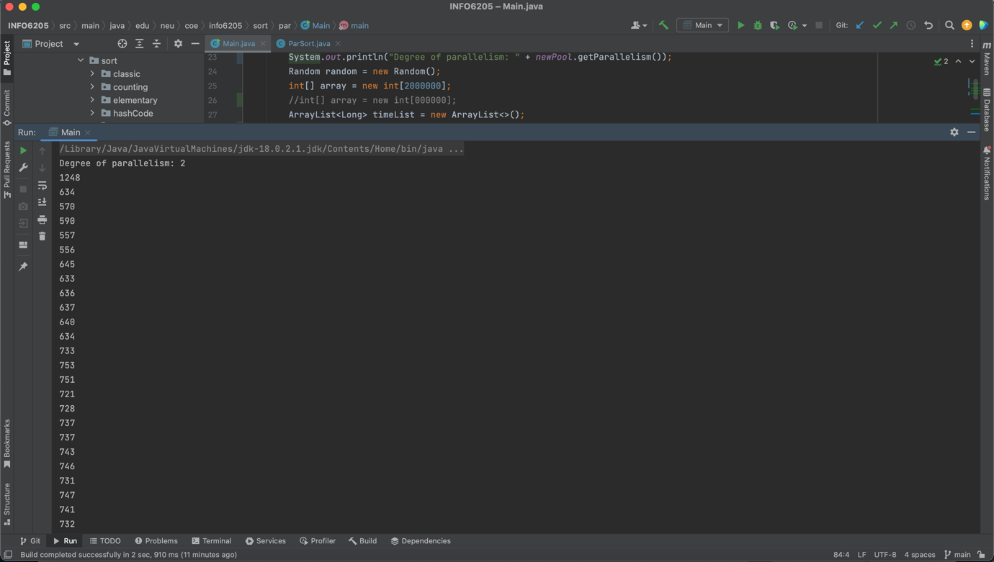

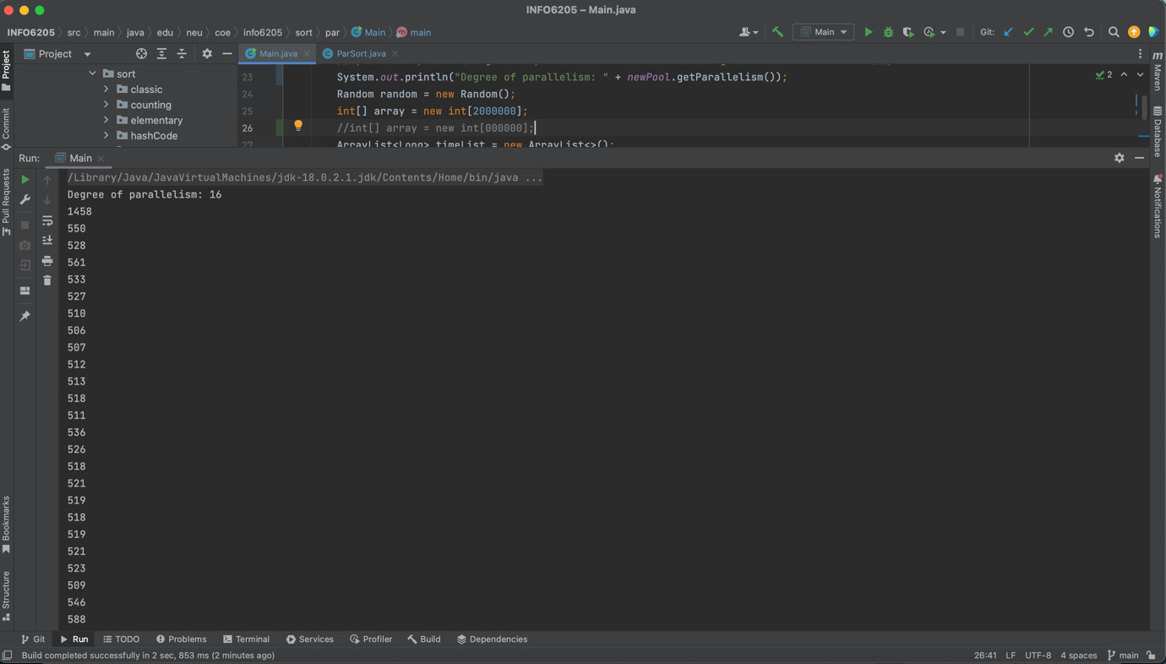

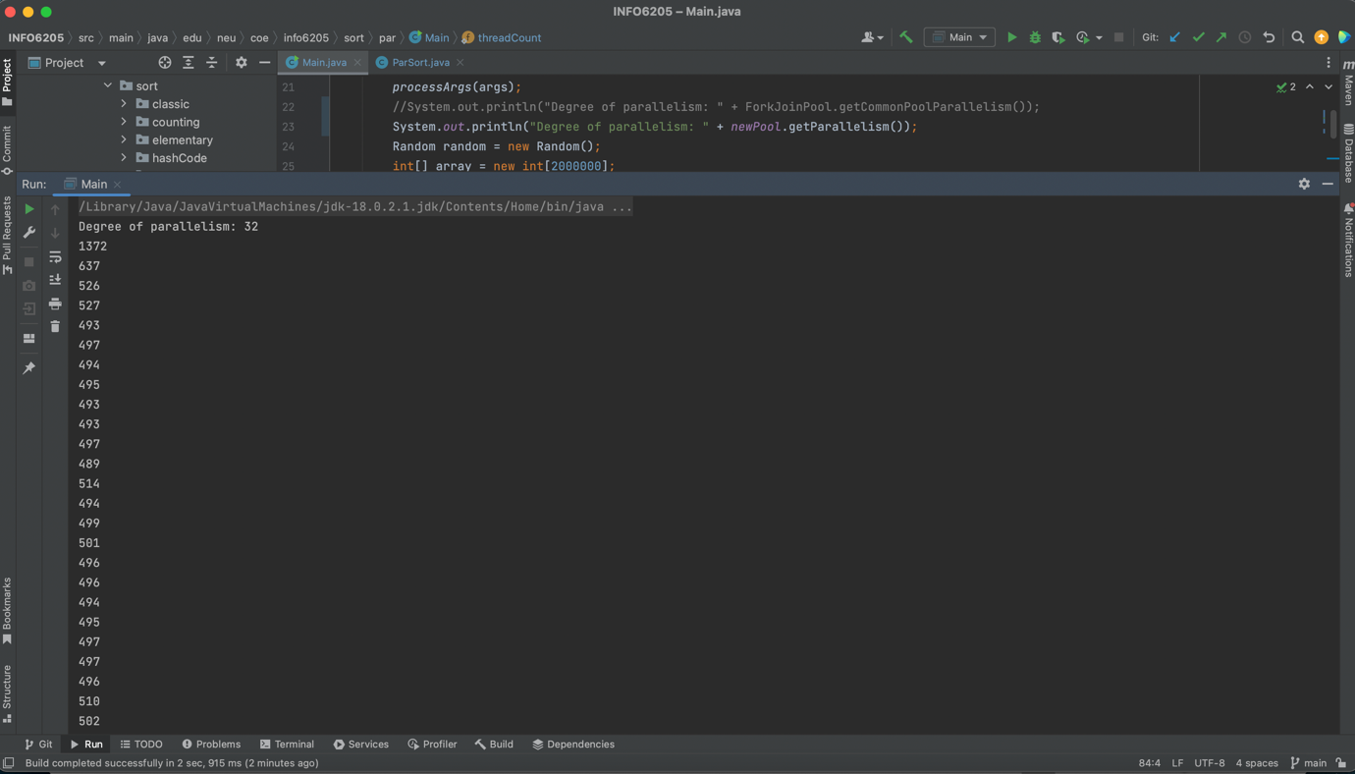

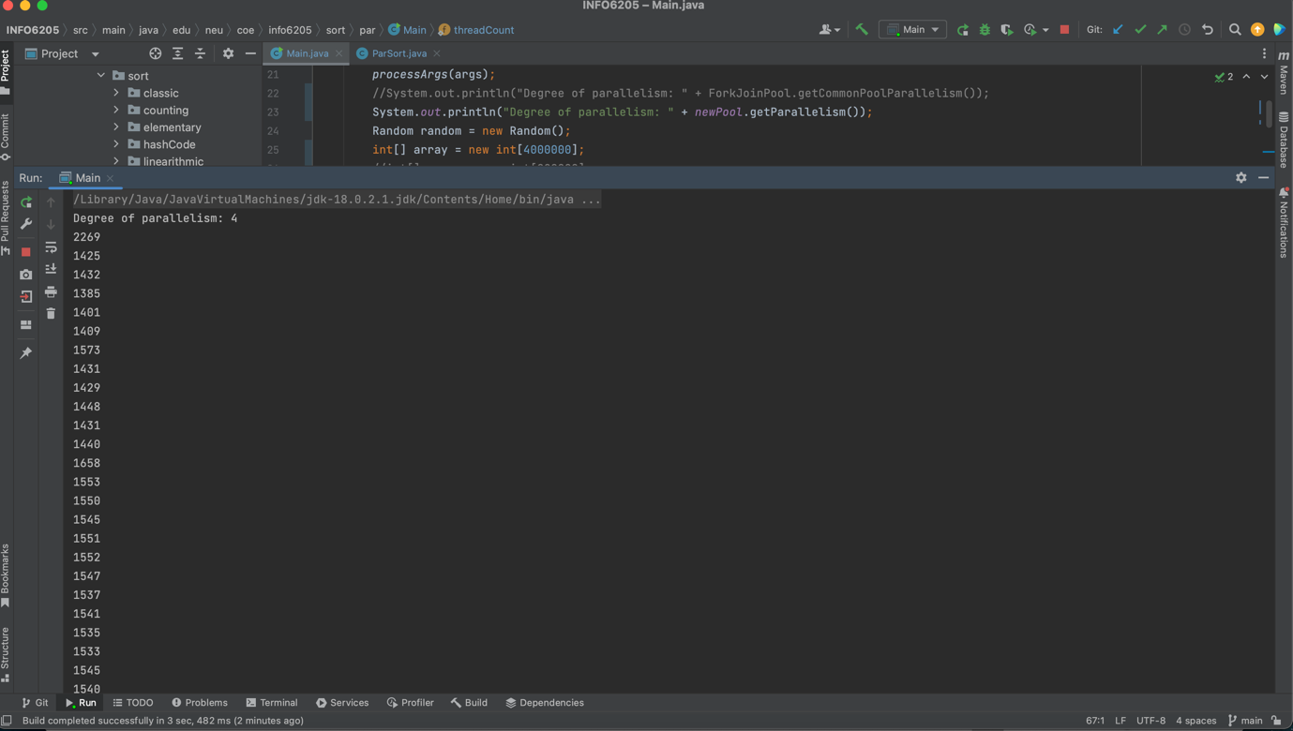

**Relationship Conclusion :-**

1. The performance of parallel sort is best when the cutoff ratio is between 0.2- 0.5 and thread count is between 2^3 and 2^5.
2. We can see that overall performance of parallel sorting(time) increases for thread 2^6 after 2^5.
3. Performance degrades and roughly remains same for the thread counts(8-32) when the cutoff ratio is above 0.5.
4. As the thread count increases the time required to sort decreases.

**Evidence to support that conclusion and Graphical Representation:**

For Array Size = 2000000, for threads 2 to 64. Time is recorded in ms.

|  |  |  |  |  |  |  |  |
| --- | --- | --- | --- | --- | --- | --- | --- |
| Cutoff | Cutoff ratio | 2 Thread | 4 Thread | 8 Thread | 16 Thread | 32 Thread | 64 Thread |
| 20000 | 0.01 | 1248 | 1384 | 1308 | 1458 | 1372 | 1249 |
| 40000 | 0.02 | 634 | 625 | 546 | 550 | 637 | 616 |
| 60000 | 0.03 | 570 | 674 | 526 | 528 | 526 | 648 |
| 80000 | 0.04 | 590 | 621 | 603 | 561 | 527 | 606 |
| 100000 | 0.05 | 557 | 552 | 646 | 533 | 493 | 585 |
| 120000 | 0.06 | 556 | 526 | 552 | 527 | 497 | 600 |
| 140000 | 0.07 | 645 | 581 | 520 | 510 | 494 | 599 |
| 160000 | 0.08 | 633 | 562 | 540 | 506 | 495 | 557 |
| 180000 | 0.09 | 636 | 562 | 498 | 507 | 493 | 552 |
| 200000 | 0.1 | 637 | 608 | 498 | 512 | 493 | 572 |
| 220000 | 0.11 | 640 | 641 | 504 | 513 | 497 | 525 |
| 240000 | 0.12 | 634 | 644 | 498 | 518 | 489 | 549 |
| 260000 | 0.13 | 733 | 673 | 521 | 511 | 514 | 528 |
| 280000 | 0.14 | 753 | 673 | 517 | 536 | 494 | 533 |
| 300000 | 0.15 | 751 | 671 | 503 | 526 | 499 | 523 |
| 320000 | 0.16 | 721 | 676 | 511 | 518 | 501 | 521 |
| 340000 | 0.17 | 728 | 674 | 516 | 521 | 496 | 524 |
| 360000 | 0.18 | 737 | 679 | 497 | 519 | 496 | 526 |
| 380000 | 0.19 | 737 | 682 | 503 | 518 | 494 | 550 |
| 400000 | 0.2 | 743 | 672 | 498 | 519 | 495 | 537 |
| 420000 | 0.21 | 746 | 673 | 503 | 521 | 497 | 525 |
| 440000 | 0.22 | 731 | 674 | 488 | 523 | 497 | 529 |
| 460000 | 0.23 | 747 | 702 | 510 | 509 | 496 | 534 |
| 480000 | 0.24 | 741 | 692 | 503 | 546 | 510 | 527 |
| 500000 | 0.25 | 732 | 681 | 505 | 588 | 502 | 536 |
| 520000 | 0.26 | 835 | 624 | 556 | 564 | 558 | 567 |
| 540000 | 0.27 | 853 | 648 | 552 | 568 | 558 | 608 |
| 560000 | 0.28 | 830 | 621 | 553 | 555 | 556 | 586 |
| 580000 | 0.29 | 829 | 613 | 557 | 560 | 555 | 554 |
| 600000 | 0.3 | 849 | 591 | 551 | 558 | 556 | 579 |
| 620000 | 0.31 | 832 | 614 | 555 | 564 | 556 | 616 |
| 640000 | 0.32 | 831 | 597 | 553 | 557 | 555 | 604 |
| 660000 | 0.33 | 842 | 598 | 553 | 555 | 557 | 560 |
| 680000 | 0.34 | 852 | 596 | 549 | 567 | 558 | 575 |
| 700000 | 0.35 | 836 | 595 | 553 | 557 | 560 | 574 |
| 720000 | 0.36 | 836 | 618 | 549 | 563 | 558 | 561 |
| 740000 | 0.37 | 837 | 593 | 550 | 558 | 558 | 561 |
| 760000 | 0.38 | 841 | 629 | 554 | 559 | 555 | 566 |
| 780000 | 0.39 | 849 | 642 | 550 | 554 | 559 | 578 |
| 800000 | 0.4 | 852 | 597 | 554 | 559 | 556 | 575 |
| 820000 | 0.41 | 840 | 599 | 549 | 558 | 560 | 579 |
| 840000 | 0.42 | 854 | 599 | 551 | 560 | 557 | 612 |
| 860000 | 0.43 | 824 | 590 | 551 | 558 | 557 | 606 |
| 880000 | 0.44 | 843 | 607 | 550 | 559 | 560 | 607 |
| 900000 | 0.45 | 833 | 595 | 554 | 553 | 557 | 609 |
| 920000 | 0.46 | 835 | 588 | 549 | 557 | 558 | 620 |
| 940000 | 0.47 | 835 | 595 | 553 | 556 | 557 | 633 |
| 960000 | 0.48 | 842 | 594 | 551 | 561 | 558 | 590 |
| 980000 | 0.49 | 833 | 593 | 553 | 557 | 557 | 607 |
| 1000000 | 0.5 | 835 | 590 | 551 | 556 | 557 | 578 |
| 1020000 | 0.51 | 802 | 821 | 784 | 802 | 785 | 811 |
| 1040000 | 0.52 | 798 | 808 | 788 | 798 | 787 | 820 |
| 1060000 | 0.53 | 800 | 820 | 787 | 795 | 782 | 816 |
| 1080000 | 0.54 | 795 | 812 | 787 | 796 | 788 | 817 |
| 1100000 | 0.55 | 797 | 830 | 785 | 798 | 787 | 816 |
| 1120000 | 0.56 | 791 | 809 | 789 | 793 | 788 | 821 |
| 1140000 | 0.57 | 790 | 810 | 788 | 788 | 787 | 818 |
| 1160000 | 0.58 | 790 | 824 | 789 | 794 | 790 | 821 |
| 1180000 | 0.59 | 793 | 816 | 793 | 797 | 786 | 821 |
| 1200000 | 0.6 | 793 | 819 | 783 | 790 | 787 | 820 |
| 1220000 | 0.61 | 794 | 818 | 786 | 789 | 789 | 836 |
| 1240000 | 0.62 | 791 | 807 | 790 | 788 | 789 | 851 |
| 1260000 | 0.63 | 791 | 823 | 786 | 785 | 785 | 833 |
| 1280000 | 0.64 | 793 | 809 | 791 | 795 | 789 | 842 |
| 1300000 | 0.65 | 808 | 810 | 786 | 792 | 789 | 831 |
| 1320000 | 0.66 | 792 | 809 | 783 | 790 | 792 | 834 |
| 1340000 | 0.67 | 791 | 813 | 786 | 796 | 789 | 829 |
| 1360000 | 0.68 | 794 | 824 | 784 | 793 | 787 | 833 |
| 1380000 | 0.69 | 791 | 810 | 789 | 790 | 788 | 833 |
| 1400000 | 0.7 | 798 | 818 | 791 | 789 | 786 | 827 |
| 1420000 | 0.71 | 792 | 816 | 785 | 788 | 787 | 832 |
| 1440000 | 0.72 | 794 | 814 | 785 | 792 | 788 | 836 |
| 1460000 | 0.73 | 790 | 810 | 783 | 787 | 788 | 836 |
| 1480000 | 0.74 | 795 | 826 | 786 | 790 | 789 | 825 |
| 1500000 | 0.75 | 795 | 799 | 786 | 788 | 788 | 829 |
| 1520000 | 0.76 | 787 | 810 | 786 | 793 | 784 | 857 |
| 1540000 | 0.77 | 793 | 825 | 788 | 789 | 789 | 846 |
| 1560000 | 0.78 | 792 | 810 | 782 | 792 | 785 | 842 |
| 1580000 | 0.79 | 792 | 820 | 784 | 791 | 787 | 848 |
| 1600000 | 0.8 | 795 | 821 | 785 | 788 | 788 | 842 |
| 1620000 | 0.81 | 789 | 816 | 788 | 791 | 789 | 841 |
| 1640000 | 0.82 | 791 | 811 | 788 | 791 | 788 | 836 |
| 1660000 | 0.83 | 789 | 801 | 789 | 789 | 791 | 833 |
| 1680000 | 0.84 | 794 | 821 | 865 | 789 | 787 | 837 |
| 1700000 | 0.85 | 792 | 812 | 793 | 793 | 789 | 844 |
| 1720000 | 0.86 | 792 | 815 | 786 | 792 | 789 | 826 |
| 1740000 | 0.87 | 791 | 813 | 784 | 788 | 782 | 840 |
| 1760000 | 0.88 | 791 | 827 | 789 | 789 | 790 | 826 |
| 1780000 | 0.89 | 797 | 799 | 786 | 791 | 787 | 845 |
| 1800000 | 0.9 | 789 | 808 | 784 | 793 | 788 | 836 |
| 1820000 | 0.91 | 790 | 819 | 786 | 793 | 785 | 842 |
| 1840000 | 0.92 | 789 | 813 | 785 | 793 | 786 | 834 |
| 1860000 | 0.93 | 786 | 820 | 785 | 795 | 788 | 848 |
| 1880000 | 0.94 | 793 | 816 | 788 | 793 | 785 | 841 |
| 1900000 | 0.95 | 791 | 817 | 784 | 794 | 787 | 842 |
| 1920000 | 0.96 | 787 | 816 | 782 | 793 | 784 | 857 |
| 1940000 | 0.97 | 788 | 825 | 782 | 794 | 788 | 879 |
| 1960000 | 0.98 | 789 | 824 | 784 | 797 | 783 | 848 |
| 1980000 | 0.99 | 792 | 816 | 785 | 794 | 784 | 833 |
| 2000000 | 1 | 789 | 820 | 782 | 796 | 788 | 857 |

Graph :-

For Array Size = 3000000, for threads 2 to 64. Time is recorded in ms.

|  |  |  |  |  |  |  |  |
| --- | --- | --- | --- | --- | --- | --- | --- |
| Cutoff | Cutoff ratio | 2 Thread | 4 Thread | 8 Thread | 16 Thread | 32 Thread | 64 Thread |
| 30000 | 0.01 | 1728 | 1678 | 1739 | 1583 | 1704 | 1610 |
| 60000 | 0.02 | 1092 | 921 | 878 | 859 | 877 | 918 |
| 90000 | 0.03 | 1035 | 817 | 832 | 796 | 785 | 1012 |
| 120000 | 0.04 | 1086 | 824 | 823 | 876 | 766 | 821 |
| 150000 | 0.05 | 949 | 780 | 791 | 857 | 743 | 804 |
| 180000 | 0.06 | 955 | 781 | 800 | 835 | 734 | 783 |
| 210000 | 0.07 | 1027 | 823 | 816 | 803 | 754 | 737 |
| 240000 | 0.08 | 1055 | 828 | 825 | 821 | 756 | 754 |
| 270000 | 0.09 | 1052 | 823 | 809 | 873 | 760 | 753 |
| 300000 | 0.1 | 1176 | 822 | 805 | 831 | 759 | 746 |
| 330000 | 0.11 | 1028 | 820 | 805 | 839 | 772 | 742 |
| 360000 | 0.12 | 1004 | 822 | 802 | 816 | 779 | 742 |
| 390000 | 0.13 | 1158 | 882 | 834 | 756 | 771 | 739 |
| 420000 | 0.14 | 1150 | 886 | 893 | 775 | 754 | 747 |
| 450000 | 0.15 | 1178 | 884 | 942 | 758 | 757 | 738 |
| 480000 | 0.16 | 1171 | 885 | 956 | 750 | 757 | 734 |
| 510000 | 0.17 | 1142 | 903 | 958 | 734 | 763 | 737 |
| 540000 | 0.18 | 1181 | 886 | 946 | 778 | 760 | 725 |
| 570000 | 0.19 | 1161 | 898 | 961 | 775 | 773 | 730 |
| 600000 | 0.2 | 1147 | 914 | 869 | 768 | 771 | 723 |
| 630000 | 0.21 | 1145 | 897 | 863 | 864 | 754 | 741 |
| 660000 | 0.22 | 1157 | 890 | 908 | 917 | 761 | 732 |
| 690000 | 0.23 | 1156 | 923 | 832 | 852 | 751 | 733 |
| 720000 | 0.24 | 1158 | 892 | 786 | 808 | 764 | 739 |
| 750000 | 0.25 | 1143 | 921 | 856 | 791 | 772 | 729 |
| 780000 | 0.26 | 1278 | 850 | 914 | 907 | 871 | 841 |
| 810000 | 0.27 | 1302 | 900 | 934 | 863 | 867 | 845 |
| 840000 | 0.28 | 1379 | 844 | 928 | 923 | 871 | 850 |
| 870000 | 0.29 | 1292 | 837 | 944 | 928 | 868 | 845 |
| 900000 | 0.3 | 1300 | 843 | 946 | 945 | 867 | 850 |
| 930000 | 0.31 | 1315 | 848 | 976 | 970 | 867 | 847 |
| 960000 | 0.32 | 1312 | 886 | 995 | 981 | 869 | 846 |
| 990000 | 0.33 | 1374 | 840 | 939 | 972 | 863 | 846 |
| 1020000 | 0.34 | 1345 | 844 | 884 | 983 | 853 | 851 |
| 1050000 | 0.35 | 1390 | 854 | 892 | 880 | 854 | 845 |
| 1080000 | 0.36 | 1453 | 845 | 874 | 913 | 853 | 847 |
| 1110000 | 0.37 | 1431 | 843 | 900 | 919 | 853 | 849 |
| 1140000 | 0.38 | 1418 | 843 | 951 | 916 | 855 | 845 |
| 1170000 | 0.39 | 1470 | 845 | 954 | 923 | 850 | 849 |
| 1200000 | 0.4 | 1412 | 843 | 956 | 939 | 857 | 847 |
| 1230000 | 0.41 | 1455 | 843 | 953 | 967 | 848 | 844 |
| 1260000 | 0.42 | 1537 | 865 | 952 | 1005 | 851 | 846 |
| 1290000 | 0.43 | 1396 | 839 | 974 | 876 | 851 | 850 |
| 1320000 | 0.44 | 1412 | 841 | 1002 | 916 | 856 | 844 |
| 1350000 | 0.45 | 1402 | 840 | 939 | 908 | 844 | 851 |
| 1380000 | 0.46 | 1489 | 839 | 933 | 875 | 855 | 849 |
| 1410000 | 0.47 | 1495 | 843 | 987 | 925 | 852 | 846 |
| 1440000 | 0.48 | 1509 | 842 | 1042 | 922 | 855 | 849 |
| 1470000 | 0.49 | 1544 | 842 | 1033 | 927 | 859 | 846 |
| 1500000 | 0.5 | 1575 | 837 | 1055 | 924 | 859 | 845 |
| 1530000 | 0.51 | 1296 | 1204 | 1313 | 1258 | 1216 | 1228 |
| 1560000 | 0.52 | 1286 | 1195 | 1279 | 1268 | 1211 | 1220 |
| 1590000 | 0.53 | 1327 | 1202 | 1284 | 1277 | 1214 | 1218 |
| 1620000 | 0.54 | 1307 | 1198 | 1296 | 1276 | 1208 | 1226 |
| 1650000 | 0.55 | 1292 | 1191 | 1366 | 1277 | 1210 | 1216 |
| 1680000 | 0.56 | 1309 | 1195 | 1291 | 1287 | 1208 | 1217 |
| 1710000 | 0.57 | 1309 | 1204 | 1301 | 1285 | 1211 | 1220 |
| 1740000 | 0.58 | 1283 | 1194 | 1293 | 1268 | 1214 | 1223 |
| 1770000 | 0.59 | 1294 | 1198 | 1292 | 1261 | 1210 | 1218 |
| 1800000 | 0.6 | 1335 | 1204 | 1298 | 1259 | 1208 | 1212 |
| 1830000 | 0.61 | 1328 | 1198 | 1295 | 1259 | 1207 | 1224 |
| 1860000 | 0.62 | 1304 | 1202 | 1291 | 1271 | 1210 | 1217 |
| 1890000 | 0.63 | 1319 | 1198 | 1304 | 1280 | 1214 | 1222 |
| 1920000 | 0.64 | 1305 | 1203 | 1291 | 1275 | 1206 | 1218 |
| 1950000 | 0.65 | 1307 | 1198 | 1300 | 1260 | 1207 | 1217 |
| 1980000 | 0.66 | 1305 | 1201 | 1303 | 1274 | 1217 | 1216 |
| 2010000 | 0.67 | 1328 | 1203 | 1336 | 1268 | 1219 | 1221 |
| 2040000 | 0.68 | 1300 | 1201 | 1294 | 1289 | 1208 | 1223 |
| 2070000 | 0.69 | 1340 | 1199 | 1313 | 1276 | 1213 | 1219 |
| 2100000 | 0.7 | 1304 | 1203 | 1308 | 1283 | 1204 | 1216 |
| 2130000 | 0.71 | 1291 | 1199 | 1300 | 1282 | 1205 | 1219 |
| 2160000 | 0.72 | 1313 | 1202 | 1322 | 1278 | 1223 | 1216 |
| 2190000 | 0.73 | 1302 | 1204 | 1335 | 1309 | 1220 | 1214 |
| 2220000 | 0.74 | 1316 | 1209 | 1282 | 1253 | 1212 | 1222 |
| 2250000 | 0.75 | 1328 | 1200 | 1294 | 1273 | 1206 | 1215 |
| 2280000 | 0.76 | 1349 | 1204 | 1314 | 1280 | 1211 | 1216 |
| 2310000 | 0.77 | 1319 | 1198 | 1299 | 1267 | 1222 | 1221 |
| 2340000 | 0.78 | 1323 | 1200 | 1307 | 1277 | 1207 | 1215 |
| 2370000 | 0.79 | 1314 | 1202 | 1309 | 1268 | 1209 | 1212 |
| 2400000 | 0.8 | 1355 | 1202 | 1316 | 1247 | 1204 | 1218 |
| 2430000 | 0.81 | 1319 | 1208 | 1342 | 1280 | 1213 | 1220 |
| 2460000 | 0.82 | 1317 | 1202 | 1331 | 1273 | 1203 | 1219 |
| 2490000 | 0.83 | 1360 | 1204 | 1319 | 1307 | 1211 | 1212 |
| 2520000 | 0.84 | 1307 | 1201 | 1347 | 1296 | 1210 | 1220 |
| 2550000 | 0.85 | 1281 | 1205 | 1344 | 1288 | 1208 | 1215 |
| 2580000 | 0.86 | 1279 | 1202 | 1321 | 1283 | 1211 | 1227 |
| 2610000 | 0.87 | 1279 | 1207 | 1347 | 1291 | 1212 | 1221 |
| 2640000 | 0.88 | 1280 | 1204 | 1334 | 1286 | 1203 | 1220 |
| 2670000 | 0.89 | 1278 | 1200 | 1360 | 1287 | 1200 | 1217 |
| 2700000 | 0.9 | 1285 | 1202 | 1280 | 1342 | 1204 | 1212 |
| 2730000 | 0.91 | 1283 | 1199 | 1284 | 1266 | 1204 | 1221 |
| 2760000 | 0.92 | 1284 | 1198 | 1289 | 1251 | 1202 | 1224 |
| 2790000 | 0.93 | 1283 | 1205 | 1284 | 1250 | 1209 | 1217 |
| 2820000 | 0.94 | 1286 | 1200 | 1300 | 1326 | 1206 | 1219 |
| 2850000 | 0.95 | 1284 | 1202 | 1288 | 1263 | 1207 | 1216 |
| 2880000 | 0.96 | 1291 | 1195 | 1304 | 1257 | 1202 | 1217 |
| 2910000 | 0.97 | 1296 | 1192 | 1299 | 1263 | 1208 | 1219 |
| 2940000 | 0.98 | 1304 | 1197 | 1296 | 1260 | 1203 | 1213 |
| 2970000 | 0.99 | 1312 | 1198 | 1303 | 1255 | 1206 | 1214 |
| 3000000 | 1 | 1333 | 1196 | 1304 | 1258 | 1213 | 1218 |

Graph:-

For Array Size = 4000000, for threads 2 to 64. Time is recorded in ms.

|  |  |  |  |  |  |  |  |
| --- | --- | --- | --- | --- | --- | --- | --- |
| Cutoff | Cutoff ratio | 2 Thread | 4 Thread | 8 Thread | 16 Thread | 32 Thread | 64 Thread |
| 40000 | 0.01 | 2558 | 2269 | 1923 | 1919 | 1862 | 1894 |
| 80000 | 0.02 | 1550 | 1425 | 1208 | 1096 | 1074 | 1113 |
| 120000 | 0.03 | 1612 | 1432 | 1135 | 1101 | 1067 | 1102 |
| 160000 | 0.04 | 1637 | 1385 | 1088 | 1069 | 1077 | 1113 |
| 200000 | 0.05 | 1586 | 1401 | 1042 | 1041 | 1062 | 1023 |
| 240000 | 0.06 | 1524 | 1409 | 1110 | 1021 | 1060 | 1037 |
| 280000 | 0.07 | 1739 | 1573 | 1061 | 1012 | 1102 | 1019 |
| 320000 | 0.08 | 1765 | 1431 | 1065 | 1032 | 1019 | 1025 |
| 360000 | 0.09 | 1768 | 1429 | 1073 | 1022 | 987 | 1017 |
| 400000 | 0.1 | 1749 | 1448 | 1064 | 1040 | 986 | 1003 |
| 440000 | 0.11 | 1744 | 1431 | 1077 | 1047 | 1007 | 1015 |
| 480000 | 0.12 | 1777 | 1440 | 1067 | 1000 | 1069 | 1020 |
| 520000 | 0.13 | 2086 | 1658 | 1134 | 989 | 969 | 989 |
| 560000 | 0.14 | 2213 | 1553 | 1199 | 997 | 963 | 986 |
| 600000 | 0.15 | 2266 | 1550 | 1269 | 1007 | 970 | 1009 |
| 640000 | 0.16 | 2202 | 1545 | 1259 | 987 | 958 | 1017 |
| 680000 | 0.17 | 2325 | 1551 | 1184 | 985 | 978 | 990 |
| 720000 | 0.18 | 2313 | 1552 | 1141 | 968 | 1019 | 976 |
| 760000 | 0.19 | 2117 | 1547 | 1138 | 968 | 965 | 996 |
| 800000 | 0.2 | 1968 | 1537 | 1096 | 973 | 975 | 983 |
| 840000 | 0.21 | 1925 | 1541 | 1085 | 965 | 963 | 1003 |
| 880000 | 0.22 | 2001 | 1535 | 1017 | 975 | 966 | 977 |
| 920000 | 0.23 | 1960 | 1533 | 969 | 975 | 959 | 978 |
| 960000 | 0.24 | 1973 | 1545 | 953 | 958 | 971 | 974 |
| 1000000 | 0.25 | 2039 | 1540 | 972 | 967 | 973 | 1001 |
| 1040000 | 0.26 | 2235 | 1470 | 1155 | 1139 | 1142 | 1153 |
| 1080000 | 0.27 | 2287 | 1464 | 1160 | 1144 | 1145 | 1152 |
| 1120000 | 0.28 | 2199 | 1459 | 1144 | 1134 | 1141 | 1147 |
| 1160000 | 0.29 | 2254 | 1454 | 1151 | 1143 | 1150 | 1149 |
| 1200000 | 0.3 | 2203 | 1463 | 1143 | 1138 | 1142 | 1150 |
| 1240000 | 0.31 | 2248 | 1458 | 1147 | 1141 | 1151 | 1153 |
| 1280000 | 0.32 | 2249 | 1468 | 1147 | 1151 | 1142 | 1149 |
| 1320000 | 0.33 | 2229 | 1484 | 1150 | 1138 | 1145 | 1153 |
| 1360000 | 0.34 | 2252 | 1463 | 1148 | 1148 | 1143 | 1151 |
| 1400000 | 0.35 | 2193 | 1468 | 1148 | 1146 | 1147 | 1151 |
| 1440000 | 0.36 | 2246 | 1468 | 1150 | 1136 | 1147 | 1148 |
| 1480000 | 0.37 | 2240 | 1467 | 1151 | 1146 | 1146 | 1146 |
| 1520000 | 0.38 | 2255 | 1460 | 1150 | 1159 | 1147 | 1150 |
| 1560000 | 0.39 | 2269 | 1473 | 1152 | 1149 | 1143 | 1145 |
| 1600000 | 0.4 | 2259 | 1471 | 1147 | 1143 | 1143 | 1148 |
| 1640000 | 0.41 | 2278 | 1477 | 1157 | 1138 | 1144 | 1150 |
| 1680000 | 0.42 | 2448 | 1478 | 1151 | 1151 | 1148 | 1148 |
| 1720000 | 0.43 | 2380 | 1468 | 1217 | 1145 | 1146 | 1147 |
| 1760000 | 0.44 | 2366 | 1468 | 1243 | 1140 | 1154 | 1151 |
| 1800000 | 0.45 | 2353 | 1479 | 1251 | 1141 | 1143 | 1150 |
| 1840000 | 0.46 | 2375 | 1465 | 1251 | 1139 | 1150 | 1147 |
| 1880000 | 0.47 | 2407 | 1461 | 1252 | 1152 | 1139 | 1153 |
| 1920000 | 0.48 | 2264 | 1462 | 1257 | 1147 | 1151 | 1152 |
| 1960000 | 0.49 | 2390 | 1459 | 1267 | 1145 | 1144 | 1150 |
| 2000000 | 0.5 | 2411 | 1470 | 1164 | 1171 | 1148 | 1151 |
| 2040000 | 0.51 | 2265 | 2146 | 1697 | 1650 | 1649 | 1662 |
| 2080000 | 0.52 | 2524 | 2151 | 1707 | 1655 | 1646 | 1653 |
| 2120000 | 0.53 | 2266 | 2152 | 1681 | 1645 | 1651 | 1668 |
| 2160000 | 0.54 | 2244 | 2148 | 1696 | 1647 | 1652 | 1659 |
| 2200000 | 0.55 | 2301 | 2142 | 1758 | 1645 | 1652 | 1657 |
| 2240000 | 0.56 | 2306 | 2144 | 1759 | 1637 | 1648 | 1656 |
| 2280000 | 0.57 | 2267 | 2147 | 1778 | 1638 | 1655 | 1651 |
| 2320000 | 0.58 | 2192 | 2142 | 1756 | 1647 | 1659 | 1659 |
| 2360000 | 0.59 | 2203 | 2148 | 1720 | 1647 | 1646 | 1663 |
| 2400000 | 0.6 | 2203 | 2150 | 1748 | 1648 | 1653 | 1668 |
| 2440000 | 0.61 | 2207 | 2152 | 1709 | 1651 | 1654 | 1666 |
| 2480000 | 0.62 | 2213 | 2144 | 1708 | 1640 | 1650 | 1652 |
| 2520000 | 0.63 | 2194 | 2138 | 1715 | 1643 | 1644 | 1661 |
| 2560000 | 0.64 | 2202 | 2146 | 1710 | 1655 | 1646 | 1661 |
| 2600000 | 0.65 | 2199 | 2159 | 1704 | 1646 | 1647 | 1664 |
| 2640000 | 0.66 | 2232 | 2158 | 1709 | 1640 | 1655 | 1657 |
| 2680000 | 0.67 | 2264 | 2157 | 1712 | 1640 | 1656 | 1664 |
| 2720000 | 0.68 | 2243 | 2156 | 1715 | 1651 | 1645 | 1663 |
| 2760000 | 0.69 | 2231 | 2160 | 1732 | 1663 | 1649 | 1659 |
| 2800000 | 0.7 | 2246 | 2149 | 1723 | 1644 | 1649 | 1660 |
| 2840000 | 0.71 | 2284 | 2155 | 1741 | 1651 | 1648 | 1651 |
| 2880000 | 0.72 | 2279 | 2157 | 1739 | 1645 | 1650 | 1656 |
| 2920000 | 0.73 | 2235 | 2141 | 1712 | 1636 | 1652 | 1658 |
| 2960000 | 0.74 | 2231 | 2137 | 1658 | 1638 | 1645 | 1656 |
| 3000000 | 0.75 | 2216 | 2160 | 1655 | 1654 | 1647 | 1655 |
| 3040000 | 0.76 | 2304 | 2150 | 1657 | 1654 | 1648 | 1660 |
| 3080000 | 0.77 | 2307 | 2158 | 1672 | 1641 | 1649 | 1654 |
| 3120000 | 0.78 | 2305 | 2144 | 1706 | 1645 | 1649 | 1654 |
| 3160000 | 0.79 | 2274 | 2145 | 1759 | 1657 | 1646 | 1660 |
| 3200000 | 0.8 | 2327 | 2144 | 1804 | 1672 | 1647 | 1658 |
| 3240000 | 0.81 | 2268 | 2142 | 1760 | 1655 | 1650 | 1652 |
| 3280000 | 0.82 | 2262 | 2145 | 1761 | 1649 | 1645 | 1663 |
| 3320000 | 0.83 | 2190 | 2144 | 1770 | 1642 | 1654 | 1652 |
| 3360000 | 0.84 | 2183 | 2143 | 1711 | 1654 | 1653 | 1664 |
| 3400000 | 0.85 | 2176 | 2140 | 1722 | 1680 | 1645 | 1655 |
| 3440000 | 0.86 | 2194 | 2152 | 1705 | 1652 | 1645 | 1653 |
| 3480000 | 0.87 | 2204 | 2145 | 1703 | 1678 | 1667 | 1655 |
| 3520000 | 0.88 | 2201 | 2144 | 1704 | 1649 | 1652 | 1655 |
| 3560000 | 0.89 | 2195 | 2147 | 1701 | 1643 | 1648 | 1661 |
| 3600000 | 0.9 | 2203 | 2151 | 1705 | 1642 | 1645 | 1656 |
| 3640000 | 0.91 | 2201 | 2147 | 1710 | 1643 | 1643 | 1656 |
| 3680000 | 0.92 | 2241 | 2168 | 1716 | 1661 | 1650 | 1664 |
| 3720000 | 0.93 | 2261 | 2154 | 1710 | 1645 | 1665 | 1654 |
| 3760000 | 0.94 | 2243 | 2154 | 1722 | 1641 | 1651 | 1656 |
| 3800000 | 0.95 | 2150 | 2150 | 1709 | 1642 | 1651 | 1649 |
| 3840000 | 0.96 | 2163 | 2146 | 1734 | 1638 | 1655 | 1651 |
| 3880000 | 0.97 | 2190 | 2150 | 1752 | 1655 | 1651 | 1657 |
| 3920000 | 0.98 | 2336 | 2147 | 1746 | 1645 | 1648 | 1655 |
| 3960000 | 0.99 | 2220 | 2149 | 1648 | 1635 | 1646 | 1657 |
| 4000000 | 1 | 2216 | 2149 | 1652 | 1645 | 1654 | 1652 |

Graph :-

