Coding Assignments

1. Hello World Program: Write a Java program that prints "Hello World!!" to the console.

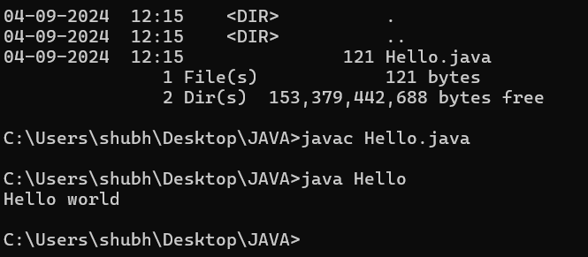

2-Compile with Verbose Option: Compile your Java file using the with javac .

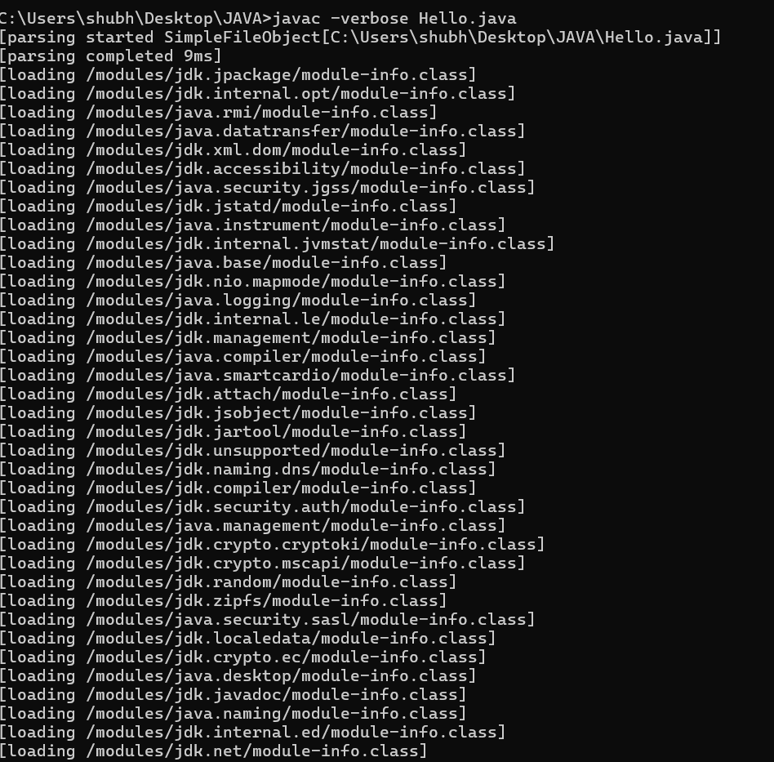

3. Inspect Bytecode: Use the javap-verbose option tool to examine the bytecode of the compiled .class file. Observe the output.

