Using <http://localhost:8080/appointment/> link adding 4 data through postman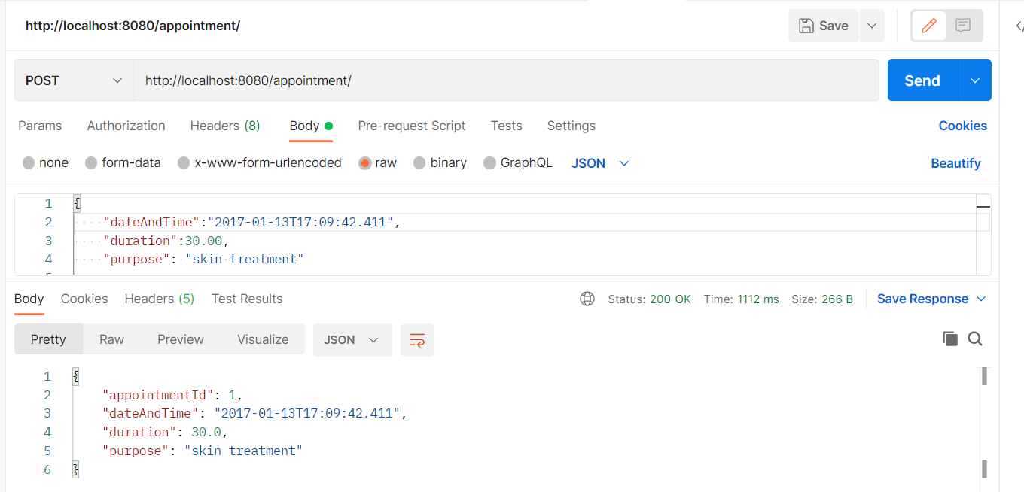

Json:

{

    "appointmentId": 1,

    "dateAndTime": "2017-01-13T17:09:42.411",

    "duration": 30.0,

    "purpose": "skin treatment"

}

{

    "appointmentId": 1,

    "dateAndTime": "2017-01-13T17:09:42.411",

    "duration": 30.0,

    "purpose": "skin treatment"

}

{

    "appointmentId": 2,

    "dateAndTime": "2017-02-13T17:09:42.411",

    "duration": 30.0,

    "purpose": "skin treatment"

}

{

    "appointmentId": 3,

    "dateAndTime": "2017-03-13T17:09:42.411",

    "duration": 30.0,

    "purpose": "skin treatment"

}

{

    "appointmentId": 4,

    "dateAndTime": "2017-04-13T17:09:42.411",

    "duration": 30.0,

    "purpose": "skin treatment"

}

{

    "appointmentId": 5,

    "dateAndTime": "2017-06-13T17:09:42.411",

    "duration": 30.0,

    "purpose": "skin treatment"

}

Using this <http://localhost:8080/appointment/data?startDate=2017-01-13T17:09:42.411&endDate=2017-04-13T17:09:42.411> link we can get appointments between 2017-01-13 to 2017-04-13

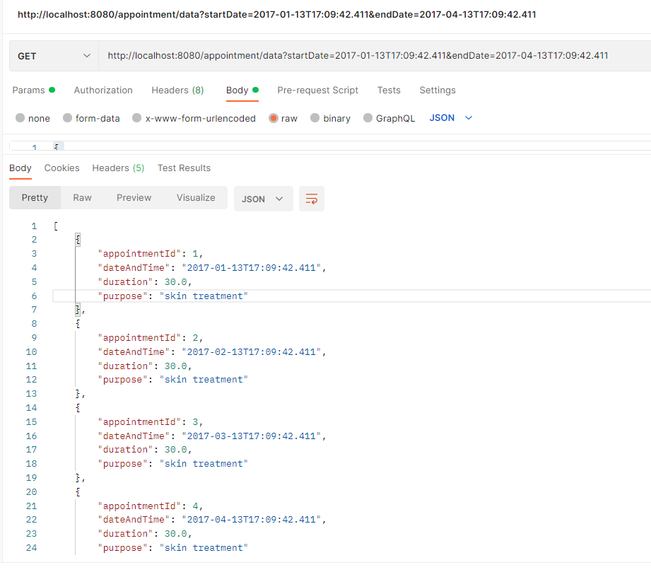

JSON

[

    {

        "appointmentId": 1,

        "dateAndTime": "2017-01-13T17:09:42.411",

        "duration": 30.0,

        "purpose": "skin treatment"

    },

    {

        "appointmentId": 2,

        "dateAndTime": "2017-02-13T17:09:42.411",

        "duration": 30.0,

        "purpose": "skin treatment"

    },

    {

        "appointmentId": 3,

        "dateAndTime": "2017-03-13T17:09:42.411",

        "duration": 30.0,

        "purpose": "skin treatment"

    },

    {

        "appointmentId": 4,

        "dateAndTime": "2017-04-13T17:09:42.411",

        "duration": 30.0,

        "purpose": "skin treatment"

    }

]