**DATA VISUALIZATION**

**Dashboard: -**

Problem: - Find Region of population in country control.

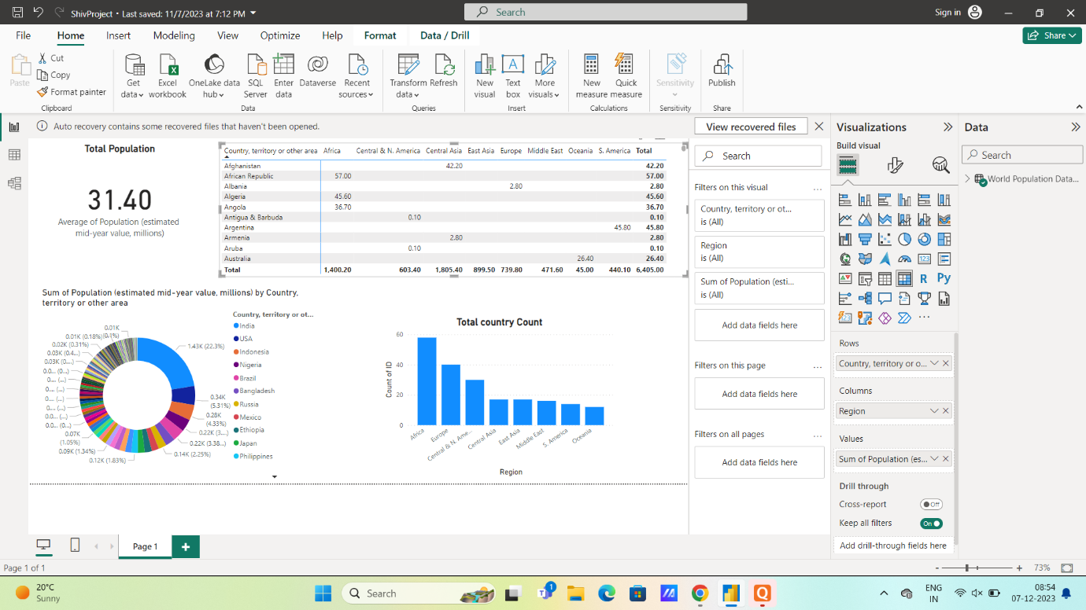

**Solve:-**

Average population of million people 31.40.

Most of area of population in India.

Oceania low population 45.00 area.

**Used Data Visualization chart: -**

1. **Create a Bar Chart:**

• After you've imported and cleaned your data, it's time to create a bar chart to visualize it. Click on the "Visualizations" tab on the left panel.

2. **Choose Bar Chart:**

• In the "Visualizations" pane, select the "Clustered Bar Chart" or "Stacked Bar Chart" icon, depending on the type of bar chart you want to create. Drag and drop the chart icon onto the report canvas.

3. **Configure the Bar Chart:**

• In the "Fields" pane (on the right), drag the appropriate fields to the chart. For a basic bar chart, you typically need a categorical field for the x-axis (e.g., product categories) and a numerical field for the y-axis (e.g., sales values). Power BI will automatically generate the chart based on your data.

4. **Customize the Chart:**

• You can customize your bar chart by formatting the axes, changing colors, adding data labels, and more. Use the "Format" tab in the Visualizations pane to make these adjustments.

5. **Interact with Data:**

• You can interact with the chart by clicking on it, slicing the data, and using filters. Power BI allows you to create a dynamic and interactive report.

**Data Modelling:**

In the Power Query Editor or the Data View, create the data model you need, including any calculations or measures required for your gauge chart.

**Create a Gauge Chart:**

In the report view, click on the "Visualizations" pane on the right.

**Choose the Gauge Chart Visualization:**

In the "Visualizations" pane, select the "Gauge" chart from the available visualizations.

**Configure Fields:**

Drag and drop the fields from your dataset into the appropriate sections of the "Fields" well in the "Visualizations" pane.

The "Target Value" field should be the maximum value or goal you want to reach.

The "Actual Value" field should be the value you want to visualize.

If necessary, you can add a "Minimum Value" field.

**Format the Gauge Chart:**

Customize the appearance of the gauge chart using the "Format" options in the "Visualizations" pane. You can change colors, fonts, and other visual settings to match your requirements.

**Add Titles and Labels:**

Add titles and labels to your gauge chart by using the "Title" and "Data labels" options in the "Visualizations" pane.

**Interactivity (Optional):**

You can add slicers or other visuals to create interactive features that filter the data displayed in the gauge chart based on user selections.

**Save and Publish:**

Save your Power BI report and publish it to the Power BI service if you want to share it with others.

**Select Histogram Visualization:**

In the "Visualizations" pane on the right side of the screen, you'll see a gallery of visualization types. To create a histogram, click on the "Histogram" icon.

**Fields and Axis:**

In the "Visualizations" pane, you will see the "Fields" section.

Drag and drop the field that you want to create a histogram for onto the "Axis" section in the "Fields" pane. This field represents the data you want to visualize the distribution of.

Power BI will automatically generate a histogram based on the data distribution in this field.

**Customize the Histogram:**

You can further customize your histogram by using the "Visualizations" pane.

Adjust the number of bins (intervals or bars) by using the "Bins" option in the "Visualizations" pane. You can specify a fixed number of bins or a specific bin width.

You can format the axis scales, title, and other properties by using the formatting options in the "Format" section of the "Visualizations" pane.

**Interact with the Histogram:**

In the report view, you can interact with the histogram. You can hover over bins to see tooltips with details, zoom in on specific ranges, or cross-highlight related visuals by selecting bins.

**Save Your Report:**

Remember to save your report periodically by going to "File" and selecting "Save" to save your changes

**Open Report View:**

In Power BI Desktop, click on the "Report" icon in the left-hand panel to enter the report view.

Select Pie Chart Visualization:

In the "Visualizations" pane on the right side of the screen, you'll see a gallery of visualization types. To create a pie chart, click on the "Pie Chart" icon.

**Fields for the Pie Chart:**

In the "Visualizations" pane, you will see the "Fields" section.

Drag and drop the field that you want to visualize as slices of the pie chart onto the "Legend" section in the "Fields" pane. This field represents the categorical data that you want to show in the pie chart.

Optionally, you can drag and drop another field onto the "Values" section if you want to represent the size of the slices with numeric values (e.g., counts or percentages). If you skip this step, Power BI will count the occurrences of each category automatically.

**Customize the Pie Chart:**

You can further customize your pie chart by using the "Visualizations" pane.

Format the title, labels, and legend in the "Format" section.

You can also explode a slice (pull it out from the pie) by clicking on it, which can help emphasize a specific category.

**Interact with the Pie Chart:**

In the report view, you can interact with the pie chart. You can click on slices to highlight them or select them for cross-filtering other visuals in your report

**Data Visualization:**