

Hands-on Lab 3: Creating a Simple Dashboard with Excel

**Estimated time needed:** 20 minutes

In this lab, you will learn how to setup and configure a relatively simple dashboard in Excel, which will help you tell a story about the data.

Software Used in this Lab

The instruction videos in this course use the full Excel Desktop version as this has all the available product features, but for the hands-on labs we will be using the free 'Excel for the web' version as this is available to everyone.

Although you can use the Excel Desktop software if you have access to this version, it is recommended that you use Excel for the web for the hands-on labs as the lab instructions specifically refer to this version, and there are some small differences in the interface and available features.**^^** If you do not yet have access to Excel for the Web, you can follow the instructions in the following lab to get started with it: [Hands-on Lab: Introduction to Excel for the web](https://cocl.us/IBMDeveloperSkillsNetwork-DA0130EN-HandsOnLab-1).

**^^** *In this lab, to do all the steps you need Excel Desktop, but you can use Excel for the web and just miss out the steps in Exercise 1 Steps 13 to 22.*

Dataset Used in this Lab

The dataset used in this lab comes from the following source: [https://www.kaggle.com/gagandeep16/car-sales](https://www.kaggle.com/gagandeep16/car-sales?cm_mmc=Email_Newsletter-_-Developer_Ed%2BTech-_-WW_WW-_-SkillsNetwork-Courses-IBMDeveloperSkillsNetwork-DV0130EN-SkillsNetwork-20531073&cm_mmca1=000026UJ&cm_mmca2=10006555&cm_mmca3=M12345678&cvosrc=email.Newsletter.M12345678&cvo_campaign=000026UJ) under a [**CC0: Public Domain license**](https://creativecommons.org/publicdomain/zero/1.0/). We are using a modified subset of that dataset for the lab, so to follow the lab instructions successfully, please use the dataset provided with the lab, rather than the dataset from the original source.

Objectives

After completing this lab, you will be able to:

* Set up a dashboard in Excel.
* Configure a dashboard layout in Excel.

Exercise 1 : Setting up a dashboard in Excel

In this exercise, you will learn how to set up a simple dashboard with visualizations in Excel.

1. Download the file [**Car_Sales_Kaggle_DV0130EN_Lab3_Start.xlsx**](https://cf-courses-data.s3.us.cloud-object-storage.appdomain.cloud/IBMDeveloperSkillsNetwork-DV0130EN-SkillsNetwork/Hands-on%20Labs/Lab%203%20-%20Creating%20a%20Simple%20Dashboard%20with%20Excel/Car_Sales_Kaggle_DV0130EN_Lab3_Start.xlsx). Upload and open it using **Excel for the web**.
2. Click **+** to add a new worksheet, then double-click **Sheet1** tab and rename it to **Dashboard**, then click **OK**.
3. Drag the **Dashboard** tab to the far right of the workbook tabs if needed.
4. Select the **Column, Pie, Sunburst Chart** worksheet tab.
5. Select the **Column chart** and press **CTRL+C**.
6. Select the **Dashboard** tab, click somewhere in the middle of the sheet, and press **CTRL+V**.
7. Select the **Column, Pie, Sunburst Chart** worksheet tab.
8. Select the **Pie chart** and press **CTRL+C**.
9. Select the **Dashboard** tab, click somewhere in the middle of the sheet, and press **CTRL+V**.
10. Select the **Column, Pie, Sunburst Chart** worksheet tab.
11. Select the **Sunburst chart** and press **CTRL+C**.
12. Select the **Dashboard** tab, click somewhere in the middle of the sheet, and press **CTRL+V**.

*If you have a copy of Excel Desktop you can continue on here and do both exercises using the first start file provided.*

**Note:** Excel for the web cannot copy slicers and pivot charts, so if you are using a version of **Excel for the web**, you will need to stop this exercise here, then open the provided [**Car_Sales_Kaggle_DV0130EN_Lab3_Ex2Start.xlsx**](https://cf-courses-data.s3.us.cloud-object-storage.appdomain.cloud/IBMDeveloperSkillsNetwork-DV0130EN-SkillsNetwork/Hands-on%20Labs/Lab%203%20-%20Creating%20a%20Simple%20Dashboard%20with%20Excel/Car_Sales_Kaggle_DV0130EN_Lab3_Ex2Start.xlsx) file, and then continue from **Exercise 2 Step 1** below.

1. Select the **Column, Pie, Sunburst Chart** worksheet tab.
2. Select the **Slicer** and press **CTRL+C**.
3. Select the **Dashboard** tab, click somewhere in the middle of the sheet, and press **CTRL+V**.
4. Select the **Bar Chart** worksheet tab.
5. Select the **Bar chart** and press **CTRL+C**.
6. Select the **Dashboard** tab, click somewhere in the middle of the sheet, and press **CTRL+V**.
7. Select the **Bar Chart** worksheet tab.
8. Select the **Slicer** and press **CTRL+C**.
9. Select the **Dashboard** tab, click somewhere in the middle of the sheet, and press **CTRL+V**.
10. At the end of this exercise your **Dashboard** worksheet should look like the image below:

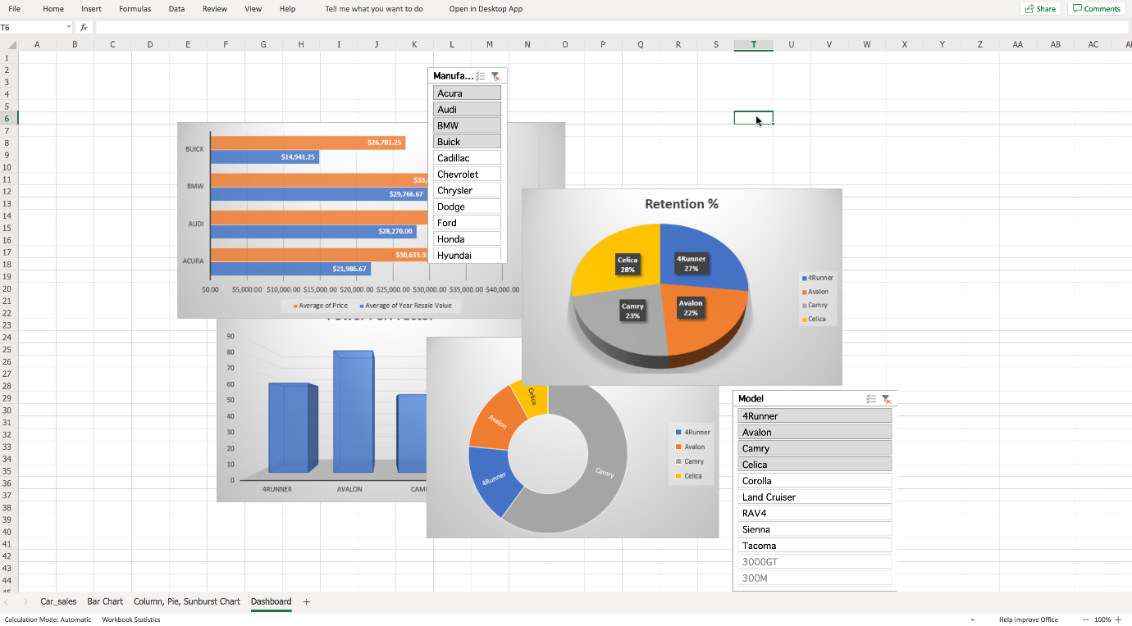

Exercise 2 : Configuring a dashboard layout in Excel

In this exercise, you will learn how to organize and layout the content of a dashboard in Excel.

*If you are using Excel for the web, then you need to open the starter file provided in the link above, after Exercise 1 Step 12.*

1. Select and drag the **Bar chart** to the top left corner of the sheet.
2. Select and drag the **Manufacturer slicer** to the top of the sheet on the right of the Bar chart.
3. Select and drag the **Pie chart** to the top right of the sheet on the right of the **Manufacturer slicer**.
4. Select and drag the **Column chart** to the bottom left of the sheet under the Bar chart.
5. Select and drag the **Sunburst chart** to the bottom of the sheet on the right of the Column chart.
6. Select and drag the **Model slicer** to the bottom left of the sheet under the Pie chart.
7. Drag and resize all the charts to make them fit better.

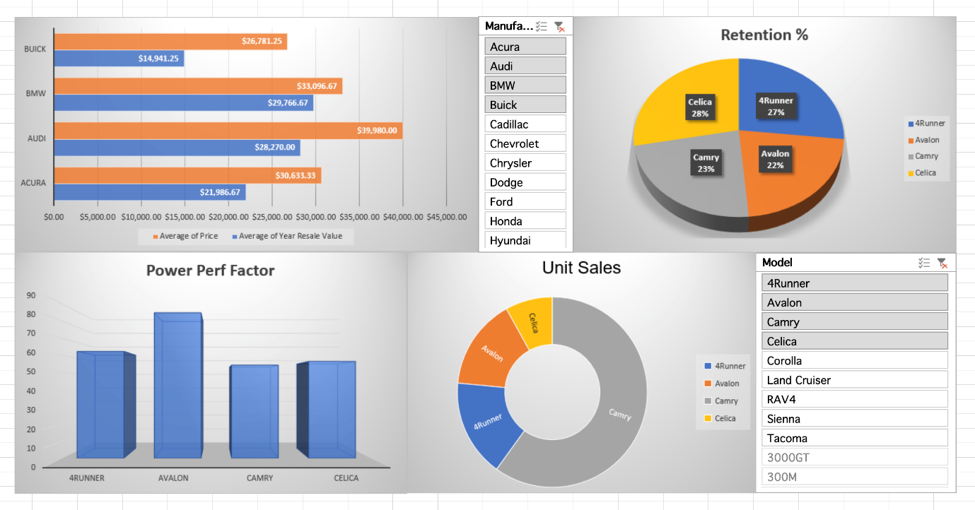

1. Select the **View** tab in the ribbon, and uncheck **Gridlines** and **Headings**.

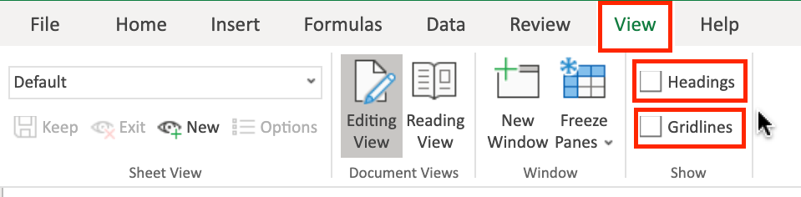

1. Double-click any tab to collapse the ribbon.
2. In the **Manufacturer slicer**, select **Audi** and click the **Multi-Select** button. Then scroll the slicer and select only **Audi, BMW, Mercedes-B, Porsche, Volkswagen**.

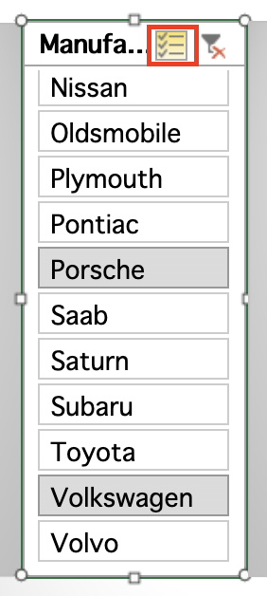

1. Click on the **Bar chart area** to access the Chart tab in the ribbon.
2. On the **Labels** group of the **Chart** tab, click **Chart Title** and select **Edit Chart Title...**.
3. In the text input area of the dialog box **Edit Title**, write **"Average Price and Year Resale Value of German Car Models"** and click **OK**.
4. In the **Model slicer**, click the **Clear Filter** button.

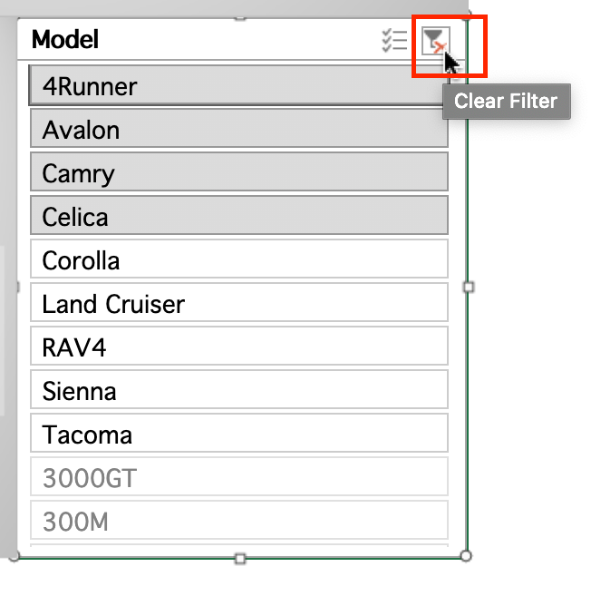

Finally your dashboard should look similar to the image below:

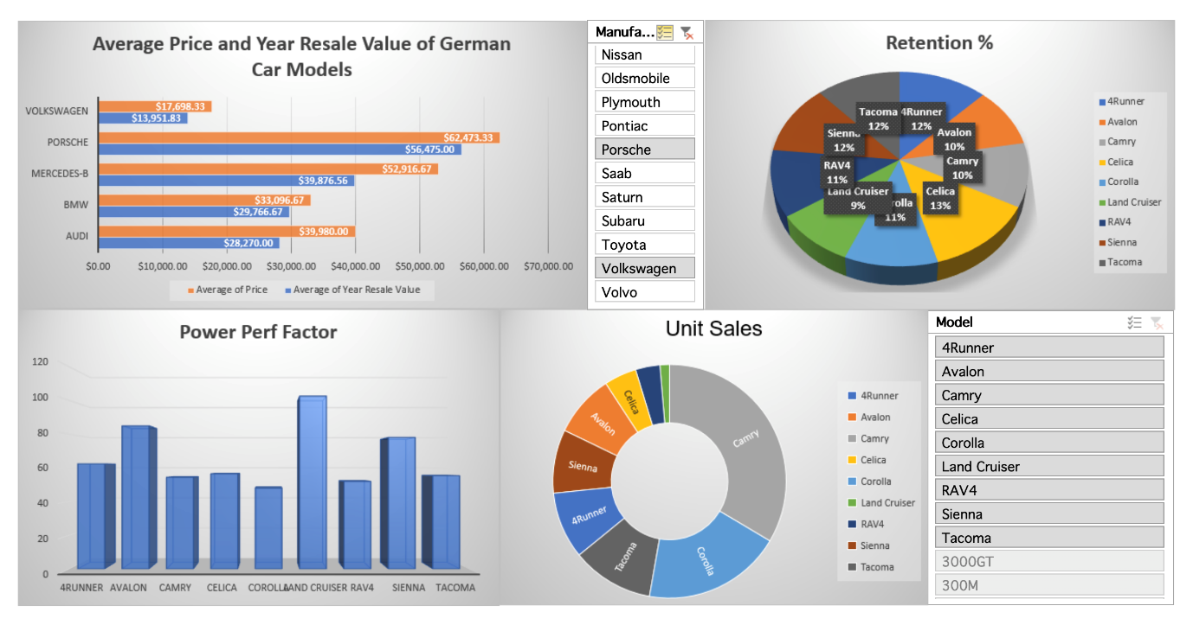

Congratulations! You have completed Lab 3, and you are ready for the next topic.

Author(s)

* [Sandip Saha Joy](https://www.linkedin.com/in/sandipsahajoy?cm_mmc=Email_Newsletter-_-Developer_Ed%2BTech-_-WW_WW-_-SkillsNetwork-Courses-IBMDeveloperSkillsNetwork-DV0130EN-SkillsNetwork-20531073&cm_mmca1=000026UJ&cm_mmca2=10006555&cm_mmca3=M12345678&cvosrc=email.Newsletter.M12345678&cvo_campaign=000026UJ)

Other Contributor(s)

* [Steve Ryan](https://www.linkedin.com/in/stevelryan?cm_mmc=Email_Newsletter-_-Developer_Ed%2BTech-_-WW_WW-_-SkillsNetwork-Courses-IBMDeveloperSkillsNetwork-DV0130EN-SkillsNetwork-20531073&cm_mmca1=000026UJ&cm_mmca2=10006555&cm_mmca3=M12345678&cvosrc=email.Newsletter.M12345678&cvo_campaign=000026UJ)

Changelog

| **Date** | **Version** | **Changed by** | **Change Description** |
| --- | --- | --- | --- |
| 2020-10-30 | 1.2 | Steve Ryan | Added Ex2 starter file and steps |
| 2020-10-19 | 1.1 | Steve Ryan | ID review |
| 2020-10-05 | 1.0 | Sandip Saha Joy | Initial version created |

© IBM Corporation 2020. All rights reserved.