

Hands-on Lab 4: Getting Started with Cognos Analytics

**Estimated time needed:** 30 minutes

IBM Cognos Analytics is an AI-fueled business intelligence platform that supports the entire data analytics cycle, from discovery to operationalization. It provides users with data discovery capabilities to visually explore and interact with their data to identify the key insights for improving data driven decisions. Users can perform data discovery and then quickly assemble that information into interactive, visually appealing dashboards; all without the need of formal training.

In this lab, first you will learn how to sign up for IBM Cognos Analytics trial plan, and learn general navigation around the Cognos Analytics user interface (UI). Next, you will learn how to upload external data files, and finally you will learn how to start a new dashboard with a template, populate it with a data visualization, and save the dashboard.

Software Used in this Lab

Like the videos in the course, for the hands-on labs we will be using IBM Cognos Analytics trial version (currently limited to 90 days) as this is available at no charge.

Dataset Used in this Lab

The dataset used in this lab comes from the following source: [https://www.kaggle.com/kyanyoga/sample-sales-data](https://www.kaggle.com/kyanyoga/sample-sales-data?cm_mmc=Email_Newsletter-_-Developer_Ed%2BTech-_-WW_WW-_-SkillsNetwork-Courses-IBMDeveloperSkillsNetwork-DV0130EN-SkillsNetwork-20531073&cm_mmca1=000026UJ&cm_mmca2=10006555&cm_mmca3=M12345678&cvosrc=email.Newsletter.M12345678&cvo_campaign=000026UJ&cm_mmc=Email_Newsletter-_-Developer_Ed%2BTech-_-WW_WW-_-SkillsNetwork-Courses-IBMDeveloperSkillsNetwork-DV0130EN-SkillsNetwork-20531073&cm_mmca1=000026UJ&cm_mmca2=10006555&cm_mmca3=M12345678&cvosrc=email.Newsletter.M12345678&cvo_campaign=000026UJ) under a [**CC0: Public Domain license**](https://creativecommons.org/publicdomain/zero/1.0?cm_mmc=Email_Newsletter-_-Developer_Ed%2BTech-_-WW_WW-_-SkillsNetwork-Courses-IBMDeveloperSkillsNetwork-DV0130EN-SkillsNetwork-20531073&cm_mmca1=000026UJ&cm_mmca2=10006555&cm_mmca3=M12345678&cvosrc=email.Newsletter.M12345678&cvo_campaign=000026UJ).

Objectives

After completing this lab, you will be able to:

* Sign up for a Cognos Analytics trial plan and navigate around the Cognos Analytics user interface.
* Upload external data files to the Cognos Analytics platform.
* Start a new dashboard with a dashboard template and populate it with a data visualization.

Exercise 1 : Sign up for Cognos Analytics Trial Plan

In this exercise, you will learn how to sign up for an IBM Cognos Analytics trial plan.

1. Go to [Try IBM Cognos Analytics](https://www.ibm.com/account/reg/signup?formid=urx-48178&cm_mmc=Email_Newsletter-_-Developer_Ed%2BTech-_-WW_WW-_-SkillsNetwork-Courses-IBMDeveloperSkillsNetwork-DV0130EN-SkillsNetwork-20531073&cm_mmca1=000026UJ&cm_mmca2=10006555&cm_mmca3=M12345678&cvosrc=email.Newsletter.M12345678&cvo_campaign=000026UJ).
2. Fill out section **1. Account information** with your information and click **Next**. The email address you are going to use here, will be called IBMid.  
   If you already have an IBMid, click **Log in**. Enter your IBMid and password.

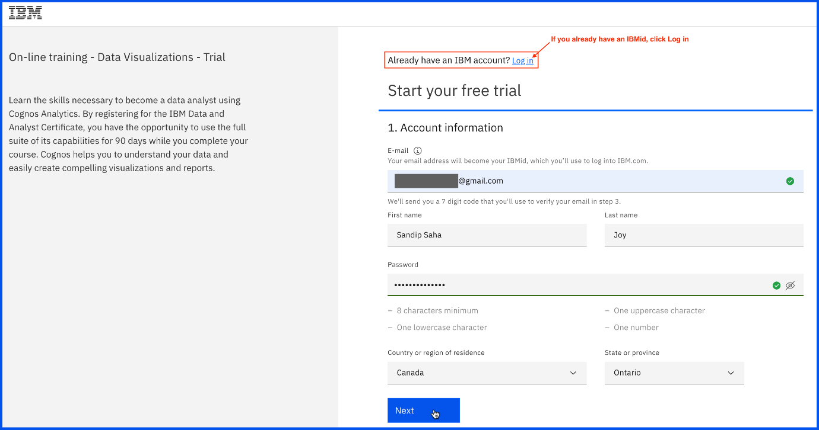

1. Fill out section **2. Additional information** with your information. In the case of the Data Center, select one which is nearest to your location. Then click **Next**.

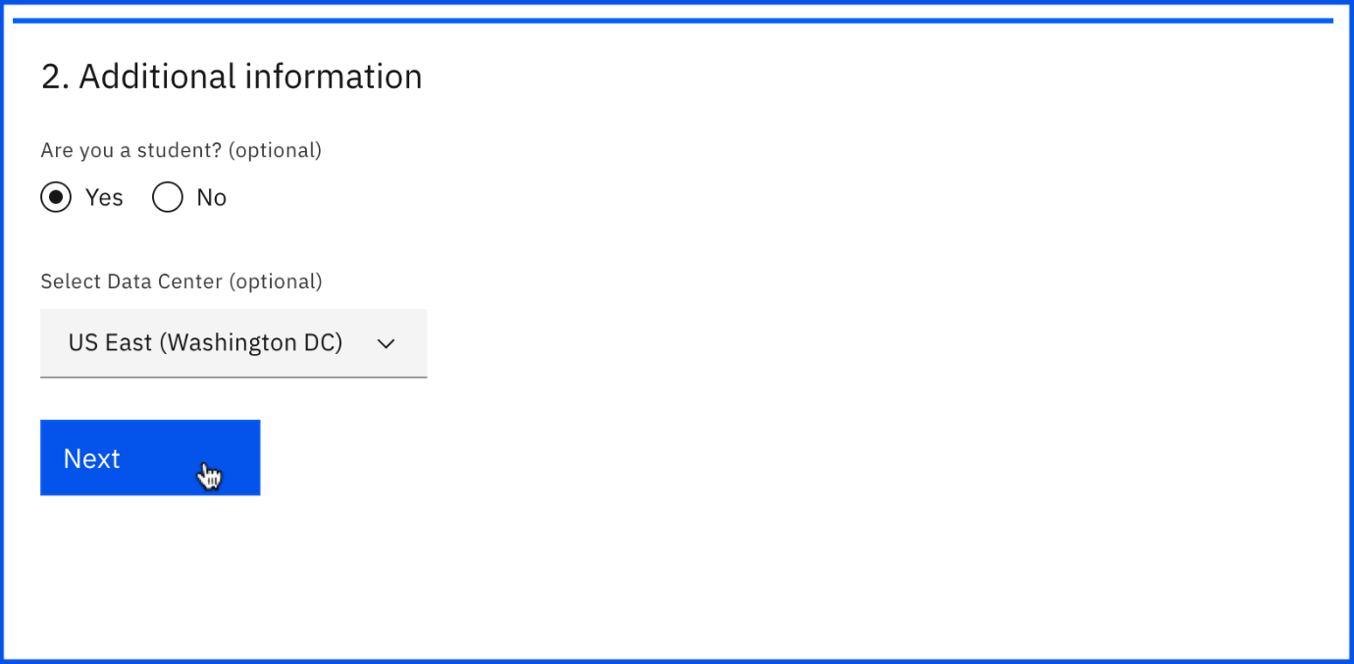

1. Now enter the 7 digit code you received on your email address and click **Create account**.

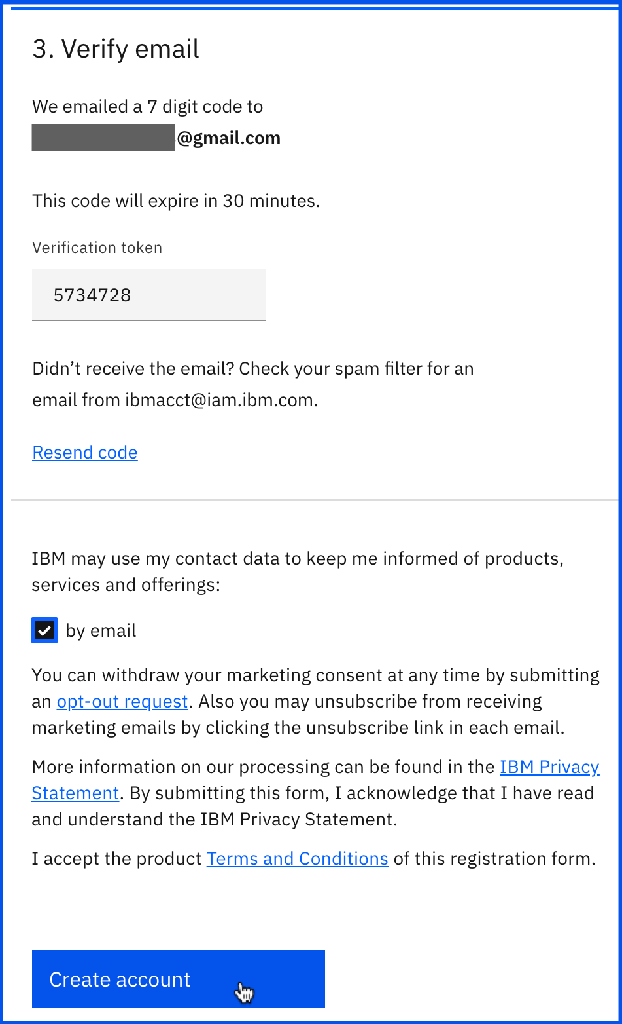

1. Click **Proceed**.

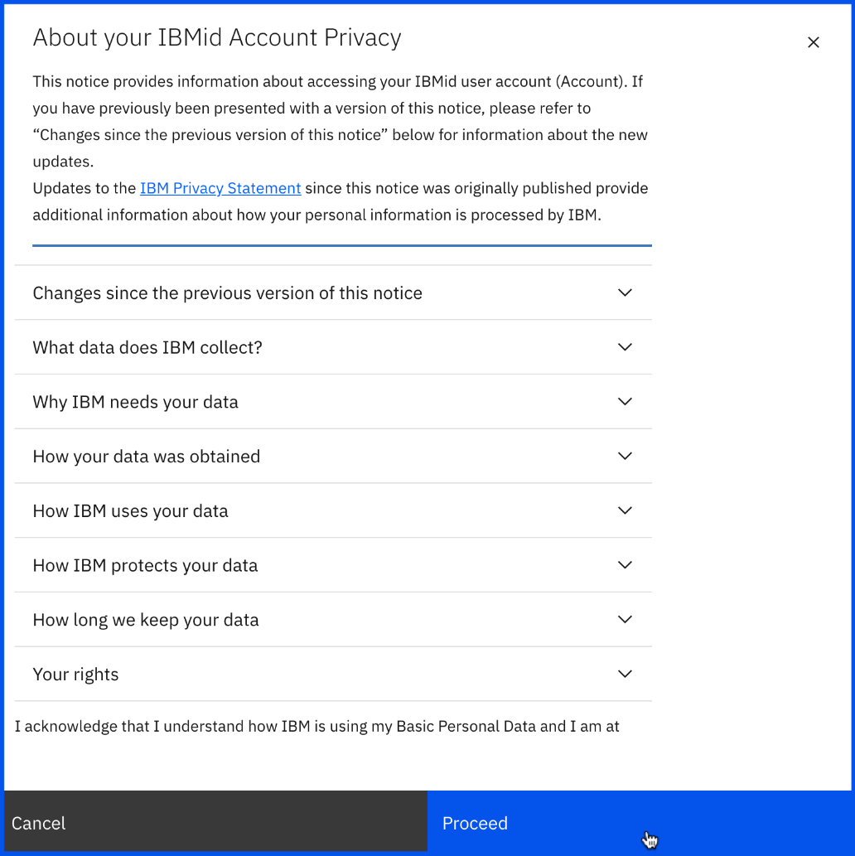

1. You are now done with the sign up procedure. You will be redirected to [myibm.ibm.com/dashboard/](https://myibm.ibm.com/dashboard?cm_mmc=Email_Newsletter-_-Developer_Ed%2BTech-_-WW_WW-_-SkillsNetwork-Courses-IBMDeveloperSkillsNetwork-DV0130EN-SkillsNetwork-20531073&cm_mmca1=000026UJ&cm_mmca2=10006555&cm_mmca3=M12345678&cvosrc=email.Newsletter.M12345678&cvo_campaign=000026UJ) automatically. Wait for some moment until the Coursera on-line training - Data Visualizations trial offering becomes active.

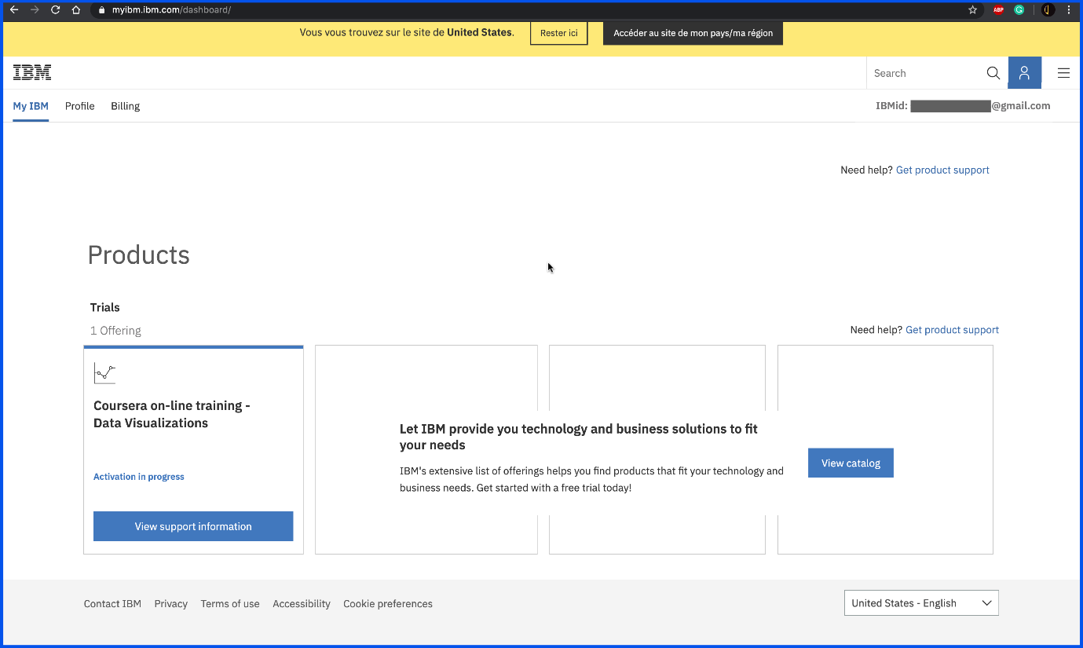

1. Click on the **Launch** button of this offering.

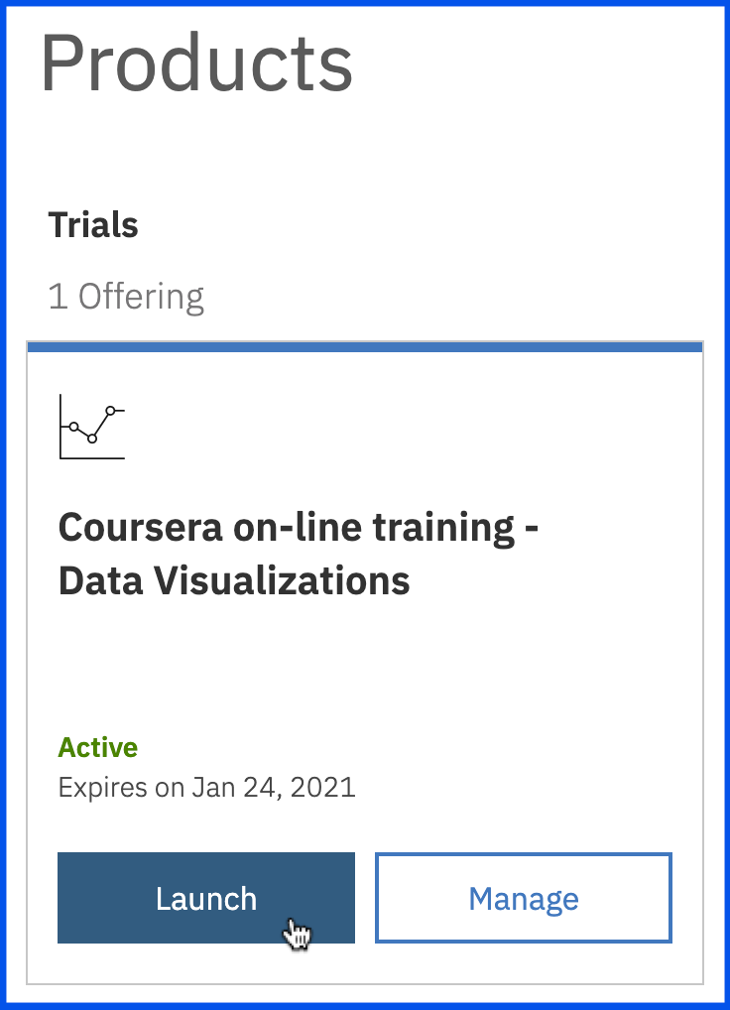

1. You have successfully launched the Cognos Analytics platform.

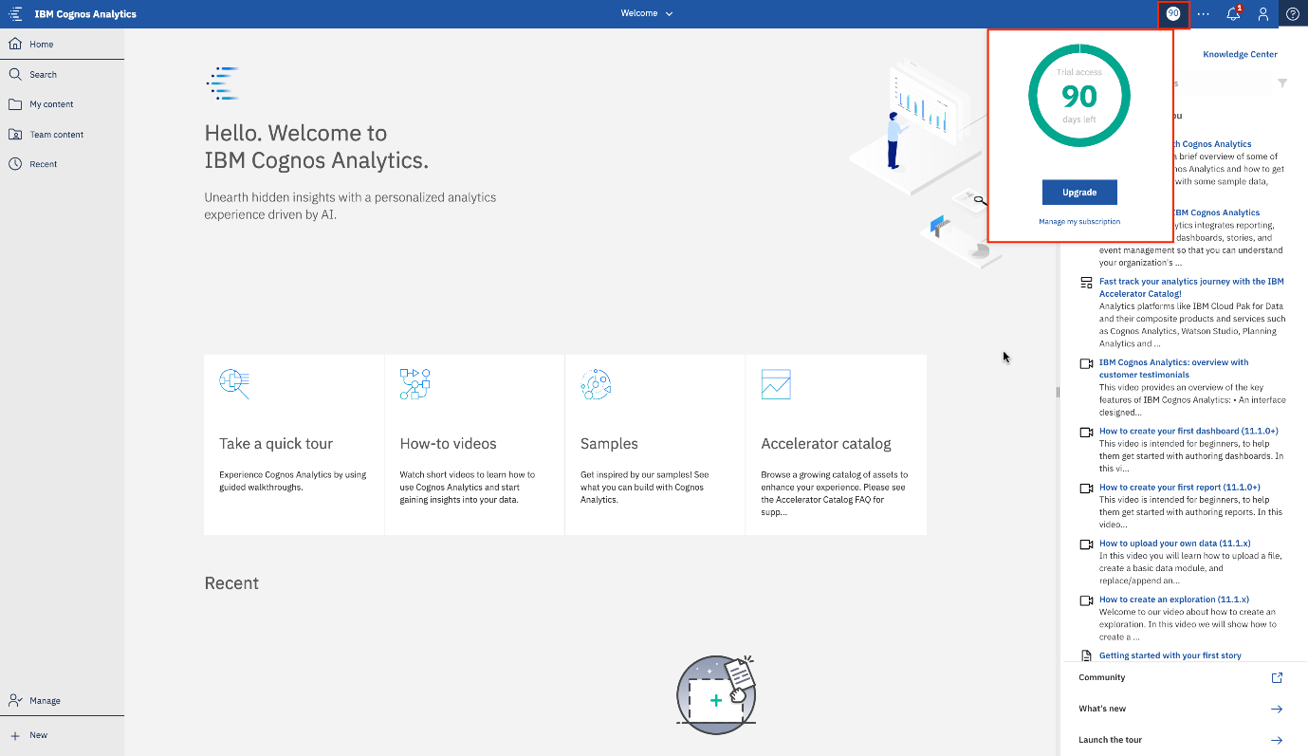

1. From now on, if you want to sign in to the Cognos Analytics platform with your IBMid, go to [myibm.ibm.com](https://myibm.ibm.com/?cm_mmc=Email_Newsletter-_-Developer_Ed%2BTech-_-WW_WW-_-SkillsNetwork-Courses-IBMDeveloperSkillsNetwork-DV0130EN-SkillsNetwork-20531073&cm_mmca1=000026UJ&cm_mmca2=10006555&cm_mmca3=M12345678&cvosrc=email.Newsletter.M12345678&cvo_campaign=000026UJ). Enter your IBMid and password. Repeat step 7 and 8.

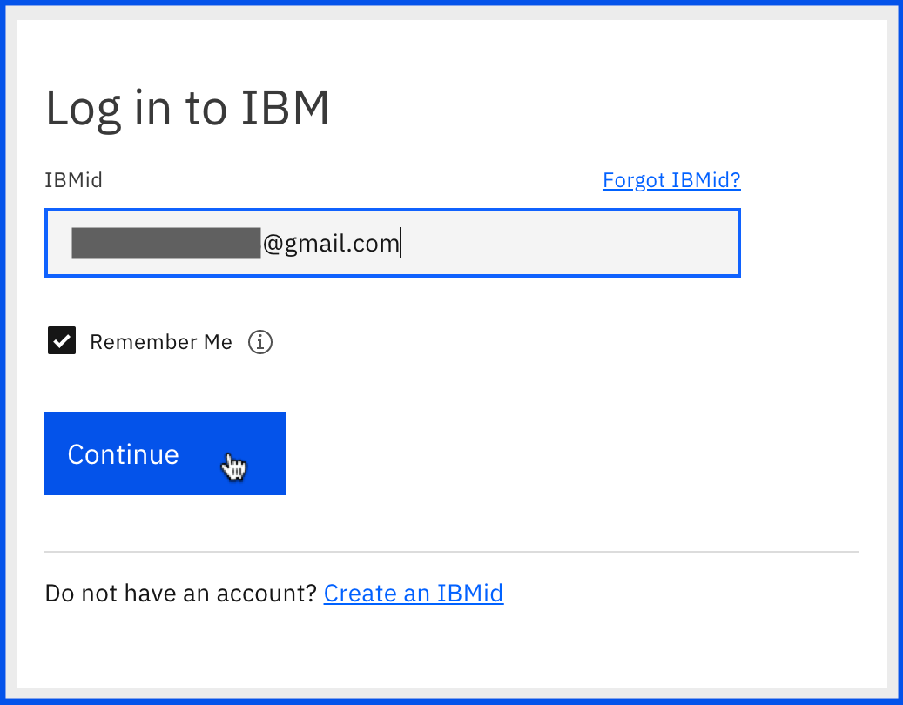

Exercise 2 : Navigate around Cognos Analytics UI and Upload External Data

In this exercise, you will learn general navigation around the Cognos Analytics user interface, and learn how to upload external data files.

Task A : General Navigation around the Cognos Analytics UI

1. The goal of the Cognos Analytics user interface (UI) is to provide you with a streamlined way to get started using Cognos Analytics and view content and activities pertinent to them. You will begin your general navigation here.

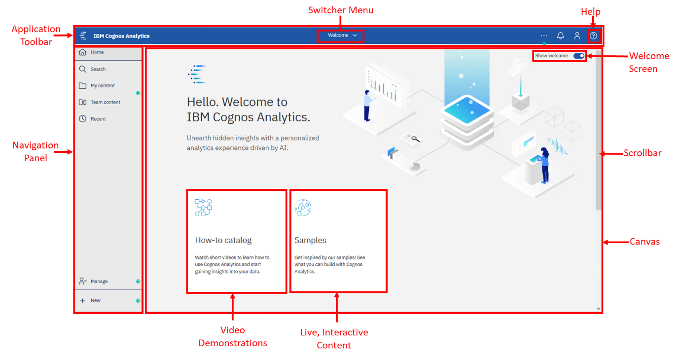

1. Click on the **Welcome Screen** toggle button on the upper right of the canvas to collapse the Welcome Screen’s Getting Started content. The canvas now shows the Recently used files in the **Recent** section, if any, along with the **File drop zone** where you can easily upload your external data files.

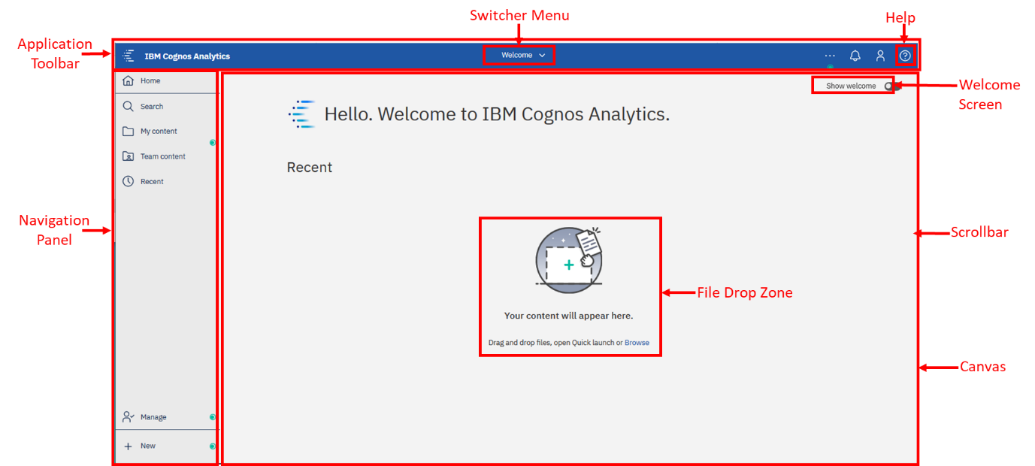

1. Once you begin working with content, the canvas will update with your recently used items. In your Cognos Analytics instance, you may see recent content on the canvas.

Task B : Upload External Data Files

1. Download the file [car_sales_data_sample.csv](https://cf-courses-data.s3.us.cloud-object-storage.appdomain.cloud/IBMDeveloperSkillsNetwork-DV0130EN-SkillsNetwork/Hands-on%20Labs/Lab%204%20-%20Getting%20Started%20with%20Cognos%20Analytics/car_sales_data_sample.csv).
2. To upload a file, you may either drag and drop this file into the File Drop Zone (highlighted in the image above), or you may click **New > Upload files** at the bottom left corner to navigate to where the file is saved. For this lab, we will use the second option. Click **New > Upload files**, then browse to the file download location, select the CSV file, and click **Open**.

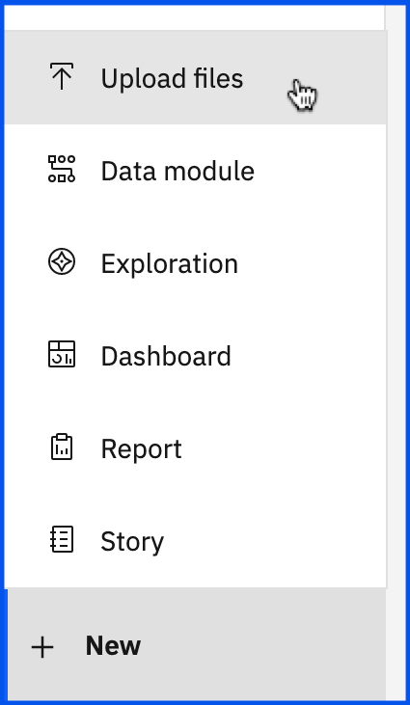

1. As the file uploads, notice that under the Switcher Menu, a series of status bars will be visible as the upload process reads and analyzes the data being brought in.

  


1. Once it completes, the status bar will update to show the successful completion before closing.



1. In the **Recent** section, you will see the new uploaded data file.

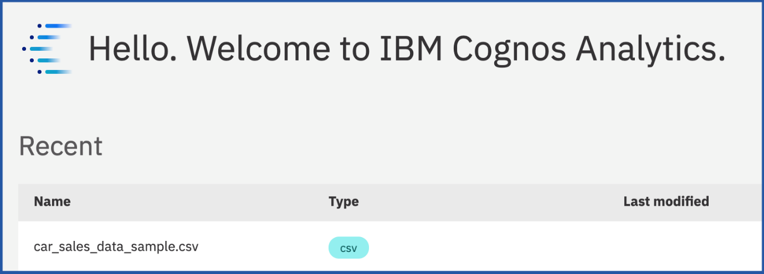

Exercise 3 : Start a New Dashboard with a Template

In this exercise, you will learn how to create a new dashboard from a template, populate it with a data visualization, and then save it.

1. Click on the uploaded data file **car_sales_data_sample.csv**.

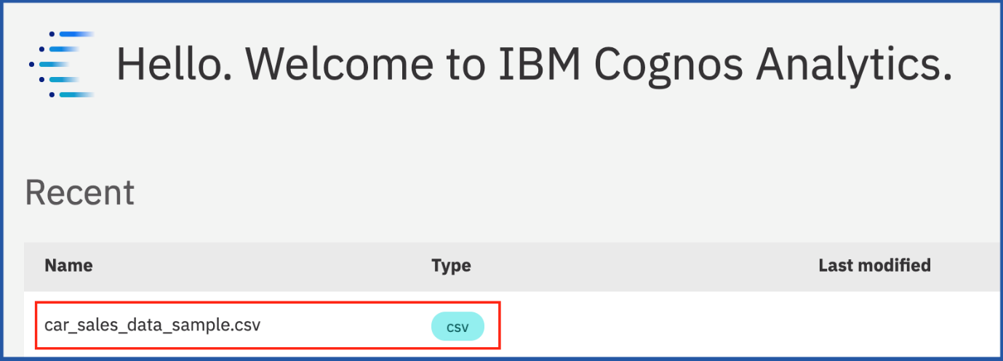

1. The Template window will display allowing you to select the type of dashboard and the template style. Select the **tabbed dashboard style**. This will allow you to have multiple pages for your dashboards. Select the **one-panel template**. Click **Create**.

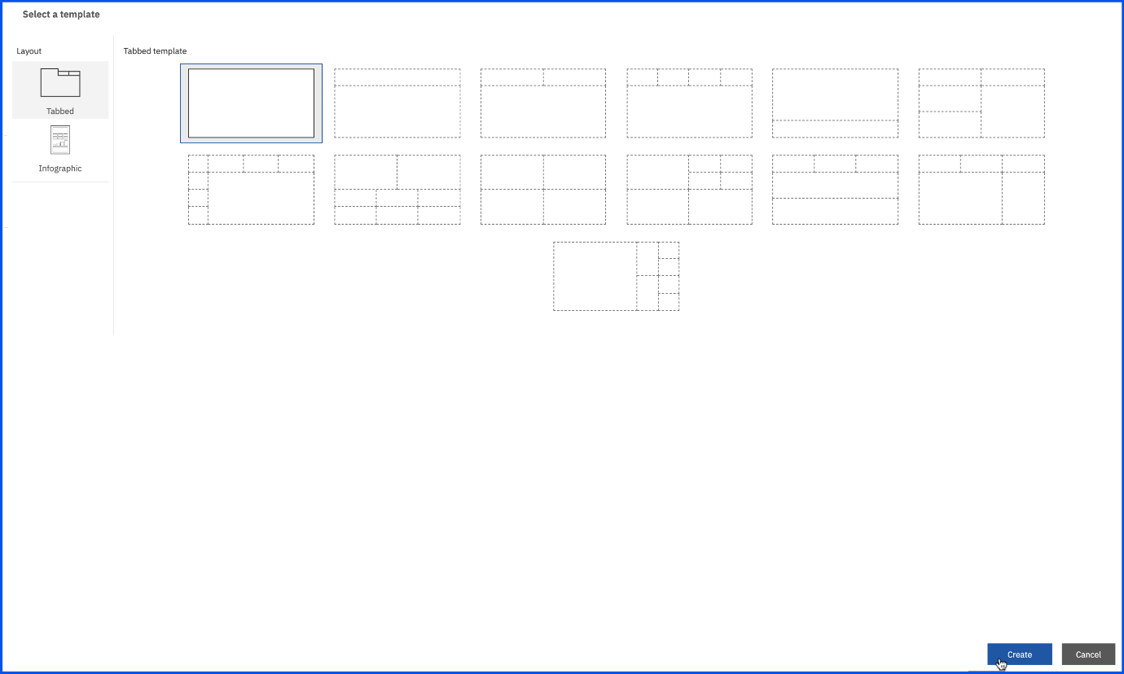

1. Now you have created a new empty dashboard using the dashboard template.

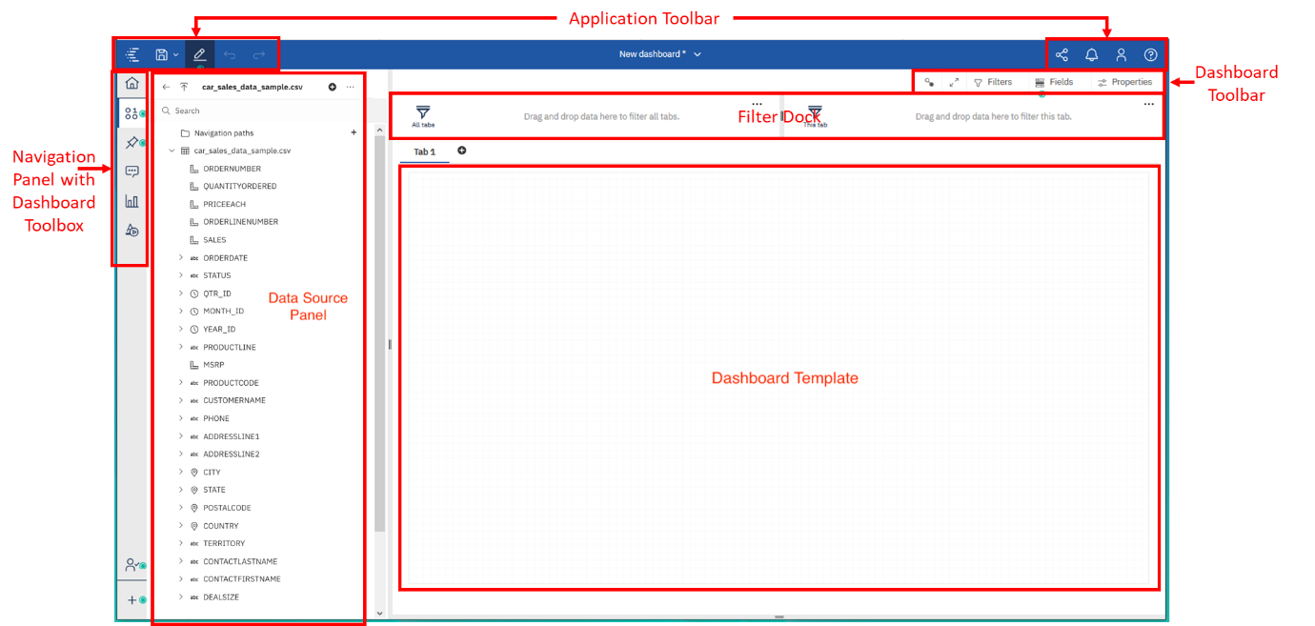

1. From the **Navigation** panel, select **Sources** to open the data source panel, if it is not already open. The **Data Source** panel displays the uploaded file **"car_sales_data_sample.csv"** as the Selected Source.



1. From the **Data Source** panel, select **SALES**. Drag it to the **Panel** and release.

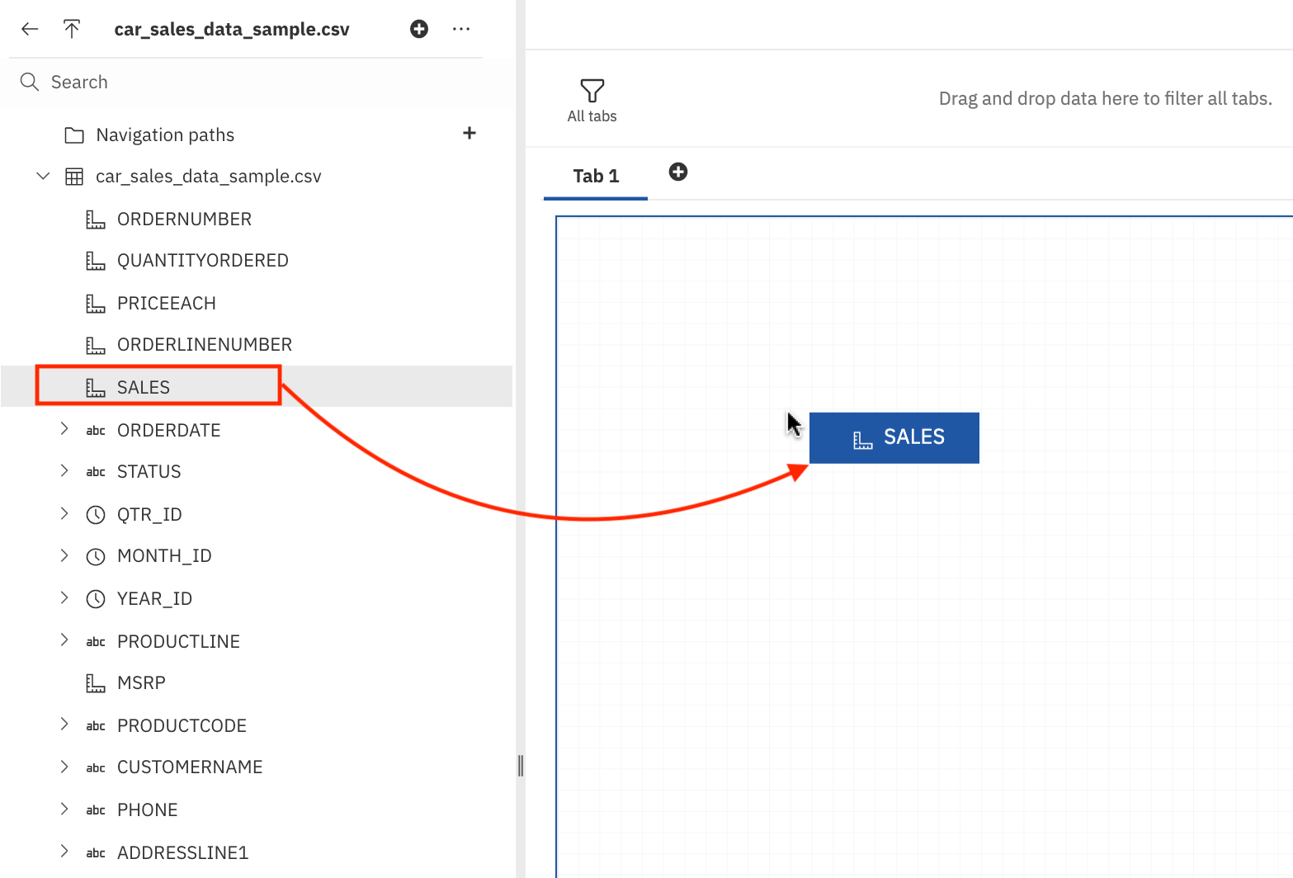

1. Now you have successfully started to populate your dashboard with data visualizations too!



1. To save the newly created dashboard, press **CTRL+S**. Select **My content** as the **Destination** and click **Save**.

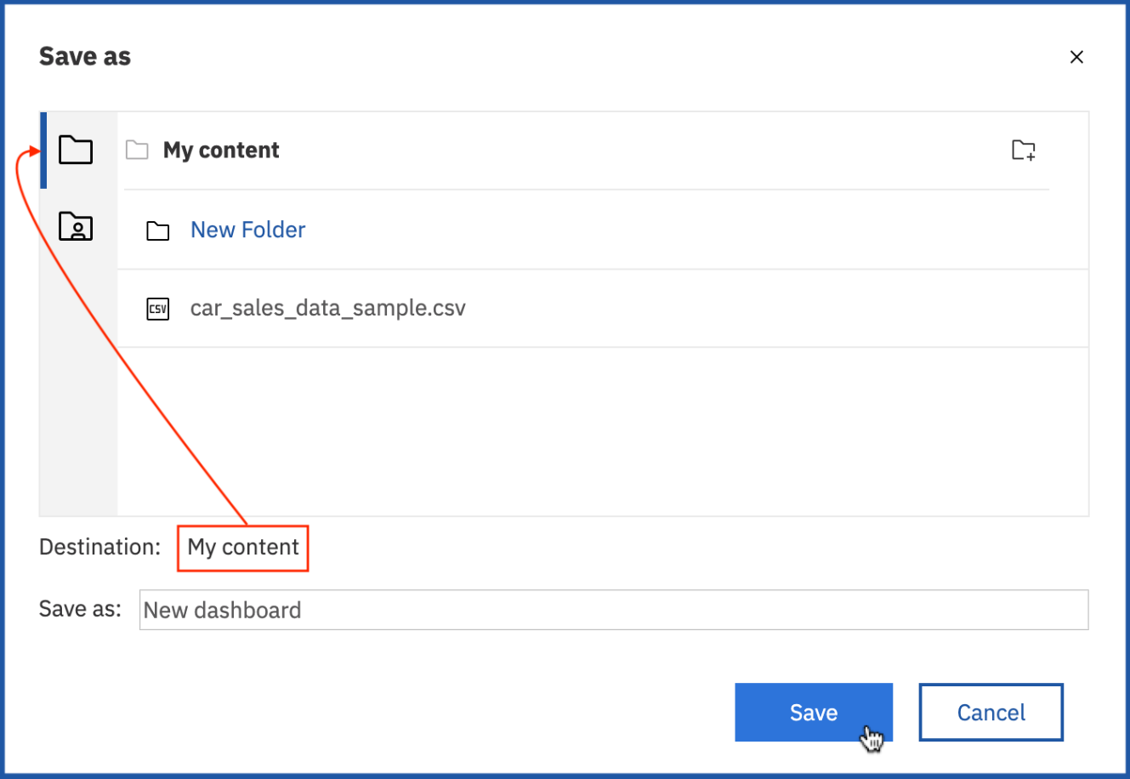

Congratulations! You have completed Lab 4, and you are ready for the next topic.