

Hands-on Lab 5A: Creating a Simple Dashboard with Cognos Analytics

**Estimated time needed:** 30 minutes

In this lab, first you will learn how to upload external data files to Cognos Analytics, and then learn how to start a new dashboard with templates. Lastly, you will learn how to create a simple dashboard.

Software Used in this Lab

Like the videos in the course, for the hands-on labs we will be using IBM Cognos Analytics trial version (currently limited to 30 days) as this is available at no charge.

Dataset Used in this Lab

The dataset used in this lab comes from the VM designed to showcase IBM Cognos Analytics. Source: [https://www.ibm.com/cloud/garage/dte/tutorial/ibm-cognos-analytics-1113-getting-started-exploration-0](https://www.ibm.com/cloud/garage/dte/tutorial/ibm-cognos-analytics-1113-getting-started-exploration-0?cm_mmc=Email_Newsletter-_-Developer_Ed%2BTech-_-WW_WW-_-SkillsNetwork-Courses-IBMDeveloperSkillsNetwork-DV0130EN-SkillsNetwork-20531073&cm_mmca1=000026UJ&cm_mmca2=10006555&cm_mmca3=M12345678&cvosrc=email.Newsletter.M12345678&cvo_campaign=000026UJ&cm_mmc=Email_Newsletter-_-Developer_Ed%2BTech-_-WW_WW-_-SkillsNetwork-Courses-IBMDeveloperSkillsNetwork-DV0130EN-SkillsNetwork-20531073&cm_mmca1=000026UJ&cm_mmca2=10006555&cm_mmca3=M12345678&cvosrc=email.Newsletter.M12345678&cvo_campaign=000026UJ). This dataset is published by IBM. You can download the dataset file directly from here: [CustomerLoyaltyProgram.csv](https://cf-courses-data.s3.us.cloud-object-storage.appdomain.cloud/IBMDeveloperSkillsNetwork-DV0130EN-SkillsNetwork/Hands-on%20Labs/Lab%205A%20-%20Creating%20a%20Simple%20Dashboard%20with%20Cognos%20Analytics/CustomerLoyaltyProgram.csv)

Objectives

After completing this lab, you will be able to:

* Upload external data files to the Cognos Analytics platform.
* Start a new dashboard with dashboard templates.
* Create a simple dashboard.

Exercise 1 : Upload External Data

In this exercise, you will learn how to upload external data files to Cognos Analytics.

1. Download the file [CustomerLoyaltyProgram.csv](https://cf-courses-data.s3.us.cloud-object-storage.appdomain.cloud/IBMDeveloperSkillsNetwork-DV0130EN-SkillsNetwork/Hands-on%20Labs/Lab%205A%20-%20Creating%20a%20Simple%20Dashboard%20with%20Cognos%20Analytics/CustomerLoyaltyProgram.csv).
2. To sign in to the Cognos Analytics platform with your IBMid, go to [myibm.ibm.com/dashboard/](https://myibm.ibm.com/dashboard?cm_mmc=Email_Newsletter-_-Developer_Ed%2BTech-_-WW_WW-_-SkillsNetwork-Courses-IBMDeveloperSkillsNetwork-DV0130EN-SkillsNetwork-20531073&cm_mmca1=000026UJ&cm_mmca2=10006555&cm_mmca3=M12345678&cvosrc=email.Newsletter.M12345678&cvo_campaign=000026UJ).
3. Enter your IBMid and password.
4. Scroll down and click **Launch**.

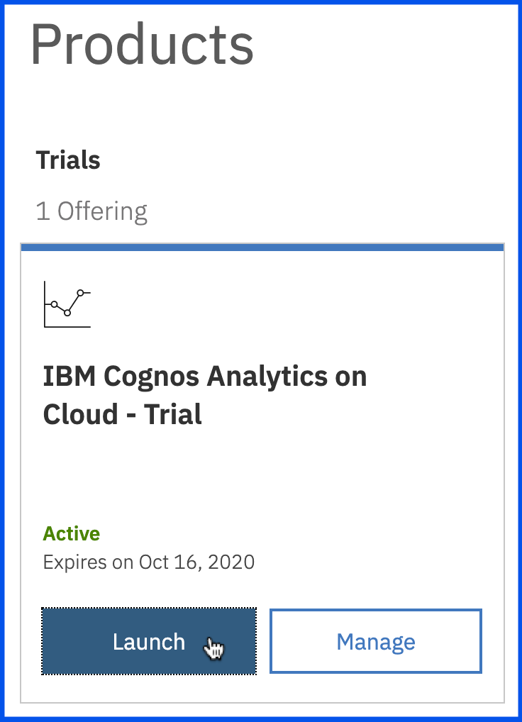

1. To upload a file, you may either drag and drop this file into the File Drop Zone (highlighted in the image above), or you may click **New > Upload files** at the bottom left corner to navigate to where the file is saved. For this lab, we will use the second option. Click **New > Upload files**, then browse to the file download location, select the CSV file, and click **Open**.

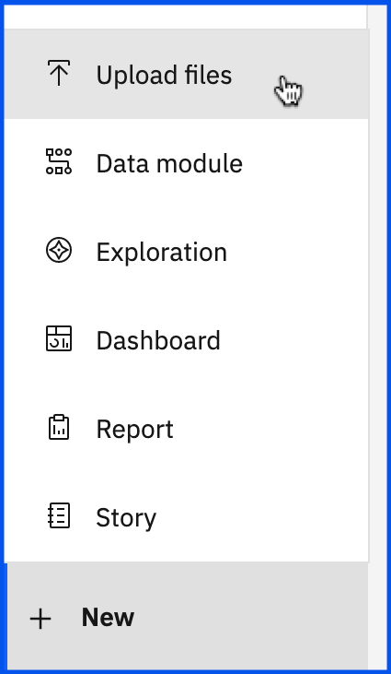

1. As the file uploads, notice that under the **Switcher Menu**, a series of status bars will be visible as the upload process reads and analyzes the data being brought in.

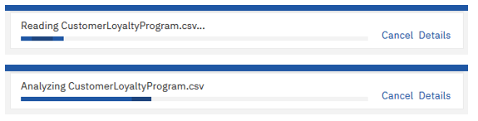

1. Once it completes, the status bar will update to show the successful completion before closing.

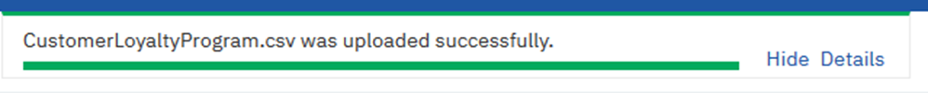

1. In the **Recent** section, you will see the new uploaded data file.

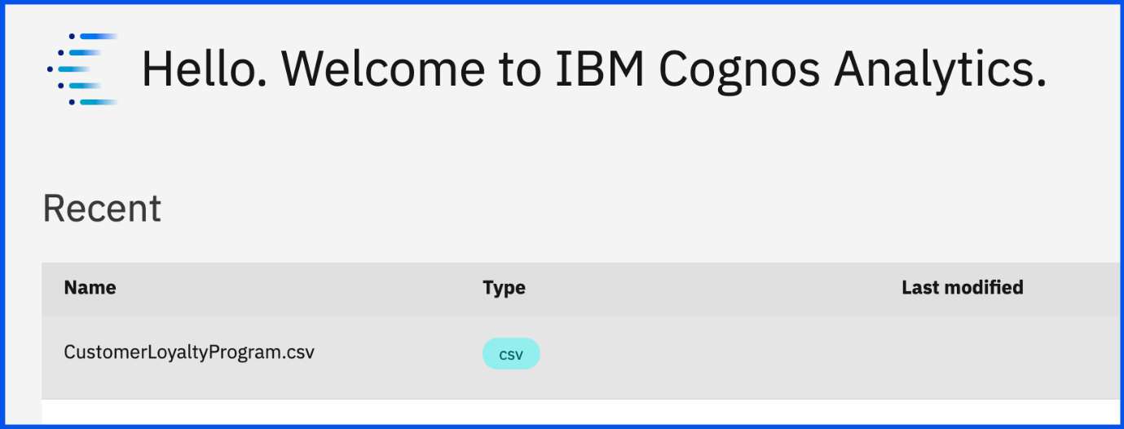

Exercise 2 : Start a New Dashboard with Templates

In this exercise, you will learn how to start a new dashboard with templates.

1. Click on the uploaded data file **CustomerLoyaltyProgram.csv**.

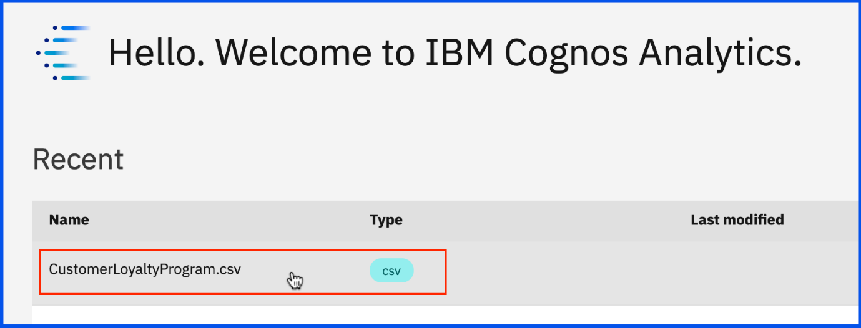

1. The Template window will display allowing you to select the type of dashboard and the template style. Select the **tabbed dashboard style**. This will allow you to have multiple pages for your dashboards. Select the **three-panel template**. Click **Create**.

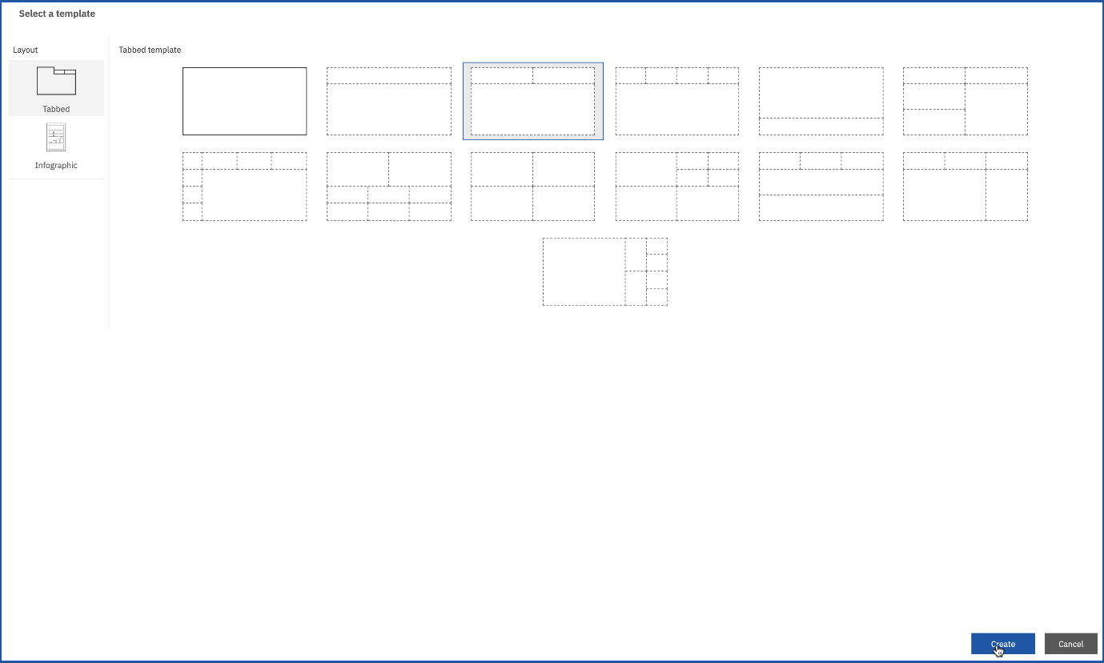

1. Now you have created a new dashboard using the dashboard template.

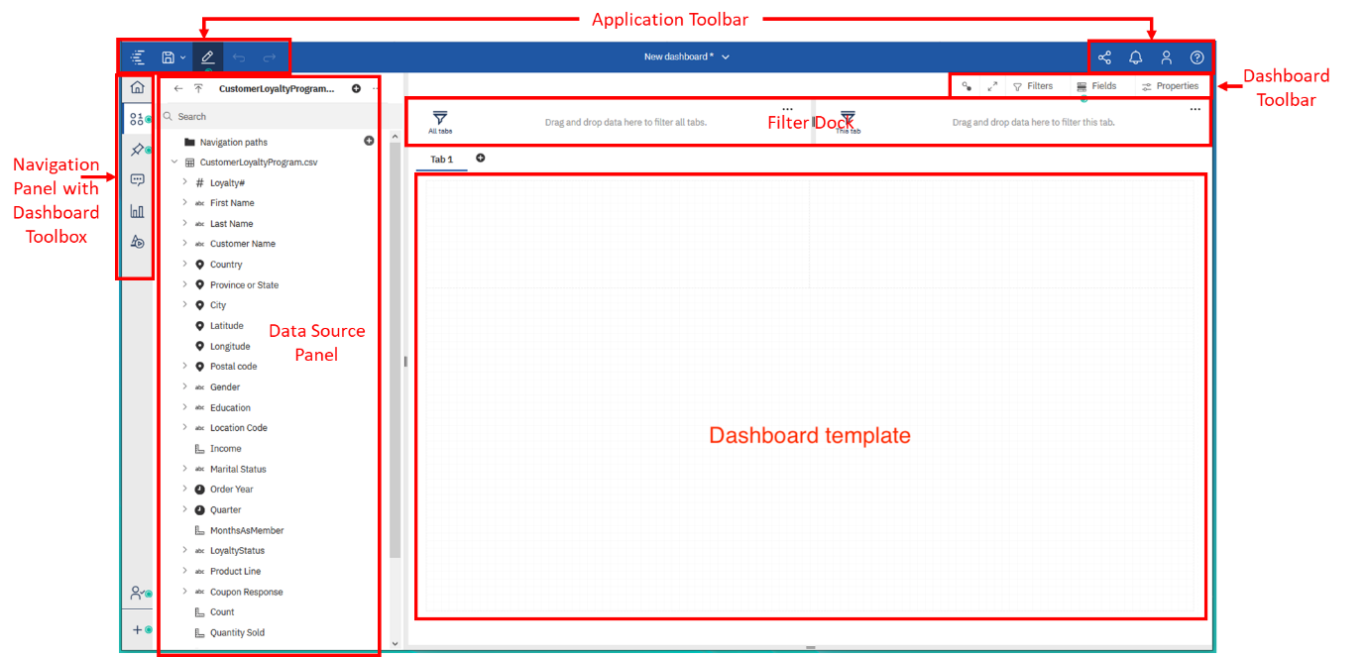

1. To save the newly created dashboard, press **CTRL+S**. Select **My content** as **Destination**. On the **Save as:** text field, write "Simple dashboard", and click **Save**.

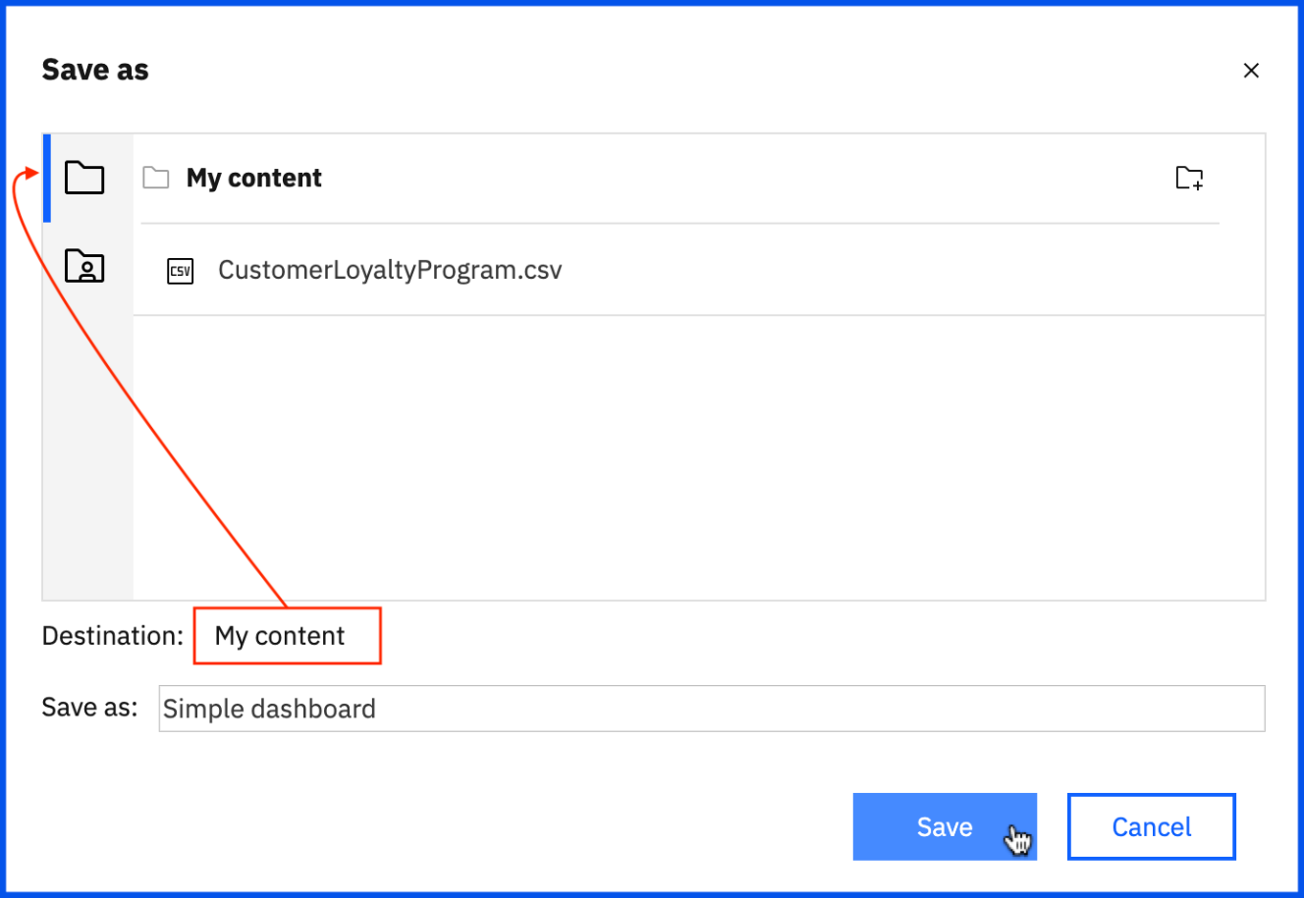

Exercise 3 : Create a Simple Dashboard

In this exercise, you will learn how to create a simple dashboard with Cognos Analytics.

1. As you build the dashboard, the location placement for Widgets in the dashboard template will be referenced using the following Panel numbers.

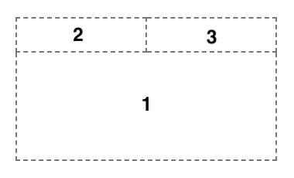

1. From the **Navigation** panel, select **Sources** to open the data source panel, if it is not already open. The **Data Source** panel displays the uploaded file **“CustomerLoyaltyProgram.csv”** as the Selected Source.



1. From the **Data Source** panel, press **CTRL** and select **Order Year, Quantity Sold, Product Line** and drag it to the center of **Panel 1**, releasing them once you see the **drop zone turn blue**.

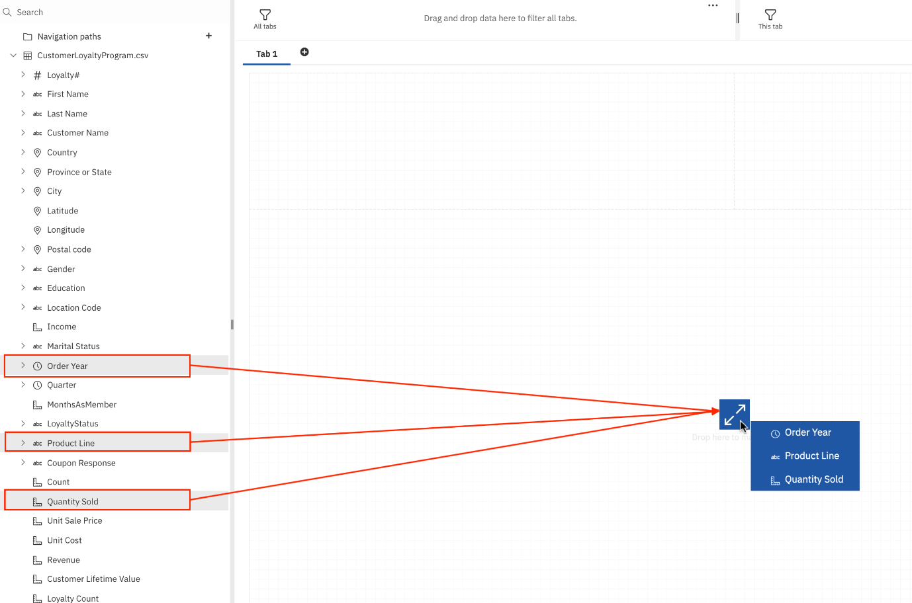

1. Click on the **Line chart in panel 1** to bring it into focus and render the **on-demand toolbar**.
2. From the on-demand toolbar, click **Edit the title**. Enter the title "Product Line Performance by Year" to the visualization.

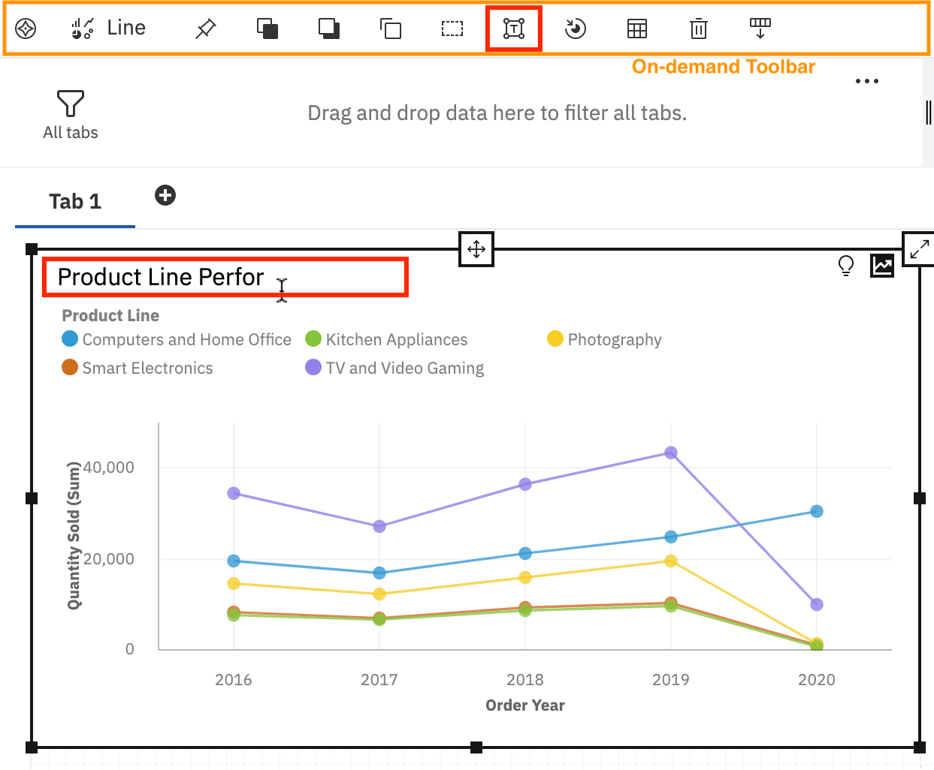

1. Highlight the **Title** to open the **Title on-demand toolbar**. From here, you can change the various properties on the title.

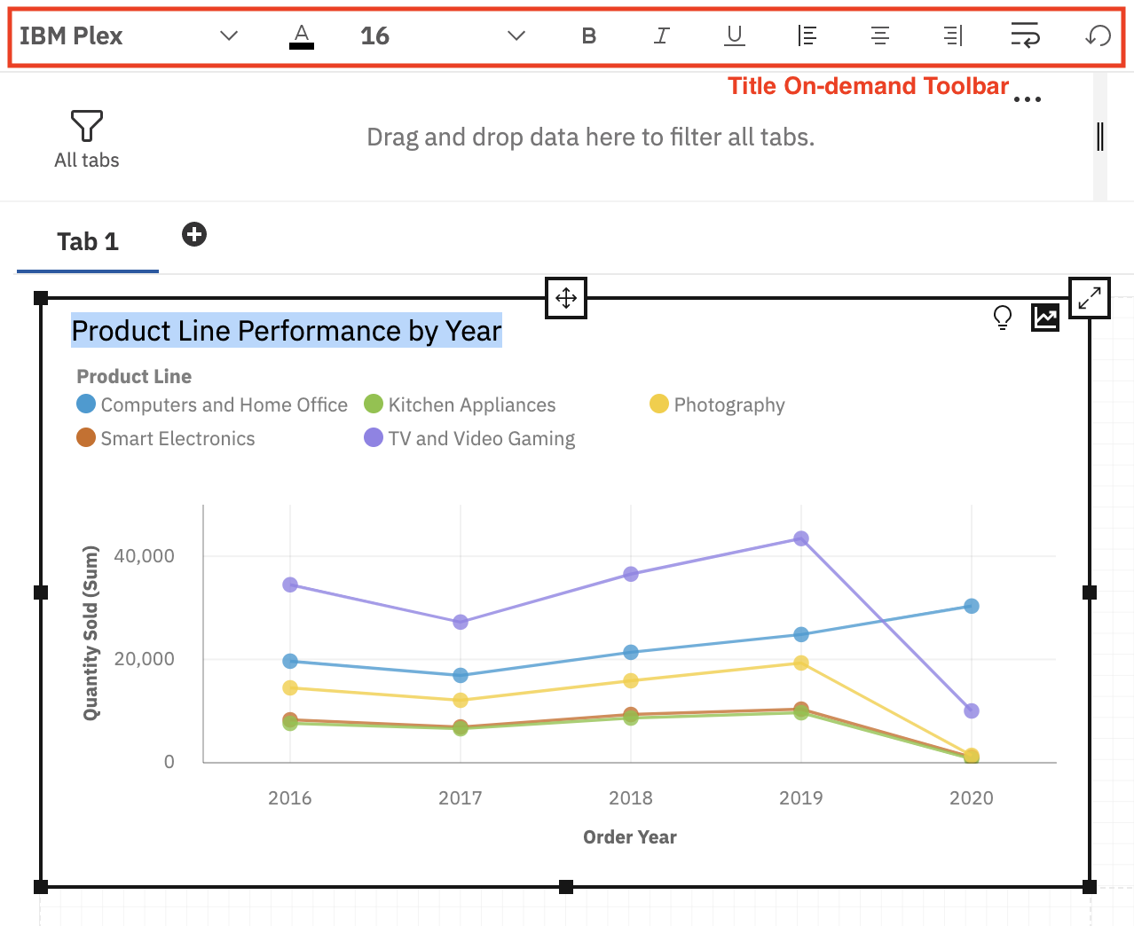

1. Click the **Color picker** icon, and change the color to **Red**, then click the font size drop-down and choose **18**.
2. From the **Data Source** panel, select **Quantity Sold** and drag it to the center of **Panel 2**, releasing it once you see the **drop zone turn blue**.

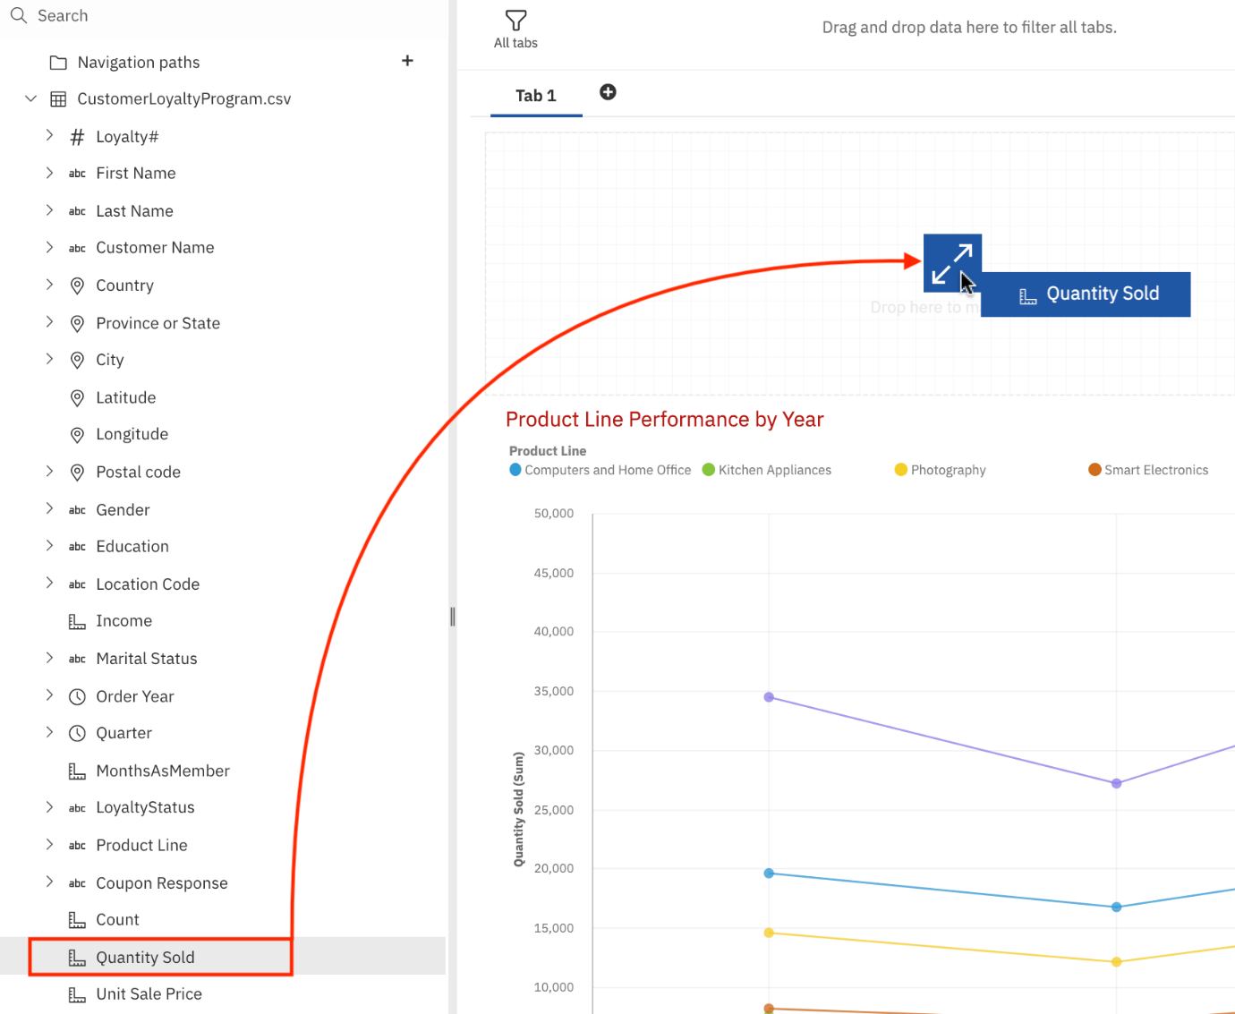

1. From the **Data Source** panel, select **Revenue** and drag it to the center of **Panel 3**, releasing it once you see the **drop zone turn blue**.

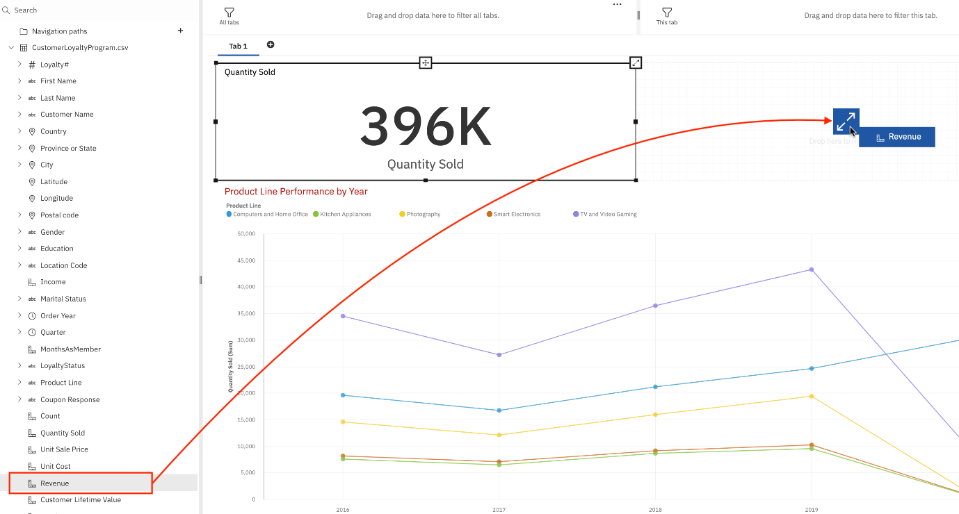

1. Click on the tab name **Tab 1** to bring up the Tab’s on-demand toolbar. Select the **Edit**.

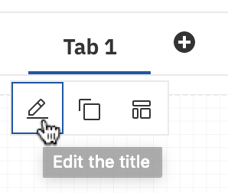

1. **Rename** the tab to "A - Product Sales”.
2. To save the current work of the dashboard, press **CTRL+S**.

Finally, your dashboard "A - Product Sales" should look like below:

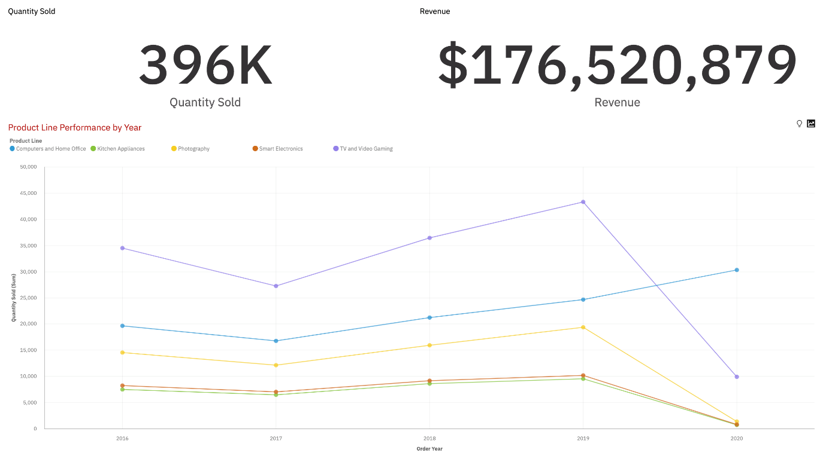

Congratulations! You have completed Lab 5A, and you are ready for the next topic.

Author(s)

* [Sandip Saha Joy](https://www.linkedin.com/in/sandipsahajoy?cm_mmc=Email_Newsletter-_-Developer_Ed%2BTech-_-WW_WW-_-SkillsNetwork-Courses-IBMDeveloperSkillsNetwork-DV0130EN-SkillsNetwork-20531073&cm_mmca1=000026UJ&cm_mmca2=10006555&cm_mmca3=M12345678&cvosrc=email.Newsletter.M12345678&cvo_campaign=000026UJ)

Other Contributor(s)

* [Steve Ryan](https://www.linkedin.com/in/stevelryan?cm_mmc=Email_Newsletter-_-Developer_Ed%2BTech-_-WW_WW-_-SkillsNetwork-Courses-IBMDeveloperSkillsNetwork-DV0130EN-SkillsNetwork-20531073&cm_mmca1=000026UJ&cm_mmca2=10006555&cm_mmca3=M12345678&cvosrc=email.Newsletter.M12345678&cvo_campaign=000026UJ)

Changelog

| **Date** | **Version** | **Changed by** | **Change Description** |
| --- | --- | --- | --- |
| 2020-09-23 | 1.2 | Steve Ryan | Post review changes |
| 2020-09-21 | 1.1 | Steve Ryan | ID review |
| 2020-09-17 | 1.0 | Sandip Saha Joy | Initial version created |

© IBM Corporation 2020. All rights reserved.