

Hands-on Lab 6: Advanced Dashboard Capabilities in Cognos Analytics

**Estimated time needed:** 30 minutes

In this lab, you will learn and leverage some advanced Cognos Analytics dashboard capabilities. You will learn how to create calculations, how to keep/exclude data points from a visualization, how to set top/bottom on a visualization, how to create and leverage navigation paths and lastly, how to filter data in a dashboard.

Software Used in this Lab

Like the videos in the course, for the hands-on labs we will be using IBM Cognos Analytics trial version (currently limited to 30 days) as this is available at no charge.

Dataset Used in this Lab

The dataset used in this lab comes from the VM designed to showcase IBM Cognos Analytics. Source: [https://www.ibm.com/cloud/garage/dte/tutorial/ibm-cognos-analytics-1113-getting-started-exploration-0](https://www.ibm.com/cloud/garage/dte/tutorial/ibm-cognos-analytics-1113-getting-started-exploration-0?cm_mmc=Email_Newsletter-_-Developer_Ed%2BTech-_-WW_WW-_-SkillsNetwork-Courses-IBMDeveloperSkillsNetwork-DV0130EN-SkillsNetwork-20531073&cm_mmca1=000026UJ&cm_mmca2=10006555&cm_mmca3=M12345678&cvosrc=email.Newsletter.M12345678&cvo_campaign=000026UJ&cm_mmc=Email_Newsletter-_-Developer_Ed%2BTech-_-WW_WW-_-SkillsNetwork-Courses-IBMDeveloperSkillsNetwork-DV0130EN-SkillsNetwork-20531073&cm_mmca1=000026UJ&cm_mmca2=10006555&cm_mmca3=M12345678&cvosrc=email.Newsletter.M12345678&cvo_campaign=000026UJ). This dataset is published by IBM. You can download the dataset file directly from here: [CustomerLoyaltyProgram.csv](https://cf-courses-data.s3.us.cloud-object-storage.appdomain.cloud/IBMDeveloperSkillsNetwork-DV0130EN-SkillsNetwork/Hands-on%20Labs/Lab%206%20-%20%20Advanced%20Dashboard%20Capabilities%20in%20Cognos%20Analytics/CustomerLoyaltyProgram.csv)

Objectives

After completing this lab, you will be able to:

* Start a new dashboard.
* Create calculations.
* Keep/exclude data points from a visualization.
* Set top/bottom on a visualization.
* Create and leverage navigation paths.
* Filter data in a dashboard.

Exercise 1 : Start a New Dashboard

In this exercise, you will start a new dashboard for working with advanced Cognos Analytics dashboard capabilities.

1. To sign in to the Cognos Analytics platform with your IBMid, go to [myibm.ibm.com/dashboard/](https://myibm.ibm.com/dashboard?cm_mmc=Email_Newsletter-_-Developer_Ed%2BTech-_-WW_WW-_-SkillsNetwork-Courses-IBMDeveloperSkillsNetwork-DV0130EN-SkillsNetwork-20531073&cm_mmca1=000026UJ&cm_mmca2=10006555&cm_mmca3=M12345678&cvosrc=email.Newsletter.M12345678&cvo_campaign=000026UJ).
2. Enter your IBMid and password.
3. Scroll down and click **Launch**.

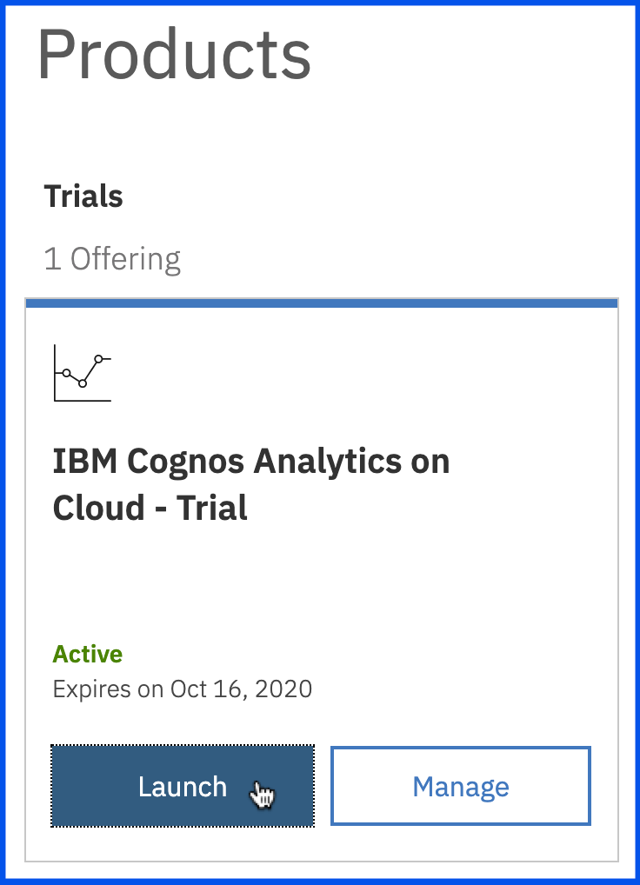

1. From the **Recent** section, click on the uploaded data file **CustomerLoyaltyProgram.csv**.

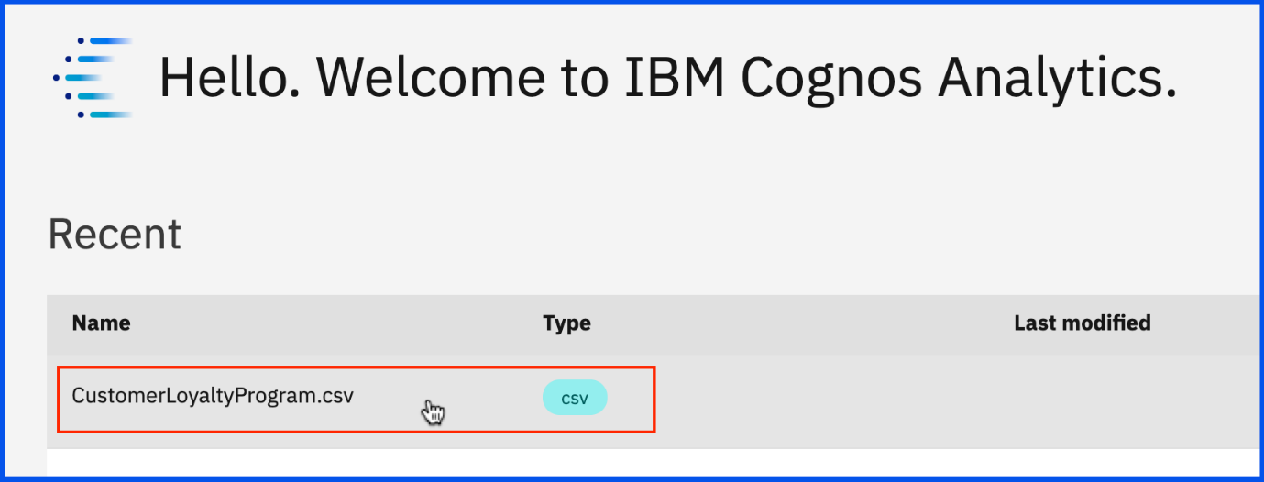

1. The Template window will be displayed, allowing you to select the type of dashboard and the template style. Select the **tabbed dashboard style**. This will allow you to have multiple pages for your dashboards. Select the **five-panel template**, then click **Create**.

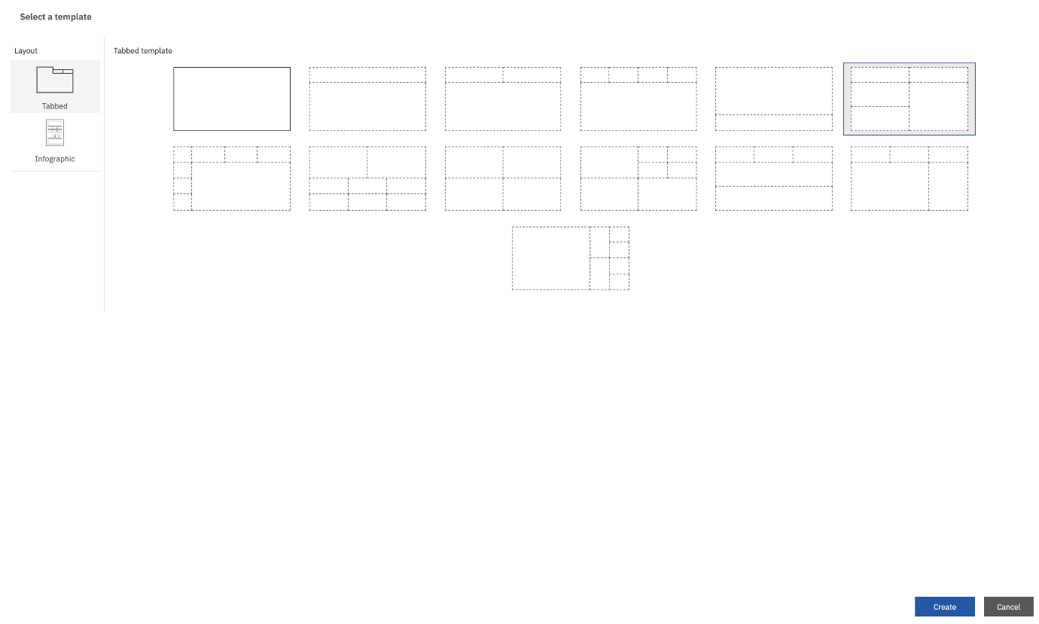

1. To save the newly created dashboard, press **CTRL+S**. Select 'My content' as the Destination. On the **Save as:** text field, type "Advanced dashboard", and click **Save**.

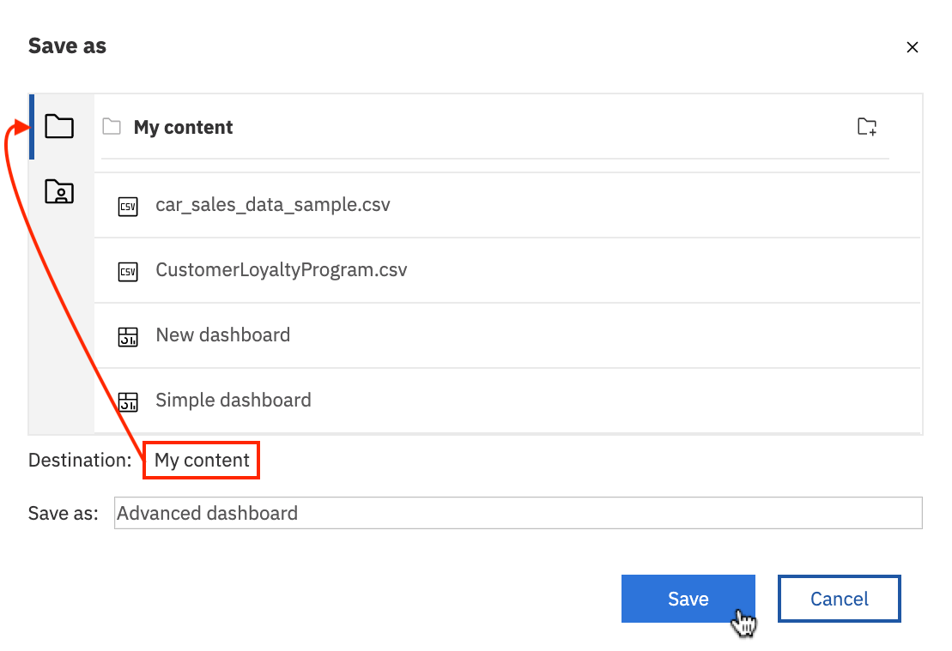

1. As you build the dashboard, the location placement for Widgets in the dashboard template will be referenced using the following Panel numbers.

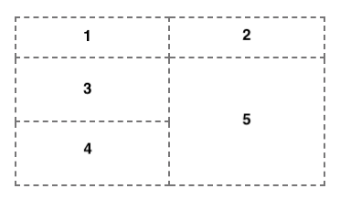

1. From the **Data Source panel**, select **Revenue** and drag it to the center of **Panel 1**, releasing it once you see the **drop zone turn blue**.

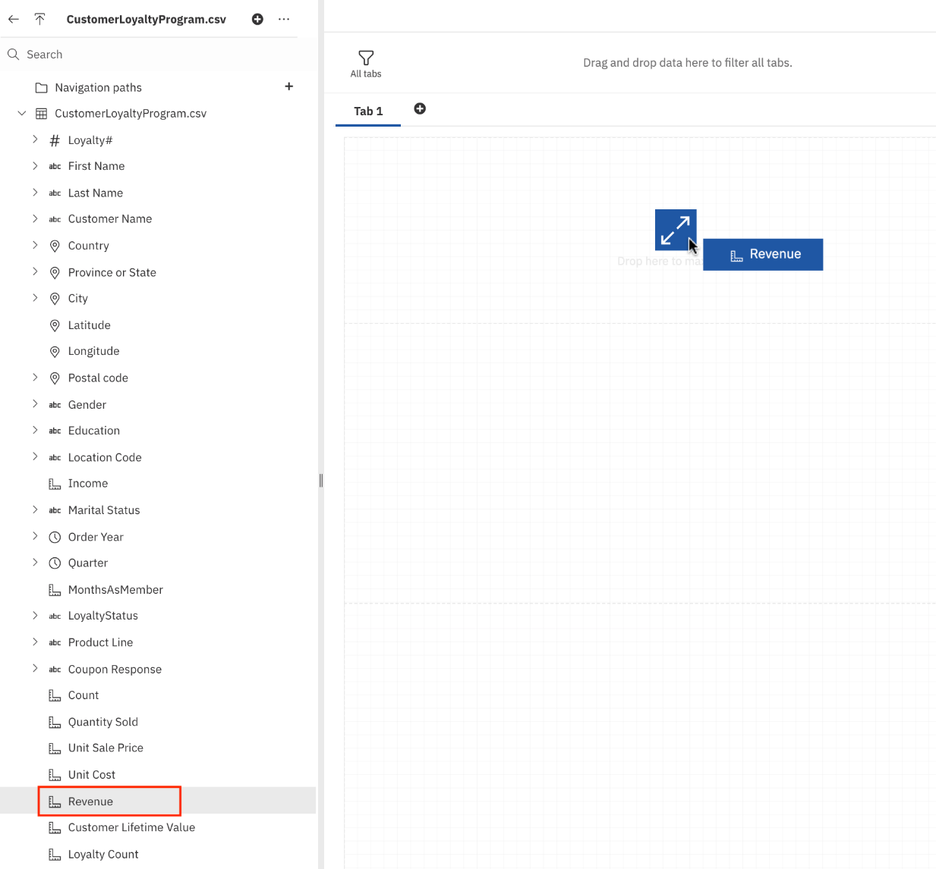

1. Click on the **Summary chart in Panel 1** to bring it into focus. From the on-demand toolbar, click **Summarize**. Then select **Average**.

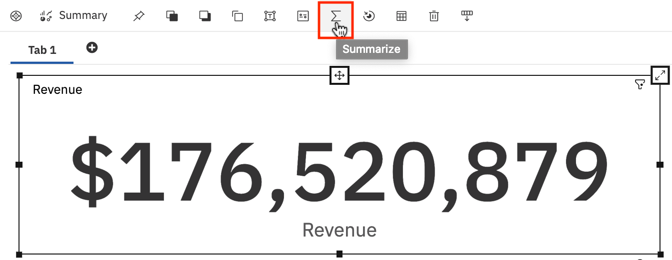  
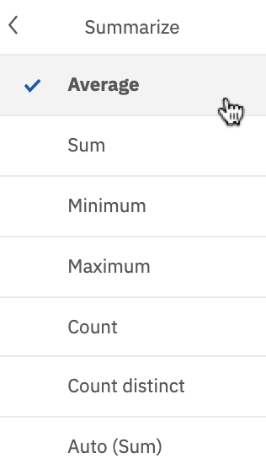

1. Click on the **Summary chart in Panel 1** if needed to bring it into focus. From the on-demand toolbar, click **Edit the title**. Enter the title **"Average Revenue"** to the visualization.
2. From the **Navigation** panel, select **Widgets** to open the widgets panel. Drag and drop **Money coin** from **Shapes** to the center of **Panel 1**.

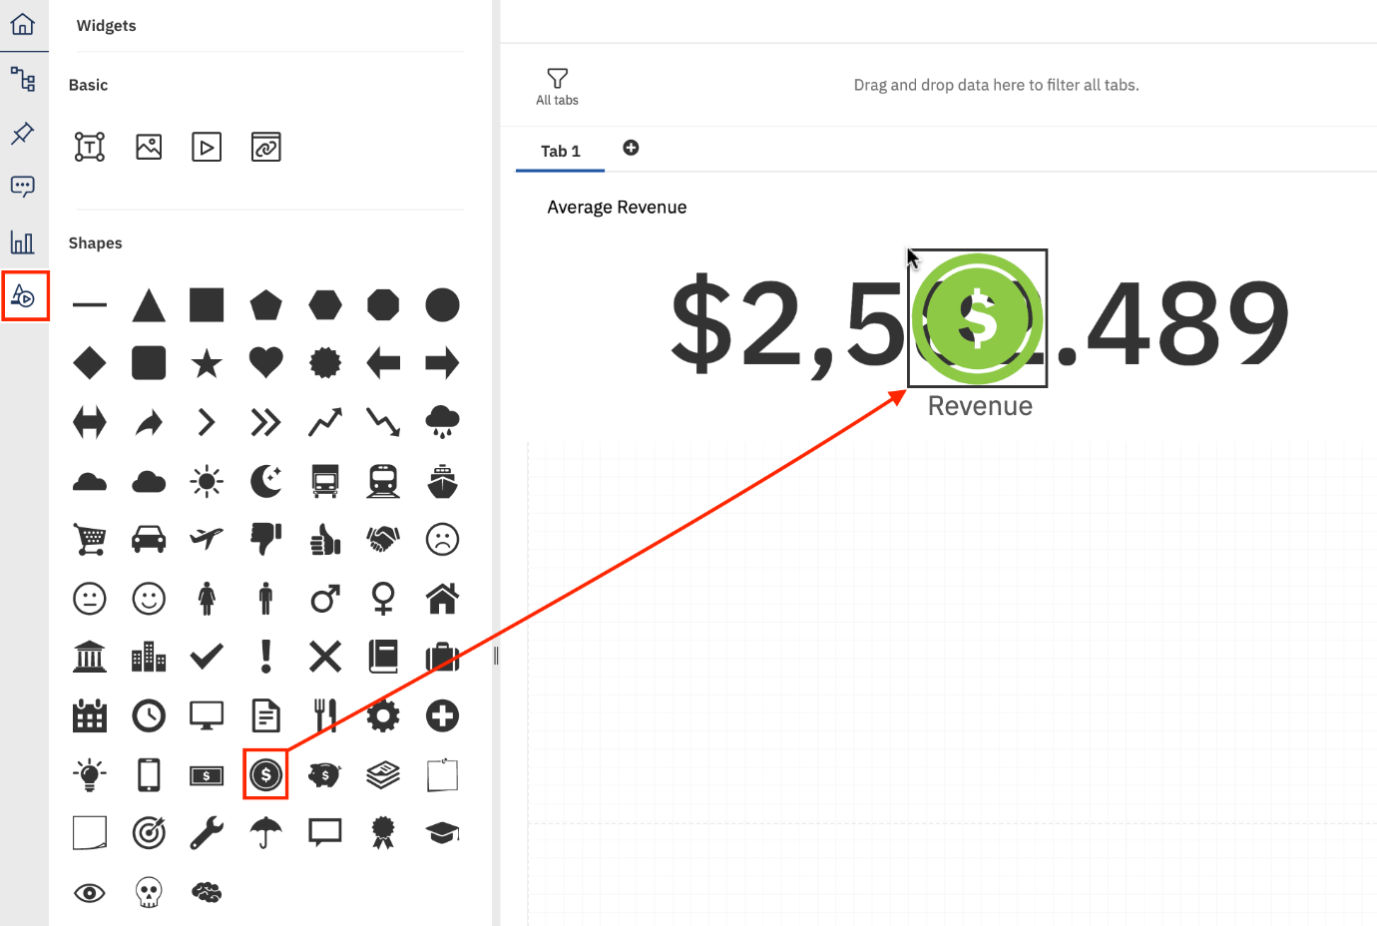

1. To save the current work in the dashboard, press **CTRL+S**.
2. Your **Panel 1 widget** should look like the one below:

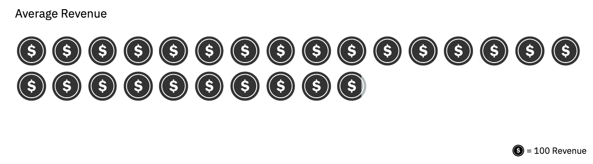

Exercise 2 : Working with Advanced Cognos Analytics Dashboard Capabilities

In this exercise, you will practice some advanced Cognos Analytics dashboard capabilities.

* Task A : Create Calculations
* Task B : Keep/Exclude Data Points from a visualization
* Task C : Set Top/Bottom on a visualization
* Task D : Create and Leverage Navigation Paths
* Task E : Filter Data in Current tab

Task A : Create Calculations

1. From the **Navigation** panel, select **Sources** to open the data source panel, if it is not already open. The **Data Source** panel displays the uploaded file **“CustomerLoyaltyProgram.csv”** as the Selected Source.
2. Right-click on the **CustomerLoyaltyProgram.csv** of data source panel and select **Calculation**.

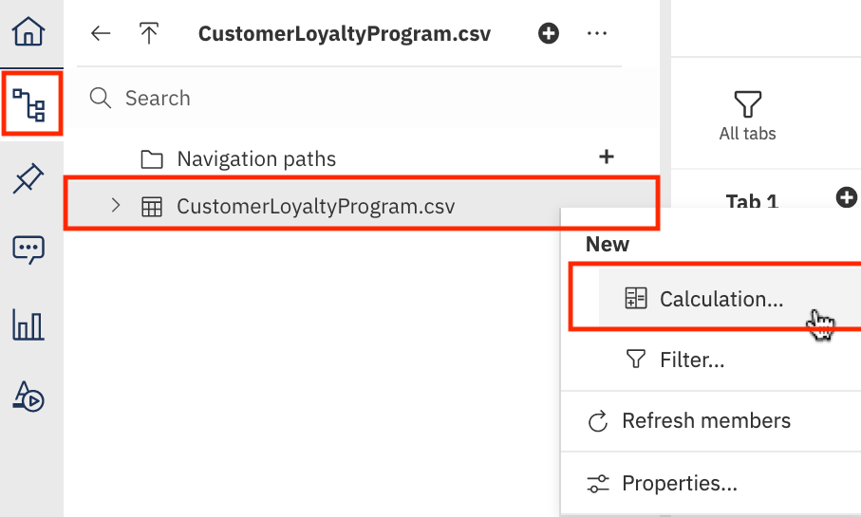

1. Name the calculation as **"Margin"**. From panel **Components** to the field **Expression**, drag and drop **Unit_Sale_Price**, type minus **-** and then drag and drop **Unit_Cost**. Click **OK**.

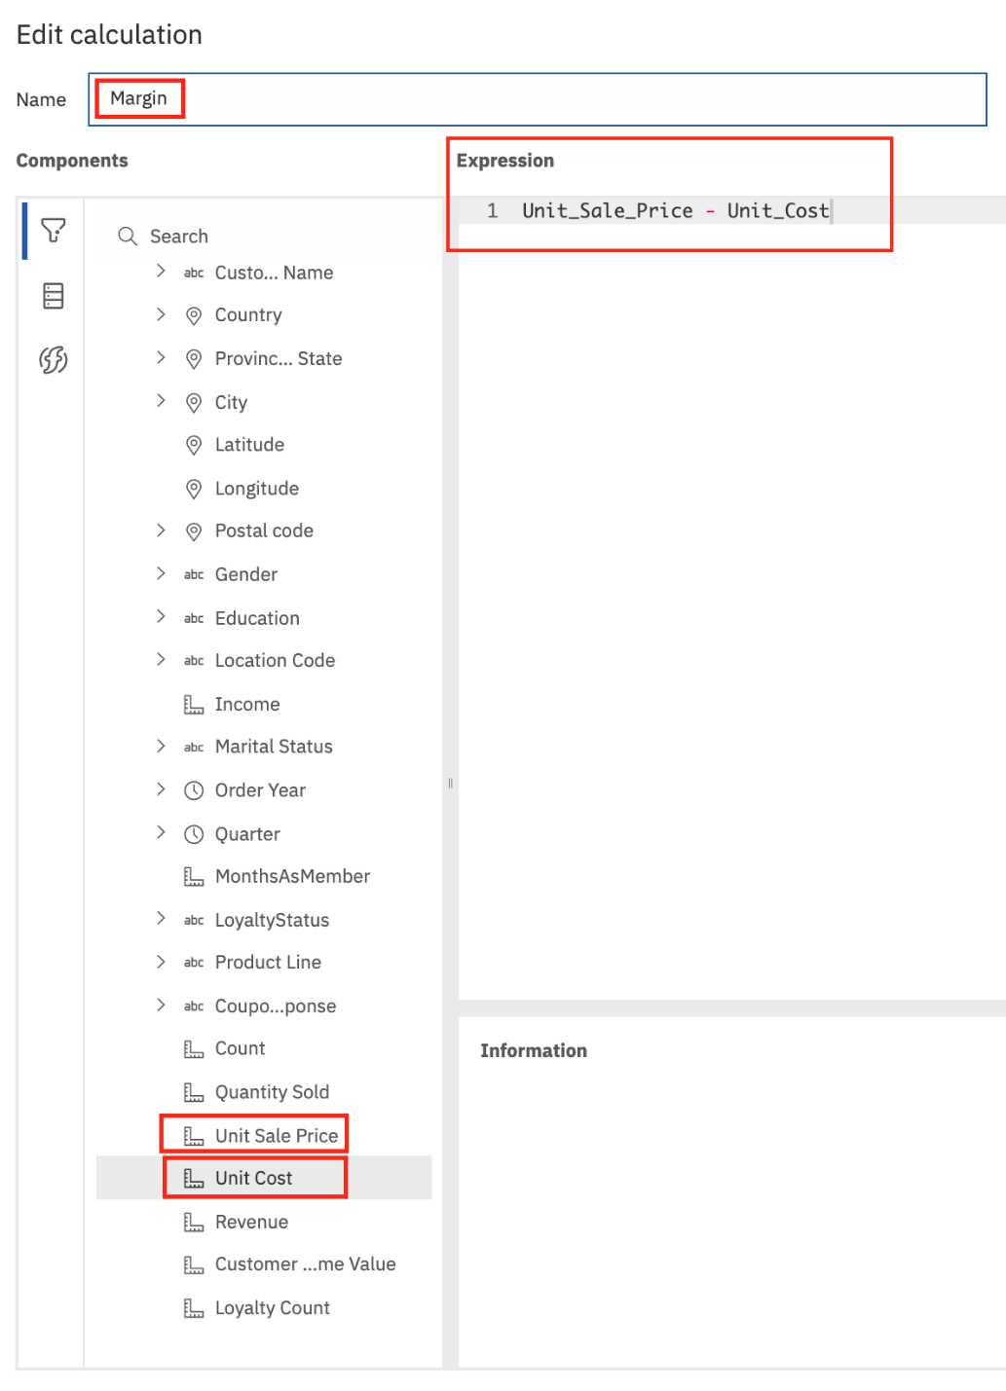

1. On the Data Source panel, expand CustomerLoyaltyProgram.csv, if needed. From the **Data Source** panel, select **Margin** and drag it to the center of **Panel 2**, releasing it once you see the **drop zone turn blue**.
2. Click on the **Summary chart in Panel 2** to bring it into focus. Right-click on the **Summary chart in Panel 2** and select **Summarize**. Then select **Average**.
3. Right-click on the **Summary chart in Panel 2** and select **Format**. Then select **Currency**. Finally select **$(USD)** as the currency.

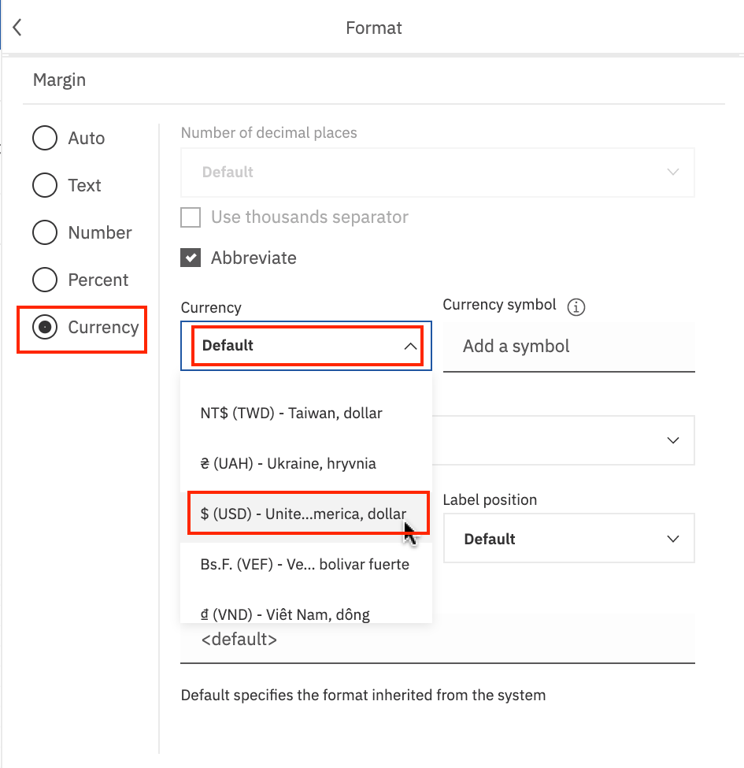

1. Click on the **Summary chart in Panel 2** if needed to bring it into focus. From the on-demand toolbar, click **Edit the title**. Enter the title **"Average Margin"** to the visualization.
2. To save the current work in the dashboard, press **CTRL+S**.
3. Your **Panel 2 widget** should look like the one below:

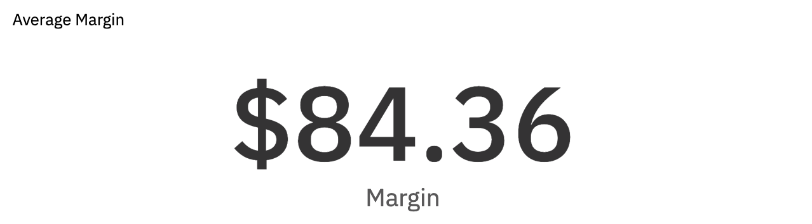

Task B : Keep/Exclude Data Points from a Visualization

1. On the Data Source panel, expand CustomerLoyaltyProgram.csv, if needed. From the **Data Source** panel, press **CTRL** and select **Revenue, Product Line** and drag it to the center of **Panel 3**, releasing it once you see the **drop zone turn blue**.
2. From the **Data Source** panel, press select **Location Code** and drag it to the **drop zone of Color** of **Panel 3**.

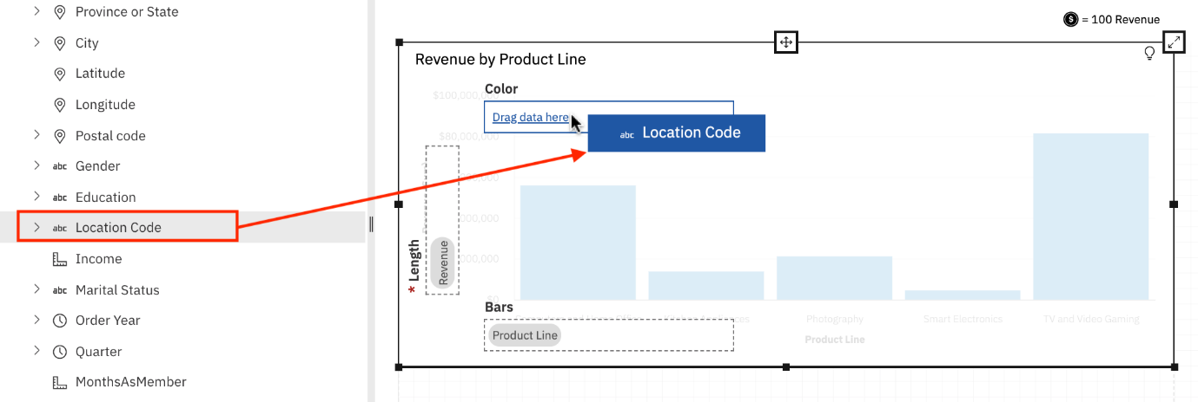

1. Right-click on the **Suburban** data point of the panel 3 visualization. Select **Exclude**.

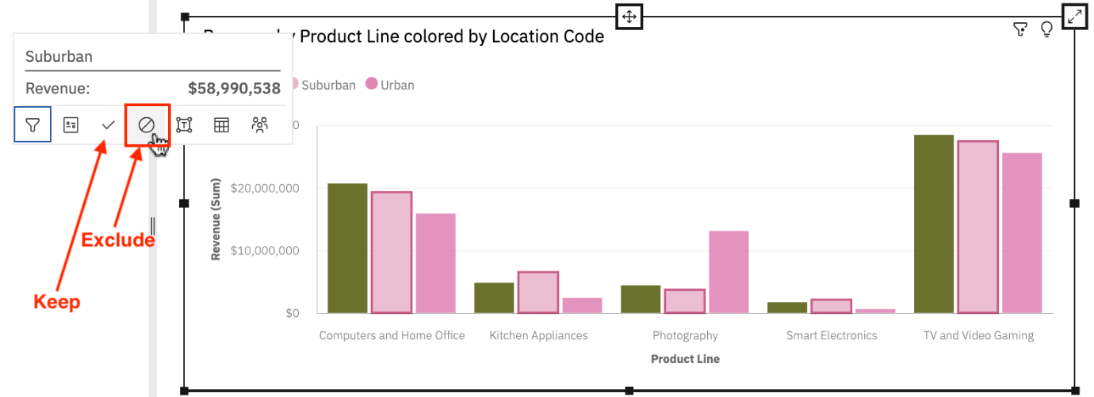

1. To save the current work in the dashboard, press **CTRL+S**.
2. Your **Panel 3 widget** should look like the one below:

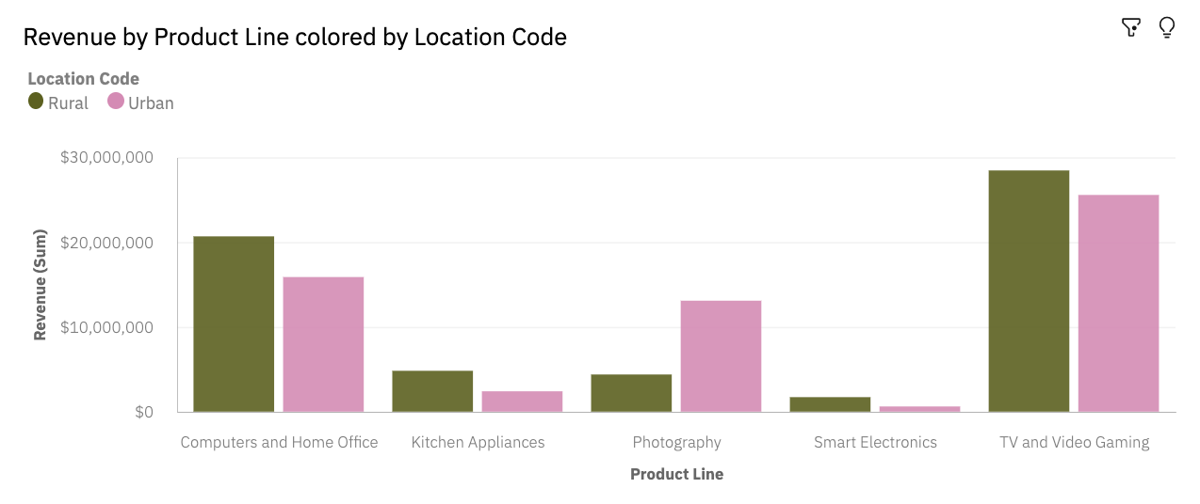

Task C : Set Top/Bottom on a Visualization

1. From the **Data Source** panel, press **CTRL** and select **Quantity Sold, City** and drag it to the center of **Panel 4**, releasing it once you see the **drop zone turn blue**.
2. Click on the **chart in panel 4** to bring it into focus and render the **on-demand toolbar**.
3. Click the **Change Visualization** button in the on-demand toolbar. Use the **arrow “>”** to expand **All Visualizations**. Find and select **Column**.
4. Click on the **Column chart in panel 4** to bring it into focus. Right-click on the axis label **Quantity Sold (Sum)** and select **Top or bottom**.

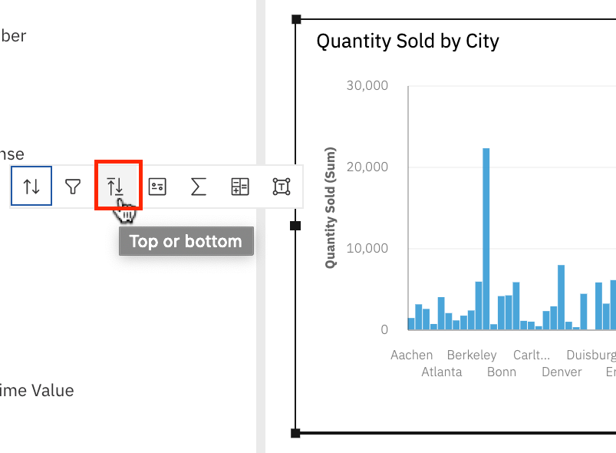

1. Set the **value of Number of results** as **10**. Select **Top count**.

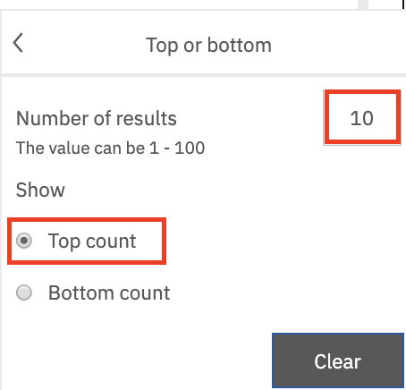

1. From the on-demand toolbar, click **Edit the title**. Enter the title **"Top 10 Quantity Sold by City"** to the visualization.
2. To save the current work in the dashboard, press **CTRL+S**.
3. Your **Panel 4 widget** should look like the one below:

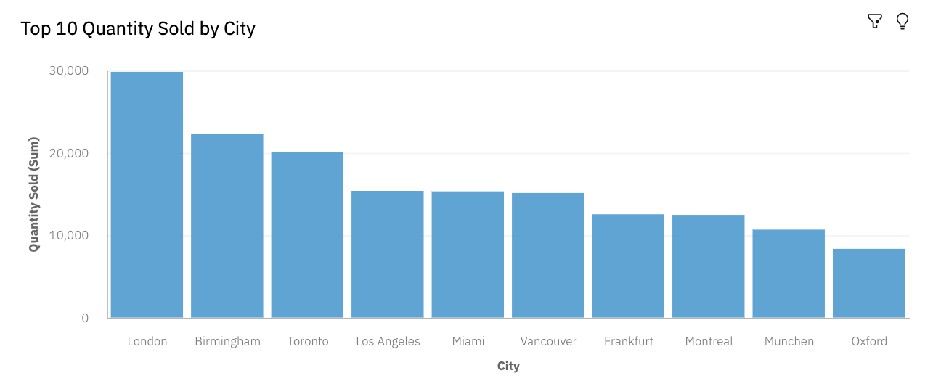

Task D : Create and Leverage Navigation Paths

1. Click on the **Create navigation path** of **Navigation paths** of the data source panel.

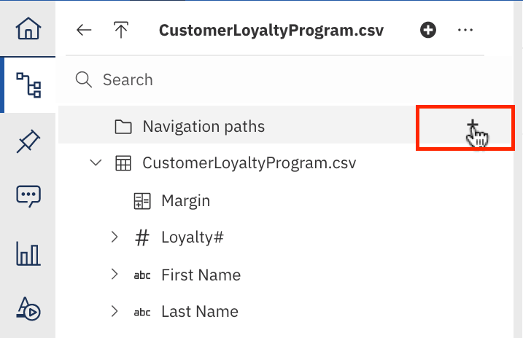

1. In the **Create navigation path** dialog box, expand CustomerLoyaltyProgram.csv, if needed. Select, drag and release **Order Year, Quarter, Country, City** sequentially, maintaining the order(shown on the image below) on the right panel. Once done, click **OK**.

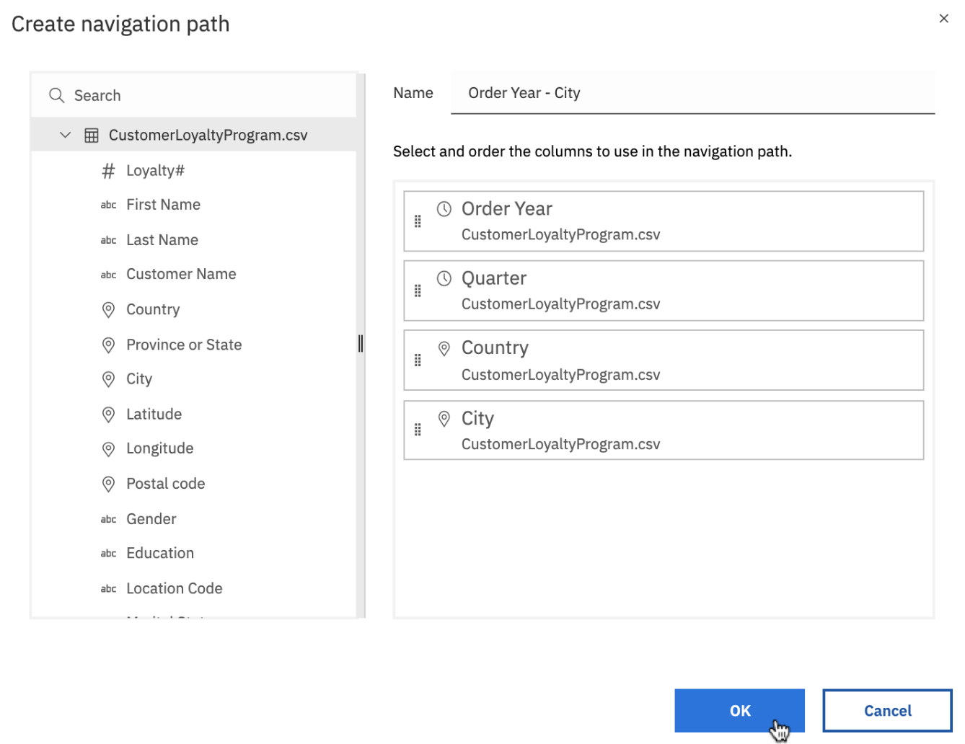

1. From the **Data Source** panel, press **CTRL** and select **Margin, Product Line, Order Year** and drag it to the center of **Panel 5**, releasing it once you see the **drop zone turn blue**.
2. Click on the **chart in panel 5** to bring it into focus and render the **on-demand toolbar**.
3. Click the **Change Visualization** button in the on-demand toolbar. Use the **arrow “>”** to expand **Recommended visualizations**. Find and Select **Bar**.
4. Right-click on the axis label **Order Year**. Select **Navigate**.

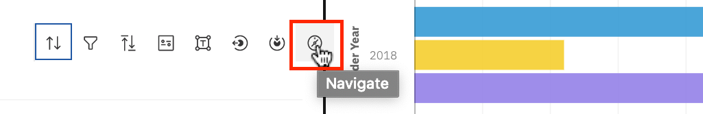

1. One by one select **Order Year, Quarter, Country, City** to navigate among the columns of the navigation paths and observe the resulting panel 5 visualization. Lastly, keep the **Order Year** selected.

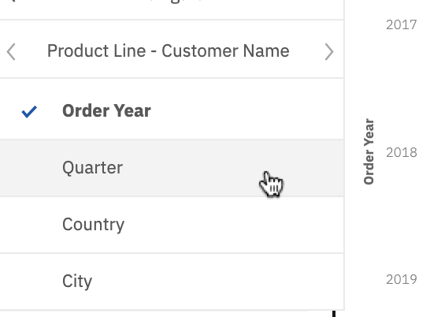

1. Alternative interactive way with Drill down/back:
   * Click on the **chart in panel 5** to bring it into focus if needed.
   * Right-click on **2016 Smart Electronics bar** of the bar chart.
   * Select **Drill down**.

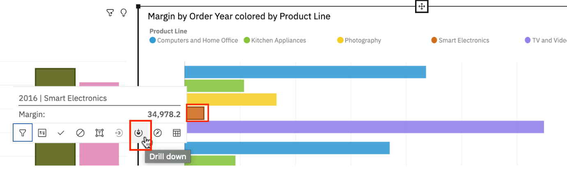

* + Now right-click on **Q1 Smart Electronics bar** of the bar chart.
  + Select **Drill back**.

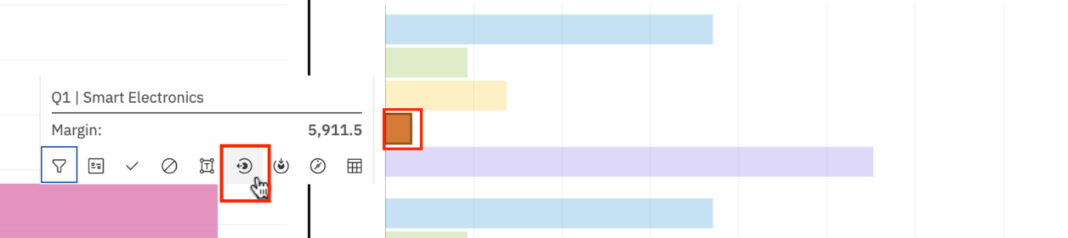

1. To save the current work in the dashboard, press **CTRL+S**.
2. Your **Panel 5 widget** should look like the one below:

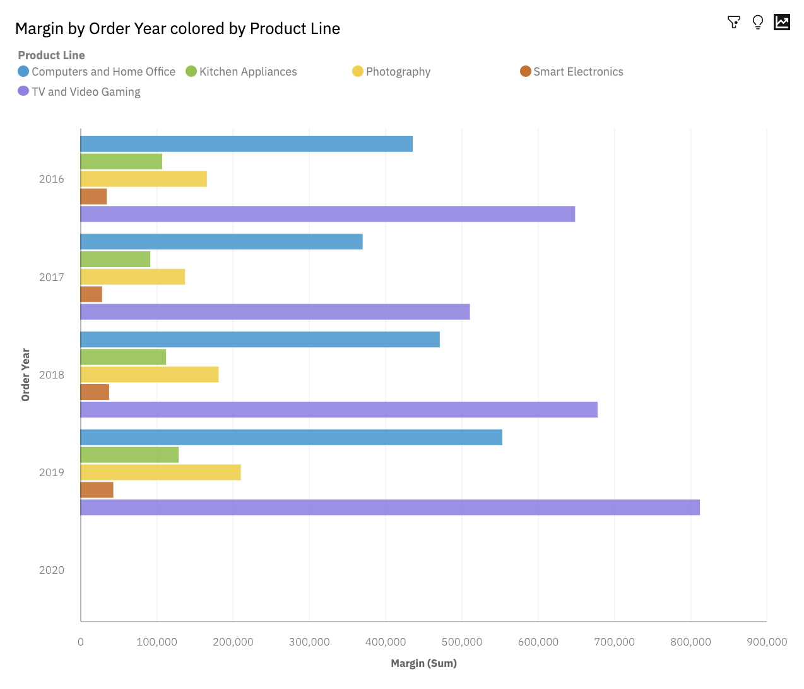

Task E : Filter Data in the Current Tab

1. If required, click **Filters** in the **Dashboard Toolbar** to display the filters pane.



1. From the **Data Source** panel, select **Product Line** and drag and release it on the **This tab** filter panel on the right-hand side.

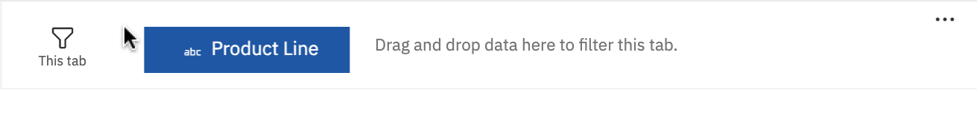

1. Click on the **Product Line** filter tab of **This tab** filter panel. Select **Computers and Home Office, Photography, TV and Video Gaming**. Click **OK**.

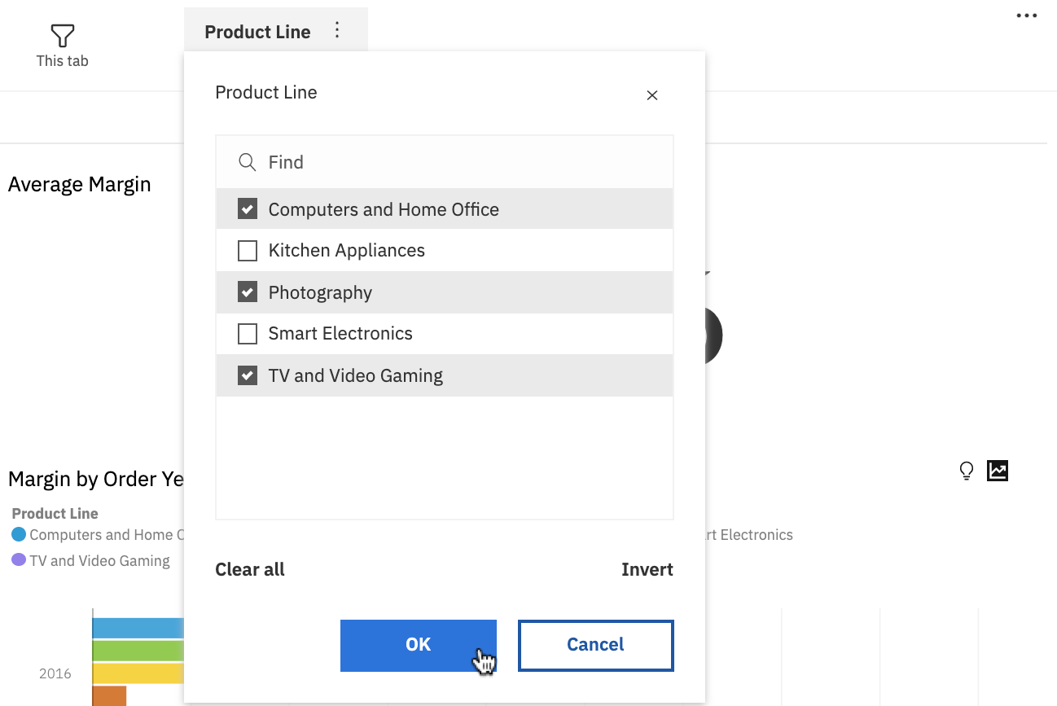

1. To save the current work in the dashboard, press **CTRL+S**.

Finally, your dashboard should look like below:

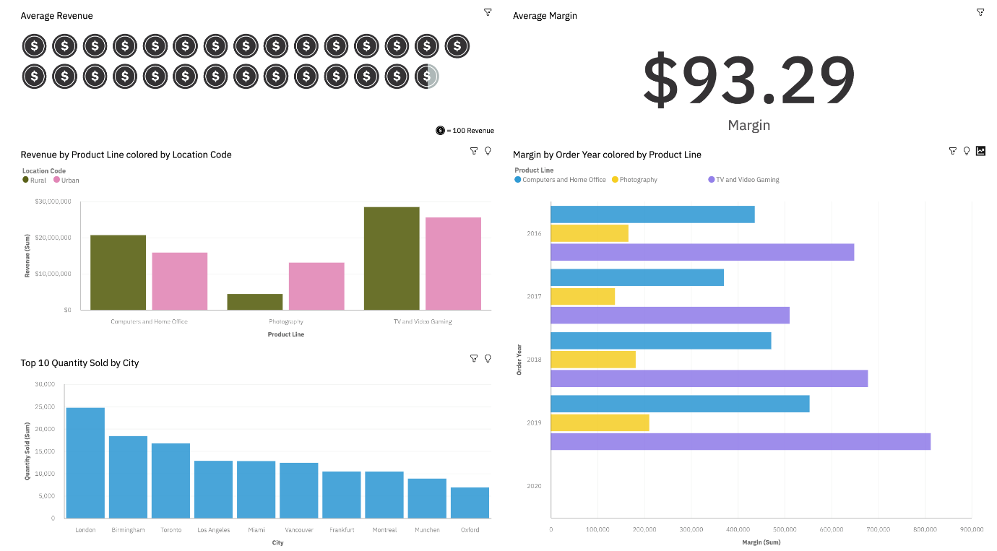

Congratulations! You have completed Lab 6, and you are ready for the next topic.

Author(s)

* [Sandip Saha Joy](https://www.linkedin.com/in/sandipsahajoy?cm_mmc=Email_Newsletter-_-Developer_Ed%2BTech-_-WW_WW-_-SkillsNetwork-Courses-IBMDeveloperSkillsNetwork-DV0130EN-SkillsNetwork-20531073&cm_mmca1=000026UJ&cm_mmca2=10006555&cm_mmca3=M12345678&cvosrc=email.Newsletter.M12345678&cvo_campaign=000026UJ)

Other Contributor(s)

* [Steve Ryan](https://www.linkedin.com/in/stevelryan?cm_mmc=Email_Newsletter-_-Developer_Ed%2BTech-_-WW_WW-_-SkillsNetwork-Courses-IBMDeveloperSkillsNetwork-DV0130EN-SkillsNetwork-20531073&cm_mmca1=000026UJ&cm_mmca2=10006555&cm_mmca3=M12345678&cvosrc=email.Newsletter.M12345678&cvo_campaign=000026UJ)

Changelog

| **Date** | **Version** | **Changed by** | **Change Description** |
| --- | --- | --- | --- |
| 2020-10-02 | 1.1 | Steve Ryan | ID review |
| 2020-09-24 | 1.0 | Sandip Saha Joy | Initial version created |

© IBM Corporation 2020. All rights reserved.