**LAB: Create your IBM Cloud Lite account**

**Lab Overview:**

In this lab, you will register for a Lite account on IBM Cloud. In this course and the other courses in this program, you will be performing hands-on labs using services in IBM Cloud. To use the IBM Cloud services, you need to create an IBM Cloud Lite account. There is NO CHARGE associated with creating this account, and neither do you have to share your credit card details.

**NOTE**: If you already have an IBM Cloud Lite account, you can skip this lab.

**Estimated time needed:** 10 minutes

Please follow the steps given below to create your Lite account on IBM Cloud.

1. Go to: [Create a free account on IBM Cloud](https://cloud.ibm.com/registration?cm_mmc=Email_Newsletter-_-Developer_Ed%2BTech-_-WW_WW-_-SkillsNetwork-Courses-IBM-DB0100EN-SkillsNetwork-23053252-www-coursera-org&cm_mmca1=000026UJ&cm_mmca2=10006555&cm_mmca3=M12345678&cvosrc=email.Newsletter.M12345678&cvo_campaign=000026UJ&cm_mmca1=000026UJ&cm_mmca2=10006555&cm_mmca3=M12345678&cvosrc=email.Newsletter.M12345678&cvo_campaign=000026UJ)
2. In the **Email** box, enter your email address and click the arrow.

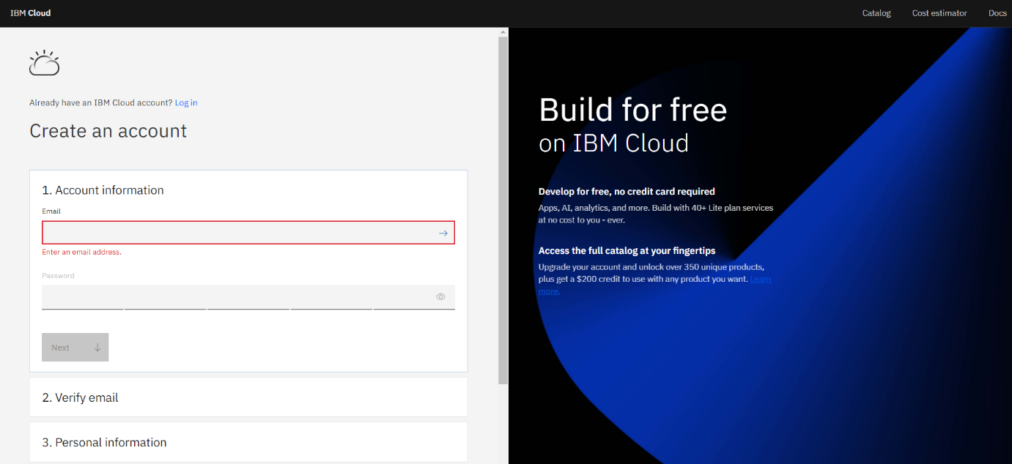  
*Figure 1-1*

1. When your email address is accepted, you will be asked to create a **Password**. Add a password of your choice. A prompt will guide you on the characters, numbers, and capitalization rules to be followed for creating the password.

Click **Next** to proceed.

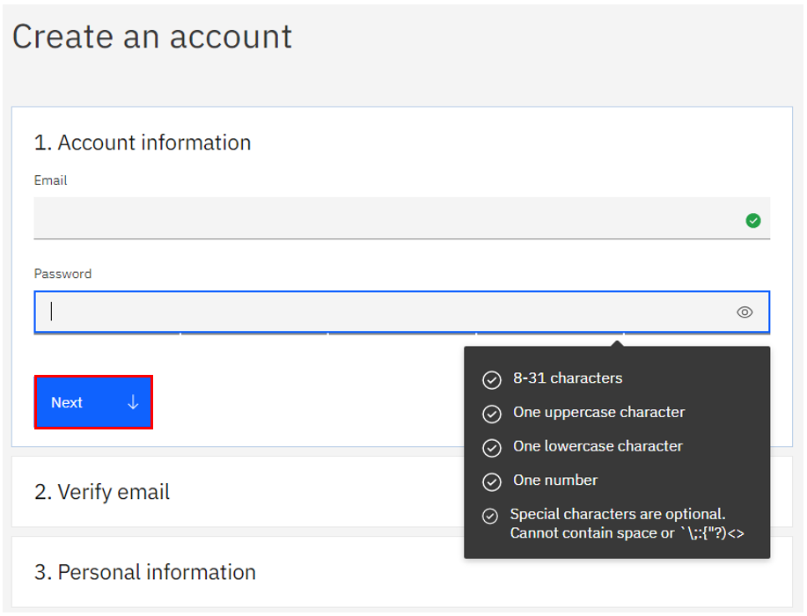  
*Figure 1-2*

1. A 7-digit verification code will be sent to your email id.

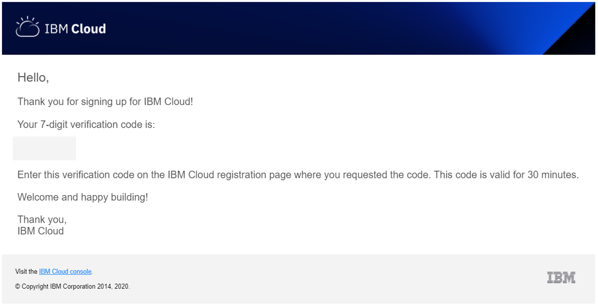  
*Figure 1-3*

1. Enter this verification code in the **Verification code** box and click **Next**.

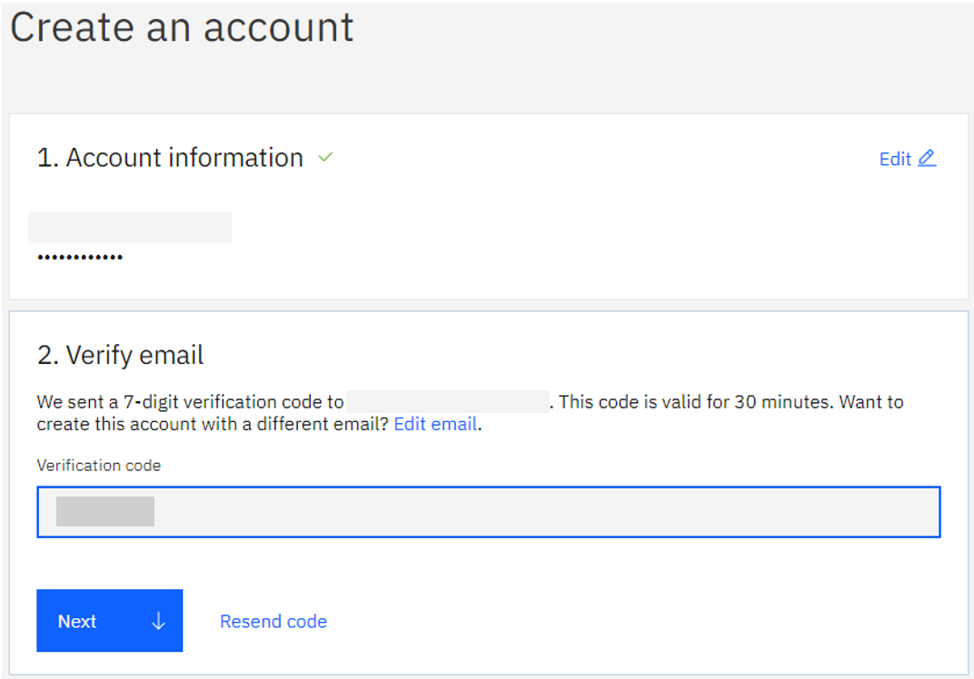  
*Figure 1-4*

1. You will be asked to enter your **Personal information**. This includes your **First name**, **Last name, and Country or region.**

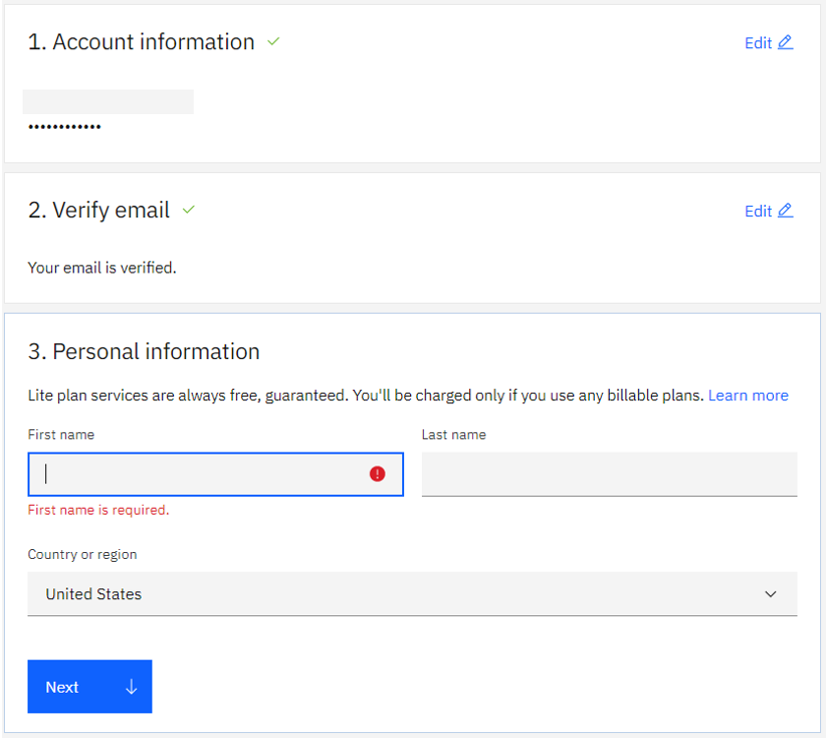  
*Figure 1-5*

Click **Next** to proceed.

1. If you would like IBM to keep you informed of products, services, and offerings, then check the **by email** box to accept the option to be notified by email.

Click on **Create account** to create your IBM Cloud Lite account.

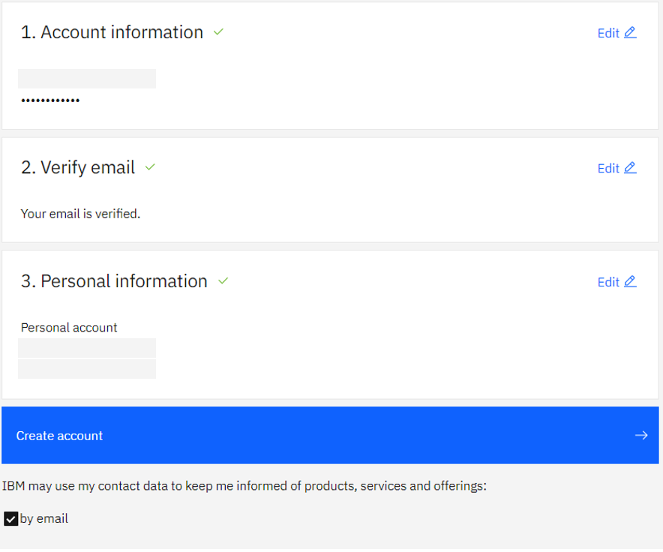  
*Figure 1-6*

This will take you to the **About your IBMid Account Privacy** page.

1. Click **Proceed** to log in to your account.

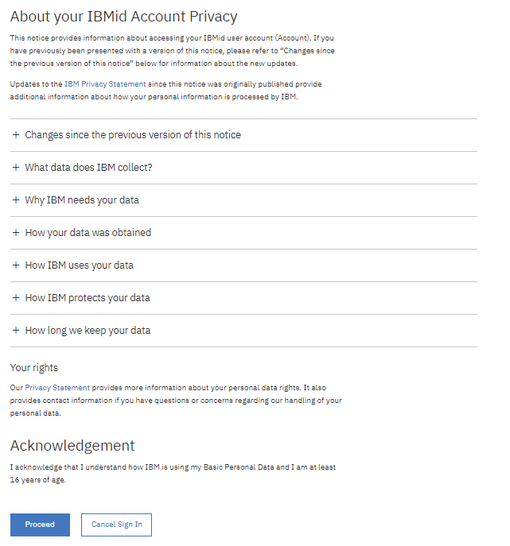  
*Figure 1-7*

Alternately, you can click on the **Log in to IBM Cloud** button in the confirmation email you receive once your account is created.

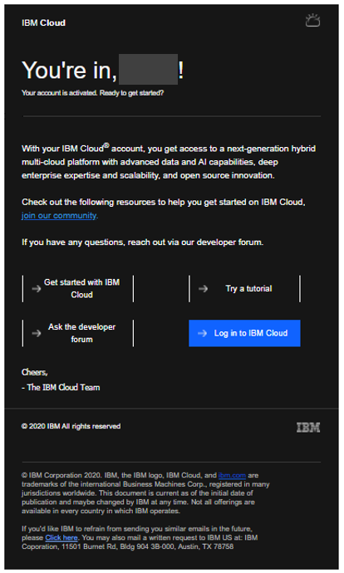  
*Figure 1-8*

This, too, will take you to the **About your IBMid Account Privacy** page since you are logging in to your account for the first time. Click **Proceed** to log in and begin using your IBM Cloud Lite account.

1. You are now logged in to your IBM Cloud Lite account.

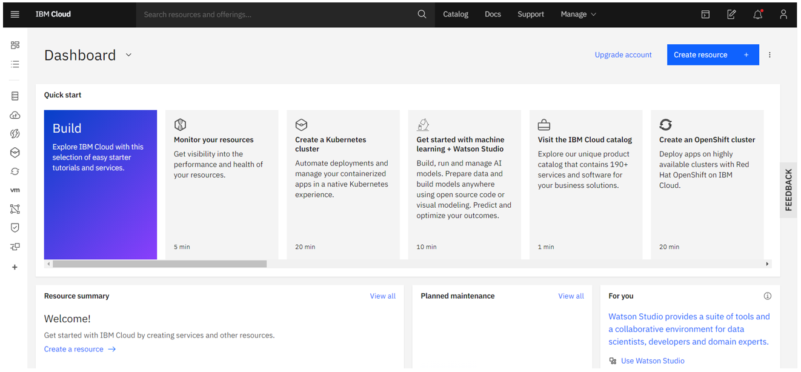  
*Figure 1-9*

Congratulations! You have successfully created your IBM Cloud Lite account.