Using loc, iloc and ix

**Effort: 15 mins**

Objective:

In this reading, you will learn about loc,iloc and ix

There are three ways to select data from a data frame in Pandas: *loc, iloc, and ix.*

loc

*loc* is primarily label based; when two arguments are used, you use column headers and row indexes to select the data you want. *loc* can also take an integer as a row or column number.

Examples of *loc* usage:

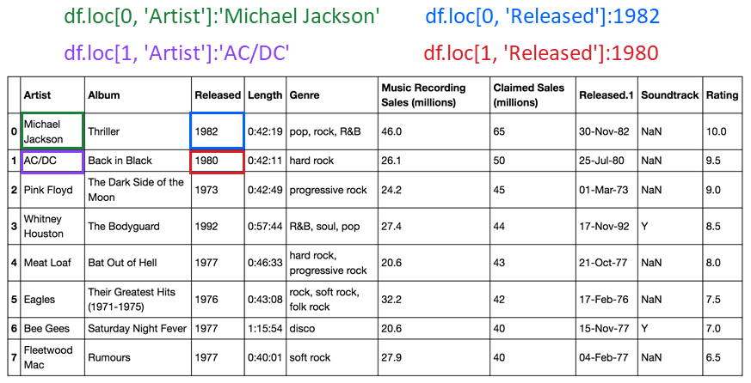 *loc* will return a *KeyError* if the requested items are not found.

iloc

*iloc* is integer-based. You use column numbers and row numbers to get rows or columns at particular positions in the data frame.

Examples of *iloc* usage:

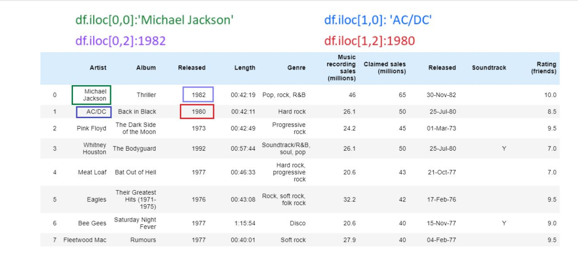

*iloc* will return an *IndexError* if the requested indexer is out-of-bounds.

ix

By default, *ix* looks for a label. If ix doesn't find a label, it will use an integer. This means you can select data by using either column numbers and row numbers or column headers and row names using *ix*.

In Pandas version 0.20.0 and later, *ix* is deprecated.

Using loc and iloc for slicing

You can also use *loc* and *iloc* to slice data frames and assign the values to a new data frame.

Creating a new dataframe with loc slicing

You can also slice data frames and assign the values to a new data frame using the column names. The code assigns the first three rows and all columns in between to the columns named Artist and Released. The result is a new data frame Z with the corresponding values.

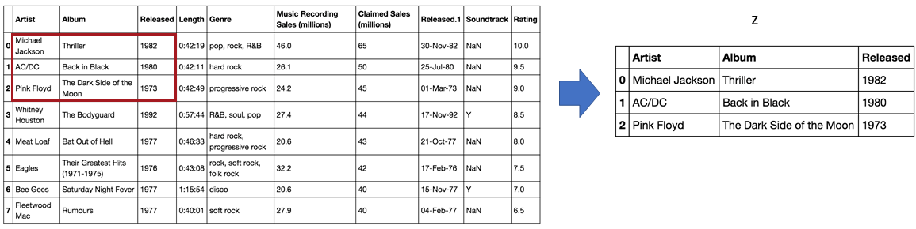

Creating a new dataframe with iloc slicing

In this example, we assign the first two rows and the first three columns to the variable Z. The result is a data frame comprised of the selected rows and columns.

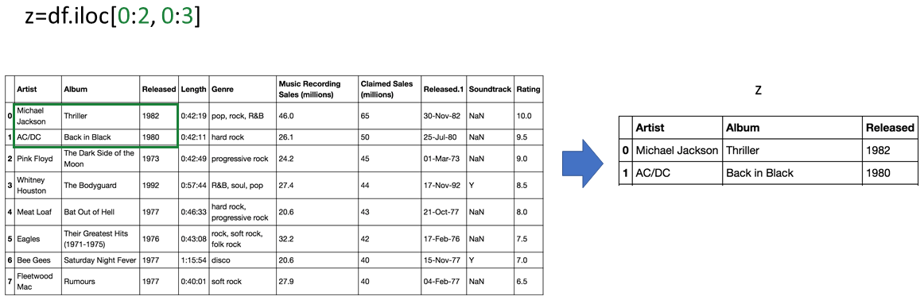

Author(s)

Joseph Santarcangelo