

Objective

After completing this lab, you will be able to:

1. Share your results
2. Get link to your notebook for peer review

Upload your Notebook

Once you complete your notebook you will have to share it. Select the icon on the top right a marked in red in the image below, a dialogue box should open, select the option all content excluding sensitive code cells.

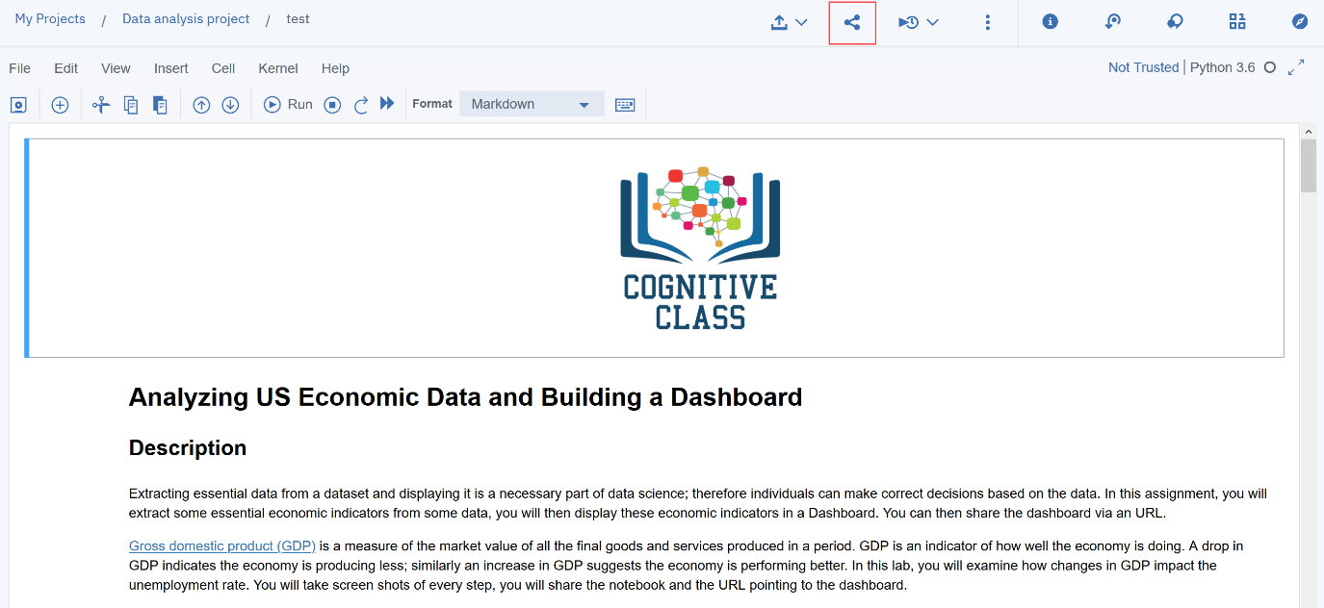 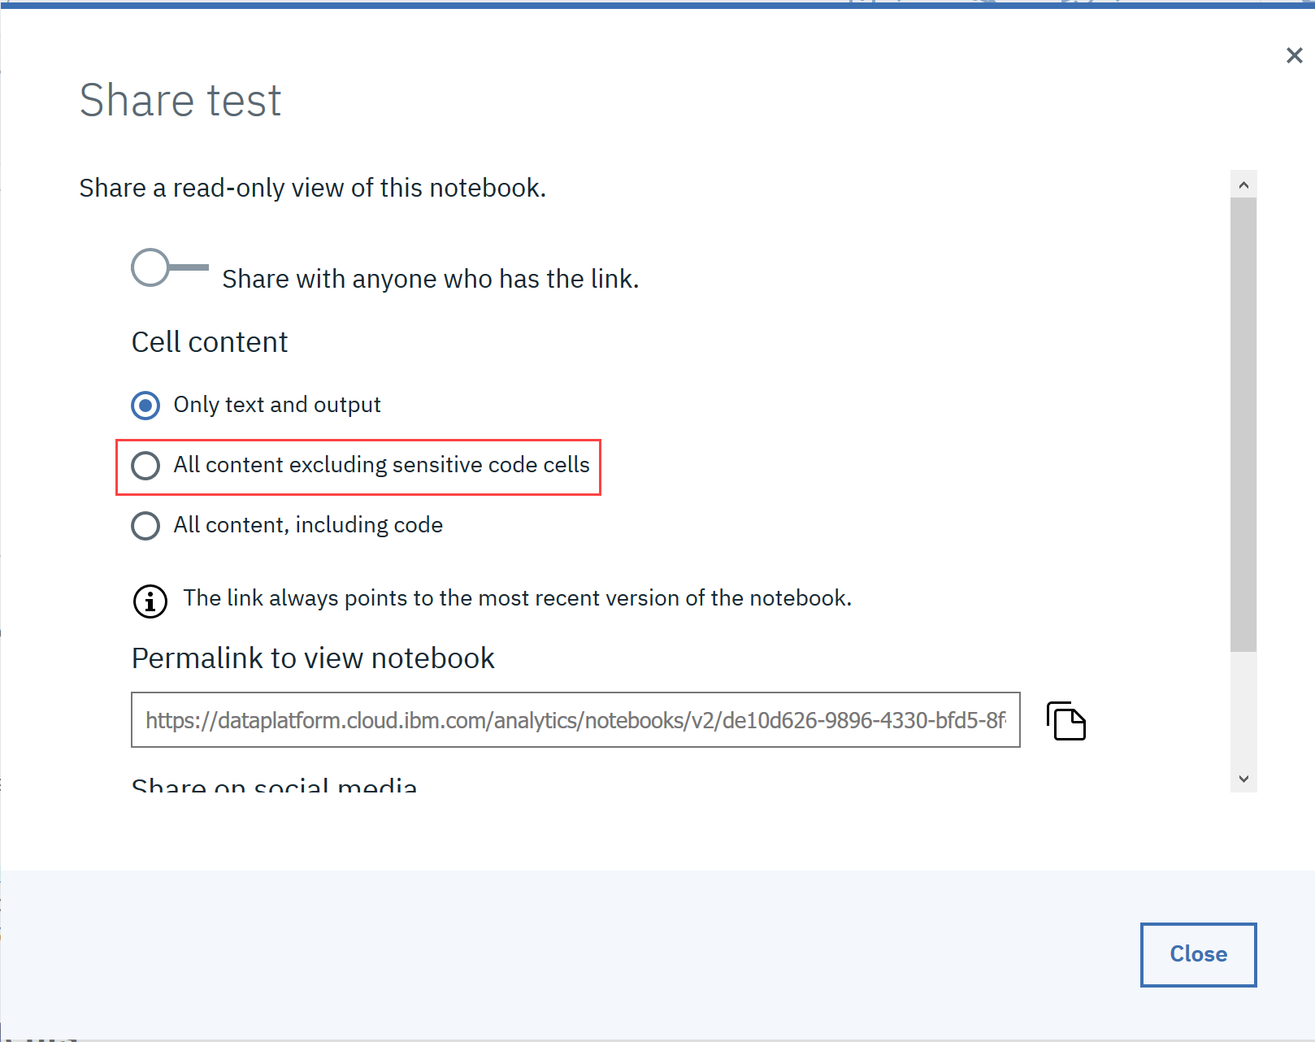 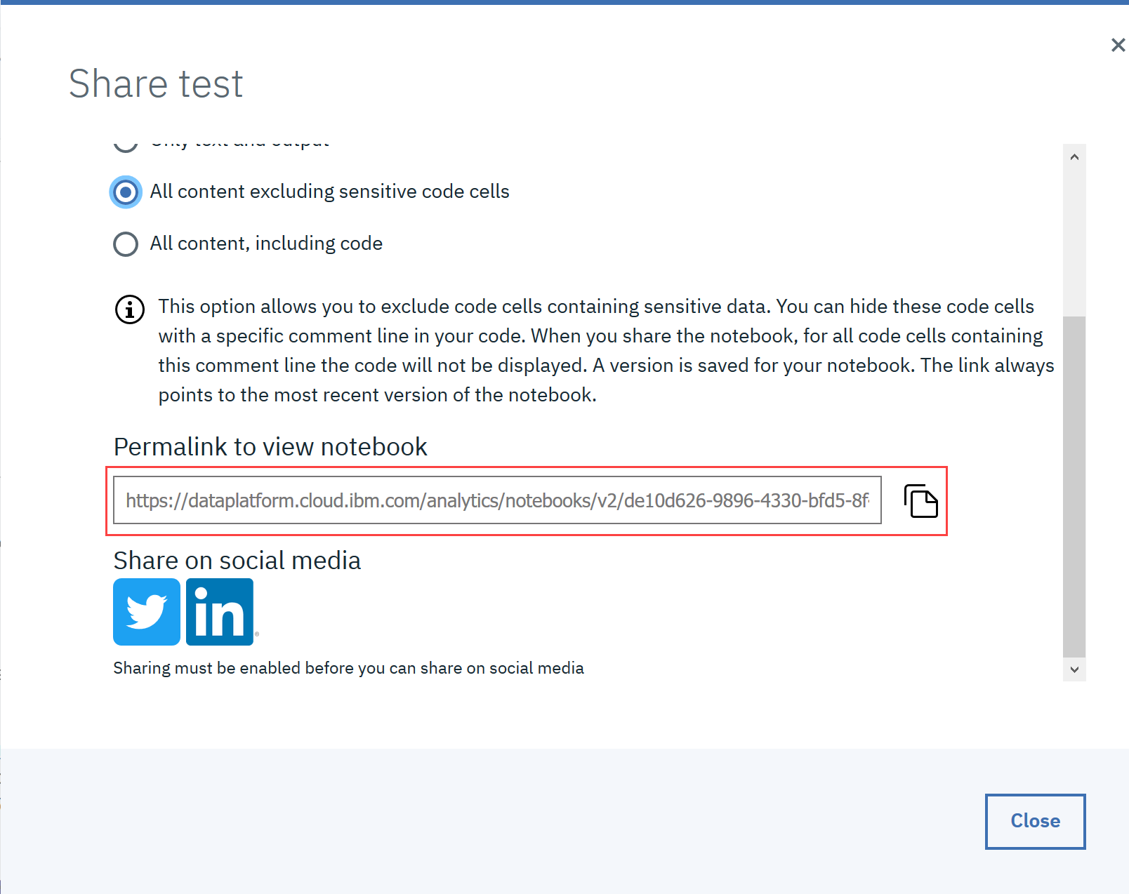

Author(s)

[Joseph Santarcangelo](https://www.linkedin.com/in/joseph-s-50398b136?cm_mmc=Email_Newsletter-_-Developer_Ed%2BTech-_-WW_WW-_-SkillsNetwork-Courses-IBMDeveloperSkillsNetwork-DL0110EN-SkillsNetwork-20647811&cm_mmca1=000026UJ&cm_mmca2=10006555&cm_mmca3=M12345678&cvosrc=email.Newsletter.M12345678&cvo_campaign=000026UJ&cm_mmc=Email_Newsletter-_-Developer_Ed%2BTech-_-WW_WW-_-SkillsNetwork-Courses-IBMDeveloperSkillsNetwork-DA0101EN-SkillsNetwork-20235326&cm_mmca1=000026UJ&cm_mmca2=10006555&cm_mmca3=M12345678&cvosrc=email.Newsletter.M12345678&cvo_campaign=000026UJ)

Changelog

| **Date** | **Version** | **Changed by** | **Change Description** |
| --- | --- | --- | --- |
| 2020-10-13 | 1.0 | Aije Egwaikhide | Created new version for notebook upload |
|  |  |  |  |

s