**Project : Company Acquisition**

There are 7 pillars of Power BI which needs to be performed to complete a project:

1) Extraction (the data from the source)

2) Transformation

3) Modelling (create table relationships)

4) Calculation (create measures and we build KPI’s)

5) Visualization

6) Distribution (publishing)

7) Automation

But first of all, let us go through the dataset.

### Understanding the dataset :

We are provided with the dataset in  the excel format which consists of five tables namely Customer Data, Metric Selection, Product Data, Regions and Sales.

Customer Data -- it is a dimension table which consists of Customer Index and Customer Name as shown below:

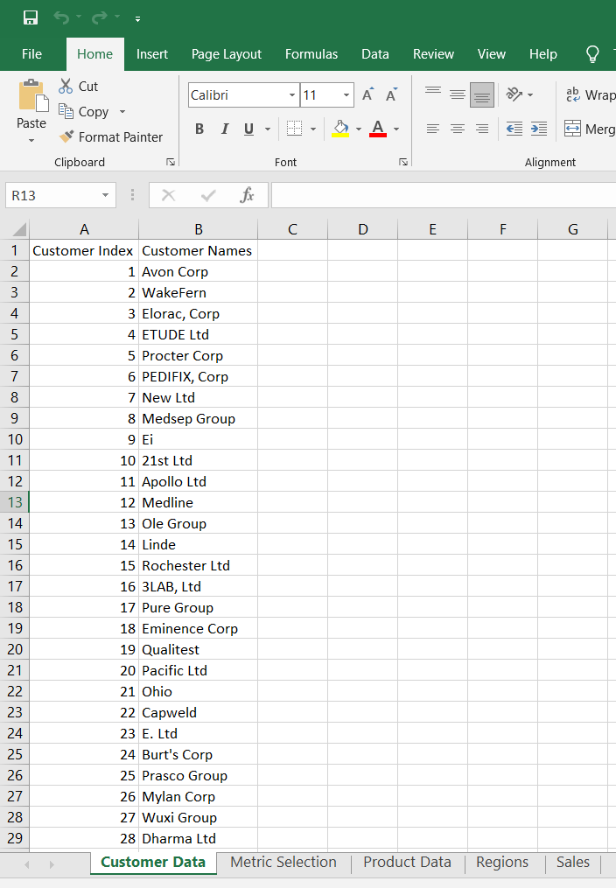

Metric Selection -- is a dimension table which consists of metrics and index as shown below:

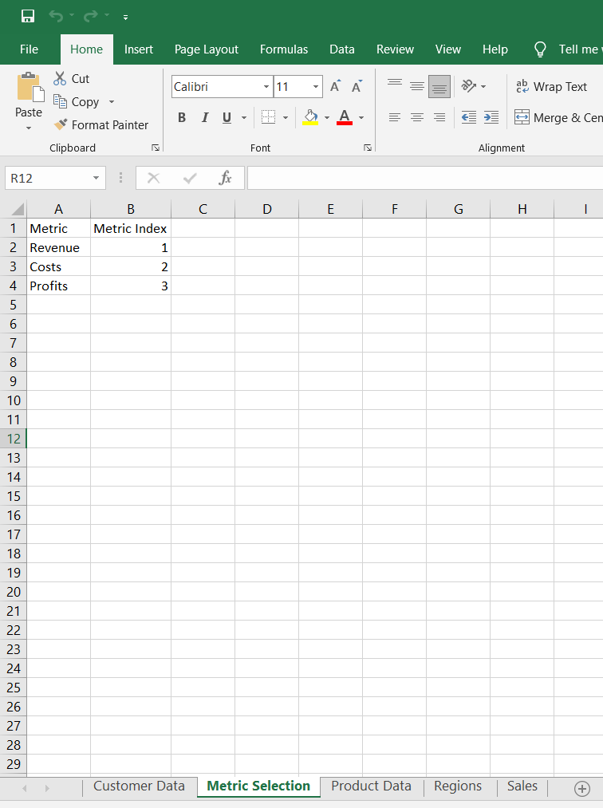

Product Data -- is a dimension table which consists of product details like product name and index.

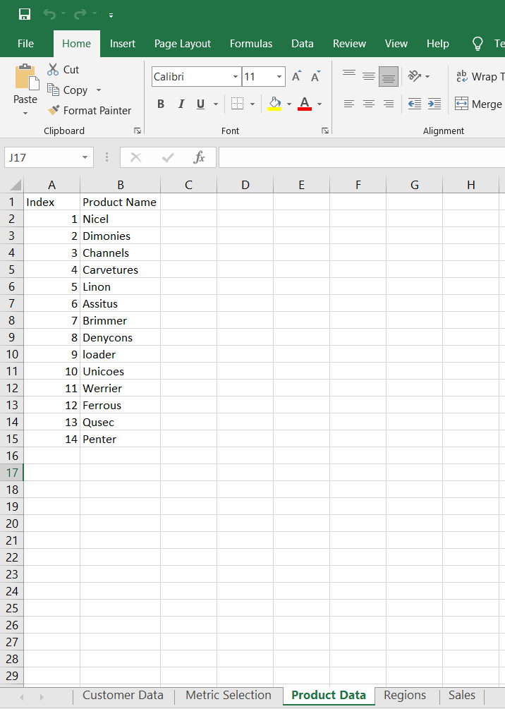

Regions -- is a dimension table with details as shown below:

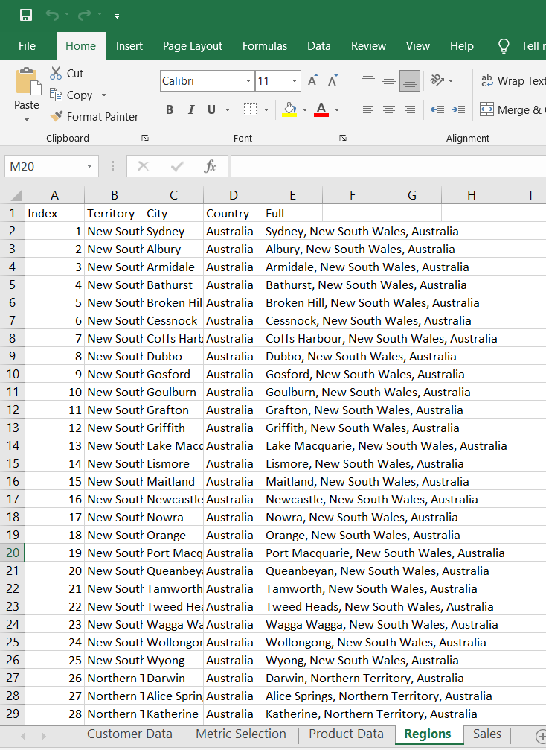

Sales Table is our only fact table which consists of the business transactions as shown below:

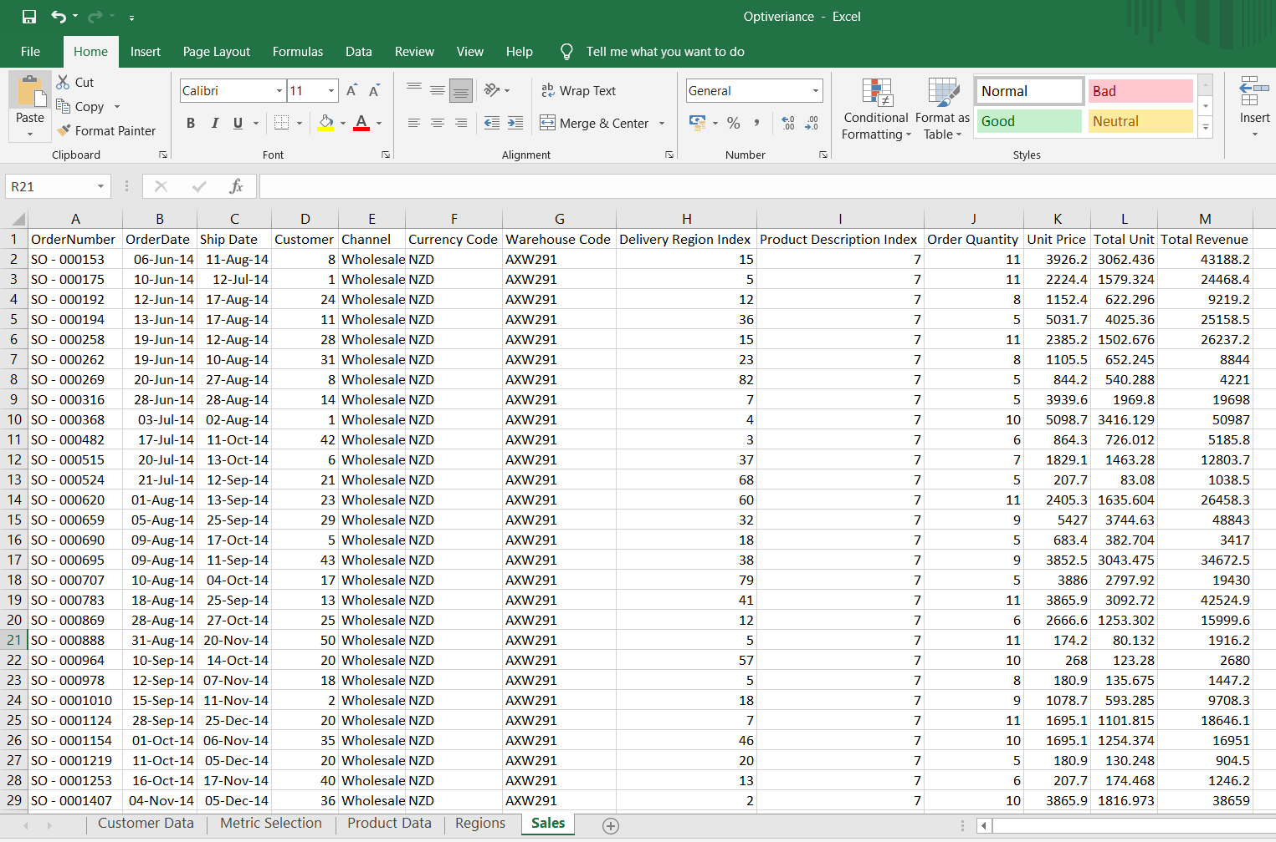

After carefully observing the data we can see that the data in these tables is pretty clean. There are no missing values or null values as such. Table headers are properly defined. Data analysis majorly depends on how clean the data is in order to pull useful insights from the data. So let us now import this dataset in our Power BI application.

**Transformation** is not required since the data is clean which is actually very rare in real life scenarios.

Let us go to **extraction** of data.

Go to Get Data 🡪 Excel from the Home menu option then browse your dataset. Select all the tables then click on Load.

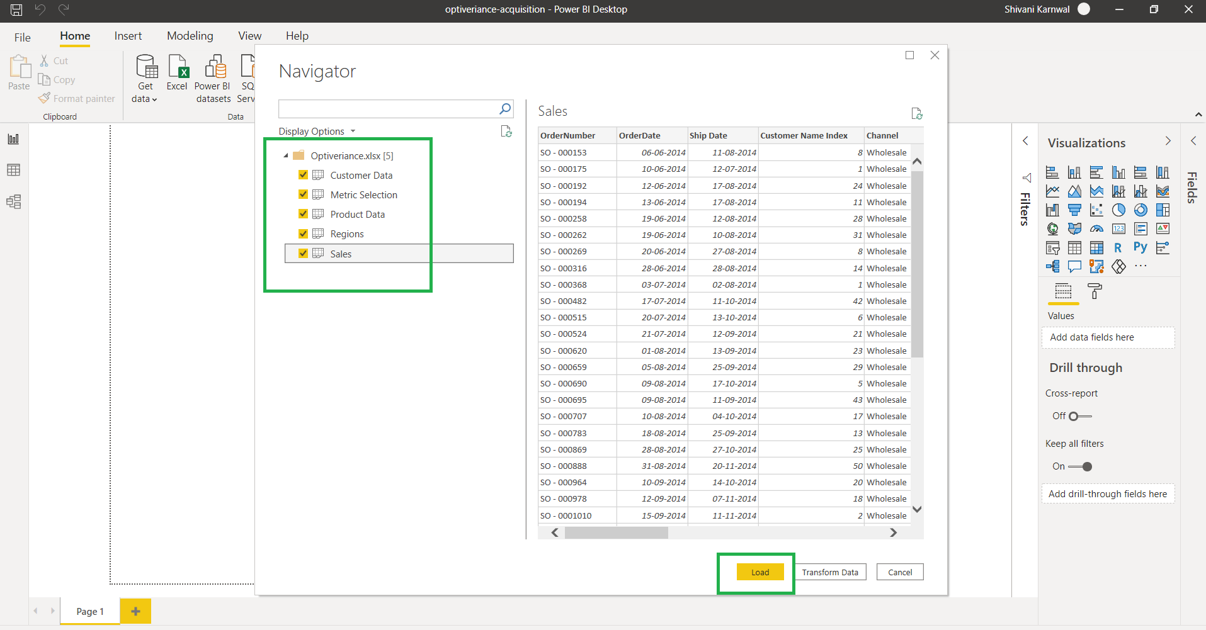

Next step is: **Data Modelling**

A good data model helps improve the performance of the report and helps reduce our DAX (data analysis expressions) measures size. A good data model makes our work less tedious.

In our scenario, we have four-dimension tables and one fact table.

The snapshot of the initial data model is showcased below:

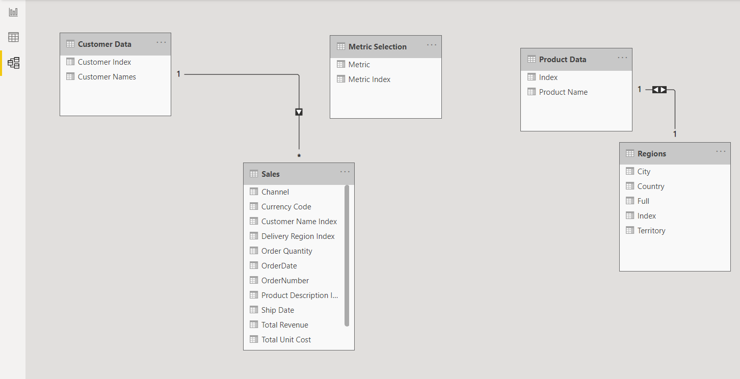

Now we will delete these automatic relationships that the Power BI has made for us. Instead, it is always preferable to manager relationships manually. Automatic relationships may not always be correct.

Star Schema is a modelling approach widely adopted by relational data warehouses. It requires the model to be split into dimension and fact tables. Dimension table describes business entities while the fact tables stores observations and events related to those business entities. Each dimension table is connected to the fact table individually.

But we see that our data model does not have any Date table for our further analysis. So, we will first create a Date table then manage the relationships.

DimDate = CALENDAR(MIN(Sales[OrderDate]),MAX(Sales[OrderDate]))

Year = FORMAT(DimDate[Date], "YYYY")

Month Num = MONTH(DimDate[Date])

Month = FORMAT(DimDate[Date], "MMMM")

Quarter Num = QUARTER('DimDate'[Date])

Quarter = FORMAT('DimDate'[Date], "\Qq")

Start by going to Data View and click Create Table then add subsequent columns.

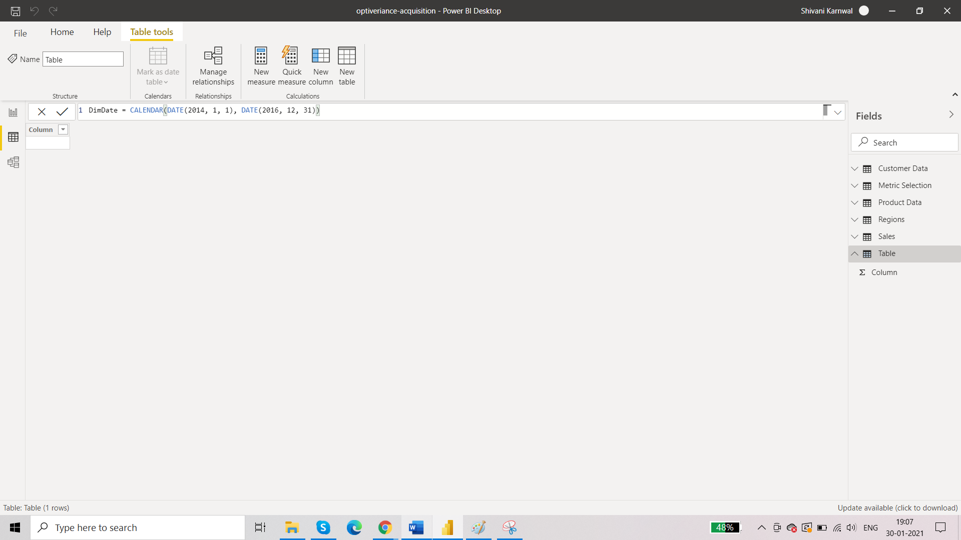

After adding all the columns, date table called ‘Dimdate’ will look like this:

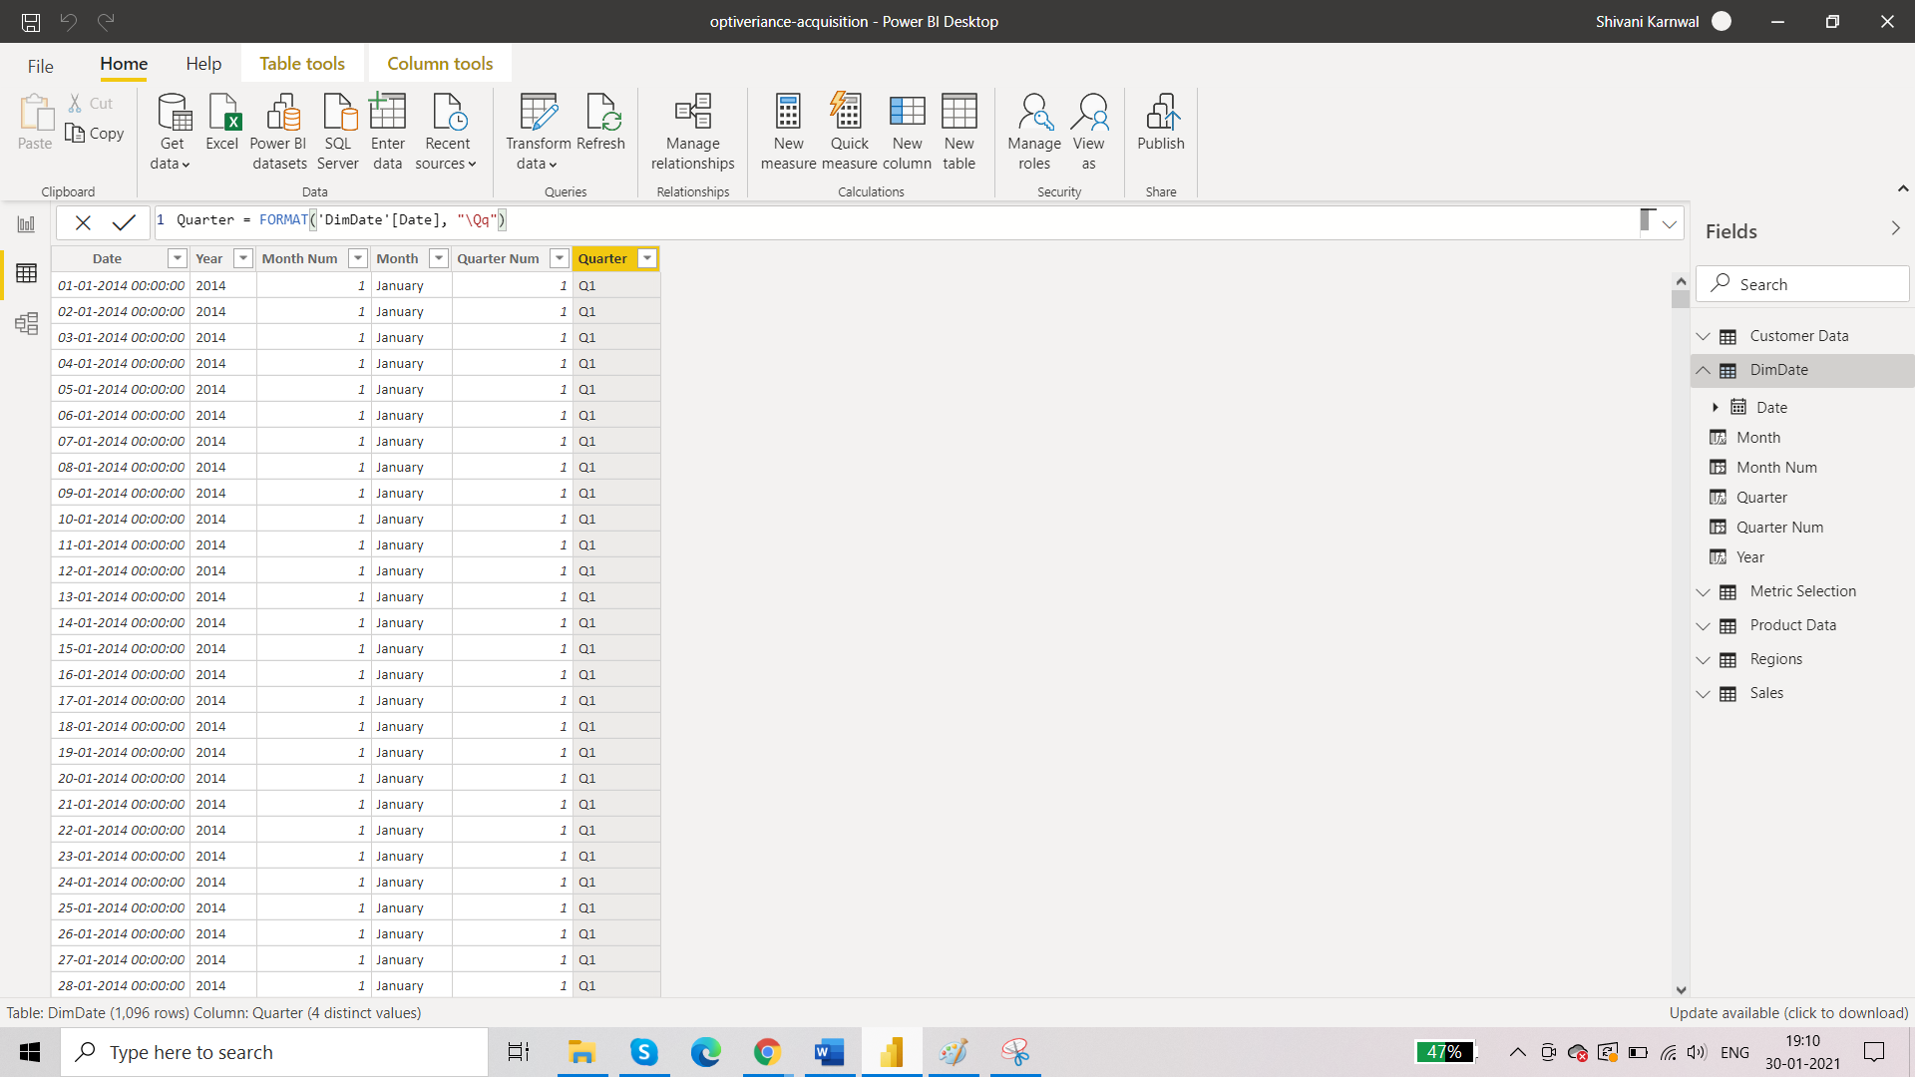

The *Order Date* column in Sales table is between 2014 and 2016, so while creating the Date table with the Calendar function we take the same interval and then created Year, Month and Quarter columns, Also, sort the *Month* column by the *Month Num* column so that it will be arranged in the visual chronologically and not alphabetically:

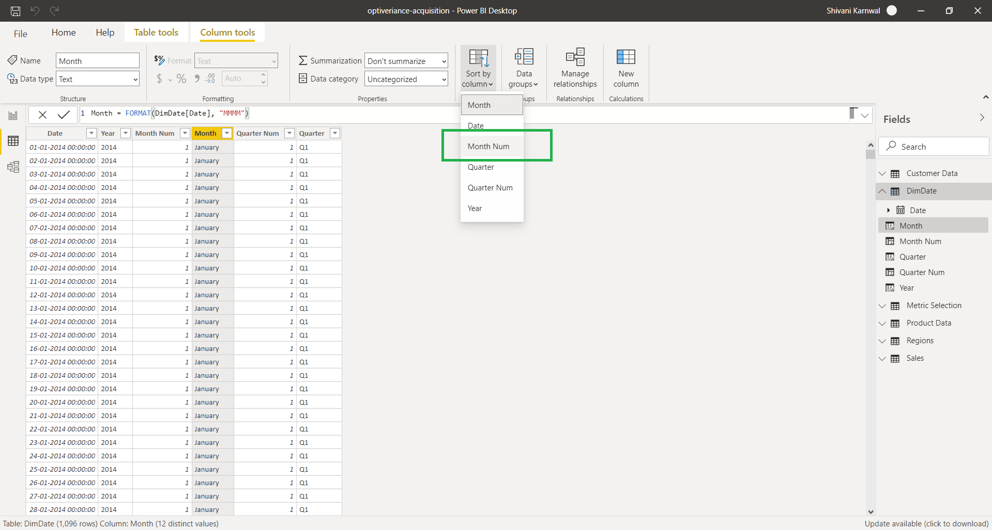

The data model looks like this:

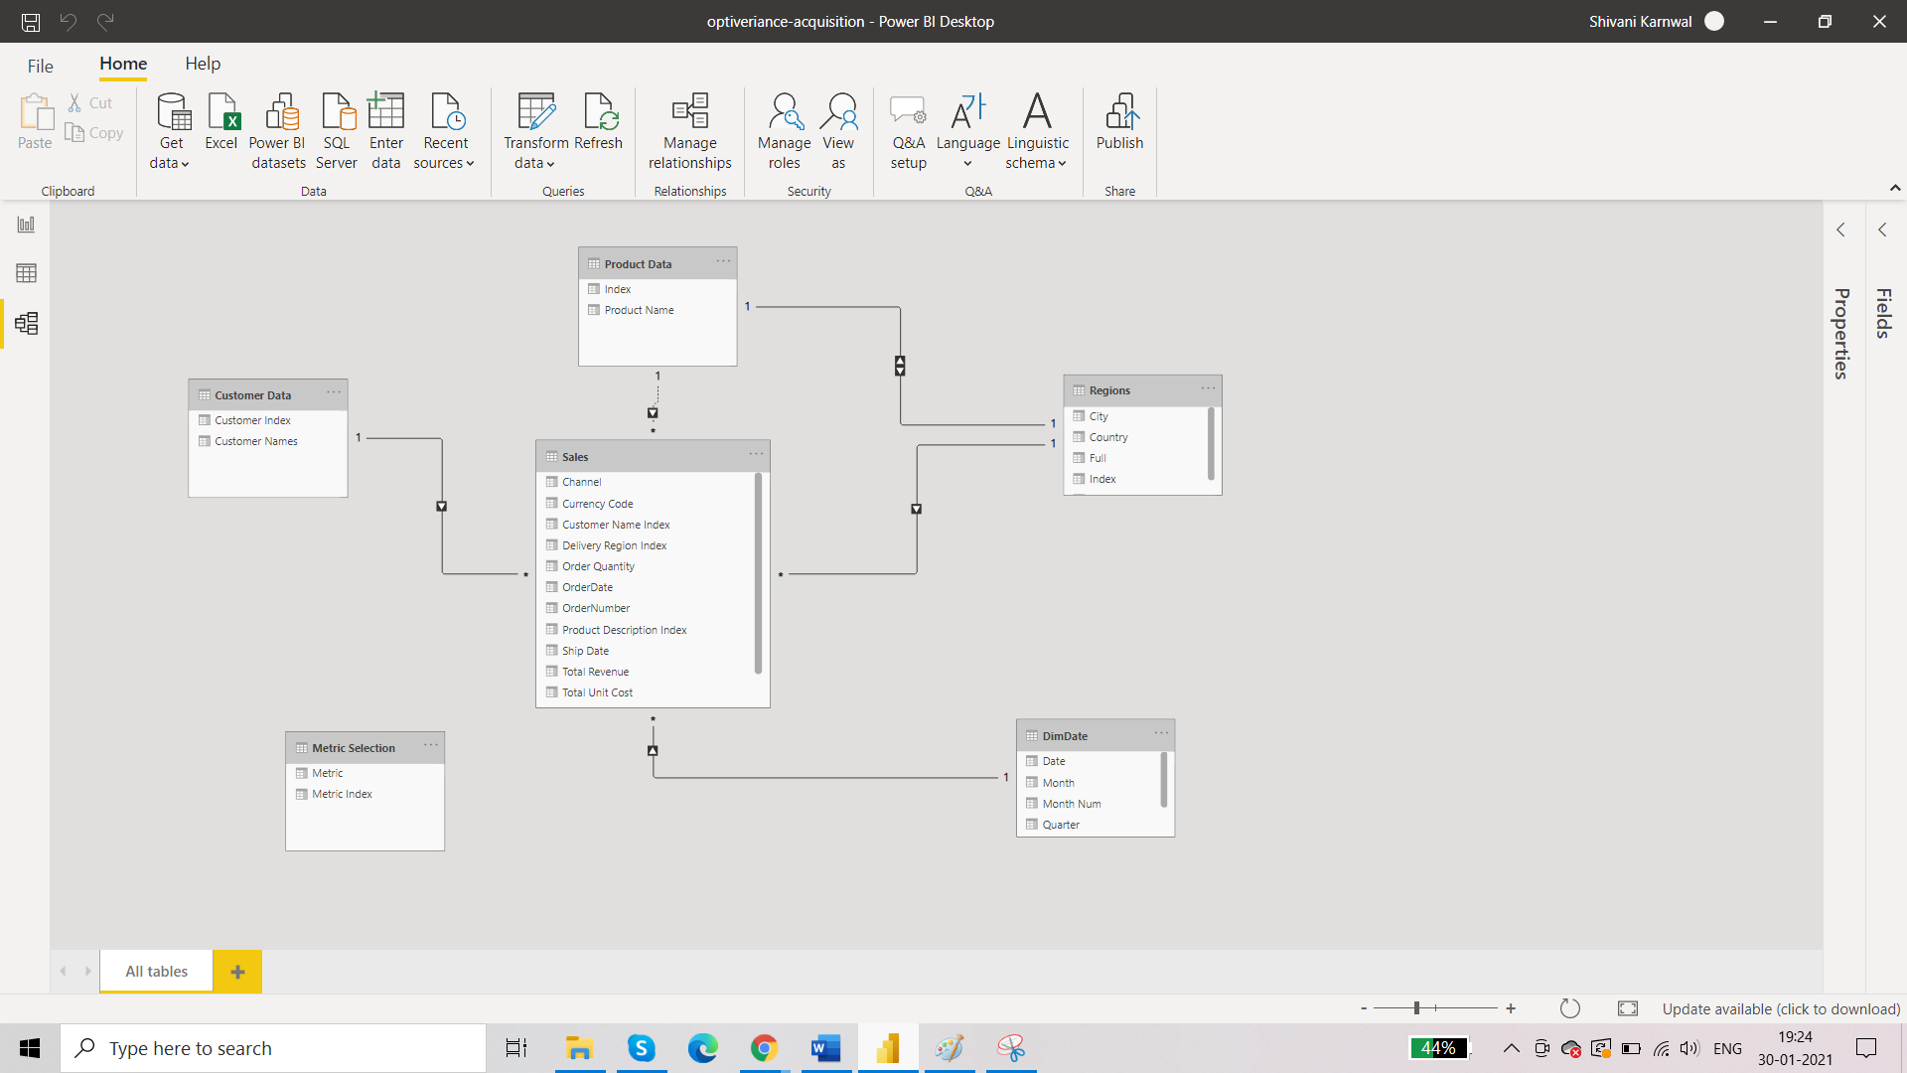

**Requirements:**

**What is Total Sales?**

Creating a measure table to keep all the important Key measures at one place.

We have used the below DAX function to calculate the total Sales:

Total Sales = SUM(Sales[Total Revenue])

Cards visualisation is used to represent the Total Sales.

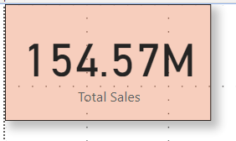

**What is the Total Quantity?**

We have used the below DAX function to calculate the total quantity:

Total Quantity = SUM(Sales[Order Quantity])

Cards visualisation is used to represent the Total Quantity.

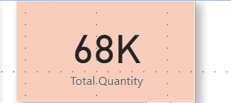

**Profit for the said period and the margin on the same.**

We have used the below DAX function to calculate the profit and profit margin :

Total Cost = SUMX(Sales, Sales[Total Unit Cost] *Sales[Order Quantity])

Total Profit = [Total Sales] - [Total Cost]

Profit Margin = DIVIDE([Total Profit],[Total Sales],0)

Using line chart visualization, we can view total sales and total profit over the years:

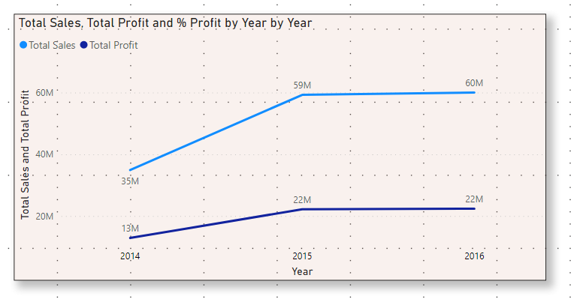

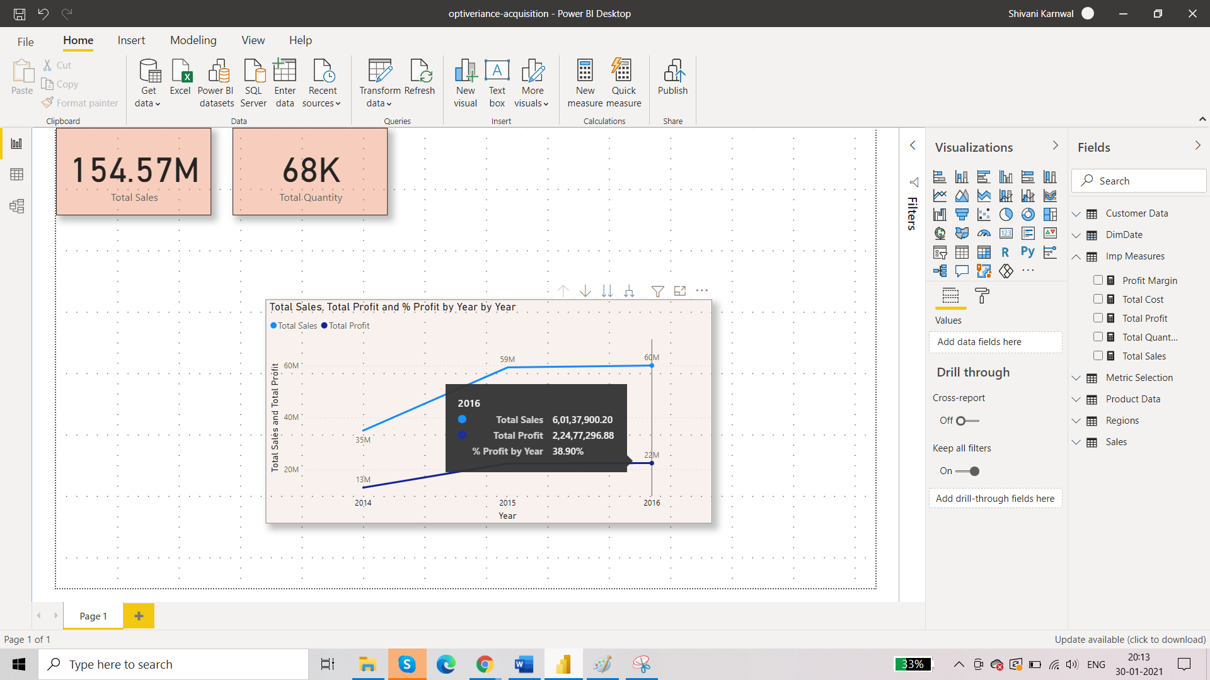

**Need to have a detailed Performance LY for any selected Year.**

We have used the below DAX function:

Performance LY = CALCULATE([Total Profit],SAMEPERIODLASTYEAR('Date'[Date index key]))

We have shown the detailed performance LY in table format as below:

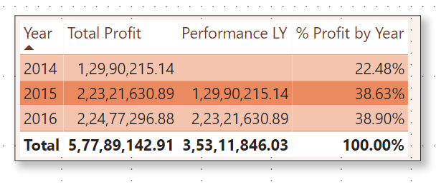

**Comparing the Performance vs LY:**

Cumulative performance in terms of Profit:

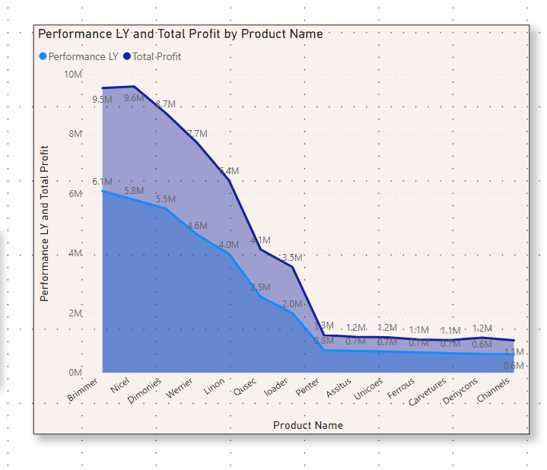

**Insights**:

• Current year sale shows better profit for all products as compared to last year profit.

• Brimmer product is in high demand and has maximum profit in terms of current and previous year sales.

• Current year, Ferrous product has lowest profit where as Unicoes product has lowest profit in last year.

**Sales 2yrs ago for any Selected Year:**

We have used the below Dax function:

Sales 2 years ago = CALCULATE([Total Sales],PARALLELPERIOD('Date'[Date index key],-2,YEAR))

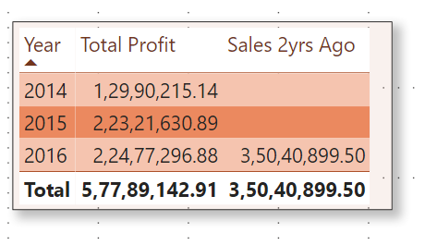

**Problem statement:**

**It is important to know the moving average in terms of Profit & Sales:**

3-month moving average(Profit) = DIVIDE(CALCULATE([Total Profit], DATESBETWEEN(DimDate[Date], FIRSTDATE(DATEADD(DimDate[Date], -2, MONTH)), LASTDATE(DATEADD(DimDate[Date], 0, MONTH)))), 3)

3-month moving average(Sales) = DIVIDE(CALCULATE([Total Sales], DATESBETWEEN(DimDate[Date], FIRSTDATE(DATEADD(DimDate[Date], -2, MONTH)), LASTDATE(DATEADD(DimDate[Date], 0, MONTH)))), 3)

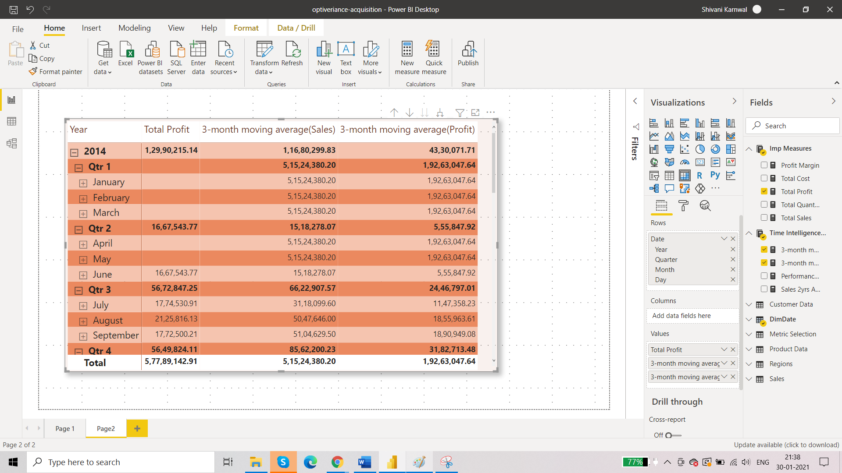

**Problem Statement:**

**The quarter-wise analysis is also important, maybe slicer.**

We have created a slicer for this task:

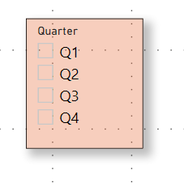

**Problem statement:**

**Total Sales, Profit and % Profit can be shown as a combo with card and line chart.**

We have already created the measures for Total Sales, Profit and %Profit.Below combo card and line chart is created.



**Problem Statement:**

**Show the sales Comparison between Cumulative Performance vs Cumulative Performance LY using an area chart:**

Profit Cumulative performance TotalYTD = TOTALYTD(SUMX(Sales, [Total Profit]), 'DimDate'[Date])

Profit Cumulative Performance TotalYTD LY = TOTALYTD([Total Profit], SAMEPERIODLASTYEAR('DimDate'[Date]))

And, below depicts the output for salesComparison between Cumulative Performance vs Cumulative Performance LY using an area chart if we select the year 2015 in Year Slicer.

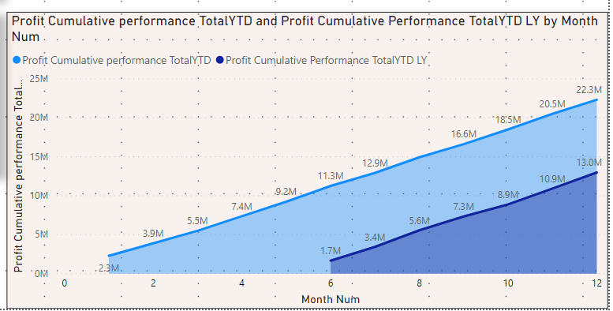

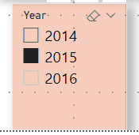

**Problem Statement:**

**Top Performer in terms of Product and Customer top 7 will give a clear idea.**

We will consider the top 7 products in terms of Sales.We will achieve this by using the following visual filter BY TOP N selection criteria:

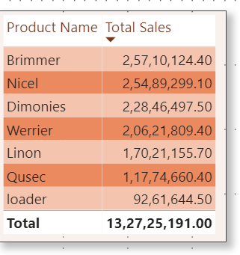

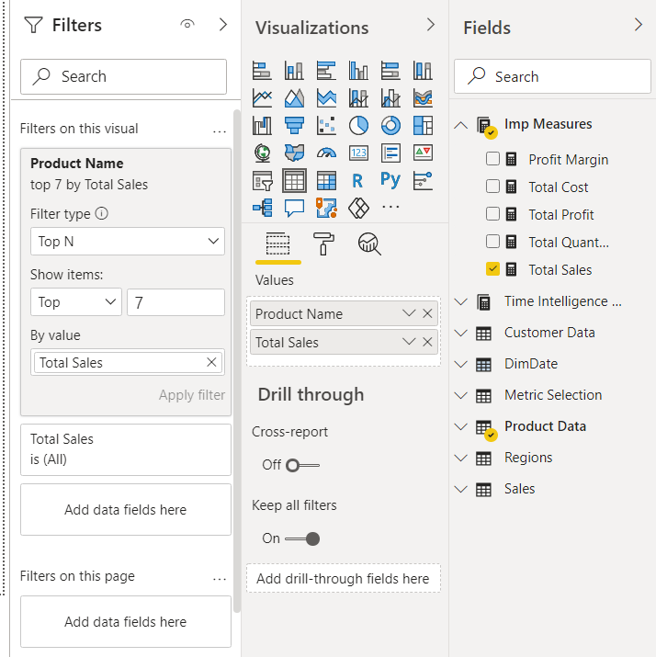

**Insights:**

Brimmer, Nicel, Dimonies, Werrier, Linen, Qusec, and Loader products has top 7 sales whereas among all Brimmer product has highest sales.

Top 7 Customers in terms of Total Sales.

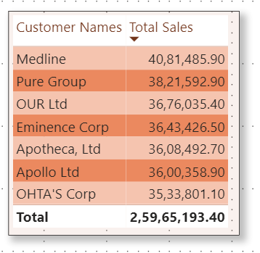

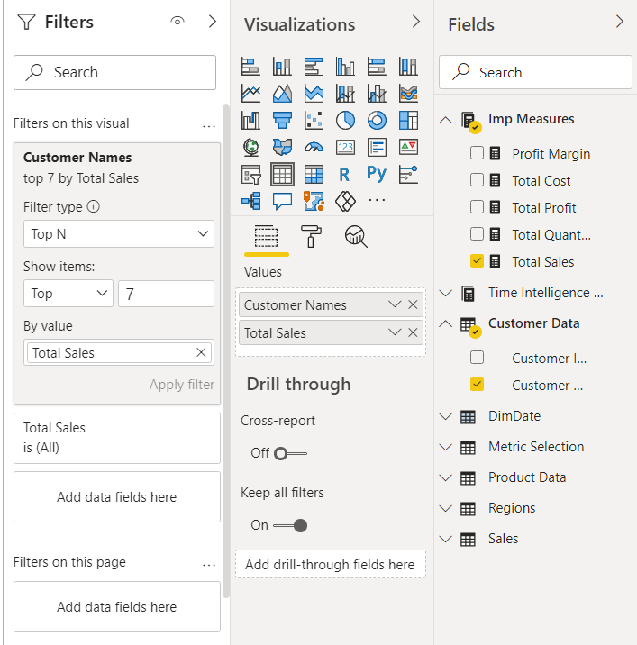

**Insights:**

Above mentioned customers has the highest sale. Among all the customers, Medline was on the top of all.

**Problem Statement:**

**Performance in terms of region sales needs to workout and also needs to work on what will be the best way to visualize it except Bar Graph.**

We can use Map visual under Visualizations pane for better visualization.

Now, the map shows region sales for each Territory of Australia as shown below:

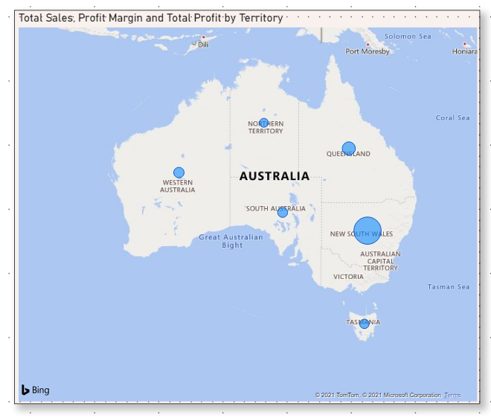

**Insights:**

1. Australia’s Northern territory and Tasmania territory needs to work out for sales.