Using CodeSkulptor3

Using CodeSkulptor3

In this specialization, you will learn to script in Python 3. For the first course of the specialization, we encourage you to use CodeSkulptor3, a browser-based environment designed to help beginning coders learn to program in Python 3. This reading provides a brief overview of how to access and use CodeSkulptor3. Note that you are not required to use CodeSkulptor3 in this specialization and that you are welcome to use a desktop version of Python such as [Thonny](https://www.coursera.org/learn/python-programming/resources/lGYpE), [IDLE](https://www.python.org/downloads/), or [Atom](https://www.coursera.org/learn/python-programming/resources/fk7RB) from the start if you so desire.

Accessing CodeSkulptor3

CodeSkulptor3 is available at [py3.codeskulptor.org](http://py3.codeskulptor.org/). Clicking this link will open CodeSkulptor3 with a default example program loaded. After entering and running "Hello world", the resulting windows should look similar to the following:

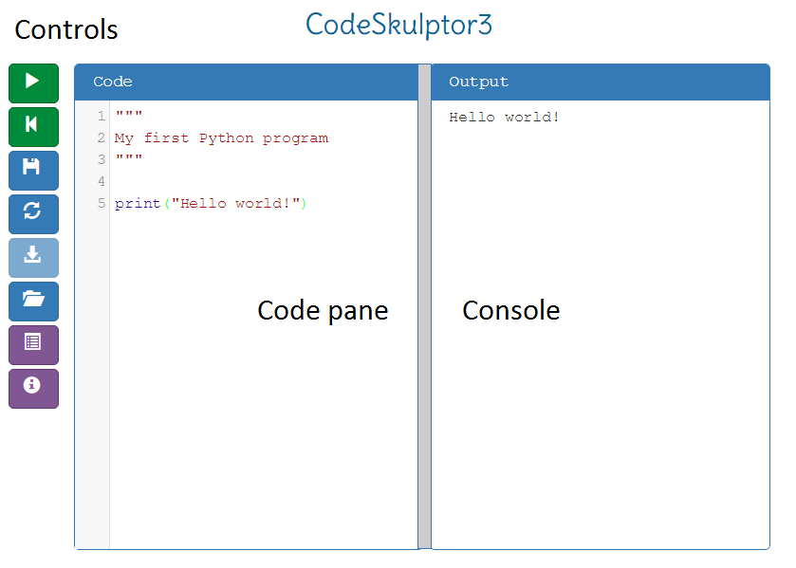

The main body of the CodeSkulptor3 window consists of a code pane (where you entered your Python code) on the left and a console (where your Python program's output appears) on the right. A sequence of buttons that control the behavior of CodeSkulptor appear at the extreme left (or top) of the window.

Note that a Python 2 version of CodeSkulptor is also available at [www.codeskulptor.org](http://www.codeskulptor.org/). While working with CodeSkulptor in this specialization, be sure that you have accessed CodeSkulptor3 so that you are using Python 3. (The URL for the Python 3 version of CodeSkulptor has the prefix "py3".) If you are having trouble accessing these pages, please consult this class resource page on "[Trouble CodeSkulptor](https://www.coursera.org/learn/python-programming/resources/vkmCs)" for suggestions.

Writing programs in CodeSkulptor3

The left-hand code pane is the area where you will enter your Python program. Clicking in the area and typing will add code to the window. To get an empty code pane, click in the pane, select all (ctrl+a) the contents of the pane, and then delete (ctrl+x) this selection.

As you entered and edit your code, note that CodeSkulptor supports all of the standard editing shortcuts such as copy (ctrl+c) and paste (ctrl+v) as well as undo (ctrl+z). CodeSkulptor3 also supports more advanced editing operations such as block commenting (ctrl+k) and block uncommenting (ctrl+shift+k). A complete list of [keyboard shortcuts](http://py3.codeskulptor.org/docs.html#tabs-CS) is available in the CodeSkulptor Docs.

Saving programs in CodeSkulptor3

Because CodeSkulptor3 runs in your web browser, CodeSkulptor3 is not allowed to directly save your code to your local file system. (Allowing a web page to directly modify your local file system would be huge security risk.) Instead, CodeSkulptor3 allows you to save your code to the cloud.

The left hand side of the CodeSkultpor3 window includes a vertical row of buttons that control the functionality of CodeSkulptor3. Clicking the third button from the top ("Save" button") causes CodeSkulptor to save a copy of your program to the cloud and generates a new distinct URL corresponding to this saved code. These saved URLs are typically of the form "[http://py3.codeskulptor.org/#user300_XXXXXXXXXX_n.py"](http://py3.codeskulptor.org/#user300_XXXXXXXXXX_n.py%22) where the ten X's are randomly chosen integer or letters and the integer n corresponds to the version of your saved code.

Since saving to the cloud in CodeSkulptor3 is quick and easy, we suggest that you save every few minutes. Once you have finished your program, we recommend that you save one last time and then retain the resulting URL so that you can access your program at a later date. Note that if you accidentally close your web browser, the URL for your last save is always available in your browser's history. Thus, if you save frequently, you are guaranteed to never lose more than a few minutes work.

In our experience, one simple way to keep track of your completed work is to email the final CodeSkulptor URL to yourself. If you are interested in having a local copy of your work (always a good idea), we suggest that you copy and paste your code into a text editor and save your code locally using the editor. If you are having trouble saving in CodeSkulptor, please consult this class resource page on "[Trouble CodeSkulptor](https://www.coursera.org/learn/python-programming/resources/vkmCs)" for some suggested fixes.

Running programs in CodeSkulptor3

Once you are ready to run/test your code, clicking the top button on the left-hand column of controls ("Run" button) causes CodeSkulptor to execute your Python 3 code. In particular, CodeSkulptor converts your Python 3 code into Javascript and then runs the resulting Javascript. The output from your code (generated by print) is then displayed in the console on the right hand side of the window. Clicking the second button from the top ("Reset" button) causes CodeSkulptor3 to terminate execution of your code and clear the console.

CodeSkulptor3 is designed to run in Chrome, Firefox, and Safari. In particular, CodeSkulptor3 does not have full functionality in Internet Explorer or Edge so please use one of the three listed browsers. If you have trouble running your programs , feel free to consult this class resource page on "[Trouble CodeSkulptor](https://www.coursera.org/learn/python-programming/resources/vkmCs)" for more information.