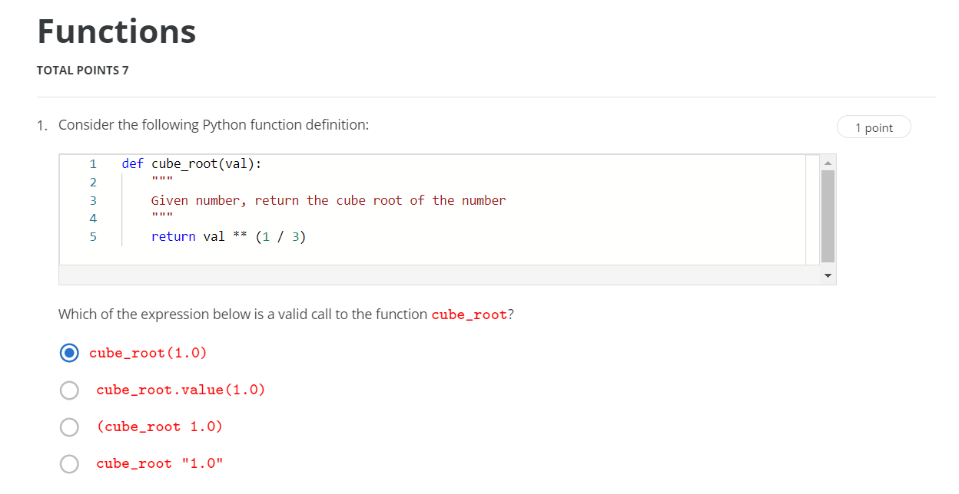

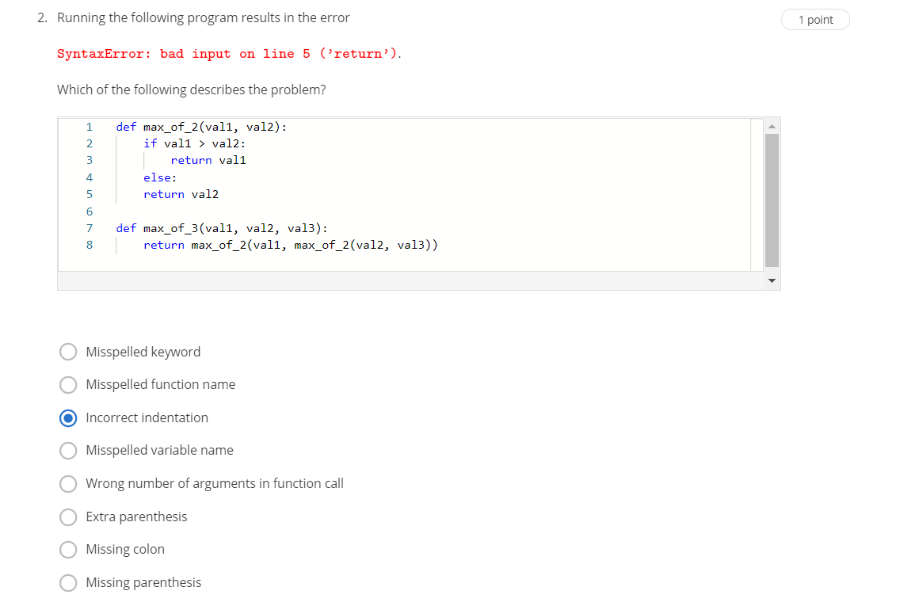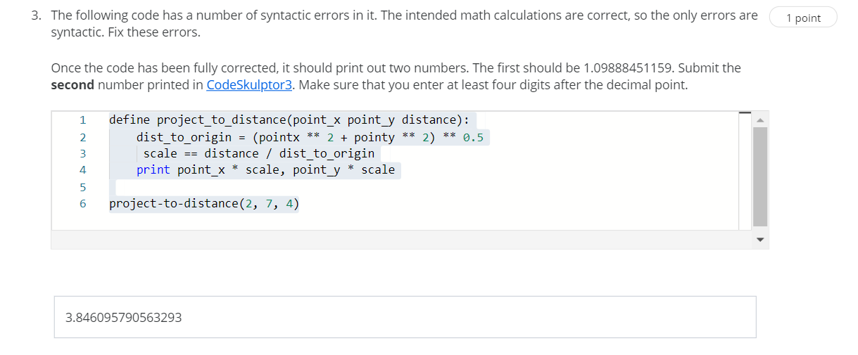

def new_function(number):

"""

new function

"""

abc =((-5)* (number**5))+(67*(number**2))+(47)

print(abc)

new_function(0)

new_function(1)

new_function(2)

new_function(3)

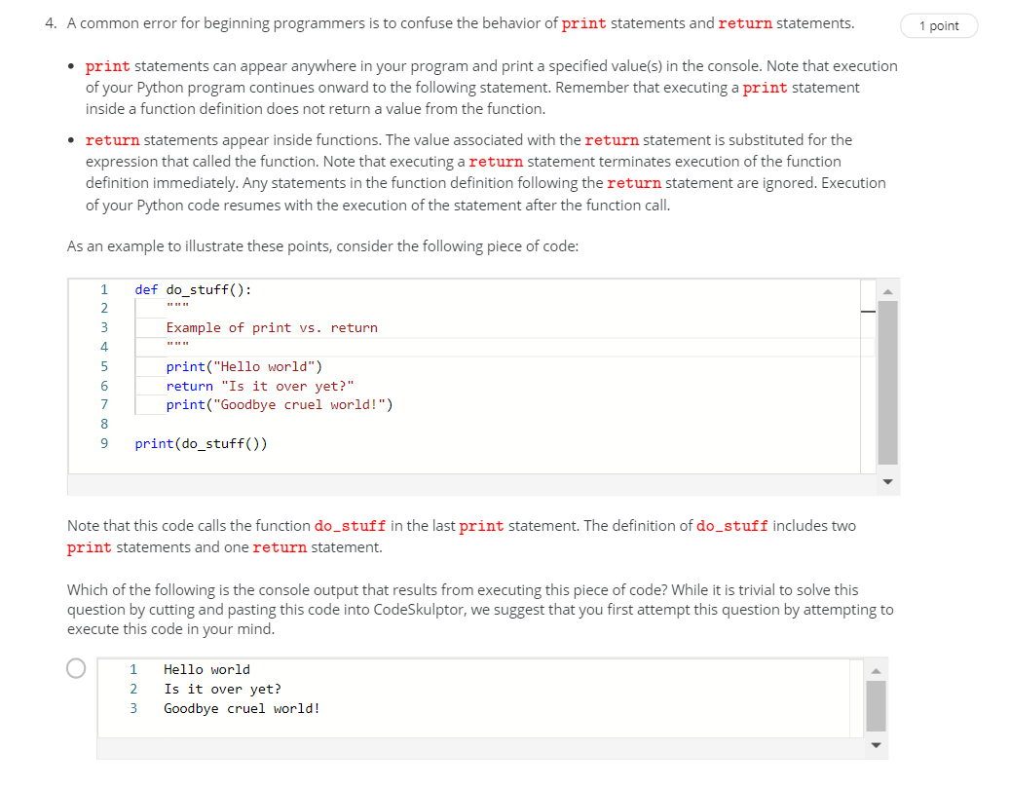

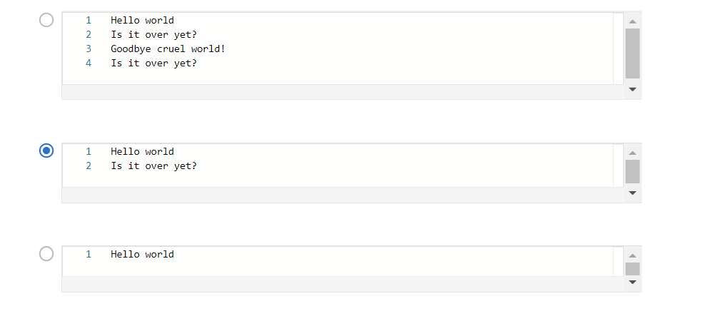

def future_value(present_value, annual_rate, periods_per_year, years):

"""

Input: the numbers present_value, annual_rate, periods_per_year, years

Output: future value based on formula given in question

"""

rate_per_period = (annual_rate / periods_per_year)

print(rate_per_period)

periods = periods_per_year * years

print(periods)

# Put your code here.

temp=(1+rate_per_period)**periods

print(temp)

future_value= present_value*temp

return future_value

print("$1000 at 2% compounded daily for 4 years yields $", future_value(1000, .02, 365, 4))

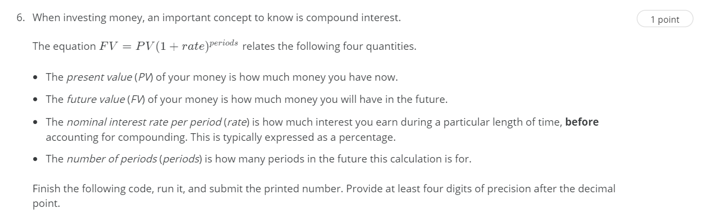

def future_value(present_value, annual_rate, periods_per_year, years):

    """

    Input: the numbers present_value, annual_rate, periods_per_year, years

    Output: future value based on formula given in question

    """

    rate_per_period = annual_rate / periods_per_year

    periods = periods_per_year * years

    # Put your code here.

print("$1000 at 2% compounded daily for 4 years yields $", future_value(1000, .02, 365, 4))

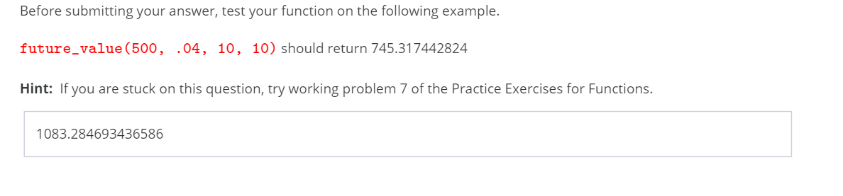

def area_of_eq_triangle(side):

return (3**0.5) / 4 * side * side

print(area_of_eq_triangle(5))

