1. QnA at PowerBI service level

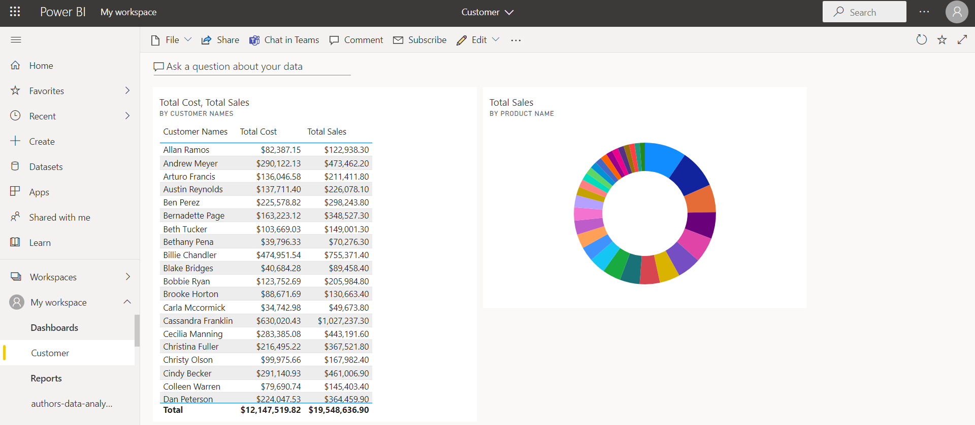

1. Data Refresh in PowerBI

When we refresh a report, the report never gets refreshed. It is the dataset that actually gets refreshed. Report is nowhere related to ‘refresh’ in PowerBI service. Everything that we do is based on dataset, so when dataset gets refreshed then report that is connected to it also gets refreshed.

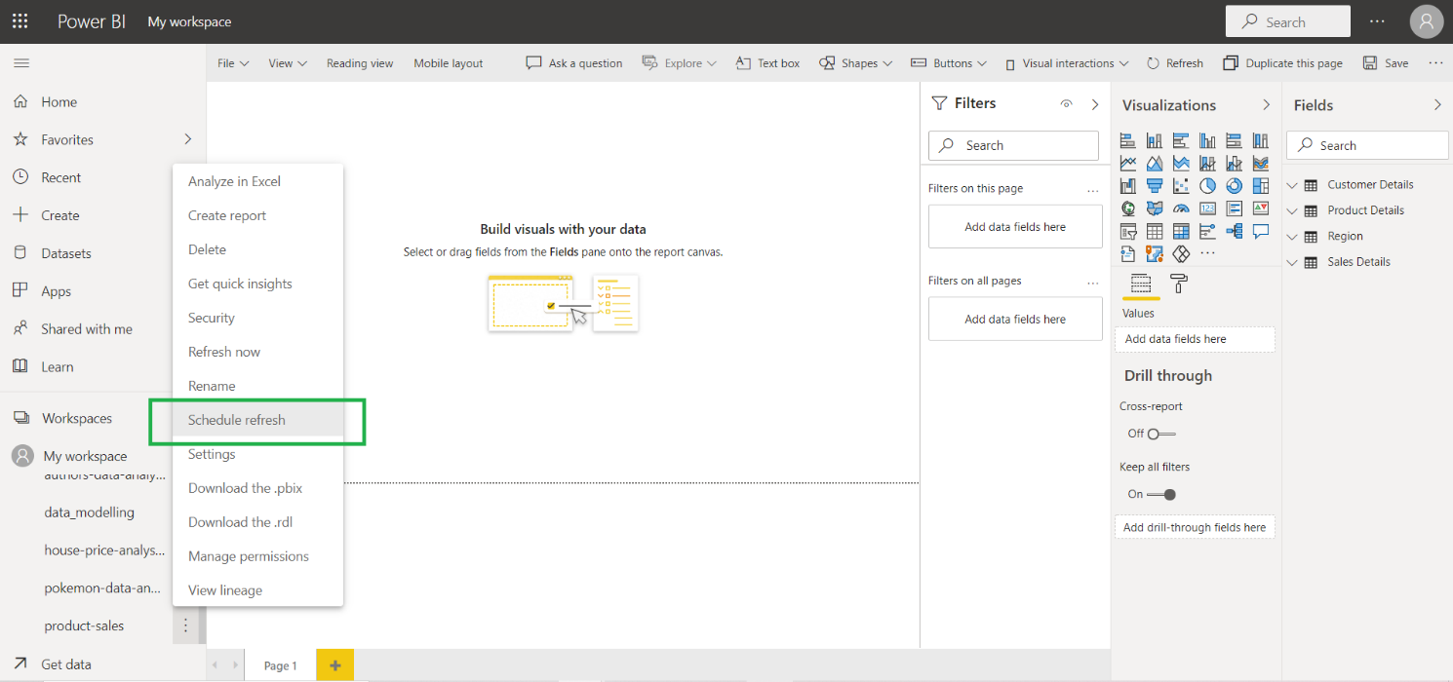

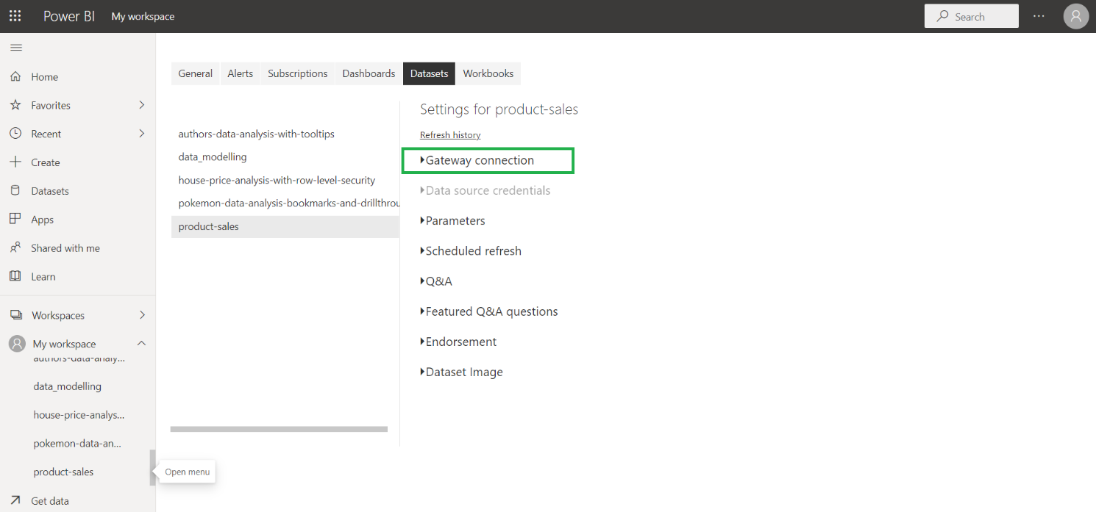

You’ll have to install the gateway.

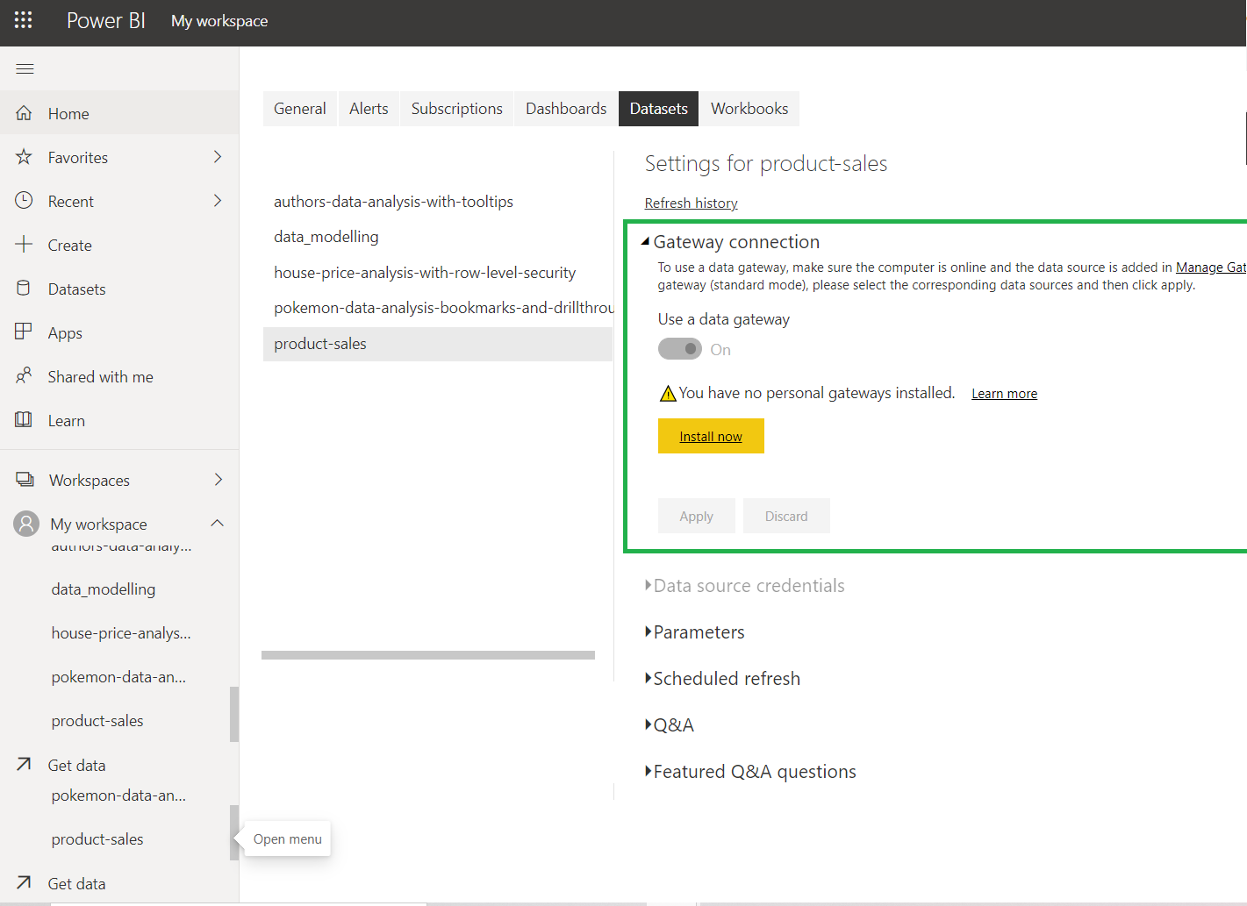

Another way to download gateway is from Home tab:

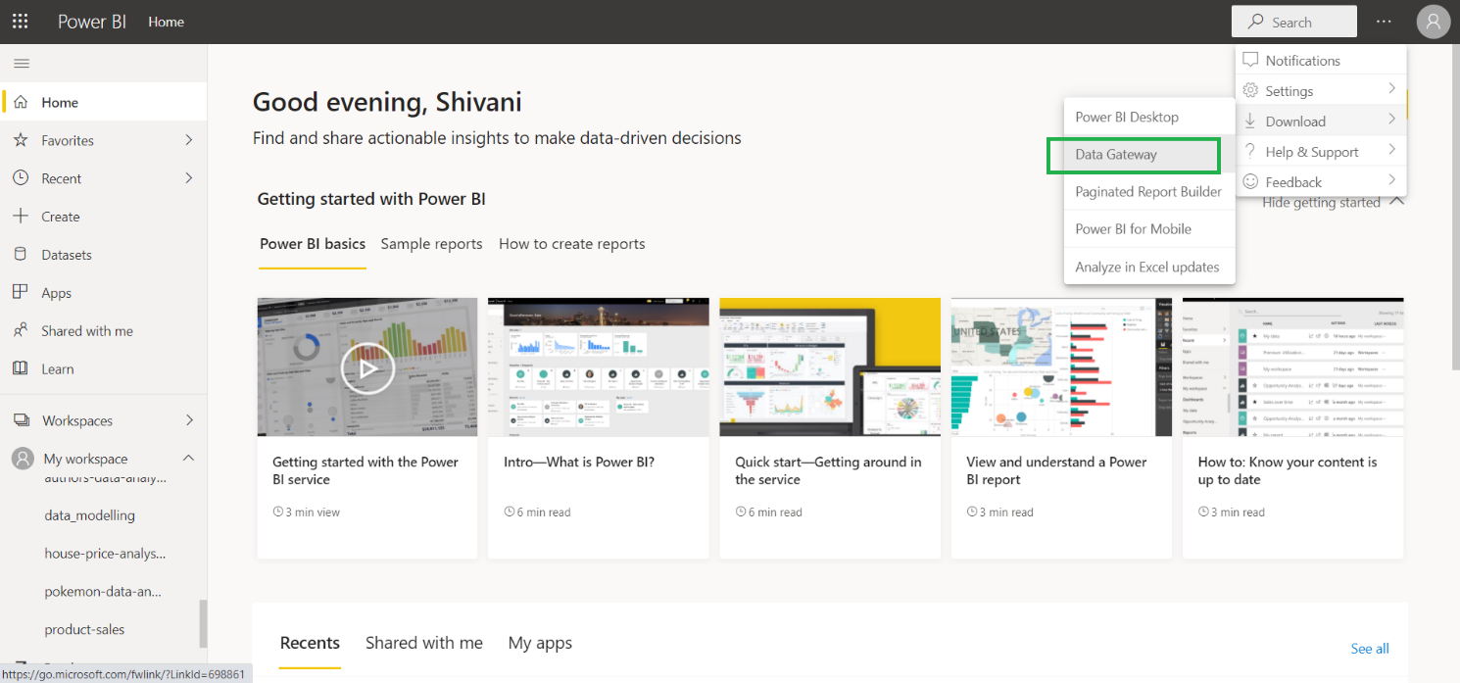

Download and install the gateway.

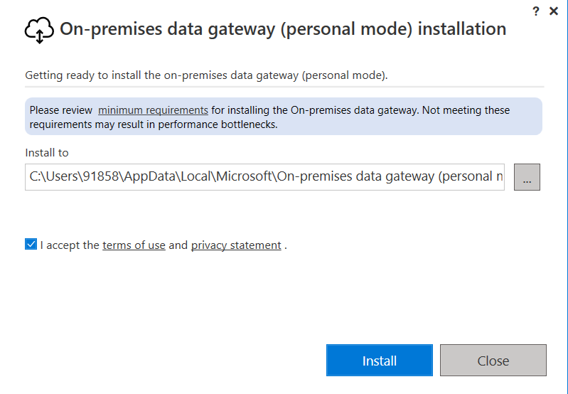

Use the same email id:

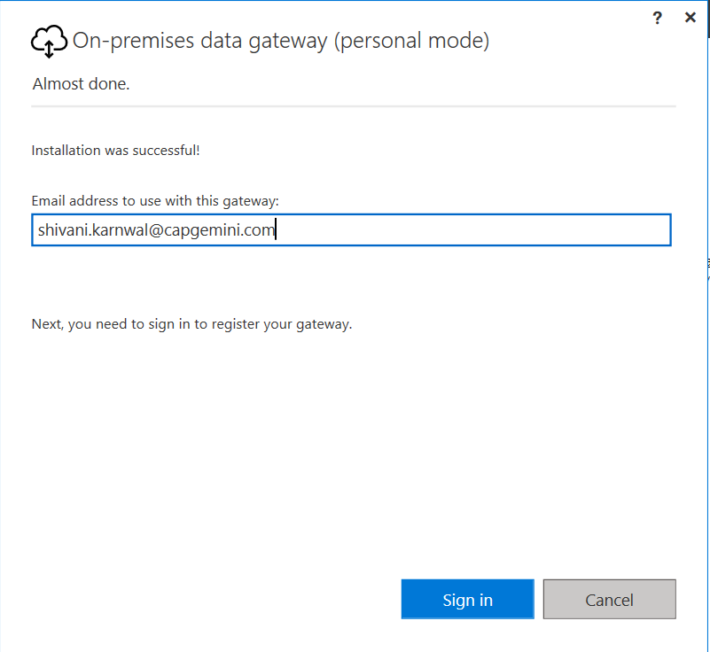

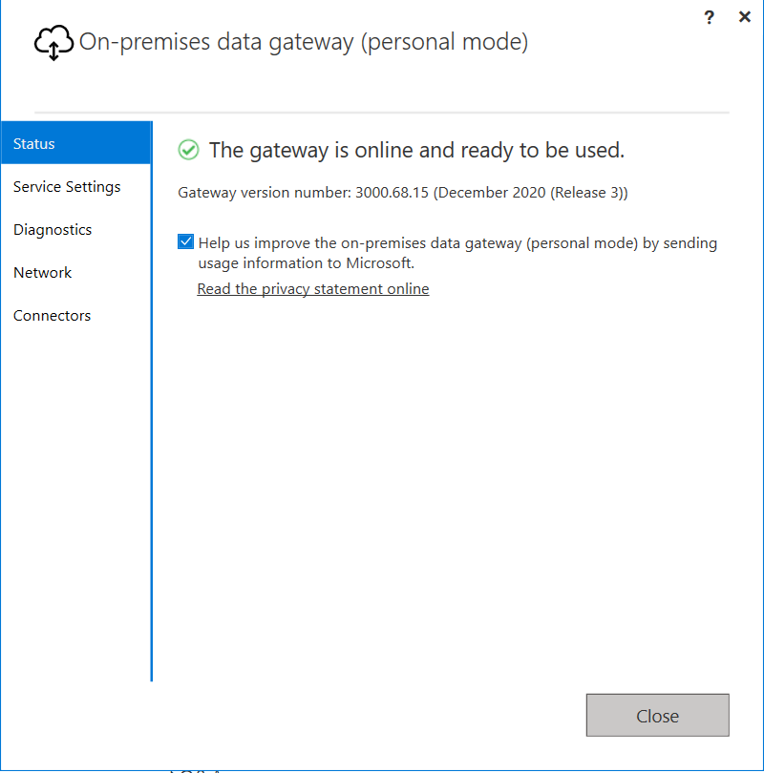

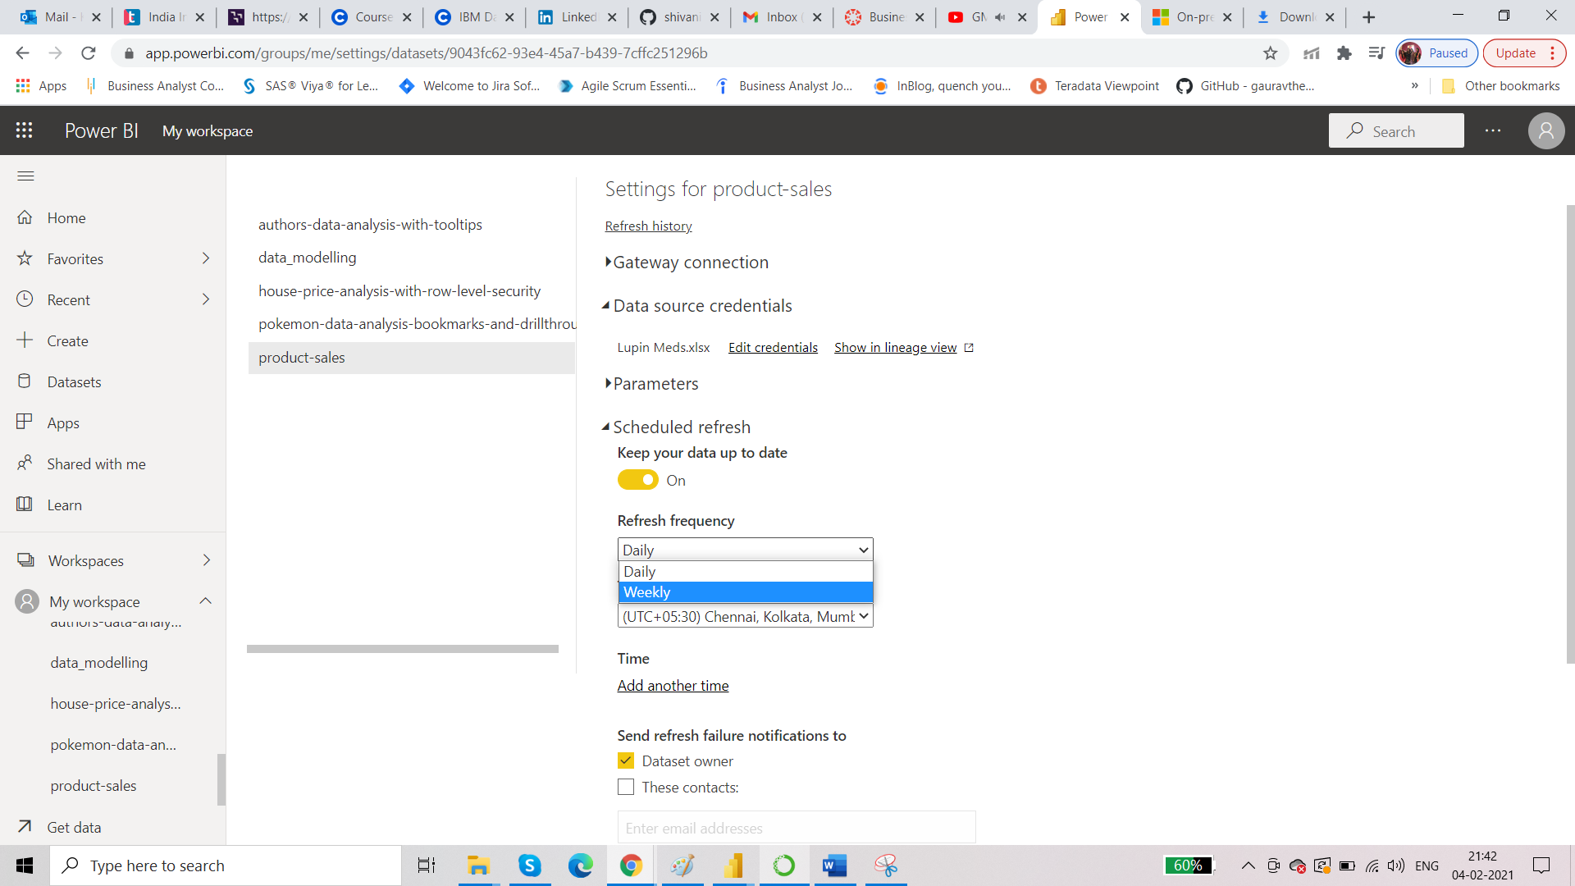

You can add frequency. You can add email in case of any failure, email is sent.

1. Requirement: There are 3 business heads: East, West and Central. These heads are part of the workspace in your PowerBI service. Business head in East should see only East related sales and profit. And like that.

There are two ways to apply such security: Static and Dynamic.

Dataset: Sales_Report

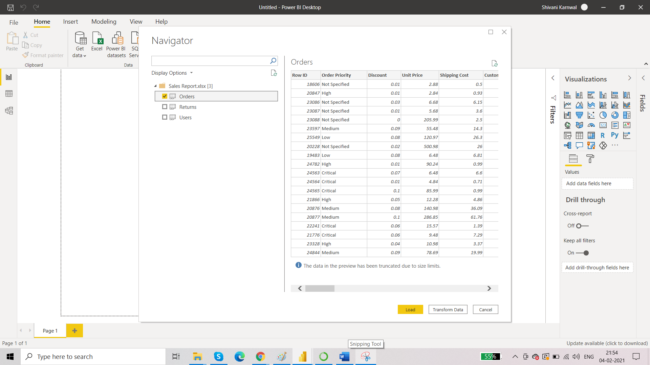

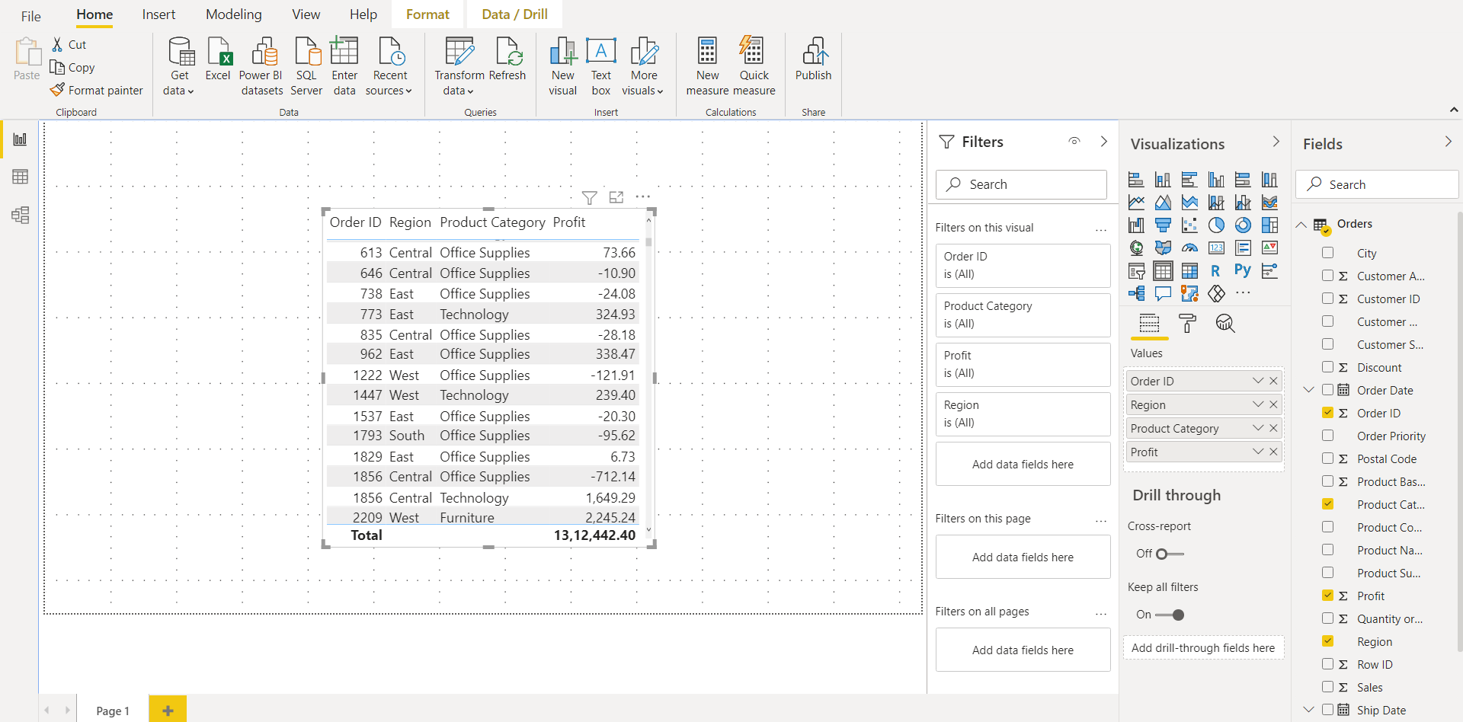

**Static Row Level Security:**

* Create the role
* View the role
* Publish it
* Test it

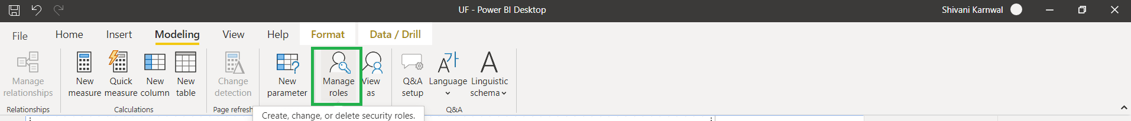

For central business head we want him to see central sales and technology related sales.

So as per the requirement we can set the filters.

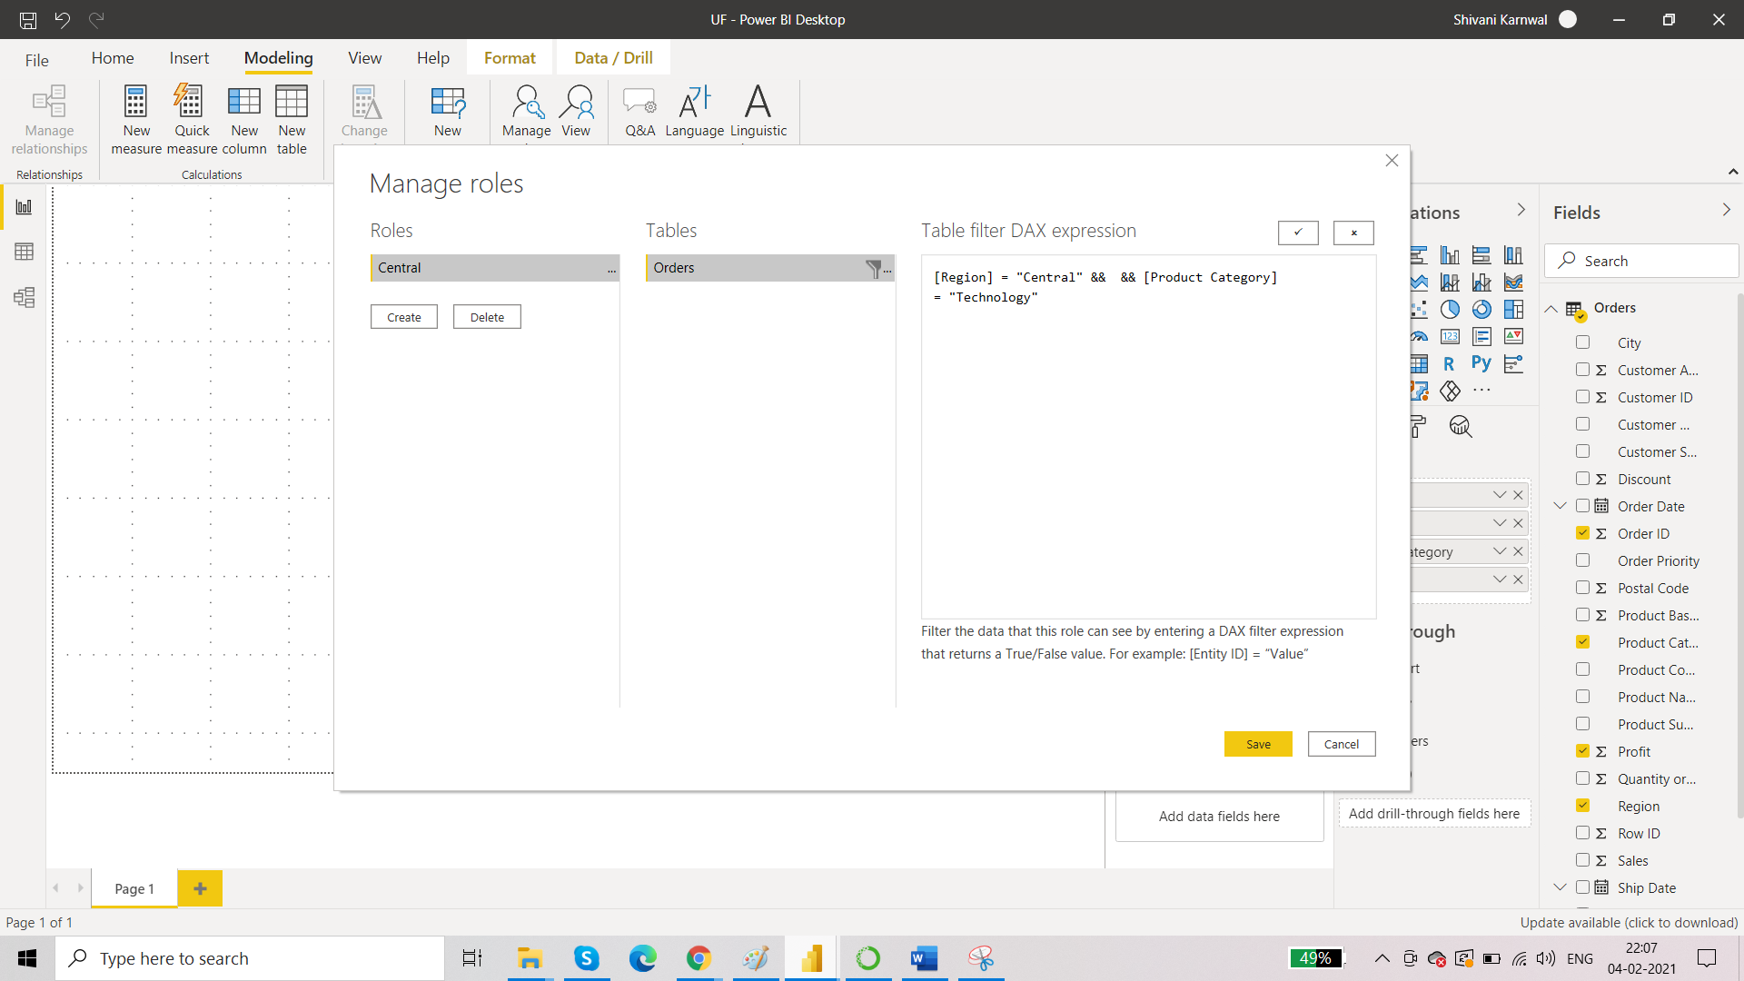

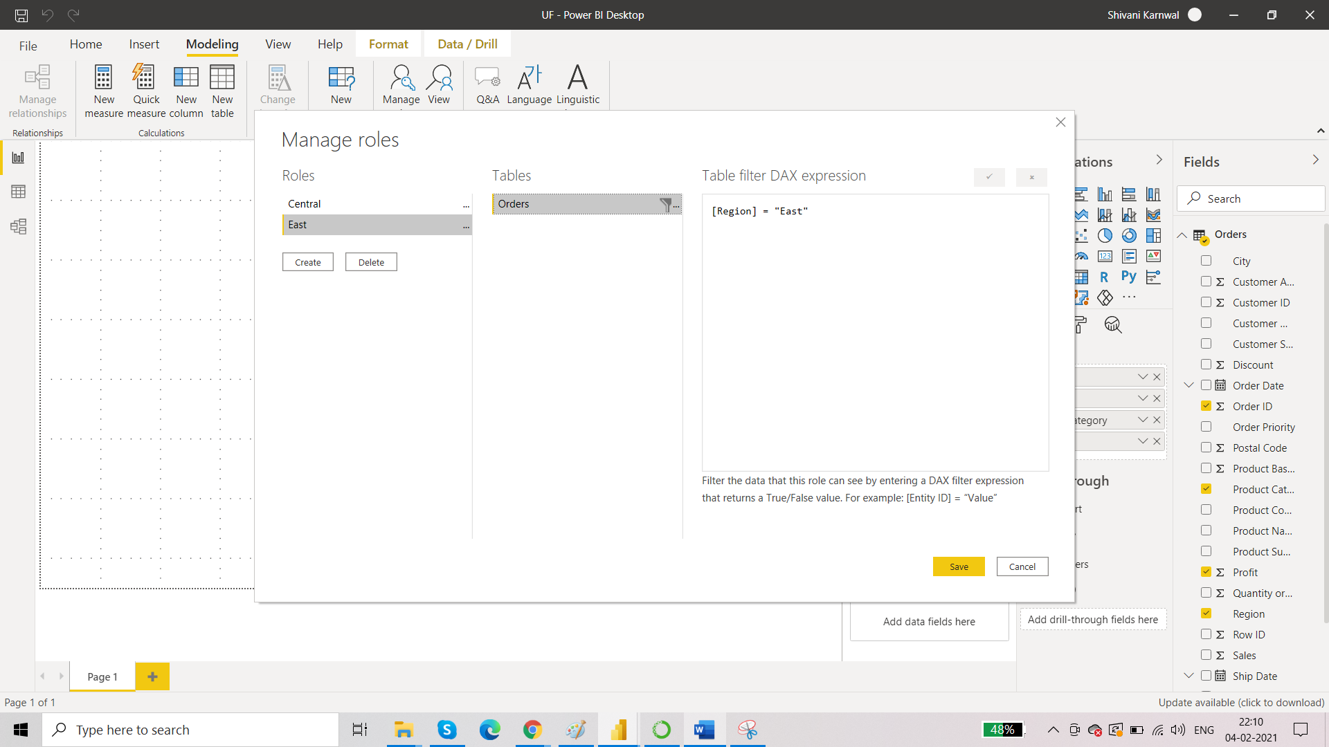

You can now view the roles:

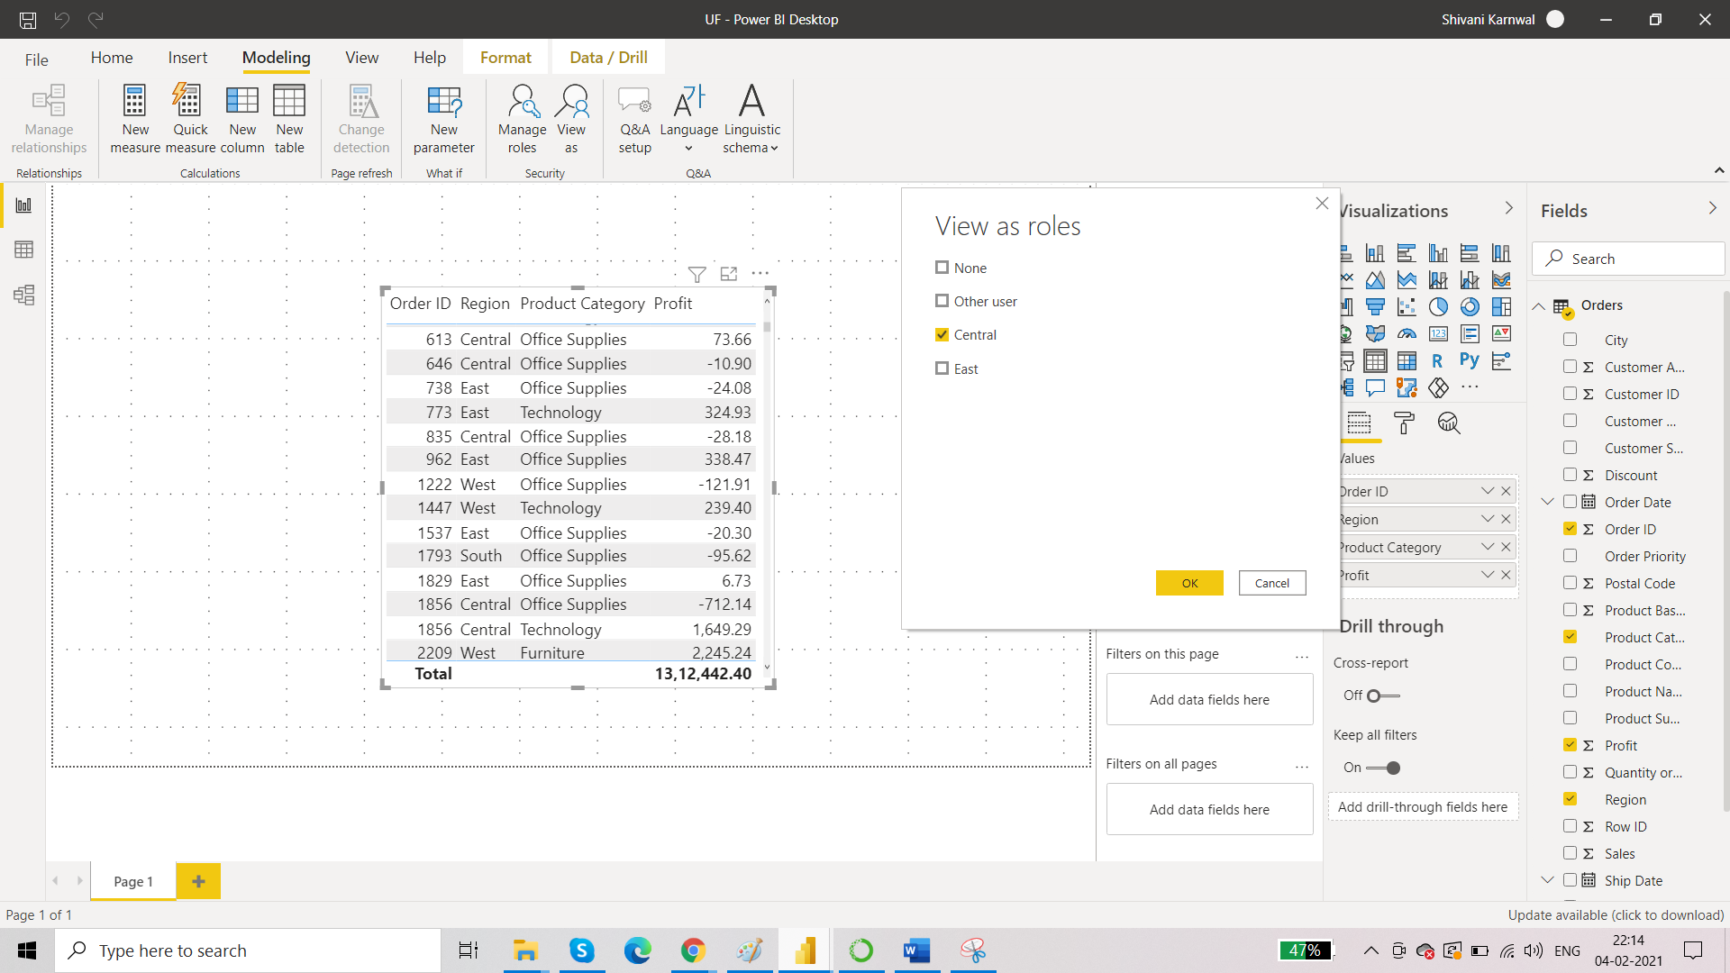

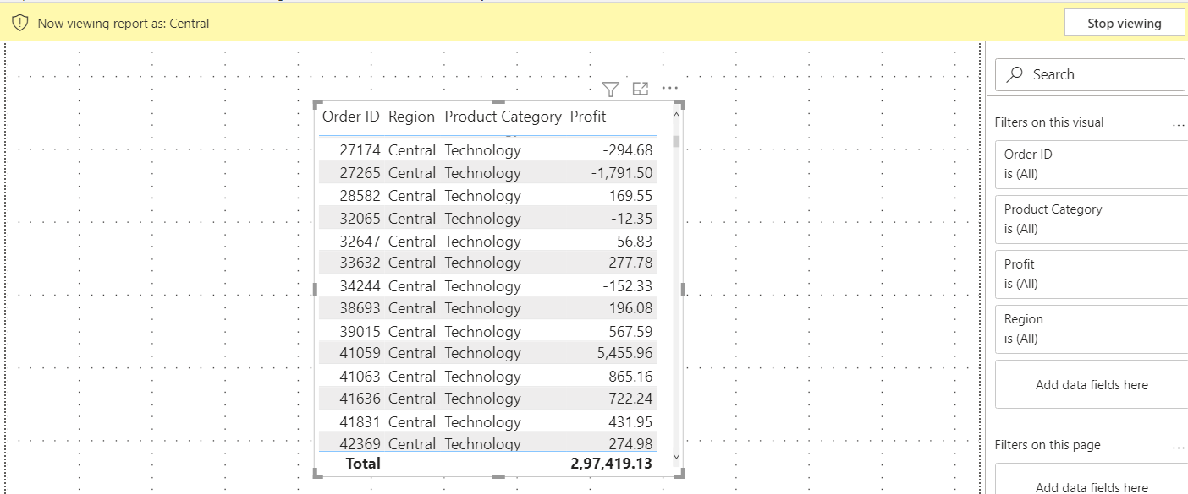

Now third step is to publish the report:

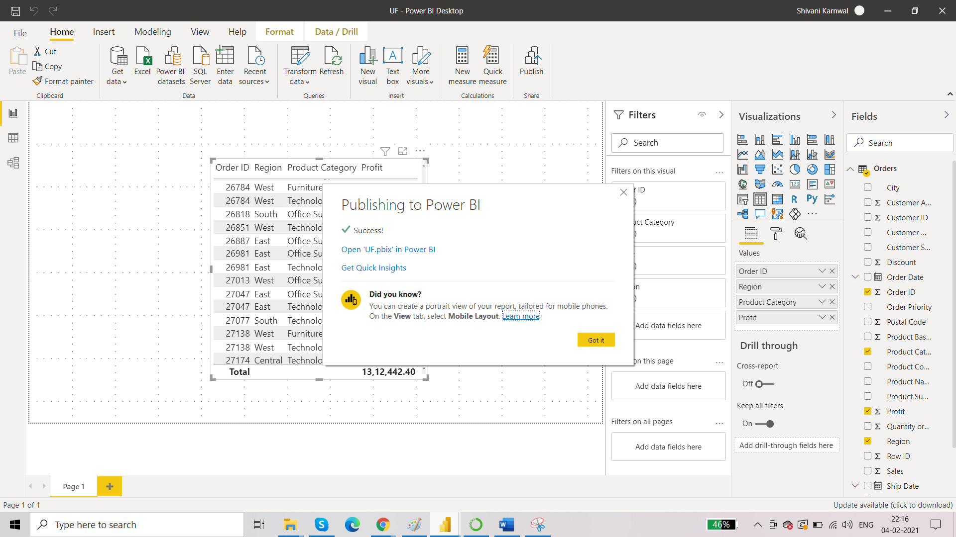

It’s time to test:

Those business heads should be a part of your workspace. You can add members in your workspace only in pro license.

Go to dataset in workspace then click on security.

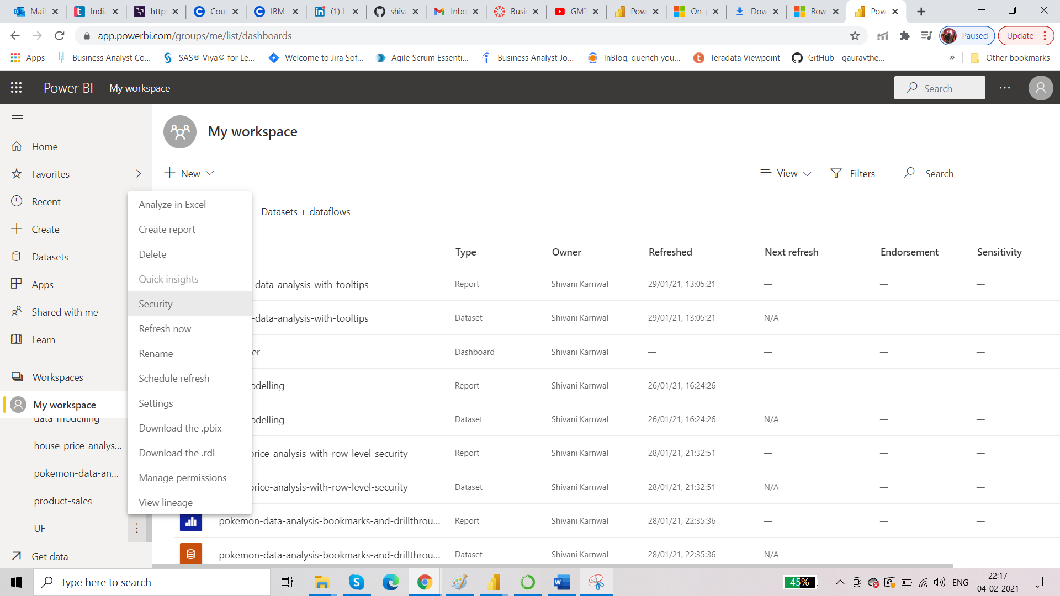

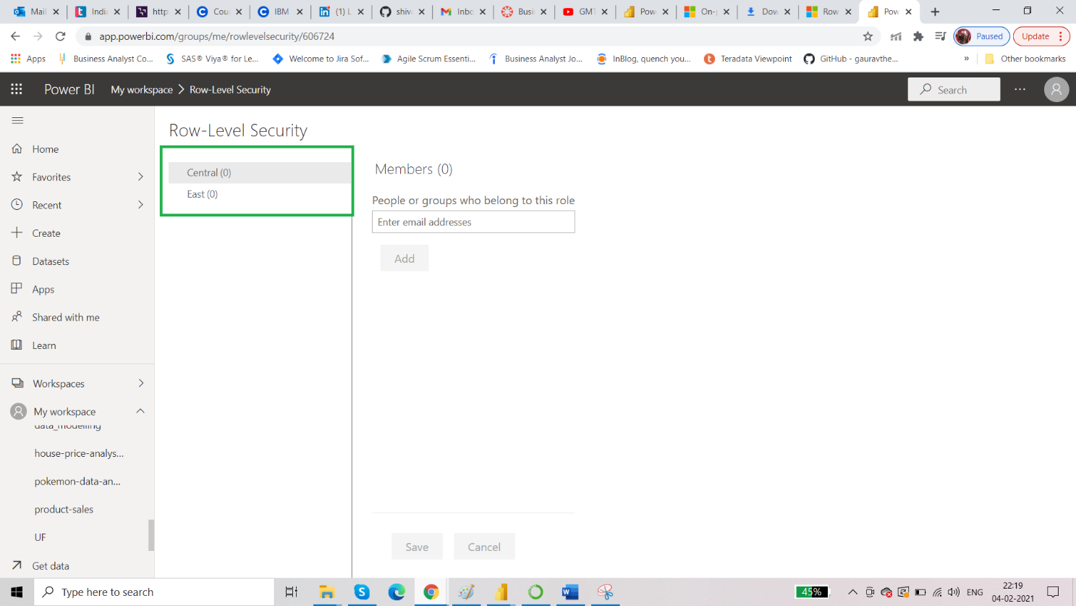

Add email ids and then go to ‘test as a role’

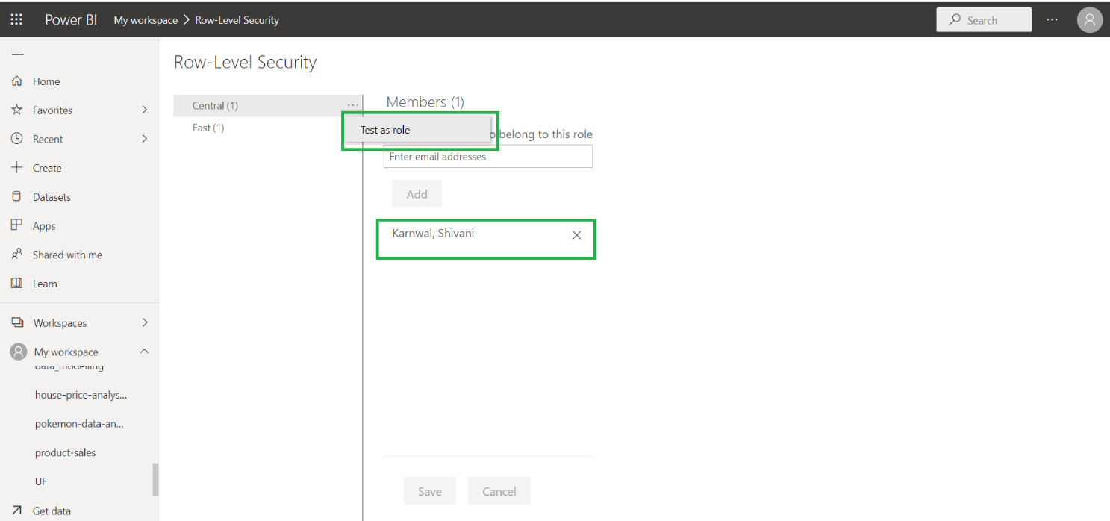

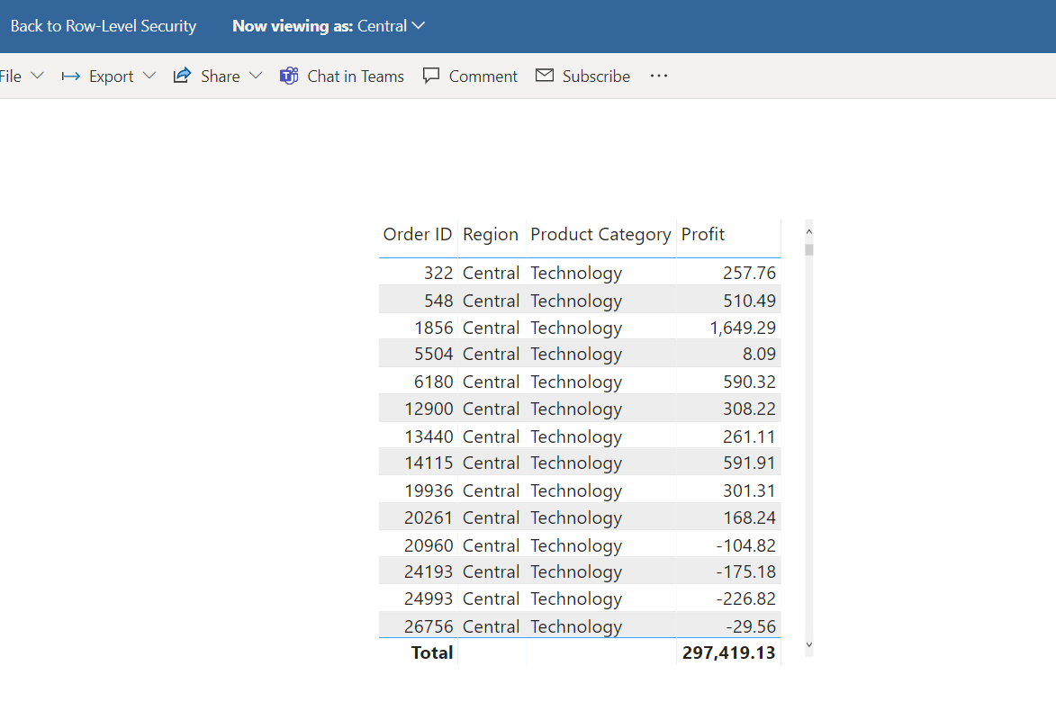

There can be requirements where the users that we want to add are more than 10/20/100 then in that case it is not possible to add them individually by entering the email id. So we use dynamic row level security.

**Dynamic Row Level Security**

This works with the help of measures.

Create a measure. The two functions: username and userprinciplename handles row level security dynamically.

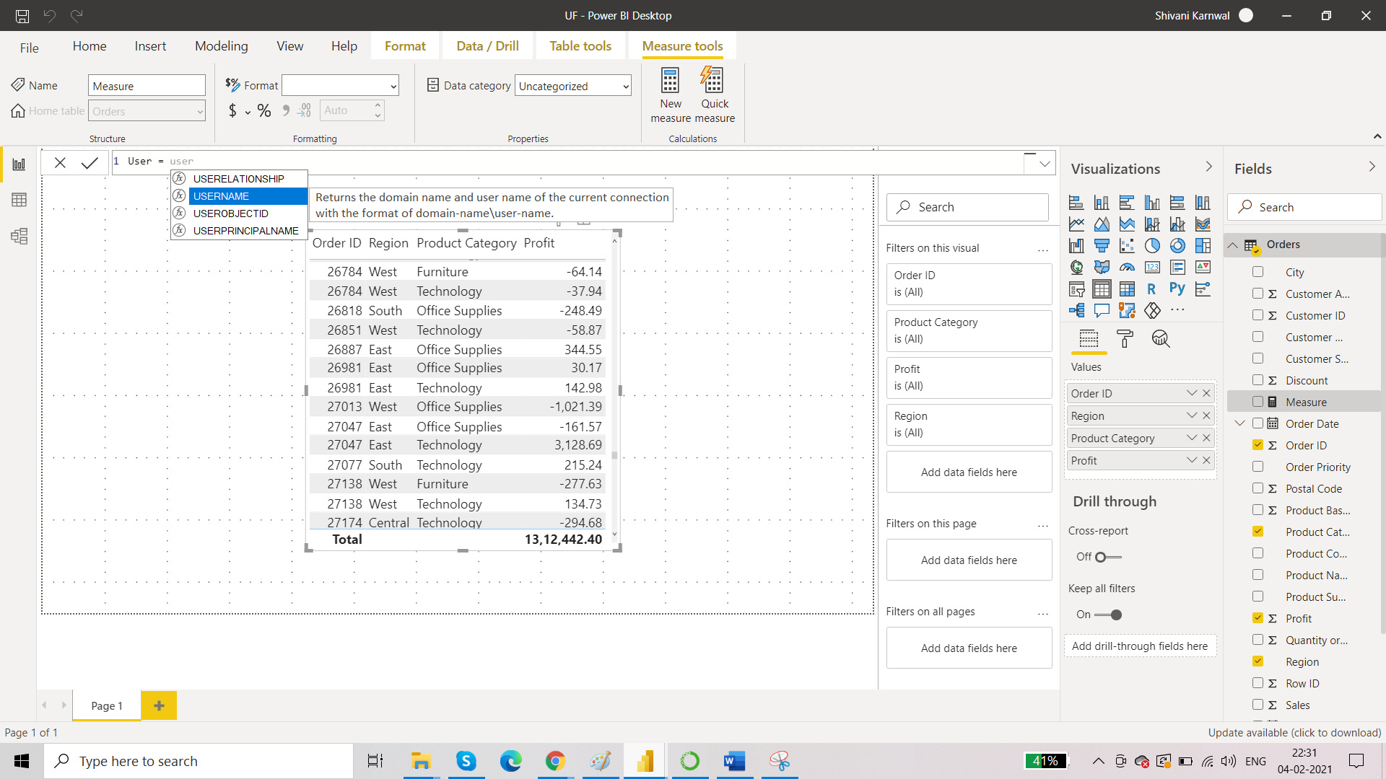

Add the measure into the report:

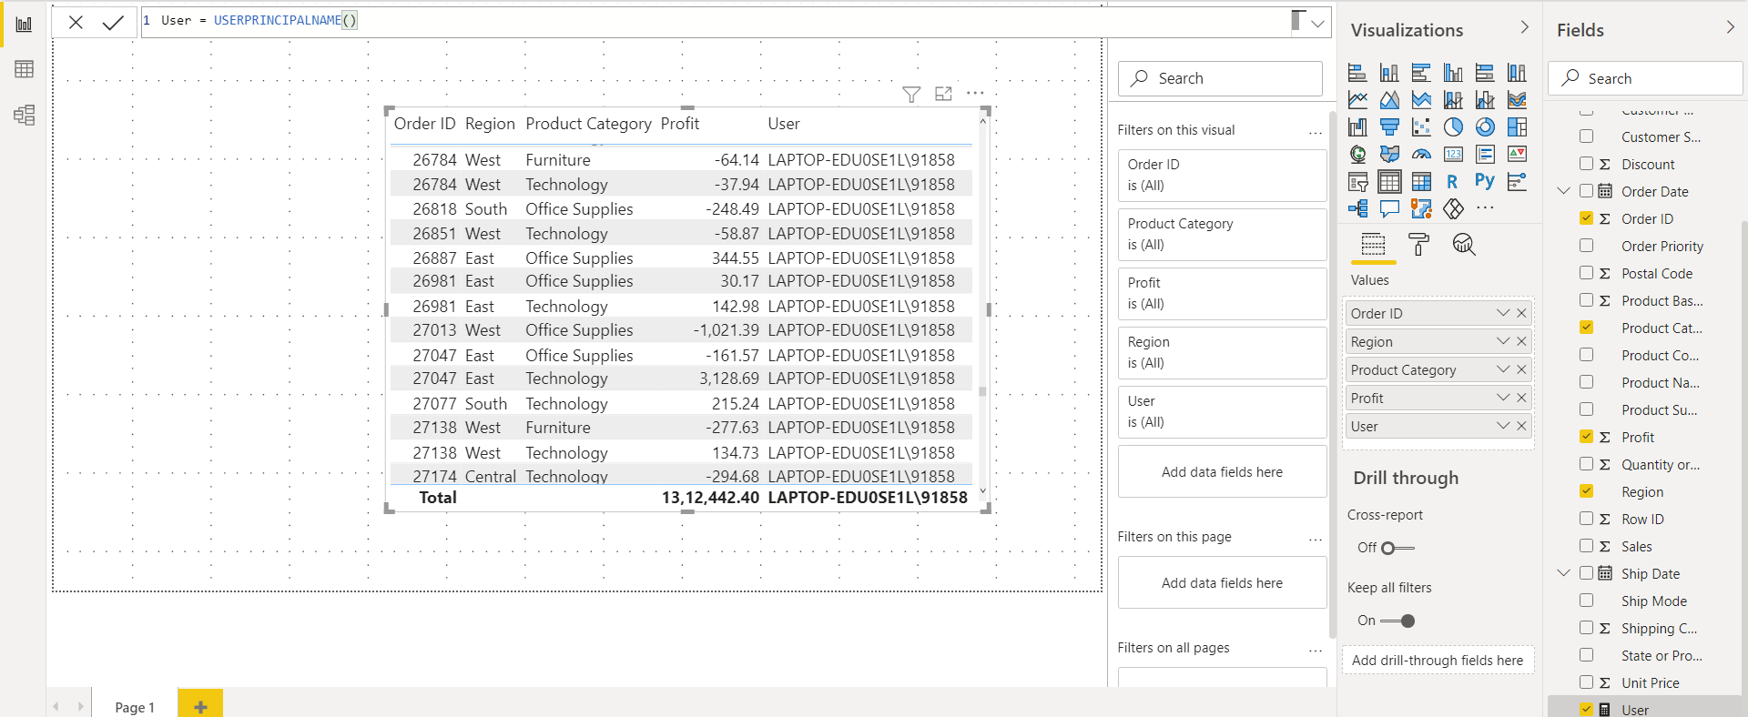

How to improve report performance:

* Always try to keep your focus on Data Modelling stage.
* Separate tables for measures
* Tables should not be too crowded
* Use DAX