LTD Sales Data Analysis using Power Query Editor

**Objective:**

• Need to showcase the Revenue as per the State

• Create a new column as per following condition as per the sales

1. Sales Range

2. Less 100

3. 1001 to 5000

4. 6000 to 10000

5. 11000 to 15000

6. 16000 to 20000

7. 21000 to 25000

8. Above 25000

• Create a new column as per following condition as per the Product Category where for:-

1. Furniture it should show “Office Infra”

2. Others it should show “Non-Office Infra

**Data Transformation:**

Load the data into Power BI application. Make sure that all the rows and columns are loaded properly and null values should not be there. Then, open the table in power query editor.

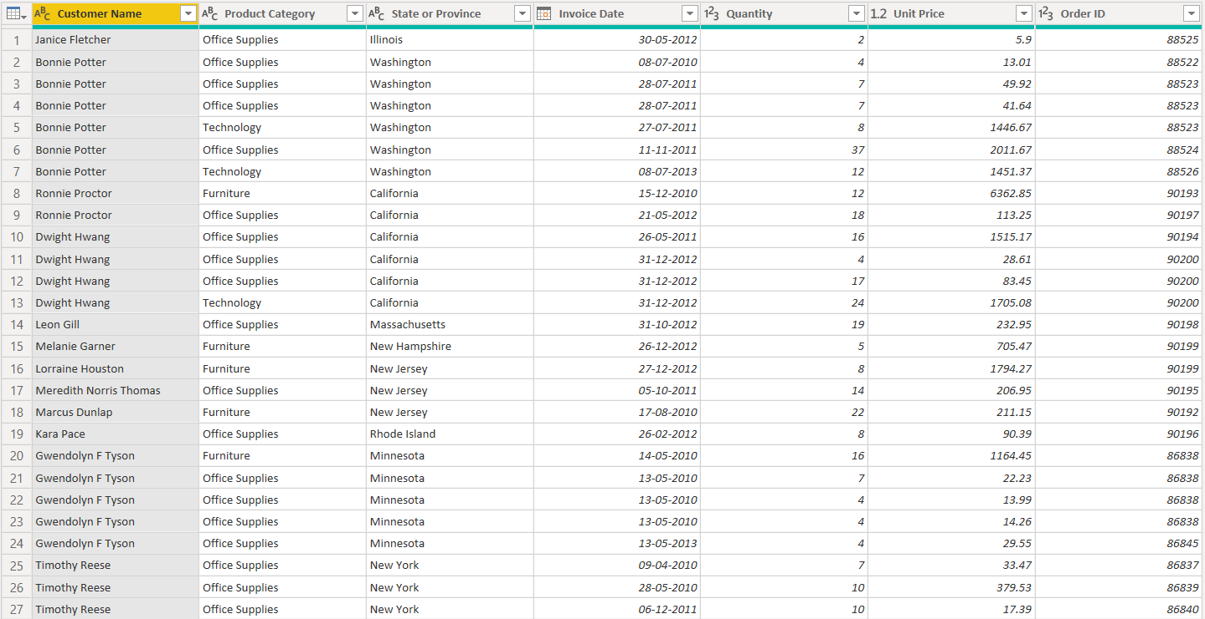

This is a sales table or sales report but we do not see any column depicting sales. So we are going to create a additional column for sales. Now we will create a custom column “Sales” using two existing columns “Quantity” and “Unit Price”. Also, round up the values.

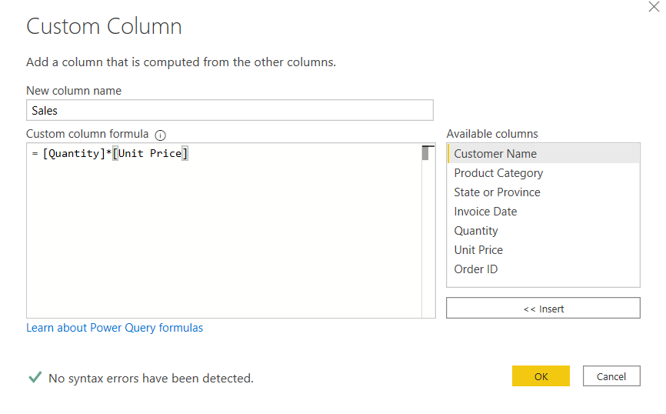

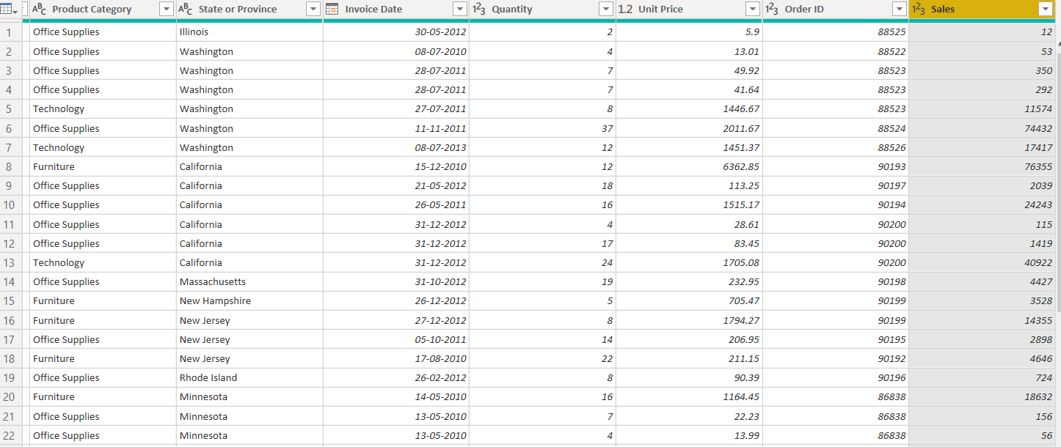

Now click ‘close and apply’.

Add the $ symbol from the data view and then open the table again in power query editor.

For displaying the ranges of sales we add custom column according to the options given.

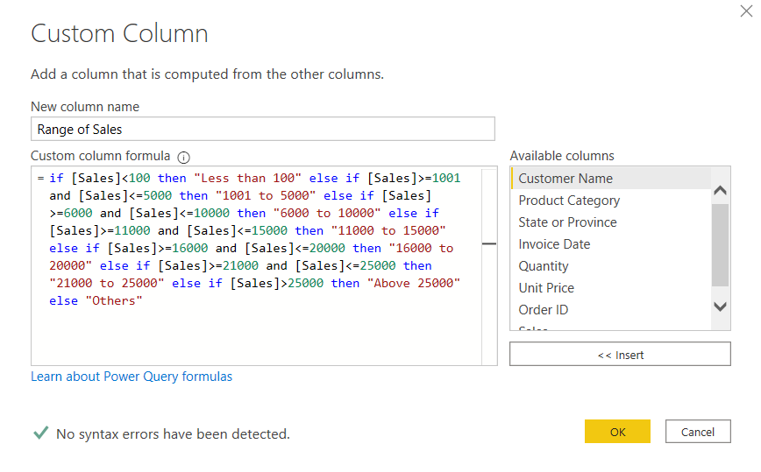

New custom column will be added.

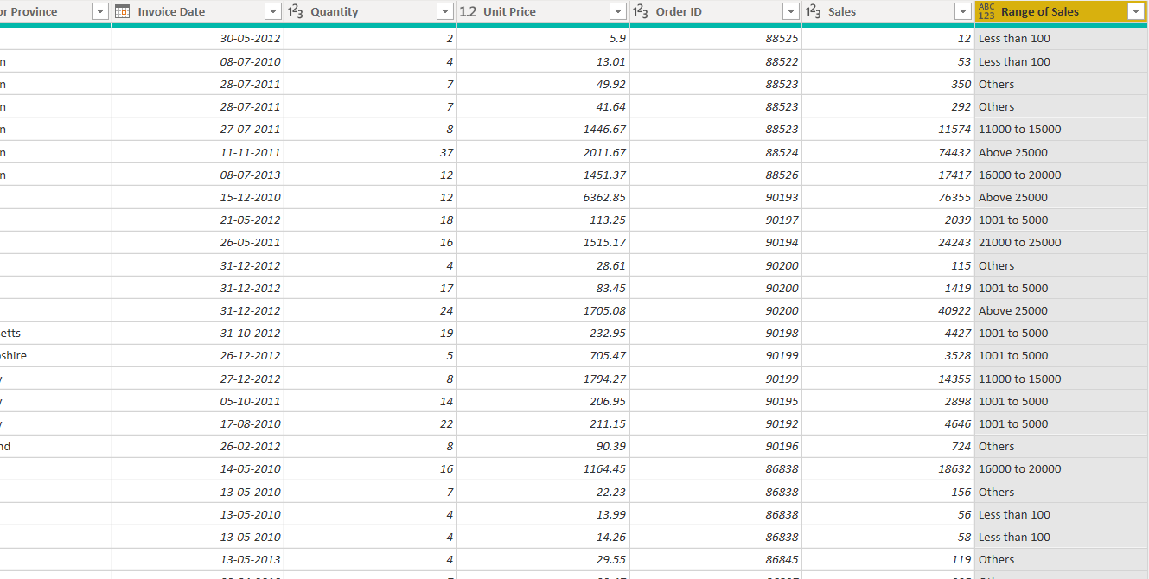

Further we are going to create a conditional column for displaying product type:

