**Analysis on GOT dataset using Power Query Editor**

This blog illustrates data transformation sing powerful functionality provided by PowerBI known as power query editor. We are going to draw some meaningful insights post the data transformation and present them in form of visualisations or dashboard.

Our dataset depicts information about richest people around the world so our focus would be to generate fascinating insights about them.

**Data transformation using power query editor:**

Firstly, take your dataset and load both the tables in Power BI application. We see two tables loaded into the report view. Make sure that there are no null values and no column is missing.

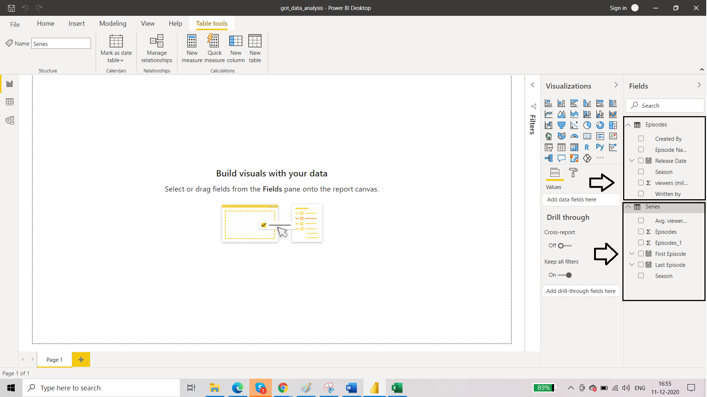

Next, we will go to data view and remove the duplicated column from ‘series’ table.

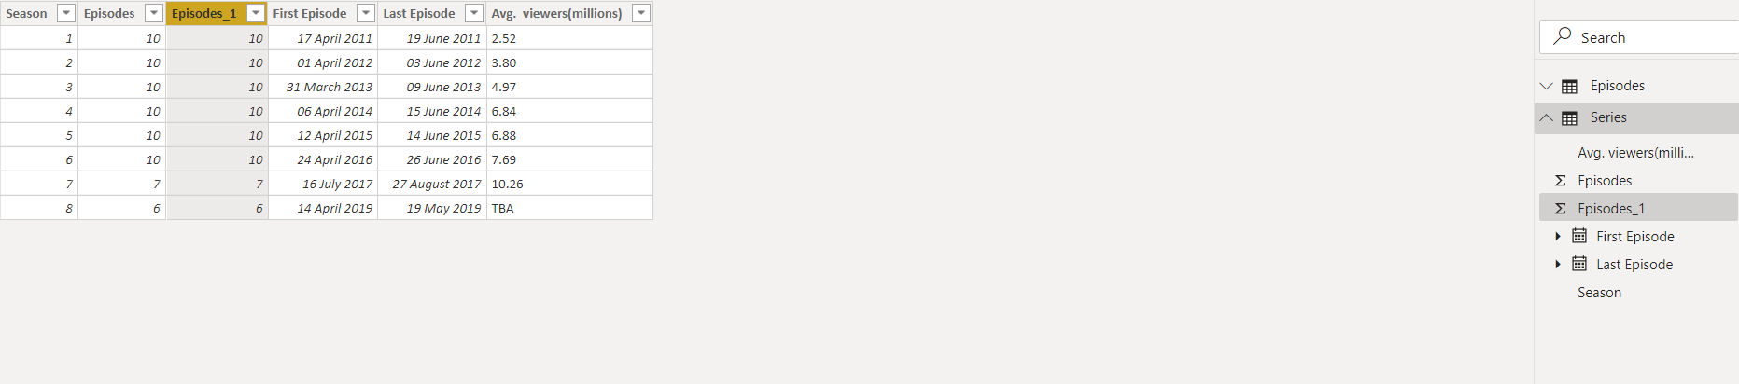

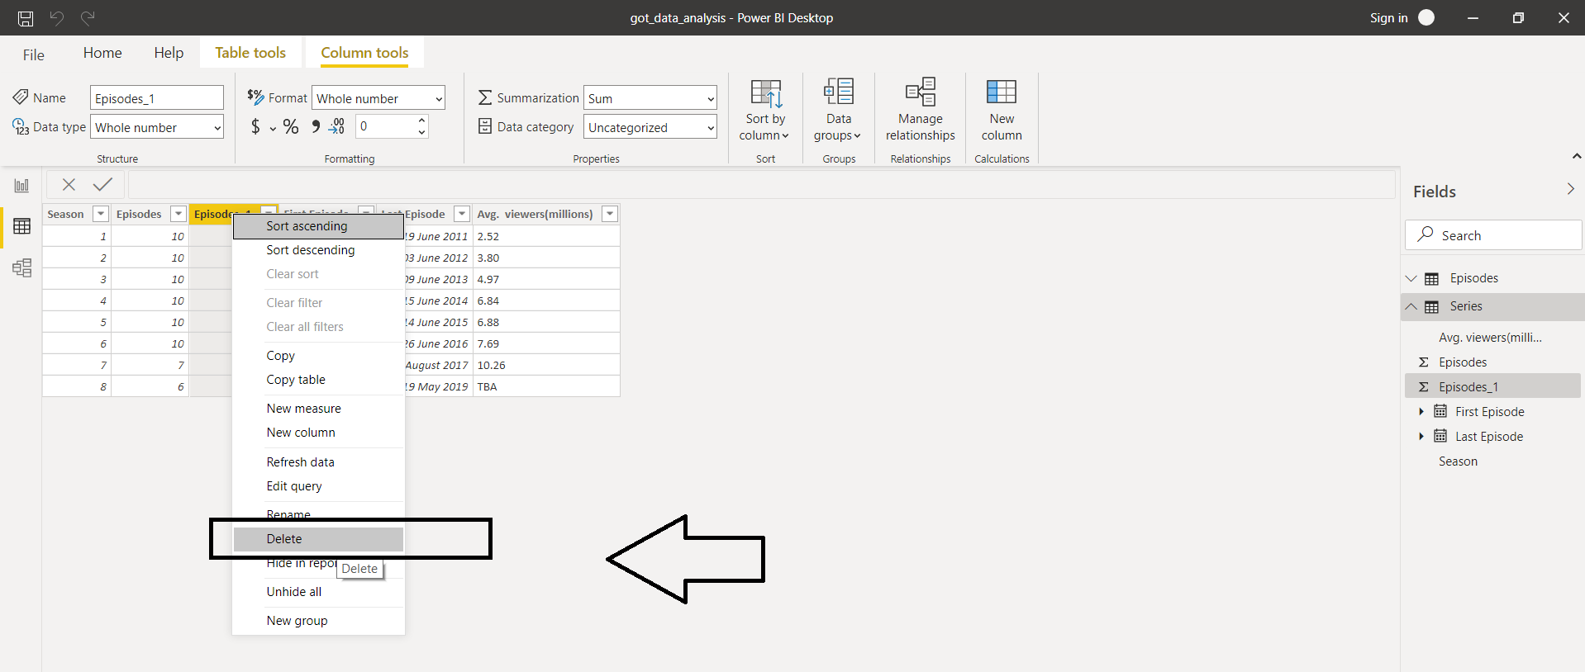

So the Series table is going to look like this:

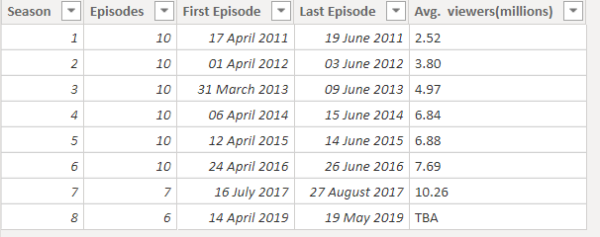

Now we will head over to Episodes table. For our working convenience we change the column name "Created by" as "Director" and "Written by" as "Author".

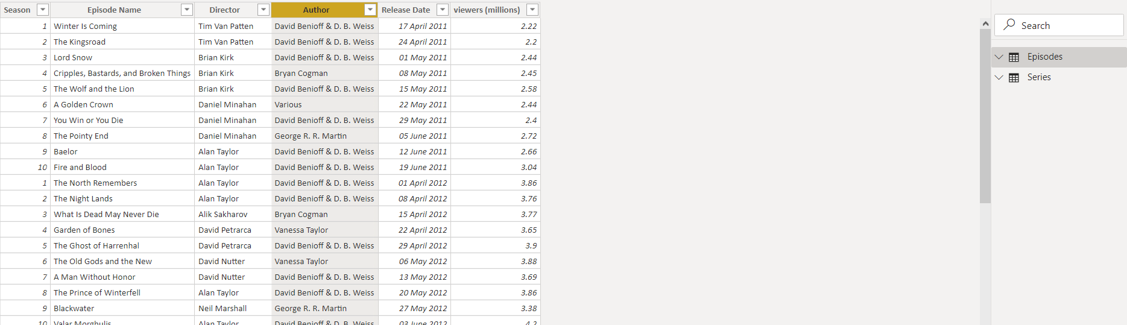

After this, we will load the data into power query editor. Now focussing on the episodes table first. As per the requirement we have to Split the "Author" column in two and replace the resulting nulls with blanks. We will be using the option split column 🡪 by delimiter.

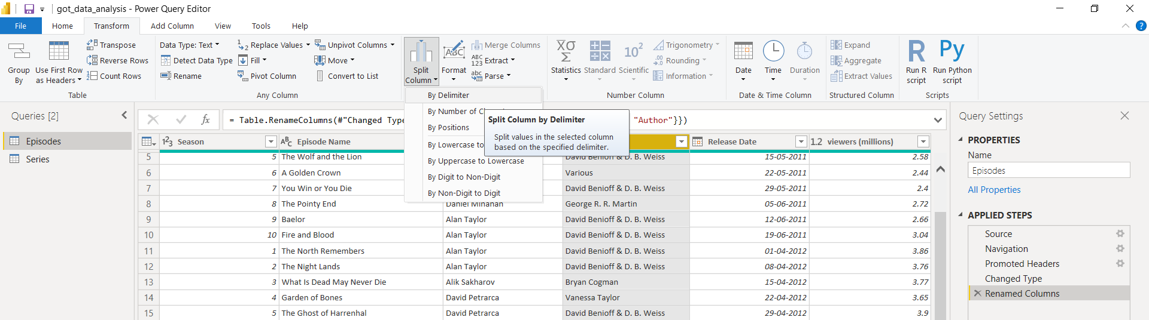

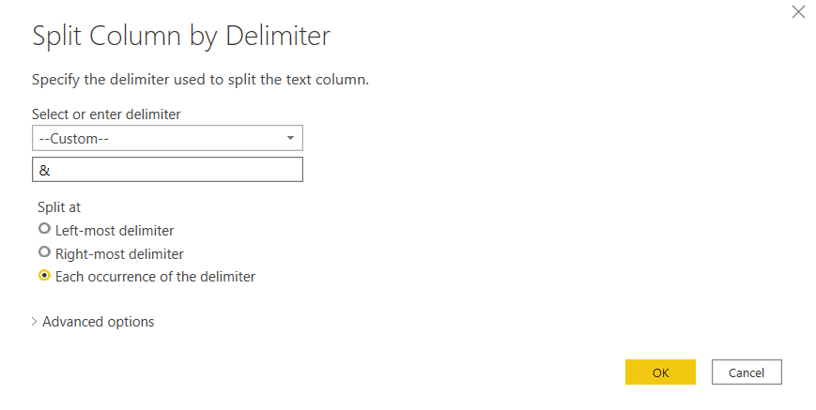

You will see the resultant table as follows:

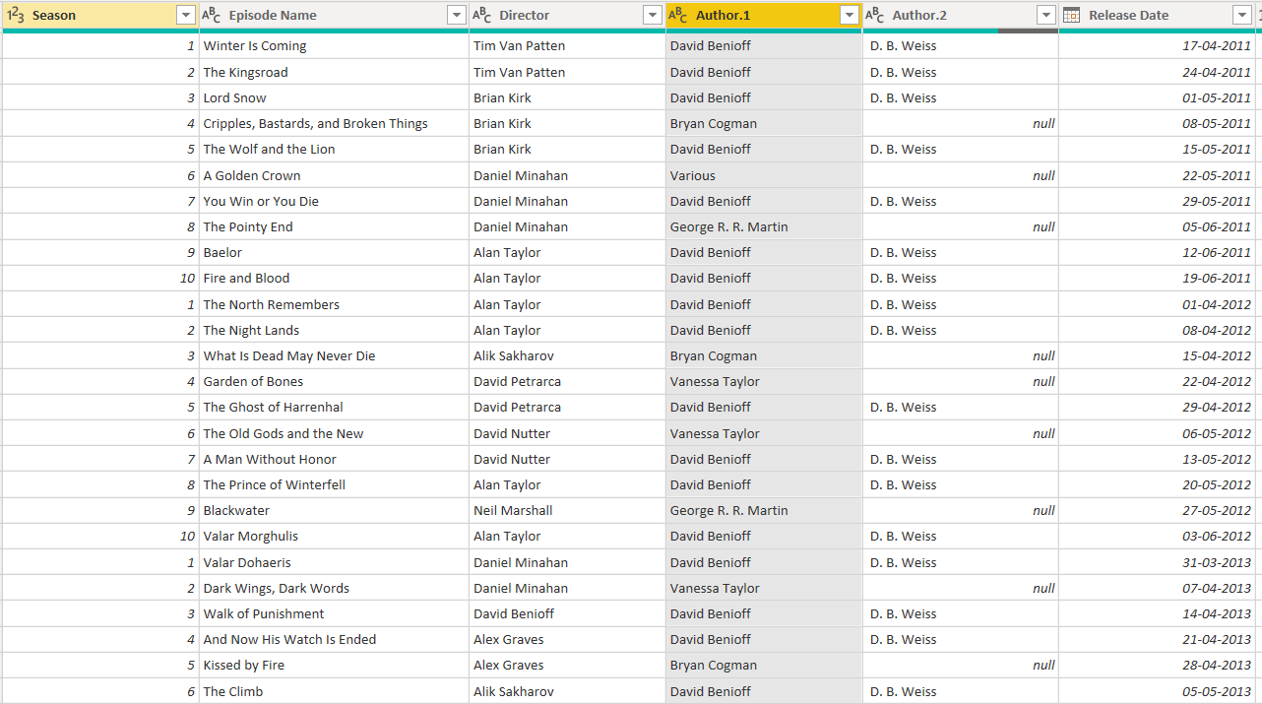

We will now replace the null values with the blanks.

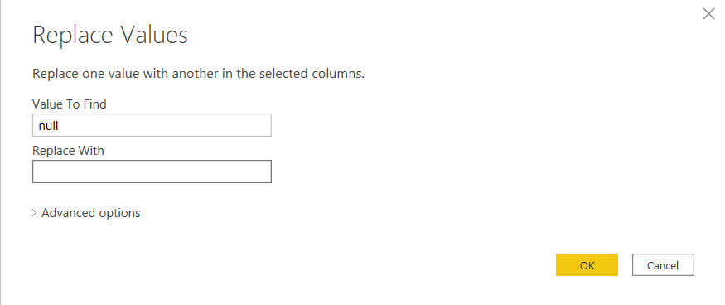

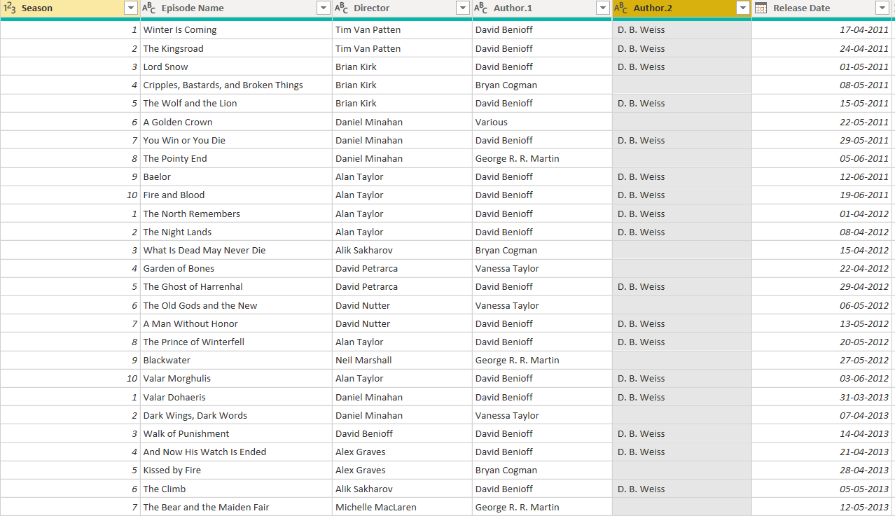

Click close and apply and return to data view. Choose the format of date which you prefer and save the data view.

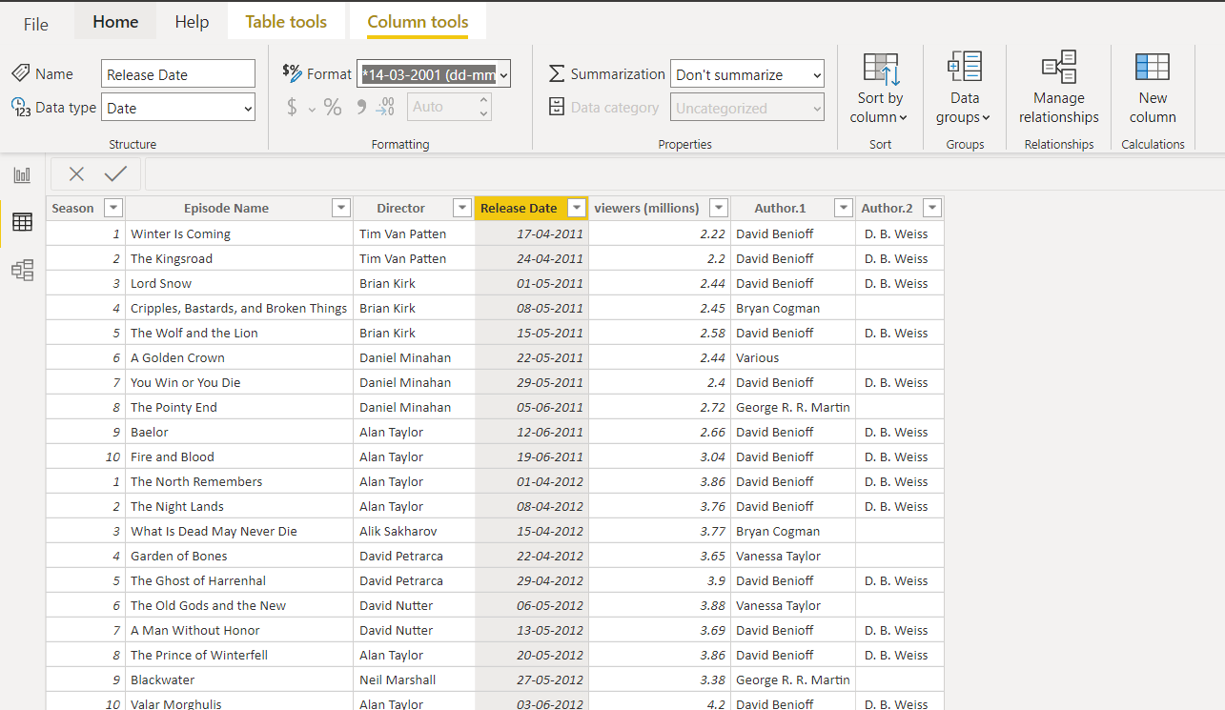

Now, as per the task, we have to see only Daniel directed shows. So we are going to put the filter on and see what the data we get.

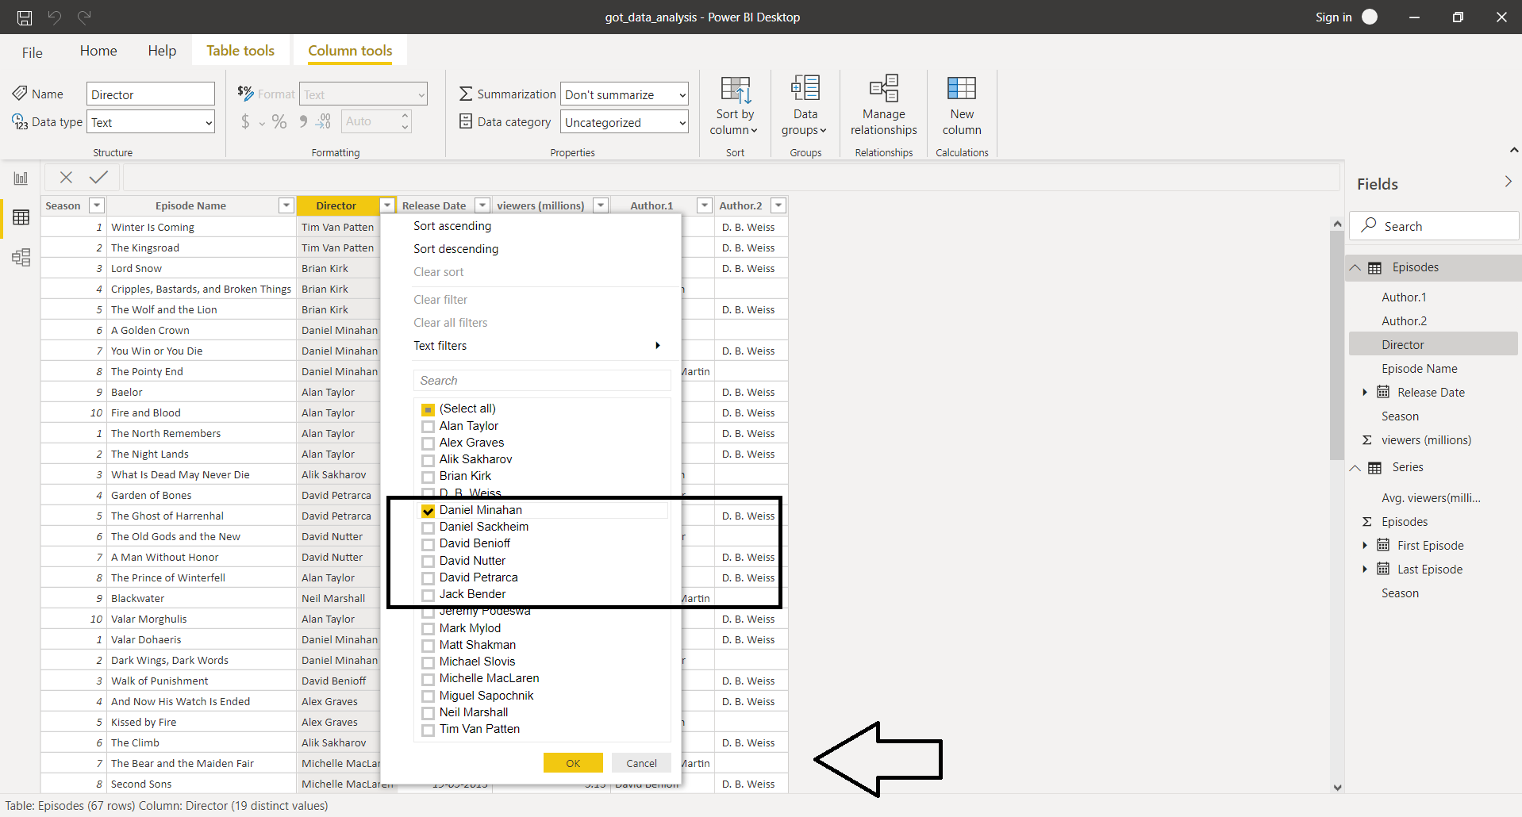

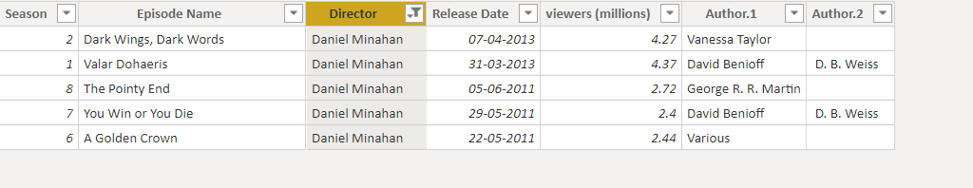

We will merge “Author.1” and “Author.2” columns into a single column “Author” to avoid complication in visualization process. Here we are using “Space” delimiter.

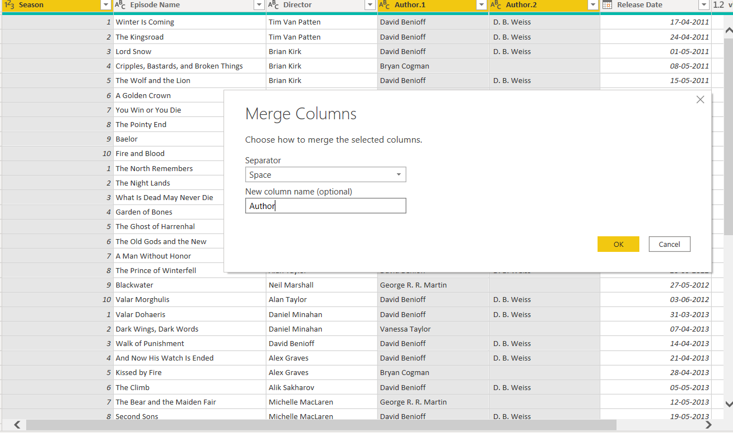

Save the changes. And now we will move on visualization part.

**Data Visualization:**

The dashboard created for the insights is as follows:

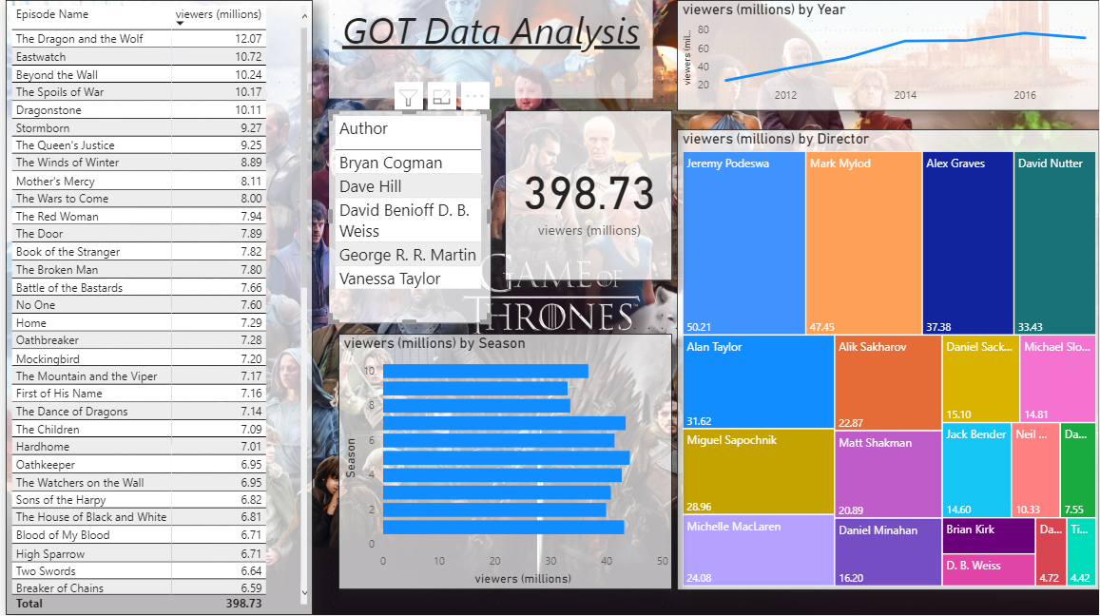

* We have total viewership of 398.73 million users.
* The top 5 directors are shown in the table.
* Directors as per the most viewership by users is shown in the treemap in the bottom left corner.
* When clicked on 2011 on the line chart, we get estimate as: Viewership: 25.15 million user, list of directors, list of episodes.

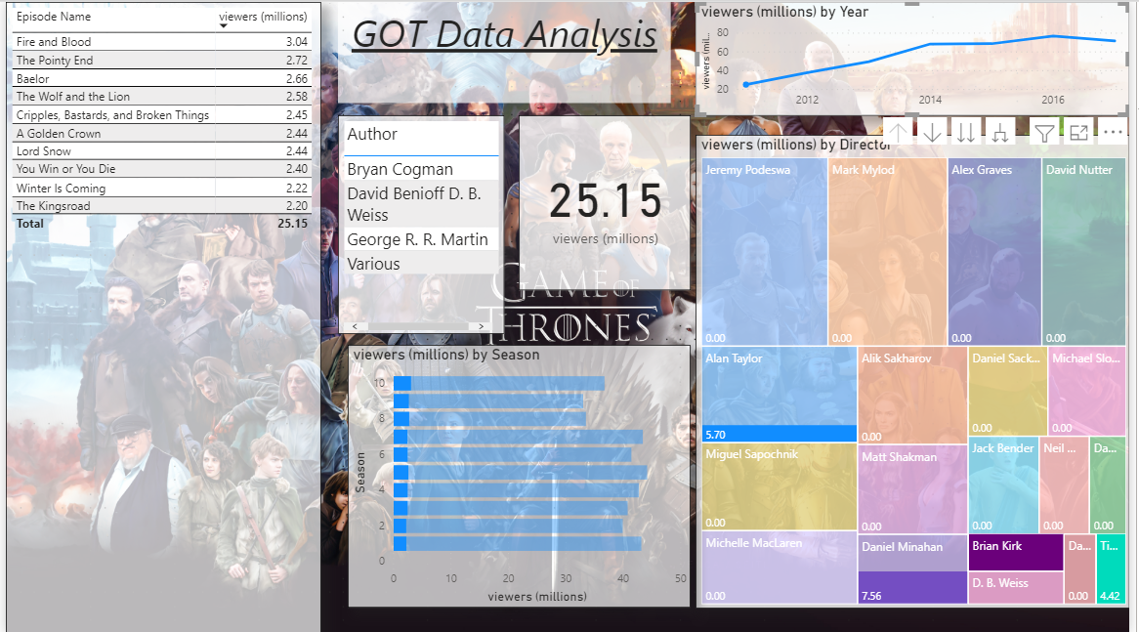

* Most watched Episode is “The Dragon and the Wolf” with 12.1 million viewers. This episode is written by the authors, David Benioff and D.B. Weiss and directed by Jeremy Podeswa. This was released in season 7 in 2017.
* Least watched Episode is “The Kingsroad” with 2.2 million viewers. This episode is written by the authors, David Benioff and D.B. Weiss and directed by Tim Van Patten. This was released in season 2 in 2011.
* Most of the episodes are written by the authors, David Benioff and D.B. Weiss. i.e. 46 episodes are written by them.
* Most watched episode is directed by Jeremy Podeswa.
* Top 5 authors are Bryan Cogman, Dave Hill, David Benioff D.B. Weiss, George R.R. Martin and Venessa Taylor.
* Most watched season is season 5 with 44.16 million viewership.
* 2016 was the year with most viewership.