**Introduction:** Sky Transportation Services Inc. has been serving the shipping industry as an over the road carrier for over eighteen years. During this time, they have constantly expanded and updated their organization in an effort to achieve a higher level of quality for the customer. They are committed in taking care of client’s transportation needs at an acceptable rate exceeding their customer’s expectations by constantly upgrading the efforts. Sky Transportation Services are always looking for and hiring experienced drivers. We have a dataset provided by them which we are going to use to analyse it using PowerBI.

**Objective -1:** The aim of this activity is to load the data in PowerBI application. After analysing the data, we are required to submit our insights on Revenue, Total Miles, Trip Type.

* You should hide the Category ID and Origin State.
* Create a table showing by Customer Name

1. Revenue
2. Total Miles
3. Trip Type

* Summarize the Revenue & Total Miles
* Save this Power BI file with the name SkyData

**Analysis:**

Power BI is a Data Visualization and Business Intelligence tool that converts data from different data sources to interactive dashboards and BI reports. Power BI suite provides multiple software, connector, and services - Power BI desktop, Power BI service based on Saas, and mobile Power BI apps available for different platforms. These set of services are used by business users to consume data and build BI reports.

Power BI desktop app is used to create reports, while Power BI Services (Software as a Service - SaaS) is used to publish the reports, and Power BI mobile app is used to view the reports and dashboards.

* Data sources: Power BI supports large range of data sources. You can click Get data and it shows you all the available data connections. It allows you to connect to different flat files, SQL database, and Azure cloud or even web platforms such as Facebook, Google Analytics, and Salesforce objects. It also includes ODBC connection to connect to other ODBC data sources, which are not listed.

Following are the available data sources in Power BI −

* Flat Files
* SQL Database
* OData Feed
* Blank Query
* Azure Cloud platform
* Online Services
* Blank Query
* Other data sources such as Hadoop, Exchange, or Active Directory

To get data in Power BI desktop, you need to click the Get data option in the main screen. It shows you the most common data sources first. Then, click the More option to see a full list of available data sources.

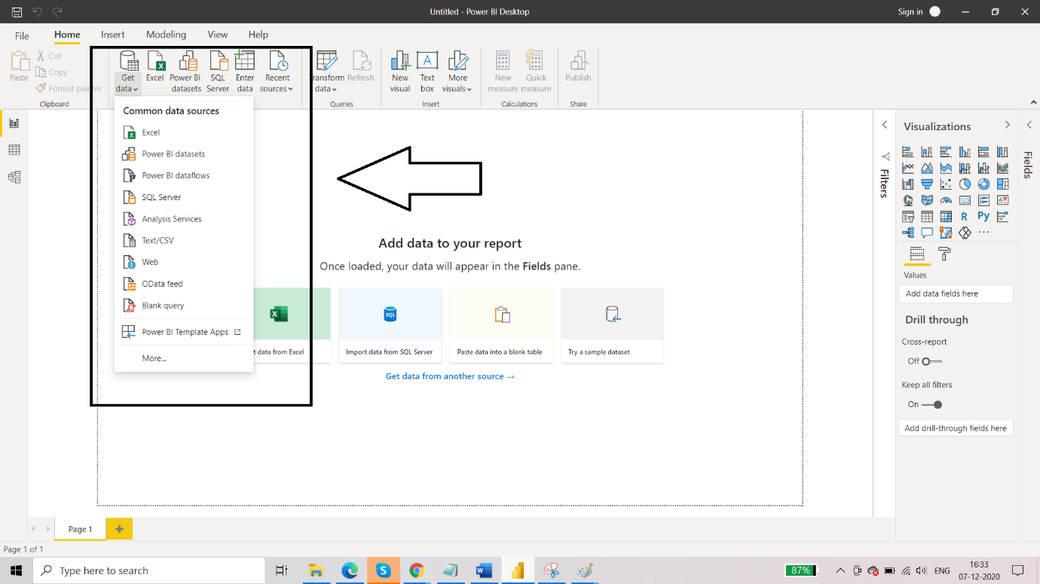

When you click “More..” tab as shown in the above screenshot, you can see a new navigation window, where on the left side it shows a category of all available data sources. You also have an option to perform a search at the top.

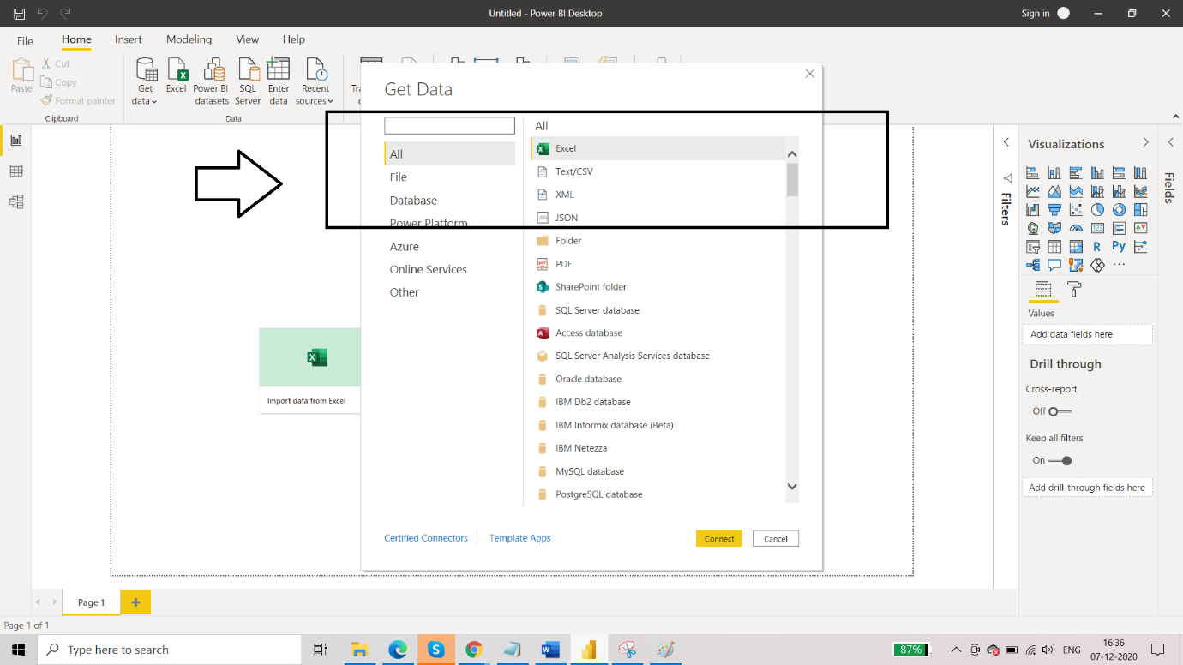

So, we will now import the required dataset from the local folder where it is stored. We will now click on CONNECT. After the connection is established, you will see the tables that are present in your dataset. Click on checkbox of all the tables that you want to include in your data analysis. Then we will get two options after selecting the dataset that is: LOAD and TRANSFORM DATA. If you want data transformations to be done on the data then select “transform data” otherwise we will go directly to “load” option.

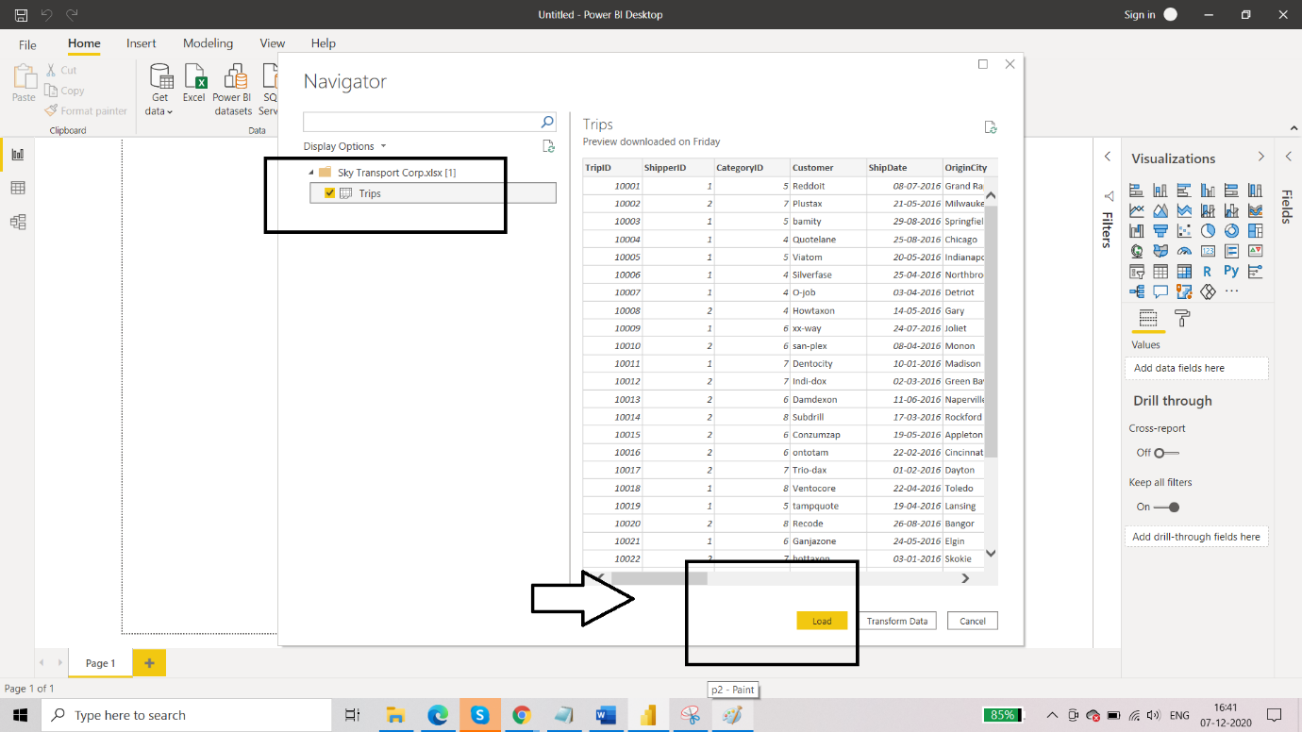

Now observe the three views present in PowerBI desktop. You will see that there are three panes that is report view, data view and model view. You can switch between these views by clicking on left most side three adjacent icons. Also in the report view, you will notice that the table is loaded and corresponding columns too.

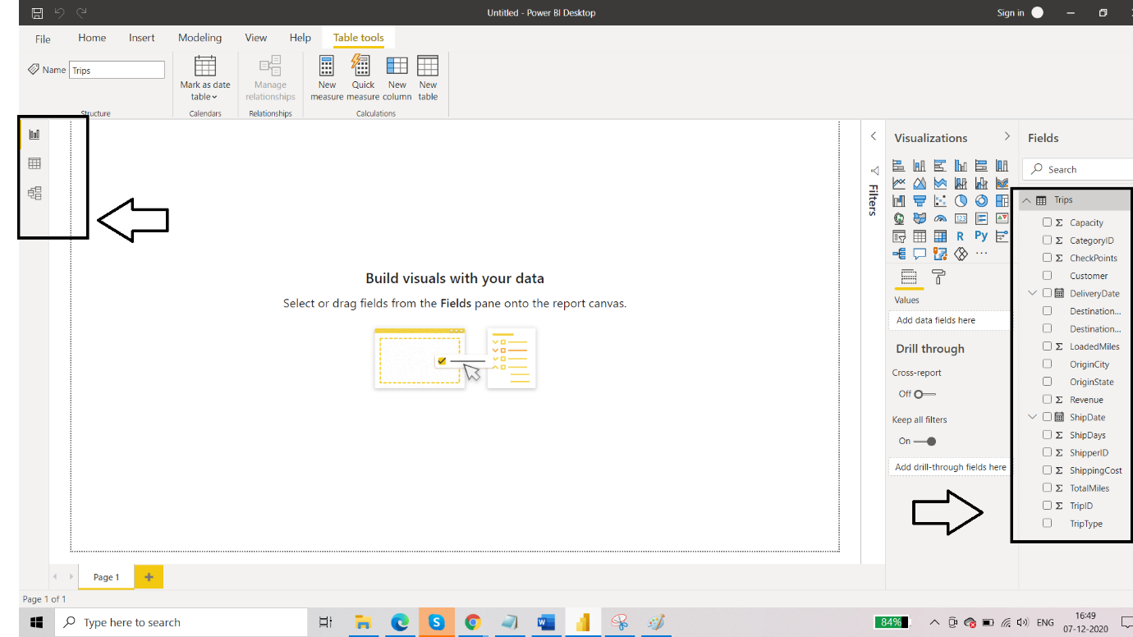

After successfully loading the data, our next step is to hide two columns which we further do not require in our analysis. For this, navigate to the model view and you’ll be able to see schema of your table. Right click on the column name that you want to hide. You’ll see the option of “hide in report view”. Enable that and then there will be a disabled eye sign next to the column name. You have then hide this column from further processing. Hide the “Origin state” column too.

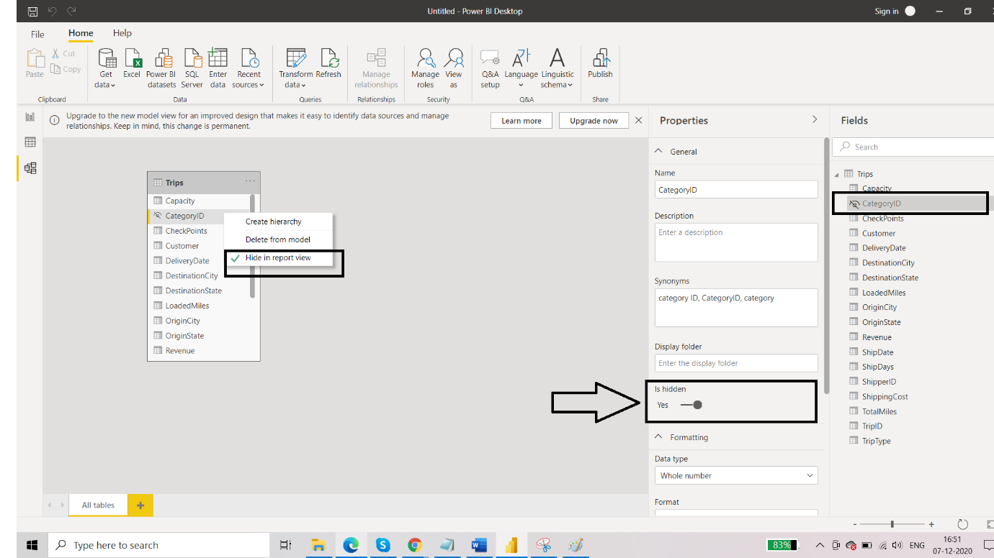

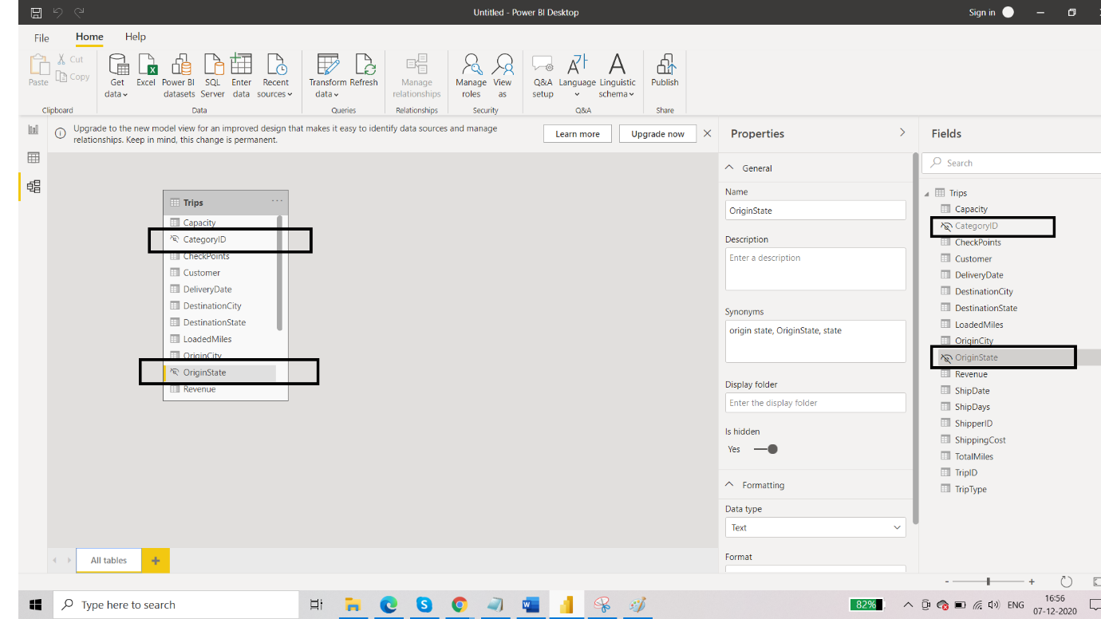

Our next target is to create a table including Revenue, Total Miles and Trip Type. For adding a table, go to report view and from visualizations pane select “table”. Drag and drop the required columns from the fields pane to the Values field of the table. You can format the table by clicking on the format icon from under visualizations pane. You can add the border, enable the shadow and choose between different styles and colours.

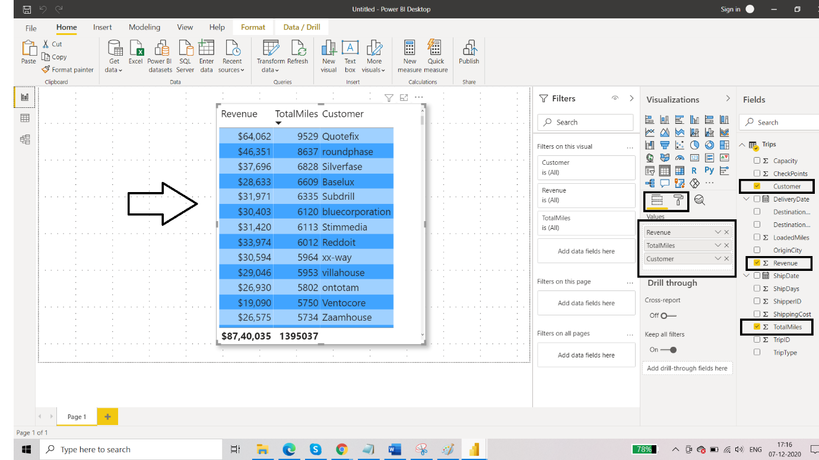

After you are happy with the data and the formatting, you will see that trip type is missing and there are thousands of rows for customer name. So we can add slicer for the trip type as well as for the customer. This will help us get a better visualization of the data. Add 2 filters from the visualizations pane and drag and drop “trip type” and “customer” from Fields pane to the slicers. You can add the similar formatting to these slicers so that it goes well with the complete report.

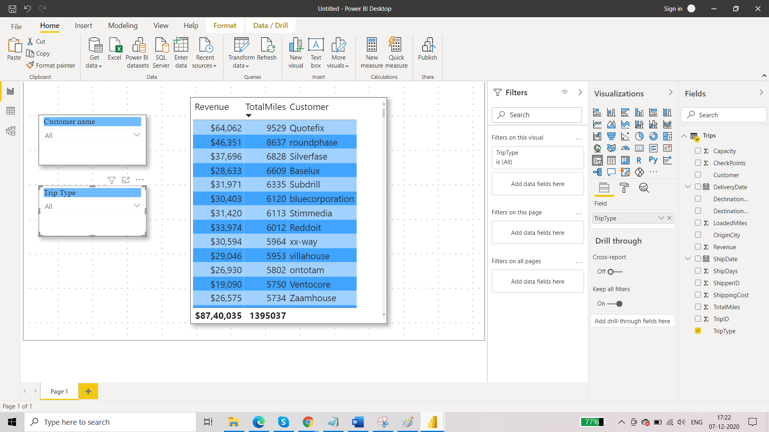

After you have added the slicers, you have two ways to select the options that is list and dropdown. To make this report look structured, we have opted for dropdown selection. In this, you will have to have to select the options by checking the check boxes. You can enable or disable multiple options to be selected. We have enabled here so that more than one customer and more than one trip type can be selected.

Next objective is to summarize total revenue and total miles. When we want to display some aggregate value, we can select card visualization. So for two parameters we need two cards. Drag and drop the cards from the visualization pane and then drop the corresponding column from the Field pane onto the values section of the card. You will now see the sum total of revenue and sum total of miles. Format these cards so that they go coherent with the entire theme. You can increase or decrease the size of the text too.

