**Objective -2:** – Develop a dashboard to show top level brief overview of Sky Transport

Report/Dashboard – Transport Data should contain the following:

* + KPIs for Total Miles, Revenue, Cost
  + Revenue Vs Miles by Shipping State
  + Revenue Vs Miles by Shipping City
  + Total Trips Vs Trips by Trip Types
  + % of Trips by Shipping State
  + Revenue Miles vs Total Miles

**Analysis:**

* KPI refers to key performance indicators. KPIs are a key visualization type used to convey high level metrics to the end users. They provide an at-a-glance metric that allows business users to know whether they are on track or off-track. Over the course of time that single metric number has been enhanced to include lines to showcase trends, date stamps, variance and many other metrics to convey key metrics in a compact and concise way.

For KPI visualization, we need three parameters namely: indicator, trend axis, and target goals. Indicator refers to the data that we want to view the trend on. Trend axis is date like parameter which is usually used to display a period of time. Then we have target which is our goal so that we can track our progress.

As per our dataset we do not have target available so we are going to use “cards” visualization in our dashboard which going to give us an idea about the total miles that are covered, total revenue that is earned and total cost incurred till date.

So, go to visualizations pane and add 3 cards and drag and drop the three specified columns. You are going to see aggregate value of these columns. Perform the formatting and adjust the cards on your dashboard. You can resize them, add some style, add or remove borders and shadow.

**As you can see Total Revenue, Total Miles and Total Shipping Cost is expressed in millions as 8.74m, 1m and 8m respectively.**

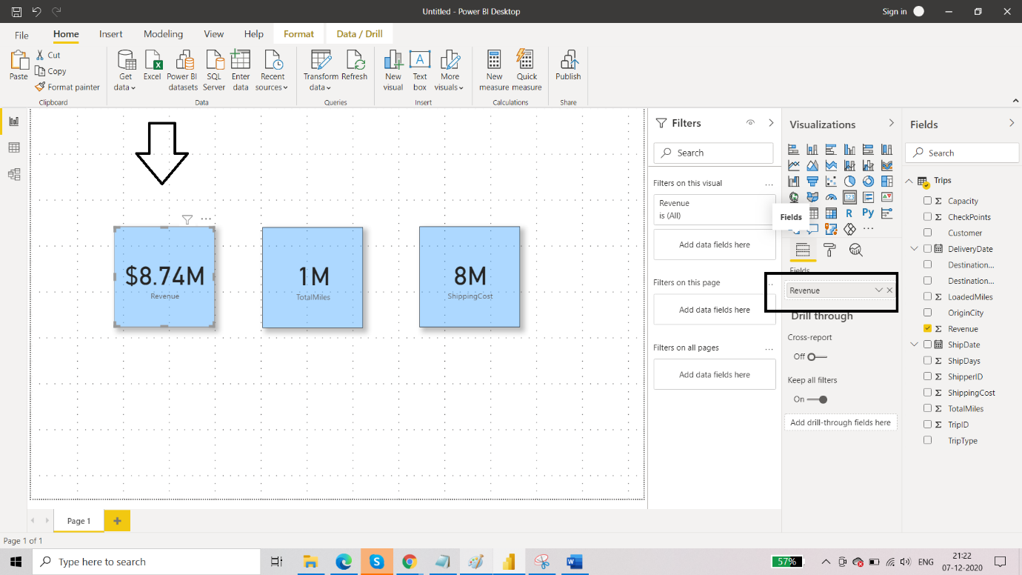

* Next, we have - Revenue Vs Miles by Shipping State and Revenue Vs Miles by Shipping City.

We are going to use clustered bar chart here. Power BI Clustered Bar Chart is used to display horizontal bars of multiple data regions (Measures) against a single Metric. So, from the visualizations pane select the visual and drag and drop the parameters from Fields pane to the chart.

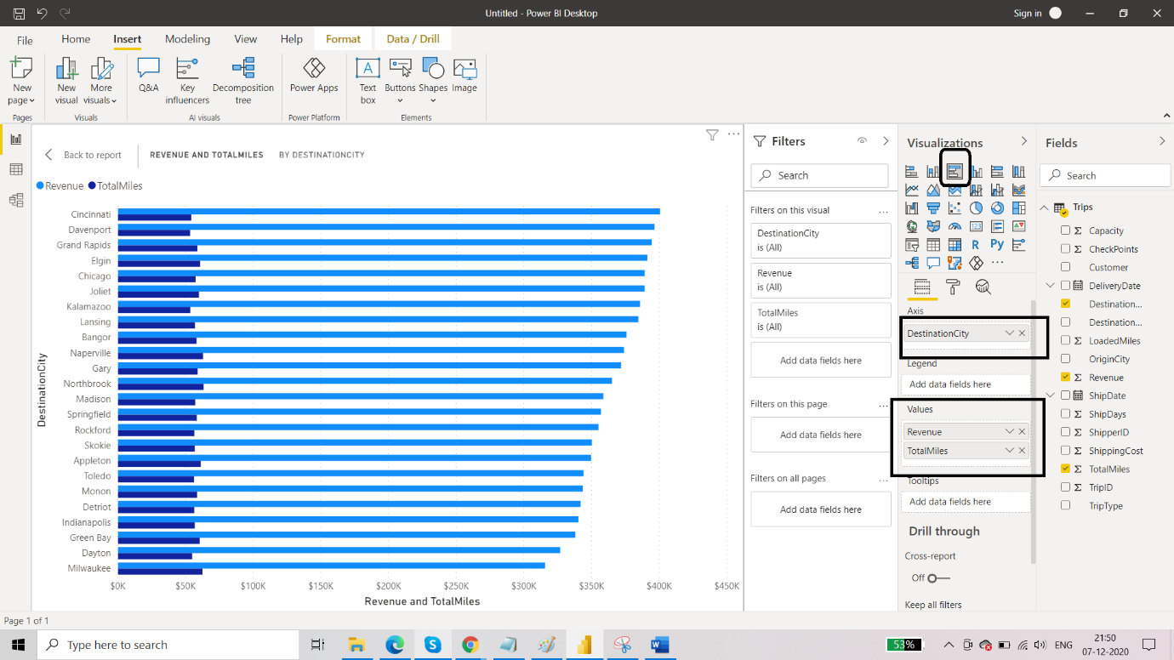

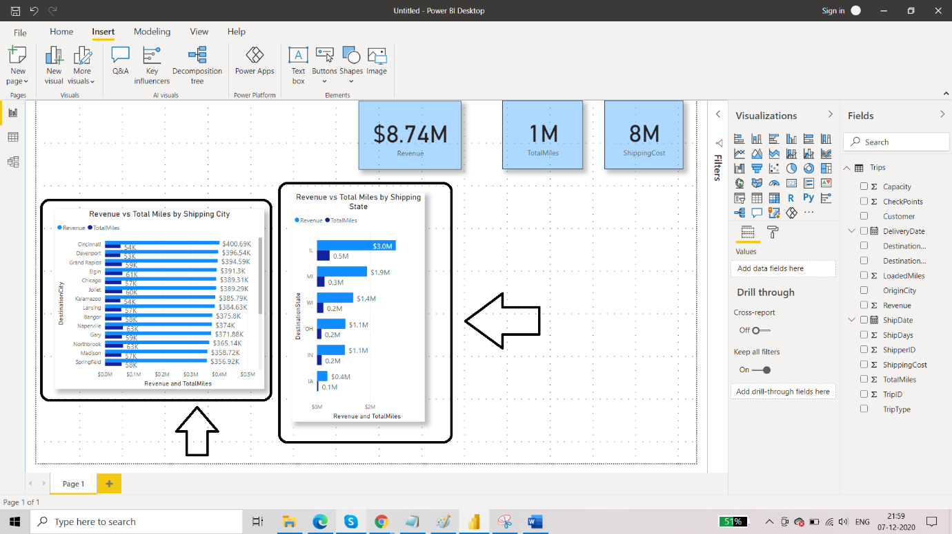

**In case of Revenue vs Total Miles by Shipping City, we can make an inference that city 'Cincinnati' is leading in terms of Revenue with value $400.69K and the city 'Northbrook' and ‘Naperville’ is leading in terms of Total miles with value 63K.**

**In case of Revenue vs Total Miles by Shipping State, we can say that state ‘IL’ is leading both in terms of Revenue and Total Miles with values $3.0M and 0.5M respectively**.

* Next up we have % of Trips by Shipping state. Whenever there is a percentage value we can opt for donut or pie chart visualization. Power BI Donut chart(Doughnut chart) is similar to a pie chart in that it shows the relationship of parts to a whole,  where all pieces together represent 100%. Donut Chart in Power Bi Desktop charts are useful when you want to display small categories of data & avoid for many categories, or when categories do not sum to 100%. Click anywhere on Donut Chart & drag columns to Fields Section.

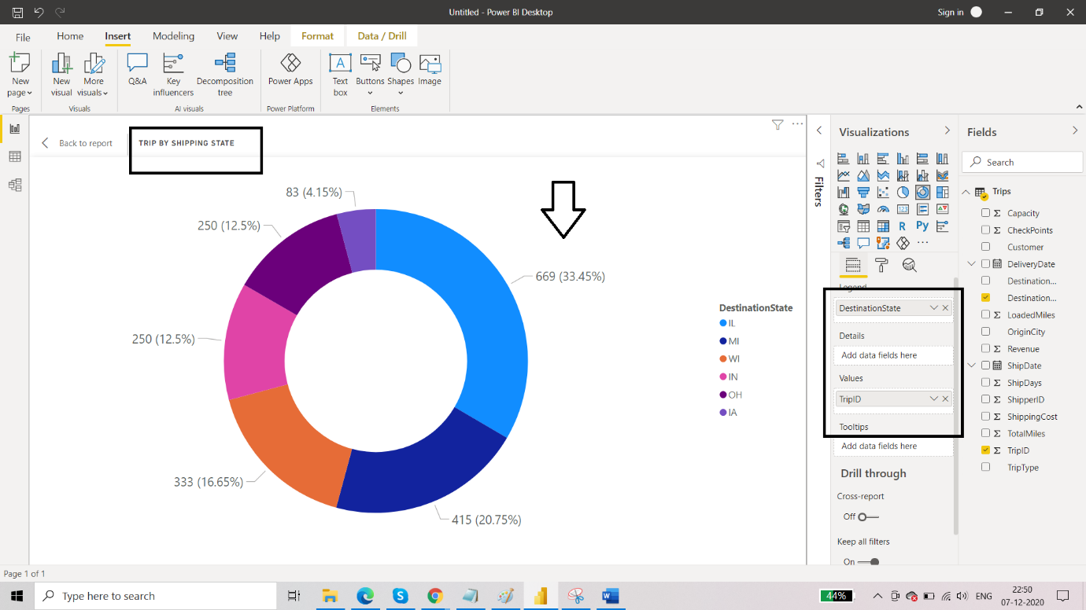

**We can infer that state IL is leading with 33.45% of total trips and the state IA is performing low with 4.15% of total trips.**

Now we have revenue miles vs total miles. This can be illustrated using scatter plot. A scatter chart shows the relationship between two numerical values. A scatter chart always has two value axes to show: one set of numerical data along a horizontal axis and another set of numerical values along a vertical axis. The chart displays points at the intersection of an x and y numerical value, combining these values into single data points.

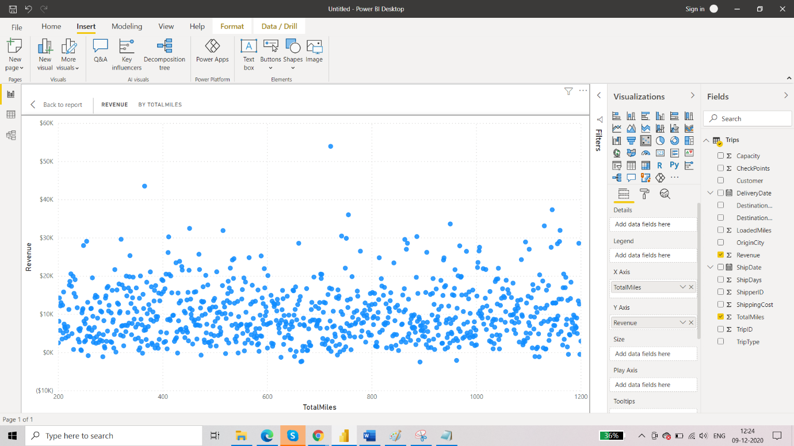

We can see that there are few outliers in the data. This was made possible because of scatter plot visualization. We can add ‘Checkpoint’ in the tool tip field so that when we hover over the points then we can see for which checkpoint the Revenue and Miles are shown.

Now, after all the visualizations are done, what we can do is add a SLICER. This will let us filter the plots and charts on the dashboard according to specified value.

For example- here we have added customer name on the slicer and selected ‘Apaxton’ customer. So all the visualizations are instantaneously updated according to that customer only.

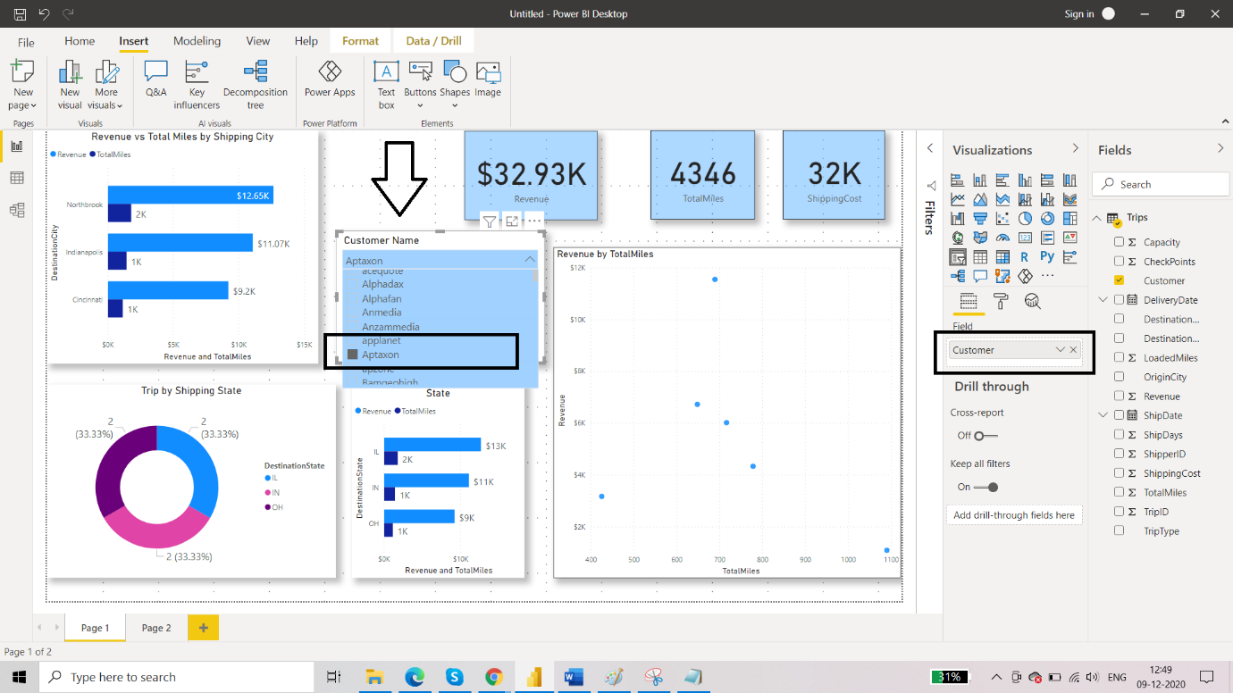

As per the objective-2, dashboard is complete and is as follows:

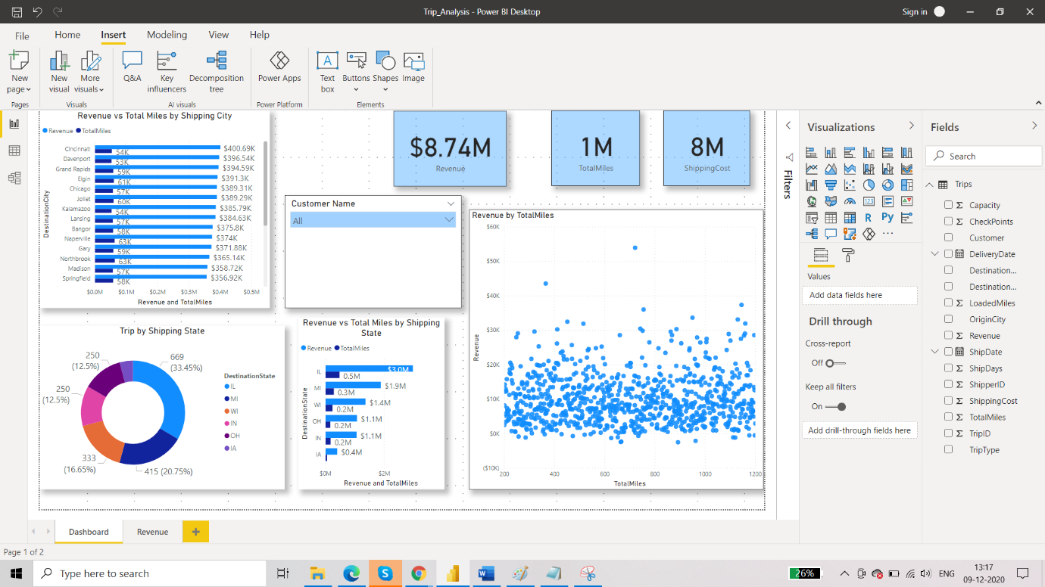

Next thing, that I was interested in knowing is that what were the top customers who were responsible for generating the maximum revenue and what was the time of the year during which that occurred.

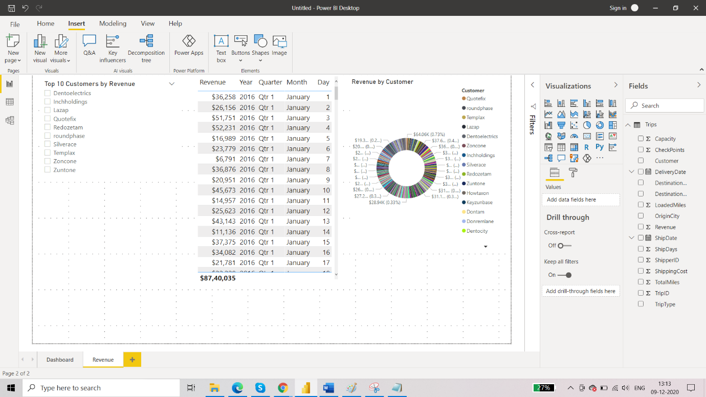

So when you select any two customers, you will be able to their corresponding dates and what part of total revenue they contributed easily.

