**Analysis on World's Richest People using Power Query Editor**

This blog illustrates data transformation sing powerful functionality provided by PowerBI known as power query editor. We are going to draw some meaningful insights post the data transformation and present them in form of visualisations or dashboard. Our dataset depicts information about richest people around the world so our focus would be to generate fascinating insights about them.

**Data transformation using power query editor:**

First of all, we will load the data into our Power BI application. Take a look at the columns and the data and we ensure that the there are no missing values and data is imported properly. It should look like this:

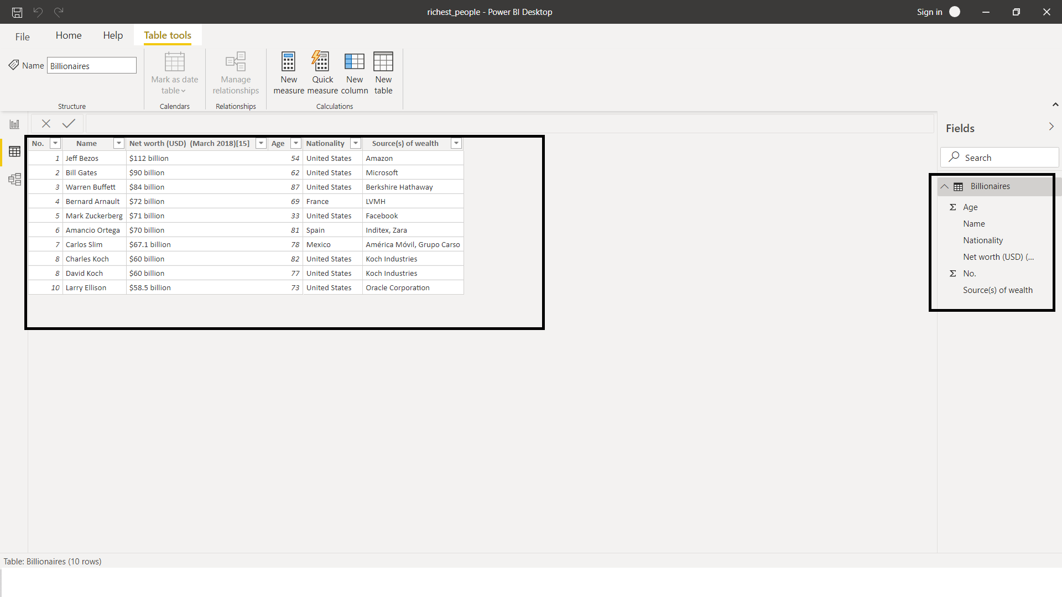

Now when we look at the third column, that is ‘Net Worth’, we do not want the word billion written after each value in the column because what we want is that it should be numerical and string part should not be there.

So, load the data into power query editor.

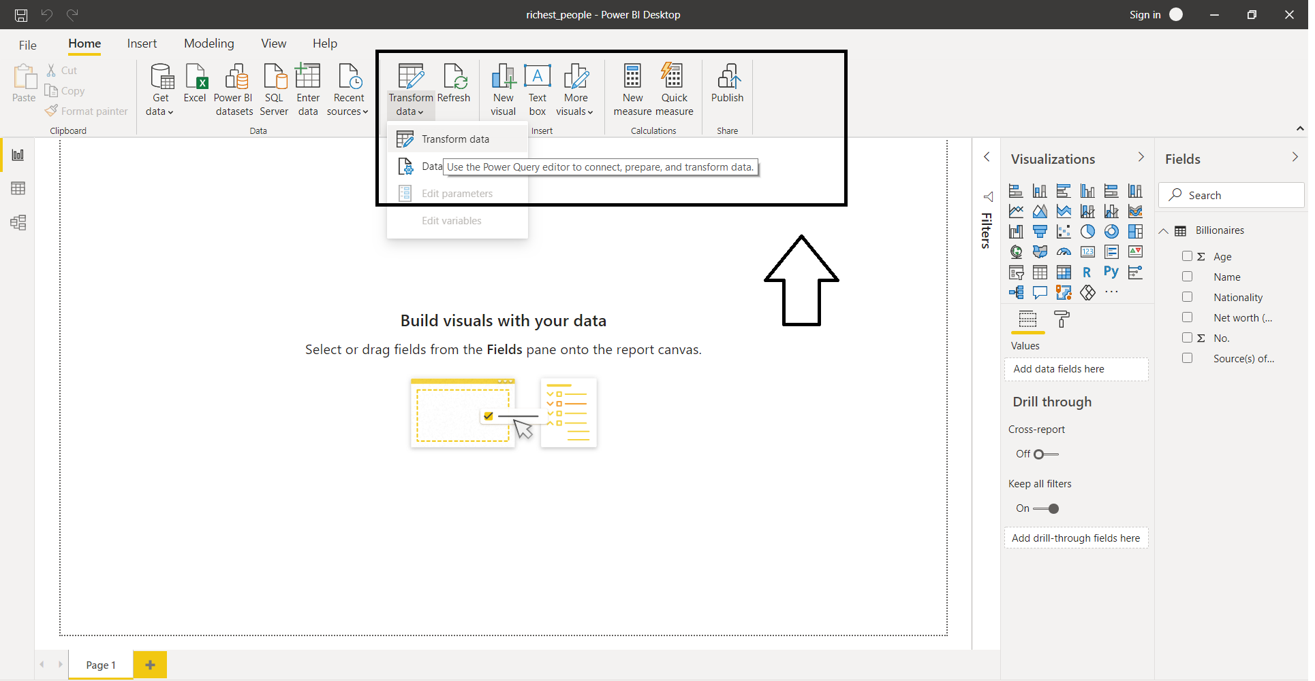

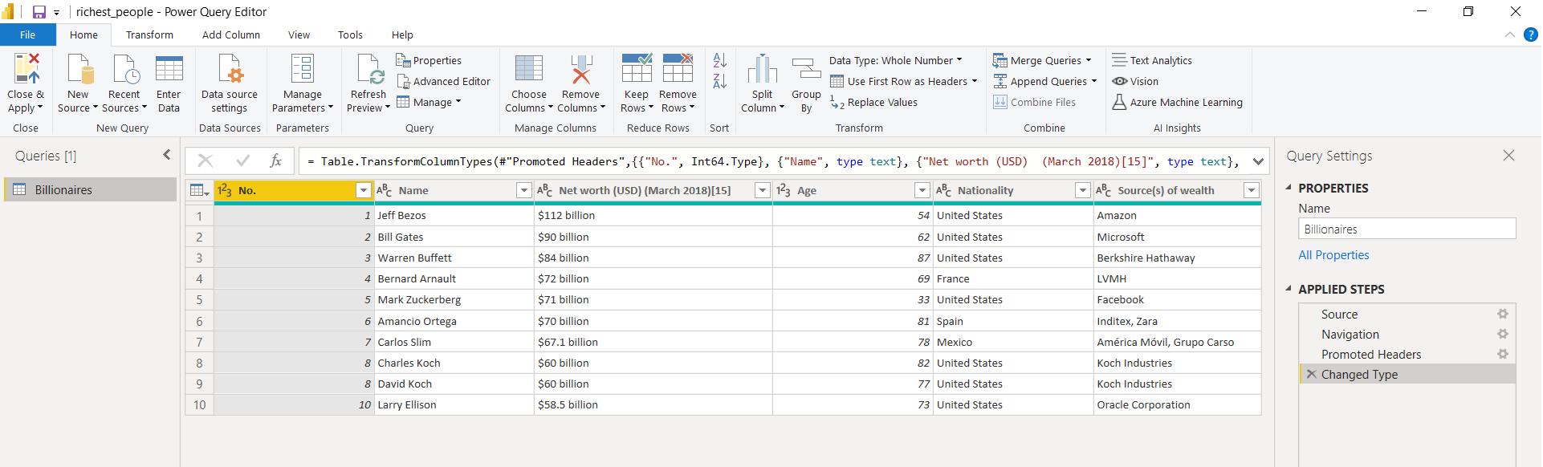

* Select the column ‘Net Worth’. Go to transform data from the menu bar above and select EXCTRACT option then go to ‘Text Between Delimiters’.

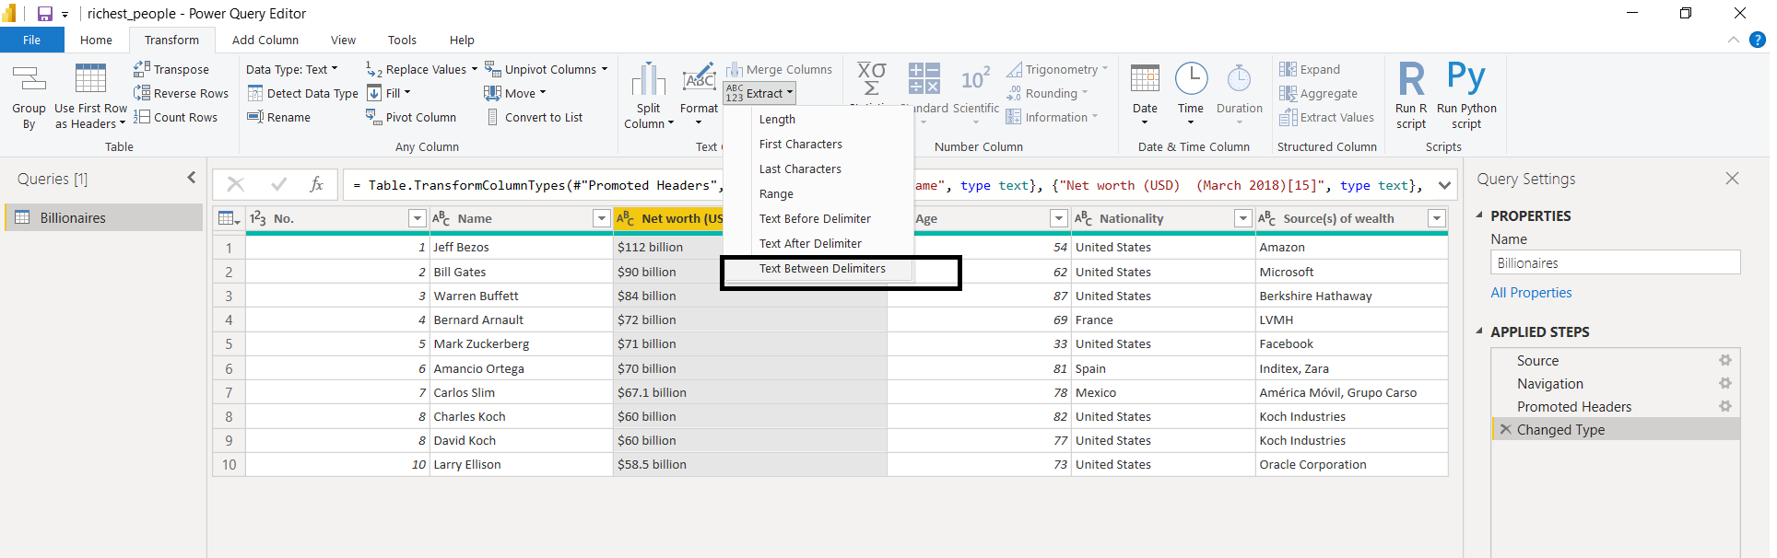

* We are interested in just the numerical part. So we want value between $ symbol and billion.

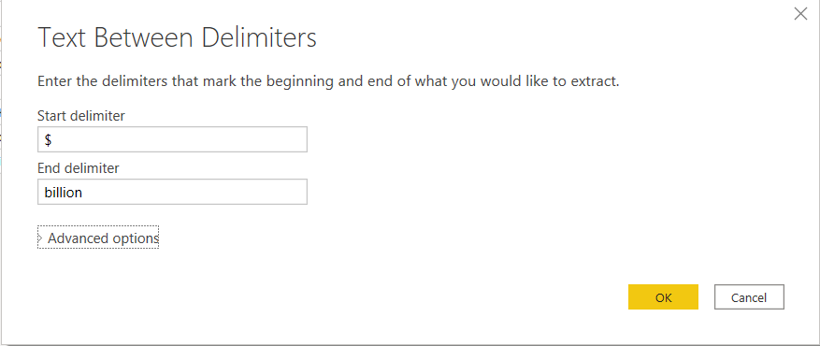

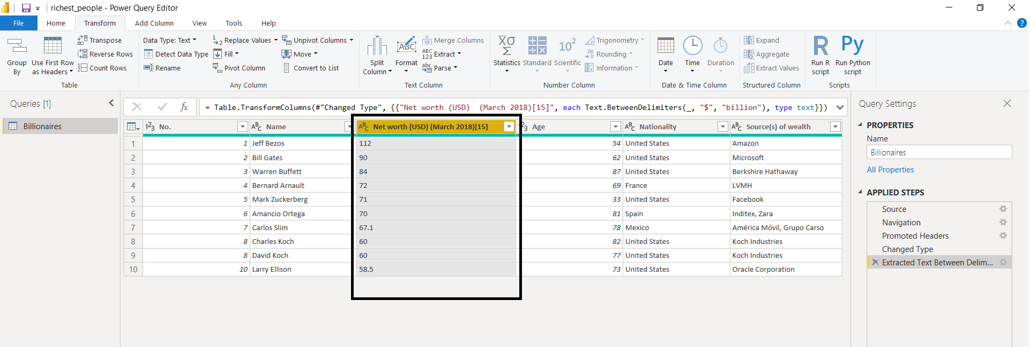

But as we can see above, the values the numerical but the data type of the column is still showing as Text. So we need to change the data type to Number.

* Select the column and right click on it. Then from there, we will go to ‘Change Type’ 🡪 ‘Whole number’. This way we will have the column type as number.

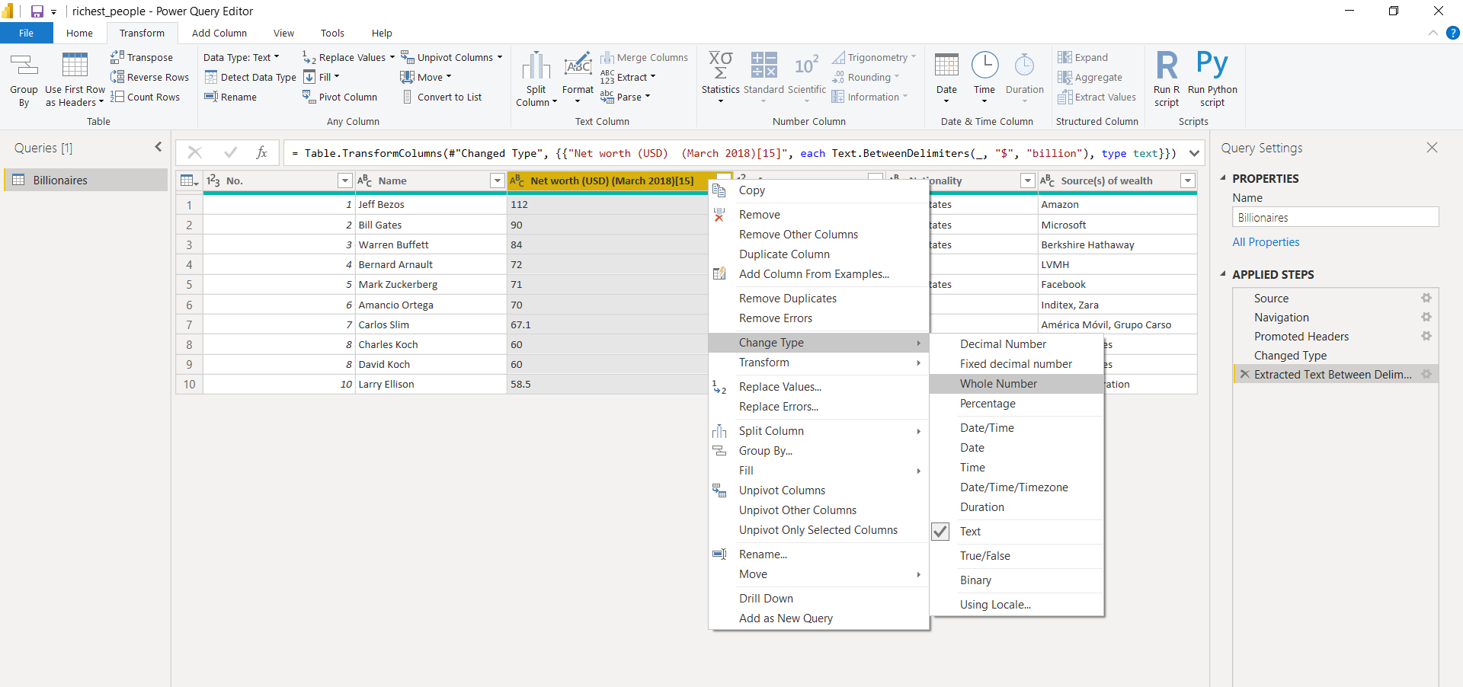

This is how the table is finally going to look:

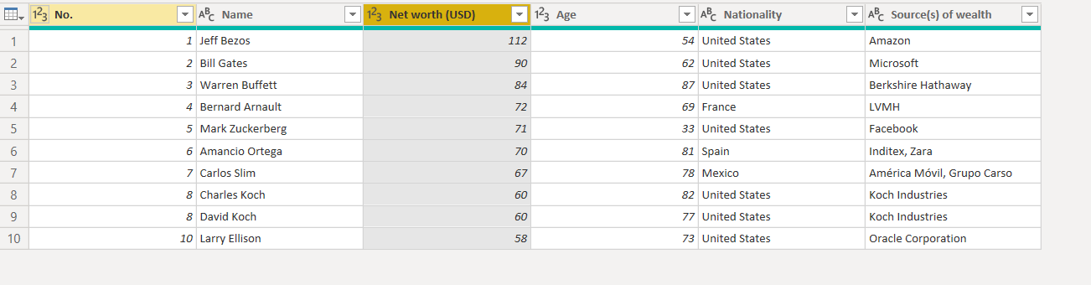

Now we are going to click CLOSE AND APPLY.

After the table is loaded in the data view, we can add the currency symbol:

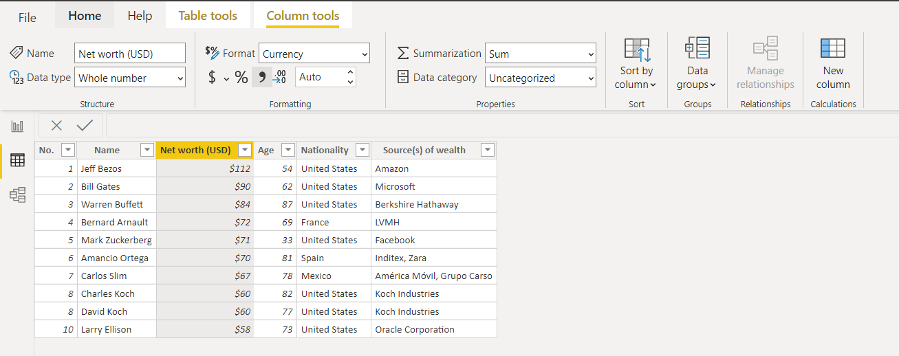

**Data Visualization:**

Now that the data is clean and transformations are completed, it is time to generate some interesting insights from the data using charts and other visualisation.

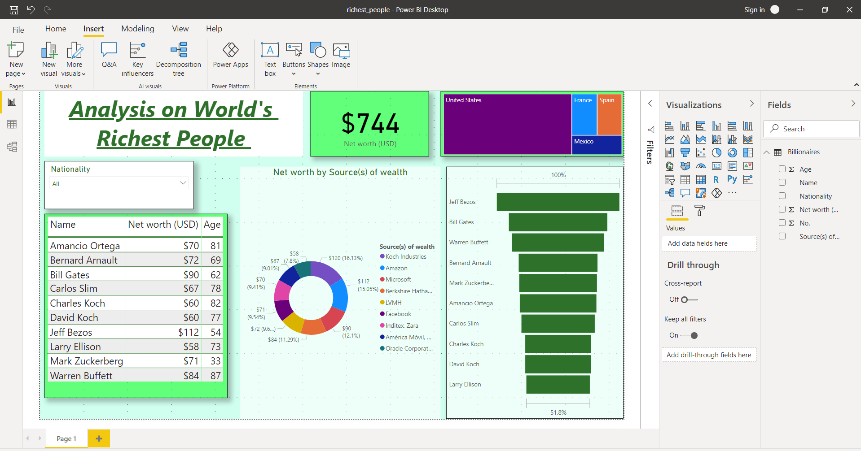

* Total worth is $744 billion USD.
* Age lies between 33-87 years
* Warren Buffet oldest person in list while Mark Zuckerberg with a youngest person.
* Amazon and Microsoft are the main players in sources of income.
* There are 4 nationalities as can be seen from the tree map on the right most top corner.
* Income distribution is shown from the funnel chart. Top spot on the basis pf net income is earned by JEFF BEZOS and 10th spot is grabbed by LARRY ELLISON.
* We can see the various sources of the income from the donut chart.
* Age distribution and net worth distribution is collectively shown by the table visualization.
* Slicer is used for filtering the data on the basis of nationality. On selecting ‘United States’ from the dropdown of the slicer we get:

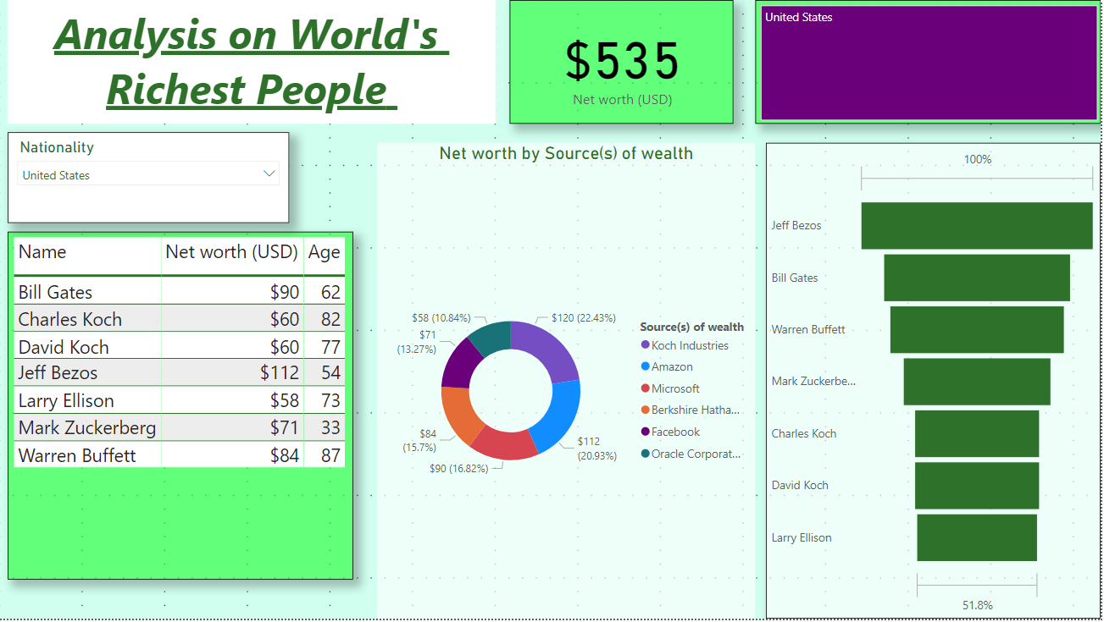

For united states there are 7 contributors out which there are 7 different sources of income and total net worth from United states is $535 billion USD

Now let us select “Spain”. We see that there is only one contributor and source of income is Inditex, Zara. Also, net worth from Spain is $70 billion USD

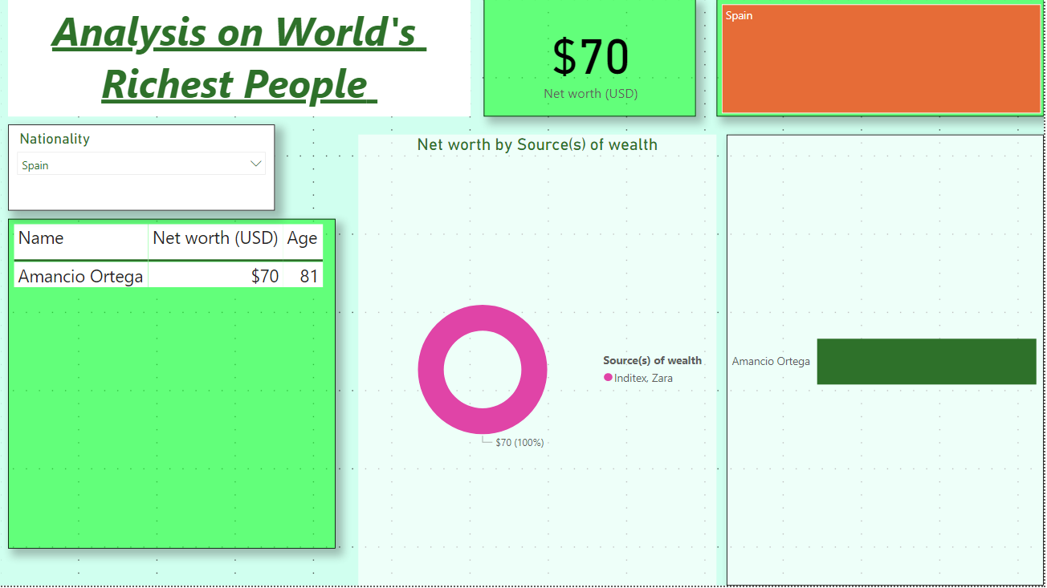

If you want to focus on only one of the rich person, for example Jeff Bezos, click on the funnel chart beside Jeff Bezos and you will observe the following:

* Net worth of Jeff Bezos: $112 billion USD
* Source if income: Amazon
* Age: 54
* Nationality: Unites states

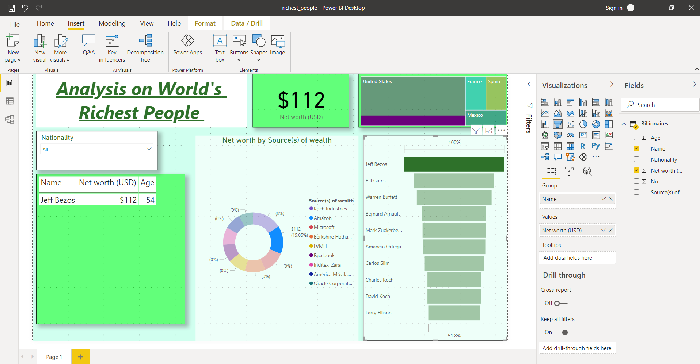

Similarly, we can select ‘Amancio Ortega’ from the funnel:

* Net worth: $70 billion USD
* Age: 81
* Source of income: Inditex, Zara
* Nationality: Spain

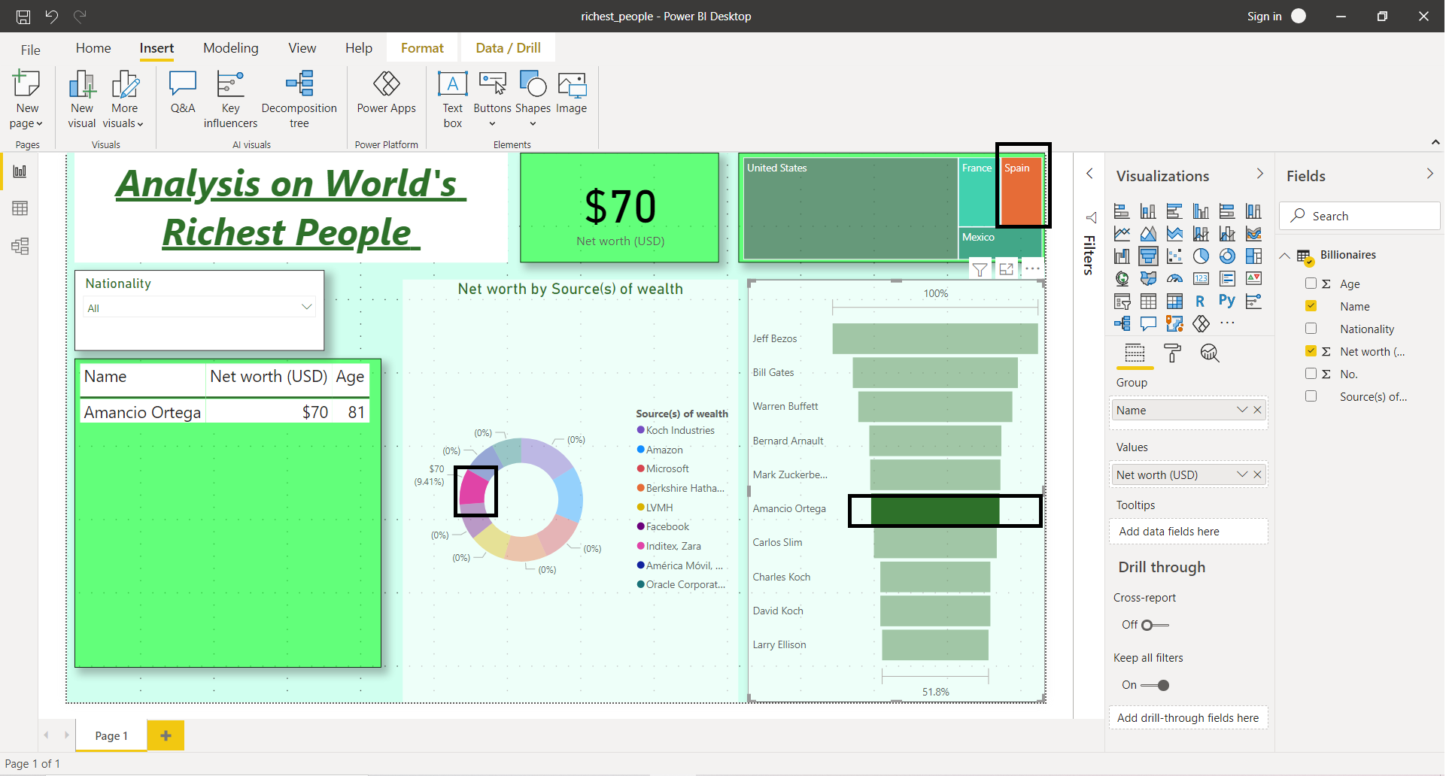

Final Dashboard:

