Data management: we will be focussing on the dimension part of the data.

Source: MotoCad

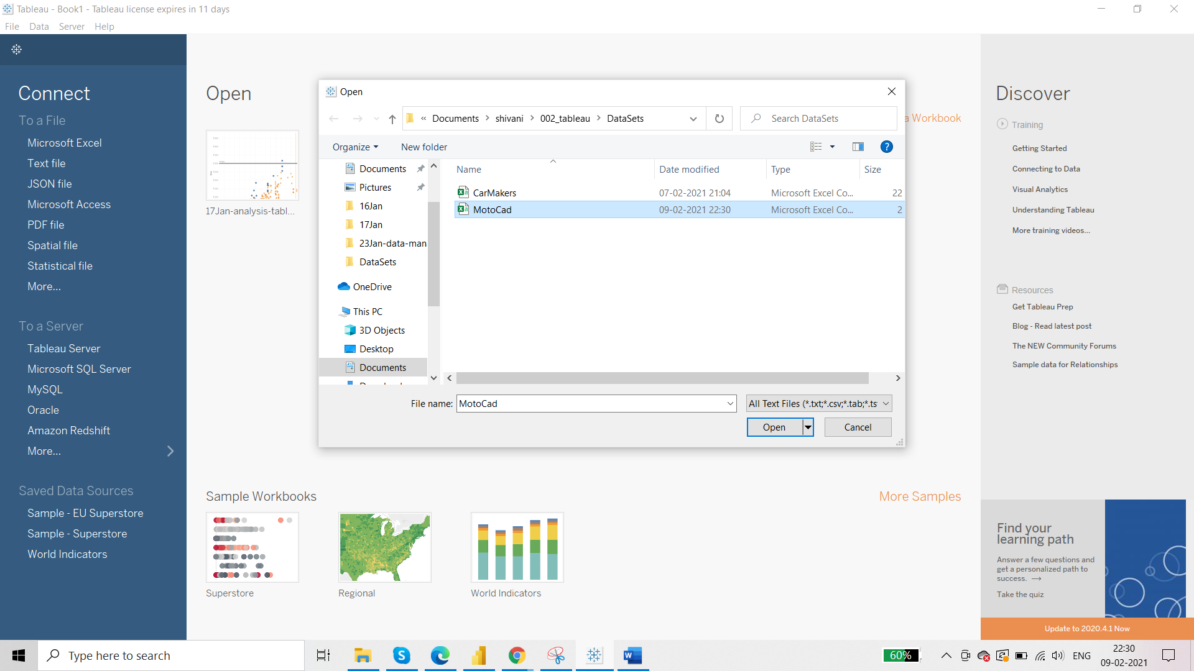

First: observe the pills under dimensions and measures whether they are accurately aligned or not

Vs, Am, Gear, Carb – these are numerical values but they can not be used for calculations. They are actually dimension values.

Final arrangement:

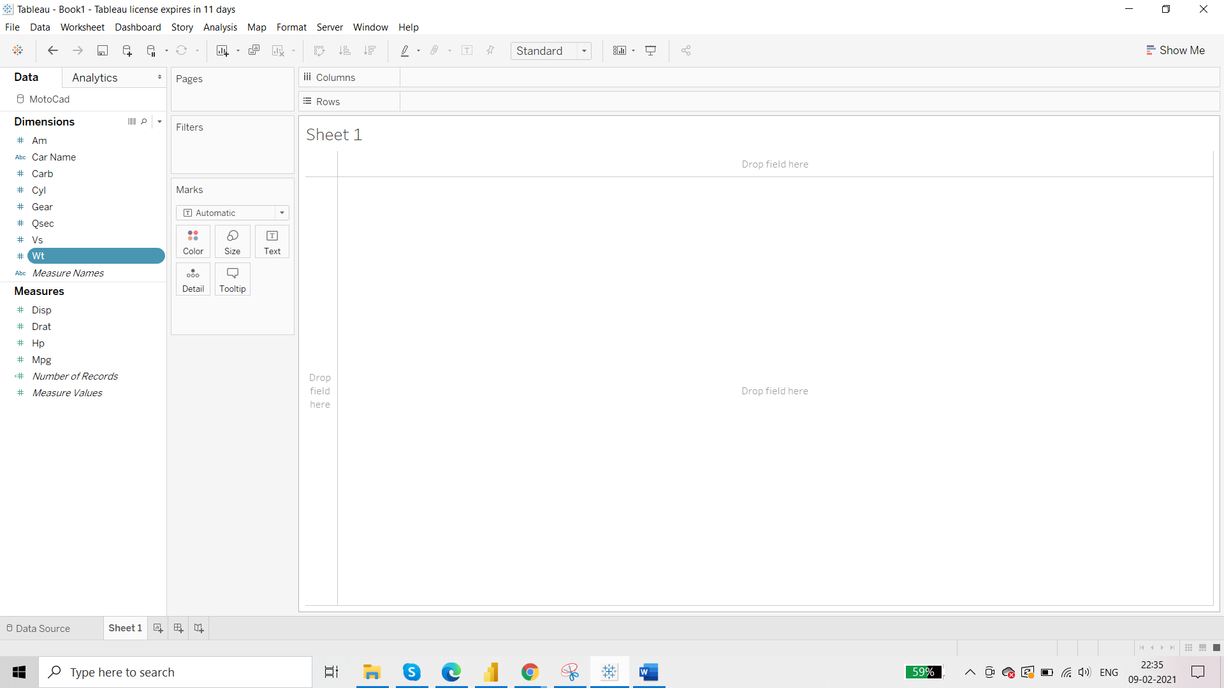

**Working with Aliases:**

Vs type engine – has two values – 0 and 1 – 0 as standard engine and 1 as VS engine

Requirement: average milage for each Vs engine type

We will first make use of Aliases

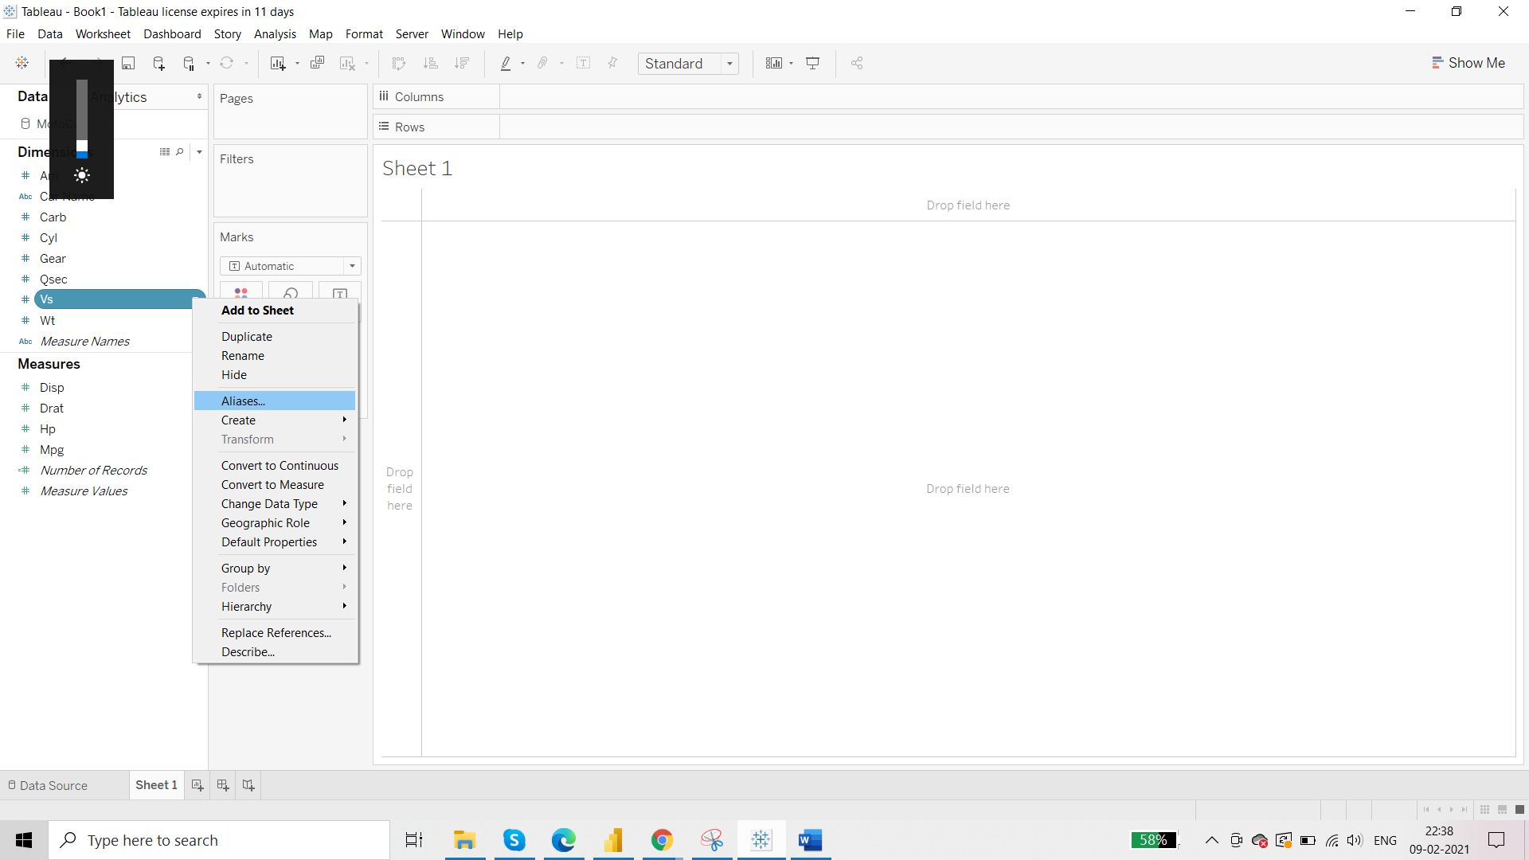

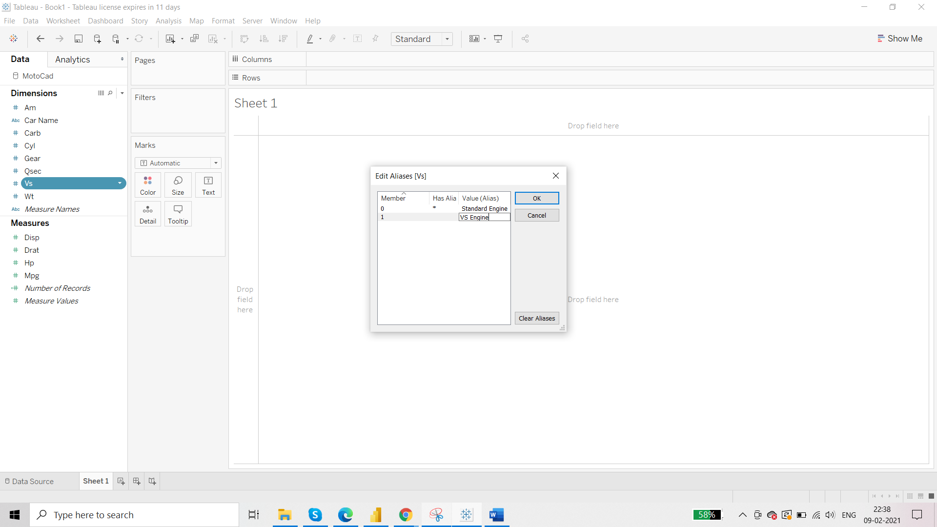

Now:

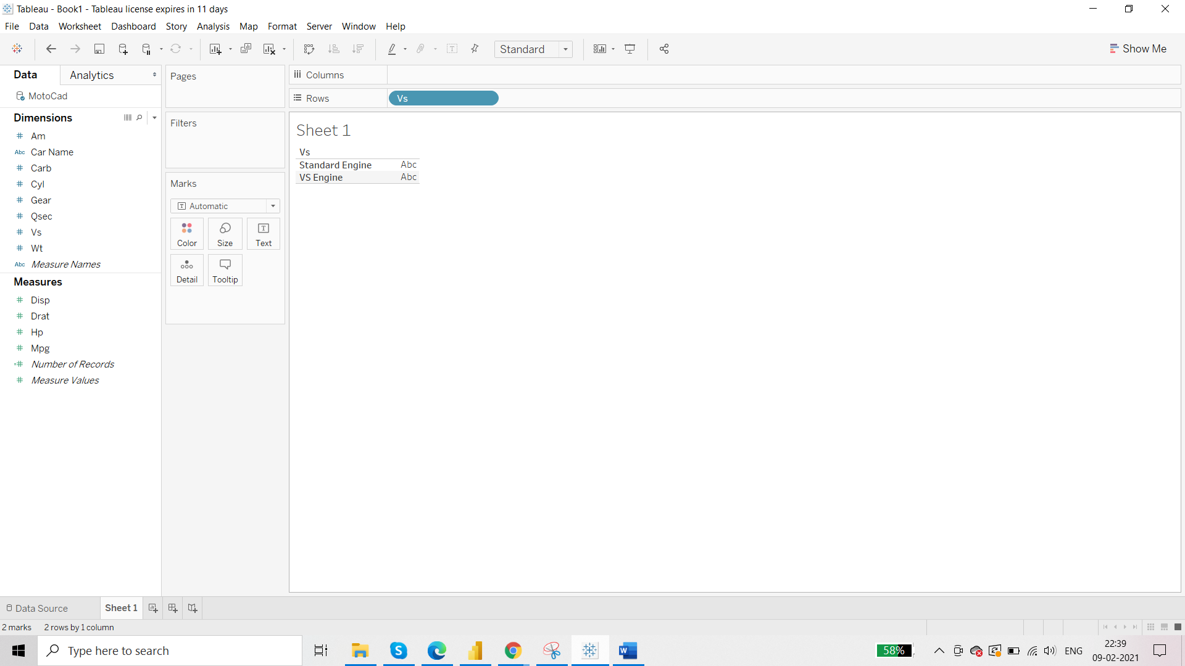

Convert it into AVG:

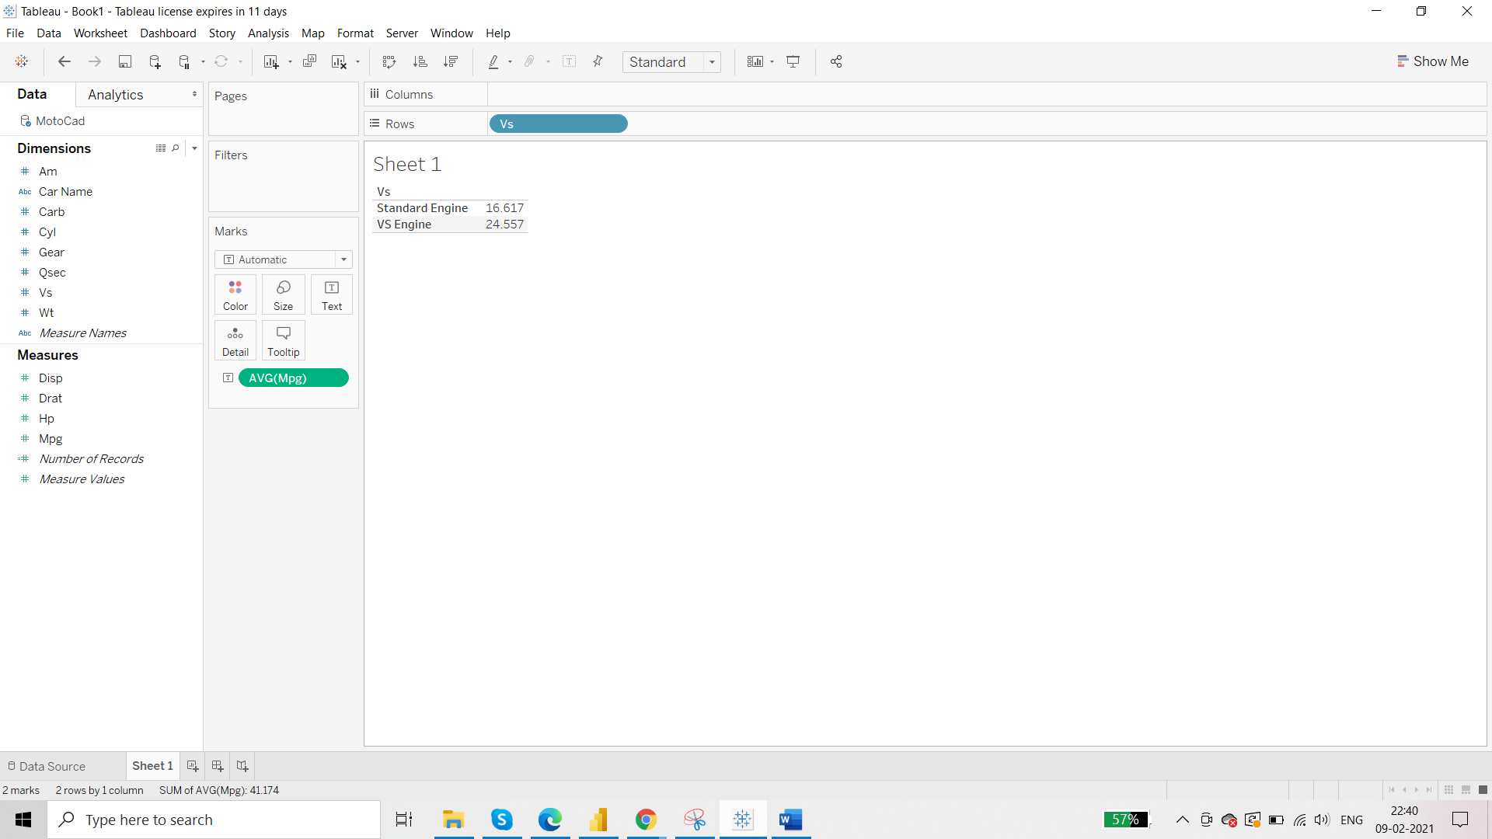

If you come to dataset:

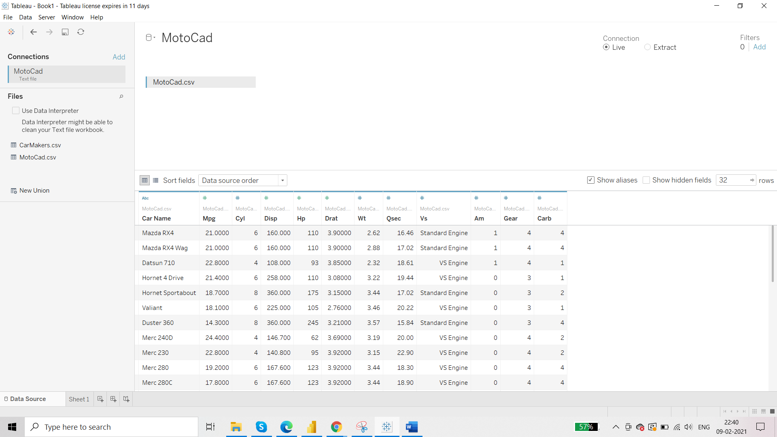

Show aliases is ticked and your set aliases is displayed.

* Aliases never change the original values
* Aliases can only be applied to dimension values

Applying aliases again:

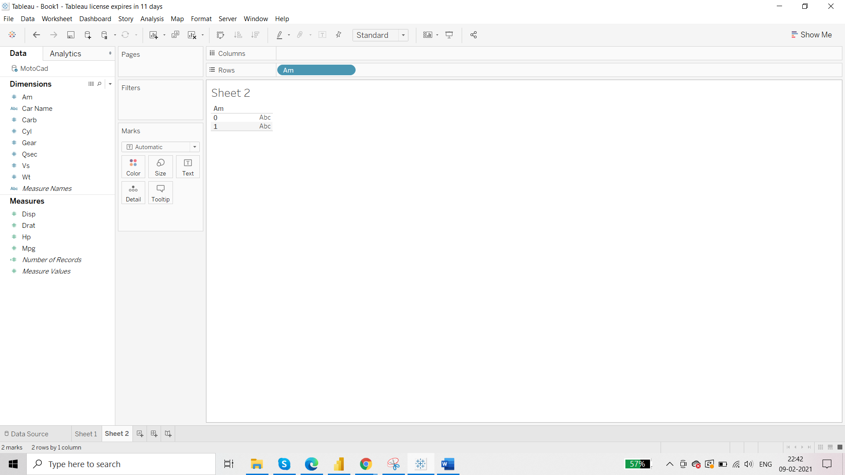

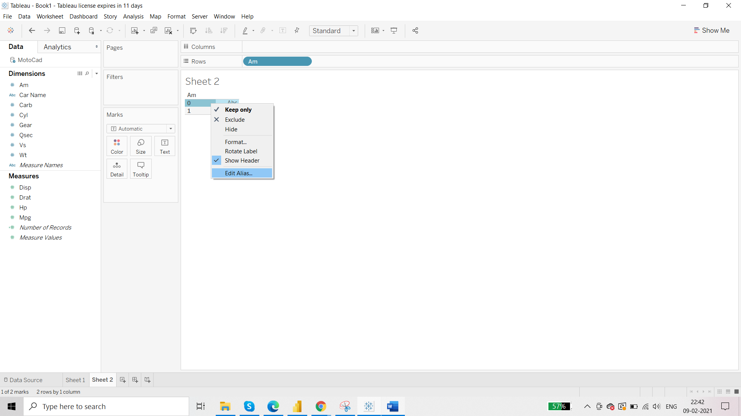

Put the average mileage:

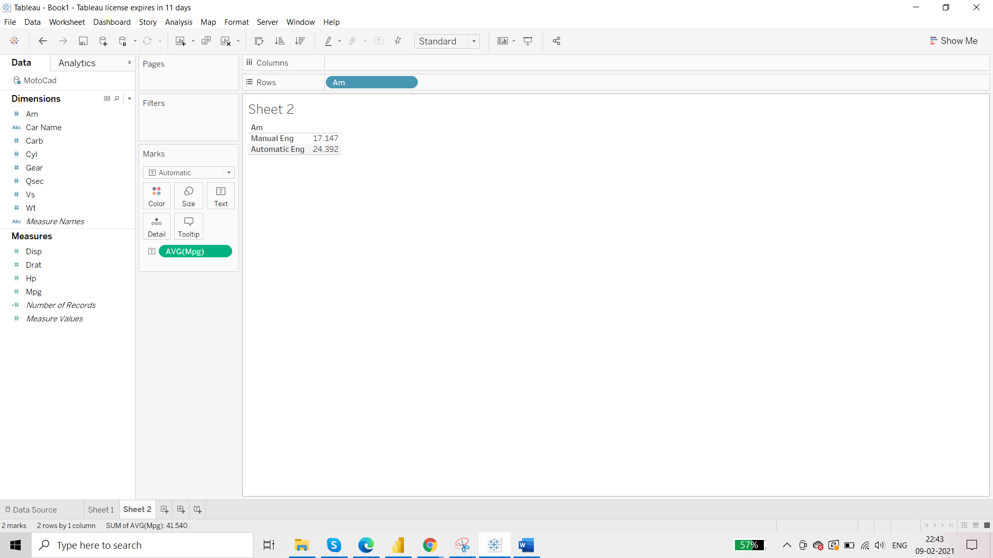

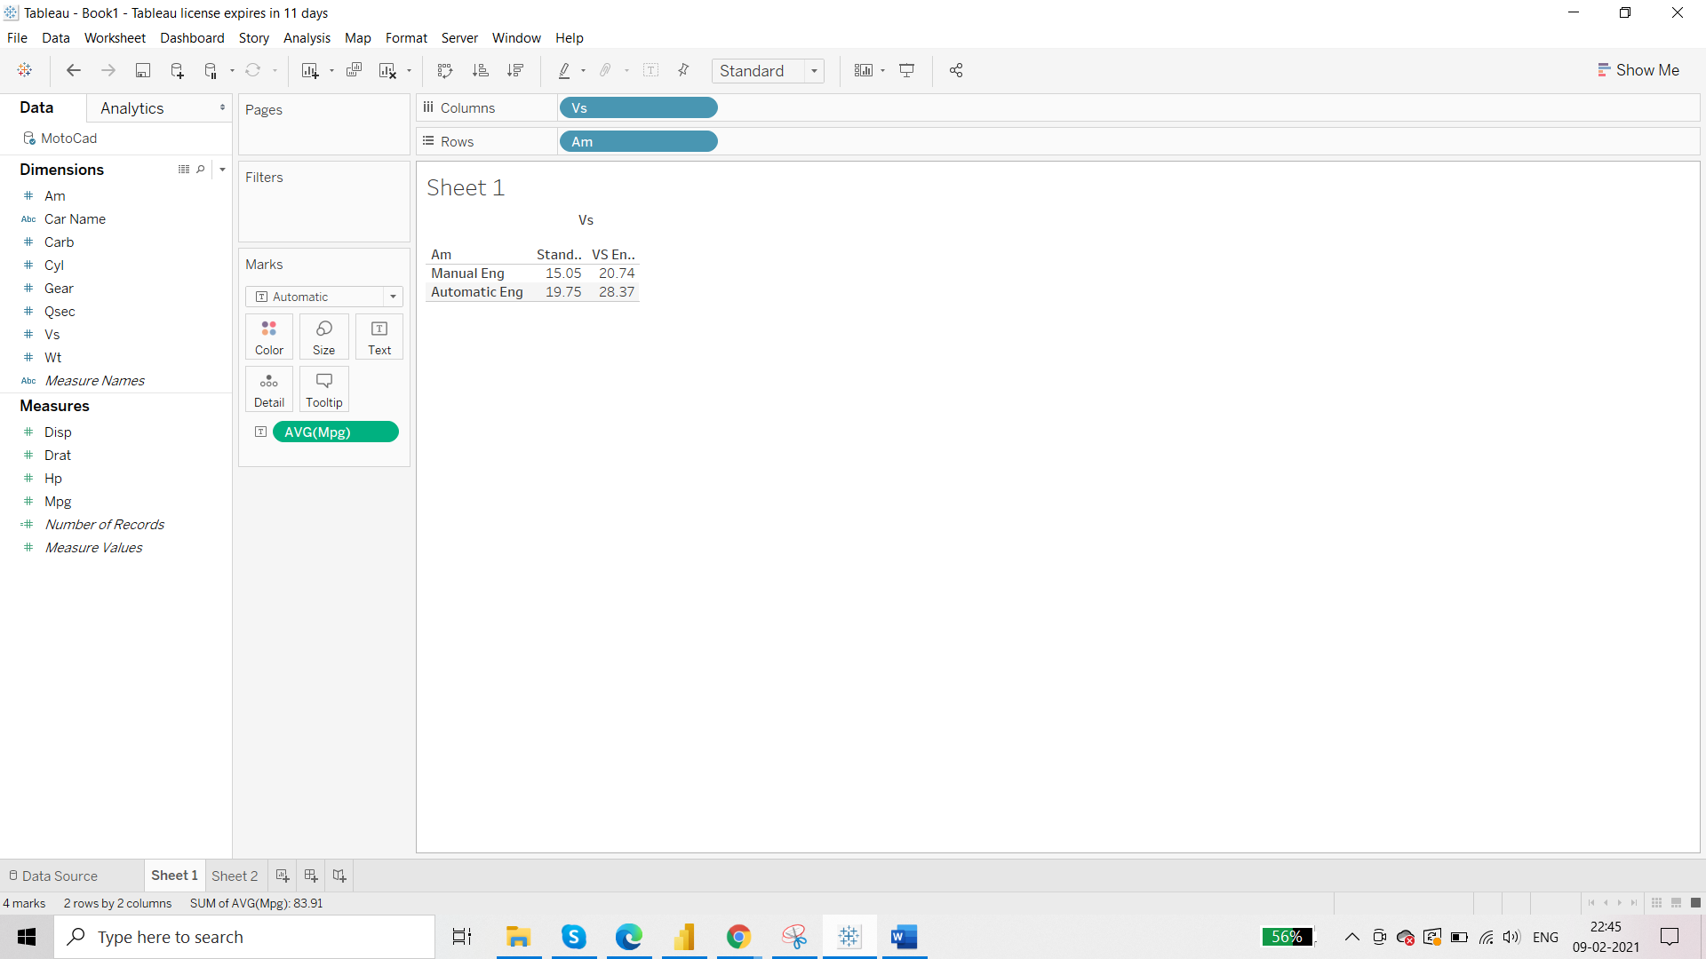

**Grouping**

Working in data management to reduce the number of data members. In Tableau,

* grouping is only applied to dimensions and not measures
* grouping results in reducing the members of dimensions
* grouping will always give you a new dimension as output
* grouping will never the original value of dimension

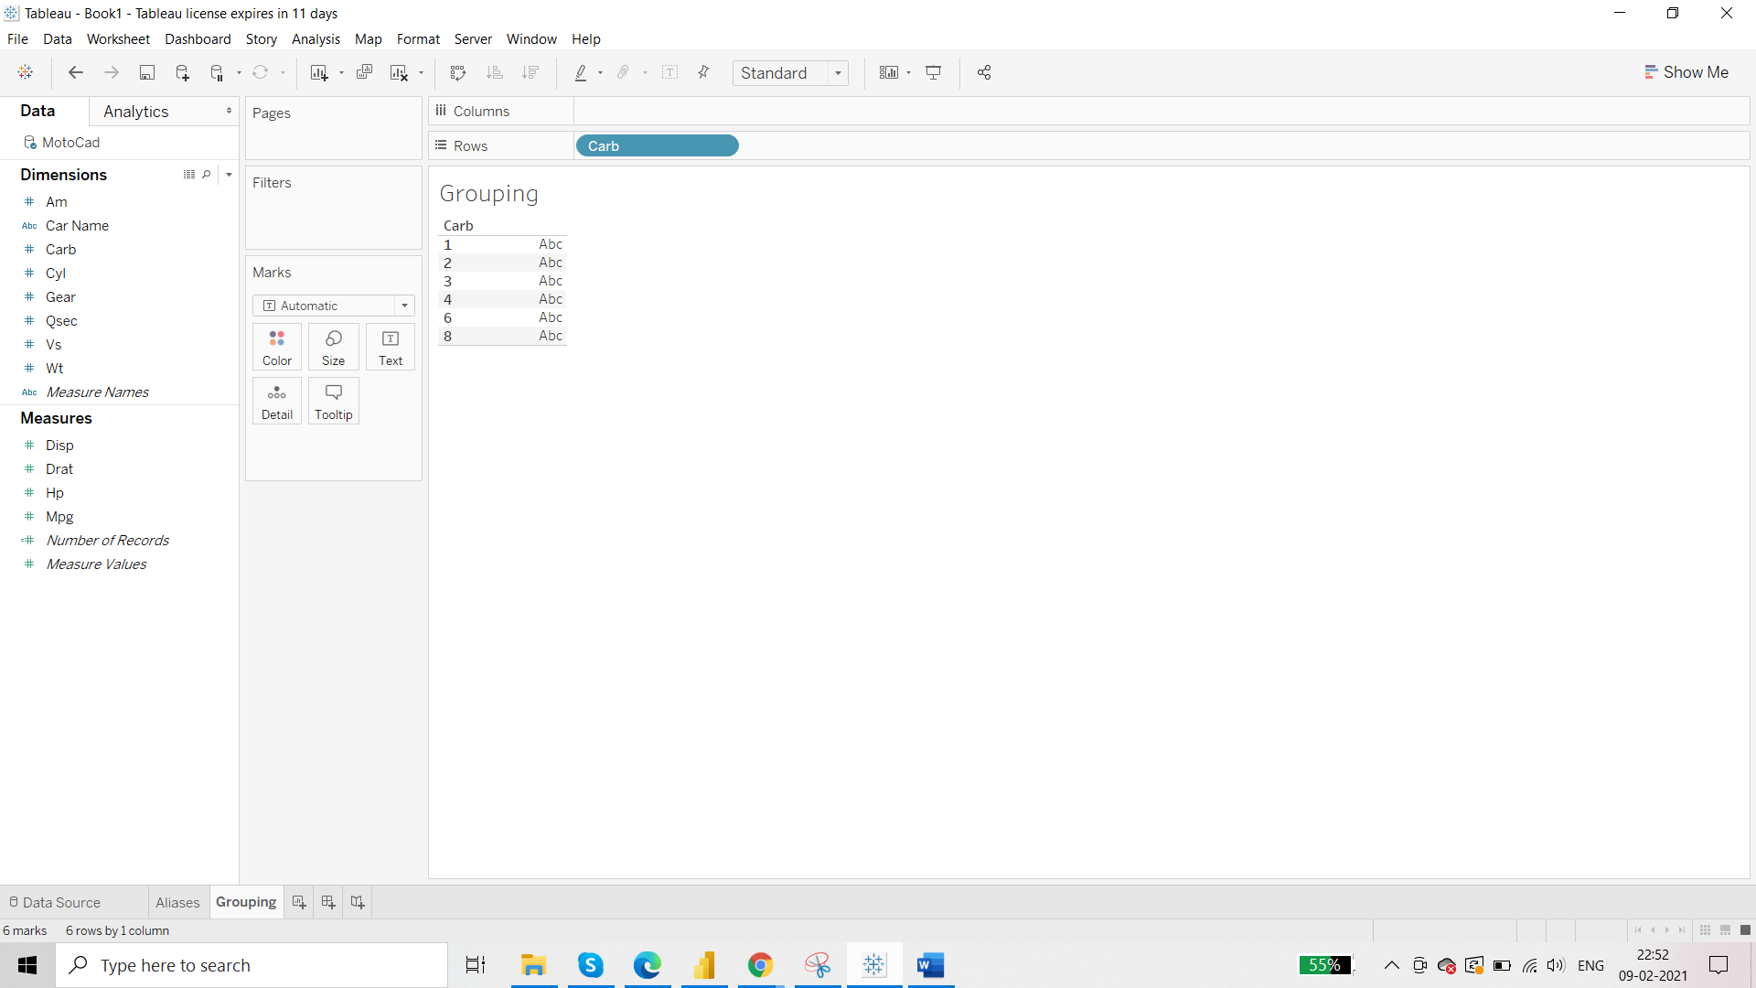

We can group the Carbonator into 2 groups:

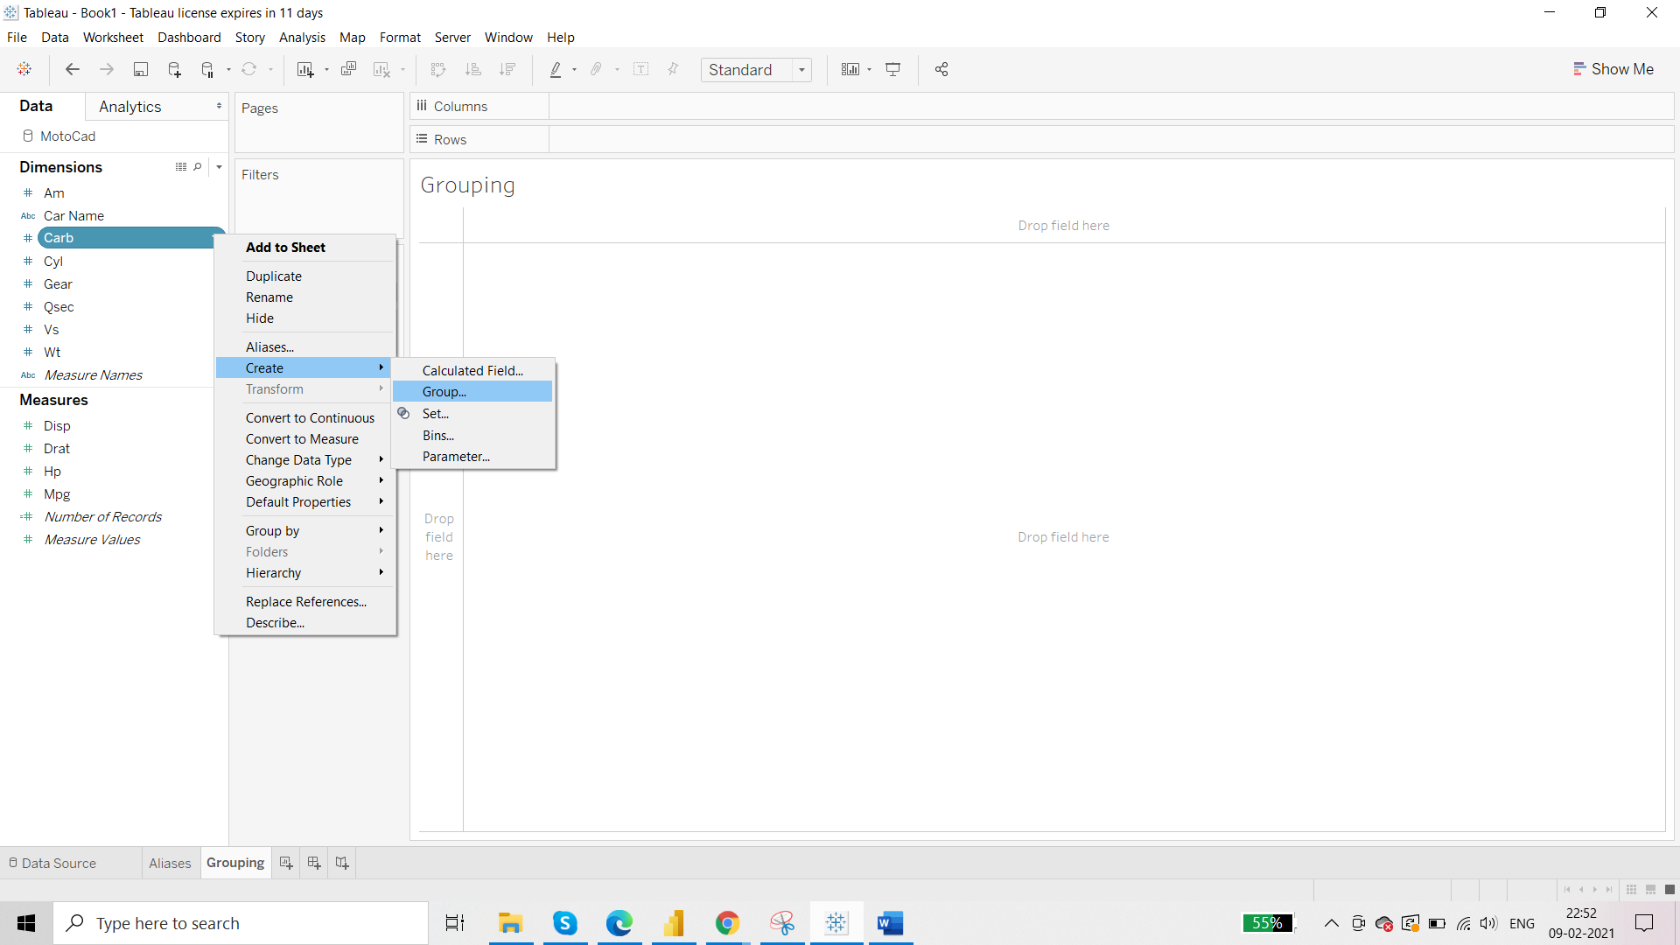

Select the members that you want you to group and name it as per your wish:

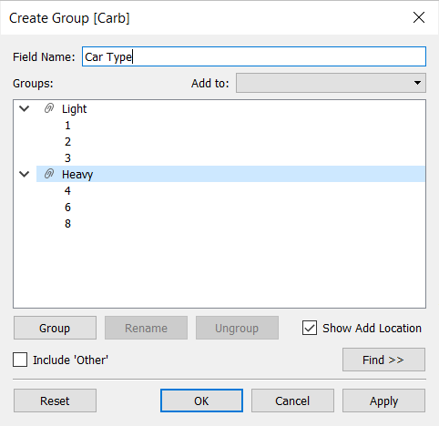

New Dimension called ‘Car Type’ is created:

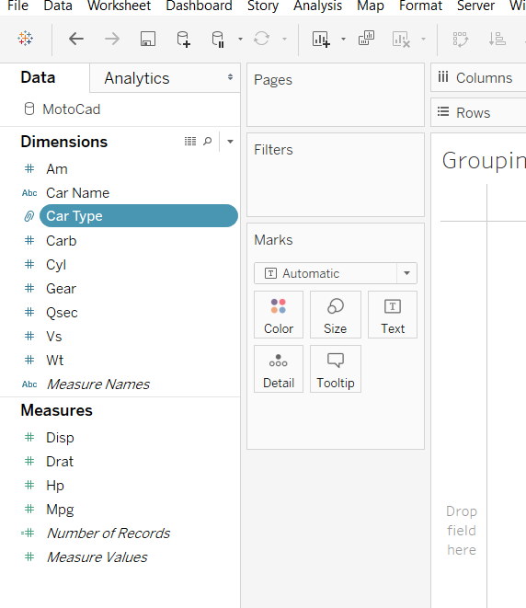

Output:

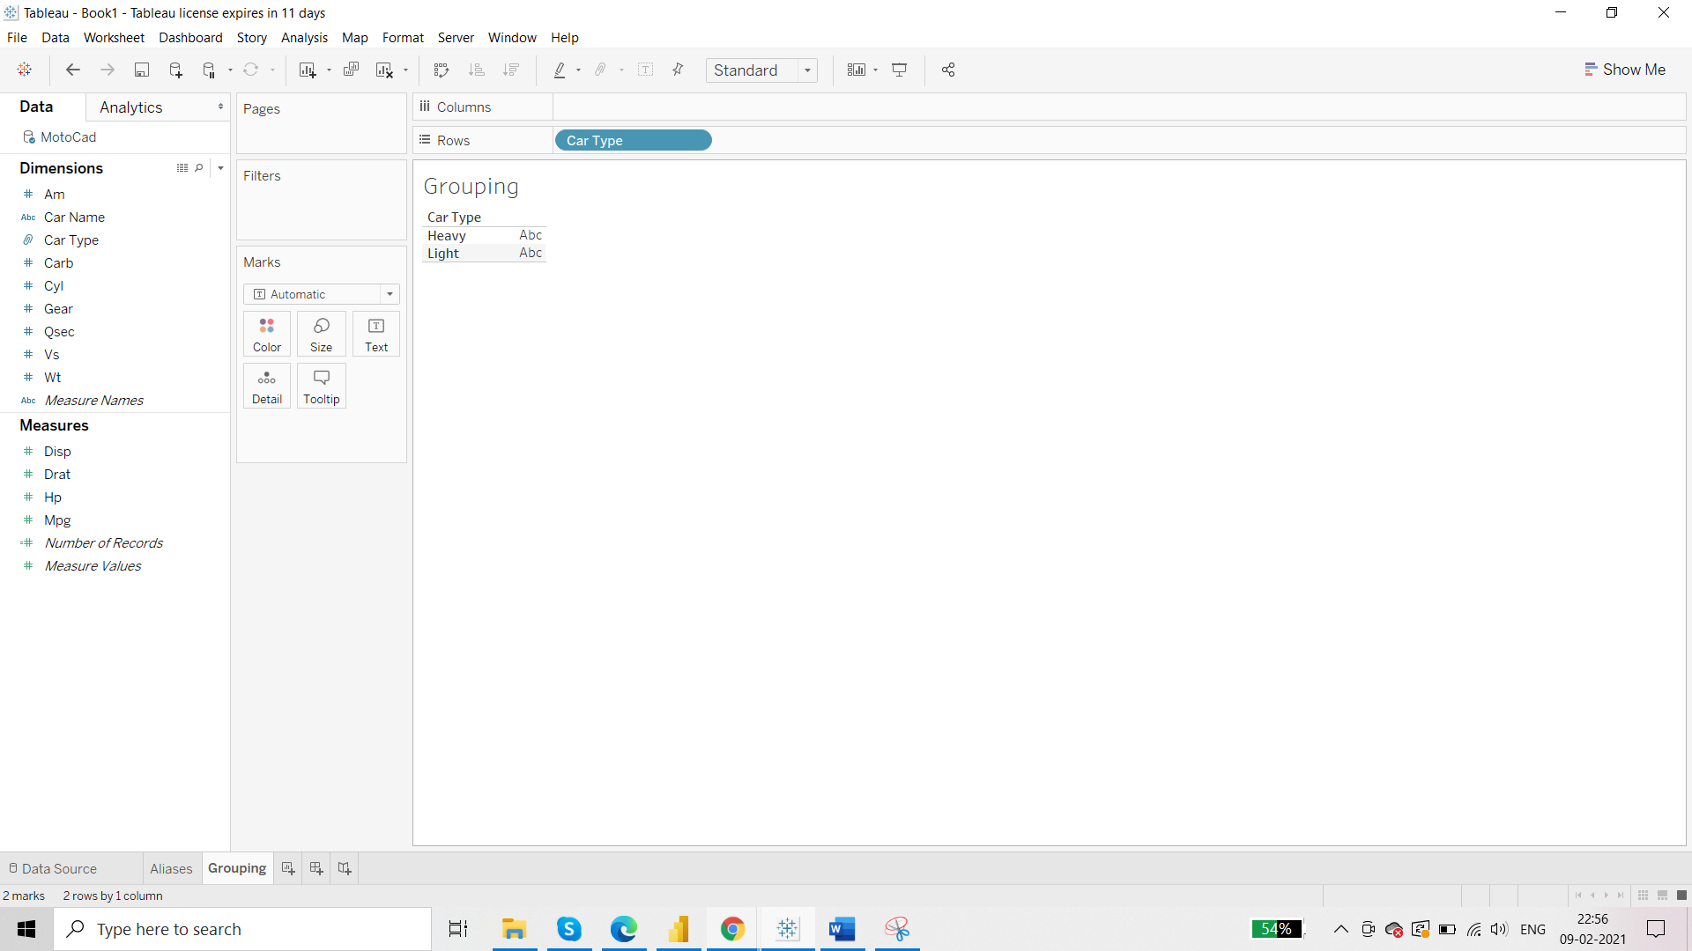

Further Analysis:

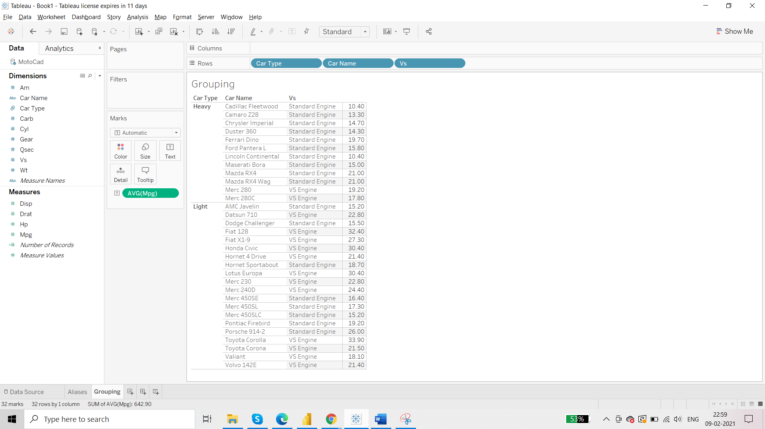

We have used three dimensions here – Car Type, Car Name and Vs and we want to use them together whenever this dataset is loaded. So that we do not have to drag all three every time instead we drag one dimension which has all three. This can be done with the help of hierarchy.

**Hierarchy**

* Can only be applied at dimensions
* Does not change the values of the original dimensions
* Always returns a new dimension
* Data members of hierarchy can be sorted as top/bottom

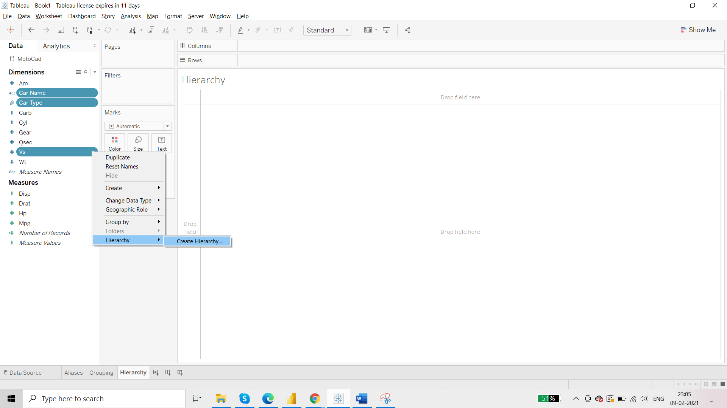

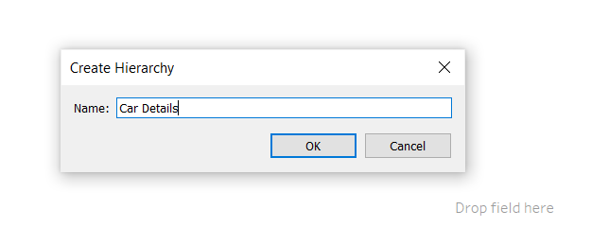

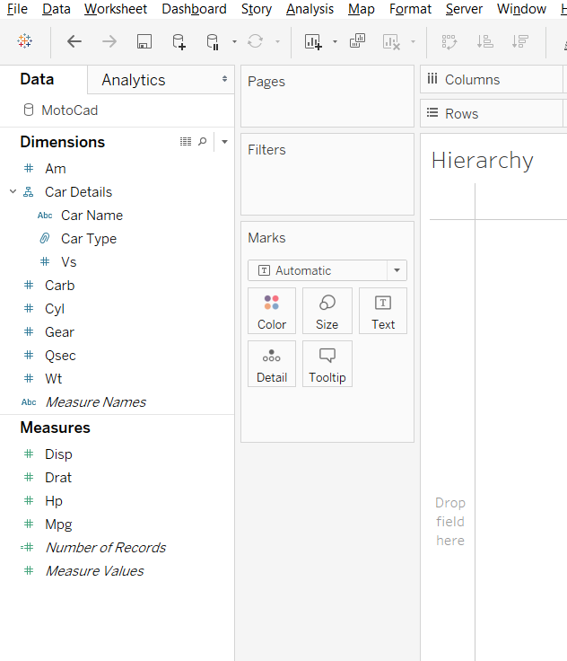

Hierarchy plays a very import role in report optimisation because with the help of hierarchy data load option can be controlled.

Suppose this report is sent to 2 different stake-holder. One is concerned about type and other is concerned about car type. This can be controlled at the end user.

When there are millions rows of data, then with the help of hierarchy we can control which part of the data to load.

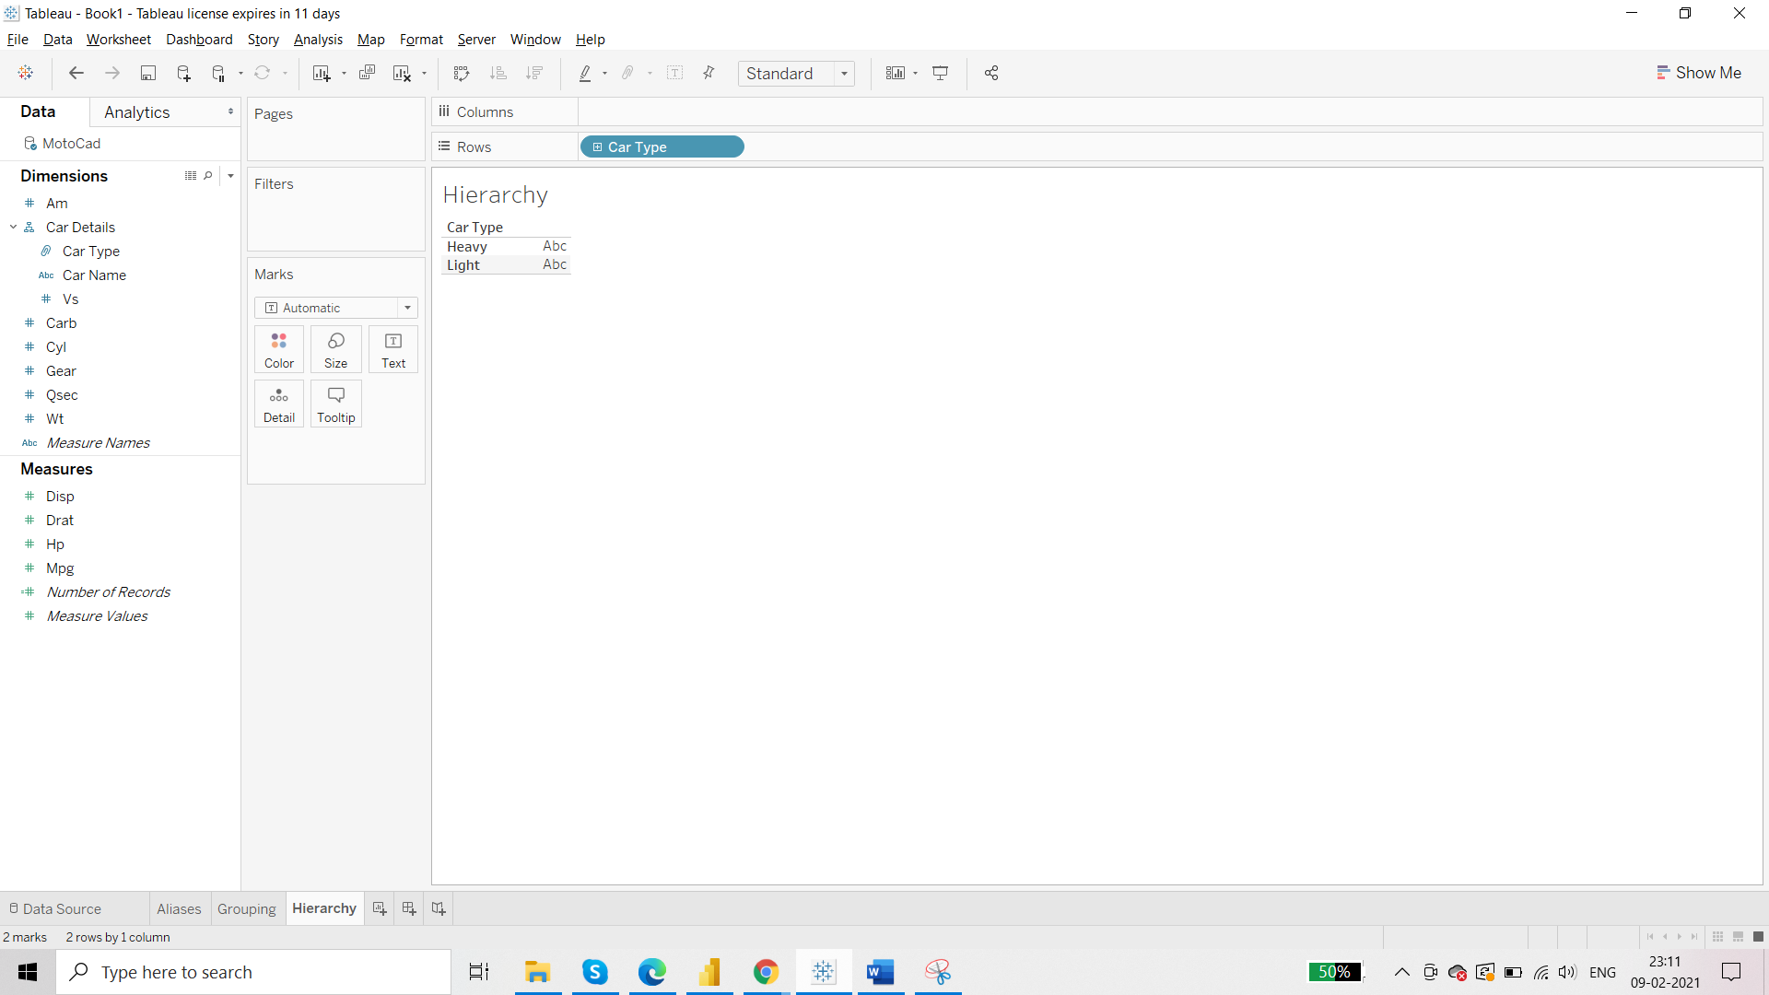

Click on + sign:

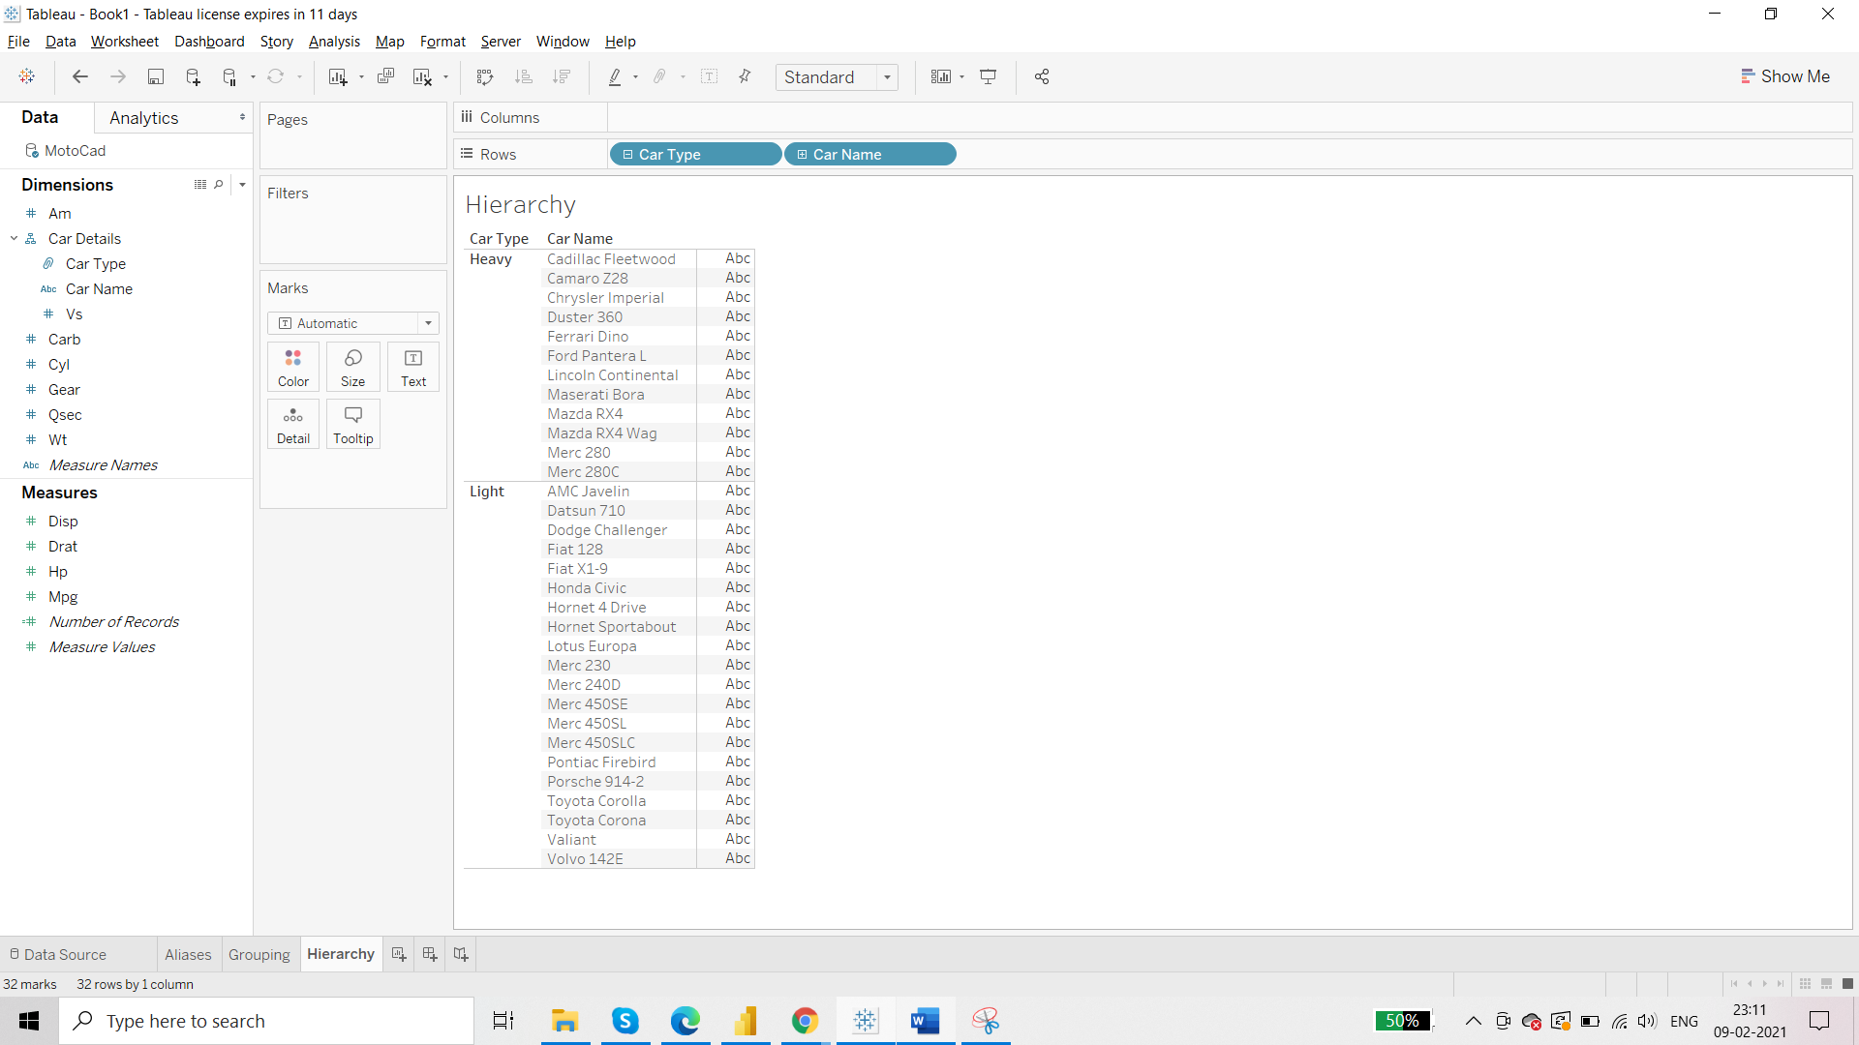

**Filters in Tableau**

Basic filters:

* Quick Filter
* Admin Filter
* Include/exclude Filter
* Visual level Filter
* Date Filter