**Data Analysis Using SQL**

1. Show all customer records

SELECT * FROM customers;

1. Show total number of customers

SELECT count(*) FROM customers;

1. Show transactions for Chennai market (market code for chennai is Mark001

SELECT * FROM transactions where market_code='Mark001';

1. Show distrinct product codes that were sold in chennai

SELECT distinct product_code FROM transactions where market_code='Mark001';

1. Show transactions where currency is US dollars

SELECT * from transactions where currency="USD"

1. Show transactions in 2020 join by date table

SELECT transactions.*, date.* FROM transactions INNER JOIN date ON transactions.order_date=date.date where date.year=2020;

1. Show total revenue in year 2020,

SELECT SUM(transactions.sales_amount) FROM transactions INNER JOIN date ON transactions.order_date=date.date where date.year=2020 and transactions.currency="INR\r" or transactions.currency="USD\r";

1. Show total revenue in year 2020, January Month,

SELECT SUM(transactions.sales_amount) FROM transactions INNER JOIN date ON transactions.order_date=date.date where date.year=2020 and and date.month_name="January" and (transactions.currency="INR\r" or transactions.currency="USD\r");

1. Show total revenue in year 2020 in Chennai

SELECT SUM(transactions.sales_amount) FROM transactions INNER JOIN date ON transactions.order_date=date.date where date.year=2020 and transactions.market_code="Mark001";

1. Select distinct(transactions.currency) from transactions;

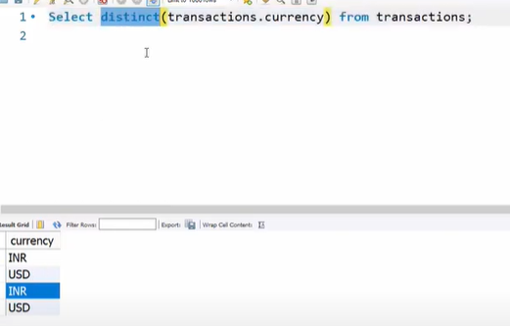

1. Paste above

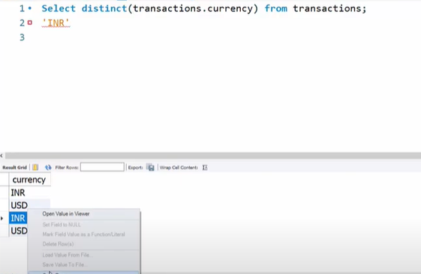

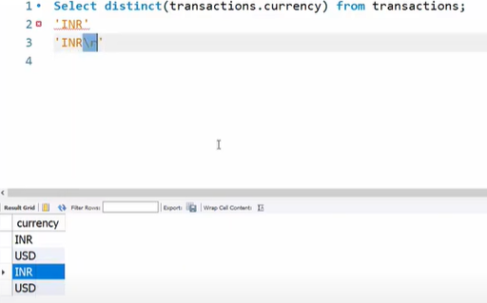

1. 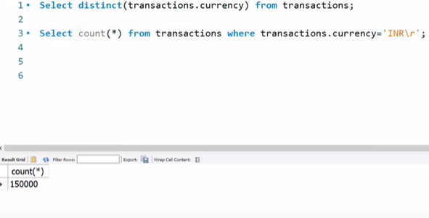
2. Here we are not writing **sales.**transactions bec we have made sale as default schema
3. INR\r and USD\r seems to be legit because there are far more values for these two rather than without \r

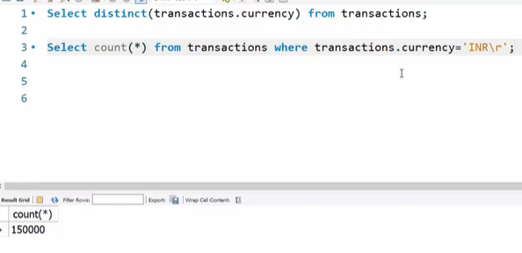

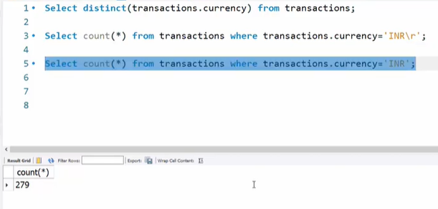

But for USD = 2 records

And USD\r = 2 records

1. First and third records are duplicate

