**K. L. E. SOCIETY’S**

**B. V. BHOOMARADDI COLLEGE OF ENGINEERING & TECHNOLOGY, HUBLI – 580031**

**(An Autonomous Institution)**



**DEPARTMENT OF INFORMATION SCIENCE & ENGINEERING**

**Report on**

“detection of nutrient deficiencies in plants leaf”

**Under the guidance of**

**Ms. Priydarshini Patil**

Submitted By

|  |  |  |
| --- | --- | --- |
| NAME | USN | ROLL_NO |
| Mahir S Magalmani | 2BV11IS0146 | 116 |
| Shivani Guldas | 2BV12IS422 | 170 |
| Venkatesh B Dematti | 2BV12IS428 | 175 |
| Vinod S Patil | 2BV12IS429 | 176 |
| Sumit Choudhary | 2BV11IS100 | 136 |

2014 – 2015

Guide Signature

**K.L.E. SOCIETY’S**

**B. V. BHOOMARADDI COLLEGE OF ENGINEERING & TECHNOLOGY, HUBLI – 580031.**

**(An Autonomous Institution affiliated to VTU, Belgaum)**

**2013 - 2014**



**DEPARTMENT OF INFORMATION SCIENCE & ENGINEERING**

**Certificate**

This is to certify that Mini Project entitled “Detection of Nutrient Deficiencies in plant leaves ” is a bonafied work carried out by the student team Shivani Guldas–2BV12IS422, Mahir S M–2BV11IS046, Vinod Patil–2BV12IS428, Venkatesh Dematti–2BV12IS429, Sumit Choudhary-2BV11IS100 in partial fulfilment of the completion of 7th semester B. E. course during the year 2014 – 2015. The project report has been approved as it satisfies the academic requirement with respect to the project work prescribed for the above said course.

|  |  |
| --- | --- |
| **Guide** | **H.O.D** |
| **Ms. Priyadarshini Patil** | **Dr. Meena S. M.** |
| **External Viva:** |  |
| **Name of Examiners** | **Signature with date** |
| **1.**  **2.** |  |

**Abstract**

Maize is most important crop which plays very important role in economic and social affairs of people, especially in India, but if disease like Alternaria Leaf Spot and deficiency of some major nutrients goes undetected in early stage then it can reduce as much as 25% of total production. Here various methods and algorithm has been discussed and compared for the detection of above. Number of methods has been proposed by various researchers which vary largely in technology. Earlier visual symptoms were the main source for defect detection in every plant, but then researchers have come with technologies like Image Processing, Optical Sensor, and Spectroscopic Determination etc.

**Acknowledgement**

We consider it a privilege to whole heartedly express our gratitude and respect to each and everyone who guided and helped us in the course of duration of this project.

We take this opportunity to thank our principal Dr. Ashok Shettar, for providing healthy environment in the college, which helped in concentrating on the task. We express a deep sense of gratitude to our HOD. Dr. Meena Marlappanavar for providing the inspiration required for taking the project to its completion.

We sincerely thank Ms. Priyadarshini Patil, Assistant Prof., Department of Information Science and Engineering for her inspiring guidance and promising support she gave us during the course of completion of this project.

Also, we would like to thank all the staff members, teaching and non - teaching staff for helping us during the course of the project. Our gratitude will not be complete without thanking the Almighty God, our beloved parents and also our friends, who have been a constant source of blessings and aspirations.

**Sumit Kumar 2bv11is100**

**Vinod Patil 2bv12is429**

**Venkatesh D 2bv12is428**

**Shivani Guldas 2bv12is422**

**Mahir S M 2bv11is046**

**CONTENTS**

ABSTRACT i

ACKNOWLEDGEMENT ii

CONTENTS iii

LIST OF FIGURES iv

LIST OF TABLES v

1.INTRODUCTION……………………………………………………………………………………………………6

1.1 Literature survey………….…………………………………………………………………………………....6

1.2 Motivation ………………………………………………………………………………………………………...7

1.3 Problem Statement …………………………………………….. …………………………………………….7

2 REQUIREMENT ANALYSIS ……………………………………………………………………………………7

2.1 System Model ………….……………………………………………………………………………………......8

2.2 Functional Requirements …………………………………………………………...................................9

2.3 Non Functional Requirements ………………………………………………………………………..….9

2.4 Database Requirements ………………………………………………………………………………..…...

3 SYSTEM DESIGN…………………………………………………………………………....................................9

3.1 Architecture Design……………………………………………………………………………………….9&10

3.2 Data Design…………………………………………………………………………….…………………………

3.3 User Interface Design ………………………………………………………………………………………...10

4 IMPLEMENTATION …………………………………………………………………………………………..…11

4.1 Initialization ……………………………………………………………………………………………………..11

4.2Segmentation……………………………………………………………………….................................12&13

4.3Results……………………………………………………………………………................................................13

REFERENCES ……………………………………………………………………………………………………..…..14

Appendix A………………………………………………………………………………...……………………………14

A.1 Screen Shot……………………………………………………………………….....................................15&16

LIST OF FIGURES

* 1. System Model……………………………………………………………………………………………….…..8
  2. Call return architecture…………………………………………..……………………………………...…10
  3. K-Means clustering algorithm…………………………………………..…………………………....….12

LIST OF TABLES

* 1. Literature survey/review…………………………………………………………………………….6
  2. User interface design…………......................................................................................................10

INTRODUCTION

This chapter gives brief introduction about the project report, overall idea about the project such as Problem definition, Objective of the project. Nutrition deficiency in plant leaves is the main motivation behind choosing this project.

Plant nutrients fall in 2 categories:

1. Macronutrients

2. Micronutrients.

Macronutrients are those elements that are needed in relatively large amounts. They include nitrogen, potassium, sulphur, calcium, magnesium and phosphorus.

Micronutrients are those elements that plants need in small amounts like iron, boron, manganese, zinc, copper, chlorine and molybdenum. Both are obtained by the roots from the soil.

1.1 Literature Survey

|  |  |  |  |
| --- | --- | --- | --- |
| **Title** | **Author** | **Year of publication** | **Description** |
| Plant disease detection  Techniques using Canny edge detection and colour histogram in image processing | Shital Bankar, Pranali Kadam, Prof. Sunil Deokule. | 2012 | This paper presents a method  for identify plant disease based on color, edge detection and  Histogram matching**.** |
| Image processing techniques for detection of leaf diseases | Arti N. Rathod, Bhavesh Tanawal, Vatsal Shah | 2013 | This paper provides various methods used to study of leaf disease detection using image processing. The methods studies are for increasing throughput and reduction subjectiveness arising from human experts in detecting the leaf disease |
| Fast and accurate detection and classification of plant diseases | H. Al-Hiary, S. Bani-Ahmad, M. Reyalat, M. Braik and Z. ALRahamneh, | 2010 | This paper deals with  1)identifying the infected object based upon k-means clustering;  2)extracting the features set of the infected objects using colour co-occurrence methodology for texture analysis;  3) Detecting and classifying the type of disease using KNNs, moreover, the classification of the plant leaves into infected and not-infected classes. |

1.2 Motivation

As plant diseases have turned into a dilemma it causes significant reduction in both quality and quantity of agricultural products. Disease is caused by pathogen which is any agent causing disease. In most of the cases pests or diseases are seen on the leaves or stems of the plant. It is found that diseases cause heavy crop losses amounting to several billion dollars annually. This has motivated us to come up with a system which does the work of detecting the nutrition defect. This is the main motivation of choosing the problem with software approach.

1.3 Problem Statement

Design a system which helps the agriculturist to diagnose, detect and further predict the deficiency in plants using image processing techniques.

Chapter 2

REQUIREMENT ANALYSIS

This chapter provides an overview of the system which detects the nutrients deficiency in maize plants. This chapter also mentions all the functional and non-functional requirements of the system.

2.1 System Model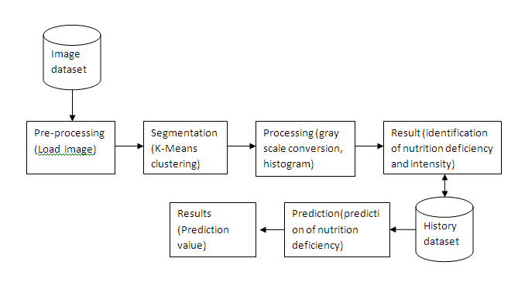

**Module wise Functionalities**

**Module -1**

Pre-processing:

1. Creating a GUI.
2. Loading an image from file (data set).

**Module-2**

Segmentation:

1. In this module we are segmenting the leaf with respect to three colours (RGB).
2. Clustering of the leaf image using KMeans Clustering Algorithm.

**Module-3**

Processing:

1. In this module we convert the segmented image into Grayscale image.
2. Compare Defected Leaf and Non-defected leaf based on Histogram.

2.2 Functional Requirements

1. User shall be able to identify the leaf disease.

2. User shall be able to quantify the defected area on leaf.

2.3 Non Functional Requirements

1. User should have clear image of leaves.

2. User should have minimum and maximum NPK value for leaf for further prediction.

Chapter 3

SYSTEM DESIGN

This chapter gives the detail design, the call return architecture and high level design of system. The architecture looks the system as the combination of different modules and how they interact with each other. The high level design identifies the modules of the system and their specification.

3.1 Architecture Design

The main function calls the fetch input module. The fetch input function in-turn calls the capture image. The capture image functions returns image the fetch input function. The fetch input function returns the image to the main function. Main function passes this data to pre-processor function which processes the image into database. The main function calls the processor function which does processing of images, like feature extraction etc., and then the processed image will be differentiated by the identification module, based on the image processing techniques.

.

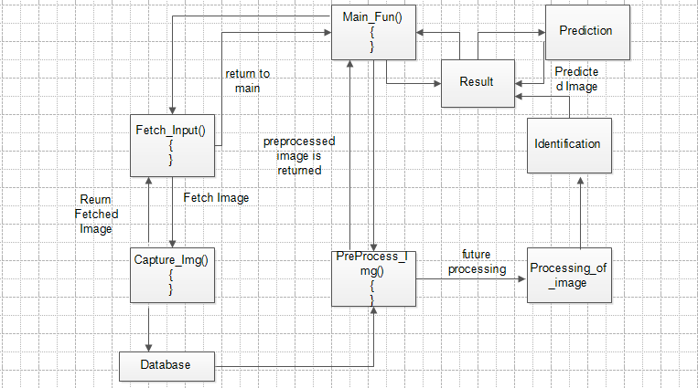 Figure 3.1: call return architecture

3.4 User Interface Design

|  |  |
| --- | --- |
| Content | Details |
| Corpus | The real time data  1) Images are captured and stored in a database and fetched from the database. |
| Input | Image from the dataset. |
| Output | Plot Histogram ,identification of Polution deficiency. |

Chapter 4

IMPLEMENTATION

4.1 Initialization

GUI is created using Microsoft Visual Studio.

In main function we create an object. This object is used run the entire application in opencv.

To load an image from a directory we use path of the stored image.That path is assigned to the actual picture box as created in GUI.

static void Main()

{Form1 ob = new Form1();

Application.Run(ob); }}

public partial class Form1 : Form

{ public Form1()

{InitializeComponent();}

}

private void btnLoadSequence_Click(object sender, EventArgs e)

{

string dir = Directory.GetParent(Environment.CurrentDirectory).FullName;

dir = Directory.GetParent(dir).FullName;

this.openFileDialog1.InitialDirectory = dir;

this.openFileDialog1.Filter="IMAGES |*.jpg;*.bmp";

this.openFileDialog1.FileName = "";

if (this.openFileDialog1.ShowDialog() == DialogResult.OK)

{

picPreview.Image = null;

picPreview.Refresh();

lblInfo.Text = "";

Image b = Image.FromFile(openFileDialog1.FileName);

picPreview.Image = new Bitmap(b,picPreview.Width,picPreview.Height);

picProcessed.Image = null;

picProcessed.Refresh();

}

}

4.2 Segmentation

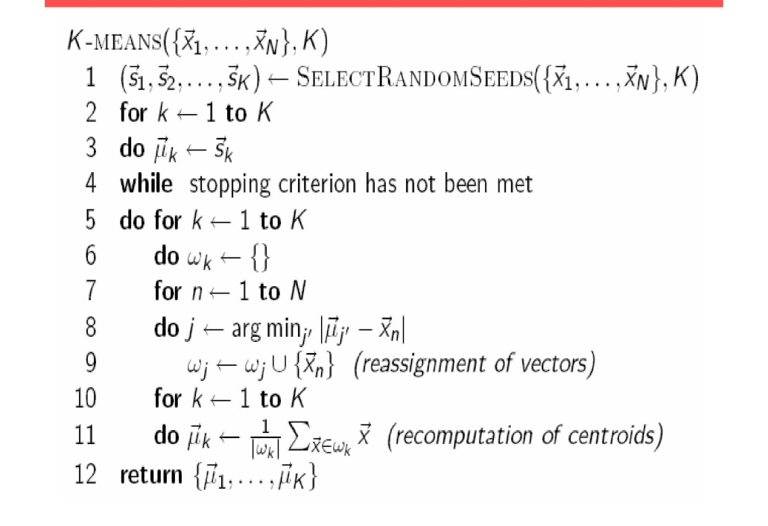

Now we are segment the image into 3 colours.

Kmeans clustering is done using following algorithm.

private void btnTrack_Click(object sender, EventArgs e)

{

if (radioButton1.Checked)

_kMeans = new KMeans((Bitmap)picPreview.Image, Convert.ToInt32(txtNumClusters.Text), ImageProcessor.Colour.Types.RGB);

else

_kMeans = new KMeans((Bitmap)picPreview.Image, Convert.ToInt32(txtNumClusters.Text), ImageProcessor.Colour.Types.HSV);

timer1.Enabled = true;

timer1.Start();

}

public KMeans(Bitmap bmp, int numCluster, Colour.Types model)

{

_image = (Bitmap)bmp.Clone();

_processedImage = (Bitmap)bmp.Clone();

_model = model;

_previousCluster = new Dictionary<string, Cluster>();

_currentCluster = new Dictionary<string, Cluster>();

FindTopXColours(numCluster); //find top X colours in the image

//create clusters for top X colours

for (int i = 0; i < _topColours.Length; i++)

{

PixelData pd = Colour.GetPixelData(_topColours[i].R, _topColours[i].G, _topColours[i].B, model);

_previousCluster.Add(_topColours[i].Name, new Cluster(pd.Ch1, pd.Ch2, pd.Ch3));

_currentCluster.Add(_topColours[i].Name, new Cluster(pd.Ch1, pd.Ch2, pd.Ch3));

}

}

4.3 Results

The segmented image is converted into grayscale image and then the histogram is plotted based on converted RGB image.

private void button2_Click(object sender, EventArgs e)

{

var colImage = new Emgu.CV.Image<Rgb, byte>(grayIm);

Emgu.CV.Image<Gray, Byte> gray = colImage.Convert<Gray, Byte>();

DenseHistogram Histo = new DenseHistogram(255, new RangeF(0, 255));

Histo.Calculate(new Image<Gray, Byte>[] { gray }, true, null);

grayHist = new int[256];

float[] gh=new float[256];

Histo.MatND.ManagedArray.CopyTo(gh, 0);

for (int i = 0; i < gh.Length; i++)

{

grayHist[i] = (int)gh[i];

}

drawHist = true;

this.Invalidate();

this.Refresh();

Application.DoEvents();

}

Appendix A

A.1 Screen Shot

1.Graphical user interface.

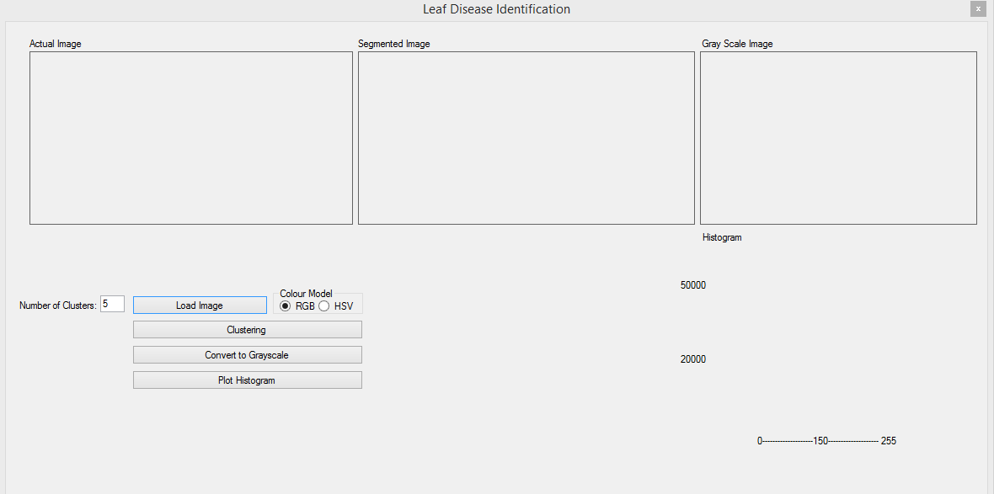

2.Load An Image

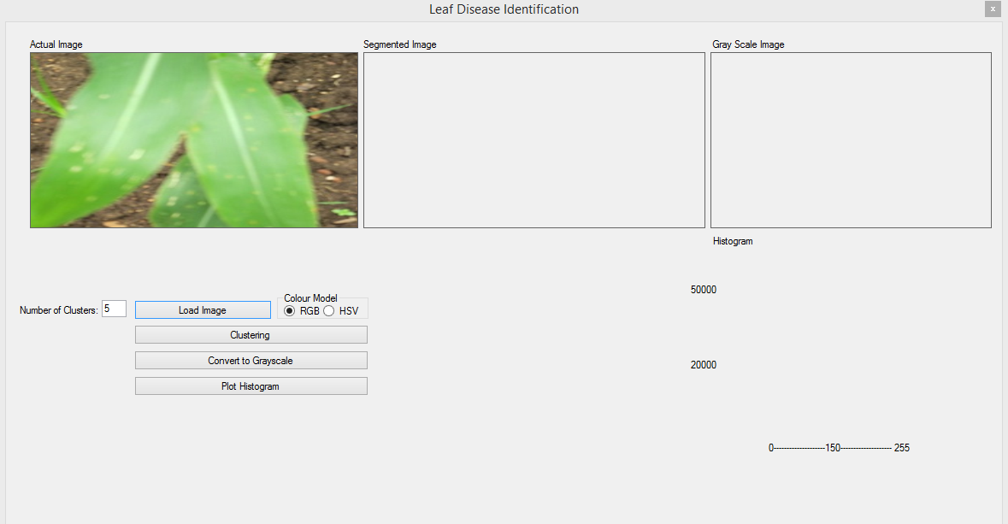

3.Segmented Image

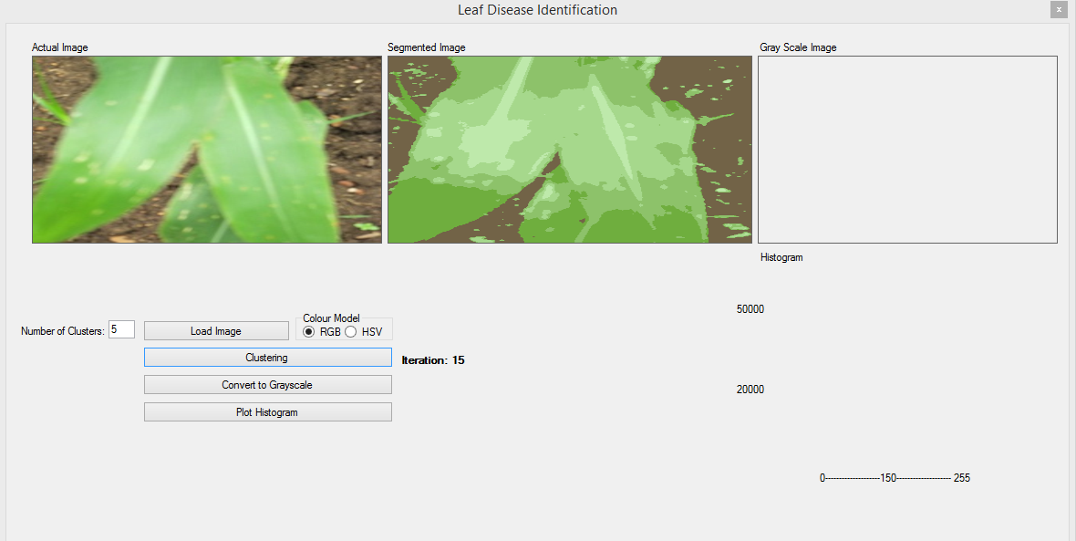

4.Conversion of segmented image into Grayscale image

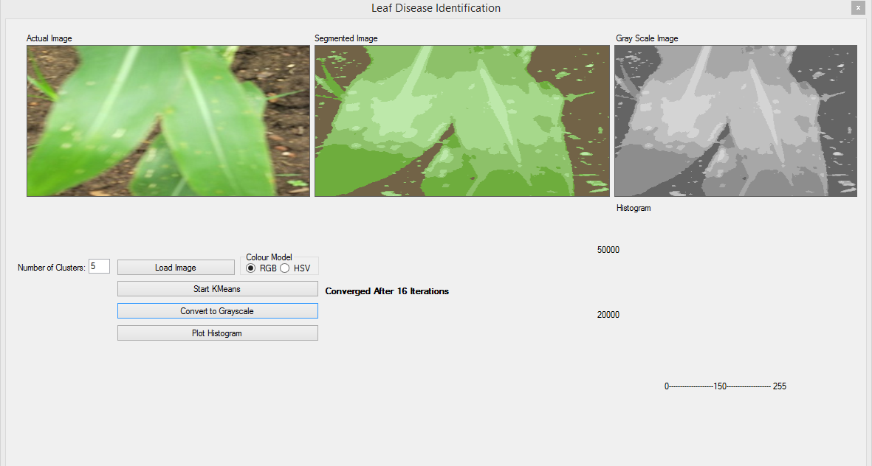

5.Plotting up of Histogram

