DATA SCIENCE PROJECT PLAN
& STRATEGY DESIGN
Predicting Customer Churn for a
Telecommunications Provider
Using Python-Based Machine Learning

Week 1 Deliverable
Comprehensive Project Planning Document
Prepared for: Data Science Professional Development Track
Date: September 2025
Total Planned Effort: 33 Hours

1. Introduction & Background

1.1 Hypothetical Problem Statement
In the highly competitive telecommunications industry, customer churn—defined as the rate at which subscribers discontinue their service—represents one of the most significant threats to long-term profitability. Industry reports consistently show that acquiring a new customer costs five to seven times more than retaining an existing one. A mid-sized telecom provider with approximately 2 million subscribers experiences an annual churn rate of 18–22%, translating into substantial revenue leakage and increased customer acquisition costs.
This project proposes a data-driven solution: building a predictive machine learning model that identifies customers at high risk of churning in the next 30–90 days. By leveraging historical customer data—including demographics, usage patterns, billing history, support interactions, and contract details—the model will generate actionable risk scores that enable targeted retention campaigns.

1.2 Project Motivation
The primary motivation stems from both financial and strategic imperatives:
- Revenue Protection: Reducing churn by even 2–3 percentage points can yield multi-million-dollar annual savings.
- Competitive Differentiation: Proactive retention improves customer experience and brand loyalty in a market dominated by price competition.
- Operational Efficiency: Moving from reactive (post-churn win-back) to predictive interventions optimizes marketing spend.
- Data Maturity Opportunity: Most telecom firms already collect rich transactional and behavioral data that remains underutilized for predictive analytics.

1.3 Justification for a Python-Based Approach
Python has become the de-facto standard for end-to-end data science workflows due to its rich ecosystem of open-source libraries, strong community support, and seamless integration from data engineering through model deployment. Its readability and modularity make it ideal for iterative experimentation, reproducibility, and eventual productionization—key requirements for a robust churn-prediction system.

2. Project Objectives & Scope

2.1 Specific Objectives
- Develop a binary classification model capable of predicting customer churn with target performance of ≥ 0.80 AUC-ROC and ≥ 0.70 F1-score on a held-out test set.
- Identify the top 10–15 most influential predictors of churn through interpretable feature-importance analysis (e.g., SHAP values).
- Segment predicted high-risk customers into actionable tiers (High / Medium / Low) to support differentiated retention strategies.
- Design a reproducible end-to-end Python pipeline covering data ingestion, cleaning, feature engineering, modeling, evaluation, and basic model monitoring.
- Produce clear documentation and visualizations that enable non-technical stakeholders to understand model recommendations and business impact.

2.2 In-Scope
- Historical customer data covering demographics, tenure, contract type, monthly charges, usage metrics (data, voice, SMS), payment method, and support ticket history.
- Supervised machine-learning approaches for binary classification (churn vs. non-churn).
- Exploratory data analysis, feature engineering, model comparison, hyperparameter tuning, and performance evaluation.
- Generation of risk scores and basic segmentation logic.
- Documentation of methodology, findings, and recommended next steps.

2.3 Out-of-Scope
- Real-time streaming data ingestion or online model serving infrastructure.
- Deep learning architectures requiring GPU resources (unless a simple baseline is warranted).
- Full production deployment, A/B testing of retention campaigns, or integration with CRM systems.
- Analysis of competitor pricing data or external macroeconomic indicators.
- Causal inference studies or uplift modeling for intervention effectiveness.

3. Methodology & Strategy
The project follows an adapted CRISP-DM (Cross-Industry Standard Process for Data Mining) methodology, emphasizing iterative refinement and business alignment at every stage.
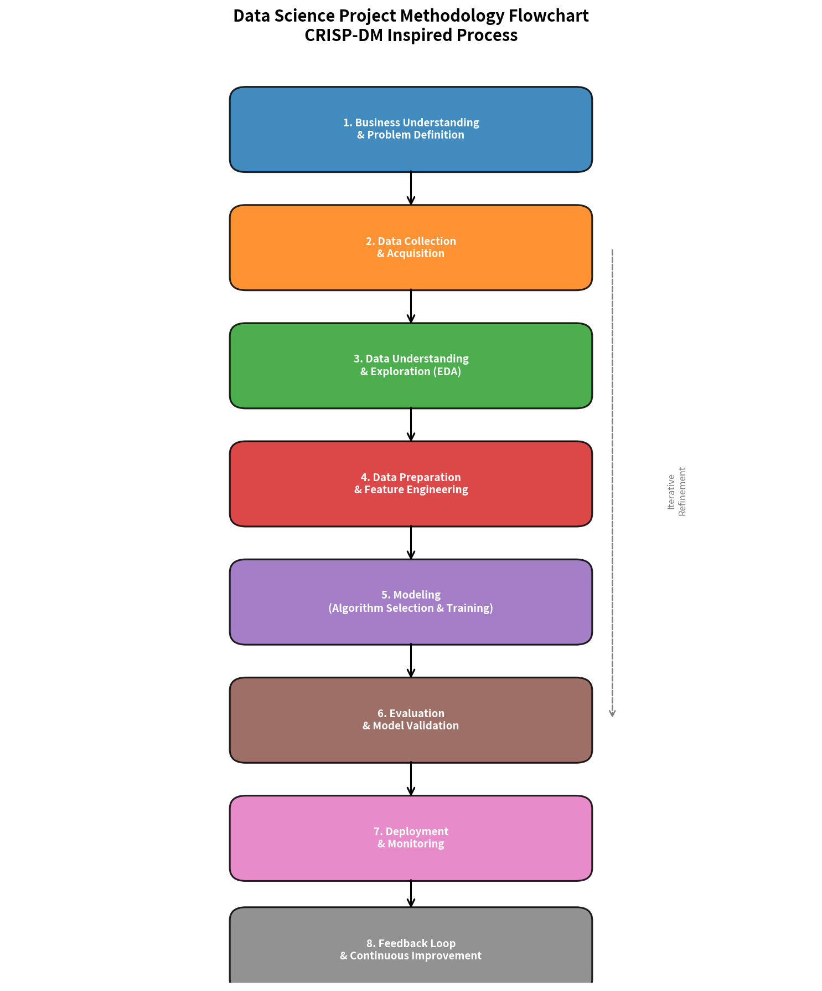
Figure 1: End-to-End Data Science Methodology Flowchart

3.1 Data Collection Strategy
Hypothetical data sources (no actual data required at this planning stage):
- CRM / Customer Master: Demographics, tenure, contract type, auto-renewal flags.
- Billing System: Monthly charges, payment method, late-payment history, invoice disputes.
- Usage Logs: Call minutes, data volume, SMS count, roaming activity, peak-hour patterns.
- Customer Support: Ticket volume, resolution time, escalation flags, NPS/CSAT scores.
- Target Variable: Binary churn label derived from service-termination events within a defined observation window.
Data will be assumed to be extractable via SQL queries or CSV/Parquet exports. A stratified sampling strategy will be planned to preserve class imbalance ratios while keeping the working dataset manageable (target: 50k–150k records).

3.2 Data Cleaning & Preparation
- Handle missing values (median/mode imputation or indicator variables depending on missingness mechanism).
- Detect and treat outliers in continuous variables (IQR method or domain-informed caps).
- Encode categorical variables (one-hot for low-cardinality, target encoding or embeddings for high-cardinality).
- Address class imbalance via stratified sampling, SMOTE, or class-weight adjustments during training.
- Create temporal features (months since last upgrade, average monthly usage trend, etc.).

3.3 Exploratory Data Analysis (EDA)
EDA will focus on understanding distributions, correlations, and early signals of churn:
- Univariate analysis of key features and the target variable.
- Bivariate relationships (churn rate by contract type, tenure buckets, payment method).
- Correlation heatmaps and multicollinearity checks.
- Visualization of usage decay patterns preceding churn events.

3.4 Modeling Strategy
A progressive modeling approach will be employed:
- Baseline: Logistic Regression with basic features (interpretable and fast).
- Tree-based models: Random Forest and Gradient Boosting (XGBoost / LightGBM) for non-linear interactions.
- Ensemble: Stacking or simple averaging of top performers if gains justify complexity.
- Hyperparameter tuning: RandomizedSearchCV or Optuna with stratified k-fold cross-validation.
- Interpretability: SHAP values and partial dependence plots for stakeholder communication.

3.5 Evaluation Framework
Primary metrics: AUC-ROC, Precision-Recall AUC, F1-score, and business-oriented lift charts. Secondary metrics include calibration (Brier score) and fairness checks across demographic segments. A time-based validation split will be preferred over random splits to respect temporal ordering.
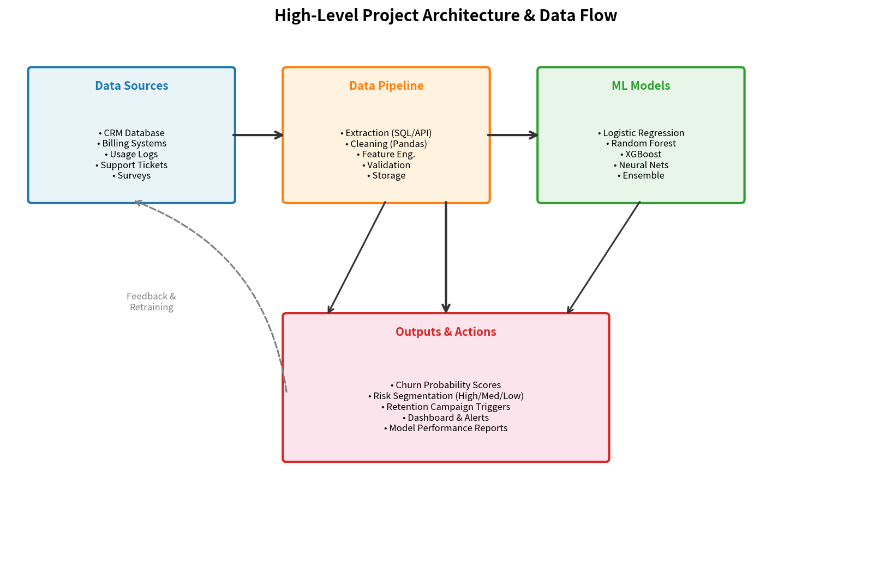
Figure 2: High-Level Project Architecture & Data Flow

4. Timeline & Tools

4.1 Project Timeline (33 Hours Total)
The following timeline allocates approximately 33 hours of focused work, balancing depth with realistic delivery expectations for a planning-plus-initial-implementation phase.
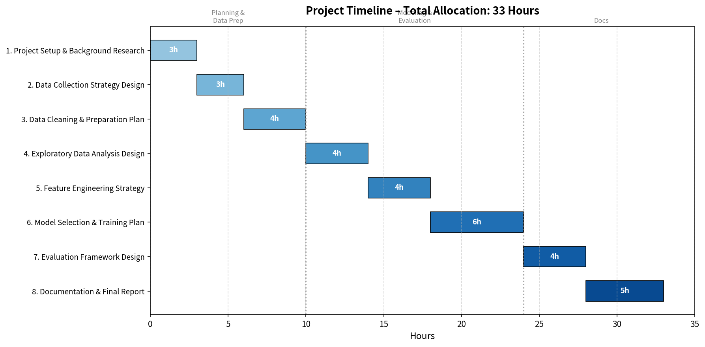
Figure 3: Project Timeline – 33-Hour Allocation
Phase / Task | Hours | Key Activities
1. Project Setup & Research | 3 | Literature review, problem framing, success metrics definition
2. Data Collection Strategy | 3 | Source mapping, schema design, sampling plan
3. Data Cleaning & Prep Plan | 4 | Missing-value strategy, outlier rules, encoding scheme
4. EDA Design | 4 | Visualization plan, correlation analysis, hypothesis generation
5. Feature Engineering Strategy | 4 | Derived features, temporal aggregates, interaction terms
6. Modeling & Training Plan | 6 | Algorithm selection, CV strategy, hyperparameter search design
7. Evaluation Framework | 4 | Metric selection, business lift definition, interpretability plan
8. Documentation & Report | 5 | Final plan write-up, diagram refinement, stakeholder summary

4.2 Python Libraries & Tools
The following tools form the core technology stack:
- Data Manipulation: pandas, NumPy, Polars (optional for larger data).
- Visualization: matplotlib, seaborn, plotly (interactive dashboards).
- Machine Learning: scikit-learn, XGBoost, LightGBM, imbalanced-learn.
- Interpretability: SHAP, ELI5, scikit-learn inspection tools.
- Experiment Tracking: MLflow or simple logging with YAML/JSON configs.
- Development Environment: JupyterLab / VS Code, Git for version control, virtual environments (venv or conda).
- Documentation: Markdown, Sphinx or simple README + notebooks.

5. Expected Outcomes & Challenges

5.1 Expected Outcomes
- A well-documented, reproducible project plan that serves as the foundation for subsequent technical implementation weeks.
- Clear success criteria and evaluation metrics aligned with both statistical rigor and business value.
- Prioritized feature and modeling roadmap that minimizes wasted experimentation.
- Stakeholder-ready visualizations and narratives explaining how predictive churn scores can drive retention ROI.
- Risk register and mitigation strategies that increase the probability of successful delivery.

5.2 Anticipated Challenges & Mitigation Strategies

Challenge 1: Class Imbalance
Risk: Churn is typically a minority class (15–25%). Models may bias toward the majority class.
Mitigation: Use stratified sampling, class weights, SMOTE or ADASYN, and evaluate with precision-recall metrics rather than accuracy alone.

Challenge 2: Data Quality & Missingness
Risk: Real-world telecom data often contains incomplete support logs, inconsistent coding of contract types, or delayed usage updates.
Mitigation: Establish clear data-quality rules early; document assumptions; create missing-value indicators; and perform sensitivity analysis.

Challenge 3: Temporal Leakage
Risk: Using future information (e.g., post-churn usage) would artificially inflate performance.
Mitigation: Strict time-based train/validation/test splits; feature engineering limited to information available at prediction time.

Challenge 4: Model Interpretability vs. Performance Trade-off
Risk: Complex models (boosting, ensembles) may outperform simpler ones but lose stakeholder trust.
Mitigation: Maintain a strong logistic-regression baseline; use SHAP for global and local explanations; present both technical and business views.

Challenge 5: Scope Creep
Risk: Temptation to expand into real-time systems, uplift modeling, or multi-product analysis.
Mitigation: Strict adherence to the defined scope; maintain a “future work” backlog; revisit scope only after core objectives are met.

5.3 Benefits of the Planned Approach
- Structured methodology reduces ambiguity and accelerates later execution phases.
- Emphasis on interpretability increases the likelihood of organizational adoption.
- Realistic hour allocation and phased deliverables support sustainable progress.
- Python-centric stack ensures portability, community support, and ease of collaboration.

6. Conclusion
This Week 1 deliverable establishes a comprehensive, actionable plan for a customer-churn prediction project in the telecommunications domain. By clearly defining the problem, objectives, scope boundaries, methodological steps, resource allocation, and risk mitigations, the foundation is laid for efficient technical execution in subsequent weeks. The chosen Python ecosystem and CRISP-DM-inspired process provide both rigor and flexibility, positioning the project for measurable business impact while remaining realistic in effort and complexity.
Success in later stages will depend on disciplined adherence to the planned timeline, continuous validation against business metrics, and transparent communication of model strengths and limitations to stakeholders.
— End of Project Plan —

