EXPLORATORY DATA ANALYSIS
& VISUALIZATION FRAMEWORK
A Comprehensive Planning Document for
Customer Churn Prediction Project
(Telecommunications Domain)

Week 2 Deliverable
EDA Process Design • Visualization Strategies • Documentation Plan
Prepared for: Data Science Professional Development Track
Continuity from Week 1 Project Plan | September 2025
Planned Effort: ≈ 33 Hours

1. Introduction to Exploratory Data Analysis

1.1 What is EDA?
Exploratory Data Analysis (EDA) is the critical first analytical stage in any data science project. It is the process of systematically examining a dataset to understand its structure, quality, distributions, relationships, and underlying patterns—before formal modeling begins. EDA combines statistical summaries, visual inspection, and domain-informed questioning to transform raw data into actionable understanding.
Unlike confirmatory analysis (hypothesis testing or model evaluation), EDA is intentionally open-ended and iterative. Its primary goals are to:
- Assess data quality and identify issues that require cleaning or transformation.
- Reveal the statistical properties of individual variables and interactions among them.
- Generate hypotheses and feature ideas that will guide subsequent modeling.
- Detect anomalies, outliers, and potential data leakage risks early.
- Communicate key insights to both technical and non-technical stakeholders.

1.2 Importance in the Data Science Lifecycle
In the context of the customer churn prediction project defined in Week 1, thorough EDA is essential. Telecom datasets are typically high-dimensional, temporally structured, and imbalanced. Skipping or rushing EDA frequently leads to:
- Models trained on flawed data (missing values treated incorrectly, leakage features included).
- Missed opportunities for powerful engineered features (e.g., usage decline trends preceding churn).
- Poor model interpretability and stakeholder distrust.
- Wasted modeling time on irrelevant or redundant variables.
A well-executed EDA framework therefore reduces downstream risk, improves model performance, and ensures that analytical decisions remain transparent and defensible.

1.3 Continuity with Week 1 Project
This framework is designed specifically for the telecommunications customer churn use case. Expected data sources include CRM records, billing systems, usage logs, and support tickets. The target variable is a binary churn indicator. All techniques described below are selected for their relevance to tabular, mixed-type data with temporal components and moderate class imbalance.

2. Anticipated Data Types & Schema Considerations
Before applying any analytical technique, it is essential to classify variables correctly. The following categories are expected in a typical telecom churn dataset:
Data Type | Examples | EDA Implications
Numerical (Continuous) | Monthly charges, data usage (GB), tenure (months) | Histograms, boxplots, correlation, outlier detection (IQR/Z-score)
Numerical (Discrete) | Number of support tickets, number of services | Count plots, bar charts, frequency tables
Categorical (Nominal) | Payment method, contract type, gender, region | Frequency tables, bar/pie charts, churn rate by category
Categorical (Ordinal) | Satisfaction score, service tier, risk band | Ordered bar charts, cumulative distributions
Binary / Target | Churn flag (0/1), auto-renew, paperless billing | Class balance check, stratified analysis, proportion plots
Temporal / Date | Signup date, last interaction, contract end date | Time-series plots, tenure calculation, lag features
Correct type identification drives every subsequent decision: choice of plots, statistical tests, encoding methods, and outlier treatment rules.

3. Data Exploration Techniques
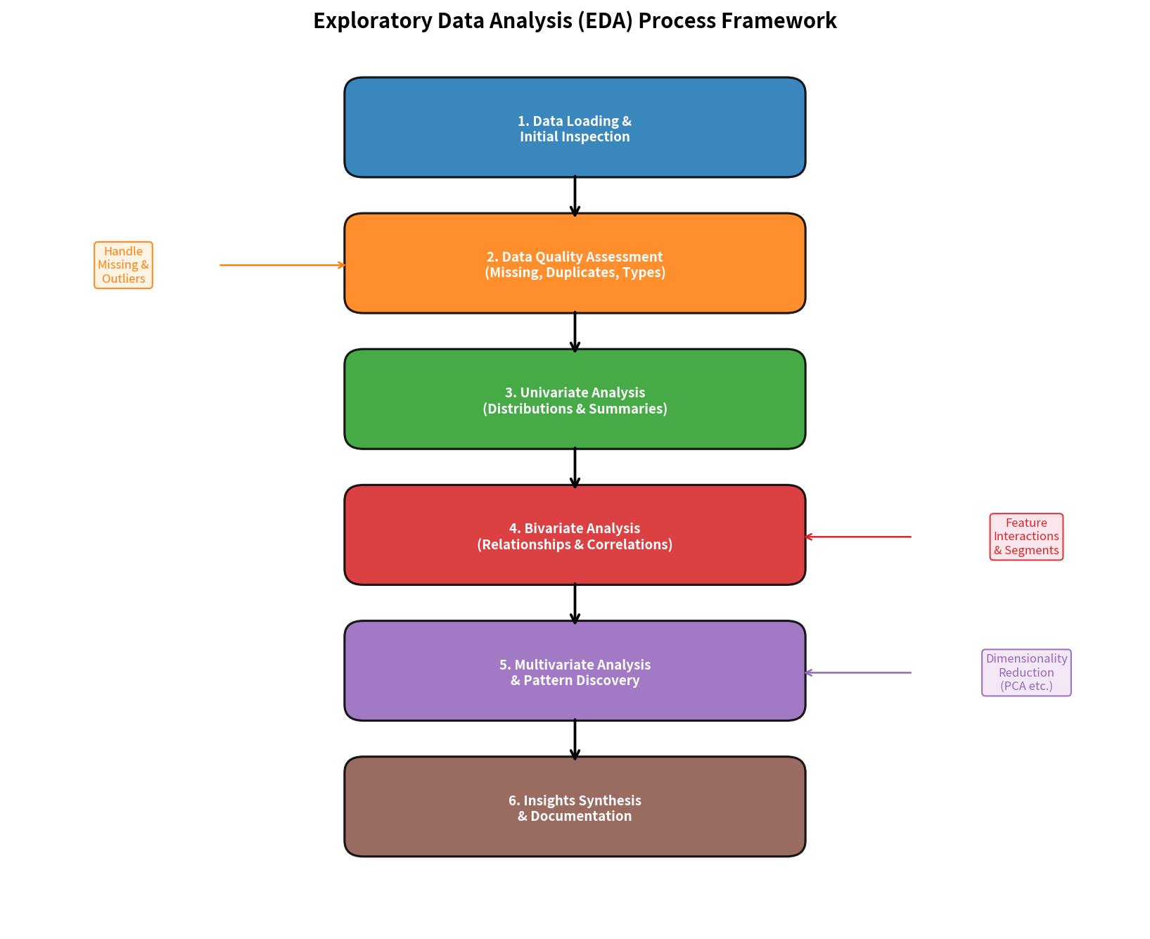
Figure 1: Six-Stage EDA Process Framework

3.1 Initial Data Inspection
- Shape & Structure: df.shape, df.info(), df.dtypes, df.head()/tail() to confirm expected dimensions and column types.
- Memory footprint: Assess whether downcasting numeric types or using categorical dtype is warranted.
- Duplicate detection: Identify and decide on treatment of exact or near-duplicate customer records.
- Unique value counts: Flag potential ID columns or high-cardinality categoricals that may need special handling.

3.2 Handling Missing Data
Missingness is rarely random in telecom data. A systematic approach is required:
- Quantify missingness: Percentage missing per column; visualize with missingno matrix or bar chart.
- Pattern analysis: Check whether missingness correlates with the target (churn) or other variables (MCAR / MAR / MNAR assessment).
- Treatment strategy: Drop columns with >40–50% missing (if low predictive value); impute numerical with median or model-based methods; impute categorical with mode or “Unknown” category; create missing-indicator flags when informative.
- Documentation: Record every imputation decision and the rationale for auditability.

3.3 Outlier Detection & Treatment
- Univariate methods: IQR rule (1.5× or 3×), Z-score / modified Z-score, visual inspection via boxplots.
- Multivariate methods: Isolation Forest, Local Outlier Factor, or Mahalanobis distance for high-dimensional outliers.
- Domain judgment: Extremely high data usage or charges may be legitimate power users rather than errors—consult business rules before capping or removing.
- Treatment options: Winsorization, log/power transforms, binning, or retention with robust models (tree-based).

3.4 Univariate Analysis
Goal: Understand the distribution and central tendency of each individual variable.
- Numerical: Mean, median, std, skewness, kurtosis; histograms + KDE; box/violin plots; QQ-plots for normality assessment.
- Categorical: Value counts, relative frequencies, mode; bar charts ordered by frequency or business logic.
- Target variable: Class balance ratio; absolute and relative churn counts. Critical for deciding on sampling or class-weight strategies later.

3.5 Bivariate Analysis
Goal: Examine pairwise relationships, especially with the churn target.
- Numerical vs. Target: Box/violin plots of feature by churn status; group means and statistical tests (t-test / Mann-Whitney).
- Categorical vs. Target: Churn rate (proportion) by category; stacked or grouped bar charts; chi-square tests of independence.
- Numerical vs. Numerical: Scatter plots (with transparency or hexbin for density); Pearson / Spearman correlation.
- Categorical vs. Categorical: Contingency tables and mosaic plots or clustered bar charts.

3.6 Multivariate Analysis
- Correlation matrix / heatmap: Identify multicollinearity among predictors.
- Pair plots / scatter-matrix: Visual overview of multiple continuous variables colored by churn.
- Segmented analysis: Churn rates across combinations of contract type × tenure bucket × payment method.
- Dimensionality reduction: PCA or t-SNE for visual exploration of high-dimensional structure (optional, mainly diagnostic).
- Interaction hypotheses: Flag potential interaction terms (e.g., high charges + month-to-month contract) for later feature engineering.

4. Visualization Strategies
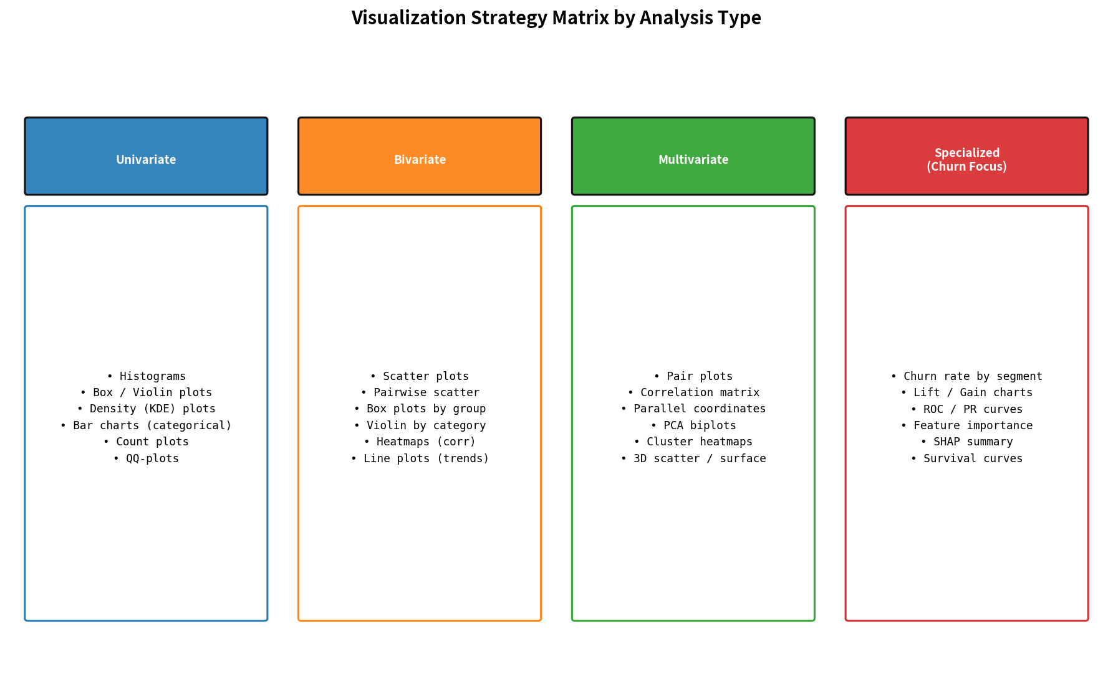
Figure 2: Visualization Strategy Matrix by Analysis Type

4.1 Core Plot Types and When to Use Them
- Histograms & Density Plots: Shape of continuous distributions (monthly charges, tenure, usage). Overlay KDE for smoother insight; facet by churn status.
- Box Plots & Violin Plots: Compare distributions across categories (charges by contract type, tenure by churn). Violin plots additionally show density.
- Bar Charts & Count Plots: Frequency of categorical variables and, more importantly, churn rate within each category.
- Scatter Plots & Hexbin: Relationships between two continuous variables; color or size by churn probability or another dimension.
- Correlation Heatmaps: Compact view of linear (Pearson) or rank (Spearman) associations; essential for multicollinearity screening.
- Pair Plots: Multi-variable scatter matrix with histograms on the diagonal—excellent for quick multivariate overview.
- Specialized Churn Visuals: Stacked area or line charts of cumulative churn over tenure; lift charts; feature importance bar plots (post-modeling, but planned early).

4.2 Design Principles for Effective Visualizations
- Always include clear titles, axis labels, and units.
- Use consistent color palettes (e.g., blue = non-churn, orange/red = churn) across the entire analysis.
- Prefer horizontal bar charts when category labels are long.
- Avoid 3D effects and unnecessary chartjunk; maximize data-ink ratio.
- For large datasets, use sampling, aggregation, or density representations (hexbin, KDE) to prevent overplotting.
- Make plots accessible: sufficient contrast, color-blind friendly palettes (e.g., viridis, colorbrewer).

5. Tools and Python Libraries
The following libraries form the recommended stack for the EDA and visualization framework. Each contributes distinct capabilities:

Core Data Handling
- pandas: Primary workhorse for data loading, cleaning, aggregation, grouping, pivot tables, and missing-value inspection. Provides the DataFrame abstraction used throughout.
- NumPy: Underlying numerical engine; used for efficient array operations, statistical functions, and random sampling.

Visualization
- matplotlib: Foundational plotting library. Full control over figure layout, dual axes, annotations, and export to high-resolution images.
- seaborn: High-level statistical graphics built on matplotlib. Ideal for distribution plots, categorical plots, heatmaps, and pair plots with minimal code.
- plotly / plotly.express: Interactive visualizations for exploratory work and stakeholder presentations. Enables zooming, hovering, and filtering.

Supporting & Specialized
- missingno: Dedicated visual diagnostics for missing data patterns (matrix, bar, heatmap, dendrogram).
- scipy.stats: Statistical tests (t-tests, chi-square, normality tests) and distribution fitting.
- scikit-learn (preprocessing & inspection): SimpleImputer, RobustScaler, PowerTransformer for diagnostic transforms; later used for feature importance.
- JupyterLab / VS Code notebooks: Interactive execution environment with rich display of tables and plots.

6. Reporting and Documentation Plan
Findings from EDA must be captured systematically so that they inform modeling decisions and remain available for future reference or audits.

6.1 Recommended Documentation Artifacts
- EDA Notebook (primary working document): A well-structured Jupyter notebook containing all code, intermediate outputs, plots, and narrative commentary. Sections mirror the six-stage process.
- Data Dictionary: Updated schema describing every column, data type, allowed values, missingness percentage, and business definition.
- Insight Log / Decision Register: Bullet-point list of key observations, hypotheses generated, and decisions taken (e.g., “Drop column X due to 62% missing and low correlation with target”).
- Visualization Gallery: Curated set of the most informative plots exported as high-resolution images for inclusion in presentations and the final report.
- Executive Summary Slide Deck: 5–8 slides highlighting the most business-relevant findings (churn drivers, segment risks, data quality caveats) for non-technical stakeholders.

6.2 Suggested Structure for the Final EDA Report
- 1. Executive Summary (key findings in 1 page)
- 2. Dataset Overview (source, size, time period, target definition)
- 3. Data Quality Assessment (missingness, outliers, duplicates, inconsistencies)
- 4. Univariate Insights (distributions of key predictors and target)
- 5. Bivariate & Multivariate Insights (relationships, correlations, segments)
- 6. Feature Hypotheses & Recommendations for Modeling
- 7. Limitations & Next Steps
- 8. Appendix (full code, additional plots, statistical test results)

6.3 Effort Allocation for This Framework
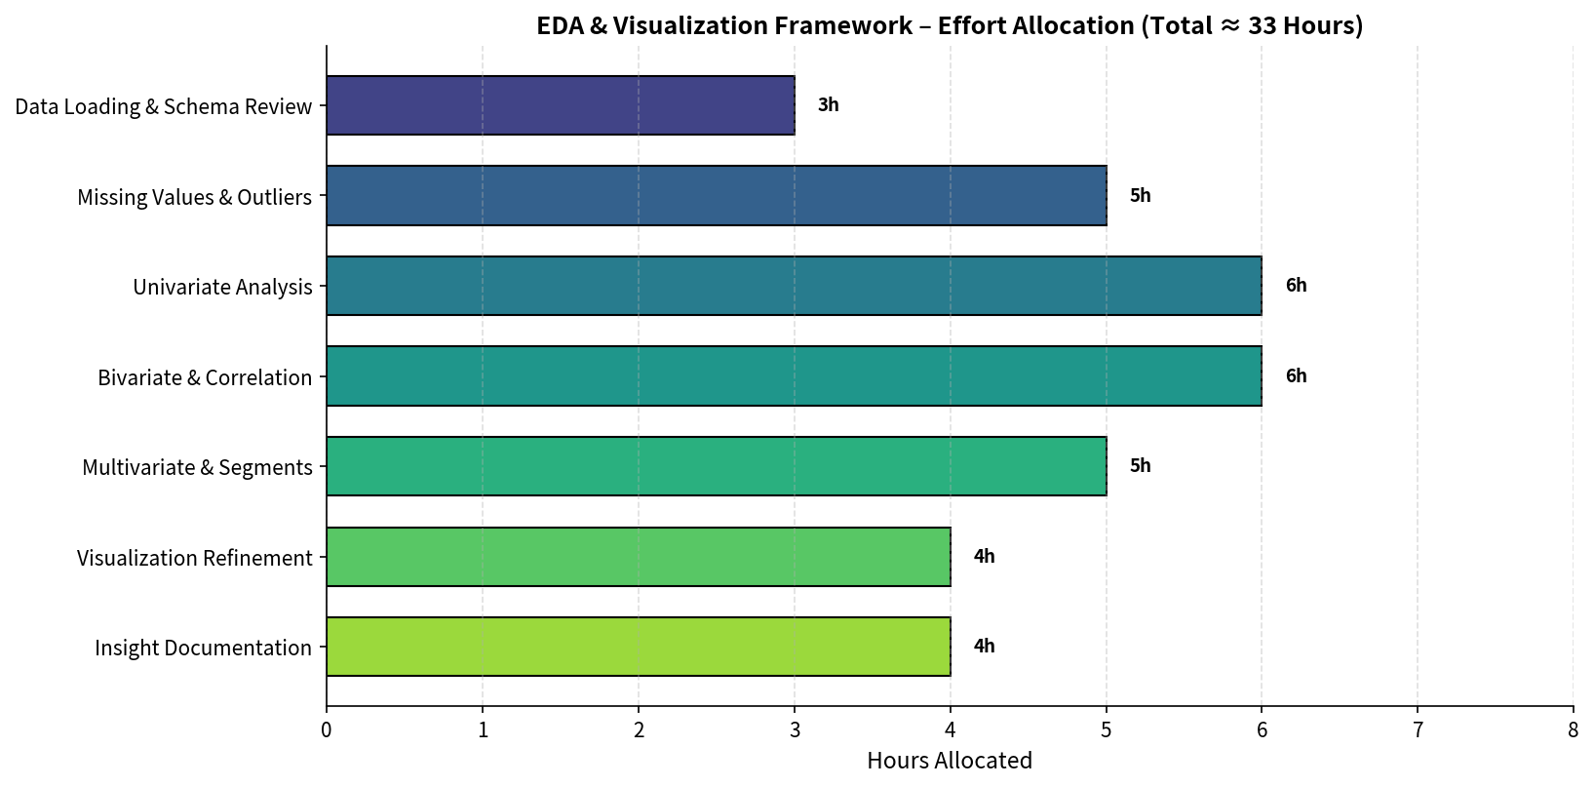
Figure 3: Recommended Effort Allocation (Total ≈ 33 Hours)

7. Conclusion
This Week 2 deliverable provides a complete, reusable framework for conducting Exploratory Data Analysis and designing effective visualizations in the context of a telecommunications customer-churn prediction project. By systematically addressing data types, quality issues, univariate through multivariate techniques, and a deliberate visualization strategy, the framework ensures that subsequent modeling work rests on a solid, well-understood data foundation.
The recommended Python stack (pandas, matplotlib, seaborn, plotly, and supporting libraries) offers the right balance of productivity, statistical depth, and presentation quality. Equally important is the documentation plan, which transforms transient notebook insights into durable knowledge assets that support modeling decisions, stakeholder communication, and future project iterations.
Adhering to this framework—while remaining flexible to emerging patterns in the actual data—will maximize the value extracted from the available information and significantly improve the probability of building an accurate, interpretable, and business-relevant churn model.
— End of EDA & Visualization Framework —

