Sam Saltman: 11: Crafting Reports

Environmental Data Analytics | John Fay & Luana Lima | Developed by Kateri Salk

Spring 2022

## LESSON OBJECTIVES

1. Describe the purpose of using R Markdown as a communication and workflow tool
2. Incorporate Markdown syntax into documents
3. Communicate the process and findings of an analysis session in the style of a report

## USE OF R STUDIO & R MARKDOWN SO FAR…

1. Write code
2. Document that code
3. Generate PDFs of code and its outputs
4. Integrate with Git/GitHub for version control

## BASIC R MARKDOWN DOCUMENT STRUCTURE

1. **YAML Header** surrounded by — on top and bottom
   * YAML templates include options for html, pdf, word, markdown, and interactive
   * More information on formatting the YAML header can be found in the cheat sheet
2. **R Code Chunks** surrounded by ``on top and bottom + Create usingCmd/Ctrl+Alt+I`
   * Can be named {r name} to facilitate navigation and autoreferencing
   * Chunk options allow for flexibility when the code runs and when the document is knitted
3. **Text** with formatting options for readability in knitted document

## RESOURCES

Handy cheat sheets for R markdown can be found: [here](https://rstudio.com/wp-content/uploads/2015/03/rmarkdown-reference.pdf), and [here](https://raw.githubusercontent.com/rstudio/cheatsheets/master/rmarkdown-2.0.pdf).

There’s also a quick reference available via the Help→Markdown Quick Reference menu.

Lastly, this [website](https://rmarkdown.rstudio.com) give a great & thorough overview.

## THE KNITTING PROCESS

* The knitting sequence 
* Knitting commands in code chunks:
* include = FALSE - code is run, but neither code nor results appear in knitted file
* echo = FALSE - code not included in knitted file, but results are
* eval = FALSE - code is not run in the knitted file
* message = FALSE - messages do not appear in knitted file
* warning = FALSE - warnings do not appear…
* fig.cap = "..." - adds a caption to graphical results

## WHAT ELSE CAN R MARKDOWN DO?

See: <https://rmarkdown.rstudio.com> and class recording. * Languages other than R… * Various outputs…

———————————————————————— start here

## WHY R MARKDOWN?

<Fill in our discussion below with bullet points. Use italics and bold for emphasis (hint: use the cheat sheets or Help →Markdown Quick Reference to figure out how to make bold and italic text).>

1. ***Easy format*** *for readers*
2. *Ability to* ***generate a report***
3. ***Reproducibility***
4. *Ability to* ***collaborate*** *connecting Rmd to github*
5. *Can use* ***multiple languages***

## TEXT EDITING CHALLENGE

Create a table below that details the example datasets we have been using in class. The first column should contain the names of the datasets and the second column should include some relevant information about the datasets. (Hint: use the cheat sheets to figure out how to make a table in Rmd)

| Names | Info |
| --- | --- |
| EPA Air | Air qualtiy |
| NTL-LTER Lake | Lake Data |
| Wind Speed | Port Arthur Texas Wind |

## R CHUNK EDITING CHALLENGE

### Installing packages

Create an R chunk below that installs the package knitr. Instead of commenting out the code, customize the chunk options such that the code is not evaluated (i.e., not run).

install.packages("knitr")

### Setup

Create an R chunk below called “setup” that checks your working directory, loads the packages tidyverse, lubridate, and knitr, and sets a ggplot theme. Remember that you need to disable R throwing a message, which contains a check mark that cannot be knitted.

getwd()

## [1] "/Users/samsaltman/Documents/R/Environmental_Data_Analytics_2022"

library(tidyverse)  
library(lubridate)  
library(knitr)  
  
mytheme <- theme_classic() +  
 theme(axis.text = element_text(color = "black"),   
 legend.position = "top")  
theme_set(mytheme)

Load the NTL-LTER_Lake_Nutrients_Raw dataset, display the head of the dataset, and set the date column to a date format.Customize the chunk options such that the code is run but is not displayed in the final document.

## lakeid lakename year4 daynum sampledate depth_id depth tn_ug tp_ug nh34 no23  
## 1 L Paul Lake 1991 140 5/20/91 1 0.00 538 25 NA NA  
## 2 L Paul Lake 1991 140 5/20/91 2 0.85 285 14 NA NA  
## 3 L Paul Lake 1991 140 5/20/91 3 1.75 399 14 NA NA  
## 4 L Paul Lake 1991 140 5/20/91 4 3.00 453 14 NA NA  
## 5 L Paul Lake 1991 140 5/20/91 5 4.00 363 13 NA NA  
## 6 L Paul Lake 1991 140 5/20/91 6 6.00 583 37 NA NA  
## po4 comments  
## 1 NA   
## 2 NA   
## 3 NA   
## 4 NA   
## 5 NA   
## 6 NA

### Data Exploration, Wrangling, and Visualization

Create an R chunk below to create a processed dataset do the following operations:

* Include all columns except lakeid, depth_id, and comments
* Include only surface samples (depth = 0 m)
* Drop rows with missing data

NTL_lake_nutrient_processed <- NTL_lake_nutrient %>%  
 select(lakename:sampledate, depth:po4) %>%  
 filter(depth == 0) %>%  
 drop_na()

Create a second R chunk to create a summary dataset with the mean, minimum, maximum, and standard deviation of total nitrogen concentrations for each lake. Create a second summary dataset that is identical except that it evaluates total phosphorus. Customize the chunk options such that the code is run but not displayed in the final document.

Create a third R chunk that uses the function kable in the knitr package to display two tables: one for the summary dataframe for total N and one for the summary dataframe of total P. Use the caption = " " code within that function to title your tables. Customize the chunk options such that the final table is displayed but not the code used to generate the table.

Nitrogen Summary

| lakename | Mean | Minimum | Maxiumum | StandardDeviation |
| --- | --- | --- | --- | --- |
| Central Long Lake | 690.0469 | 343.020 | 953.063 | 209.09341 |
| Crampton Lake | 362.6813 | 353.380 | 376.304 | 12.05748 |
| East Long Lake | 810.7834 | 380.620 | 2608.956 | 335.41457 |
| Hummingbird Lake | 1036.6695 | 779.053 | 1221.960 | 204.36889 |
| Paul Lake | 368.7564 | 45.670 | 628.625 | 106.34741 |
| Peter Lake | 561.8752 | 219.720 | 2048.151 | 305.64909 |
| Tuesday Lake | 423.5605 | 237.363 | 554.418 | 78.84522 |
| West Long Lake | 762.6017 | 303.170 | 2870.302 | 402.95992 |

Phosphorus Summary

| lakename | Mean | Minimum | Maxiumum | StandardDeviation |
| --- | --- | --- | --- | --- |
| Central Long Lake | 21.70981 | 8.190 | 37.270 | 7.076388 |
| Crampton Lake | 11.16033 | 5.803 | 15.555 | 4.946759 |
| East Long Lake | 29.28984 | 8.000 | 101.050 | 17.375710 |
| Hummingbird Lake | 36.21925 | 32.765 | 42.119 | 4.146717 |
| Paul Lake | 10.45606 | 1.222 | 36.070 | 4.805142 |
| Peter Lake | 18.39153 | 0.000 | 64.383 | 10.976205 |
| Tuesday Lake | 11.71853 | 6.325 | 18.663 | 3.044289 |
| West Long Lake | 19.82981 | 2.690 | 63.243 | 10.541276 |

Create a fourth and fifth R chunk that generates two plots (one in each chunk): one for total N over time with different colors for each lake, and one with the same setup but for total P. Decide which geom option will be appropriate for your purpose, and select a color palette that is visually pleasing and accessible. Customize the chunk options such that the final figures are displayed but not the code used to generate the figures. In addition, customize the chunk options such that the figures are aligned on the left side of the page. Lastly, add a fig.cap chunk option to add a caption (title) to your plot that will display underneath the figure.

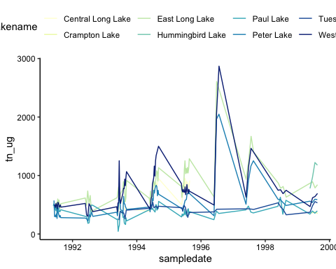

Nitrogen Summary

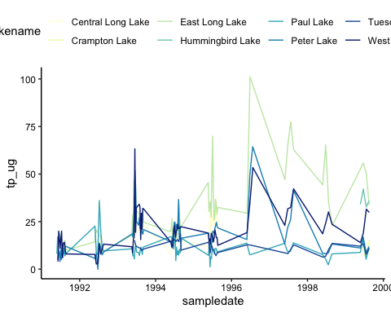

Phosphorus Summary

### Communicating results

Write a paragraph describing your findings from the R coding challenge above. This should be geared toward an educated audience but one that is not necessarily familiar with the dataset. Then insert a horizontal rule below the paragraph. Below the horizontal rule, write another paragraph describing the next steps you might take in analyzing this dataset. What questions might you be able to answer, and what analyses would you conduct to answer those questions?

The results indicate that nitrogen and phosphorous are present in all the lakes. Some of the lakes saw significant spikes between the years 1996-1998. There is the possibility that there was an extreme event that increased runoff high in both phosphorous and nitrogen during this period.

The next step is to analyze periods of spikes. We may want to look into seasonal data, and we may want to include additional datasets on upstream anthropogenic activities. The goal of the next steps is to determine how to prevent a significant spike in nitrogen and phosphorous in these lakes.

## KNIT YOUR PDF

When you have completed the above steps, try knitting your PDF to see if all of the formatting options you specified turned out as planned. This may take some troubleshooting.

## OTHER R MARKDOWN CUSTOMIZATION OPTIONS

We have covered the basics in class today, but R Markdown offers many customization options. A word of caution: customizing templates will often require more interaction with LaTeX and installations on your computer, so be ready to troubleshoot issues.

Customization options for pdf output include:

* Table of contents
* Number sections
* Control default size of figures
* Citations
* Template (more info [here](http://jianghao.wang/post/2017-12-08-rmarkdown-templates/))

pdf_document:  
toc: true  
number_sections: true  
fig_height: 3  
fig_width: 4  
citation_package: natbib  
template: