**11. Sets, Parameters, Groups:**

1. **Parameters can be used in ?**

**Ans:** You can use parameters in calculations and calculated fields that are used in the view. You can display the parameter control in the view for users to select parameters. You can reference parameters in parameter actions.

1. What are the different ways to create a Parameter?

**Ans:** A parameter is a workbook variable such as a number, date, or string that can replace a constant value in a calculation, filter, or reference line.

For example, you may create a calculated field that returns True if Sales is greater than $500,000 and otherwise returns False. You can replace the constant value of “500000” in the formula with a parameter. Then, using the parameter control, you can dynamically change the threshold in your calculation.

To use a parameter, you must:

1. Set up the initial parameter.
2. Use the parameter in an element such as a calculation, filter, or reference line.
3. Adjust the parameter value by:
   * Showing the parameter control
   * Using a parameter action
   * Setting a dynamic parameter to update automatically.
4. Create a parameter.
5. To create a parameter from the Data pane:
6. In the Data pane, click the drop-down arrow in the upper right corner and select **Create Parameter**.

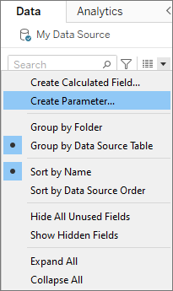

1. In the Create Parameter dialog box, give the field a **Name**.

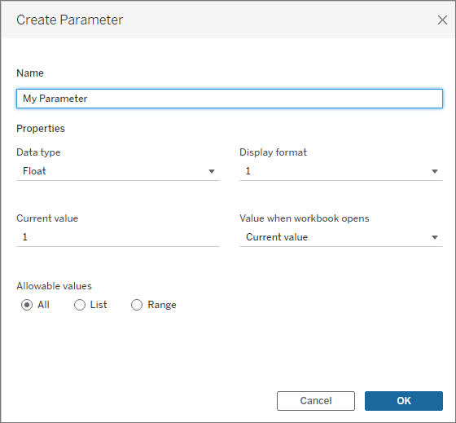

1. Specify the data type for the values it accepts.

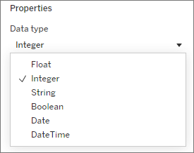

1. *Optional:* Specify a current value. This is the default value for the parameter.
2. *Optional:* Specify a value when the workbook opens.
3. Specify the display format to use in the parameter control (Tableau Desktop only)

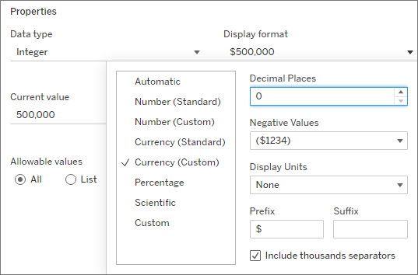

7. Specify how the parameter accepts values. You can select from the following options:

* **All**: The parameter control is a simple text field.
* **List**: The parameter control provides a list of possible values for you to select from.
  + If you select List, you must specify the list of values. Click in the left column to type your list of values, or you can add members of a field or paste from the clipboard by selecting **Add values from**.

* **Range**: The parameter control lets you select values within a specified range.
  + If you select Range, you must specify a minimum, maximum, and step size. The step size controls the jumps between values, such as letting you choose each number (5, 6, 7...) or going from 5 to 10 to 15.

1. When finished, click **OK**.

