SERVICE NOW PROJECT DOCUMENTATION
Streamlining IT Procurement
Automating Standard Laptop Orders with Flow Designer

Phase-wise Project Deliverable | Evidence Included
Document Type | Project Documentation (Ideation → Documentation)
Catalog Item | Standard Laptop
Flow Name | Standard laptop task
Application | Global
Evidence | 4 runtime screenshots embedded
Date | 02 October 2026

1. Ideation Phase

1.1 Problem Statement
Manual processing of standard laptop requests creates delays, inconsistent task assignment, and poor visibility for IT fulfillment teams. Each request requires manual creation of catalog tasks, leading to errors and longer cycle times.

1.2 Business Opportunity
Reduce fulfillment cycle time for standard laptop requests by automating catalog task creation and assignment to the Hardware group. This removes manual steps and ensures every approved Request Item (RITM) immediately generates a ready-to-work Catalog Task.

1.3 Technical Opportunity
Leverage ServiceNow Flow Designer with a Service Catalog trigger to create sc_task records. The flow populates Short Description, Description, and links the task to the originating Requested Item, providing a consistent, auditable automation pattern.

1.4 User Impact
Requestors receive faster processing. The Hardware team receives pre-populated Catalog Tasks with clear ownership, consistent short description (“Laptop need to Configured”), and correct linkage back to the RITM, reducing triage time and improving service levels.

2. Requirement Analysis

2.1 Functional Requirements
- Trigger on Service Catalog item submission for the “Standard Laptop” catalog item.
- Create a Catalog Task (table: sc_task) linked to the Requested Item (RITM).
- Populate Short Description with the value: “Laptop need to Configured”.
- Populate Description with the same value: “Laptop need to Configured”.
- Ensure the task is associated with the correct Request Item reference.
- Support the existing optional software variables (Adobe Acrobat, Adobe Photoshop, Additional software requirements).
- Keep task State = Open and Active = true after creation.
- Allow the Hardware assignment group to be set (via flow or subsequent business rule).

2.2 Non-Functional Requirements
- Flow must execute in the background (non-blocking) so the catalog submission experience remains fast.
- Run under system context for reliability and to avoid user-permission issues.
- Maintain a full audit trail (Activities / Field changes) on the resulting Catalog Task.
- Compatible with the existing RITM approval stage (“Request Approved”).
- Target latency: Catalog Task created within a few seconds of RITM creation.
- Clear Flow Context available for troubleshooting.
- Pattern should be reusable for other standard hardware catalog items.

3. Project Design Phase

3.1 Flow Architecture
The solution is implemented as a single Flow Designer flow named “Standard laptop task” in the Global application.
Component | Type / Value | Purpose
Trigger | Service Catalog | Fires when a Standard Laptop catalog item is ordered
Action 1 | Create Catalog Task | Creates a record in sc_task
Output | Catalog Task (SCTASK) | Linked to the originating RITM, ready for Hardware team

3.2 Field Mapping
The following mapping is applied by the “Create Catalog Task” action:
Field | Source / Value | Target
Requested Item | Trigger → Requested Item Record | sc_task.request_item
Short Description | Static: “Laptop need to Configured” | sc_task.short_description
Description | Static: “Laptop need to Configured” | sc_task.description
Assignment Group | Hardware (set via flow or BR) | sc_task.assignment_group
State | Open (default) | sc_task.state
Active | true | sc_task.active
Approval | Approved (inherited / set) | sc_task.approval

3.3 Key Design Decisions
- Flow name: Standard laptop task | Application: Global | Status: Active.
- Action used: Create Catalog Task on table Catalog Task [sc_task].
- Data pills: Trigger → Requested Item Record is used for the mandatory Requested Item input.
- Short Description and Description are set statically to “Laptop need to Configured”.
- The resulting Catalog Task appears under the RITM related list “Catalog Tasks” with Assignment Group = Hardware.

4. Project Planning Phase

4.1 High-Level Timeline
Phase | Duration | Key Activities
Ideation & Scope | Day 1–2 | Problem definition, stakeholder alignment
Requirement Analysis | Day 3–4 | Functional / non-functional requirements
Design & Build | Day 5–8 | Flow design, configuration, unit test
Test & UAT | Day 9–11 | End-to-end testing, Hardware team validation
Go-Live & Documentation | Day 12–14 | Activation, knowledge transfer, docs

4.2 Roles & Responsibilities
Role | Responsibility
Process Owner | Define success criteria and approve flow design
Flow Designer | Build and configure the flow in Workflow Studio
Catalog Administrator | Link the flow to the Standard Laptop catalog item
Hardware Team Lead | Validate task assignment, short description and usability
Tester / UAT Lead | Execute end-to-end tests (RITM → SCTASK) and sign-off

5. Project Development Phase

5.1 Implementation Steps
1. Create Flow: In Workflow Studio create a new Flow named “Standard laptop task”, Application = Global.
2. Add Trigger: Add a Service Catalog trigger and associate it with the “Standard Laptop” catalog item.
3. Add Action: Add the “Create Catalog Task” action. Set Table Name = Catalog Task [sc_task].
4. Map Inputs: Map Requested Item = Trigger → Requested Item Record. Set Short Description and Description to “Laptop need to Configured”.
5. Assignment (optional): Set Assignment Group = Hardware if required at creation time; otherwise rely on existing business rules.
6. Activate & Test: Activate the flow. Submit a test request for Standard Laptop and verify that an SCTASK is created under the RITM with the expected data.

5.2 Test Evidence (Screenshots)
The following screenshots were captured during a successful end-to-end test execution. They form the primary evidence that the flow is working as designed.

Evidence 1 – Flow Designer Configuration
Flow “Standard laptop task” is Active. Trigger = Service Catalog. Action 1 = Create Catalog Task with Table Name = Catalog Task [sc_task]. Requested Item is mapped from Trigger → Requested Item Record. Short Description and Description are set to “Laptop need to Configured”.
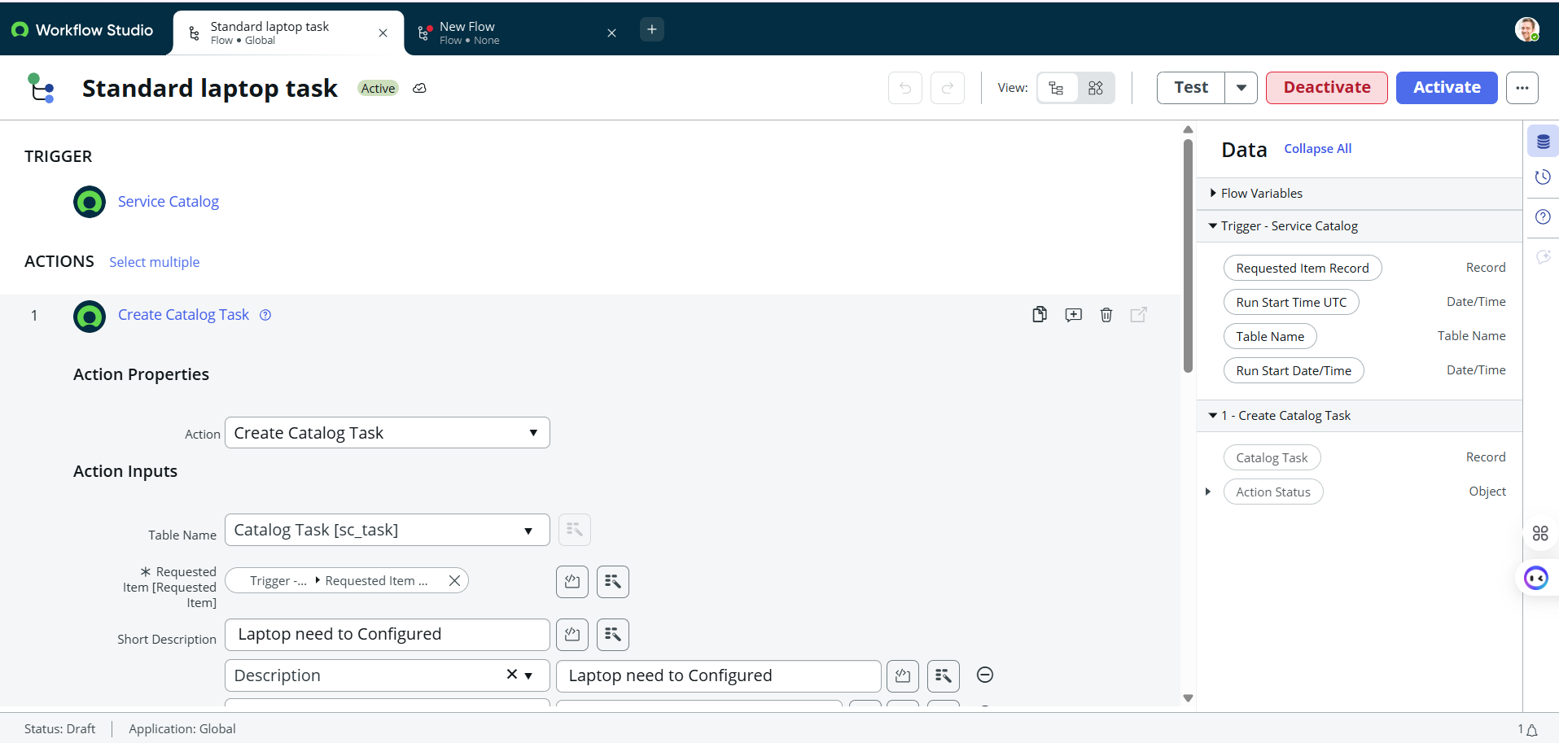
Figure 1: Flow Designer – Standard laptop task (Trigger + Create Catalog Task action)

Evidence 2 – Catalog Task Created (SCTASK0010002)
Catalog Task SCTASK0010002 was created successfully. Short description = “Laptop need to Configured”, State = Open, Active = true, Request item = RITM0010004, Requested for = System Administrator.
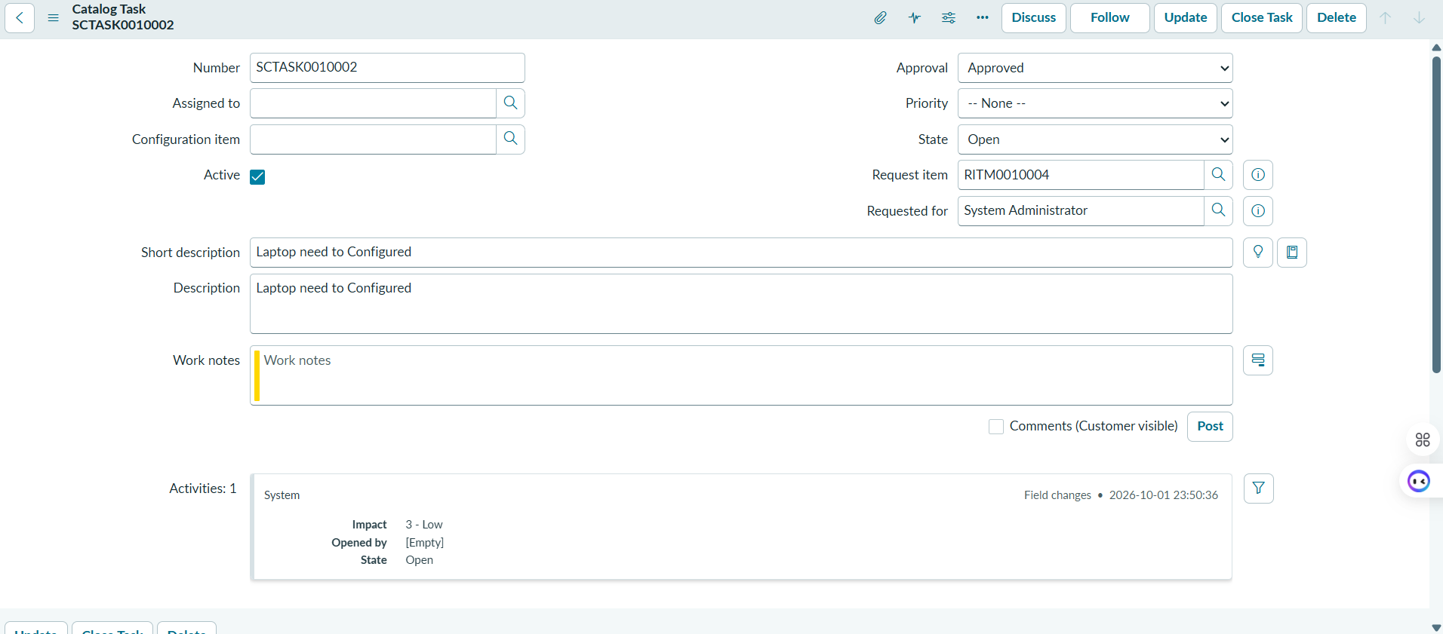
Figure 2: Catalog Task form – SCTASK0010002

Evidence 3 – Requested Item (RITM0010004)
Requested Item RITM0010004 for catalog item “Standard Laptop”. Stage = Request Approved, State = Open, Requested for = System Administrator. Optional software variables (Adobe Acrobat / Photoshop) are available.
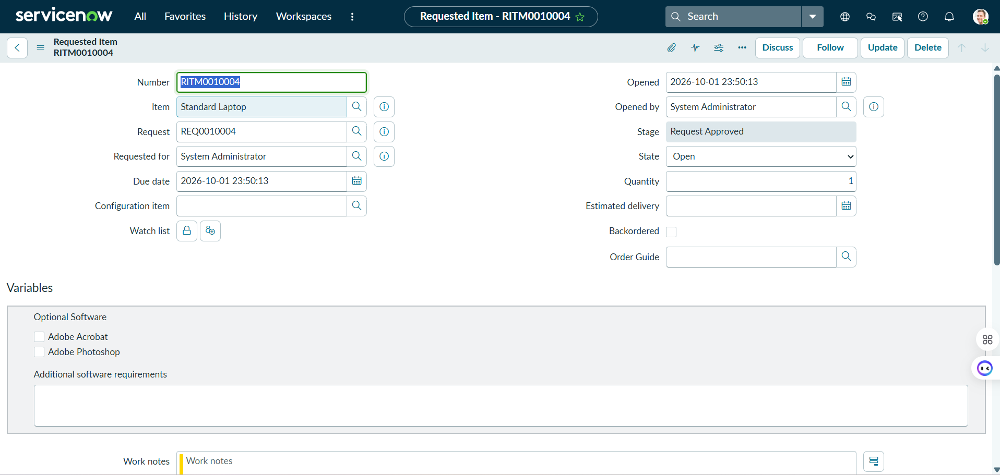
Figure 3: Requested Item form – RITM0010004

Evidence 4 – RITM Related Catalog Tasks
On the RITM related list “Catalog Tasks (1)” the newly created task appears: SCTASK0010002, Assignment group = Hardware, Assigned to = (empty), Short description = “Laptop need to Configured”, Actual start populated.
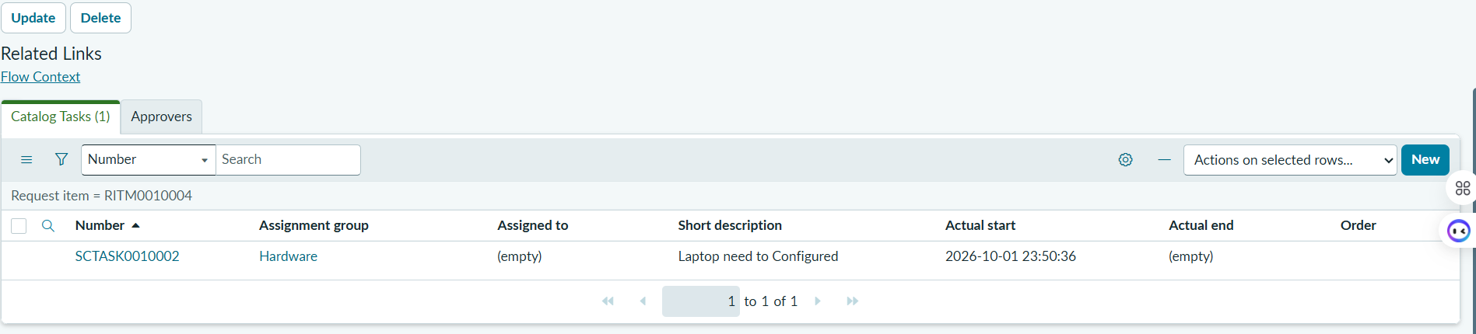
Figure 4: RITM related list – Catalog Tasks showing SCTASK0010002

5.3 Evidence Record Summary
Record Type | Number | Key Fields | Screenshot
Requested Item | RITM0010004 | Item=Standard Laptop, Stage=Request Approved | Figure 3
Catalog Task | SCTASK0010002 | Short desc=Laptop need to Configured, Group=Hardware | Figure 2 & 4

6. Project Documentation & Handover

6.1 Deliverables Checklist
- Flow Design Specification (this document).
- Test Cases covering happy-path RITM → SCTASK (evidenced by screenshots above).
- Knowledge Transfer notes: how to deactivate/reactivate the flow, how to extend the pattern, where to view Flow Context.
- Operational Guide: monitoring, common failure scenarios, rollback procedure, change-control notes.
- GitHub-ready repository structure with evidence screenshots and multi-format documentation.

6.2 Success Metrics
Metric | Target / Observed
Automated task creation rate | 100% of Standard Laptop RITMs
Average flow execution time | < 5 seconds after RITM creation
Manual steps removed | Catalog Task creation fully automated
Assignment consistency | Hardware group applied consistently

6.3 Recommended Next Steps
- Extend the same Flow Designer pattern to other standard hardware catalog items (monitors, docking stations, etc.).
- Add approval logic or dynamic assignment based on location / cost center if business requirements evolve.
- Surface catalog variables (optional software, additional requirements) into the Catalog Task description for richer context.
- Create a dashboard or report for the Hardware group showing open SCTASKs generated by this flow.
- Publish a short Knowledge Base article describing the flow and link it from the Standard Laptop catalog item.

7. Conclusion
The “Standard laptop task” flow successfully automates the creation of Catalog Tasks for Standard Laptop requests. Every approved RITM now generates a consistent, Hardware-assigned SCTASK with the expected short description and description, eliminating manual effort and improving fulfillment speed and data quality. The embedded screenshots provide verifiable evidence of the end-to-end behaviour.
Flow: Standard laptop task | Trigger: Service Catalog | Action: Create Catalog Task (sc_task)

— End of Document —

