**Great Outdoor Documentation**



**Team Members :**

|  |
| --- |
| Shivani Mane |
|  |
| Aashi Mandawat |
|  |
| Deepali Matkar |
|  |
|  |

Table of Contents

1. Introduction ------------------------------------------------------------------------------------
2. Overview-----------------------------------------------------------------------------------------
3. Team Member Work Allocation-------------------------------------------------------------
4. Epic & Stories -----------------------------------------------------------------------------------
5. Use Cases ----------------------------------------------------------------------------------------
   * 1. Product Management System -----------------------------------------------------------
6. Add a Product ---------------------------------------------------------------------
7. Edit a Product ---------------------------------------------------------------------
8. Delete a Product------------------------------------------------------------------
9. Add a Product Master------------------------------------------------------------
10. Search a Product------------------------------------------------------------------
11. Filter a Product -------------------------------------------------------------------
    * 1. Address Management System-----------------------------------------------------------

A) Add an Address--------------------------------------------------------------------

B) Update an Address----------------------------------------------------------------

C) Delete an Address-----------------------------------------------------------------

* + 1. Wishlist Management System -----------------------------------------------------------

A) Add a Product ---------------------------------------------------------------------

B) View Wishlist ---------------------------------------------------------------------

iv)Adding Item To cart------------------------------------------------------------------------

v)Placing the Order---------------------------------------------------------------------------

vi) Cancel Management System-------------------------------------------------------------

A) Cancel an Order--------------------------------------------------------------------

B) Cancel a Product-------------------------------------------------------------------

vii) Shelf Time Report------------------------------------------------------------------------

viii)User Management System-----------------------------------------------------------

A) User Registration--------------------------------------------------------------------

B) User Login----------------------------------------------------------------

C) User Logout-----------------------------------------------------------------

ix) Retailer Inventory Management System-----------------------------------------------

A) View Inventory

1. Class Diagram ----------------------------------------------------------------------------------
2. ER Diagram--------------------------------------------------------------------------------------
3. Test Case Scenario -----------------------------------------------------------------------------
4. BDD------------------------------------------------------------------------------------------------
5. Conclusion----------------------------------------------------------------------------------------

1. Introduction

Great Outdoors (GO) is an electronic distributor of outdoor products. GO sources the products from various manufacturers and supplies it to Retailers across various countries.

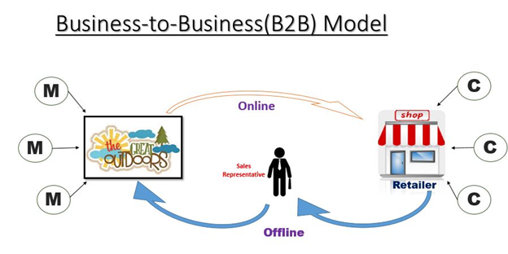

GO primarily deals with *5 Product Categories*:

1. Camping Equipment

2. Golf Equipment

3. Mountaineering Equipment

4. Outdoor Protection

5. Personal Accessories

*Contribution to Topline*

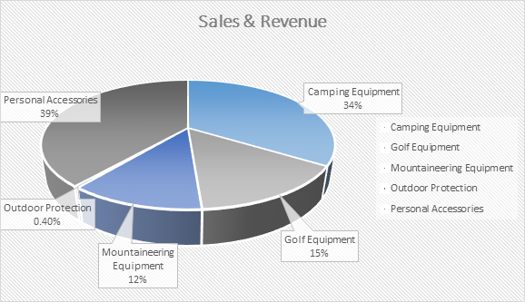

*Contribution to Bottom-line*

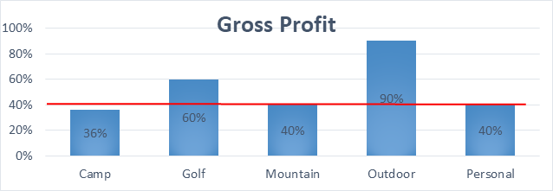

2.Overview

Great Outdoors have the following functional requirements:

* Order Management
* Change Revenue Mix
* Return Management
* Retail Store Inventory

The model followed was an agile model. Agile SDLC model is a combination of iterative and incremental process models with focus on process adaptability and customer satisfaction by rapid delivery of working software product. Agile Methods break the product into small incremental builds. These builds are provided in iterations.

The project had eight sprints to undergo. Every sprint had incremental learning. The first sprint had design and BDD/TDD implementations to display followed by core java and collection implementation in the second sprint. The database was static made through collections to enhance and have a practical knowledge on the collections framework. The third sprint had JDBC implementation in the middle layer. The UI was not yet done so we had a presentation layer in core java itself to test our functionalities. The next sprint bought in the UI and the BDD approach in Angular followed by Cucumber and Selenium testing. The next sprint got the entire user interface ready with Rest services and JPA implemented. Spring Framework was introduced to us in the next sprint with Rest implementation incorporated into Spring because of its feasibility. The last sprint got Spring converted to Spring Boot along with Logger implementation and herein the entire application is ready to serve a shopping site with the major functionalities.

4. Epic & Stories

|  |  |  |  |  |  |
| --- | --- | --- | --- | --- | --- |
| Epic | Stories | | As a/an | I want to | So that .. |
| Product Management System | Add a Product | | Product Master | Enter the product details and Image | A new product is added to the product database |
| Update a Product | | Product Master | Change the details entered for the product | To update the product details or to increase the quantity of a particular product in stock |
| Delete a Product | | Product Master | To delete a product | Product will be soft deleted from the product database |
| Search a Product | | User | To search a product by name or brand name or features | Easy to find a product from the entire stock |
| Filter a Product | | User | To filter a product according to product brand and price range | Easy to find a product according to user preference |
| Add a Product Master | | Admin | To register a product master | To give access to a great outdoor employee to perform the above operation |
| Epic | | Stories | As a/an | I want to | So that .. |
| Address Management System | | Add an Address | Retailer | Enter an address details to add Address | A new Address is added to the address database |
| Update an Address | Retailer | To update an Address | To update the address details in address section |
| Delete an Address | Retailer | To delete an Address | address will be deleted from the address database |
| Epic | | Stories | As a/an | I want to | So that .. |
| Wishlist Management System | | Add Product to wishlist | Retailer/ Sales Representative | Add product in my wishlist by clicking on heart | Product can be added into my wishlist |
| View WishList | Retailer/ Sales Representative | View my Wishlist | I can see products in my Wishlist |

|  |  |  |  |  |  |  |  |  |
| --- | --- | --- | --- | --- | --- | --- | --- | --- |
| Epic | Stories | | As a/an | | I want to | | So that .. | |
| Cancel Management System | Cancel an Order | | Retailer | | Cancel an order which is not yet dispatched. | | An order is cancelled. | |
| Cancel a Product | | Retailer | | Cancel a product which is not yet dispatched. | | A product is cancelled. | |
|  | |  | |  | |  | | . | |

|  |  |  |  |  |
| --- | --- | --- | --- | --- |
| Epic | Stories | As a/an | I want to | So that .. |
| Cart Management System | Add an Item to cart | Retailer | |  | | --- | | Enter the product and quantity as a retailer | | The products are added to the cart |
|  | Place order | Retailer | He/she can  Place an order | Order should placed to cart |
|  | Remove product | Retailer | Can remove order | Order should remove |
|  | Get product  By UserId and  ProductId | Retailer | Can see Product |  |
|  | Update quantity | Retailer | Can update  quantity | Quantity can update |
|  | Get Orders by OrderId | Retailer | Can see orders by order Id |  |
|  | Cancel Order | Retailer | Cancel Order by OrderId |  |
|  | Cancel Order by OrderId and ProductId | Retailer | Can cancel an order by using orderId and productId |  |
|  | Get All orders by UserId | Retailer | Can see all orders by userId |  |

|  |  |  |  |  |
| --- | --- | --- | --- | --- |
| Epic | Stories | As a/an | I want to | So that .. |
| Retailer Inventory Management System | View Inventory | Retailer | View Retailer Inventory | Can see inventory |
| Item wise Delivery Report | Retailer | Gets an Item wise Delivery Report | Can see item wise delivery reports |

Use Case Diagram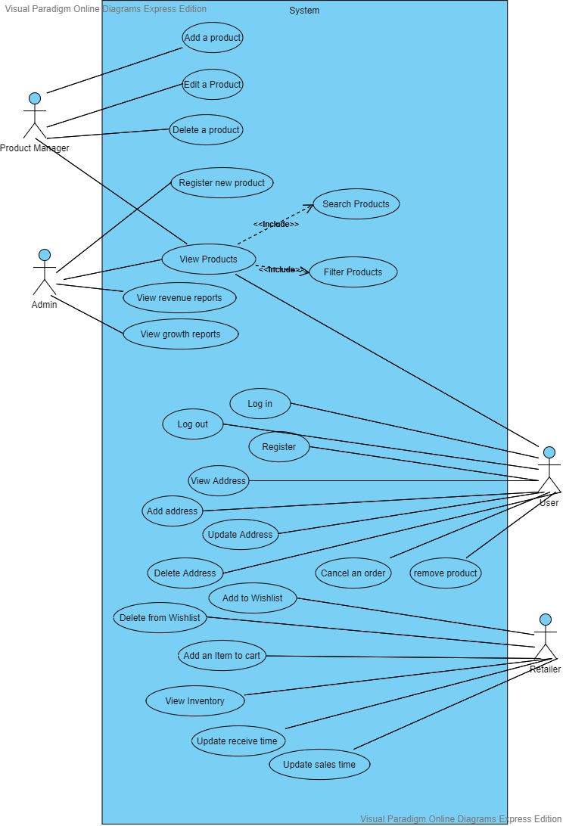

5.1 Product Management System

Overview

Product is one of the most important aspects of any e-commerce website. Great Outdoors follows a Business to Business model. Great Outdoor is currently focusing on 5 categories of products like camping, mountaineering, outdoors, personal and golf. Our main aim is to make a user friendly product management system where operations can be performed with one click. We tried to improvise the update option in such a way that the update form will be pre field with the data of the product such that the user has to only update the field user wants. Our Software is also made highly secured using authentication guard of angular. Product Management System can only be accessed with proper credentials of a product master.

Prerequisite

User must be logged in as product master to perform the add product, edit product and delete product functionalities.

User must be logged in as admin to add product master.

Filter Product, Search Product and view Product functionalities can be performed by any user.

Non Functional Requirement:

All modules are show designed that the result will be obtained within 10 seconds of request. Proper Loading indicator has been instantiated. Hence once a request been asked no one can further request anything. Authentication has been given a higher priority. All form validations are properly maintained. To make it more user friendly proper alert messages are shown wherever required. For instance if someone click on any other tab while filling up a form, our software will show a pop up alert – “all the data will be discarded” before navigation to the clicked tab. Pop message will also be shown during any action like delete add or edit product. Any changes in database will only be performed if user gives a confirmation to those pop up warnings.

Product Management Data Flow Diagram Level 0

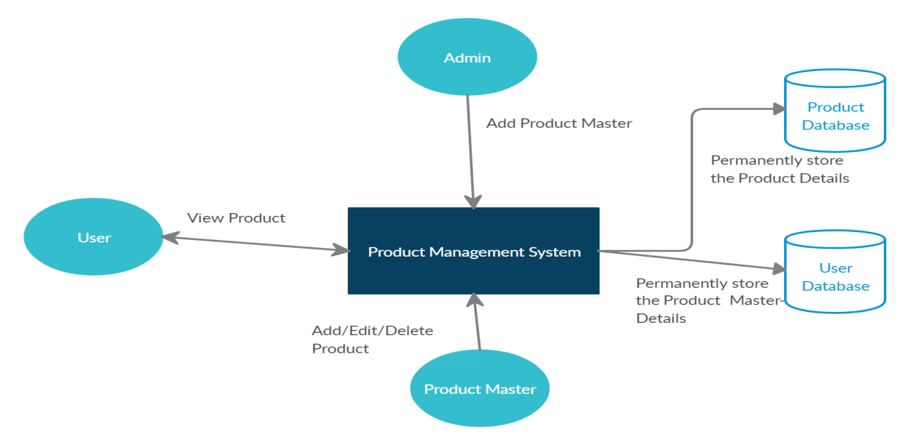

Class Diagram for Product Management

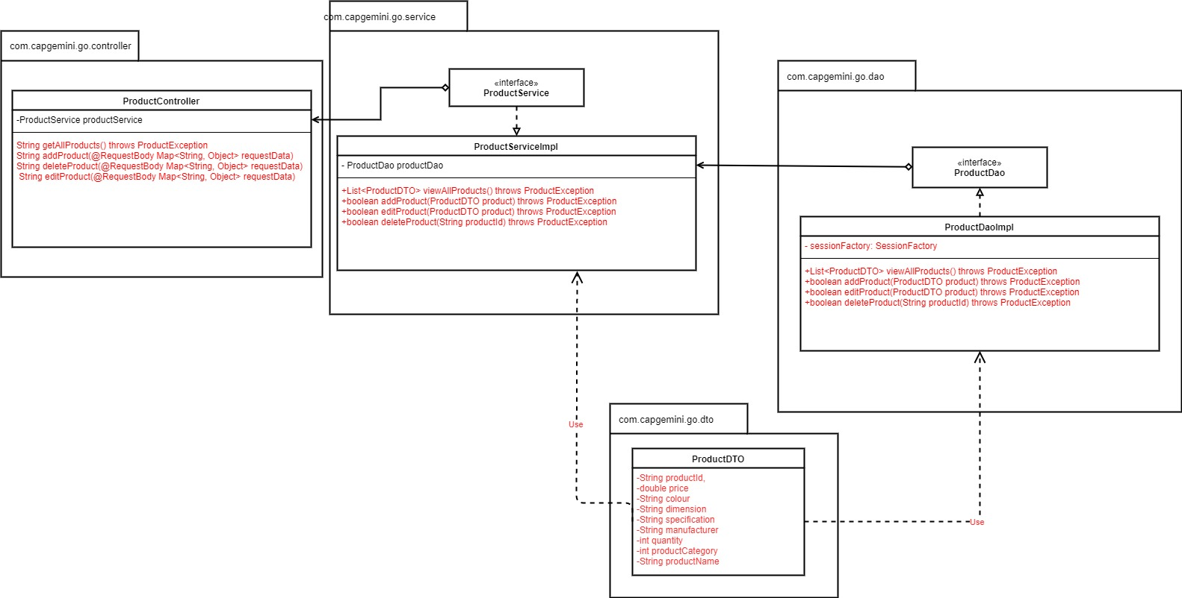

a) Add a Product

This module has been designed to add a product in the database. This can be only accessed by Product Master. The form is designed with proper validation.

Validation:

Product Id: product id should be alphanumeric and must start with an alphabet

Images: Should be in .jpg format

All fields are required.

Sequence Diagram for Adding a Product

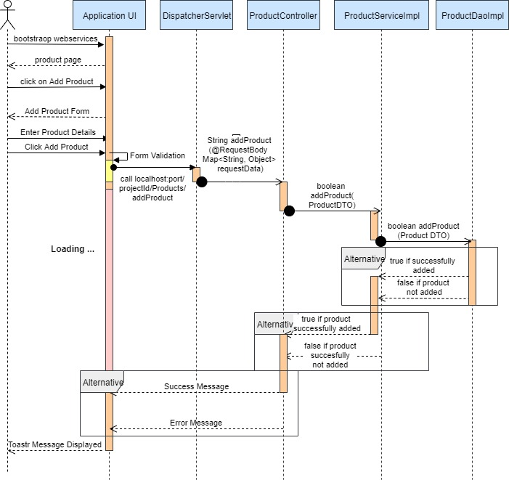

* 1. Edit a Product

It has been observed that during manual entry for a product any individual can often make mistakes in entering data. Hence there should always be a scope to update the data which has been once entered. Thus it is our client requirement to introduce an edit option. Hence we have implemented an user friendly edit option for our product management system. Just on clicking an edit icon over a particular product the edit form will pop up. Now we gather from user review that if they have to refill the entire product form then there might be a chance of making more mistakes. It may happen that on correcting a particular data user have entered some wrong data for other fields. Hence our software is designed in such a way that on clicking the edit option, the form will be already prefilled with data. User has to only make changes where it requires. Moreover we have been restricted to make any further changes in the product ID field otherwise it will be treated as a completely new product. On changing the quantity filed it will be treated as the no of new items we want to add for that particular product.

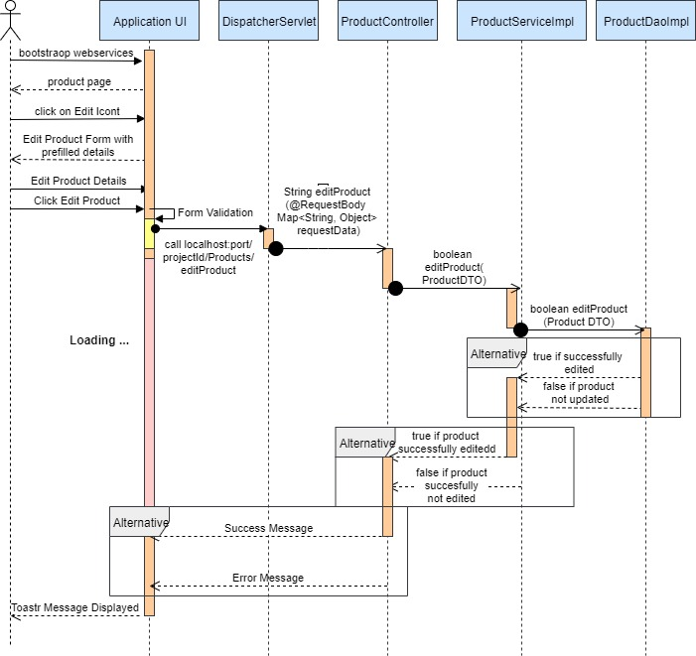

Sequence Diagram for Editing a Product

* 1. Delete a Product

User/ Product Master needs to click a button to delete a product. A confirmation warning will pop up. On clicking on the confirm message the product will be deleted. It has been found through several researches that there can be nothing more important than data. Hence no one wants to lose any data which has been one generated. Thus we have implemented soft delete operation for deleting a product. It will only change the product present status as false and will not show up in product page. However it will be always recorded in the database.

Sequence Diagram for Deleting a Product

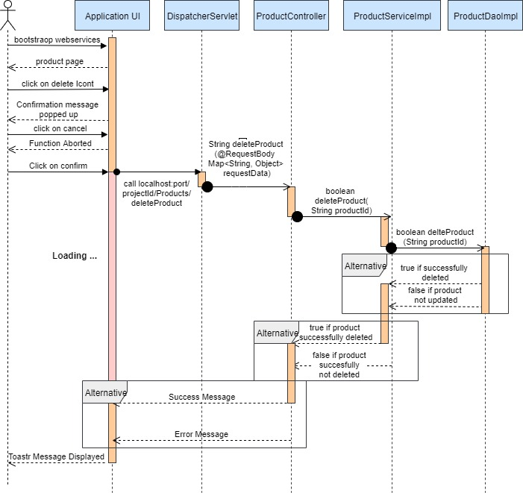

* 1. Add a Product Master

We have extended the functionality of registering a user to implement this module. It is very similar to registering a regular user. Only difference lies in role mapping. We have defined a user category field in user database where it has been mapped to a product master category. Our registration function has been well designed show that the password entered is properly encrypted. We have also designed an user friendly registration form with several validations.

**User Id:** Should be alphanumeric and must starts with a letter

**Password :** Should contains at least one small letter, one capital letter, one digit, one special character like @,#,! and must be at least 8 characters long.

**Re-enter Password :** Should match with the previous password to prevent any mistype.

**Phone Number and email :** email should be in proper email format and phone number must be 10 digits long

* 1. Search a Product (Implemented in Front End)

The entire model has been designed in such a way that we can enter any keyword related to the product to find the product. Keyword such as brand name, product name or description feature can be used. The entire functionality has been designed in Angular.

f) Filter Product (Implemented in Front End)

We have provided a toggled filter button which open ups to a filter bar. Many customers are brand specific as well as everyone has a specific budget during shopping. Thus, we provide a filter option with price range and brand . We have also provided an additional sort feature which will sort the product by price. Normally product will be sorted by name.

5.2 Address Management System

Overview

Addresses provide a means of physically locating a building. They are used in identifying buildings as the end points of a [postal system](https://en.wikipedia.org/wiki/Mail). Great Outdoors follows a Business to Business model. Address Management system is very user friendly, where retailer can add new address and also the same retailer can add new addresses to existing retailer account. For unique identity we are creating individual address identity for individual address. Retailer can also update the existing address and also delete the address from its account. Our Software is also made highly secured using authentication guard of angular. Address Management System can only be accessed with proper credentials of a retailer.

Prerequisite

User must be logged in as retailer to perform the add address, update address and delete address functionalities.

Non Functional Requirement:

All modules are show designed that the result will be obtained within 10 seconds of request. Proper Loading indicator has been instantiated. Hence once a request been asked no one can further request anything. Authentication has been given a higher priority. All form validations are properly maintained. To make it more user-friendly proper alert messages are shown wherever required. For instance if someone click on any other tab while filling up a form, our software will show a pop up alert – “all the data will be discarded” before navigation to the clicked tab. Pop message will also be shown during any action like delete add or edit product. Any changes in database will only be performed if user gives a confirmation to those pop-up warnings.

Class Diagram for Product Management

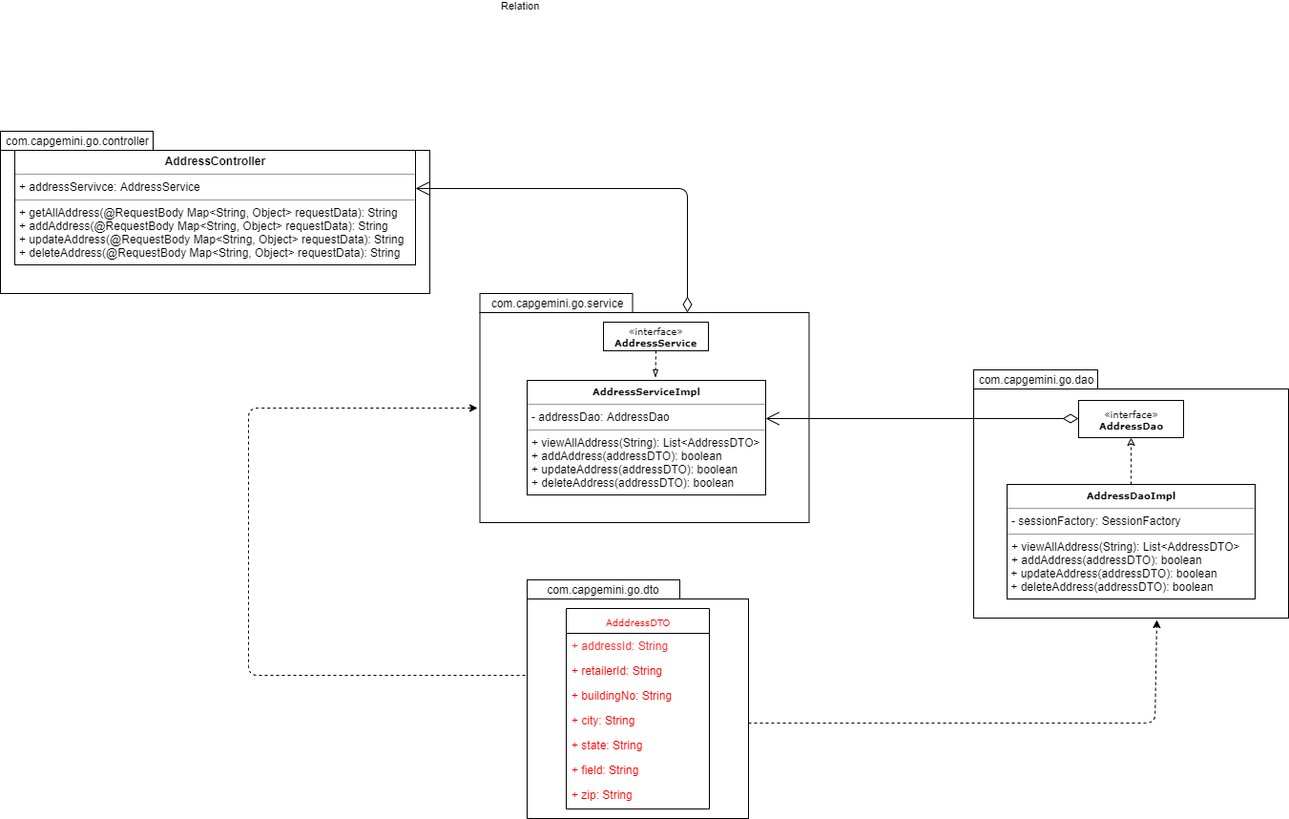

a) Add an Address

This module has been designed to add a address in the database. This can be only accessed by Retailer. The form is designed with proper validation. The address ID is being generated automatically by our system so that each address have their own unique identity.

Validation:

City: city name should be correct

State: state name should be correct

Country: country name should be correct

All fields are required.

Sequence Diagram for Adding an Address

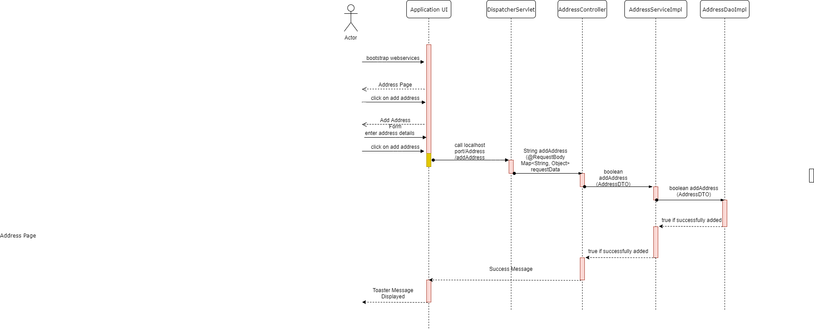

b) Update an Address

There should always be a scope to update the data which has been once entered. Thus, it is our client requirement to introduce an update option. Hence, we have implemented an user friendly update option for our address management system. Just on clicking an update icon over a particular address the update form will pop up. Hence our software is designed in such a way that on clicking the update option, the form will be already prefilled with data. User has to only make changes where it requires. More over we have been restricted to make any further changes in the address ID field.

Sequence Diagram for Updating an Address

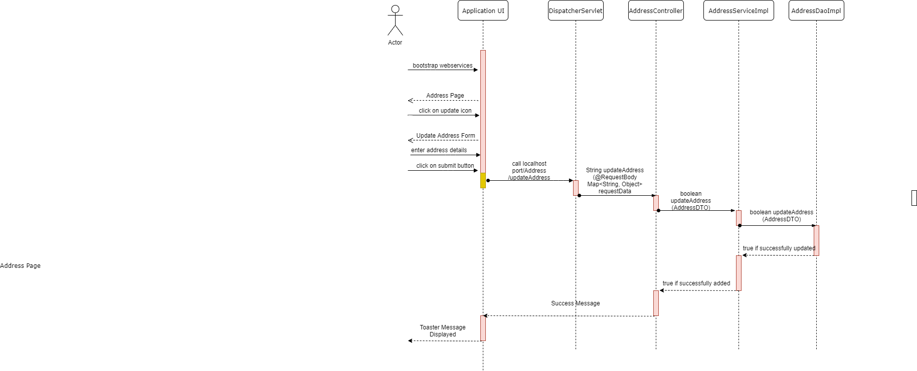

c) Delete an Address

User needs to click a button to delete an Address. A confirmation warning will pop up. On clicking on the confirm message the address will be deleted.

Sequence Diagram for Deleting an Address

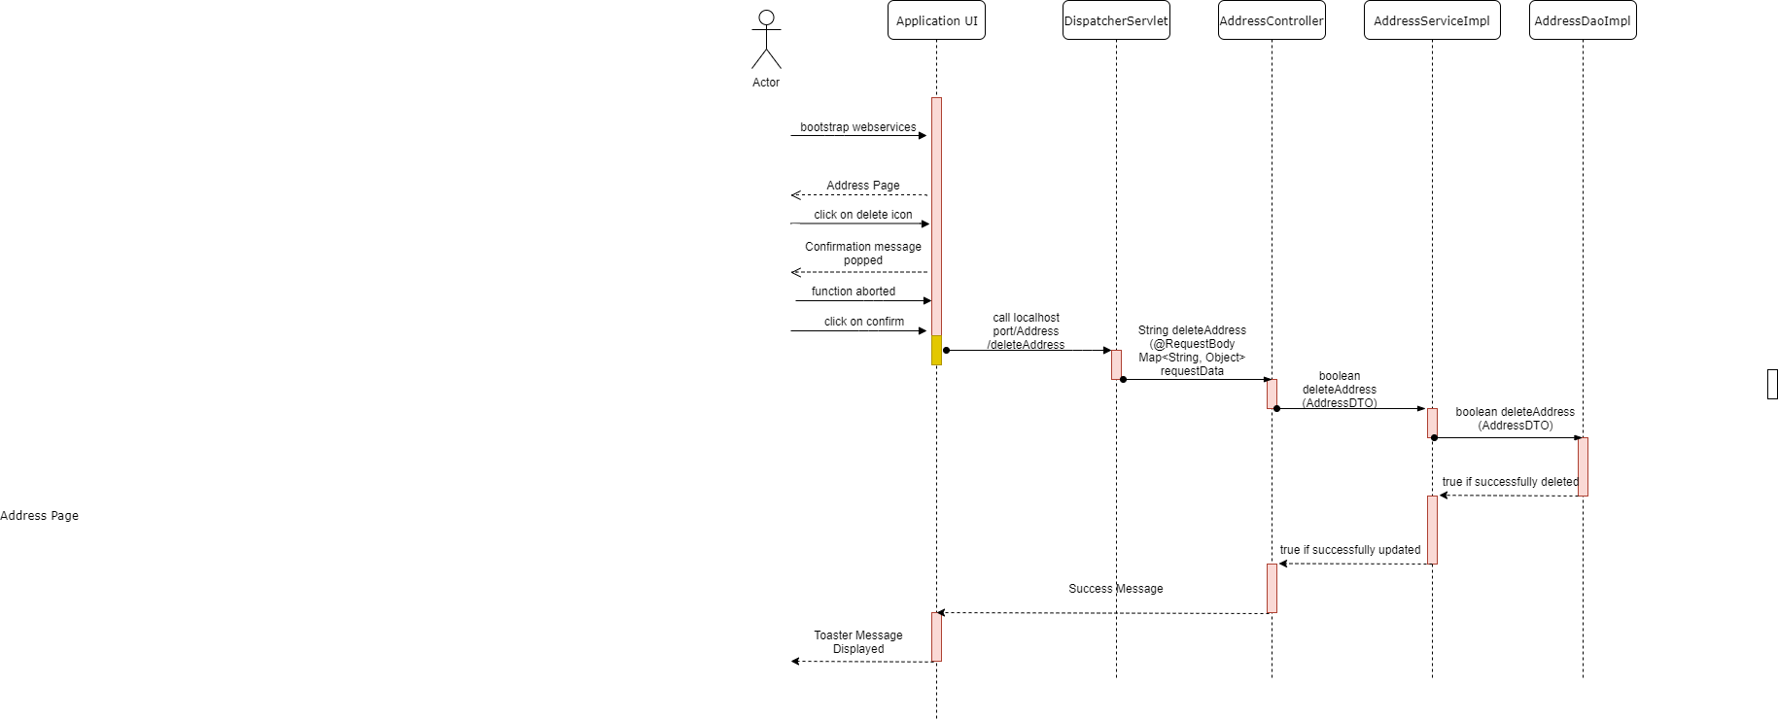

5.3 User Management System

Overview

User management is one of the main aspects for any application. Registering a new user, Logging-In as different roles of user and Logging-out comes under this system. Our Software is made highly secured using authentication guard of angular. Also, Authorization is used to ensure that different types of users can access different types of functionality i.e. Role Mapping.

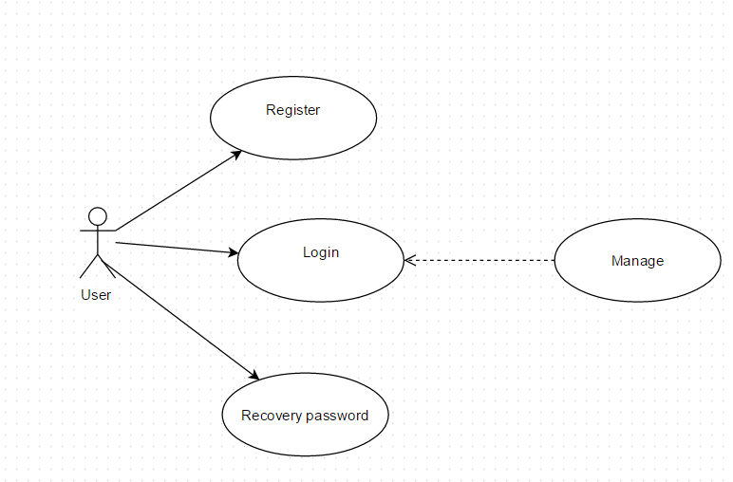

* 1. User Registration

Registration functionality is user to Register a New User to the Great Outdoors database. Only Sales-Representative and Retailer can register directly from this functionality . We have to select the user category in the drop-down menu from where it will be mapped to different category roles. Our registration function has been well designed show that the password entered is properly encrypted. We have also designed an user friendly registration form with several validations.

**User Id:** Should be alphanumeric and must starts with a letter

**Password :** Should contains at least one small letter, one capital letter, one digit, one special character like @,#,! and must be at least 8 characters long.

**Re-enter Password :** Should match with the previous password to prevent any mistype.

**Phone Number and email :** email should be in proper email format and phone number must be 10 digits long.

*\*All fields are required.*

Sequence Diagram for User Registration

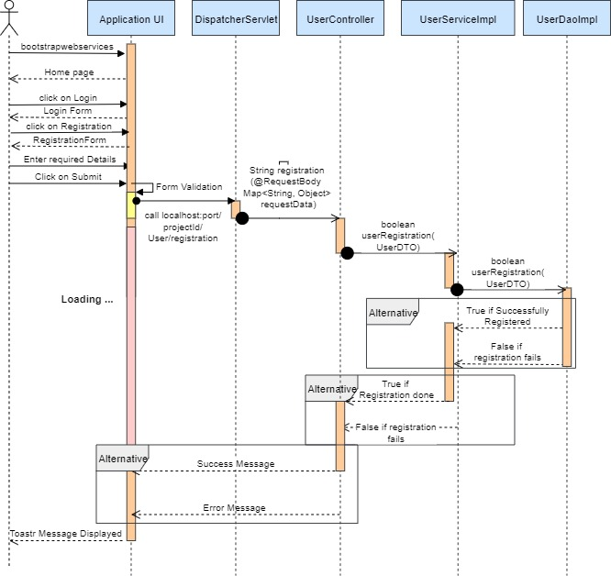

b) User Login

This module has been designed to Log-In an existing user. Any type of user can Log-in from this functionality. The form is designed with proper validation.

***Validation***:

**Password :** Should contains at least one small letter, one capital letter, one digit, one special character like @,#,! and must be at least 8 characters long.

*\*All fields are required.*

Sequence Diagram for User Login

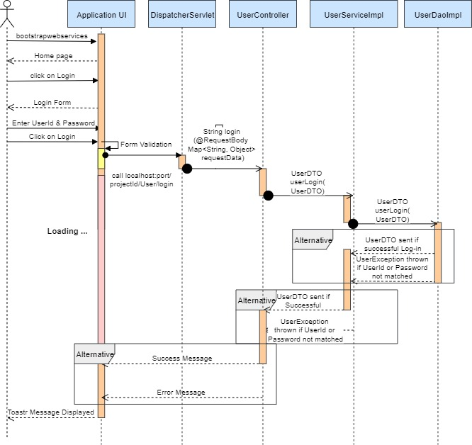

b) User Logout

This module has been designed to Log-Out an already logged-in user.

***Pre-Requisite***:

User should already be logged-in.

Sequence Diagram for User Logout

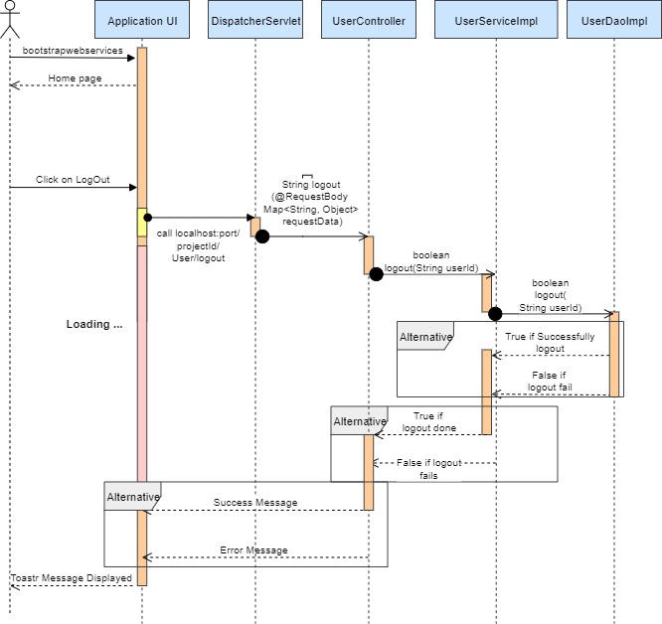

5.4 Wishlist Management System

Overview

Wishlist management is one of the unique features of this application. This feature can be used by either **retailer** (who is the key customer of our services) and **sales representative** (who makes online entry of all offline orders). This feature enables user to build a list of their favourite products and keep it separately. Every user can have their different list of products. To make it simple we have given option to our user to add their favourites in their wish list by just clicking in heart icon on the product while on home page.

Use Case Diagram for Wishlist Management System

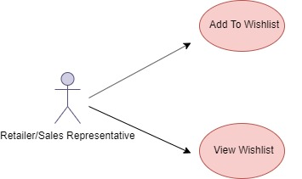

a) Add Product to Wishlist

This function is used by user to add the product in their Wishlist.

***Pre-Requisite***:

User should already be logged-in and on home page.

Sequence Diagram

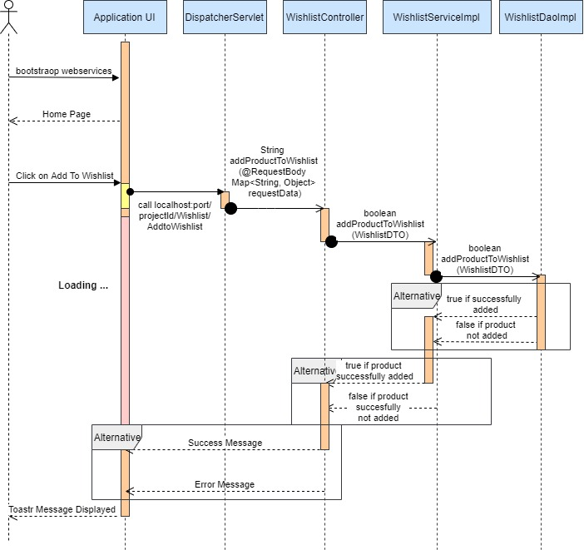

b) View Wishlist

This module has been designed to view Wishlist of user.

***Pre-Requisite***:

User should already be logged-in and clicks on Wishlist on navbar.

Sequence Diagram

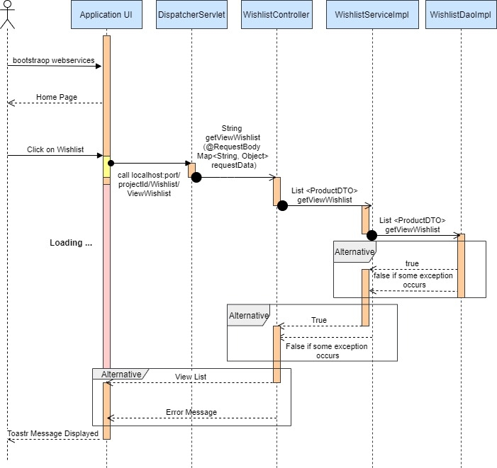

5.5) Retailer Add Item to Cart System

Overview

In an e-commerce site, a retailer or a customer chooses different products to place order for. For that, he needs to add the products to his cart. So, cart plays a very important role for placing the order in the e-commerce sites. We have tried to make the process of adding the item to cart an easier one so that the customer doesn’t find any difficulties or complexities in adding the item to the cart. The product will be added to the cart only when the credential of the retailer is correct.

Prerequisite

User must be logged in as retailer to perform the add item to cart functionality. He/she has to give his/her correct credential to add the item into the cart.

Use Case Diagram for Add Item to Cart System

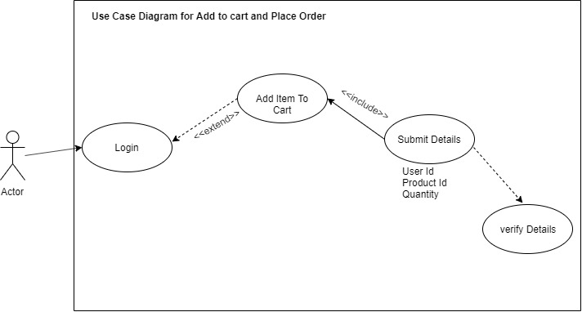

Sequence Diagram for Adding Item to cart

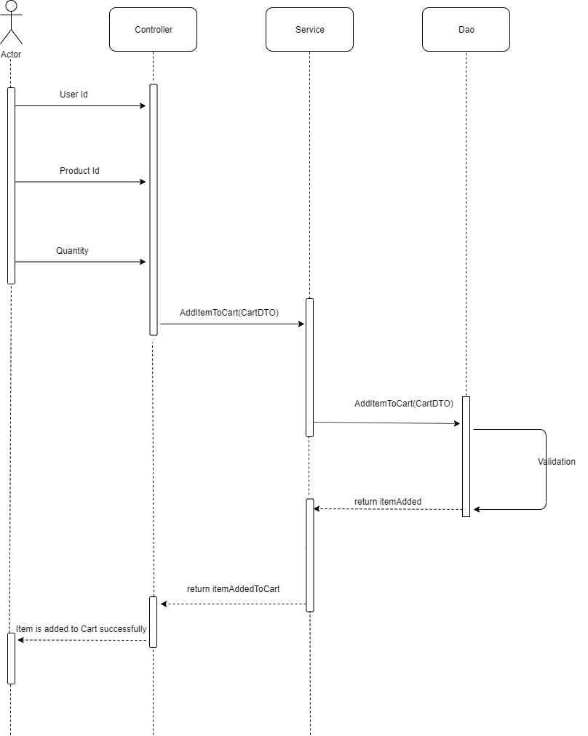

Class Diagram for Adding Item to cart

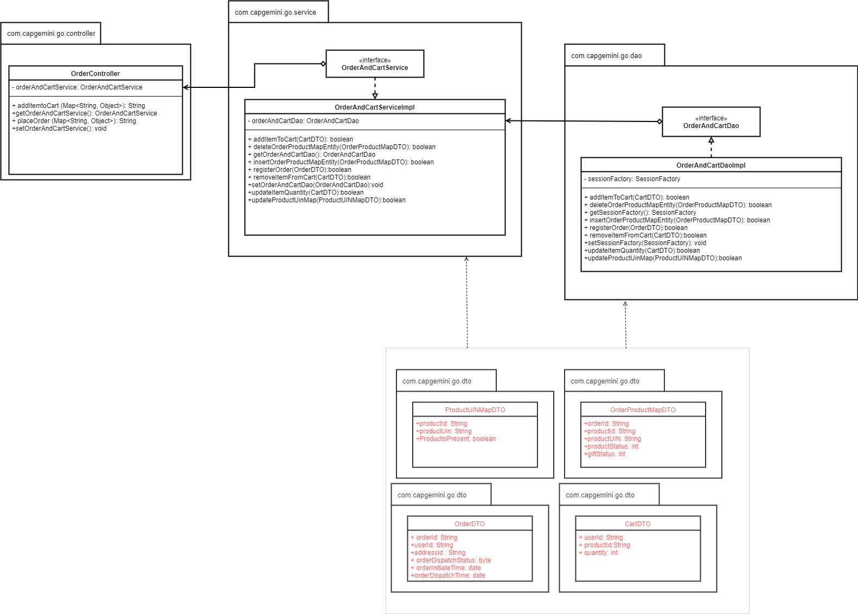

a) View Revenue Reports

This function is used by admin to view Revenue Reports of various users and products within a particular period.

***Pre-Requisite***:

Admin should already be logged-in and reports page.

Sequence Diagram

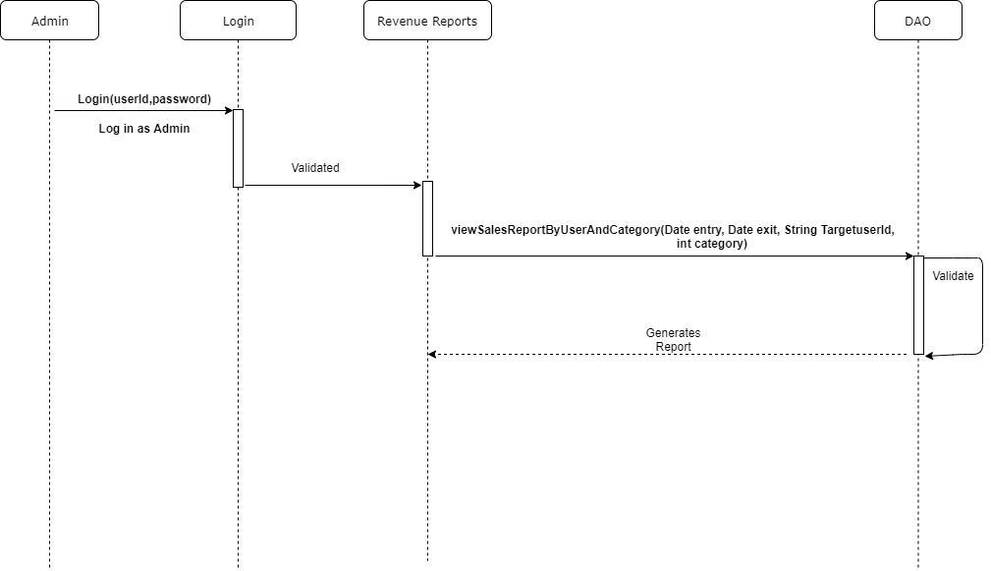

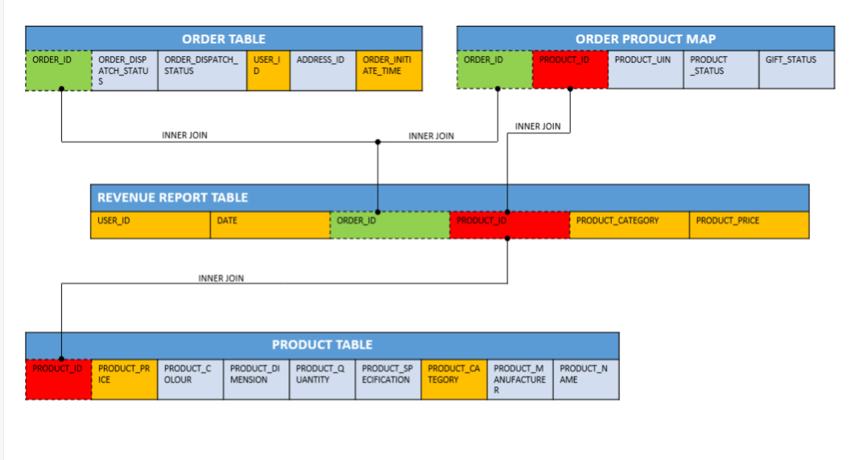

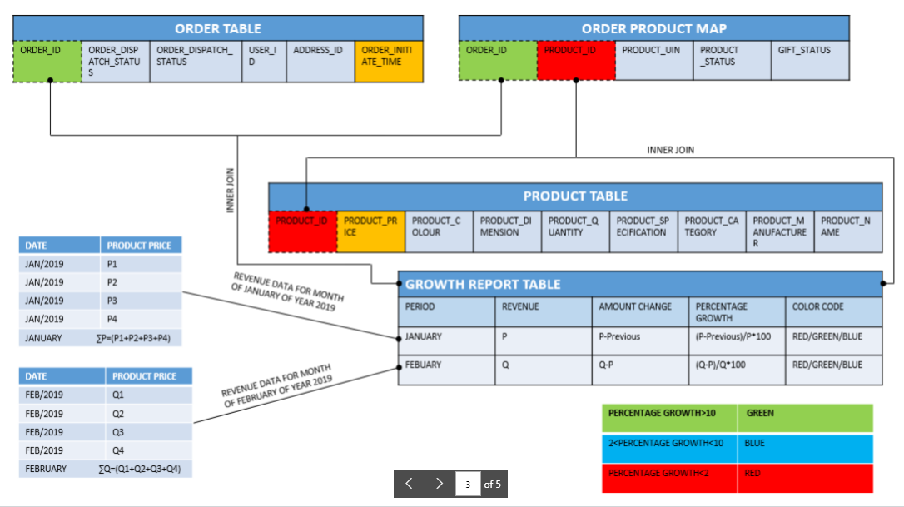

Class Diagram for retailer inventory:

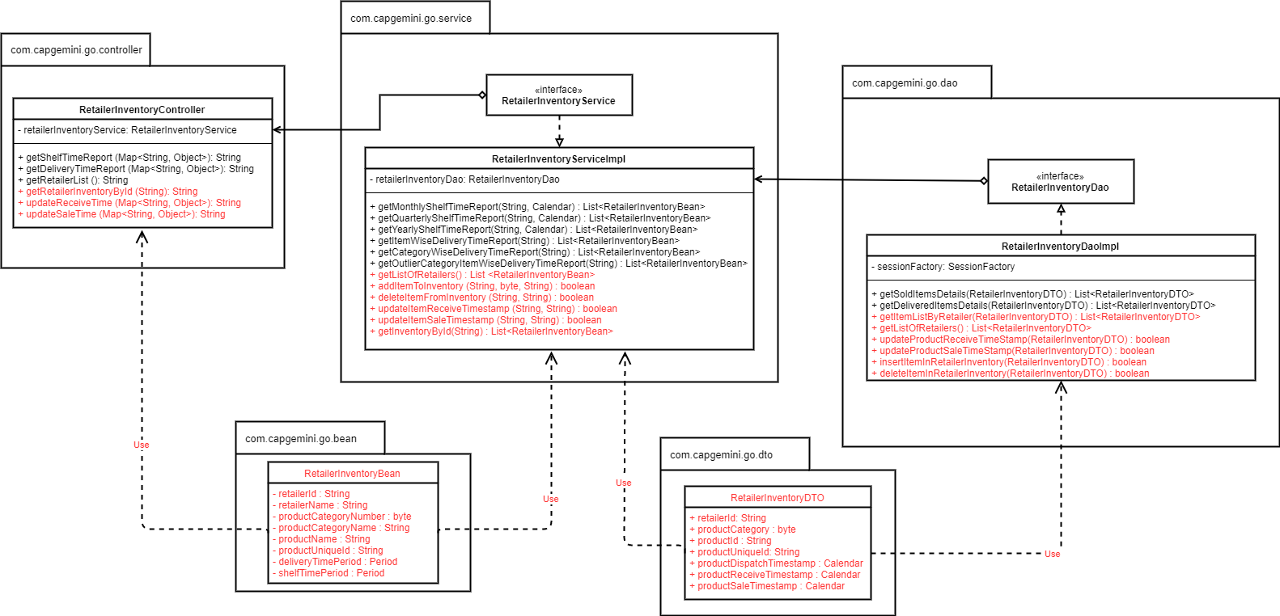

10. System Requirements

Below is a list of the minimum Hardware and Software requirements to access Great Outdoors website.

**Operating System:**

* Windows 7 and above.
* Mac OSX 10.8, 10.9, 10.10 or 10.11
* Android 3 and onwards.

**Hardware:**

* Processor (CPU) with 2 gigahertz (GHz) frequency or above
* A minimum of 4 GB of RAM
* Monitor Resolution 1024 X 768 or higher (For better view)
* A minimum of 5 GB of available space on the hard disk
* Internet Connection Broadband (high-speed) Internet connection with a speed of 2 Mbps or higher
* Keyboard and a Mouse or some other compatible pointing device

**Browsers:**

* Chrome* 58+

*.*

**Browser Configuration:**

Your browser must be configured as follows:

* **Strongly Recommended--**add [www.greatoutdoors.com](http://www.greatoutdoors.com/) to trusted sites.
* JavaScript must be enabled
* CORS must be configured properly
* Cookies must be enabled.
* Pop-up windows must be enabled.

**Software:**

* Java — to view and interact with all available blackboard applications.
* Eclipse — Eclipse workbench was used to run JDK (write, compile and run the code).
* Visual Studio Code — for writing codes for frontend using angular, VS Code was used as a workbench.
* Apache Tomcat — it was used as a server for hosting the website.