**Name: Shivani Moun**

**Email id:** [**shivanimoun34@gmail.com**](mailto:shivanimoun34@gmail.com)

**SET A**

**In the given dataset we had certain questions to answer I have majorly tried to solve with the better effects of visualizations and sql queries.**

1. Which is the movie(s) with the smallest runtime? Which is the movie(s) with the highest runtime?

Solution -

SELECT movie

From movie_dataset

Where (select min(runtime) from movie_dataset);

SELECT movie

From movie_dataset

Where (select max(runtime) from movie_dataset);

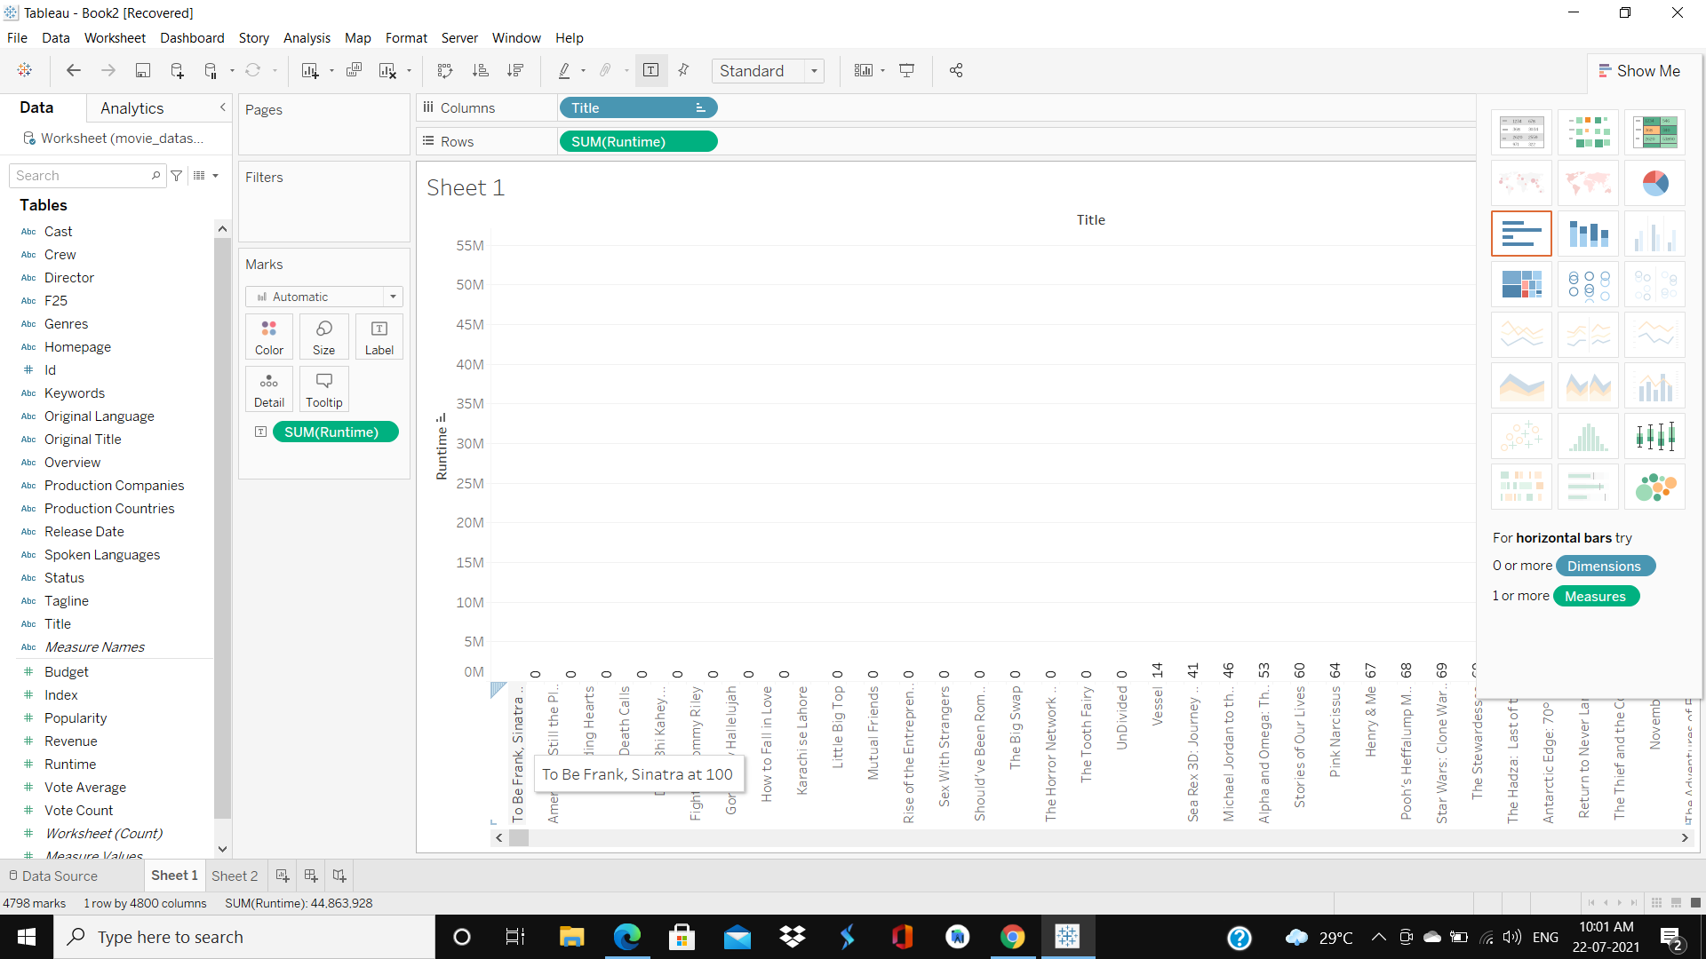

The movies having smallest runtime are total 18 consisting America is still place, to be frank simmatra at 100, death calls and so on.

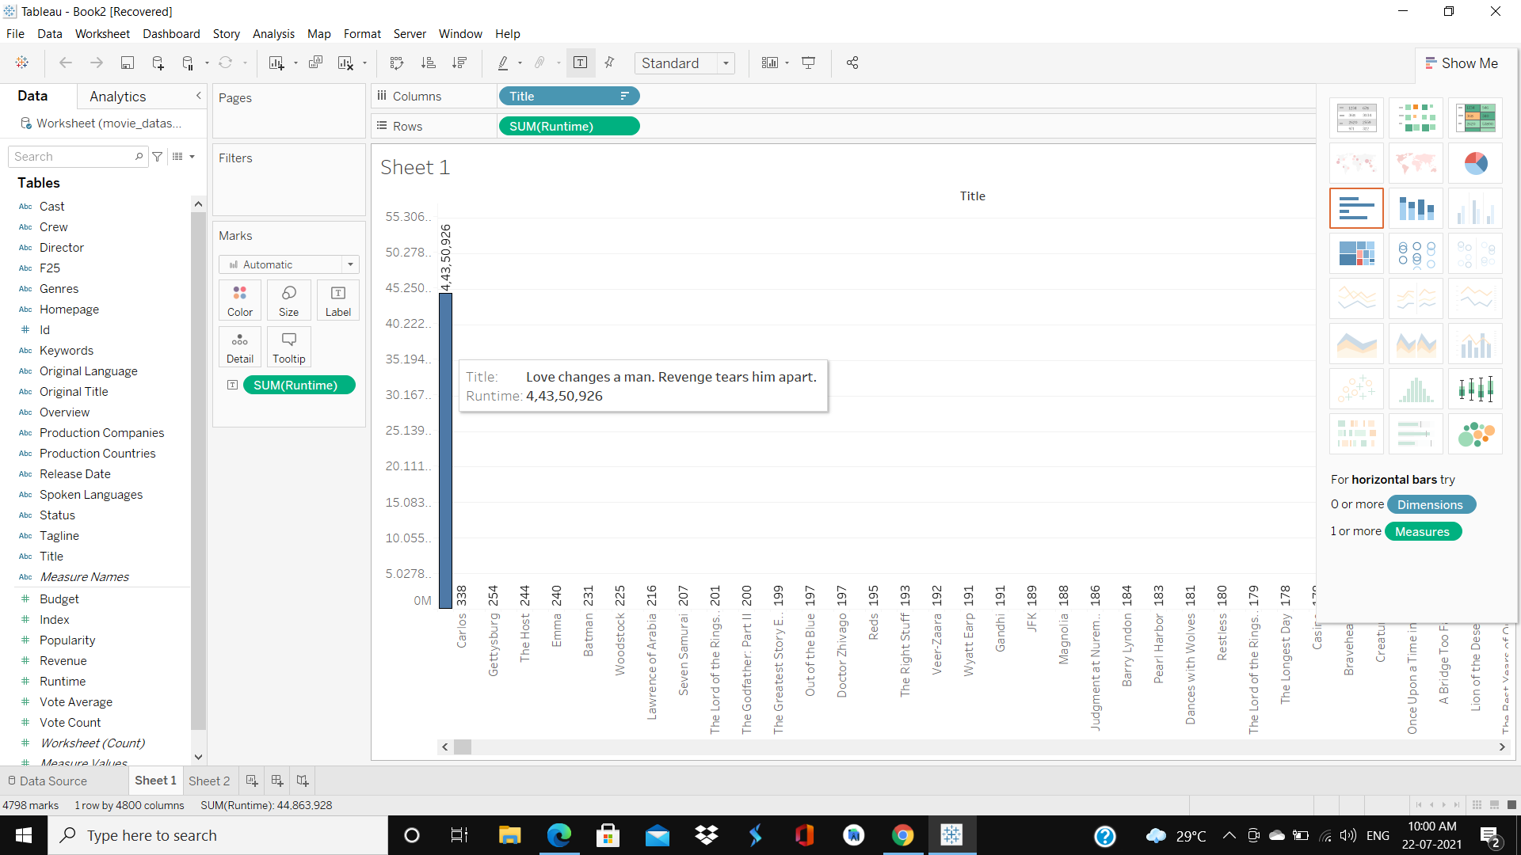

There's a movie having highest run time is ‘love changes a man and revenge tears him apart’ with 44350926 minutes runtime.

**2. Take the top 5 production houses (by budget) and list their top 5 most popular movies, their revenue and vote_average**

**Solution-**

Select movie_title ,revenue, vote_average

From movie_dataset

Limit 5

Where (select production_companies having max(budget) from movie_dataset limit 5);

**3. List the production house for every year from 2000-2016 which has released the greatest number of movies in that year**

**Solution -**  select distinct(production_companies)

From movie_dataset

Where (select max(movies_title) From movie_dataset where release_date between 1-1-2000

And 31-12-2016);

**4. You are going to invest all your life's savings in a production company. You have two choices "Marvel Studios" and "DC Comics". Which company would you bet on? This is an open-ended question. Define your own metrics to measure which one is a better investment opportunity and defend your analysis.**

**Solution-**

To measure the better investment opportunities, we need certain parameters to analyze on their histories.

1. Easiest way, we can compare the revenue collection earned by moves of the respective production houses
2. Runtime of the movies of the respective production houses can also give a measure to analyze.
3. Frequency of the releases made in the past year by the production house.
4. Last but not least we can use popularity attribute to analyze the better investment option.

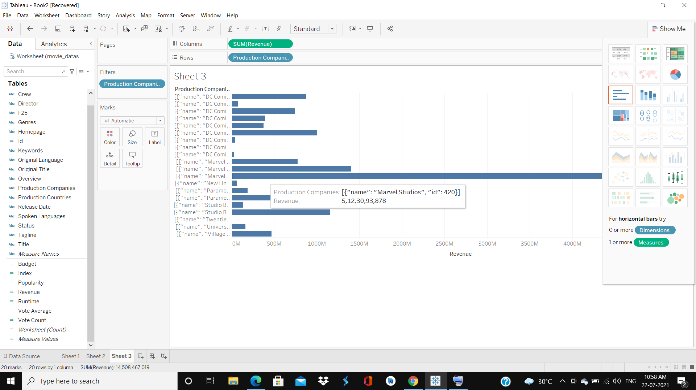

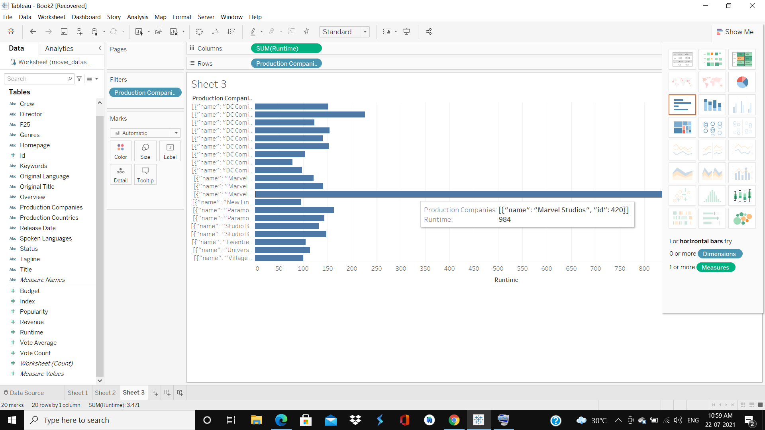

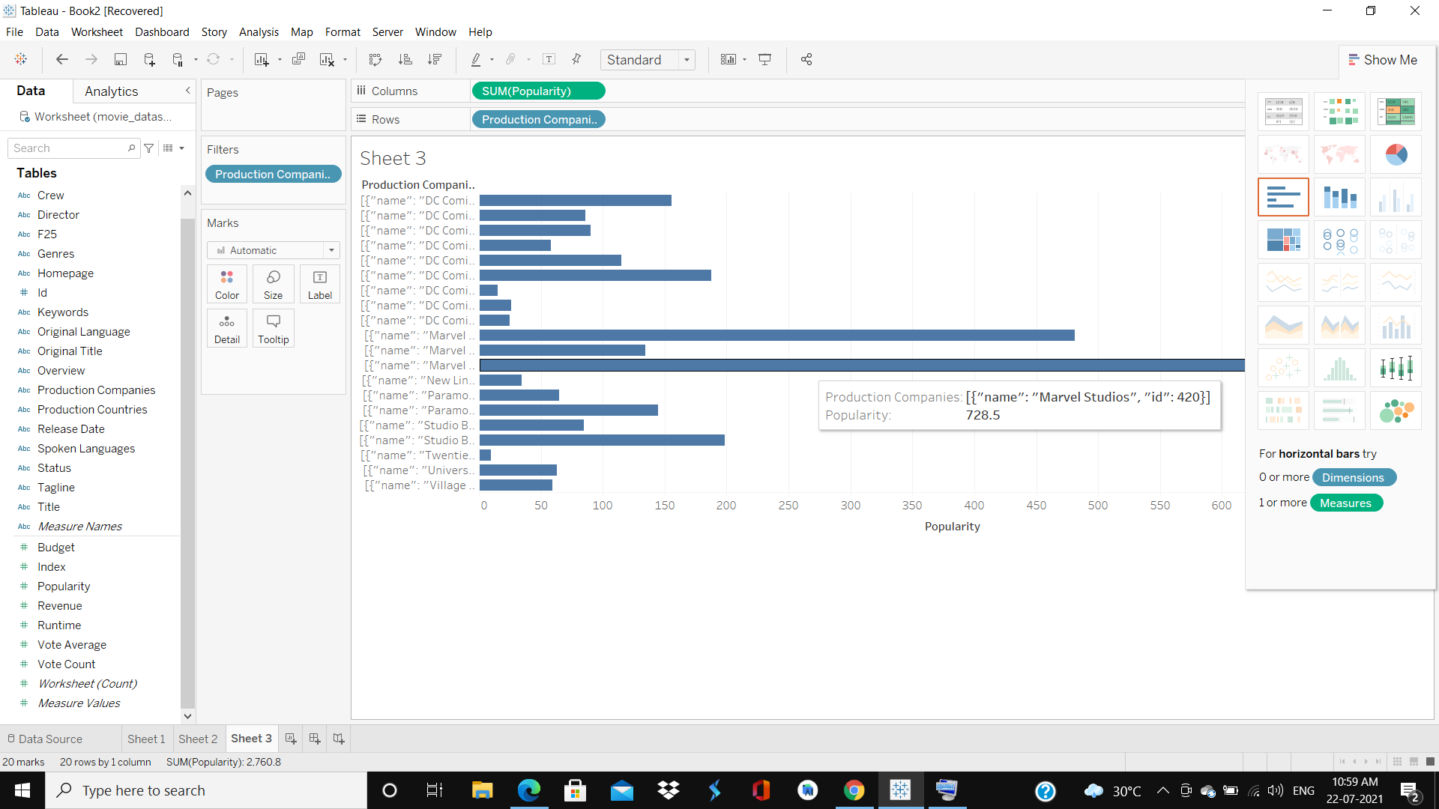

After analyzing all the above parameters, we came on the conclusion that marvel studios will be better option to invest if we consider revenue, popularity and runtime as a major concern.

**Set 2**

**---W**hen the concern about the architecture of e-commerce site comes to the role, I would like to suggest the 3-tier architecture where three parts of the business that run on the different parts of the architecture (client-side server-side and the database side) it basically implies that the user interface runs on the client side while database data is stored on the server side. Practically, we can say there are three layers to work upon including presentation layer, business layer, and data layer which are independent and can run on different servers. Because sometimes having two major tiers is not enough for the system to function well. Therefore, there is a need to have three tiers.

Schemas: -

For this project we can go for the three relations one campaign management having attributes manager_id, manager_name and campaign_id. Here manager_Id would be unique every time thus, we can consider it as a primary key well as campaign id will also remain unique as different campaign mangers handle different campaigns at a time it can also be declared as a primary key if manager id not. And then the same would act as a candidate key in the further relations.

**CAMPAIGN_MANAGEMENT**

|  |  |  |
| --- | --- | --- |
| **manager_id** | **manager_name** | **campaign_id** |
|  |  |  |
|  |  |  |

Another relation will be including product details having attribute named as product_id, product_category, campaign_id where campaign id will be treated as the candidate key for the product relation.

**Product**

|  |  |  |  |
| --- | --- | --- | --- |
| **product_id** | **product_category** | **campaign_id** | **Manager_id** |
|  |  |  |  |

And the final relation would be consisting the relation named as offer which will be having all the details of the offer and having attributes as start time, end time discount, type of the discount

**Offer:**

|  |  |  |  |  |
| --- | --- | --- | --- | --- |
| **Camapaign_id** | **Start_date** | **End_date** | **Discount type** | **Total discount** |
| Black_friday |  |  | Credit card |  |
| End_of_season |  |  | Coupon code |  |
| Etc. |  |  | Etc. |  |

After doing all the data stuff we have certain important things to implement the feature of the discounts. Hence, we will think about more possible ways for which the campaign manager will decide the conditions and type of discount with the final amount of discount he wants to provide. While creating this we should keep some restrictions for example the quantity of the stuff, usage restrictions or restricting the number of times a coupon can be used, adding an expiry date to the coupons

And then finally we are ready to display them on our page. We will calculate ethe total bill after deducting the discounted price of the item.

For the display purpose we can continue with the same language in which the page was built in and add certain buttons for some use like one to avail the offer and the code for that offer, quantity of the product etc.

**Thank you.**