**Course Enrollment System**

The Course Enrollment System is designed to facilitate efficient course management and enrollment processes within educational institutions. Utilizing MongoDB, the system's database schema comprises several collections that collectively support the platform's functionality, ensuring a streamlined experience for administrators, instructors, and students.

**Admin Collection**

The admin collection stores information about the system administrators. Each document in this collection includes a unique _id, the administrator's name, and their password. This collection is crucial for managing access to the system's backend functionalities, allowing administrators to oversee and manage the overall course enrollment operations.

**Instructor Collection**

The instructor collection maintains records of instructors. Each document contains a unique _id, the instructor's name, email, password, mobile, and a list of courses they teach. This collection ensures that instructors can be easily associated with the courses they manage, facilitating communication and schedule management between the administration and teaching staff.

**Student Collection**

The student collection holds data on the students enrolled in the institution. Each document includes a unique _id, the student's name, email, password, mobile, a list of courses they are enrolled in, fees details, nextDue date for the next payment, and any overdue fees. This collection supports student management, course enrollment tracking, and financial transactions related to course fees.

**Courses Collection**

The courses collection contains detailed information about each course offered. Each document features a unique _id, the name of the course, the instructor responsible, the number of seatsLeft, a description of the course, a list of students enrolled, and a reference to the schedule. This collection is central to the system, enabling the management of course details, availability, and student enrollments.

**Sections Collection**

The Sections collection is crucial for managing the various sections of each course offered. Each section has a unique identifier (id), name of the section, associated course id, number of seats left, list of students enrolled, and the instructor assigned to the section. This collection helps in organizing the different sections of a course, monitoring available seats, and ensuring that each section is staffed with the appropriate instructor and attended by the enrolled students.

**Enrollments Collection**

The Enrollments collection keeps track of the enrollment details for each course. Each enrollment entry includes a unique identifier (id), name of the student, associated course id, student id, and instructor id. This collection is essential for managing and tracking the enrollment of students in various courses, ensuring that students are enrolled in the correct classes with the appropriate instructors.

**Payment Collection**

The payment collection tracks all financial transactions related to course enrollments. Each document comprises a unique _id, the student making the payment, the course for which the payment is made, the payDate, amount paid, card number, cvv, expDate, and the cardHolderName. This collection is vital for handling fee payments, ensuring secure and accurate financial records within the system.

Overall, these collections work together to support a comprehensive and efficient Course Enrollment System, ensuring seamless interactions between administrators, instructors, and students.

**Database Model**

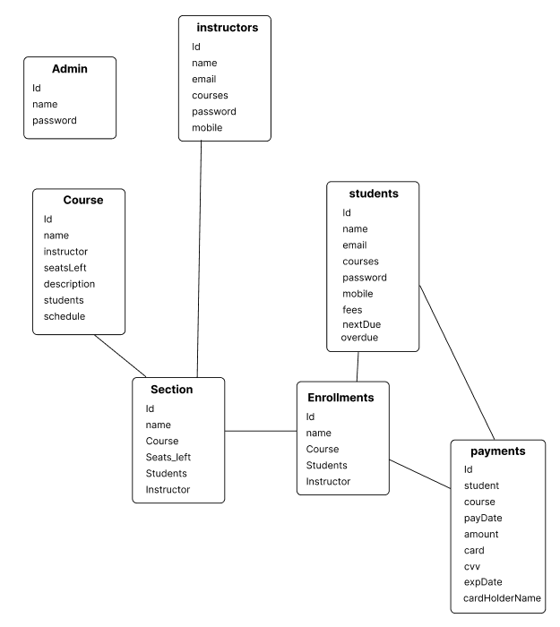

**Sample Data**

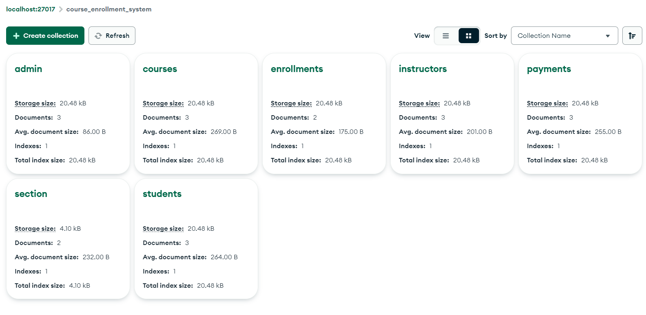

**Admin Collection**

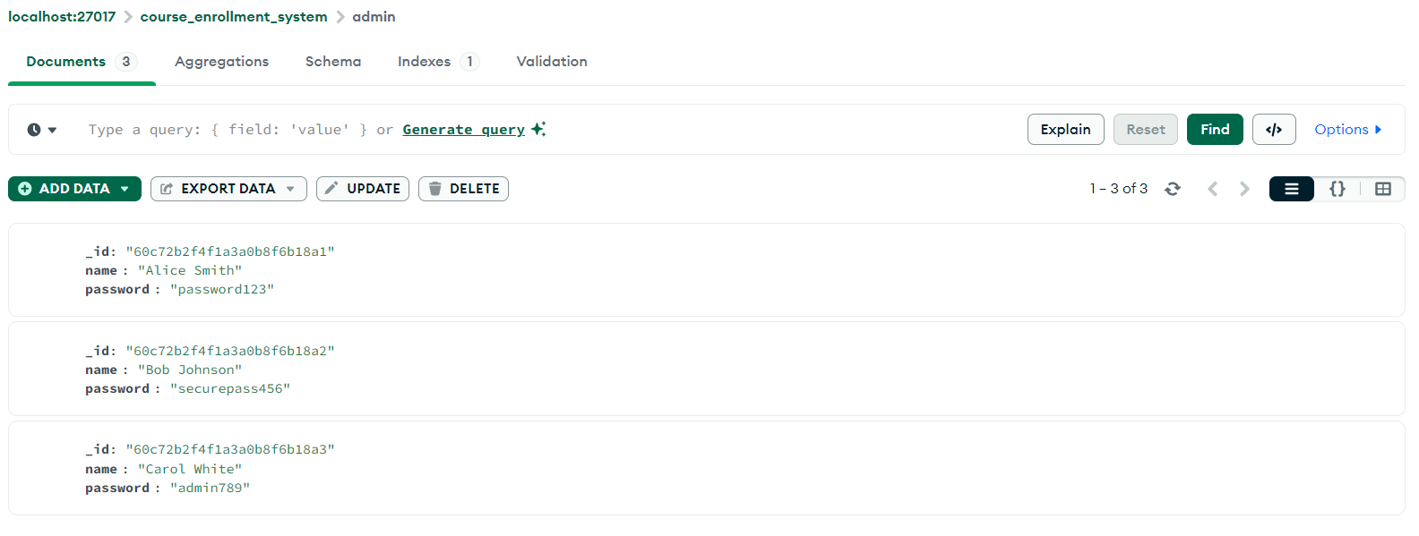

**Course Collection**

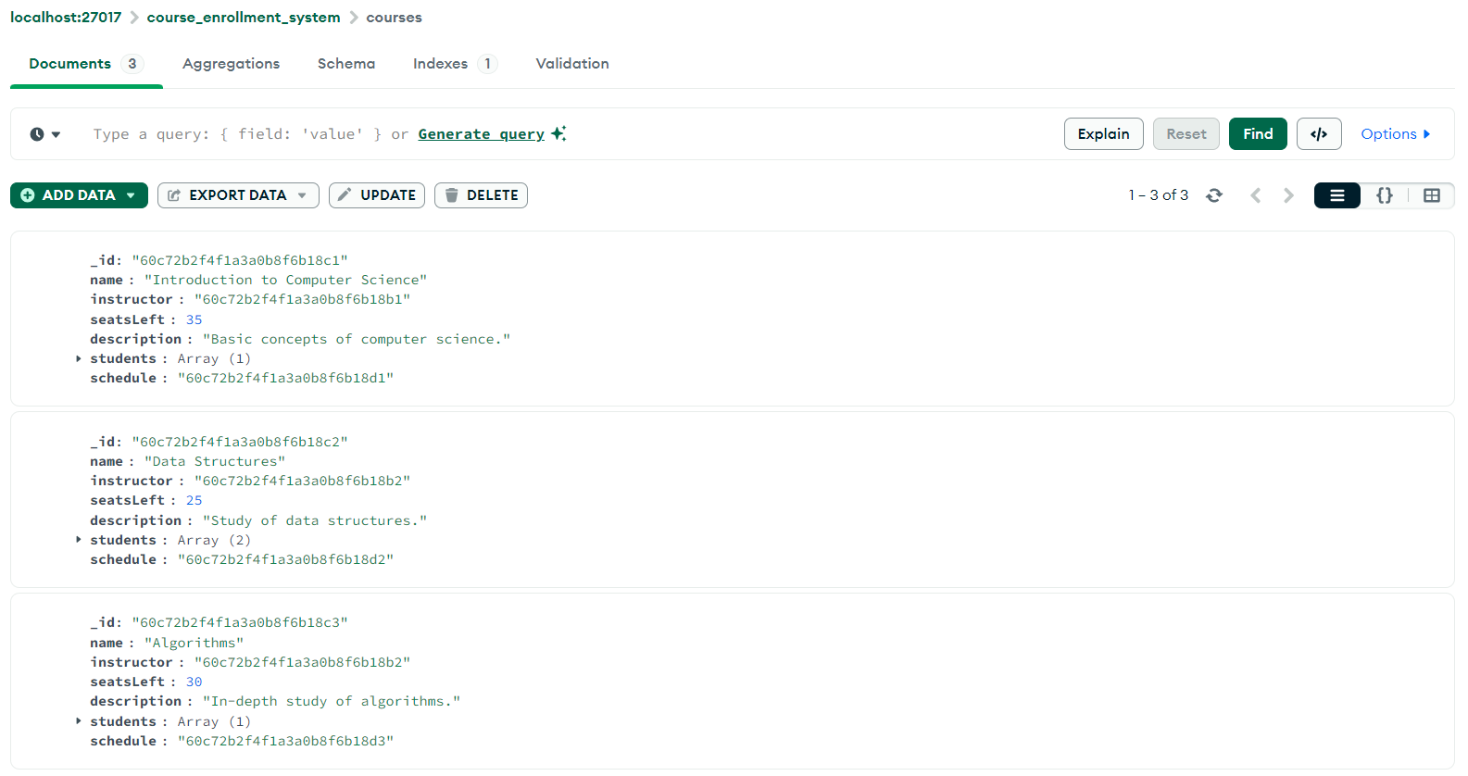

**Instructor Collection**

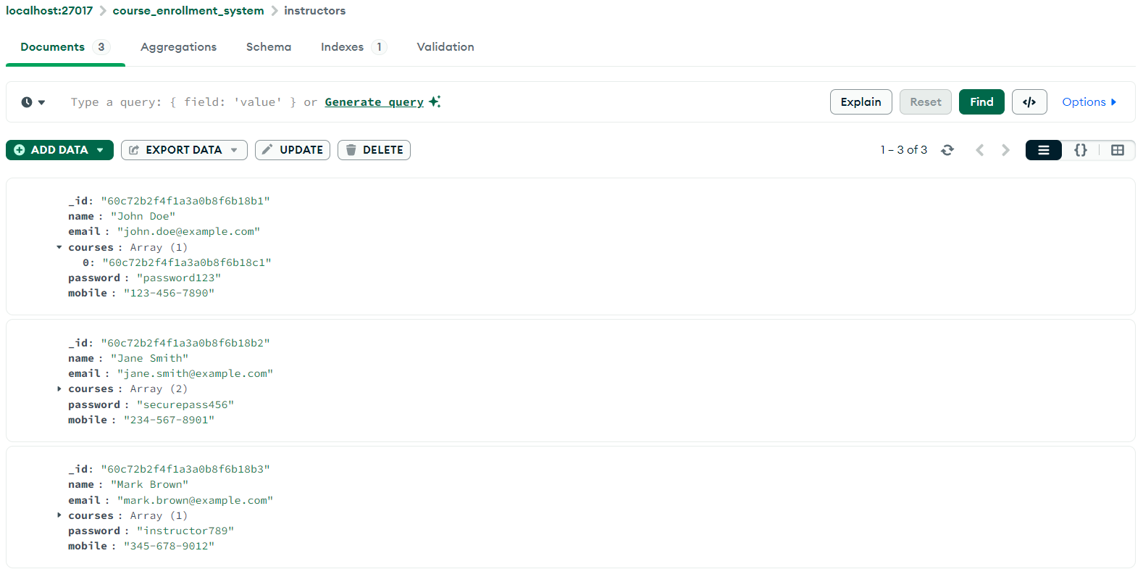

**Payment Collection**

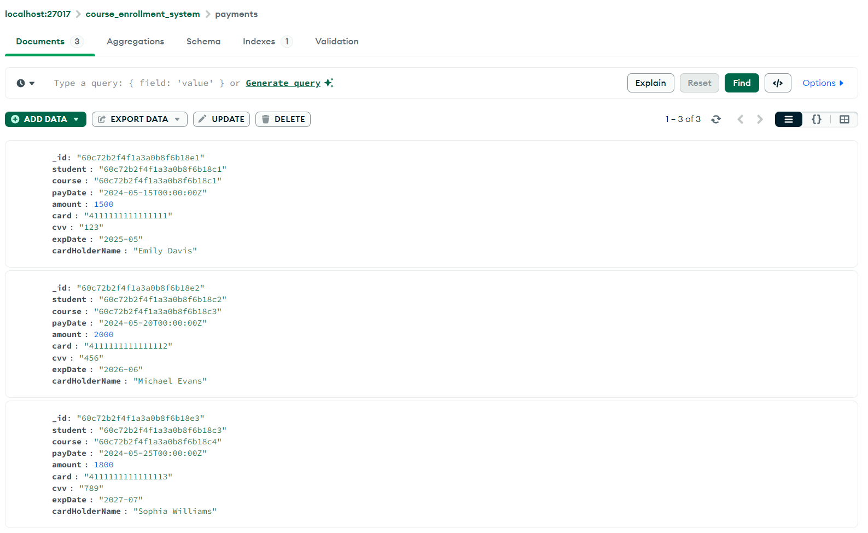

**Section Collection  
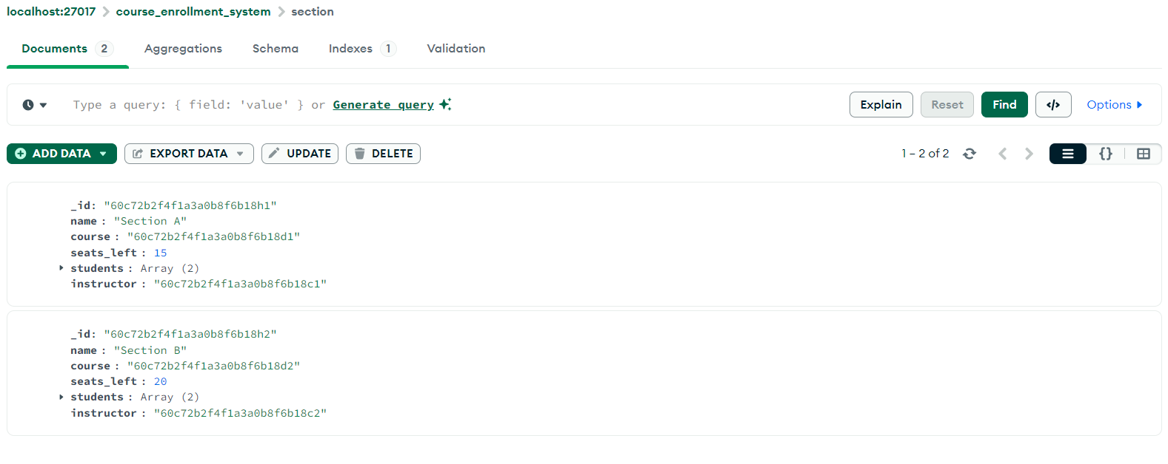**

**Enrollment Collection**

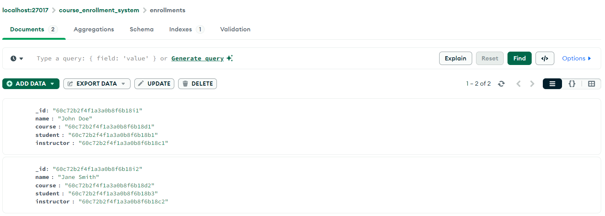

**Students Collection  
