ASSIGNMENT 4 FML

Shivani Haridas Pitla

2022-11-06

library(tidyverse)

## Warning: package 'tidyverse' was built under R version 4.2.2

## ── Attaching packages ─────────────────────────────────────── tidyverse 1.3.2 ──  
## ✔ ggplot2 3.3.6 ✔ purrr 0.3.4   
## ✔ tibble 3.1.8 ✔ dplyr 1.0.10  
## ✔ tidyr 1.2.0 ✔ stringr 1.4.1   
## ✔ readr 2.1.2 ✔ forcats 0.5.2   
## ── Conflicts ────────────────────────────────────────── tidyverse_conflicts() ──  
## ✖ dplyr::filter() masks stats::filter()  
## ✖ dplyr::lag() masks stats::lag()

library(ggplot2)  
library(factoextra)

## Warning: package 'factoextra' was built under R version 4.2.2

## Welcome! Want to learn more? See two factoextra-related books at https://goo.gl/ve3WBa

library(ISLR)  
library(gridExtra)

##   
## Attaching package: 'gridExtra'  
##   
## The following object is masked from 'package:dplyr':  
##   
## combine

library(cluster)  
library(dplyr)

PHARMACEUTICALS=read.csv("C:/Users/shiva/Downloads/Pharmaceuticals.csv")

#a. Use only the numerical variables (1 to 9) to cluster the 21 firms. Justify the various choices made in conducting the cluster analysis, such as weights for different variables, the specific clustering algorithm(s) used, the number of clusters formed, and so on.   
  
#choosing the numerical variables and removing the Null Values from the dataset.  
colSums(is.na(PHARMACEUTICALS))

## Symbol Name Market_Cap   
## 0 0 0   
## Beta PE_Ratio ROE   
## 0 0 0   
## ROA Asset_Turnover Leverage   
## 0 0 0   
## Rev_Growth Net_Profit_Margin Median_Recommendation   
## 0 0 0   
## Location Exchange   
## 0 0

row.names(PHARMACEUTICALS)<- PHARMACEUTICALS[,1]  
PHARMACEUTICALS1<- PHARMACEUTICALS[, 3:11]  
head(PHARMACEUTICALS1)

## Market_Cap Beta PE_Ratio ROE ROA Asset_Turnover Leverage Rev_Growth  
## ABT 68.44 0.32 24.7 26.4 11.8 0.7 0.42 7.54  
## AGN 7.58 0.41 82.5 12.9 5.5 0.9 0.60 9.16  
## AHM 6.30 0.46 20.7 14.9 7.8 0.9 0.27 7.05  
## AZN 67.63 0.52 21.5 27.4 15.4 0.9 0.00 15.00  
## AVE 47.16 0.32 20.1 21.8 7.5 0.6 0.34 26.81  
## BAY 16.90 1.11 27.9 3.9 1.4 0.6 0.00 -3.17  
## Net_Profit_Margin  
## ABT 16.1  
## AGN 5.5  
## AHM 11.2  
## AZN 18.0  
## AVE 12.9  
## BAY 2.6

# Scaling and Normalisation the dataset(PARMACEUTICALS).  
PHARMACEUTICALS_SCALE <- scale(PHARMACEUTICALS1)  
head(PHARMACEUTICALS_SCALE)

## Market_Cap Beta PE_Ratio ROE ROA Asset_Turnover  
## ABT 0.1840960 -0.80125356 -0.04671323 0.04009035 0.2416121 0.0000000  
## AGN -0.8544181 -0.45070513 3.49706911 -0.85483986 -0.9422871 0.9225312  
## AHM -0.8762600 -0.25595600 -0.29195768 -0.72225761 -0.5100700 0.9225312  
## AZN 0.1702742 -0.02225704 -0.24290879 0.10638147 0.9181259 0.9225312  
## AVE -0.1790256 -0.80125356 -0.32874435 -0.26484883 -0.5664461 -0.4612656  
## BAY -0.6953818 2.27578267 0.14948233 -1.45146000 -1.7127612 -0.4612656  
## Leverage Rev_Growth Net_Profit_Margin  
## ABT -0.2120979 -0.5277675 0.06168225  
## AGN 0.0182843 -0.3811391 -1.55366706  
## AHM -0.4040831 -0.5721181 -0.68503583  
## AZN -0.7496565 0.1474473 0.35122600  
## AVE -0.3144900 1.2163867 -0.42597037  
## BAY -0.7496565 -1.4971443 -1.99560225

# Using several values of K, computing K-means clustering for various centers, and comparing the results  
kmeans.1 <- kmeans(PHARMACEUTICALS_SCALE, centers = 2, nstart = 25)  
kmeans.2<- kmeans(PHARMACEUTICALS_SCALE, centers = 5, nstart = 25)  
kmeans.3<- kmeans(PHARMACEUTICALS_SCALE, centers = 6, nstart = 25)  
Plot.1<-fviz_cluster(kmeans.1, data = PHARMACEUTICALS_SCALE)+ggtitle("k=2")  
plot.2<-fviz_cluster(kmeans.2, data = PHARMACEUTICALS_SCALE)+ggtitle("k=5")  
plot.3<-fviz_cluster(kmeans.3, data = PHARMACEUTICALS_SCALE)+ggtitle("k=6")  
grid.arrange(Plot.1,plot.2,plot.3, nrow = 3)

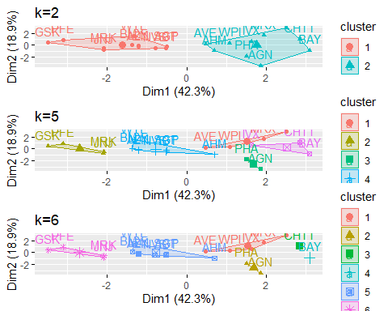

distance<- dist(PHARMACEUTICALS_SCALE, method = "euclidean")  
fviz_dist(distance)

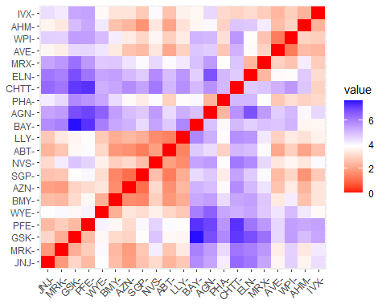

Aggregate.data<-kmeans(PHARMACEUTICALS_SCALE,5)  
aggregate(PHARMACEUTICALS_SCALE, by=list(Aggregate.data$cluster), FUN=mean)

## Group.1 Market_Cap Beta PE_Ratio ROE ROA  
## 1 1 -0.8705151 1.34098686 -0.05284434 -0.6184015 -1.19284783  
## 2 2 -0.4392513 -0.47018004 2.70002464 -0.8349525 -0.92349509  
## 3 3 -0.1799275 -0.81238208 -0.22714308 -0.3387161 -0.04563784  
## 4 4 0.9547543 -0.06120687 -0.35764816 1.0818081 1.10336187  
## 5 5 -0.9668697 1.51626107 -0.57398880 -0.8382671 -0.98926727  
## Asset_Turnover Leverage Rev_Growth Net_Profit_Margin  
## 1 -0.4612656 1.3664470 -0.69129140 -1.3200002  
## 2 0.2306328 -0.1417034 -0.11684587 -1.4165148  
## 3 -0.1976853 -0.4168821 -0.14141325 0.1923035  
## 4 0.8566361 -0.2797499 -0.01818848 0.7082574  
## 5 -1.8450624 0.5302448 1.71238901 0.2445520

aggregate_Data1 <- data.frame(PHARMACEUTICALS_SCALE, Aggregate.data$cluster)  
aggregate_Data1

## Market_Cap Beta PE_Ratio ROE ROA Asset_Turnover  
## ABT 0.1840960 -0.80125356 -0.04671323 0.04009035 0.2416121 0.0000000  
## AGN -0.8544181 -0.45070513 3.49706911 -0.85483986 -0.9422871 0.9225312  
## AHM -0.8762600 -0.25595600 -0.29195768 -0.72225761 -0.5100700 0.9225312  
## AZN 0.1702742 -0.02225704 -0.24290879 0.10638147 0.9181259 0.9225312  
## AVE -0.1790256 -0.80125356 -0.32874435 -0.26484883 -0.5664461 -0.4612656  
## BAY -0.6953818 2.27578267 0.14948233 -1.45146000 -1.7127612 -0.4612656  
## BMY -0.1078688 -0.10015669 -0.70887325 0.59693581 0.8617498 0.9225312  
## CHTT -0.9767669 1.26308721 0.03299122 -0.11237924 -1.1677918 -0.4612656  
## ELN -0.9704532 2.15893320 -1.34037772 -0.70899938 -1.0174553 -1.8450624  
## LLY 0.2762415 -1.34655112 0.14948233 0.34502953 0.5610770 -0.4612656  
## GSK 1.0999201 -0.68440408 -0.45749769 2.45971647 1.8389364 1.3837968  
## IVX -0.9393967 0.48409069 -0.34100657 -0.29136529 -0.6979905 -0.4612656  
## JNJ 1.9841758 -0.25595600 0.18013789 0.18593083 1.0872544 0.9225312  
## MRX -0.9632863 0.87358895 0.19240011 -0.96753478 -0.9610792 -1.8450624  
## MRK 1.2782387 -0.25595600 -0.40231769 0.98142435 0.8429577 1.8450624  
## NVS 0.6654710 -1.30760129 -0.23677768 -0.52338423 0.1288598 -0.9225312  
## PFE 2.4199899 0.48409069 -0.11415545 1.31287998 1.6322239 0.4612656  
## PHA -0.0240846 -0.48965495 1.90298017 -0.81506519 -0.9047030 -0.4612656  
## SGP -0.4018812 -0.06120687 -0.40231769 -0.21181593 0.5234929 0.4612656  
## WPI -0.9281345 -1.11285216 -0.43297324 -1.03382590 -0.6979905 -0.9225312  
## WYE -0.1614497 0.40619104 -0.75792214 1.92938746 0.5422849 -0.4612656  
## Leverage Rev_Growth Net_Profit_Margin Aggregate.data.cluster  
## ABT -0.21209793 -0.52776752 0.06168225 3  
## AGN 0.01828430 -0.38113909 -1.55366706 2  
## AHM -0.40408312 -0.57211809 -0.68503583 3  
## AZN -0.74965647 0.14744734 0.35122600 4  
## AVE -0.31449003 1.21638667 -0.42597037 3  
## BAY -0.74965647 -1.49714434 -1.99560225 1  
## BMY -0.02011273 -0.96584257 0.74744375 4  
## CHTT 3.74279705 -0.63276071 -1.24888417 1  
## ELN 0.61983791 1.88617085 -0.36501379 5  
## LLY -0.07130879 -0.64814764 1.17413980 3  
## GSK -0.31449003 0.76926048 0.82363947 4  
## IVX 1.10620040 0.05603085 -0.71551412 1  
## JNJ -0.62166634 -0.36213170 0.33598685 4  
## MRX 0.44065173 1.53860717 0.85411776 5  
## MRK -0.39128411 0.36014907 -0.24310064 4  
## NVS -0.67286239 -1.45369888 1.02174835 3  
## PFE -0.54487226 1.10143723 1.44844440 4  
## PHA -0.30169102 0.14744734 -1.27936246 2  
## SGP -0.74965647 -0.43544591 0.29026942 3  
## WPI -0.49367621 1.43089863 -0.09070919 3  
## WYE 0.68383297 -1.17763919 1.49416183 4

# estimating how many clusters there are  
# To calculate the value of k, the data are scaled using the elbow method.  
fviz_nbclust(PHARMACEUTICALS_SCALE, FUNcluster = kmeans, method = "wss") + labs(subtitle = "Elbow Method")

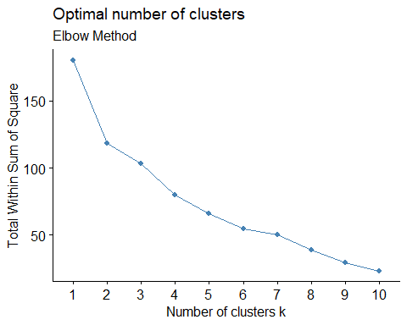

# The number of clusters is calculated by scaling the data using the silhouette method.  
fviz_nbclust(PHARMACEUTICALS_SCALE,FUNcluster = kmeans,method = "silhouette")+labs(subtitle="Silhouette Method")

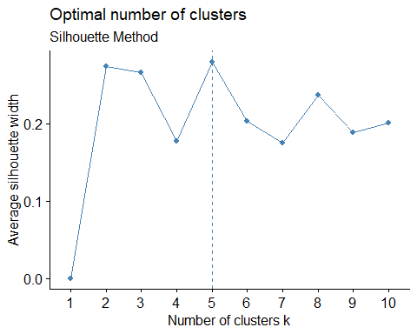

# Final analysis and Extracting results using 5 clusters and Visualize the results  
set.seed(300)  
FINALCLUSTER<- kmeans(PHARMACEUTICALS_SCALE, 5, nstart = 25)  
print(FINALCLUSTER)

## K-means clustering with 5 clusters of sizes 8, 3, 4, 2, 4  
##   
## Cluster means:  
## Market_Cap Beta PE_Ratio ROE ROA Asset_Turnover  
## 1 -0.03142211 -0.4360989 -0.31724852 0.1950459 0.4083915 0.1729746  
## 2 -0.87051511 1.3409869 -0.05284434 -0.6184015 -1.1928478 -0.4612656  
## 3 -0.76022489 0.2796041 -0.47742380 -0.7438022 -0.8107428 -1.2684804  
## 4 -0.43925134 -0.4701800 2.70002464 -0.8349525 -0.9234951 0.2306328  
## 5 1.69558112 -0.1780563 -0.19845823 1.2349879 1.3503431 1.1531640  
## Leverage Rev_Growth Net_Profit_Margin  
## 1 -0.27449312 -0.7041516 0.556954446  
## 2 1.36644699 -0.6912914 -1.320000179  
## 3 0.06308085 1.5180158 -0.006893899  
## 4 -0.14170336 -0.1168459 -1.416514761  
## 5 -0.46807818 0.4671788 0.591242521  
##   
## Clustering vector:  
## ABT AGN AHM AZN AVE BAY BMY CHTT ELN LLY GSK IVX JNJ MRX MRK NVS   
## 1 4 1 1 3 2 1 2 3 1 5 2 5 3 5 1   
## PFE PHA SGP WPI WYE   
## 5 4 1 3 1   
##   
## Within cluster sum of squares by cluster:  
## [1] 21.879320 15.595925 12.791257 2.803505 9.284424  
## (between_SS / total_SS = 65.4 %)  
##   
## Available components:  
##   
## [1] "cluster" "centers" "totss" "withinss" "tot.withinss"  
## [6] "betweenss" "size" "iter" "ifault"

clusplot(PHARMACEUTICALS_SCALE,FINALCLUSTER$cluster, color = TRUE, labels = 2,lines = 0)

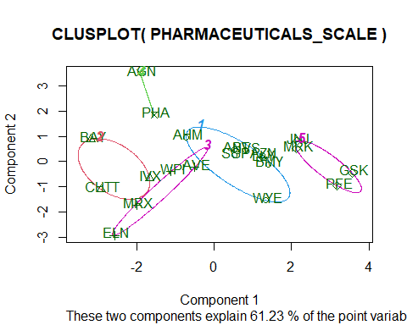

#b) Interpret the clusters with respect to the numerical variables used in forming the clusters.  
#Cluster 1 consists of the stocks AHM, SGP, WYE, BMY, AZN, ABT, NVS, and LLY (lowest Market Cap, lowest Beta, lowest PE Ratio, highest Leverage, and highest Revenue Growth).  
#Cluster 2 (lowest Rev Growth, highest Beta and levearge, lowest Net Profit Margin) is composed of the stocks BAY, CHTT, and IVX.  
#Cluster3 Lowest PE Ratio, Highest ROE, Lowest ROA, Lowest Net Profit Margin, Highest Rev Growth: WPI, MRX, ELN, AVE  
#cluster4 AGN, PHA (highest PE Ratio, lowest Asset Turnover, and lowest Beta)  
#cluster5 JNJ, MRK, PFE, and GSK(Highest Market Cap, ROE, ROA, Asset Turnover Ratio, and Lowest Beta/PE Ratio)  
  
PHARMA_CLUSTER <- PHARMACEUTICALS[,c(12,13,14)]%>% mutate(clusters = FINALCLUSTER$cluster)%>% arrange(clusters, ascending = TRUE)  
PHARMA_CLUSTER

## Median_Recommendation Location Exchange clusters  
## ABT Moderate Buy US NYSE 1  
## AHM Strong Buy UK NYSE 1  
## AZN Moderate Sell UK NYSE 1  
## BMY Moderate Sell US NYSE 1  
## LLY Hold US NYSE 1  
## NVS Hold SWITZERLAND NYSE 1  
## SGP Hold US NYSE 1  
## WYE Hold US NYSE 1  
## BAY Hold GERMANY NYSE 2  
## CHTT Moderate Buy US NASDAQ 2  
## IVX Hold US AMEX 2  
## AVE Moderate Buy FRANCE NYSE 3  
## ELN Moderate Sell IRELAND NYSE 3  
## MRX Moderate Buy US NYSE 3  
## WPI Moderate Sell US NYSE 3  
## AGN Moderate Buy CANADA NYSE 4  
## PHA Hold US NYSE 4  
## GSK Hold UK NYSE 5  
## JNJ Moderate Buy US NYSE 5  
## MRK Hold US NYSE 5  
## PFE Moderate Buy US NYSE 5

#(c)Is there a pattern in the clusters with respect to the numerical variables (10 to 12)?   
plot1<-ggplot(PHARMA_CLUSTER, mapping = aes(factor(clusters), fill=Median_Recommendation))+geom_bar(position = 'dodge')+labs(x ='No of clusters')  
plot2<- ggplot(PHARMA_CLUSTER, mapping = aes(factor(clusters),fill = Location))+geom_bar(position = 'dodge')+labs(x ='No of clusters')  
plot3<- ggplot(PHARMA_CLUSTER, mapping = aes(factor(clusters),fill = Exchange))+geom_bar(position = 'dodge')+labs(x ='No of clusters')  
grid.arrange(plot1, plot2, plot3)

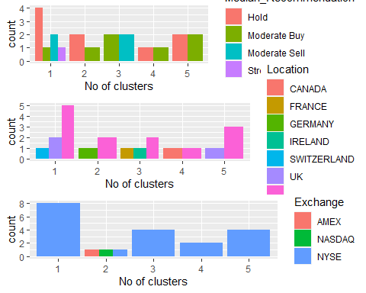

#Given the graph:  
#Cluster 1: The Hold median, which also includes distinct Hold, Moderate Buy, Moderate Sell, and Strong Buy medians, is the highest in this cluster. They are from the US, the UK, and Switzerland and are traded on the NYSE.  
#Cluster 2 features a distinct Hold and Moderate Buy median as well as a varied count between the US and Germany, despite the fact that the firms are evenly distributed throughout AMEX, NASDAQ, and NYSE.  
#Cluster 3 is traded on the NYSE, has distinct counts for France, Ireland, and the US, and has median buy and sell prices that are roughly similar.  
#Cluster 4: has the same hold and moderate buy medians and is distributed throughout the US and UK in addition to being listed in.  
#Cluster 5: only listed on the NYSE, evenly distributed across the US and Canada, with medians of Hold and Moderate Buy.  
#Regarding the media recommendation variable, the clusters exhibit a certain pattern:  
#Hold Recommendation is present in Clusters 1 and 2.  
#All of Clusters 3, 4, and 5 have a moderate purchase recommendation.

# (d)Provide an appropriate name for each cluster using any or all of the variables in the dataset.  
  
#Cluster 1 :- HIGH HOLD CLUSTER  
#Cluster 2 :- HOLD CLUSTER  
#Cluster 3 :- BUY-SELL CLUSTER  
#Cluster 4 :- HOLD-BUY CLUSTER  
#Cluster 5 :- HOLD-BUY CLUSTER