

WALCHAND COLLEGE OF ENGINEERING, SANGLI

DEPARTMENT OF COMPUTER SCIENCE AND ENGINEERING
A
Project Report
On

“SUSHRUSHA-The Sonography Assistant”

BY
1. Aishwarya Heshi 2014BCS002
2.Shivani Kondewar 2014BCS006
3.Sumit Kathale 2014BCS051
[T.Y.B.Tech (CSE)]

UNDER THE GUIDANCE OF

Prof. A. R. SURVE

Walchand College of Engineering, Sangli. 2016-17
CERTIFICATE
This is to certify that the project report entitled

“SUSHRUSHA-The Sonography Assistant”

TO
WALCHAND COLLEGE OF ENGINEERING, SANGLI
Has been completed under my guidance and supervision. To the best of my knowledge and belief, the matter presented in this project report is original and has not been submitted elsewhere for any other purpose.

Submitted by:
Name Exam No.
1. Aishwarya Heshi 2014BCS002
2.Shivani Kondewar 2014BCS006
3.Sumit Kathale 2014BCS051

Prof. Swapnil Mahadeshwar Prof. Dr. S. H. Bhandari
Project Guide Head of Department

ACKNOWLEDGEMENT

We are extremely grateful and remain indebted to our guide Prof.Mr. A. S. Surve sir for being a source of inspiration and for his constant support in the Design, Implementation and Evaluation of the project.
We are thankful to him for his constant constructive criticism and invaluable suggestions, which benefited us a lot while developing the project on “SUSHRUSHA”. He has been a constant source of inspiration and motivation for hard work. He has been very co-operative throughout this project work. It would be our pleasure to express our thanks for his encouragement, co-operation and without which we might not be able to accomplish this project.

INDEX

CONTENTS | PAGE NO.
- Introduction to SUSHRUSHA | 5
2.System Analysis | 10
3.System Design | 14
4. Implementation | 15
- Snapshots and Result | 18
- Conclusion and Future Work | 25
- References | 26

Chapter 1

INTRODUCTION

1. Introduction

In this world everyone needs a work to be done very fast in efficient and in less efforts.. Man has researched different technology for his sake of life. In today’s world of connectedness, people are becoming accustomed to easy access to information. Whether it’s through the internet or television, people want to be informed and up-to-date with the latest events happening around the world. Converting speech to text and text to speech has many applications in today’s world because it would be very tedious job to deal with some situations. Now a day’s many professionals prefer to use speech recognition techniques because they can interact with system easily and it requires very less time. The main objective of this project is to make report generation of sonography record in very efficient manner. and to design a simple, easy to install, user friendly system, which can receive and display report in a particular manner.
With respect diagnosis of patient radiologist/doctor keep record of various parameters according to the problem of patient. Also here the extra expenses paid by doctor on assistant is less,so money is saving and work is done in less time and efficiently.

Users of the System:
- Radiologist
- doctor

1.1 Motivation

Taking reports while diagnosis of patient after doing sonography is important thing.Doctor must has to appoint some person to do all report generation work. Also the work which that assistant does is not very efficient in terms of time and accuracy.Doctor has to pay for that assistant.So our system is nothing but a helping hand for doctors which will help them to generate reports in efficient manner.Only he has to give commands and system will update the changes accordingly. This system will help not only doctors but the patients in getting properly diagnosed.

1.2 Problem Definition

The project is about generating report of sonography by radiologist in efficient manner. The system has to recive the speech massage from radiologist and it generates the reort .Doctor will give the commands fo ex.to insert the size of some organ according to that it will do upadation.,it will display generation of report immediately. The text data is sent in real time is to continuously monitored and validated before it is displayed on the monitor. The entire system shall be a stand lone system with some human intervention.

  - Scope of the project

To design an automatic, self enabled ,highly reliable report generation of sonography. System should continuously listen to doctor , and doctor should properly speak in order to generate report properly. Message displayed should be updated every time the user sends new data. There should be proper wireless network or any internet setting available so that speech recognition can be happen in desired manner. Any radiologist /doctor are able to access the server. User should get an update every time that report is properly generated.

Chapter 2
SYSTEM ANALYSIS

2.1 System Model
The waterfall model is well suited for the system development. The model consists of gathering the requirements at very first phase. Then the activities like design, implementation, testing and maintenance are carried out sequentially.

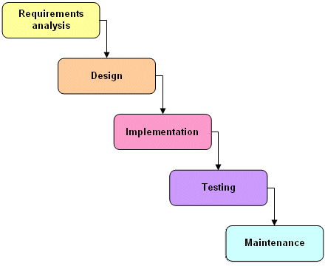
Fig.2.1 Waterfall Model

  - Functional Requirements
Software requirements:
- Front end
- Microsoft
- Rasbian OS

- Back end
- Python
- Oracle
- Eclipse.marse1
Hardware requirements:
- Microphone

2.3 Performance Requirements
- Minimal expanses done the assistant fo generating reports.
- Better output with respect to consumed resources like time and cost.

2.4 Software Quality Attributes
The three major software quality attributes are cost, schedule, and quality with other supporting Software Quality Attributes as follows:

- Functionality: Sushrusha :sonography assistant respectively fulfill the desired functionalities.

- Reliability: Sushrusha :sonography assistant maintain a required level of performance

- Usability: Sushrusha :sonography assistant is easy to learn and use.

- Maintainability: Sushrusha :sonography assistant is easy to maintain i.e. to modify for required improvements and corrections if any.

Chapter 3
SYSTEM DESIGN

3.1 System Overview

3.1.1 Product Features

The major features of the Sushrusha :sonography assistant being developed are:
- TIt has sending message window to send messages.
- The updated report is visible to both doctor and patient.
- When patient visits more than one time the past reports are already present with doctor and patient id remain same.
- It automatically generate word document of report.
- We are storing all the details in database

3.1.2 Operating Environment

Doctor should have his personal computer with windows platform. Microphone should be available with doctor.Net connection should be available there.

Design and Implementation Constraints

- A doctor needs to give proper commands in particular sequence and according to particular functionalities.

2) patients will only be able to view the report on screen..

Chapter 4
IMPLEMENTATION

- Problem Solving Approach

- To establish a system which works as assistant in report generation.
- Configure display side setup as Server.
- Configure user side setup as Client
- Use of google api for speech recognition .
- Create .docx files to store patients reports.
- Use using special and general verbal commands to do some functionalities.
- Use python platform to create code.
- Use pyaudio to use microphone, use gTTs for converting text to speech.

Chapter 5
SCREENSHOTS & RESULTS

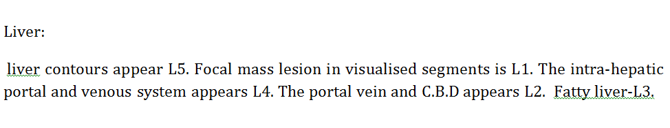

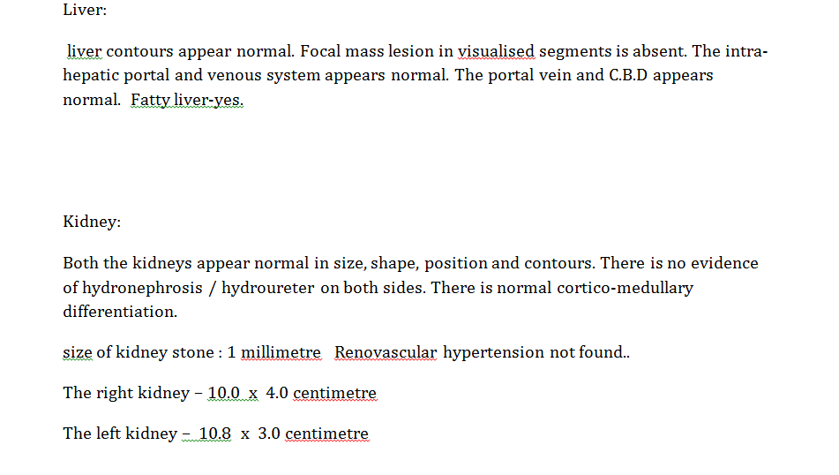
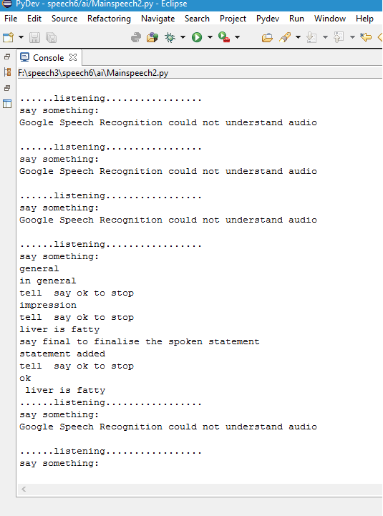

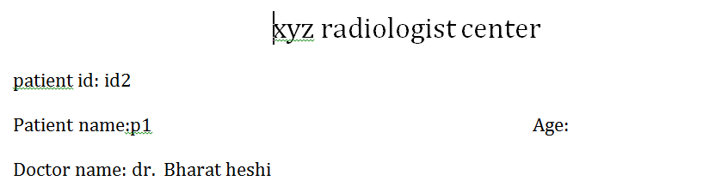

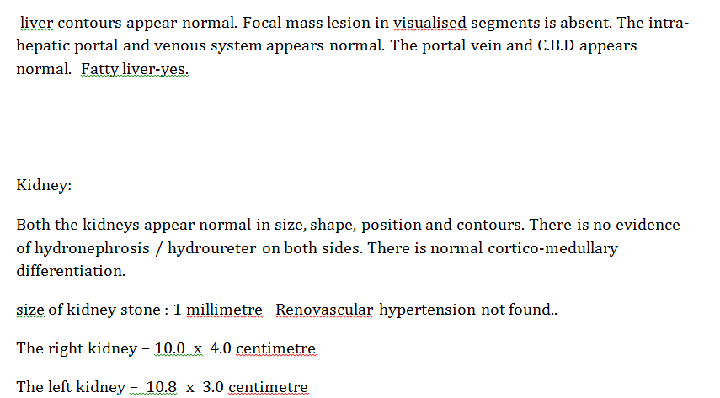

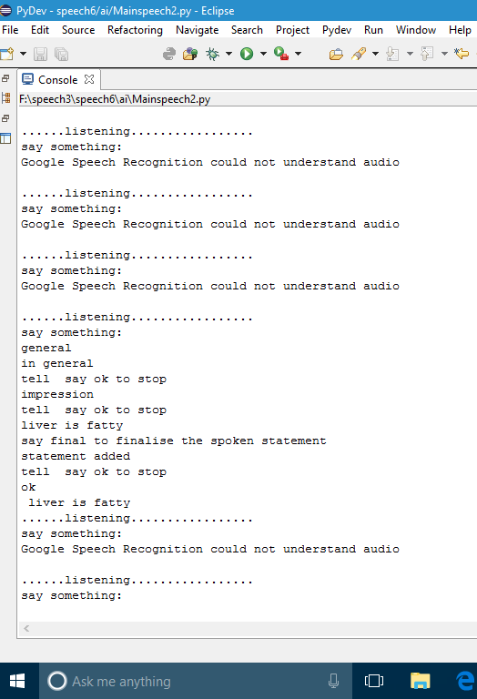

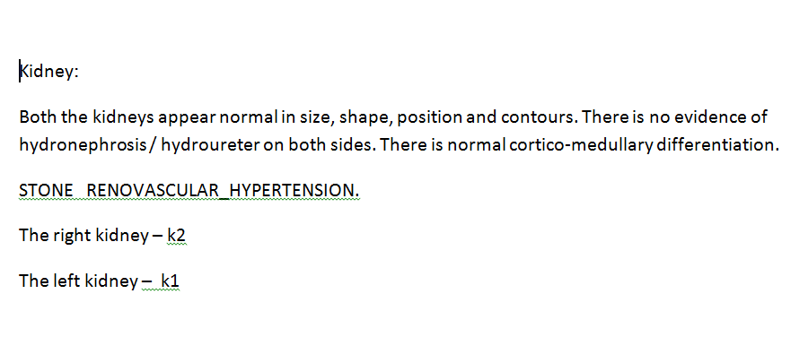

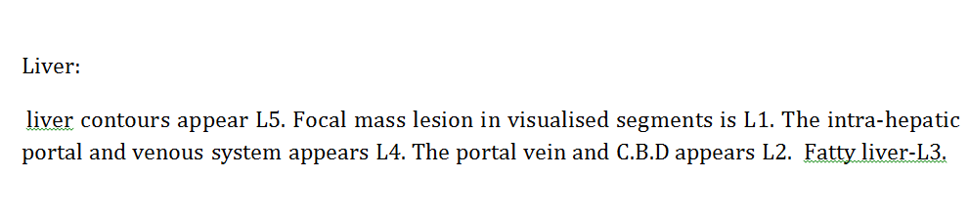
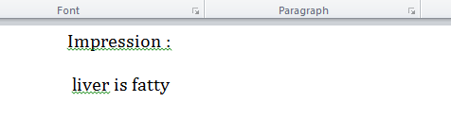

Chapter 6
CONCLUSION & FUTURE WORK

- Conclusion
Sushrusha : sonography assistant is a software system which enable doctor/radiologist to generate report of diagnosis without the use special assistant. It reduces extra expenses done for appointing separate assistant. Also it does its work very efficiently and in very less time. The job of doctor has become very easy than previous tedious one. Doctor can do many functionalities with the help of different methodologies.

Future Scope:
We can integrate it on android and web platform.
Further the impression can be predicted using machine learning.

REFERENCES

- http:/www python.org.com
- speech 0.5.2:Python Package Index pypi.python.org
- Python Release Python 3.6.0b2|Python.org
- http://python central.io/execute-python
- https://pypi.python.org/pypi/speech/0.5.2#downloads
- Speech recognition 3.4.6:Python Package Index

References

